III. primary school Varaždin, Croatia
Ivana Perkovca Square 35,
42000 Varaždin

HOW LIME TREE AFFECTS PEOPLE'S LIVES AND SURROUNDINGS

Antonela Nikolić
7. A.

Mentors: Anica Vragović
Marina Balažinec

In Varaždin, 6 December 2020.

Content

HOW LIME TREE AFFECTS PEOPLE'S LIVES AND SURROUNDINGS 1
1. Introduction 3
1.1. Project goal 3
1.2. Trees and man 3
1.3. Our linden tree 4
1.4. Research questions 4
2. Materials and methods 5
3. Conclusion 9
4. Literature 9

Introduction

The effects of climate change are being felt all over the world: winters are getting warmer, hurricanes, floods and fires are more frequent, sea levels are rising and entire communities like coral reefs are disappearing. The most common cause of this is man.
I met with the fact of climate change for the first time when I was 10 years old in science class and wanted to contribute to the protection of our planet and actively participate in environmental observation, so I joined the GLOBE program. As part of the GLOBE program, I have been watching the lime tree outside the school for 3 years and I noticed that this year it budburst started 2 weeks before previous years. Looking at the lime tree, I learned a lot about the environment and the nature around us. I've learned that all ecosystems are connected and we're all dependent on each other. With this work I want to emphasize this connection between people and nature and to show how much lime tree in front of the school affects us students by producing oxygen.

Project goal

- Develop awareness of human connection with nature
- Encourage other students to actively participate in environmental protection and nature protection
- Encourage school authorities to plant more trees around the school
- Link mathematics with nature

Trees and man

The best way to change the world is to change ourselves. So I decided to mathematically calculate how much one lime tree in front of the school means to us and encourage the school to plant more trees. According to Hewitson, m² leaves produce 500 mL of oxygen per hour, and the average person breathes 12 times per minute in a resting state, and in one breath there is 500 mL of air, of which 79% oxygen (Car, 2011). I took these facts into when calculation for our lime tree.

Our lime tree

Our lime tree belongs to the species of small-leaved lime lat. Tilia cordata. Small-leaved lime is a deciduous tree that grows up to 18 m. Canopy is dense, in youth conical and symmetrical and later in the form of a hemisphere, rounded and wide. The flowers are pale yellow (5 to 15) collected in a pactous inflorescence with a winged side, pleasant smell. It blooms between June and July. The fruit is a multi-seeded nutmeg pear-shaped, reddish in color. It requires loose, deep, well-drained soil, thrives on other types of soil; adaptable to different soil pH reactions. It likes a sunny to semi-shaded position. Tolerates urban planting conditions; pollution, compacted and alkaline soils, poorly drained soils (Drijen 2020).
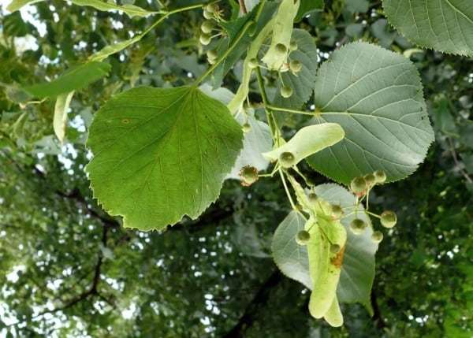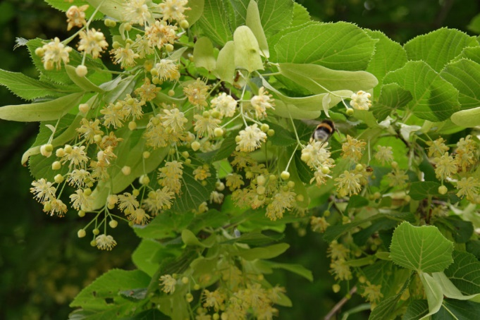
Picture 1. Picture 2.

Research questions

- How much lime tree produces oxygen in one hour, in one day and in one year?
- How much oxygen does the average person breathe in one hour, in one day and in one year?

Materials and methods

In order to calculate how much oxygen our lime tree produces in one hour, I took one leaf and calculated it’ s surface using millimeter paper (Picture 3 and 4). In order to get an approximate number of leaves on the lime tree, I took a wire cube with a volume of 2.2 dm³ and counted the leaves in it (Picture 5). Then I calculated the volume of the lime conopy to get the number of cubes in the canopy of lime.
Picture 3. Lime tree leaf on millimeter paper Picture 4. Calculate leaf surface
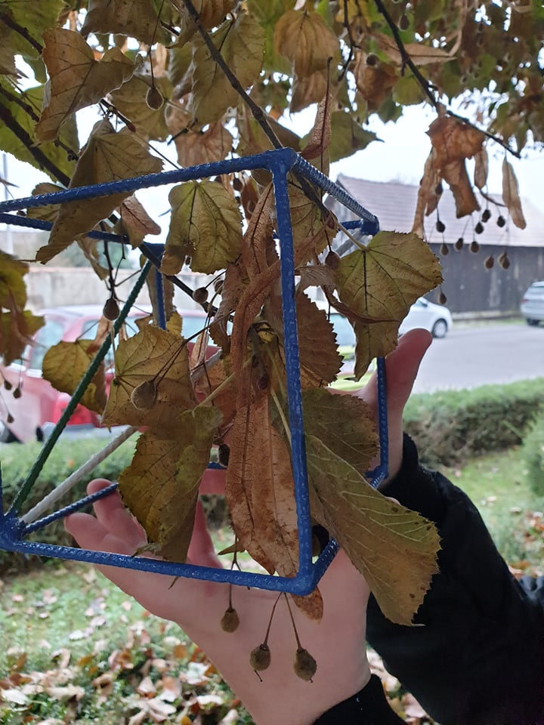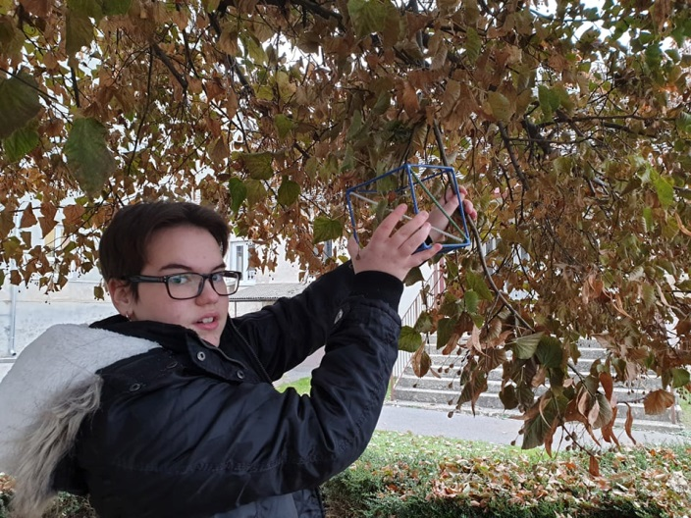
Picture 5. Counting leaves in a cube with a volume of 2.2 dm³
The lime canopy has the shape of a cone (Picture 6.) so I used the formula for the volume of the cone to calculate the volume of the lime tree. For this calculation, I needed the height of the lime canopy (h) and the radius of the canopy at the base (r).
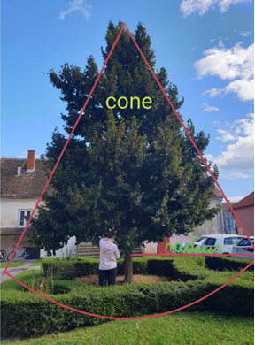Picture 6.
Lime tree
h = 5.64 m, height of lime tree from ground to top is 7.64 m
r = 2m, with of canopy at the base is 4 m
The volume of the cone (the volume of the lime canopy) is calculated according to the formula:
V= $\frac{B ∙ h}{3}$
B - cone base (circle surface)
h – lime tree canopy height, 5.64 m

V= $\frac{B ∙ h}{3}$ B = r² · π
V= 2$\frac{12.56 ∙ 5.64}{3}$ B= r² · 3.14m
V= 4 $\frac{70.84}{3}$ B= 2² · 3.14m
V= 23.61≈ 24m² B= 12.56 m²
V= 2 400dm²
LIME VOLUME IS 2 400 dm²
Number of leaves on lime tree
Cube edge 1 CUBE = 16 leafs
a =1.3 dm NUMBER OF CUBES =$\frac{VOLUME OF LIME CANOPY}{VOLUME OF CUBE}$
V=a³ $\frac{2400}{2.2}=10909.90$≈ 10,910
V=1.3³ 10910 · 16 leafs= 174,560
V= 2,197 dm³≈2.2 dm³
Lime tree has 174,560 LEAVES
Amount of oxygen produced
One leaf produces 0.05 mL of oxygen per 1 cm² (Hewitson) in one hour
Average lime tree leaf area:
P= 42 cm²
42 · 0.05 = 2.1 mL/h
SINGLE LEAF = 2.1 mL oxygen/hour
WHOLE LIME TREE
IN HOUR
174 560 (number of leaves) · 2.1 = 366 576 ml ≈367 L/h
IN THE DAY
367 · 24= 8808 L per day
ANNUALY
8808 · 365 = 3 214 920 L per year

Amount of inhaled oxygen (1 person):
1 breath
1 breath – 500 mL of air – 79% oxygen
79% of 500 mL
0.79 ̇· 500= 395 mL of oxygen/inhalation
IN THE hour
1 min – 12 breaths
1 hour = 60 minutes
12 · 395 mL · 60 = 284 400 mL/h
IN THE DAY
1 day= 24 hours
1 hour= 60 min =>24 · 60 = 1440 min in one day
1 440 · 4 740 = 6 825 600 mL oxygen/day
ANNUALY
365 · 6 825 600 mL = 2 491 344 000 mL $≈$ 2 491 344 L $≈$ 2.5 · ${10}^{9}$L/year

Our school (434 people)
391 students + 43 employees = 434 people in our school
IN THE HOUR
434 · 284 400 = 123 429 600 mL/h
IN THE DAY
434 ·6 825 600 mL per day = 2 962 310 400 mL or 2 962 310 L/day
ANNUALY
2 962 310 l · 434 = 1 081 243 296 L $≈$ 1.08 · ${10}^{9}$L/ yearly

Conclusion

Our lime tree produces about 3 214 920 L of oxygen per year, and employees and students of our school need about 1 081 243 296 L of oxygen per year. Which is about 336 times more than our Lime tree produces.
I am extremely pleased to have conducted this research to highlight the importance of tree planting and their usefulness and lack in the environment of our school. I am aware that we cannot plant 336 trees in the schoolyard, but I hope that this work will encourage planting at least 2-3 trees around the school in order to be closer to nature.
I enjoyed following and measuring the lime in front of the school and using mathematics. Mathematics is really all around us and the foundation of all natural sciences and I'm always happy when I can apply math knowledge to concrete and life things.

- Literature
Car, H. (2012). LJUDSKO TIJELO: PLUĆA I DISANJE. Matka: časopis za mlade matematičare, 20(79), 168-168.

Drijen d.o.o. Drijen, vrtni centar https://drijen.hr/ pristupljeno 10.12.2020.

Hewitson, W. (1962). Comparative morphology of the Osmundaceae. Annals of the Missouri Botanical Garden, 57-93.

