**Investigation of Mosquito Larvae Habitats in The Water Ditch at Hsin Tien Senior High School**

LUO, XIN YI HUANG, YU CHIN LIU, YU HSUAN

Teacher：CHEN, CHENG CHANG

Hsin Tien Senior High School

Taiwan

2021/03/09

**Abstract**

Due to our previous participation in the mosquito seminar , when registering for the science fairs, we thought that if the subject is related, it will be easier when researching, so we decided to study topics related to mosquitoes.

In Taiwan, mosquitoes are everywhere, and they live in humid places, such as mud, tree holes, grass, or ditches. In Hsin Tien High School, mud and tree holes are not common, and the grass is in the sun, cannot guarantee the growth environment required for larvae, so we only have a ditch. After the observation, we analyzed the data and we wanted to know whether there will be larvae in every ditch, and whether the number of larvae varies in different places.

This research mainly observes the water ditches and conducts in-depth research on several of them. We observe regularly once a week, and after the exchange meeting in Southeast Asia, it will be changed to five times a week, focusing on the observation of water temperature and water ditches. The observation items are water temperature, air temperature, pH value of water, the number of larvae caught, and environmental records of water ditch. In the future, it is planned to increase observation of dissolved oxygen and water quality. After observing and recording, we analyze the data and ask some questions. For example, the collective death of the larvae collected at the beginning of the observation, and the relationship between the number of larvae collected and the rainfall. In the process of discussing these issues, we use the data at hand and online data to analyze and find out the reasons. This report will present all our research processes.

**Research Question and Hypothesis**

1. Is rainfall related to the number of larvae caught?
2. Is there a positive correlation between the number of larvae and rainfall?
3. Why larvae can be caught in place A, but place B not?
4. Why after the capture, the larvae died one after another?

**Research Methods and Materials**

* Preparation before observation:

After deciding that the research topic is the ecology of our high school ditch, we first decided on the location of the ditch to be observed. It took us one noon. The observable water ditch has the following conditions: first, it should not be too deep, otherwise the distance from the bottom of the water ditch will be too far to collect samples; second, the water ditch cover is not available Was locked. In our high school, not every ditch cover can be easily removed, some will be firmly locked with screws. Finding a ditch cover that can be easily removed is the first task. After finding the appropriate water ditch, we began to discuss the items to be observed and the tools that need to be prepared. After considering the time available for observation each week, we decided to check the water temperature, air temperature, air pressure, number of larvae and the water ditch environment observation at noon on each Monday.

* Observation work at noon every Monday:

1. After arriving at the pre-determined observation site, we will remove the ditch cover to see the condition in the ditch (if there is no water, we will only write down the description of the ditch environment and end today's observation), and Make observations
2. Use a water temperature measuring instrument to measure the water temperature, and then take half a cup of water with a glass
3. Division of labor to do the next observation work(A: LUO, XIN YI B: LIU, YU HSUAN C: HUANG, YU CHIN)

Division of labor table

|  |  |  |  |
| --- | --- | --- | --- |
| A：LUO, XIN YI B：LIU, YU HSUAN C：HUANG, YU CHIN | | | |
| Identify the type of sample | A | Pick up the larva | BC |
| Measure the pH value | A | Separate | BC |
| Measure the water temperature | A | Observe the larva | ABC |
| Take a photo | B | Observe the ditch | ABC |
| Measuring temperature and air pressure | C | Recording | ABC |
| Fetch water | BC | Check the information | ABC |
| Water quality | BC | Make report | ABC |

1. When A goes to the biological laboratory, use the instrument for measuring acid and alkali and the test paper for measuring acid and alkali to measure acid and alkali
2. B and C do the remaining observation items: separate the larvae and describe the environment and conditions of the water ditch that day. When we find that there are larvae or other non-larvae creatures in the water glass, we will first use a dropper or spoon to divide them into small bottles. If the creatures bigger, they will be packed in larger bottles. The most special thing is that if when a pupa is caught, it will be placed in a feeding box for the insect. The box is called "the luxurious first-class cabin for biological samples". There will be some water and a branch in it to the larvae. When it hatches into a mosquito, it will not fall into the water to drown. And the description of the water ditch environment has some key points, such as the amount of water, whether the water looks turbid, whether there are more leaves, and whether there are non-aquatic organisms in it.

* Observations beyond noon on Monday:

Due to time constraints, some observations were not carried out on the same day, such as temperature, air pressure, and the exact types of organisms collected. Hsin Tien High School has a measuring station that will observe temperature, soil temperature, cloud coverage and other items, so we can directly obtain air pressure and temperature data we want from the observed data. It is a little more difficult to distinguish the types of organisms. We will consult our instructors, biology teachers, check information online or go to the library to find information. In the end, some creatures can distinguish by us, and some can not. In addition to the above work, we will also keep a daily record of the collected organisms, especially the larvae, which will peel off, grow larger, even pupation, and become adults. It was also because of the daily records that we find the collected larvae died one after another only later.

**Results**

Hsin Tien High School, 2020/12/19 to 2021/01/11 rainfall (mm)

|  |  |  |  |  |  |
| --- | --- | --- | --- | --- | --- |
| 2020/12/19 | 4.5 | 2020/12/27 | 2 | 2021/01/04 | 0 |
| 2020/12/20 | 3.6 | 2020/12/28 | 3.6 | 2021/01/05 | 5.6 |
| 2020/12/21 | 4.4 | 2020/12/29 | 2 | 2021/01/06 | 3.5 |
| 2020/12/22 | 0.4 | 2020/12/30 | 3.6 | 2021/01/07 | 25.1 |
| 2020/12/23 | 15.1 | 2020/12/31 | 2 | 2021/01/08 | 15.6 |
| 2020/12/24 | 9.8 | 2021/01/01 | 0 | 2021/01/09 | 12.0 |
| 2020/12/25 | 3.2 | 2021/01/02 | 0 | 2021/01/10 | 1.0 |
| 2020/12/26 | 4 | 2021/01/03 | 5.6 | 2021/01/11 | 7.8 |

Water ditch ecological observation data

|  |  |  |  |  |  |  |
| --- | --- | --- | --- | --- | --- | --- |
| **Date** | **Air**  **temperature (**°C**)** | **Place** | **Water temperature (**°C**)** | **pH** | **Mosquito larva(Culex)** | **Rainfall (mm)** |
| 12/15 | 19.1 | A | X | X | 0 | 3.4 |
| B | X | X | 0 |
| 12/21 | 18.2 | A | 17.0 | instrument:9.65 | 1 | 4.4 |
| B | 17.0 | X | 0 |
| 12/25 | 17.3 | A | X | X | 0 | 3.2 |
| B | X | X | 0 |
| 12/28 | 22.0 | A | 21.0 | instrument:6.65 | 1 | 3.2 |
| B | 21.0 | instrument7.0 | 0 |
| 1/4 | 22.0 | A | 20.0 | instrument:9.94  paper:7 | 4 | 5.6 |
| B | 19.0 | instrument:9.94  paper:7 | 0 |
| 1/11 | 18.0 | A | 12.0 | instrument:6.7  paper:6 | 0 | 7.8 |
| B | 12.0 | instrument:7.4  paper:6 | 0 |

The relationship between rainfall and the number of larvae caught

The difference between A and B

|  |  |  |  |  |  |  |
| --- | --- | --- | --- | --- | --- | --- |
|  | **Is there a larva** | **Water clarity** | **Is it in the shadow** | **Amount of water** | **Number of leaves** | **Aquatic organisms** |
| Place A | Yes | Mixed | Yes | Less | More | Big mouth snail |
| Place B | No | Clearer | No | More | Less | Cricket |

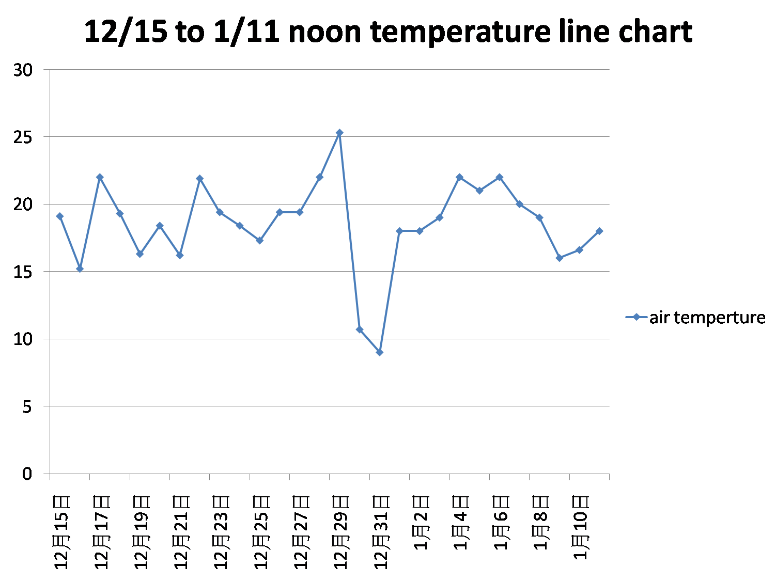

**Discussion**

* The amount of rainfall is related to the number of larvae caught. Within a certain amount of rainfall, the more rainfall, the greater the number of larvae caught. We think it is because there is water in the ditch that mosquitoes will lay eggs, but if there is too much water, the larvae will be washed away.
* Regarding whether the amount of rainfall is directly proportional to the number of larvae, as mentioned above, the amount of rainfall is not always proportional to the number of larvae. When the rainfall exceeds a certain value, the number of larvae will decrease instead, because too much water will form a flow of water. The water in the ditch is not still water, and the larvae will be washed away.
* Why there are more larvae in land A than land B, we think there are the following reasons:

1. The crickets in the B area will eat the larvae. Because crickets are omnivorous, and there are many crickets in the B area, but there are no larvae. Let us suspect that this is the reason.
2. Compared with A, the water ditches in B are wider, the water quality is cleaner, the drainage is better, and there may be have less food-plankton that larvae can eat.
3. Compared with land B, land A have more mud, there will be more hiding places for larvae, and there will be more plankton. Simply put, the more food, the more larvae.
4. Although there are trees on land A and land B, the trees on both land B are taller. It is speculated that the water ditches in land B will receive more sunlight and the water ditches will be too bright. But mosquitoes like dark places.
5. There are a lot of big mouth snails in A, but the larvae do not decrease. We guess that if they are not in a symbiotic relationship, they are in a single symbiotic relationship.

* Why did the larvae die one after another?

1. At first we thought that the temperature was too low and the larva died, but after checking the temperature, we found that the reason was not the case.
2. After that, we checked the observation records and found that the larva had not been ventilated for four consecutive days, and it was speculated that the cause of the larva’s death was hypoxia.

**Conclusion**

1. The more rainfall, the more water and larvae in the ditch; when the amount exceeds a certain value, the water in the ditch starts to flow, and the larvae will hardly be caught or not caught at all. It is easiest to catch the larvae two or three days after it rains.
2. The less sunlight and the more muddy the ditch is exposed to, the more larvae will be, and vice versa. In addition, if there are other creatures in the ditch, it will also affect the number of larvae. If there are creatures that feed on larvae, there will be fewer larvae. And the more plankton in the water, the more larvae there will be.
3. The larva needs a water environment, but it also needs oxygen, otherwise it will drown.

**Bibliography/Citations**

[https://www.google.com/maps/@12.9278984,90.3815462,11373190m/data=!3m1!1e3 (2021.01.27)](https://www.google.com/maps/@12.9278984,90.3815462,11373190m/data=!3m1!1e3(2021.01.27))

<https://zh.wikipedia.org/wiki/%E6%B0%B4%E8%9A%A4> (2021.02.02)

<https://news.ebc.net.tw/news/living/109477> (2021.02.02)