Kyllinga brevifolia surround soil characteristics in school

Student Name:CHANG,WEI-JIE、CHA,YUE-TING and HUNG,MING-WEI

School:New Taipei Municipal Hsin Tien Senior High School

Teacher: CHEN, CHENG-CHANG
Taiwan

8 March 2023

Foreword:
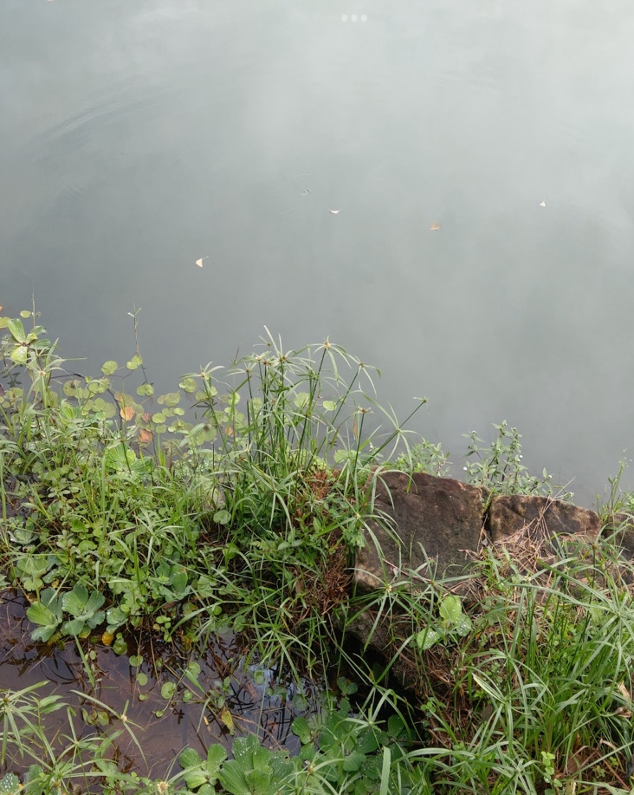
Kyllinga brevifolia is a Cyperaceae Kyllinga vegetation, most of them grow near water sources or moist environments, Once, when we were observing weather conditions. We suprisingly found out that there are also Kyllinga brevifolias on the lawn of our school. Due to its habit of growing near water sources , its appearance of growing on the lawn of our school surprised we a lot, after all, there are no water sources around. Thus, we start observing its growth and we wish to compare the humidity of growth environment of Kyllinga brevifolia with other lawns that do not have Kyllinga brevifolia growing through this research.
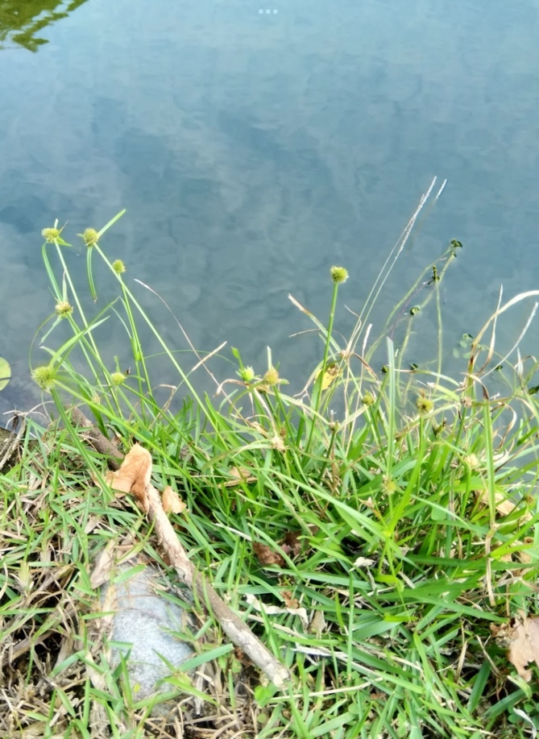

Research methods:
- Collect the soil probably half of the glassware（Kyllinga brevifoli soil beside the Stevenson screen sod in school that deep with 5,15,20(cm) add no grass soil be middle, east west south north each collect no grass soil
- Because the soil not very difference, so we change the place in process,（Kyllinga brevifotoli have or have not soil beside the Stevenson screen sod in school (deep with 5,15,20 add no grass soil) and the no sod soil in playground
- After the collection and go to the laboratory to measure the soil with 200g
- Take to the oven to bake
- Wait for next time after collect soil take out,each of them measures how much g (seldom g is moisture)
- Each of cup take 20g soil, add 40g distilled water stir well wait for settle
- Use burette to absorb above water
- And use pH instrument and pH test papers to measure pH

Material:
- Glassware
- Burette
- Scoop
- Electronic scales
- Distilled water
- pH instrument and pH test papers
- Neutral water
- Plastic box
- Oven
- Hoe
- Thermometer
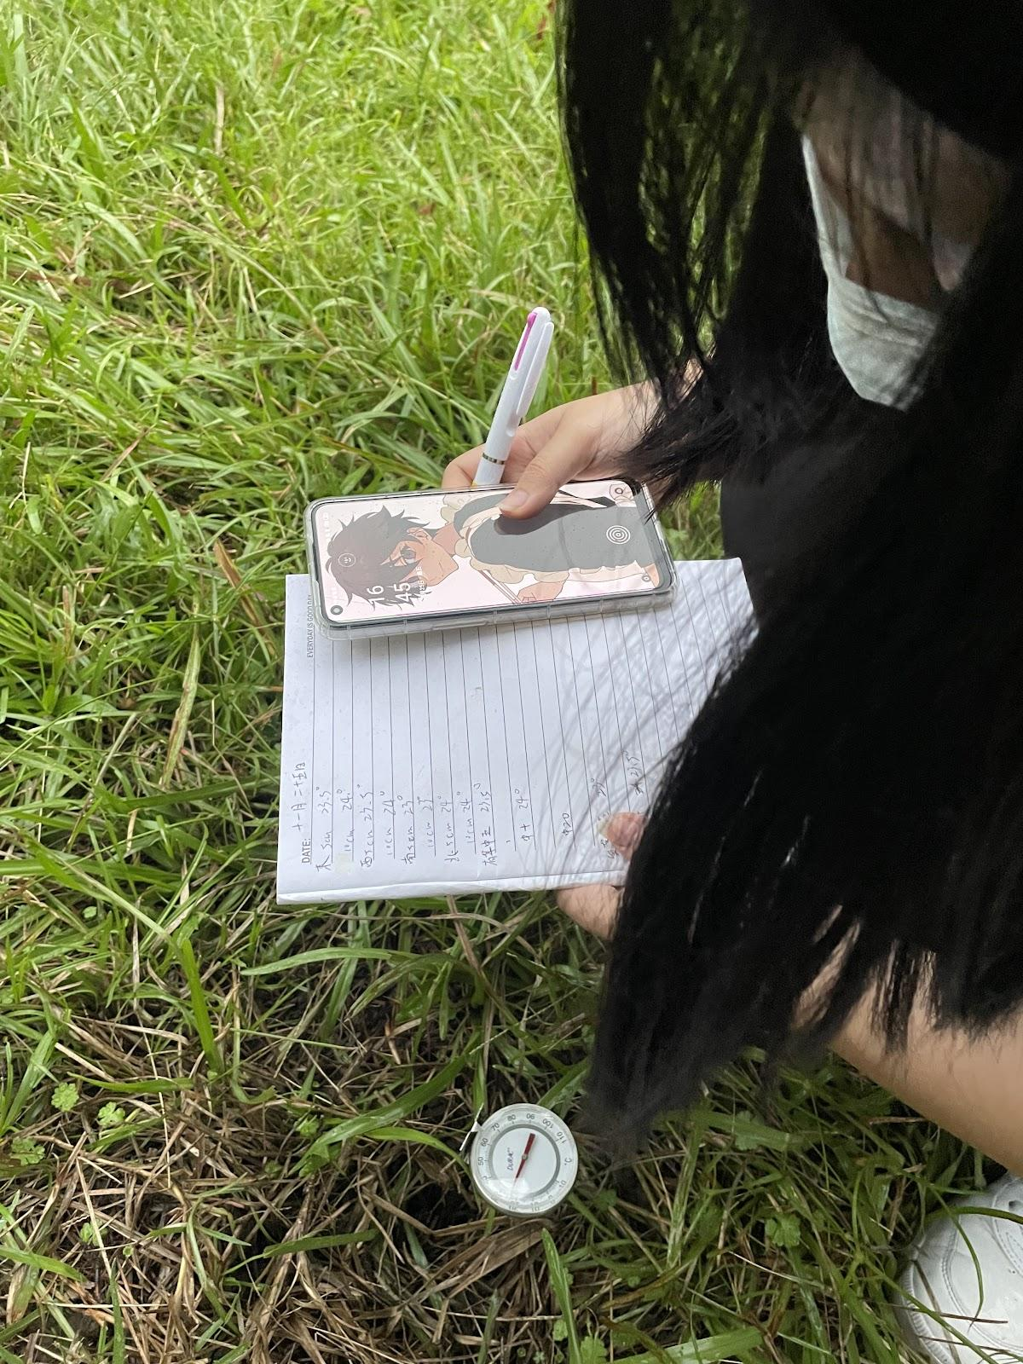
Recording the soil temperature.
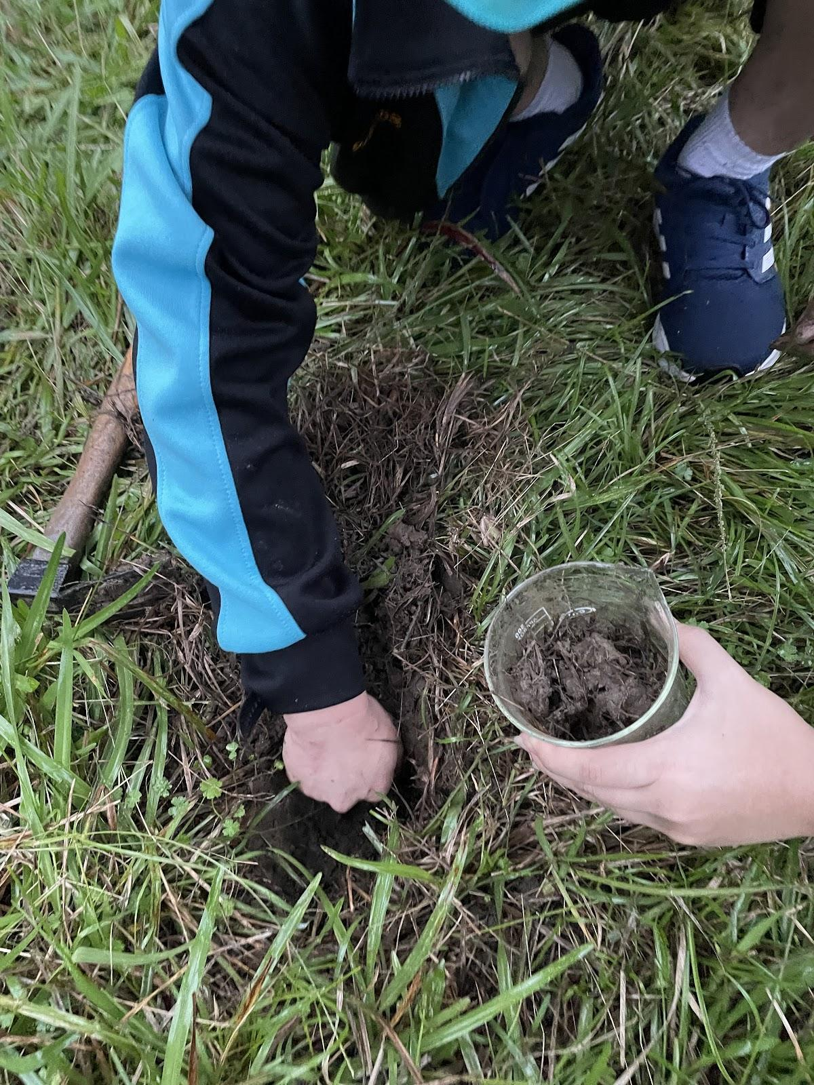
We collecting the difference kinds of soil.

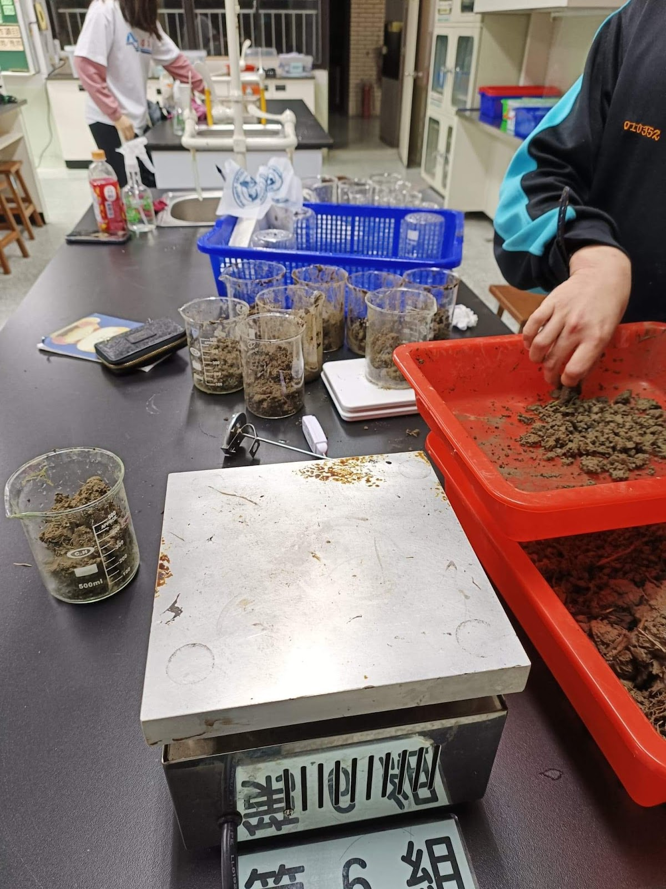
Measure the soil with 200g

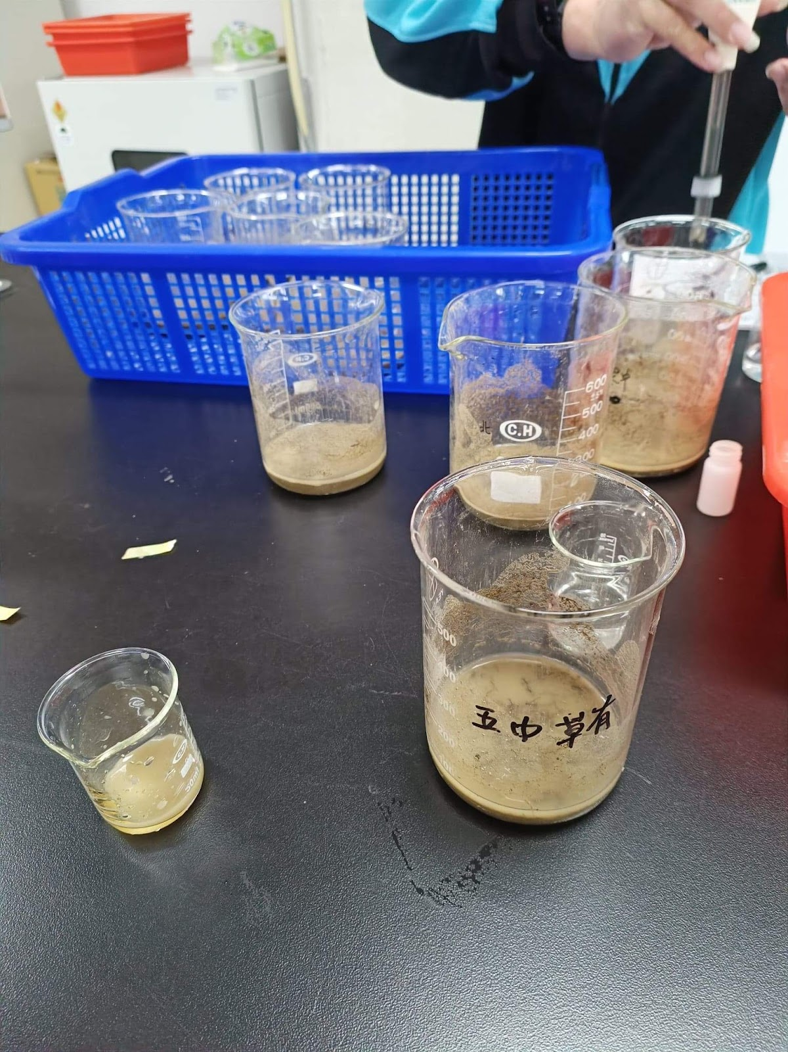
Measure the soil pH

Experiment:
Operational variation：soil moist
Control for variations：temperature, sunshine, soil kind
Strain factors：Kyllinga brevifoli grow state

Introduce for sheet:
a- Without Kyllinga brevifolia around the shutter at a depth of 5 cm
b- Without Kyllinga brevifolia around the shutter at a depth of 10 cm
c- Without Kyllinga brevifolia around the shutter at a depth of 15 cm
d- Have Kyllinga brevifolia around the shutter at a depth of 5 cm
e- Have Kyllinga brevifolia around the shutter at a depth of 10 cm
f- Have Kyllinga brevifolia around the shutter at a depth of 15 cm
g- Without Kyllinga brevifolia around the sports ground at a depth of 15 cm
h- Without Kyllinga brevifolia around the sports ground at a depth of 15 cm
i- Without Kyllinga brevifolia around the sports ground at a depth of 15 cm

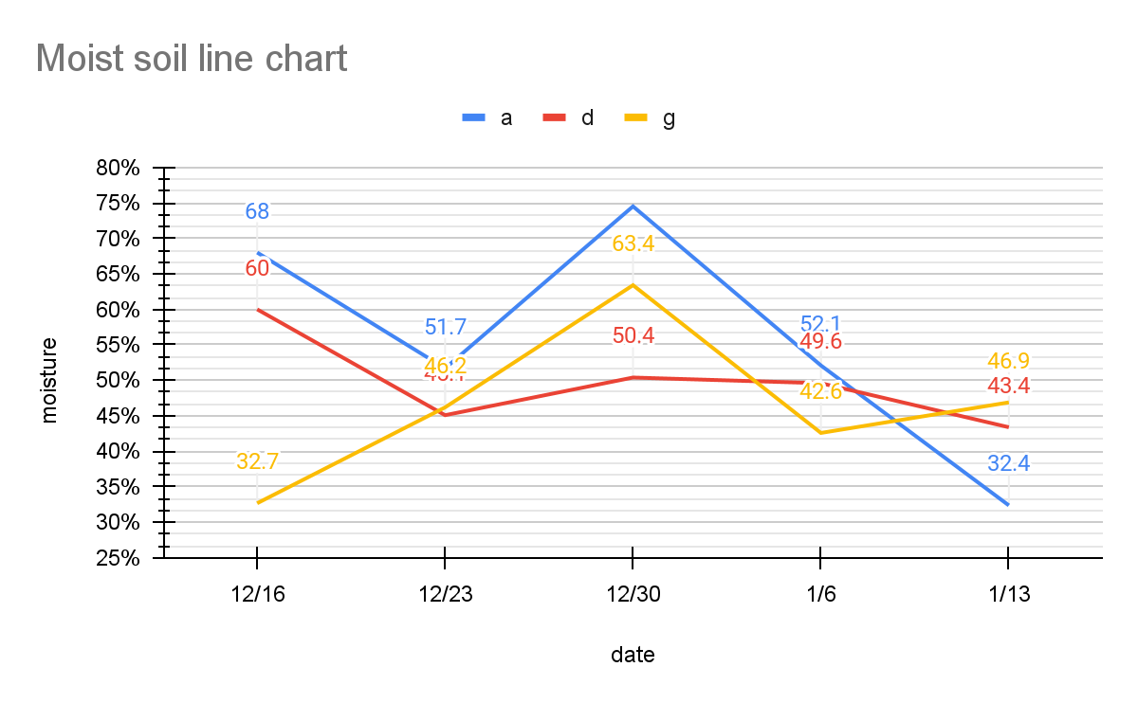
Discussion:
According to this chart, we can see differences in soil moisture at different depths in the same location. The fluctuations in moisture content on the playground are very significant, and the second largest fluctuation occurs in the soil next to the same thermometer screen but without Kyllinga brevifolia water centipedes. Although the soil where Kyllinga brevifolia water centipedes grow is not the wettest, the moisture content is relatively average. However, surprisingly, the soil without Kyllinga brevifolia water centipedes has a higher average moisture content than the soil where they do grow.

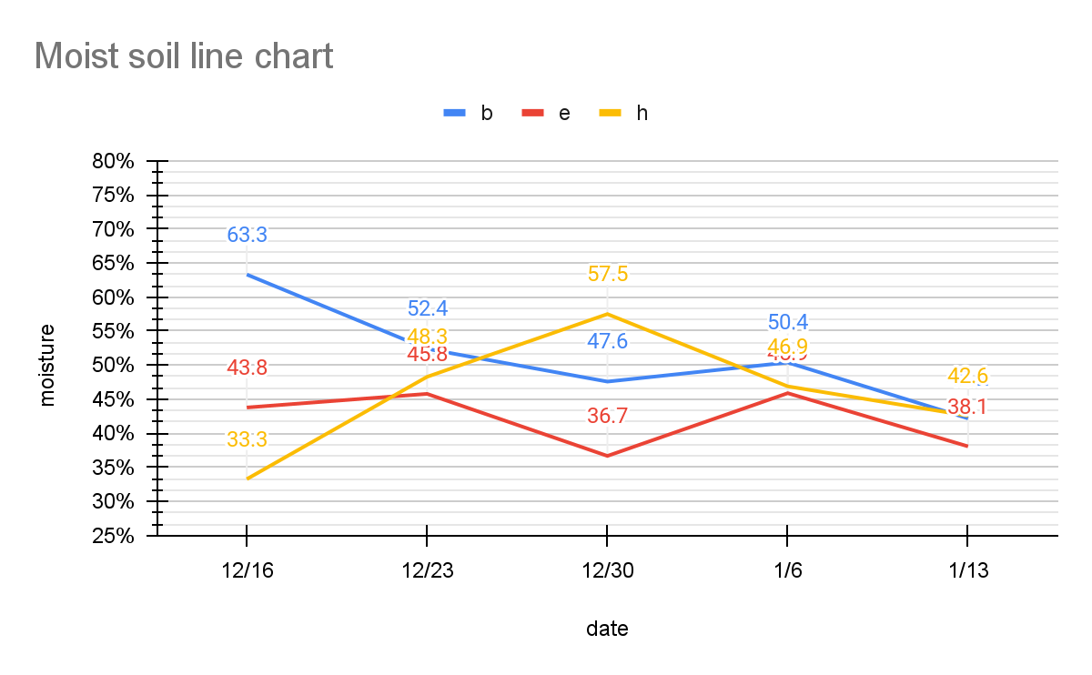
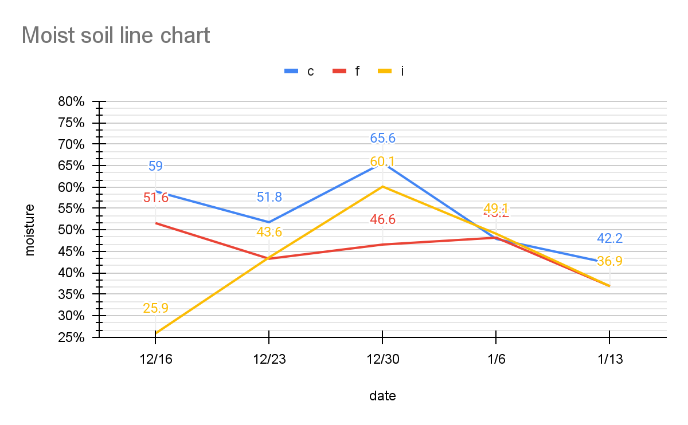
The pH of the soil where Kyllinga brevifolia grows is maintained below 7, but the difference in pH is not too big.
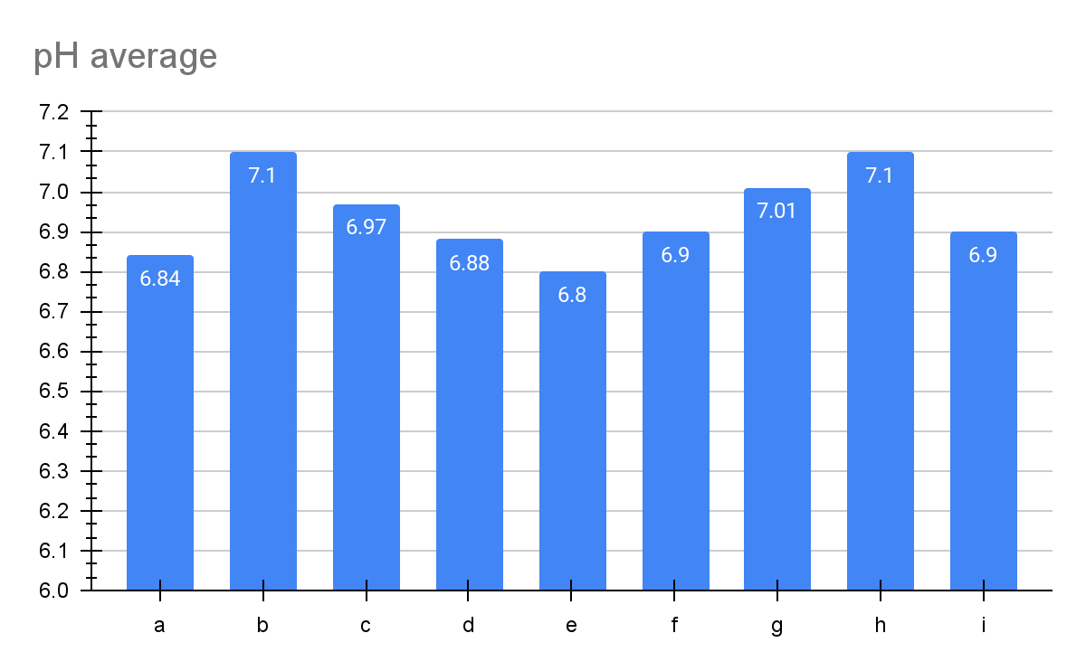
The pH of the soil where Kyllinga brevifolia grows is maintained below 7, but the difference in pH is not too big.

Conclusion:
- According to the experimental results, the growth of the Kyllinga brevifolia may require soil moisture to be kept relatively stable in addition to sudden high humidity.
- In Taiwan, the northern region receives rainfall throughout the year, so soil with good water retention near the thermometer screen containers is suitable for the growth of the Kyllinga brevifolia.
- As for the pH level, due to insufficient data and the relatively small difference in soil acidity at the school, it cannot be used as a basis for evaluation.

Division of work:
Consolidation form, analyze data, Translate English and compile the report
-CHA,YUE-TING
Write experiment idea, design experiment, compile the report
-CHANG,WEI-JIE
Compile the report, translate English and confirm report
-HUNG,MING-WEI

Bibliography and citations:
徐玲明、蔣慕琰(2000)。短葉水蜈蚣發芽特性及其藥劑防除。植物保護學會會刊。

短葉水蜈蚣。維基百科。

短葉水蜈蚣。臺灣生命大百科。

短葉水蜈蚣。臺灣生物多樣性網絡。

С. I.Peng(1975)。短葉水蜈蚣。典藏臺灣。

鈴木重良(1934)。短葉水蜈蚣。典藏臺灣。

