**Data display and analysis**

Our school is located on the island of Ugljan at 19.7 meters above sea level. Its coordinates are: N44 ° 08'18 ", E15 ° 17'87"

According to the Köppen climate classification, our school is located in an area of ​​Mediterranean climate with hot dry summers (Csa). It is also called the olive climate. The characteristics of this climate are: dry period in the warm part of the year, the driest month has less than 40 mm of precipitation and less than a third of the rainiest month in the cold part of the year, and in most parts there are also two maximums of precipitation. Winters are mild with occasional cold waves.

The average temperature in the coldest month of January is 7.3 ° C, and in the warmest month of July 23.9 ° C. Precipitation is higher in the cold season than in the warm season, with an average of 879 mm of precipitation per year. Snow is a rare occurrence.

Licehtesteinisen Gimnazija is located in Liechtenstein in Vaduz at 470 meters above sea level. Its coordinates are: N 47 ° 09 '20 “; E 09 ° 30 '12 “

Vaduz is characterized by an oceanic climate with mild summers and cold winters. The Köppen-Geiger climate classification system classifies the climate as a moderately warm humid climate with a warm summer (Cfb). It is also called a beech climate. Climate properties are: mean temperature of the warmest month <22 ° C; has a temperature of ≥ 10 ° C for at least 4 months. Favorable annual rainfall and sufficiently high temperatures: suitable conditions for the development of the plant world.

The city records a significant increase in precipitation during the summer, but generally little precipitation is seen throughout the twelve months. Vaduz receives an average of about 900 mm of precipitation per year. Vaduz's warmest month, July, records that average maximum temperatures reach 25 ° C, while average minimum temperatures are around 14 ° C. The coldest month, January, has average highs of 3 ° C and average lows of -3 ° C. The average air temperature in January is 0.7 ° C, and in July 19 ° C.

We compared the weather conditions of our schools by using data on the amount of precipitation and the maximum, minimum and current air temperatures in 2019.

We first wanted to find out if 2019 deviates from the climatic characteristics for the study area.

For comparison, we took the total amount of precipitation and the mean daily air temperature of the coldest month and the warmest month.

Table 1.- Monthly temperatures of the coldest month and warmest month ( °C), the amount of precipitation for Preko and Vaduz in 2019 (mm) and the multi-year average

|  |  |  |
| --- | --- | --- |
| Meteorološki parametri | Preko | Vaduz |
| Srednja mjesečna temperatura najhladnijeg mjeseca | 7°C | 0,9°C |
| Višegodišnji prosjek srednje mjesečne temperature | **7,3**°C | **0,7**°C |
| Srednja mjesečna temperatura najtoplijeg mjeseca | 26,5 °C | 24,9°C |
| Višegodišnji prosjek srednje mjesečne temperature | **23,9**°C | **19**°C |
| Ukupna količina oborina u 2019.g | 1081 mm | 879 mm |
| Višegodišnji prosjek količine oborina | **879 mm** | **900 mm** |
| Nasuši mjesec u 2019.g | 1 mm | 14,7 mm |
| Najkišovitiji mjesec u 209.g | 160 mm | 176,6 mm |

Comparing the data obtained in 2019 with the climatic characteristics of our area, we see that in 2019 it deviates slightly from these characteristics. Namely, the coldest month is January and the average monthly air temperature corresponds to the average. The warmest month is July for Vaduz and August for Preko and the average air temperature is slightly higher than the average in the studied areas.

Total precipitation In 2019. was 1081 mm, and the average for our area is 879 mm. We see that the amount of precipitation in 2019 deviates slightly from the average. Our driest month has less than 40 mm of precipitation and less than a third of the rainiest month of the year which corresponds to the characteristics of the climatic characteristics of our area. There was no snow, and snow is a rare occurrence in our area.

The total amount of precipitation in 2019 in Vaduz was 870.3 mm, and the average is 900 mm. The highest precipitation was recorded in the summer, especially in August, which is a characteristic of the area, and the lowest in December. We do not have data on snow for 2019, but we found that 104 cm of snow falls annually in the area.

We then calculated the mean daily air temperatures and the mean monthly. The amount of precipitation was calculated by summing the precipitation by months. As the difference in altitude of the investigated schools is greater than 400 m, we corrected the air temperature data for Vaduz.

In the free atmosphere, the average temperature decreases to 0.65 ° C for every 100 m of altitude, which in our case would be 0.6 ° C / 100 mx 400 m is 2.6 ° C. The air temperatures for Vaduz were corrected so that we are medium monthly temperatures added 2.6.

We presented the data in tables and graphs.

Table 2 - Monthly air temperatures in Preko and Vaduz in 2019. (°C)

|  |  |  |  |  |  |  |  |  |  |  |  |  |
| --- | --- | --- | --- | --- | --- | --- | --- | --- | --- | --- | --- | --- |
|  | Mjeseci | | | | | | | | | | | |
| Istraživačko područje | 1 | 2 | 3 | 4 | 5 | 6 | 7 | 8 | 9 | 10 | 11 | 12 |
| Preko | 7,0 | 10,4 | 13,4 | 15,9 | 16,4 | 26,6 | 26,5 | 27,8 | 23,2 | 18,7 | 15,7 | 12,6 |
| Vaduz | 3,5 | 7,7 | 10,4 | 14,9 | 14,8 | 24,6 | 24,9 | 22,9 | 18,8 | 16,8 | 10,3 | 8,4 |

Table 2 shows the differences in the mean monthly air temperature throughout the year at the observed stations. The largest difference in temperature is visible in the 11th month, and the smallest in the 4th month. The lowest average monthly temperatures were recorded in January, and the highest in August in Preko, and in July in Vaduz.

Our lowest temperature was measured in the 1st month and was 0 ° C. In Vaduz, the lowest temperature was -7.1 ° C and was measured in February.

The highest temperature in them was measured in July and was 31.7 ° C, and in our country 36.1 ° C and was measured at the end of June.

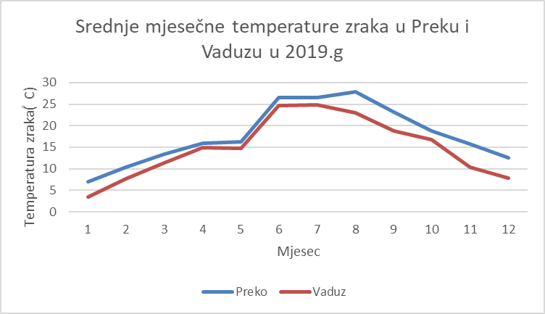

Graph 1. – Monthly air temperature in Preko and Vaduz in 2019.( °C)

From Graph 1 we can see that our average monthly air temperatures in 2019 are different throughout the year, ie that they are more in Preko than in Vaduz. The average annual air temperature in Preko in 2019 was 17.8 ° C, and in Vaduz 13.9 ° C.

We compared our data and the data of the nearest meteorological station in Zadar and presented the data graphically. The meteorological station in Zadar is located by the sea, and its instruments are much more precise than ours. Our school is located on an elevated position, it is not located near the sea, our measuring instruments are accurate, but the data are read by students and our meteorological house is located in the school garden not far from the school building (approx. 4 m). Therefore, it is possible that our data are not as accurate as the official data, as can be seen from Graph 2.

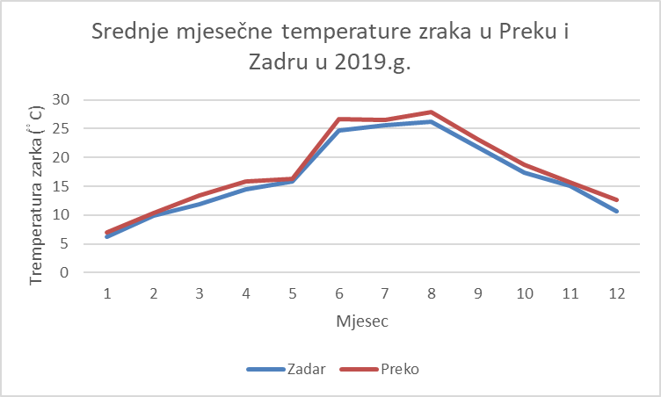

Graph 2. – Monthly air temperature in Preko and Zadar in 2019 ( °C)

We further compared the amount of precipitation last year measured at the measuring stations of the surveyed schools. We presented the data graphically.

Graph 3 – Annual course of precipitation in Preko and Vaduz in 2019.(mm)

From Graph 3 we see that the amount of precipitation - rain in school data differs significantly. The minimum amount of precipitation in Preko was in June, and the maximum in April. The months with very little precipitation in our country are February, June and August, while in other months there was a lot of precipitation, especially in April. In the gymnasium, the amount of precipitation is evenly distributed throughout the year, with very little rain in the winter months because it probably snows then. The maximum amount of precipitation was measured in August (176.6 mm) and the minimum in December (14.7 mm). A total of 874.8 mm of precipitation fell in Vaduz in 2019, which is slightly less than the average value of precipitation for the area. In our country, a total of 1081 mm fell, which is more than the average.

The difference in the amount of precipitation in 2019 at the investigated stations is 206.2 mm.

We also compared the amount of precipitation in 2019 in Zadar and Preko.

Table 3 – Annual course of precipation in Preko and Zadar in 2019.( mm)

|  |  |  |  |  |  |  |  |  |  |  |  |  |  |
| --- | --- | --- | --- | --- | --- | --- | --- | --- | --- | --- | --- | --- | --- |
|  | Mjeseci | | | | | | | | | | | |  |
| Mjesto | 1 | 2 | 3 | 4 | 5 | 6 | 7 | 8 | 9 | 10 | 11 | 12 | Ukupno |
| Zadar | 94,7 | 13,0 | 41,8 | 80,5 | 176,7 | 5,4 | 76,3 | 16,2 | 118,9 | 86,0 | 246,4 | 167,2 | 1123,3 |
| Preko | 105,0 | 2,0 | 40,0 | 160,0 | 150,0 | 1,0 | 107,0 | 15,0 | 120,0 | 93,0 | 159,0 | 129,0 | 1081,0 |

In Table 3, we compared our data and the data of the nearest meteorological station in Zadar. Our data is a little different, probably because our data is measured by students. Also our rain gauge is located near the school building. From the data we see that in 2019 more precipitation fell than the average. The average for our area is 879 mm.

**Discussion and conclusions**

Comparing the weather characteristics of LiechtensteinischersGimnazium and our schools, it can be seen that the weather conditions are different. According to the Köppen climate classification, our school is located in the area of ​​Mediterranean cumin with hot summer (Csa), and LiechtensteinischersGimnazium is located in the area of ​​moderately warm humid climate with warm summer (Cfb). They also differ in altitude. We can also explain the differences in climate due to the proximity of the sea in our country.

Comparing the weather conditions in 2019 and the climatic characteristics of our research areas, we noticed that there were minor deviations from the average. The coldest month in Preko (January) was the coldest in 2019. by 0.3 ° C, and the warmest month of July was warmer than the average by 2.6 ° C. In Valduz, the coldest month (January) was colder by 0.2 ° C, and the warmest month July was warmer by 3.3 ° C. The total amount of precipitation in our country in 2019 was higher than the average by 202 mm, and in Vaduz it was 52.2 mm smaller. We did not have snow, and we were not able to get data for Vaduz. So 2019 does not deviate too much from the climatic characteristics of the researched areas.

Comparing the mean monthly air temperatures it is evident that our mean monthly air temperatures are higher compared to the Liechtensteinischers Gimnazium. Although summer highs and winter lows are observed in both schools. Our maximum air temperature was measured at the end of June and was 36.1 ° C, and at Liechtensteinischers Gimnazium it was measured in July and was 31.7 ° C.

Our lowest air temperature was measured in January and was 0 ° C, and in Liechtensteinisches Gimnazium it was measured in February and was -7.1 ° C.

The amount of precipitation (rain) also differs significantly in the data measured at school measuring stations. Although there is precipitation in both areas throughout the year, the Liechtensteinisches Gimnazium especially shows a large amount of precipitation in the summer in August, while in our country there is much less precipitation in that period. In Vaduz, the amount of precipitation is more evenly distributed than in our country.

Comparing our data and the data of our nearest meteorological station, small differences can be noticed in the measured data for 2019. Probably because our data is collected by students and our weather station is located near the school building.

**Literary sources**

<https://www.globe.gov/globe-data/visualize-and-retrieve-data>

<https://en.wikipedia.org/wiki/Vaduz#Climate>

<https://en.wikipedia.org/wiki/Adriatic_Sea#Climate>

[**http://meteovaduz.schulen.li/**](http://meteovaduz.schulen.li/)

[**https://meteo.hr/**](https://meteo.hr/)