**Soil pH observation at the campus**

Student: Zi-Yu Li / Chia-En Tsai

Teacher: Cheng-Chang Chen

School: Hsin Tien Senior High school

Country: Taiwan

Date: 2021/3/8

**Abstract**

Soil is an indispensable thing in life and is closely related to our lives. In recent years, the problem of acid rain has become more and more serious. In order to know its impact on soil pH and whether acid rain will affect the growth of plants in the future, we decided to personally observe and experiment to see.

**Research Question**

* Will rain affect the pH value of the soil?
* Will the pH value of soil in the same place but at different depths be the same?
* Will the pH of the soil affect the growth of plants?
* Is it possible that exotic plant species will be eliminated by changing the pH of the soil?

**Hypothesis**

* The acidity and alkalinity of rain water will affect soil pH.
* Soils at different depths have different pH values.
* The pH of the soil affects the growth of plants.
* By changing the pH of the soil, exotic plants can be eliminated.

**Introduction and Review of Literature**

<http://nrch.culture.tw/twpedia.aspx?id=21557>

<http://www.rhythmsmonthly.com/?p=10410>

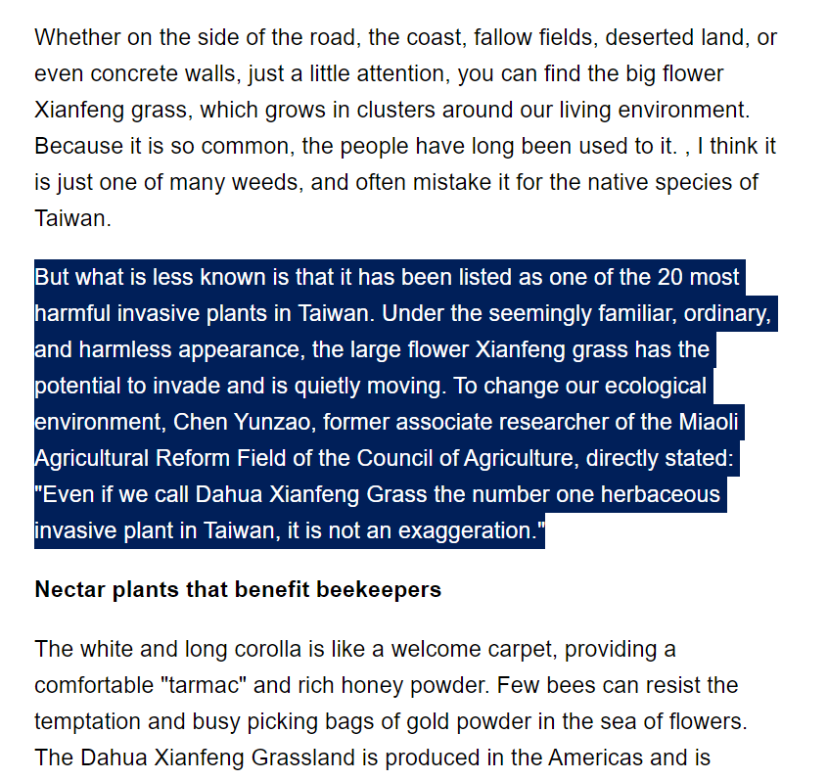

**Research Methods and Materials**

(1) **Soil acquisition**   
Materials:

* Zipper bag
* Marker
* Shovel

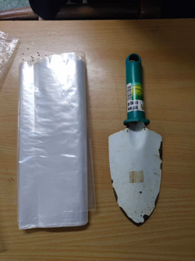

Method:

1. We sampled four locations. (A/B/C/D)

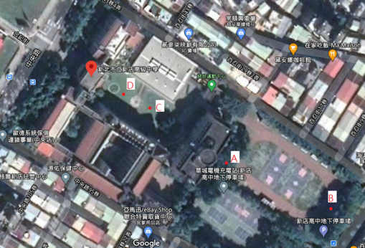

1. Sampling the soil on the surface and the soil 10 cm below the surface at each location. Avoid collecting anything other than soil.(Take samples after removing weeds from the ground)

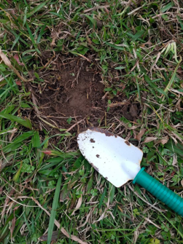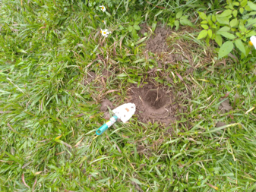

1. Mark the location, time and depth after putting it in the zipper bag.

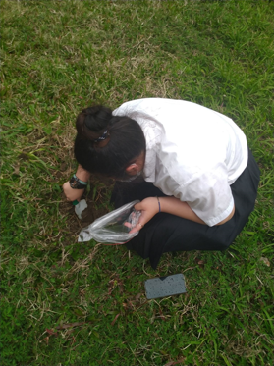

1. Collecting on rainy and non-rainy days.

**Soil pH measuremen**t  
Materials:

* pH tester
* Beaker
* Stirring rod
* Pure water
* Pen
* paper
* Balance
* Soil
* No. 10 Sieve
* Dryer
* Label
* GLOBE Data(Rainfall / pH value of rainwater)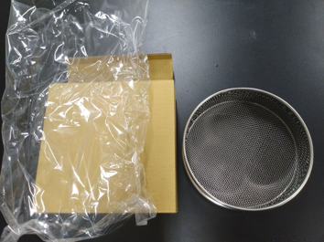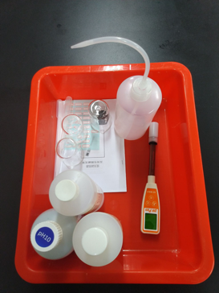

Method:

1. Dry the soil.

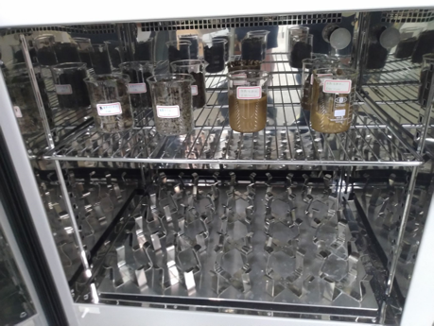

1. Sieved soil. (Put the soil in different places in different beakers and label them)

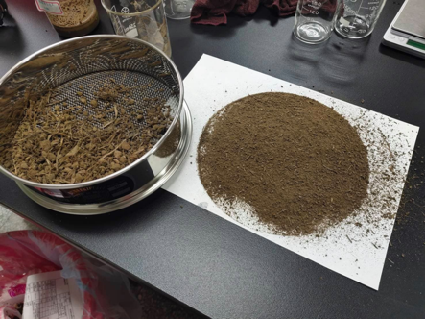

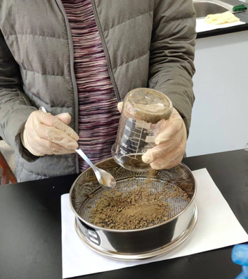

1. Put it in a beaker and mix with pure water, and mark the number. (Ratio 1:1)

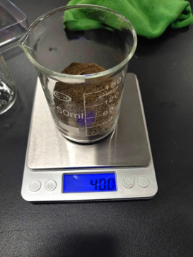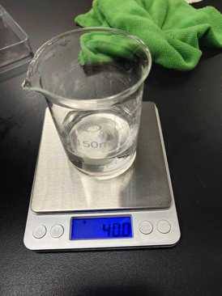

1. Stir for 30 seconds and then let stand for 3 minutes, repeat three times and then let stand for 5 minutes.

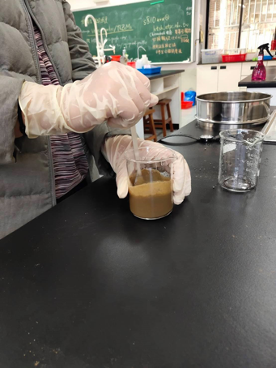

1. Measure with pH tester.(Just measure the upper liquid, do not insert the instrument into the sediment!)

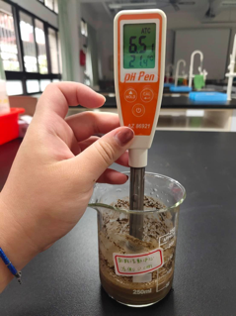

**Bidens alba planting**

Materials:

* Potted plants
* pH tester
* Soil (From the same place, with the same pH)
* Pure water
* Shovel
* Seed
* Vinegar
* Lemon juice

Method:

1. Collect the seeds of Bidens alba.

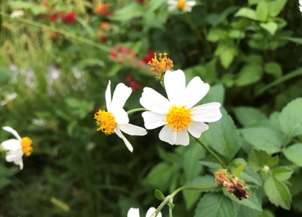

1. Put the seeds in the soil.

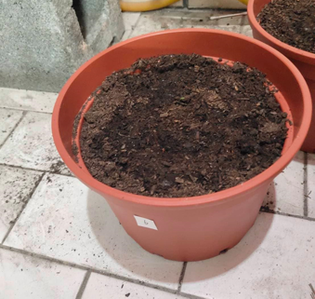

1. Use vinegar and lemon juice to change the pH of vinegar.

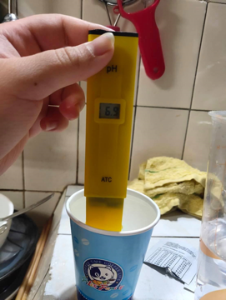

1. Divide into five pots and pour water with different pH values ​​respectively. (pH : 6 / 6.5 / 7 / 7.5 / 8 )

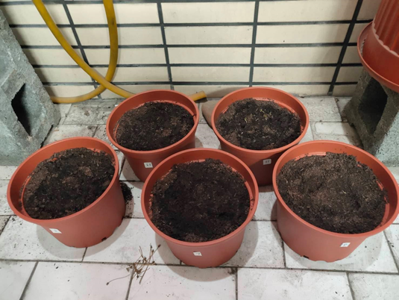

1. Observe the growth.

**Results**

1. **Soil pH measurement**

|  |  |  |  |  |  |
| --- | --- | --- | --- | --- | --- |
| Location number | Date | Depth | pH Value | Rainfall | pH Value of rainwater |
| A | 2021/1/20 | 0cm | 6.63 | 0 | - |
| A | 2021/1/20 | 10cm | 6.58 | 0 | - |
| B | 2021/1/20 | 0cm | 7.25 | 0 | - |
| B | 2021/1/20 | 10cm | 7.40 | 0 | - |
| C | 2021/1/6 | 0cm | 6.69 | 25.1 | 5 |
| C | 2021/1/6 | 10cm | 6.62 | 25.1 | 5 |
| D | 2020/12/25 | 0cm | 6.12 | 3.20 | Too little to measure |
| D | 2020/12/25 | 10cm | 6.06 | 3.20 | Too little to measure |

|  |  |  |  |  |  |
| --- | --- | --- | --- | --- | --- |
| Location number | Date | Depth | pH value | Rainfall | pH Value of rainwater |
| A | 2021/3/2 | 0 | 6.66 | 10 | 6 |
| A | 2021/3/2 | 10 | 6.53 | 10 | 6 |
| B | 2021/3/2 | 0 | 7.02 | 10 | 6 |
| B | 2021/3/2 | 10 | 7.15 | 10 | 6 |
| C | 2021/2/26 | 0 | 6.55 | 0 | - |
| C | 2021/2/26 | 10 | 6.84 | 0 | - |
| D | 2021/2/26 | 0 | 6.51 | 0 | - |
| D | 2021/2/26 | 10 | 6.86 | 0 | - |

1. The pH of 0 cm at location A slightly rises after rainfall (Increase by 0.03), The PH value is slightly lower at 10 cm above the ground. (Decrease by 0.05)
2. The pH value of location B 0 cm and 10 cm away from the ground will be slightly lower. (Decrease by 0.23 and 0.25 respectively)
3. The place c is 0 cm above the ground, the pH value has increased by 0.14 after rainfall, 10 cm above the ground, it’s reduced by 0.22.
4. After the rain, the pH value of location D has reducing (The surface soil is reduced by 0.39; The soil 10 cm above the ground is reduced by 0.80)
5. **Bidens alba planting**

As of 3/6 :

1. Potted plants using water with a pH of 6, A total of one seedling grew.

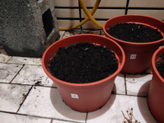

1. Potted plants using water with a pH of 6.5, A total of three seedling grew.

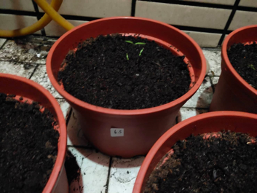

1. Potted plants using water with a pH of 7, A total of three seedling grew.

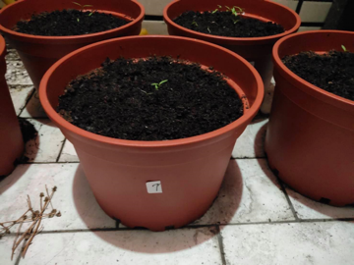

1. Potted plants using water with a pH of 7.5, A total of fourteen seedling grew.

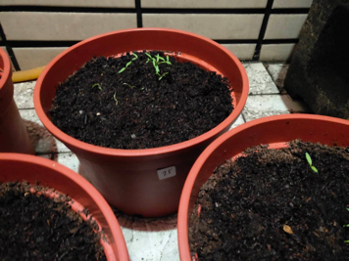

1. Potted plants using water with a pH of 8, A total of four seedling grew.

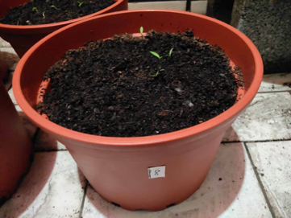

**Analysis**

* In the first experiment, we used a pH meter to measure the pH of the soil before the rain and what changes happened after the rain.
* In the second experiment, we observed the growth process of Bidens alba to find out the unsuitable environment for its growth. In this case, we can reduce the growth of Bidens alba by changing the pH of the soil.

**Discussion**

* After a rainfall, the pH value of all soils has changed, So rainfall has an impact on the pH of the soil.
* The pH value of the soil in the same place will not increase or decrease at the same time due to rainfall, It may be due to the fact that the surface soil is drenched in more rain.
* Bidens alba is the best in soil with a pH of 7.5, this may be the most suitable environment for its growth.

**Conclusion**

1. The pH of the soil will be affected by rain.
2. The pH value of soil at different depths in the same place will be different.
3. The pH of the soil affects the growth of plants.
4. The growth of exotic plants can be reduced by changing the pH of the soil.

Bibliography/Citations:

<https://www.globe.gov/do-globe/globe-teachers-guide/soil-pedosphere>

<https://www.globe.gov/documents/352961/353769/Soil+pH+protocol/782a668b-cecb-4801-ad80-db32a701eb58>

Badge Descriptions/Justifications:

**Data Scientist : In the report, we use a lot of data to observe and draw conclusions.**

**Make an Impact:** If this method of exterminating exotic plants by changing the pH of the soil is feasible, then in the future, we can use this method to reduce the number of exotic plants.