the GLOBE program at our school and the local community
Students: Pavla Paclíková, Filip Švácha, Martina Váňová
School: Gymnázium dr. A. Hrdličky Humpolec, Czech Republic
Teachers: Petr Filip, Jiří Svoboda
Date: 11th June 2014

Table of Contents
Title page 1
Table of contents 2
Acknowledgements 2
Abstract 3
Research questions 4
Hypotheses 4
Investigation plan 4-5
Research methods 5-6
Data and data analysis 6-9
Conclusions 9
Discussion 9-10
Citations 10

Acknowledgements
We thank many of our colleagues for their daily measurements of atmospheric conditions, our teachers and colleagues for help and advice. We also thank our colleagues, teachers and friends for providing their photos of extreme weather conditions.

THE GLOBE PROGRAM AT OUR SCHOOL AND THE LOCAL COMMUNITY
Pavla Paclíková, Filip Švácha, Martina Váňová
Gymnázium dr. A. Hrdličky, Humpolec, Czech Republic

Petr Filip, Jiří Svoboda, natural science teachers

Abstract
Students of our school have been participating on the GLOBE program for 18 years. This project focuses on possible applications of the GLOBE program after data are sent to the GLOBE database, particularly with respect to the inhabitants of our town and students of our school. General public can find summaries of our data on-line in the town chronicle and in books dedicated to our region. To draw local people’s attention to global climate change we compared our data with trends described by Intergovernmental Panel on Climate Change, gathered photos of recent extreme weather conditions in our region and prepared presentations. At our school, the GLOBE program is realised through after-school activities of several students supervised by one teacher. They observe the environment and work on various projects such as monitoring of local springs and revitalisation of a well in the town’s park. Other students are informed about the program mainly through notice boards, school website and school magazine. We suggest that lesson plans should be created or adopted to the school curriculum to implement the GLOBE program in regular classes. We believe that our project might be a good inspiration for our colleagues joined in the GLOBE program.

Grade level: Secondary

Research questions
In this project, we deal mainly with the question: “How can we use our data after they are sent to the GLOBE database?”. The first step is simply to share the data, to present them to general public and at schools. However, data might be misinterpreted so we also wanted to present our point of view and use the data to cultivate public opinion. We decided to stress the current changes in the global climate. We presume that the best way to make people more interested is through the local impacts. We hope that our presentations and following discussions show that exact measurements throughout the world are needed to study processes like the climate change, but they can be illustrated using some local data. Several further questions are tightly connected with this topic. One of them is, naturally: “What can we do about the climate changes in our town?”. Apart from theoretical recommendations, we would like to present our projects focused on the water in the region of our town.

Hypotheses
- Our data can be presented in a medium easily available to the inhabitants of our town.
- Our data can be used as an appropriate illustration of global climate change.
- Students can help to monitor and revitalise local springs and wells.

Investigation Plan
First, we gathered all the meteorological data obtained at our school and summarised the projects carried out there, mostly by some other students involved in the GLOBE program. The following work was done in co-operation of all three authors of this study, Martina Váňová, Filip Švácha and Pavla Paclíková. Some of the data, especially from the early years, had to be transformed from handwritten notes; most of the data were downloaded from the GLOBE database. The data were summarised and analysed in Microsoft Excel. The graphs were prepared in collaboration with the teacher of IT. During the project, we were lead by our teachers P. Filip and J. Svoboda, who helped particularly with the design of the study and with communication between us and the town’s institutions. In the time when this project report is sent, we are preparing the summaries of the data and presentations, which will be delivered when we come back from the Globe Learning Expedition in New Delhi.

Research methods
We gathered the data obtained by the students at our school, where the following atmospheric conditions are measured:
- Clouds types
- Cloud cover
- Humidity
  - Digitally measured
- Rainfall
- Snowfall
  - New snowfall
  - Total snowfall
- Temperature: current, maximal, minimal
- Contrails
We summarise for each month the following data which are to be published in the town chronicle: average precipitation, maximal and minimal temperature and any notes on extreme conditions (e.g., hails, heavy rain). Extreme weather conditions described in the report presented by Intergovernmental Panel on Climate Change (IPCC 2013) were searched for in our data using tables in Microsoft Excel and graphs (see Graphs 1, 2, Table 1). Photos to illustrate those extreme weather conditions were kindly provided by our teachers and friends.

Data and Data Analysis
The data presented periodically in the town chronicle (in Czech) can be found at http://infohumpolec.cz/muzeum/. Some of our data have been chosen for the publication about our region (Humpolec v zrcadle času. IV. “Humpolec a Zálesí v obraze přírody”, 2012). The text about the local climate (written by our teacher P. Filip) was accompanied by pictures (Graph 1). Detailed information was published in the form of tables (e.g., Table 1). Extreme weather conditions were chosen as the best topic for presentations to general public with respect to the conclusions of the Intergovernmental Panel on Climate Change (IPCC 2013). They can be illustrated, for instance, by graph 2 showing the number of nights with the minimum temperature above 20 °C.
Graph 1: Graphical representation of some of the data obtained at our school in year 2003.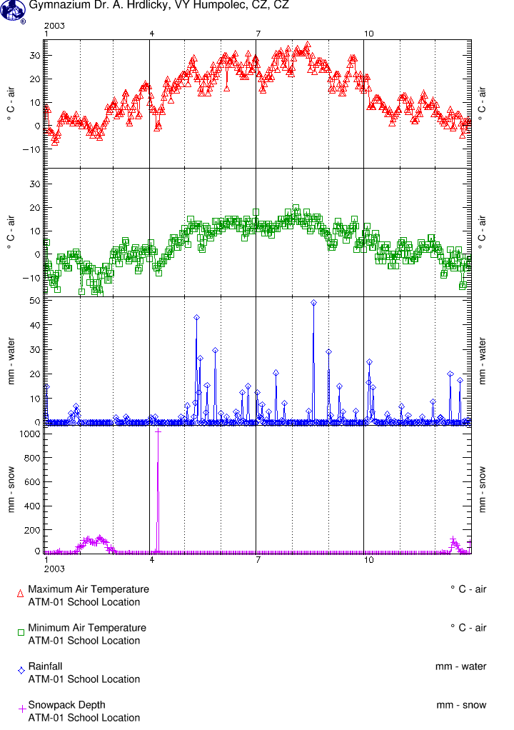

Table 1: Data published in the book dedicated to the nature of our region “Humpolec v zrcadle času. IV. Humpolec a Zálesí v obraze přírody” (2012). The table was translated and modified to fit in this document. Extremes are in bold and underlined.
Year | 1996 | 1997 | 1998 | 1999 | 2000 | 2001 | 2002 | 2003 | 2004 | 2005 | 2006 | 2007 | 2008 | 2009 | 2010
The last day with snowfall |  | 16 Apr. | 24 Mar. | 21 Mar. | 31 Mar. | 14 Apr. | 7 Apr. | 9 Apr. | 23 May | 21 Mar. | 27 Mar. | 21 Mar. | 22 Mar. | 25 Mar. | 22 Mar.
The first snowfall | 28 Nov. | 27 Oct. | 14 Nov. | 15 Nov. | 18 Dec. | 9 Nov. | 13 Oct. | 23 Oct. | 9 Nov. | 18 Nov. | 2 Nov. | 10 Nov. | 20 Nov. | 13 Oct. | 25 Nov.
No. of days with snow layer | 34 | 74 | 71 | 73 | 72 | 82 | 62 | 66 | 90 | 109 | 89 | 52 | 39 | 88 | 123
Max. snow high (mm) |  | 193 | 380 | 323 | 420 | 410 | 440 | 120 | 345 | 540 | 670 | 320 | 260 | 315 | 445
Max. precipitation (mm) | 53 | 31 | 26 | 30 | 25 | 45 | 105 | 491 | 33 | 47 | 48 | 30 | 19 | 61,5 | 44
Max. temp.  [°C] | 29 | 29 | 35 | 32 | 34 | 32 | 32 | 35 | 31.4 | 34.7 | 33.5 | 35.8 | 31.9 | 32.7 | 34.2
Min. temp. [°C] | -21 | -15 | -17 | -16 | -18 | -16 | -21 | -17 | -20 | -16.6 | -20.7 | -10.9 | -11.1 | -17.0 | -19.4
No. of days with the max. above 30 °C | 0 | 0 | 9 | 7 | 14 | 12 | 10 | 15 | 3 | 8 | 16 | 14 | 13 | 8 | 18
No. of days with the min. above 20 °C | 0 | 1 | 2 | 0 | 3 | 0 | 1 | 1 | 0 | 0 | 5 | 1 | 0 | 0 | 2
No. of days with the min. below -10 °C |  | 18 | 24 | 28 | 22 | 31 | 23 | 31 | 36 | 44 | 26 | 18 | 15 | 44 | 60

Graph 2: The number of nights with the minimum temperature above 20 °C in a year.

Conclusions
The data might be presented in a periodical available to general public. In addition, the data can be used in publications dedicated to the region. Natural curiosity of readers focused mostly on extremes might be used to stress the impacts of current global climate change. GLOBE project might be used as a basis for monitoring and revitalisation of local environment.

Discussion
This study does not want to question or confirm the existence of global climate change, which should be discussed using much more data than we have. We compared our data with those trends only to illustrate this topic to local community using some events they experienced personally. For this purpose, we have prepared presentations on the topic. These will be delivered when we come back from the Globe Learning Expedition, since the combination of the presentations with a short report about the GLE would be more attractive and effective. We believe that the successful co-operation of students and the town council in the form of short projects will continue to improve the local environment. The GLOBE program is being realised mostly through after-school activities. We think that it can be implemented more in classes if appropriate lesson plans and tools are designed or adopted to the school curriculum.

Citations
Humpolec v zrcadle času. IV. Humpolec a Zálesí v obraze přírody, 2012, Humpolec, Město Humpolec, ISBN 978-80-260-3235-9, pp. 203
IPCC, 2013: Summary for Policymakers. In: Climate Change 2013: The Physical Science Basis. Contribution of Working Group I to the Fifth Assessment Report of the Intergovernmental Panel on Climate Change [Stocker, T.F., D. Qin, G.-K. Plattner, M. Tignor, S.K. Allen, J. Boschung, A. Nauels, Y. Xia, V. Bex and P.M. Midgley (eds.)]. Cambridge University Press, Cambridge, United Kingdom and New York, NY, USA.

