Effect of moisture on soil temperature
Submitted
by Secondary School 19
Students
Gomana Malek Karsom
Lama mohammad Al amode
Esraa Eid Alshalale
Fy Abdoalrahman Alsobhe

Globe Teacher: Ebtisam Ahmed Nahhas

Supervision :
Dr. Nadia S. Al-Kaff and Dr. Nahla A. Bouqellah

2019

Abstract
The current research aimed to identify the relationship between soil temperature and relative air humidity (moisture) content. Differences on soil temperature and air moisture levels were observed during the period between 1 -31 of January in this year (2019) in Al-Medinah Al-Munwarah. The data were collected using two digital thermometers for both temperature and humidity. Data was collected and logged into the data sheets to be analyzed. It was found that there was a correlation between soil temperature and air humidity. Results showed that when humidity increased soil temperature decreased. Moreover, when soil temperature raised, relative air humidity reduced. It was concluded that there was a negative correlation between relative humidity and soil temperature.

Research questions
Air relative humidity is the amount of water vapor present in the air, especially in the troposphere. Generally, humidity in the Kingdom of Saudi Arabia rises at the coastal and Western highlands in most days. However, humidity records found to be reduced in land The Red Sea and the Arabian Gulf are the main sources of moisture In the Kingdom of Saudi Arabia. In Al-Madinah Al-Munwarah , where this study was carried out, humidity increases during summer and decreases in winter months.
To study the effect of moisture on soil temperature, the study attempted to answer the following questions:
1. Is there a relationship between air relative humidity and soil temperature?
2. Does air relative humidity effect on soil temperature?

Hypothesis
- There is a positive correlation between soil temperature air humidity.
- The is no correlation between air humidity and soil temperature.

Research importance:
Soil temperature is very important in our environments. There are different factors which may affect its level. One of these factors is air humidity. However, these factors could influence the relationship between humidity and soil temperature such as vegetation.

Material and Methods
Soil temperature measured as follows :
Measuring soil temperature a depth of 10 cm from soil.
- Great soil temperature which was the highest soil temperature in the study site within 24 hours.
- Low Soil temperature which was the lowest soil temperature in the study site within 24 hours.
- Current soil temperature which was measured at study site
Soil temperature was measured using a device (digital thermometer) (Figure 1).
Relative Humidity was also measured which was the ratio between the amount of water vapor in the air at a certain temperature to the amount of water vapor in the air at saturation degree (Figure 1).
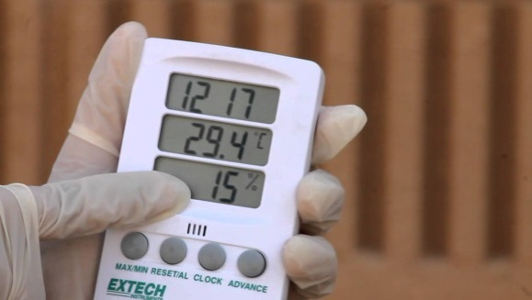
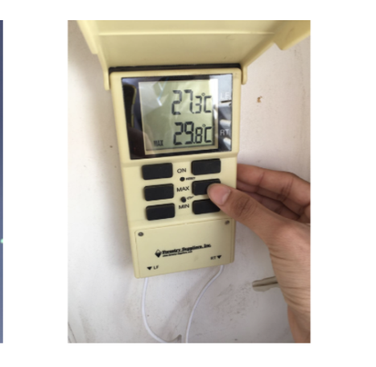

Figure1. Digital thermometer used to record temperature and (left) and air humidity (right).
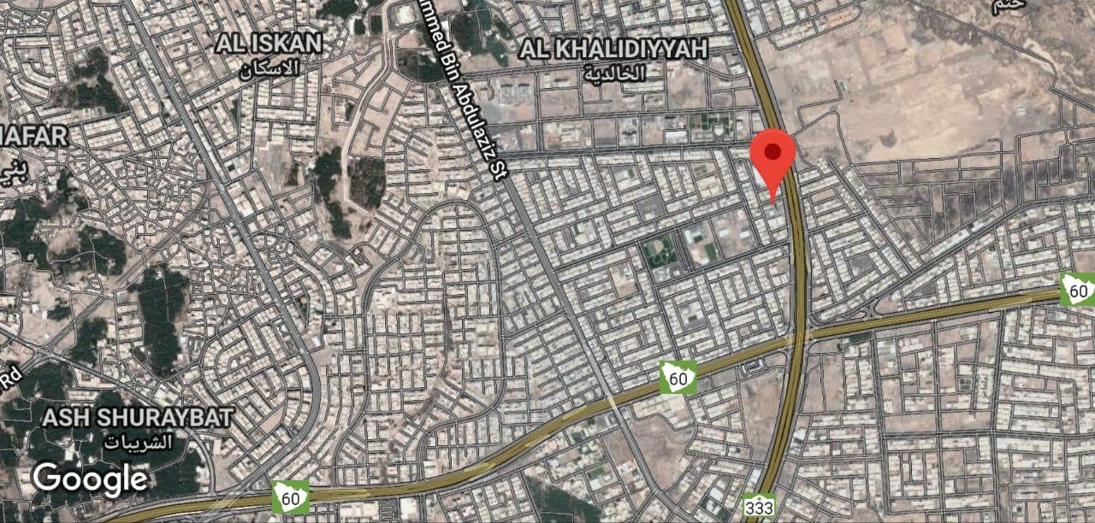
The study carried out in the Secondary school number 19 in Al-Medinah Al-Munwarah (Figure 2).
Figure 2. Secondary school number 19 location in Al-Medinah Al-Munwarah

Introduction
Soil temperature is not constant; but continuously changing, in response to constant changes in weather conditions. The continuous change of soil temperature, in regular periodic succession, is the daily range between night and day; and in the annual range, between summer and winter. These cycles, daily and annual, of soil temperature, are not quite static; they are slightly changeable, due to occasional, irregular phenomena such as cold waves, warm waves, rainstorms, snowstorms and droughts. Changes in the soil properties themselves also disrupt the cycle pattern, both daily and annually, to their temperature. The most important properties of soil, with temporary changes: reflectivity of radiation from the surface, thermal capacity and thermal conductivity.
The soil temperature, and the pattern of its change in time and space, has a significant impact on the physical, chemical and biological processes of soil systems [1]. The effect of soil temperature can be summarized in the following points: first, soil temperature control and has a direct effect on the speed of chemical reactions occurring in the soil, such as the degradation of minerals organic maters. The higher the soil temperature, the faster are the decomposition reactions. Second, soil temperature affects the solubility of carbon dioxide (CO2). Carbon dioxide, dissolved in water solution and plays a significant role in the rest of soil chemical reaction. The product of these reactions will effect different characteristics of soil such as it is pH level (acidity) by affecting the concentration of hydrogen cation H+ . The third point is that soil temperature fluctuation, shrinkage and expansion of metals, varying and resulting in changes inn mechanical structure and characteristic of the soil weathering. Therefore, soil texture and properties changes[2]. The fourth point is that soil temperature affects different biological activities. The effect could have a direct effect on soil vegetative, microorganisms and animals. The soil lower temperature (below zero by approximately 5 ° C, above zero) biological activity in soil the activity in the soil can be affected and slow down and some can be ceased.

Results and discussion
Data analysis showed that the highest temperature recorded in January 2019 was 25 ̊C and the lowest temperature was 17 ̊C and this result indicated a decrease in the temperature of soil (Figure 3).
Humidity percentage recorded at similar period of time as the temperature in January of 2019. The highest humidity recorded 27, whereas the lowest percentage recorded was 16. This result indicates a decrease in the amount of in air moisture Figure 4 showed.
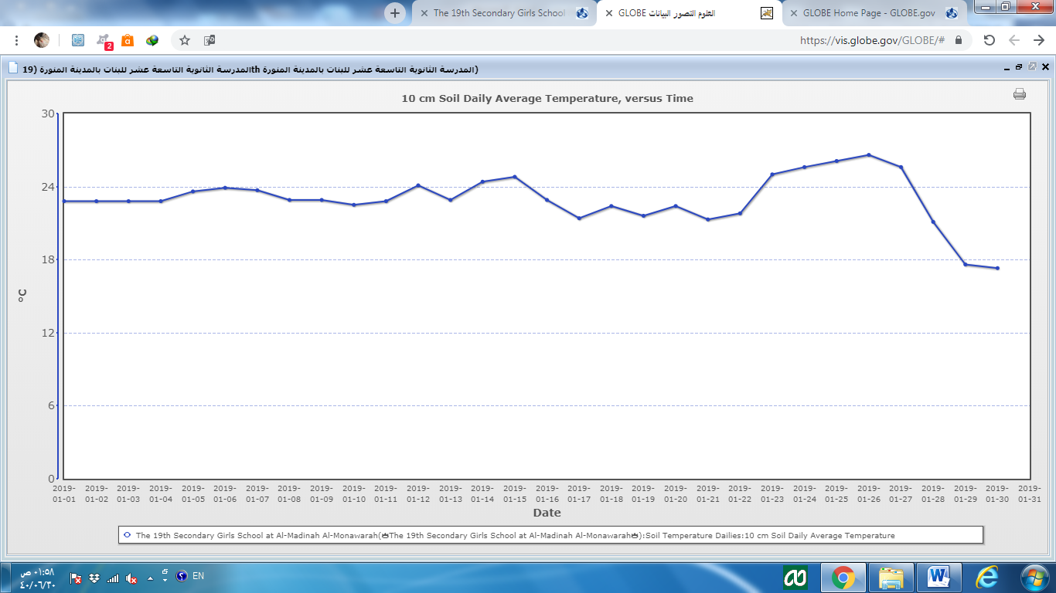
This indicated that the relationship between soil temperatures negatively correlated. The higher humidity, the lower soil temperature was recorded. In contrast, the higher the temperature of soil, the lower the humidity measured. .
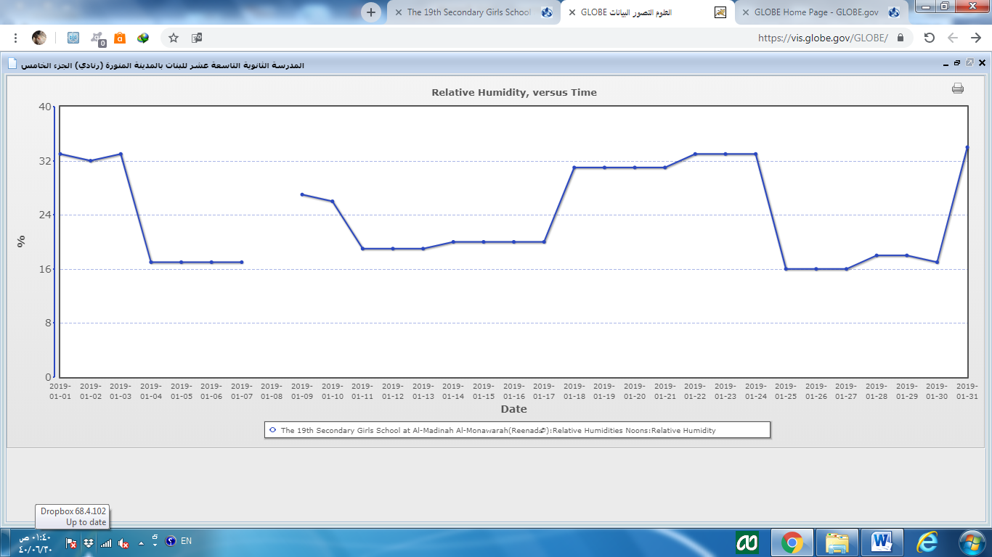
Figure 3. Temperature measurements for January (1 to 31), 2019. Timing: 9 GMT

Figure 4. Air humidity measurements for January (1 to 31), 2019. Timing: 9 GMT

Stabile soil temperature was measured during January 2019 and then start to fluctuate up and down until the end of the month.
Humidity records during the month of January 2019 were instable of the It started noticeably to decline. Then records showed fluctuation until the end of the month. It decreases and returns to rise again.
Acknowledgments
For the Environmental Globe Program: A.Ebtisam Ahmed Nahas and Dr. Nadia Saleh Al-Kaff and Dr. Nahla Alsayed Bouqellah

Difficulties
There are missing measurements in the site for some days
References:
- Feng H and Liu Y (2015) Combined Effects of Precipitation and Air Temperature on Soil Moisture in Different Land Covers in a Humid Basin. Journal of Hydrology, 531, 1129–1140. 10.1016/j.jhydrol.2015.11.016
- .Micro-Geographic Encyclopedia
- GLOB, Globe Environmental Program protocol

