Hydrology and climate change project
“TOGETHER TO THE BEST FUTURE”
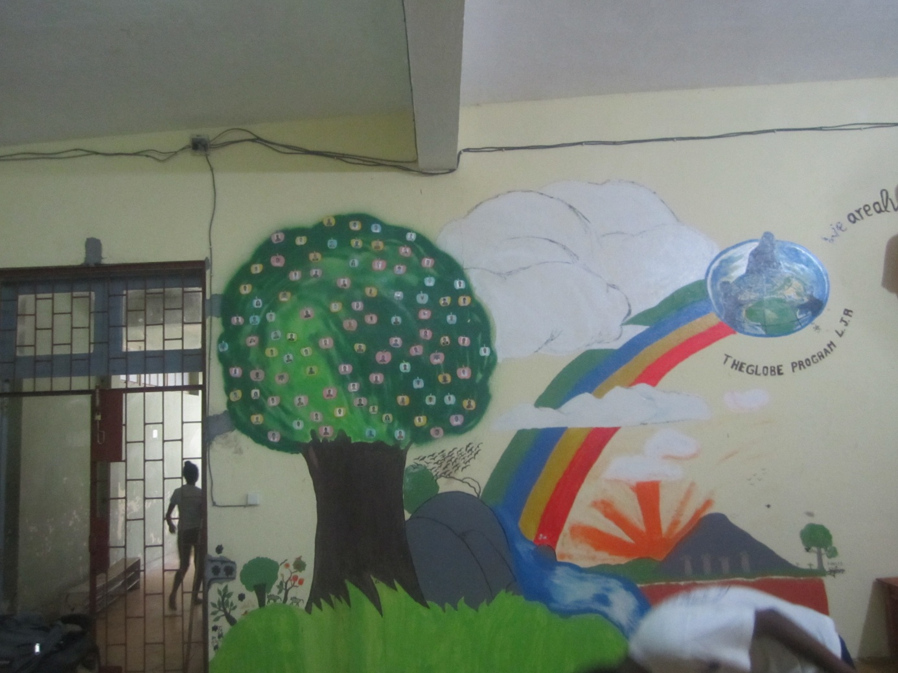

Organization : LYCEE JACQUES RABEMANANJARA TOAMASINA
Authors : Students
GRAD LEVEL : SECONDARY
Project type : Research report
GLOBES TEACHERS: Doris RABENANDRASANA-TORA ADONIS RICARDO
E-mail : dorirabe@gmail.com
CONTRIBUTOR : ASCAL

TABLE OF CONTENTS

Page 1 : Title of research project
Page 2 : Table of content
Page 3 : Summary of research project
Page 4 :Tables and graphs showing the results obtained during the sampling
Page 5 : Methods and materials used
Page 6 : Citations
Page 7-11 : Pictures of the “climate change documentation center”
Page 12 : Pictures release

Our school is called Lycée Jacques RABEMANANJARA ,it is located in the eastern part of Madagascar, in the city of TOAMASINA.It is a place of economical development, so that many authorities of our country spend their studies there (e.g former priminister ,minister,…).But ,now ,our school is in a dangerous situation because of sea raising. In sight to protect it, we carry out more investigation on hydro geological study of the sea abording our school(site hydrology 2) since 2014.For that ,in order to determine factors and impacts of climate change and to find a mitigate and adaptation actions of it on school and spot around .In fact ,since 2014 until now, we adapt two methods : globe program collecting data and UNESCO Sandwatch methods (page 5 ).
Abording to our study and observing, we notice on real raising temperature of the sea( 27°C in February 2014 and 31°C in 2017) and an acidification of the sea ( 8 in 2014 and 5.4 in 2016).We notice too a strange phenomenon : a lot of jellyfish , little shrimp and little Calmar dead along the beach in February and march 2016.We hypothesize that this phenomenon may be the both impacts of raising temperature of the sea and its acidification. Furthermore, we are worry of corrals reefs damage due to this sea acidification and lack of oxygen. We noted to a digging alarming of the beach go in 25cm in 2014 with 101 in 2017 before the Enowa cyclon.
To conclude, we like to participate in the fight against climate change and we decide to build a “climate change documentation center” to help the next generation of young people understand what climate change is and how they can work to address the impact of climate change is crucial to the future of this earth. So , we inform and educate a population and particularly students in our school ;our region ; and our country,(see pictures page 6 to 8).

I- temperature variation of the sea
Month&  year | February  2014 | February  2015 | February  2016 | February  2017
Temperature  Of the sea | 27°C | 28°C | 29°C | 31°C

II- pH variation of the sea
Month&  year | February  2014 | February  2015 | February  2016 | February  2017
Tempetature  Of the sea | 8.4 | 7.5 | 5.6 | 5.4

III BEACH PROFILES

MATERIALS AND METHOD USED
- MATERIALS
State school uses a globe materials mentioned in protocols globe and the method concerned materials: tube of transparency, pH paper or pH meter, compass, thermometer, GPS, measurement data sheet ,camera,

- METHOD :SANDWATCH OF UNESCO(mast)

1-Monitoring the environment
-Measurements of water quality : temperature of water, pH of the water, transparency of the water.
-Measurements of the beach debris, the erosion and accretion over time, the
Beach profiles , sampling the views of beach users.
2-analysing the results
Analysis of the monitoring activities and the feedback received
3-sharing a results and findings
4- taking action
- Planning a Sandwatch project (e.g sensitize the residents and the people concerned, beach cleaning, recycle the objects found,planting to stabilize the dunes,…)
- Building climate resilience

Gillian cambers, paul diamonds, Sandwatch adapting to climate change and educating for sustainable development ,UNESCO,PARIS ,2010
UNESCO ,Climate change inside and outside the classroom,Rhodes University,Grahamstown,South Africa,8-11 October 2013
Site Web Globe Program “virtual conference symposium 2016”
Site Web “WIKIPEDIA”

Situation of the beach nearest the lycee J rabemananjara toamasina
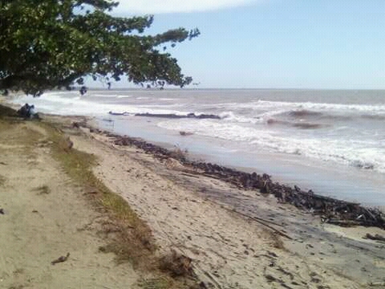

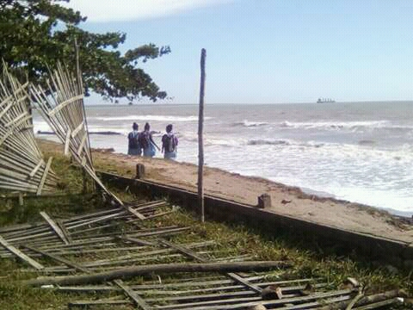
After the passage of “enowa” cyclone
MOMENT OF THE PREPARATION OF THE ROOM BY THE GLOBE EDUCATORS AND STUDENTS
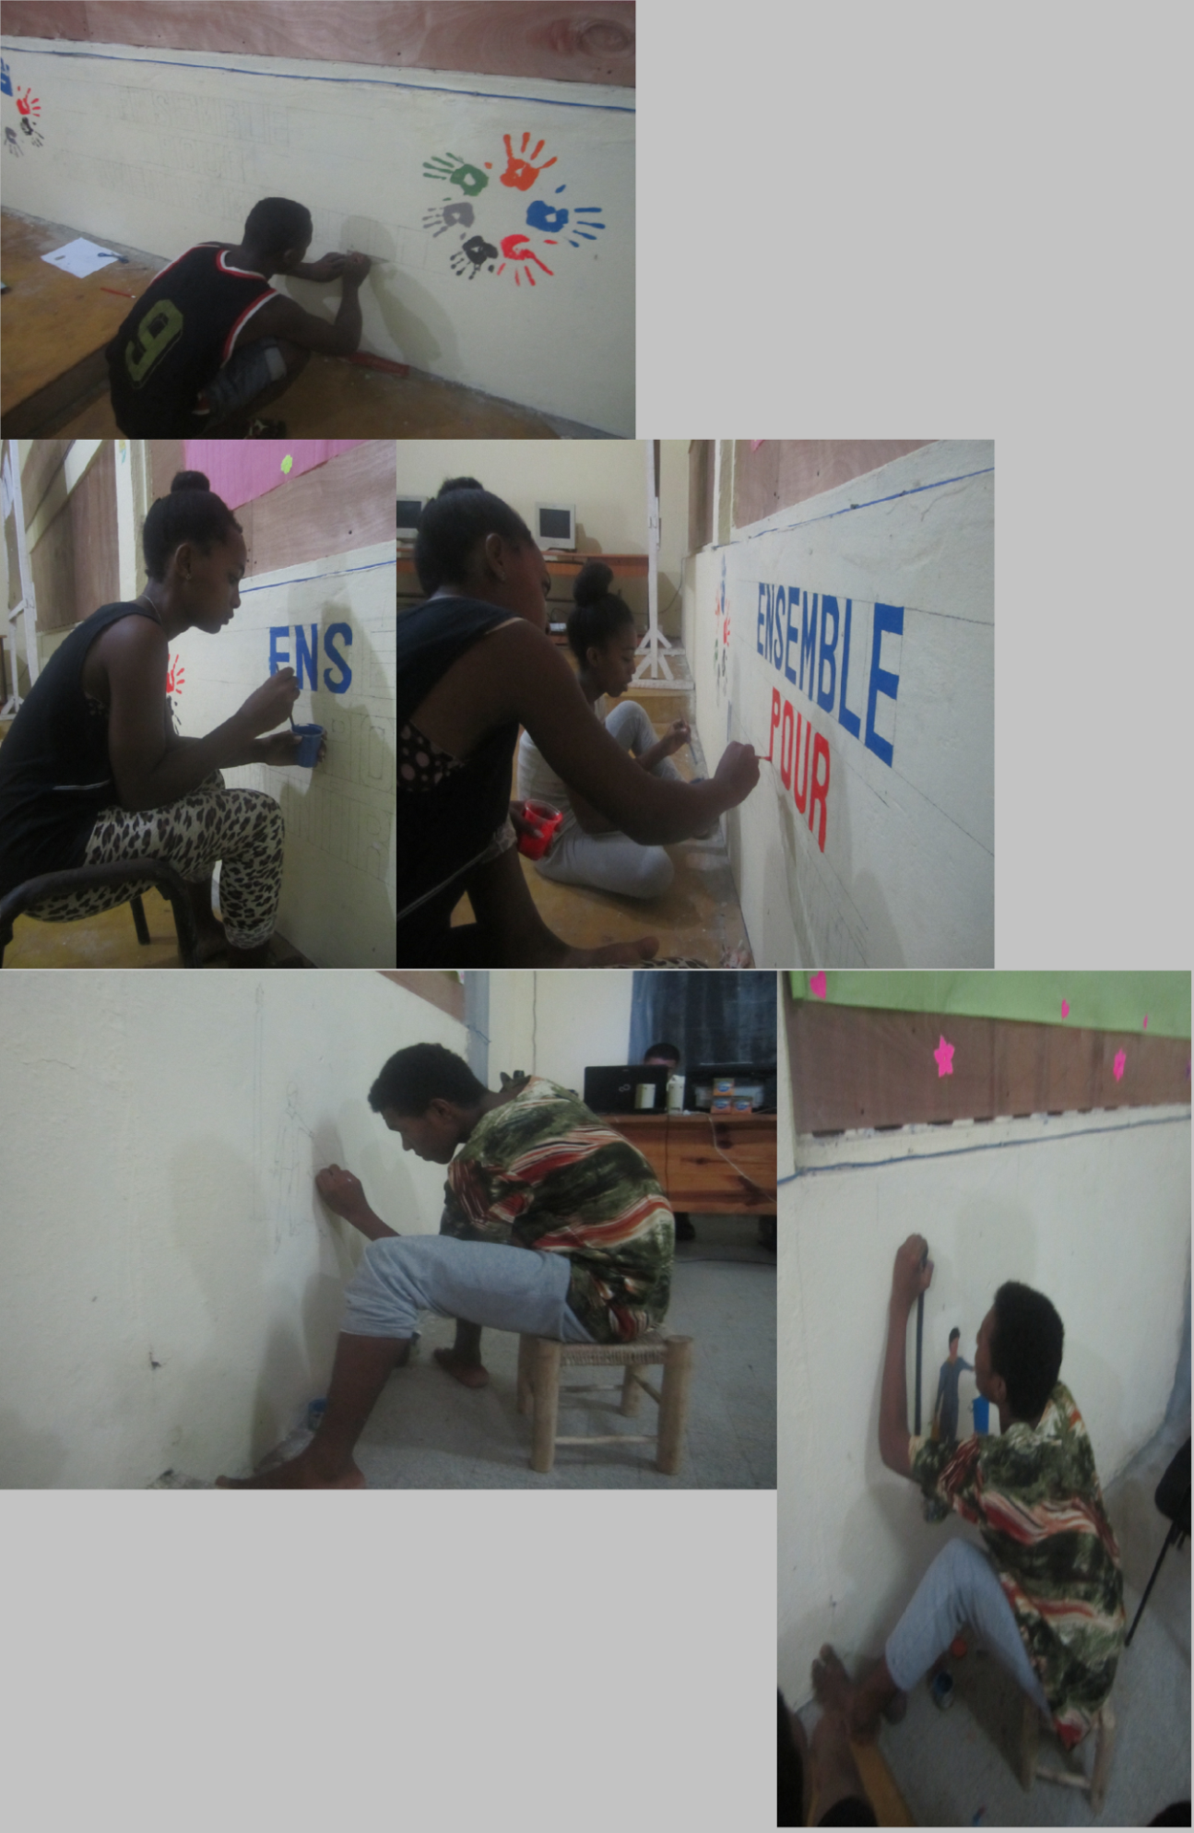

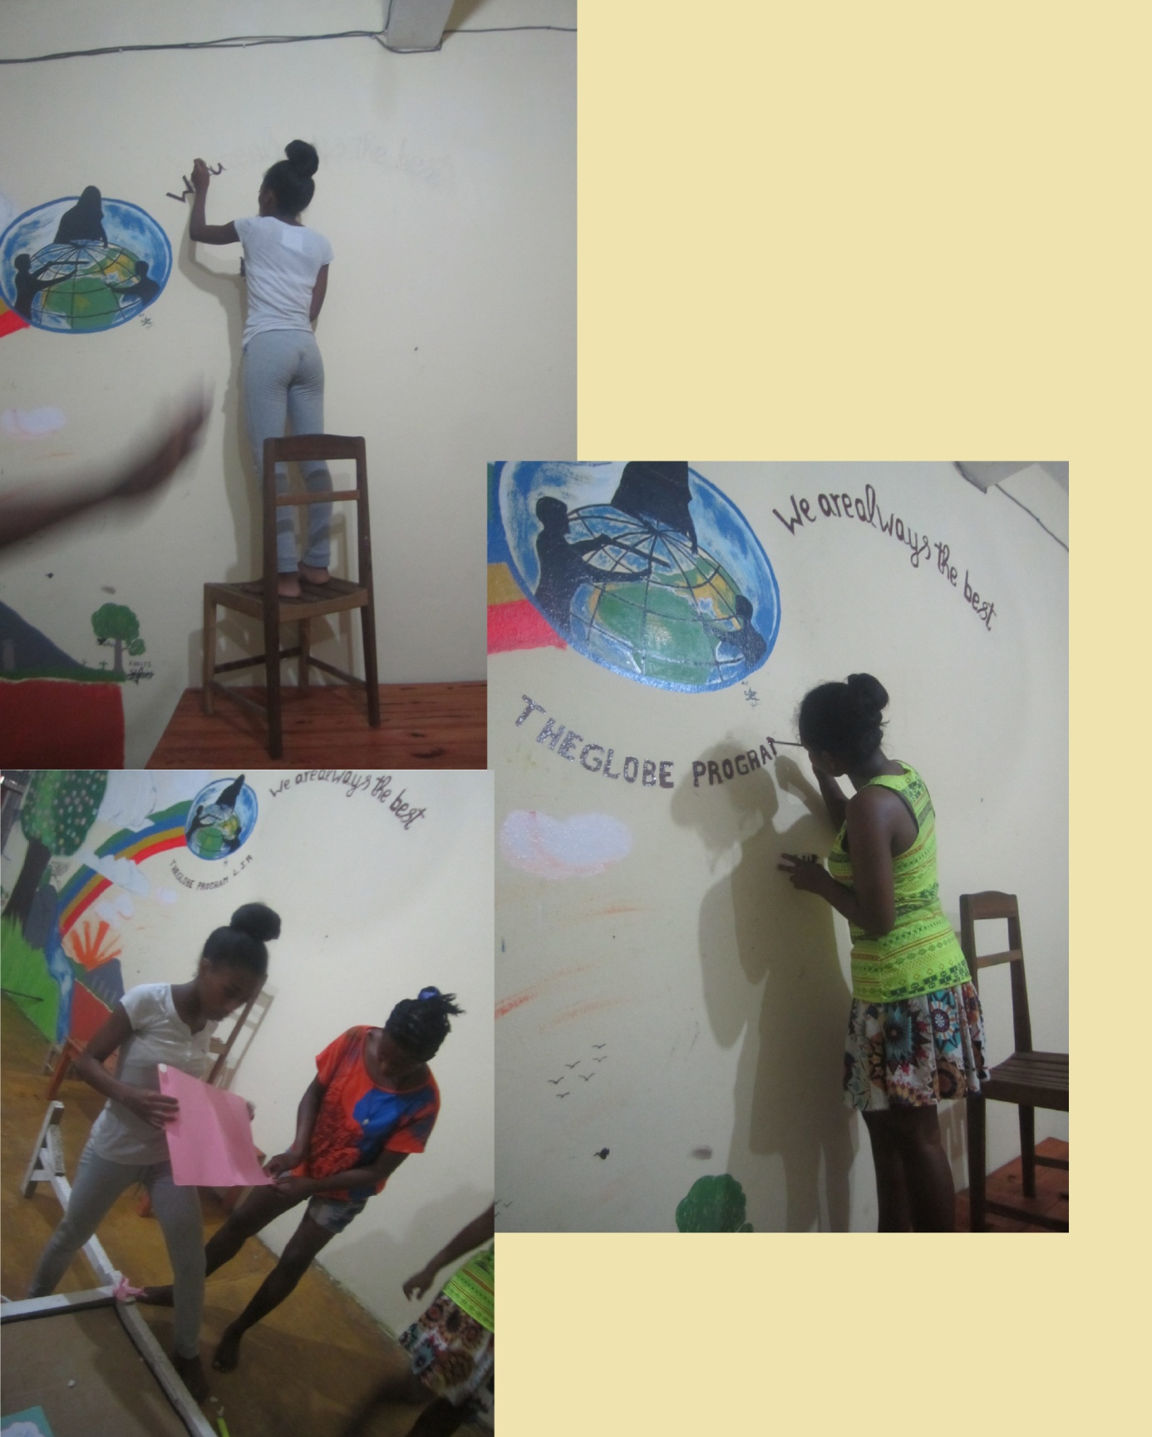

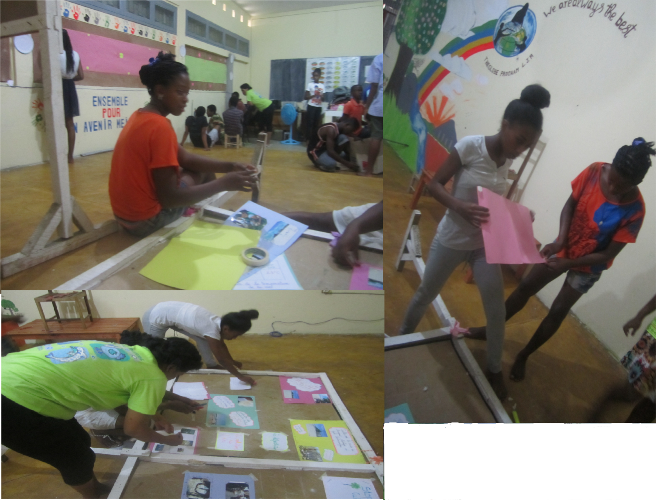

CELEBRATION OF “ THE CLIMATE CHANGE DOCUMENTATION CENTER“ BY THE AUTHORITIES AND PARTNERS(march 2017)

