TTO Globe Science Fair Project

End report
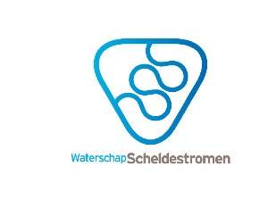
Client: Wouter Quist
Company: Waterschap Scheldestromen
Group: T4
V4C: Arco Hollestelle, Bart Stolk, Jesse Mijnders, William Trinh
V4D: Hannele Provoost, Michel Voogd

Date of submission: 28-05-17

Summary
The research on the relation between nitrogen in ditches and ditches with eco-friendly embankments is necessary because it has never been done this extensively before and building these embankments has cost a lot of money. Due to this reasoning, Waterschap Scheldestromen is eager to find out whether these eco-friendly embankments make a difference in the amount of nitrogen in ditches.
Our main research question is: "Do eco-friendly embankments have a positive effect on the amount of nitrogen (nitrate and ammonium) in the water?". And our hypothesis to this question is that eco-friendly embankments do have a positive effect on the amount of nitrogen in the water.
The measurements were taken according to the method we have established. The acquired data contained the following substances:
- pH value (only available in the artificial ditches)
- Temperature (only available in the artificial ditches)
- Salinity (only available in the artificial ditches)
- Nitrate/ nitrite
- Ammonia/ ammonium
These substances were measured with measurement strips and electronic measurement tools.
First, we made a simulation of ditches, so that we could see what would happen. We created several scenarios with our artificial ditches, which were duplicated to ensure the accuracy. The three scenarios were:
- Water, soil and plant
- Water and soil
- Water
Furthermore, we have measured the actual environment in two different locations. One which contained the eco-friendly embankment and one which did not contain the eco-friendly embankment.
We continued to observe the weather condition each day we measured the water, which plays an important role in the observed data. Eventually, we converted the data into several graphs and tables.
In the end, we concluded that eco-friendly embankments do have a positive effect on the amount of nitrogen in the water.

Prologue
This project has started on behalf of Mr. Quist from Waterschap Scheldestromen as our second Technasium project this year. It was a research project and we had to find out if ecofriendly embankments had a positive effect on the amount of nitrogen (nitrate and ammonium) in the water, compared to normal embankments. We divided our group, consisting of six members, in two smaller groups. One group (group 2) was the research group, and the other group (group 1) would compare all the results and would come up with the main conclusion. The members of group one were Michel Voogd, William Trinh, and Hannele Provoost and when we could start our measurements, Michel helped with doing the measurements as well. He did the measurements in the ditch with ecofriendly embankments. The second group consisted of Arco Hollestelle, Bart Stolk and Jesse Mijnders. Arco did the measurements in the ditch with normal embankments, Jesse and Bart did the measurements on the roof, in our simulations.
First, we want to thank Mrs. Flameling of the UCR in Middelburg for her support at the start of the project. She provided us with a lot of information. Secondly, we want to thank Mr. Lindhout and Mr. Minneboo for helping us with the measurements and access to the roof of the school. We are very grateful that we could store our simulations over there. Lastly, we want to thank Mr. Quist, for helping us during the project and providing us with useful feedback. We also want to give a special thanks to Waterschap Scheldestromen for financing our measuring equipment.

Table of contents
Summary 1
Prologue 2
Introduction 4
Pre-research 5
Nitrogen cycle 5
Problems caused by too much nitrogen 7
Research question and hypothesis 8
Main question 8
Sub-questions 8
Hypothesis 8
Method and materials 9
Results 12
Roof 12
Eco-friendly embankments & non-eco-friendly embankments 13
Tables 14
Roof 14
Non-eco-friendly embankment 16
Eco-friendly embankment 16
Graphs 17
Roof 17
Eco-friendly embankments & non-eco-friendly embankments 20
Conclusion, discussion and recommendations 22
Conclusion 22
Discussion 22
Recommendations 22
Epilogue 23
List of resources 24
Attachments 26

Introduction

We are team T4 and we are doing research on eco-friendly embankments. We are doing this project for Mr. Quist from Waterschap Scheldestromen. The research on eco-friendly embankments is necessary because it has never been done so extensively before and building those embankments has cost a lot of money. Therefore, Waterschap Scheldestromen wants to know if they really make a difference. The results of this research will be presented in our final report and poster presentation. Also, we will present our findings on the TTO Globe science fair. We believe this research will be able to contribute to GLOBE, as this lesser-known natural situation is applicable everywhere in the world. As so, all our conducted data will be uploaded and accessible to everyone within GLOBE. We hope that our report will help institutions to start research around the globe instead of only one small area.
In this end-report, we will first show what researches we did before starting the measurements, we will describe this in pre-researches. Then, we will tell our research question and our hypothesis in the chapter called: research question and hypothesis. Afterwards you can find the chapter methods and materials, in which we will describe what we did during this project and what materials we needed to do so. Afterwards we will show our results using tables and we are also going to describe them. Coming next are the conclusion, discussion and recommendations in which we will explain our conclusion, describe what we could have done differently and we will give some advice. The last three chapters are the epilogue, list of resources and the attachments.

Pre-research

Nitrogen cycle
It contains several processes in which certain bacteria are involved.
Nitrification: the process in which ammonium or ammonia is converted into nitrites. In addition, nitrites can be converted into nitrates.
Ammonification: dead animals or waste are converted into ammonium by the bacteria and fungi. Initial nitrogen in the wastes are organic, which is the fundamental beginning for ammonium formation.
Assimilation: plants absorb nitrogen through the soil with the hair on the roots, by absorbing nitrates, nitrites, ammonium and amino acid.
Denitrification: finalizing the nitrogen cycle, in which nitrates are reduced to nitrogen and releasing it in the air.
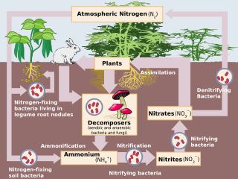
Nitrogen cycle

Nitrification happens if the soil conditions are favourable. Nitrosomonas are the bacteria which initiate the first process of the cycle. The bacteria feed on the carbon during the reaction process, thus leaving carbon aside in the equation.
"2NH4+ + 3O2 → 2NO2- + 2H2O + 4H+ + energy"
Followed by the second step of the nitrification process, the conversation of nitrite to nitrate is initiated by the bacteria Nitrobacter.
2NO2- + O2 → 2NO3- + energy
Nitrobacter can be identified in the picture as “Nitrifying bacteria”, which represents the type of bacteria that initiates the conversation.
”Nitrobacter play an important role in the nitrogen cycle by oxidizing nitrite into nitrate in soil and marine systems. Unlike plants, where electron transfer in photosynthesis provides the energy for carbon fixation, Nitrobacter uses energy from the oxidation of nitrite ions, NO2−, into nitrate ions, NO3−, to fulfill their energy needs. Nitrobacter fixes carbon dioxide via the Calvin cycle for their carbon requirements. Nitrobacter cells have been show to recover following extreme CO2 exposure Nitrobacter have an optimum pH between 7.3 and 7.5, and will die in temperatures exceeding 120 °F (49 °C) or below 32 °F (0 °C)." Source: Wikipedia
The above-mentioned “Calvin cycle” is, shortly told, the set of chemical reactions that take place in chloroplasts, which are small organelles inside the cells of plants of algae that are responsible for the photosynthesis. This cycle describes the several steps in the photosynthesis.
Nitrite is toxic to plants and other organisms, so the importance of proper conversation is essential in the cycle.
Plants are the source for nitration fixation. Followed by the fixating bacteria, formation of ammonium and ammonia is formed. Then the process is continued by the nitrifying bacteria, which oxidize the ammonia and ammonium. Nitrite is converted into nitrate, which can go two sides. Nitrate can be consumed by plants or can be denitrified, which closes the cycle.

Problems caused by too much nitrogen
Too much nitrogen in the water causes algae to grow faster than ecosystems can handle. Significant increases in algae harm water quality, food resources and habitats, and decrease the oxygen that fish and other aquatic life need to survive. Large growths of algae are called algal blooms and they can severely reduce or eliminate oxygen in the water, leading to illnesses in fish and the death of large numbers of fish. Some algal blooms are harmful to humans because they produce elevated toxins and bacterial growth that can make people sick if they come into contact with polluted water, consume tainted fish or shellfish, or drink contaminated water.
- Agriculture: Animal manure, excess fertilizer applied to crops and fields, and soil erosion make agriculture one of the largest sources of nitrogen and phosphorus pollution in the country.
- Storm water: When precipitation falls on our cities and towns, it runs across hard surfaces - like rooftops, sidewalks and roads - and carries pollutants, including nitrogen and phosphorus, into local waterways.
- Wastewater: Our sewer and septic systems are responsible for treating large quantities of waste, and these systems do not always operate properly or remove enough nitrogen and phosphorus before discharging into waterways.
- Fossil Fuels: Electric power generation, industry, transportation and agriculture have increased the amount of nitrogen in the air through use of fossil fuels.
- In and Around the Home: Fertilizers, yard and pet waste, and certain soaps and detergents contain nitrogen and phosphorus, and can contribute to nutrient pollution if not properly used or disposed of. The amount of hard surfaces and type of landscaping can also increase the runoff of nitrogen and phosphorus during wet weather.

Research question and hypothesis
Main question
Do eco-friendly embankments have a positive effect on the amount of nitrogen (nitrate and ammonium) in the water?

Sub-questions
- What are eco-friendly embankments?
- What is the Nitrogen cycle and how does it work?
- How did humans disturb the nitrogen cycle?
- What kind of problems are caused by too much nitrogen in the environment?
- What are the EU directives on nitrates (in the water)?

Hypothesis
We think that eco-friendly embankments do have a positive effect on the amount of nitrogen in the water.

Method and materials
The method described below is how we first wanted to do our project. Afterwards we will describe how we did it and why we chose to do it this way.
Research question
Do eco-friendly embankments have a positive effect on the amount of nitrogen (nitrate and ammonium) in the water?
Measurement plan: Embankment simulation
Necessities:
- Containers: 4 big ones, 2 smaller
- Ditch water
- Soil from the eco-friendly embankments
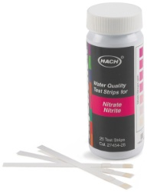
- Plants from the eco-friendly embankments, e.g. reed, yellow flag, loosestrife. (depends on what the embankments contain)
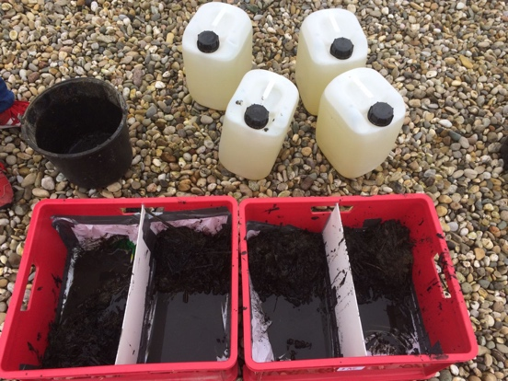
- pH test strips
- Thermometer
- Salinity meter
- NO₂/NO₃ meter
- NH₃/NH₄ meter

The containers for the simulation
The mentioned test strips in the plan

How to do it?
- Number the containers, the small ones are 1 and 2, the bigger ones are 3 up to and including 6.
- Fill container 1 and 2 with ditch water. (duplicate)
- Fill container 3 and 4 with ditch water and soil from the embankments. (duplicate)
- Fill container 5 and 6 with ditch water, soil from the embankments and some plants as named above. (duplicate)
- Place the containers at an open place with enough sunlight. (We will place it on the roof of the school).
- Let the ground in containers 3 up to and including 6 sediment and then refresh the water before you start the measurements.
- Measure the pH and the salinity values as well as the temperature, NO₂, NO₃, NH₃ and NH₄ values.
- Note the values in the diagram.
Measurement plan: Actual environment
Necessities:
- Eco-friendly embankments (figure 1&2)
- Normal ditch
- NO₂/NO₃ test strips
- NH₃/NH₄ test strips
- pH test strips
- Thermometer
- Salinity meter
The mentioned test strips in the plan

How to do it:
- Measure the values on different depths, the first measurement is on the surface and the second measurements between 40 and 60 cm.
- Use the strips as explained in the manual for NO₂, NO₃, NH₃ and NH₄ values.
- Measure pH values, salinity and temperature.
- Note the values in the diagram.

Execution:
Necessities:
- Eco-friendly embankments
- Normal ditch
- NO₂/NO₃ test strips
- NH₃/NH₄ test strips

How we did it:
- We measured the values on different depths, the first measurement was on the surface and the second measurement was between 40 and 60 cm.
- We then used the strips as explained in the manual for NO₂, NO₃, NH₃ and NH₄ values.
- Finally, we noted the values in the diagram.

Why we chose to do it like this:
We chose to measure at different depths to see if there's any difference in the NO₂/NO₃ and NH₃/NH₄ between the surface of the water and the body of water.

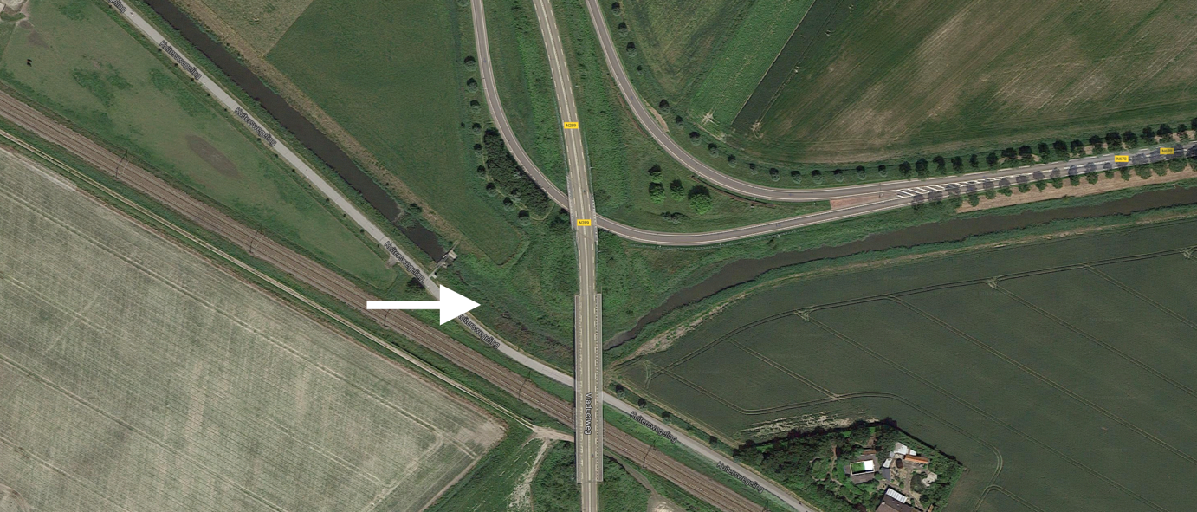
Figure 1: The location of the eco-friendly embankments near Kapelle
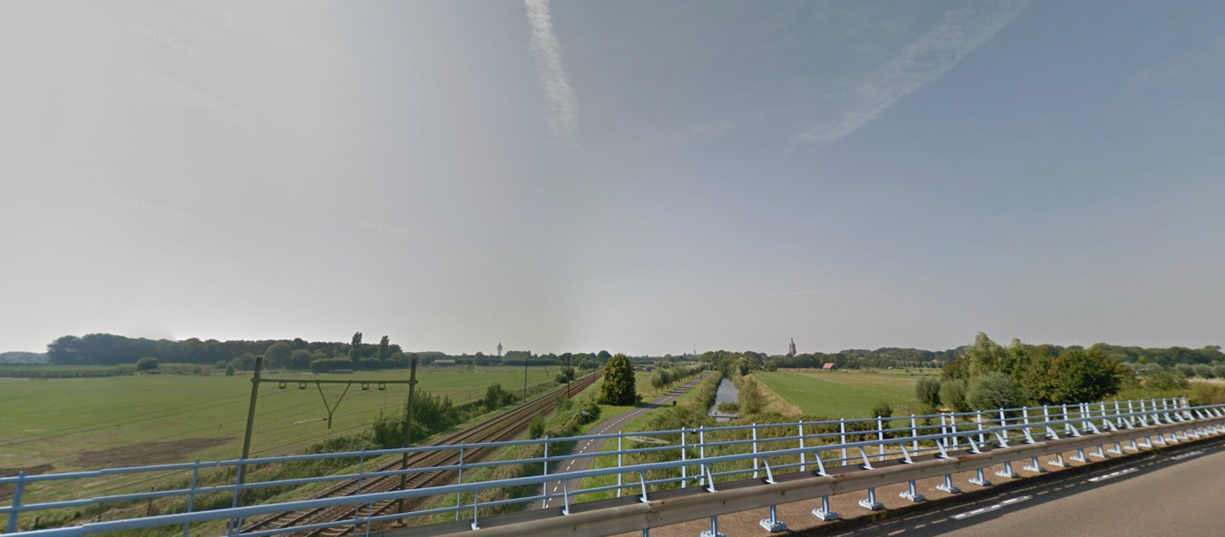
Figure 2: An overview over the whole eco-friendly embankment

Results

Roof
The results on the roof show a very consequent graph. There are not many peaks to observe. This can mean that the tools are not very accurate or the amount of substances in the water has decayed. The latter may be caused by the large interval of three weeks, which are between the 5th and 6th measurement day.
One matter to take account of is the switch of a conductivity to a resistivity electrical meter. This was required, as the values of the conductivity measurement tool showcased a value of 0. Several days had passed by then and we concluded the tool to be useless, which led to the switch to a resistivity measurement tool.
An increase in the outdoor temperature led to the increase of the water temperature, which on their side, caused a decrease in pH and NH₃/NH₄ values.
NH₃/NH₄ values tend to be the most stable in simulation 3&4, which are the containers with only water & soil. This may be caused by the availability of the bacteria in the soil, which is not present in simulation 5&6, and the unavailability of the plants, which are present in simulation 1&2.
The resistance values seemed to rise throughout all the measurements. As several values are possibly suffering from decay. This might be the reason for the slowly increased value of resistance.
In graph 3, the pH differences between the simulation is clearly visible, as the quite stable values are quite clumped with their pair. Simulation 1&2 are both very close to 8 as pH value, which means the water is very neutral. As for the simulations 3&4, the values are a bit higher, followed by the values of simulation 5&6, which also showcase the highest pH values. Possible causes for the slow decrease might be the decay of the substances and bacteria in the water.
The temperatures of the water in simulation 5&6 were usually a bit higher than the rest. One possible cause might be the colour of the bucket, which is black. Black is known to absorb a lot of the solar energy and thus might be the cause of the increased temperature in the two simulations

Eco-friendly embankments & non-eco-friendly embankments
When it has rained, the concentrations of nitrate have doubled in the ditch without eco-friendly embankments. Several causes of this sudden increase might have been the acid rain or the raindrops taking the substances from the manure on the farmland back to the ditchwater. We have taken a sample of rainwater by placing a small bucket which could gather and keep the rain in it. The water did not show any value for nitrate, which meant that the rain itself was not responsible for the increase. This leaves the last cause viable.
On the other hand, this was not the case in the eco-friendly ditch. Nonetheless, the same cause of the possible nitrate increase is applicable in this ditch. Yet, the values stayed the same.
This shows a difference in the bacteria composure of the two ditches. In graph 6 to 8, it is clearly visible that the values in the eco-friendly embankments maintain a stable level of substances. The values in the non-eco-friendly embankments show a slightly different graph, where the values shift a bit between each day.
According to graph 8 and table 3&4, the NH₃/NH₄ values tend to stay very stable in the eco-friendly embankment. For example, after the rainfall during the night from the 28th to the 29th of April, NH₃/NH₄ values kept their values stable. Contrarily, the values in the non-eco-friendly embankment shift between the values quite a bit. Especially after the rainfall, the increase in NH₃/NH₄ values are to take note of. This may be explained by the fact that rain droplets fall on farmland, which will slowly take the several substances in manure with them. This water will end up in the ditches eventually. The graph shows a well visible difference between the two embankments.
Nitrite values tend to be hard to break down in the non-eco-friendly embankment, as graph 6 has showcased. The values of NO₂ seem to not go lower than 1ppm, compared to the values in the eco-friendly embankment. This result is very possible due to the presence of the plants in the eco-friendly embankment. These plants might be the cause of the NO₂ filtration, as the bacteria for the breakdown are in the roots of the plants.

Tables

Roof
Day | Simulation | Weather | Tempe-  rature  water  in (°C) | Resistance in (kilo ohm) | pH value | NO3  Mg/L | NO2  Mg/L | NH3/4  Mg/L
1. 08-04-2017 | 1 | 11°C, dry, cloudy | 11.2 | - | 8.30 | - | - | -
 | 2 | " | 11.0 | - | 8.38 | - | - | -
 | 3 | " | 11.0 | - | 8.39 | - | - | -
 | 4 | " | 11.1 | - | 8.38 | - | - | -
 | 5 | " | 11.4 | - | 8.66 | - | - | -
 | 6 | " | 11.6 | - | 8.67 | - | - | -
2. 09-04-2017 | 1 | 12°C, dry,  Partly cloudy | 10.2 | - | 8.25 | - | - | -
 | 2 | " | 9.0 | - | 8.37 | - | - | -
 | 3 | " | 8.9 | - | 8.41 | - | - | -
 | 4 | " | 8.8 | - | 8.43 | - | - | -
 | 5 | " | 9.6 | - | 8.73 | - | - | -
 | 6 | " | 10.5 | - | 8.72 | - | - | -
3. 10-04-2017 | 1 | 8°C, it had rained, cloudy | 8.0 | 92 | 8.33 | - | - | -
 | 2 | " | 6.1 | 78 | 8.31 | - | - | -
 | 3 | " | 7.2 | 89 | 8.49 | - | - | -
 | 4 | " | 6.5 | 90 | 8.50 | - | - | -
 | 5 | " | 6.0 | 87 | 8.99 | - | - | -
 | 6 | " | 6.4 | 90 | 8.97 | - | - | -
4. 11-04-2017 | 1 | 7°C, dry, sunny | 8.0 | 130 | 8.14 | - | - | -
 | 2 | " | 5.5 | 120 | 8.15 | - | - | -
 | 3 | " | 5.8 | 110 | 8.30 | - | - | -
 | 4 | " | 4.5 | 113 | 8.30 | - | - | -
 | 5 | " | 4.1 | 124 | 8.67 | - | - | -
 | 6 | " | 6.1 | 117 | 8.57 | - | - | -
Table 1: First part of the table regarding the simulation

Day | Simulation | Weather | Tempe-  rature  water  in (°C) | Resistance in (kilo ohm) | pH value | NO3  Mg/L | NO2  Mg/L | NH3/4  Mg/L
5. 12-04-2017 | 1 | 13°C, dry, partly cloudy | 16.7 | 71 | 8.32 | 0 | 0 | 0.25
 | 2 | " | 15.7 | 62.5 | 8.33 | 0 | 0 | 0.25
 | 3 | " | 16.6 | 68.2 | 8.47 | 1 | 0 | 0.25
 | 4 | " | 17.9 | 63.0 | 8.49 | 1 | 0 | 0.25
 | 5 | " | 18.6 | 66.5 | 8.64 | 1 | 0 | 0.5
 | 6 | " | 18.7 | 60.9 | 8.59 | 1 | 0 | 0.25
6. 15-5-2017 | 1 | 21°C, dry, partly cloudy | 17.8 | 590 (Different multimeter) | 8.39 | 0 | 0 | 0.25
 | 2 | " | 14.9 | 318.8 | 8.30 | 0 | 0 | 0.25
 | 3 | " | 14.7 | 439 | 8.56 | 0 | 0 | 0.25
 | 4 | " | 14.1 | 187.9 | 8.40 | 0 | 0 | 0
 | 5 | " | 15.3 | 276.5 | 8.63 | 0 | 0 | 0.25
 | 6 | " | 16.6 | 210.5 | 8.68 | 0 | 0 | 0.25
7. 16-5-2017 | 1 | 24°C, dry, cloudy | 19.4 | 97.2 | 8.22 | 0 | 0 | 0.25
 | 2 | " | 19.3 | 107.2 | 8.15 | 0 | 0 | 0.25
 | 3 | " | 19.1 | 131.4 | 8.39 | 0 | 0 | 0
 | 4 | " | 19.0 | 165.7 | 8.45 | 0 | 0 | 0.25
 | 5 | " | 19.9 | 155.4 | 8.66 | 0 | 0 | 1
 | 6 | " | 20.2 | 137.3 | 8.65 | 0 | 0 | 0.25
8. 17-5-2017 | 1 | 27°C, dry, partly cloudy | 23.4 | 163.8 | 8.18 | 0 | 0 | 0.25
 | 2 | " | 21.9 | 201.4 | 8.08 | 0 | 0 | 0
 | 3 | " | 21.6 | 203.7 | 8.20 | 0 | 0 | 0.25
 | 4 | " | 20.9 | 206.0 | 8.33 | 0 | 0 | 0
 | 5 | " | 20.9 | 181.6 | 8.57 | 0 | 0 | 0
 | 6 | " | 22.3 | 143.9 | 8.52 | 0 | 0 | 0

Table 2: Second part of the table regarding the simulation

Non-eco-friendly embankment
Day | Level of measure-ment | Weather | NO₂⁻ | NO₃⁻  ppm | NH₃ / NH₄  ppm
1. 23-04 | Surface | Sunny | 1 | 0,15 | 0,25
2. 24-04 | Surface | Sunny with clouds | 1 | 0,15 | 0,25
3. 26 - 04 | Surface | Sunny | 1 | 0,15 | 0,25
4. 28 - 04 | Surface | Rained at night | 2 | 0,3 | 0.5
5. 01 - 05 | Surface | Cloudy | 1 | 0,15 | 0.5
6. 02 - 05 | Surface | Sunny | 1 | 0,15 | 0.5
7. 03 - 05 | Surface | sunny | 1 | 0,15 | 0.5
8. 04 - 05 | Surface | sunny | 1 | 0,15 | 0.5
9. 05 - 05 | Surface | sunny | 1 | 0,15 | 0.5
10. 06 - 05 | Surface | sunny | 1 | 0,15 | 0.5
Table 3: Table of acquired values in the Non-eco-friendly embankment

Eco-friendly embankment
Day | Level of measure-ment | Weather | NO₂⁻  ppm | NO₃⁻  ppm | NH₃ / NH₄  ppm
1. 24-04 | Surface | Cloudy | 0 | 0,15 | 0,25
 | 40-60 cm |  | 0 | 0,15 | 0,25
2. 25-04 | Surface | Cloudy | 0,5 | 0,15 | 0,25
 | 40-60 cm | Has rained | 0 | 0,15 | 0,25
3. 26-04 | Surface | Sunny | 0 | 0,15 | 0,25
 | 40-60 cm | Has rained | 0 | 0,15 | 0,25
4. 27-04 | Surface | Sunny | 0 | 0,15 | 0,25
 | 40-60 cm |  | 0 | 0,15 | 0,25
5. 28-04 | Surface | Sunny | 0 | 0,15 | 0,25
 | 40-60 cm |  | 0 | 0,15 | 0,25
6. 01-05 | Surface | Cloudy | 0 | 0,15 | 0,25
 | 40-60 cm |  | 0 | 0,15 | 0,25
7. 02-05 | Surface |  | 0 | 0,15 | 0,25
 | 40-60 cm |  | 0 | 0,15 | 0,25
8. 03-05 | Surface |  | 0 | 0,15 | 0,25
 | 40-60 cm |  | 0 | 0,15 | 0,25
9. 04-05 | Surface |  | 0 | 0,15 | 0,25
 | 40-60 cm |  | 0 | 0,15 | 0,25
10. 05-05 | Surface |  | 0 | 0,15 | 0,25
 | 40-60 cm |  | 0 | 0,15 | 0,5
Table 4: Table of acquired values in the Eco-friendly embankment

Graphs

Roof
Graph 1: Water temperature in the simulation
Graph 2: Resistance in the simulation

Graph 3: pH values in the simulation
Graph 4: NO3- values in the simulation

Graph 5: NH3/NH4 values in the simulation

Eco-friendly embankments & non-eco-friendly embankments
Graph 6: Values of NO2- in the actual environment

Graph 7: Values of NO3- in the actual environment
Graph 8: Values of NH3/NH4 in the actual environment

Conclusion, discussion and recommendations

Conclusion
The results point out that the ditch with eco-friendly embankments have less nitrates in the water than the ditch without eco-friendly embankments. The eco-friendly embankments not only have a positive influence on the life in the ditch, but they also help filtering out part of the nitrates this is clearly visible if it has rained and in the "normal" ditch the values doubled and in the ditch with the eco-friendly embankments they stayed about the same. From this we can conclude that the eco-friendly embankments have a positive effect on the number of nitrates in the water. Therefore, this confirms our hypothesis.

Discussion
Several components in the measurement plan were discarded in the actual environment during the process. This was caused by the inaccessibility of the several electronic measurement tools outside the school. The pH-values, salinity values and temperature values were measured by electronic devices.
The accuracy of the NO₃⁻ and NH₃/NH₄ are to be taken into consideration due to the usage of strips with a range indicator. The ranges were not very specific, which gives an inaccurate value. Furthermore, the low values of NO₃⁻ and NH₃/NH₄ in the water make the strips more inaccurate, as the values are not adjusted for the natural environment.
During the measurements in the actual environment, the values of the two experimental ditches kept producing the same values. There were several occasions in which the values represented a higher value, what had been influenced by the weather circumstances. Thus, the supply of new water by rain and other nearby streams should be taken into consideration, as the tested water has been refreshed continuously.

Recommendations
We would like to bring to attention that the used measurement strips are inaccurate, which can be replaced by spectrophotometers in order to attain higher accuracy.
Furthermore, measurements in the actual environment are taken without salinity, water temperature and pH values. Therefore, we cannot link certain values with certain circumstances. We would like to advise that future projects regarding this subject should be measuring the mentioned values.

Epilogue

We see this project as one of our most interesting projects so far. First of all, we enjoyed this project because of the combination of taking test samples, analysing them and then searching for a connection between the results. However, we did have some disappointments. These began with us never receiving our background information from the IB-department, furthermore it took a while to acquire the materials needed to take our measurements which reduced our morale because of the lack of tasks in that period of time. When we finally received these materials, we were able to sprint to the finish and complete this project with success.

List of resources

ASLO, Association for the Sciences of Limnology and Oceanography. Nitrogen processing in a tidal freshwater marsh, from the World Wide Web on the 16th of January 2017: http://www.aslo.org/lo/toc/vol_50/issue_6/1945.pdf

Betavak.nl, science works. Deciding of the ammonia-, nitrite- and nitrate levels of water, from the World Wide Web on the 16th of January 2017: http://www.betavak.nl/biologie/stikstof.htm

Biologiepagina.nl. Nitrogen cycle practice, from the World Wide Web on the 16th of January 2017:
http://biologiepagina.nl/Oefeningen/Stikstofkringloop/stikstofkringloop.htm

Bioplek. Nitrogen cycle, from the World Wide Web on the 16th of January 2017: http://www.bioplek.org/animaties/ecologie/stikstof/inhoudstikstofkringloop.html

ECN. The fertilizing of the air, from the World Wide Web on the 16th of January 2017: https://www.ecn.nl/fileadmin/ecn/corp/Nieuwsbrief_NL/2010/Januari/Het_bemesten_van_de_lucht.pdf

Ersjournals, flagship scientific journal of ERS. Short-term effects of nitrogen dioxide on mortality, from the World Wide Web on 23rd of February 2017:
http://erj.ersjournals.com/content/erj/27/6/1129.full.pdf

ESA, Ecological Society of America. Human alteration of the global nitrogen cycle: sources and consuquences, from the World Wide Web on the 23rd of February 2017: http://onlinelibrary.wiley.com/doi/10.1890/1051-0761(1997)007%5b0737:HAOTGN%5d2.0.CO;2/full

European Comission. The European nitrate directives, from the World Wide Web on the16th of January 2017: http://ec.europa.eu/environment/pubs/pdf/factsheets/nitrates/nl.pdf

Medscape. Nitrogen Dioxide Toxicity, from the World Wide Web on the 23rd of February 2017: http://emedicine.medscape.com/article/302133-overview

Nature, international weekly journal of science. An Earth-system perspective of the global nitrogen cycle, from the World Wide Web on the 23rd of February 2017: http://www.nature.com/nature/journal/v451/n7176/full/nature06592.html

NCBI, National Center for Biotechnology Information. Effect of short-term, low-level nitrogen dioxide exposure on bronchial sensitivity of asthmatic patients, from the World Wide Web on the 23rd of February 2017: https://www.ncbi.nlm.nih.gov/pmc/articles/PMC436654/

NCBI, National Center for Biotechnology Information. Global Nitrogen: Cycling out of Control, from the World Wide Web on the 23rd of February 2017: https://www.ncbi.nlm.nih.gov/pmc/articles/PMC1247398/

ScienceDaily, your source for the latest research reviews. Changing global nitrogen cycle impacting human health, from the World Wide Web on the 23rd of February 2017: https://www.sciencedaily.com/releases/2003/06/030613074458.htm

The environmental literacy council. Nitrogen cycle, from the World Wide Web on the 23rd of February 2017: https://enviroliteracy.org/air-climate-weather/biogeochemical-cycles/nitrogen-cycle/

University of Missouri. Nitrogen cycle, from the World Wide Web on the 23rd of February 2017: http://extension.missouri.edu/p/WQ252

Wikipedia, the free encyclopedia. Nitrogen cycle, from the World Wide Web on the 16th of January 2017: https://en.wikipedia.org/wiki/Nitrogen_cycle

Youtube. Nitrogen cycle, from the World Wide Web on the 16th of January 2017: https://www.youtube.com/watch?v=8k6sHx0Wyqg&feature=youtu.be

Attachments

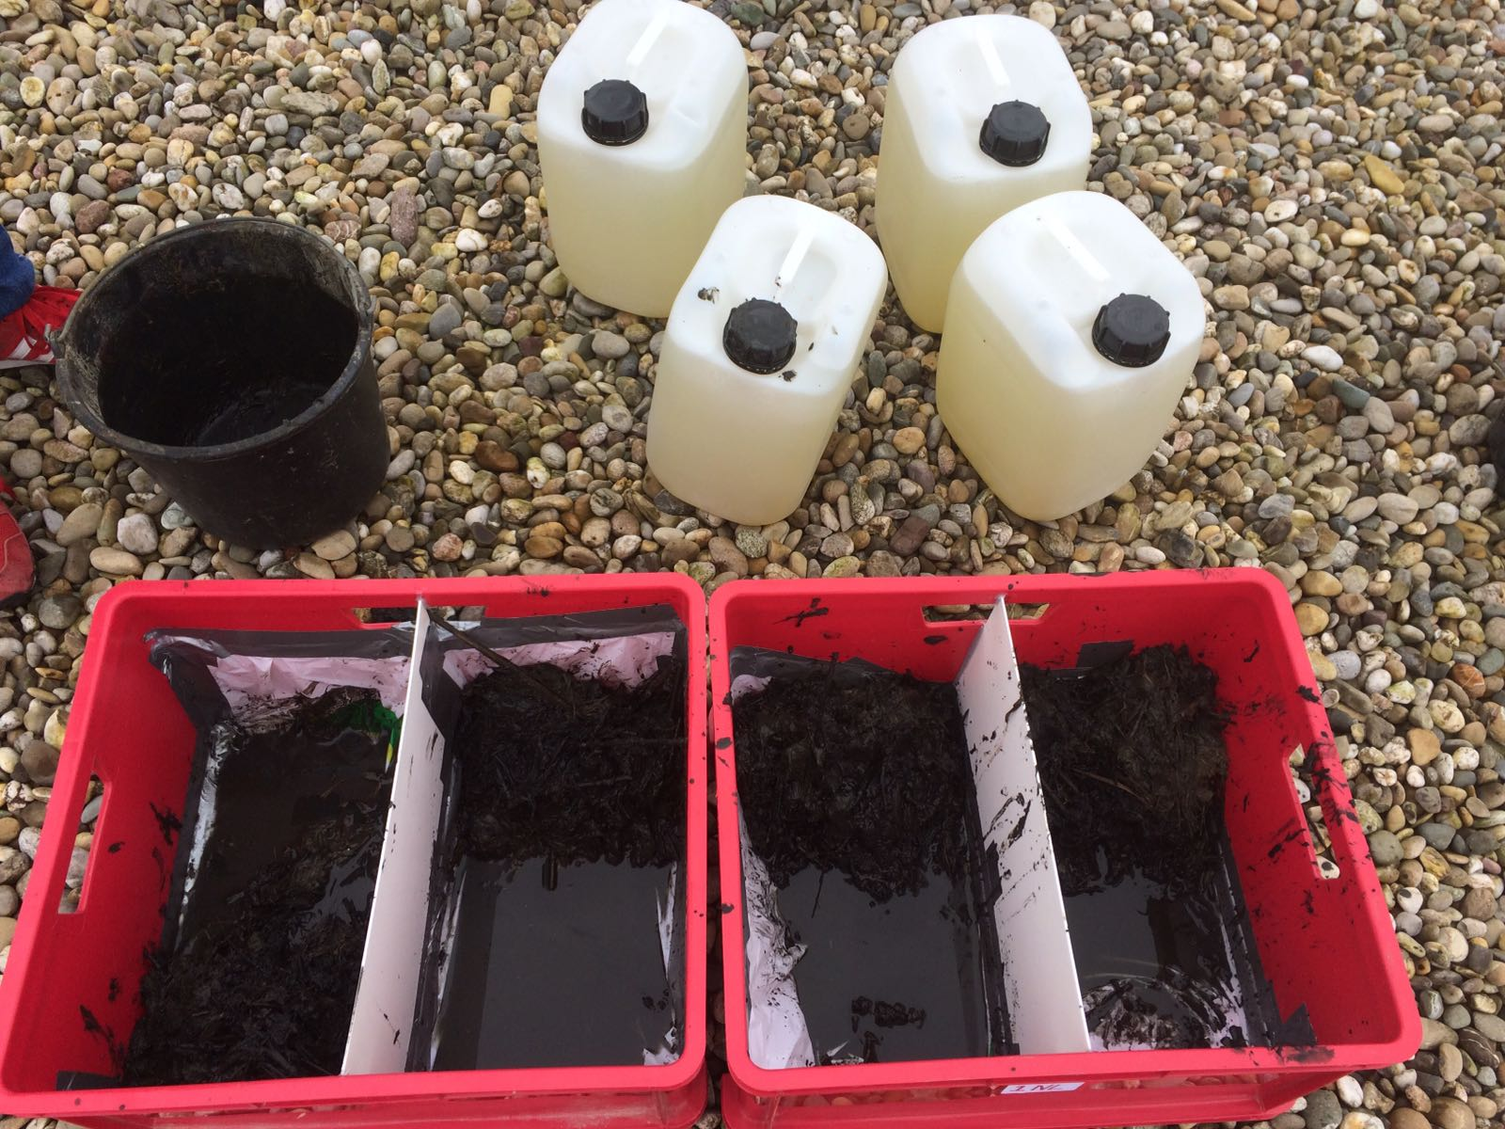
Picture 1: A photograph of the two containers.
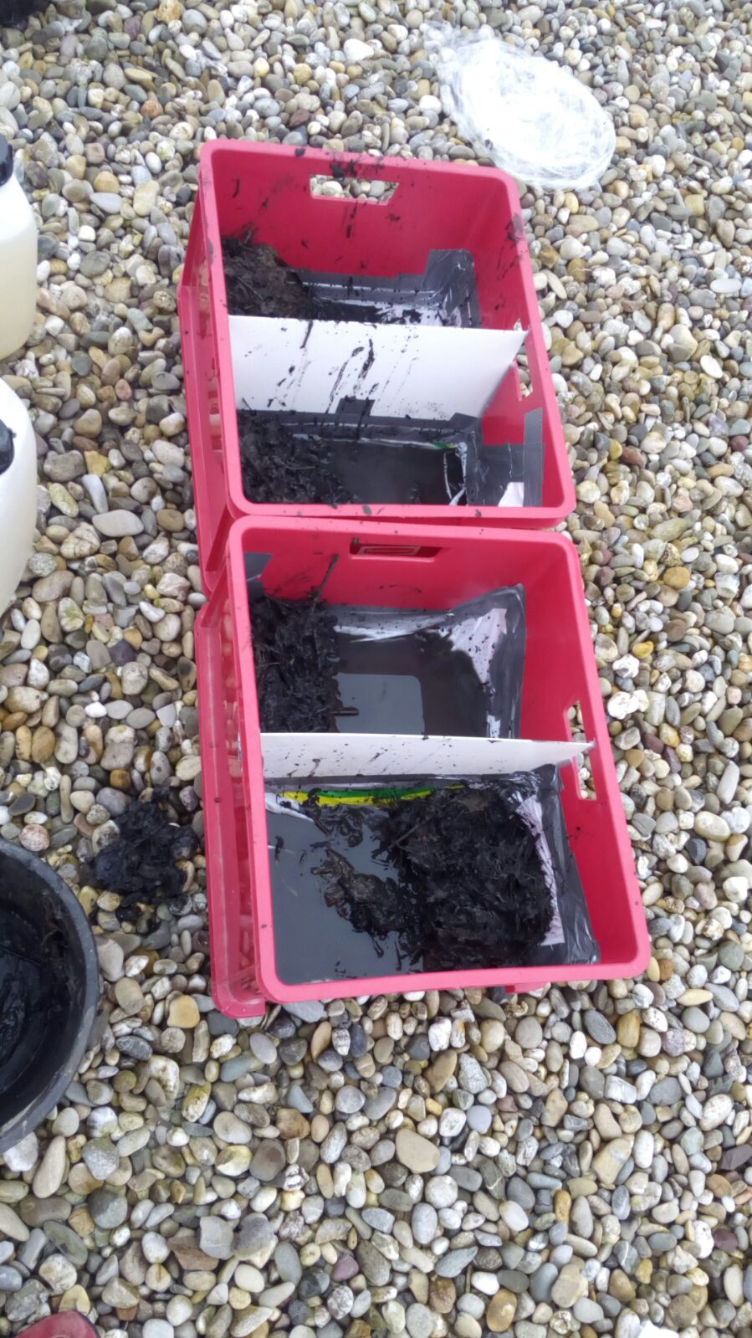
Picture 2: A photograph with the visible soil
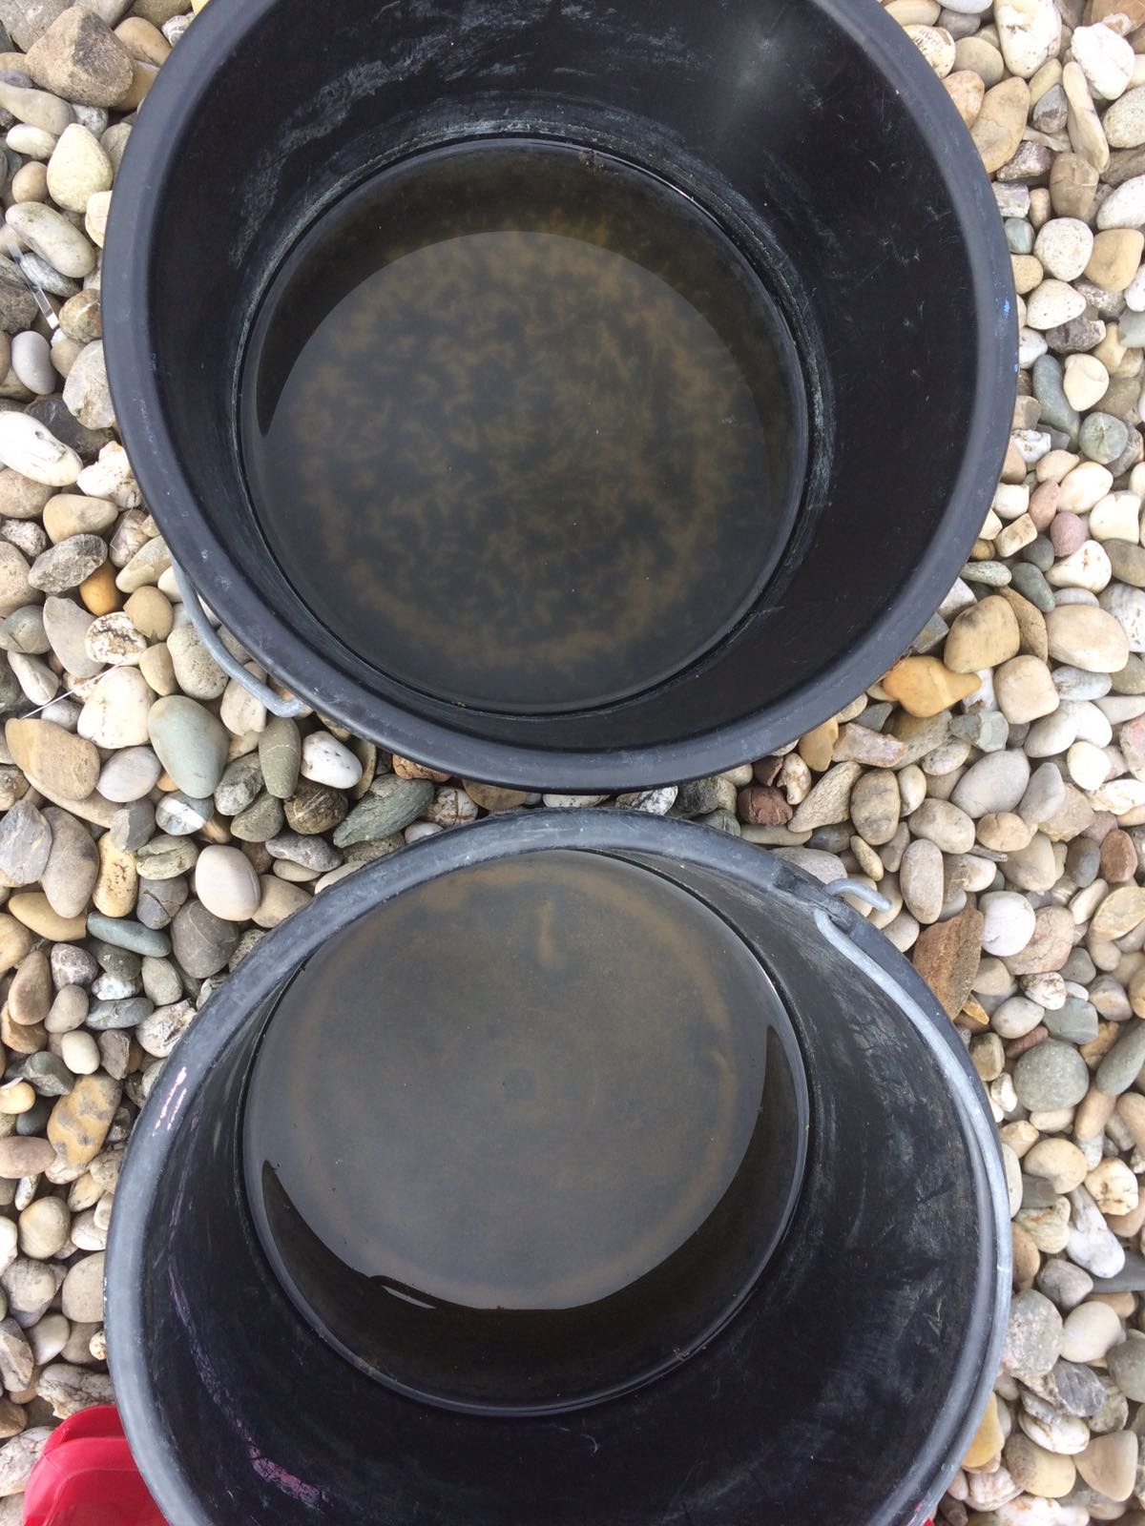
Picture 3: Simulation 5&6 containing only water
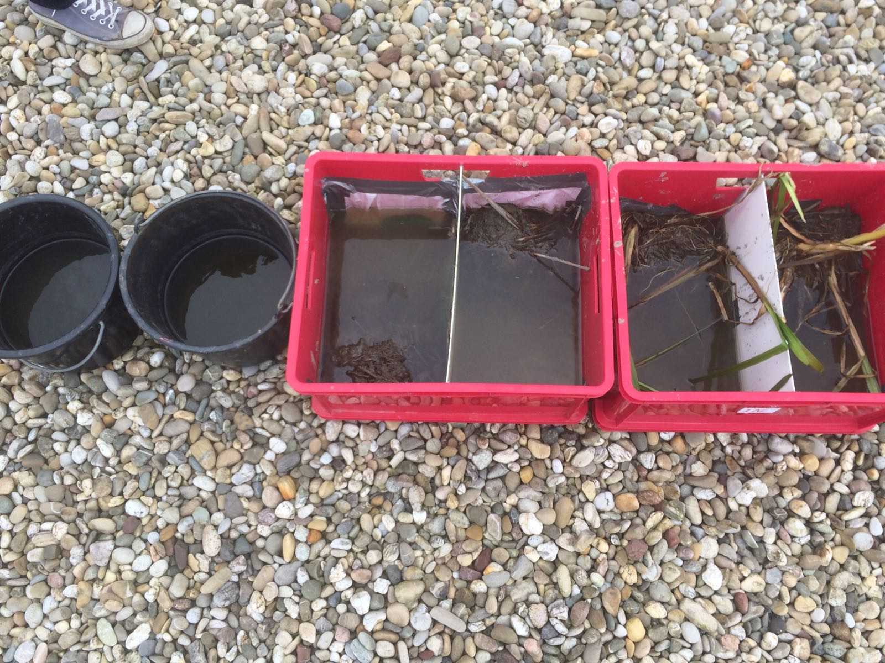
Picture 4: All containers of the simulation

