Analysis of Data Collected On The Effects of Select Weather Factors on
Temperature

Student Researchers:
Adam Ali and Ali Akil

School:
Crestwood High School, Dearborn Heights, MI 48127

High School Science Teacher:
Mrs. Diana Johns

Table of Contents

Abstract & Research Questions…………………………………………………………………...3
Null Hypotheses…………………………………………………………………………………..4
Introduction and Review of the Literature……………………………………………………...4-5
Research Methods………………………………………………………………………………...6
Results……………………………………………………………………………………….….7-8
Discussion………………………………………………………………………………......……..9
Conclusion……………………………………………………………………………….…….9-10
Acknowledgements & Badges…………………………………………………………………...11
Bibliography and Citations…………………………………………………………………........12

Abstract
Surface temperature is a critical factor that influences local and regional heating because the troposphere we live in warms from the bottom up. Scientists closely monitor the surface temperature in their efforts to document and explain our rising worldwide temperatures. This year’s polar vortex in January was a recent weather phenomenon. With our research, we sought to determine if there is a correlation between the air temperatures and surface temperatures during this frosty period and if the polar vortex had an effect on the data we collected at all. For the majority of this school year, we have been collecting surface and air temperature data as well as cloud types and other select atmospheric parameters. We found that wind chill was consistently lower than air and surface temperature and the surface temperature was lower than air temperature on all but 2 days. It was also observed that the cloud cover doesn’t correlate with the surface temperature during this period but further research has to be done. When comparing our temperatures with the average Detroit Metropolitan area it was noted that the average of Detroit was consistently higher due to recordings taken at higher altitudes.

Research Questions
Is there a time delay between the change in near-surface temperature and actual surface temperature? Does the percent cloud cover correlate with surface temperature? Does Crestwood High School’s air temperature and surface temperature correlate with the average air temperature of the Detroit Metropolitan area?

Null Hypotheses
Null Hypothesis 1: There is no correlation between air temperature and surface Temperature. Null Hypotheses 2: There is no direct correlation between cloud cover and Surface Temperatures. Null Hypotheses 3: There is no correlation between wind chill and surface temperature. Null Hypotheses 4: There is no correlation between the CHS air and surface temperature correlate with the temperature of the Detroit Metropolitan area.

Introduction and review of Literature
In January 2019, the Midwestern region of North America experienced unforgettable weather conditions. Residents endured constant sub-zero temperatures dipping all the way down to -40 degrees Fahrenheit wind chill on multiple days. Although this resulted in 7 days of school closings and harsh road conditions, we saw this as an opportunity to continue the daily collection of data and focus our research on this frosty period. Our interests in performing research involving this paramount weather phenomenon was further deepened after witnessing the record-breaking temperatures. Scientists currently use surface temperature data from satellites to monitor weather and climate change around the world. Satellite temperatures of Earth’s surface are very accurate but typically give averaged readings over the large areas they are sampled from. Some climate skeptics currently question if NASA surface temperature data is accurate or not. Because our school is collecting surface temperature measurements at the same place over a period of many years, our data will allow scientists to verify that what data they sense from up on high, is comparable to what we see on Earth’s surface. To better understand the role that surface temperatures play in localized areas, it is important to get data from smaller parcels of land to see specifically how that particular surface responds to incoming solar insolation. Many small-scale and localized factors still need considerable research before a complete understanding of the role surface temperature plays in microclimate settings and at the community level (soil moisture levels, frozen ground, frost levels, etc.). This research found that very few schools consistently collect surface temperature data during the coldest months of the year. Our research found that accurate measurements can be taken throughout the most intensely cold portions of the year if students are properly protected from the elements and the instruments properly acclimated. To identify winter (December-February) heat island effects, it is suggested that GLOBE schools partner together and make a commitment to collect data not just during field campaigns but throughout the coldest months of winter. Only by combining a multitude of data from a whole host of local sites and over a long period of time will we be able to make any true contribution to a deep understanding of how localized surface temperature changes are being affected by climate change. Localized surface temperature data also allows scientists to accurately assess Climate change is currently linked to greater changes in temperatures than seen. By keeping track of the temperature and its increase, we can determine how much time we have left to find a solution to this critical issue. Due to the greenhouse gases released from the burning of fossil fuels the global average surface temperature rose from 1.1 to 1.6 degrees Fahrenheit between the years 1906 and 2005. This, alongside the fact that the rate of temperature increase has doubled in the last fifty years and will continue to rise, demonstrates the importance of recording and analyzing surface temperature data to ensure a healthier and safer future for this planet.

Research Methods
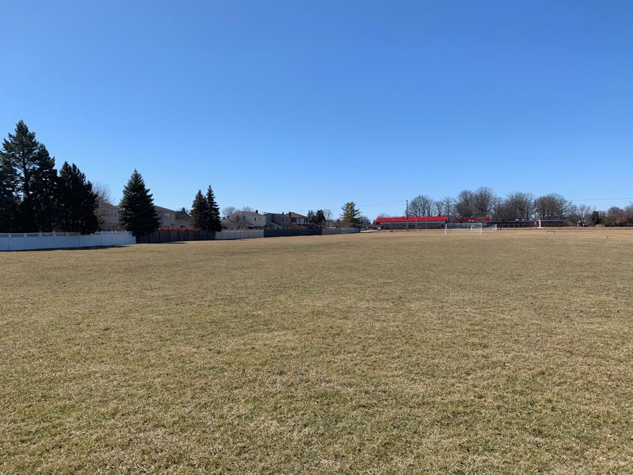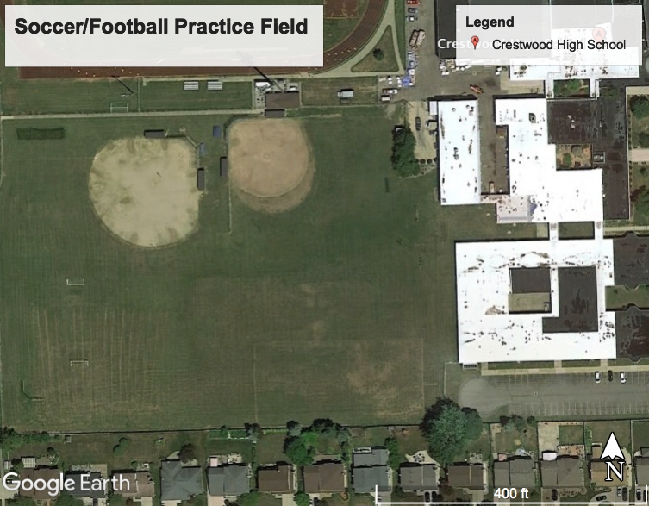
Figure 1-2: Figure 1 and 2 show the areas where measurements were taken (Crestwood High School, Dearborn Heights, MI 48127) The exact location: 42.320672 N, -83.293938 W.
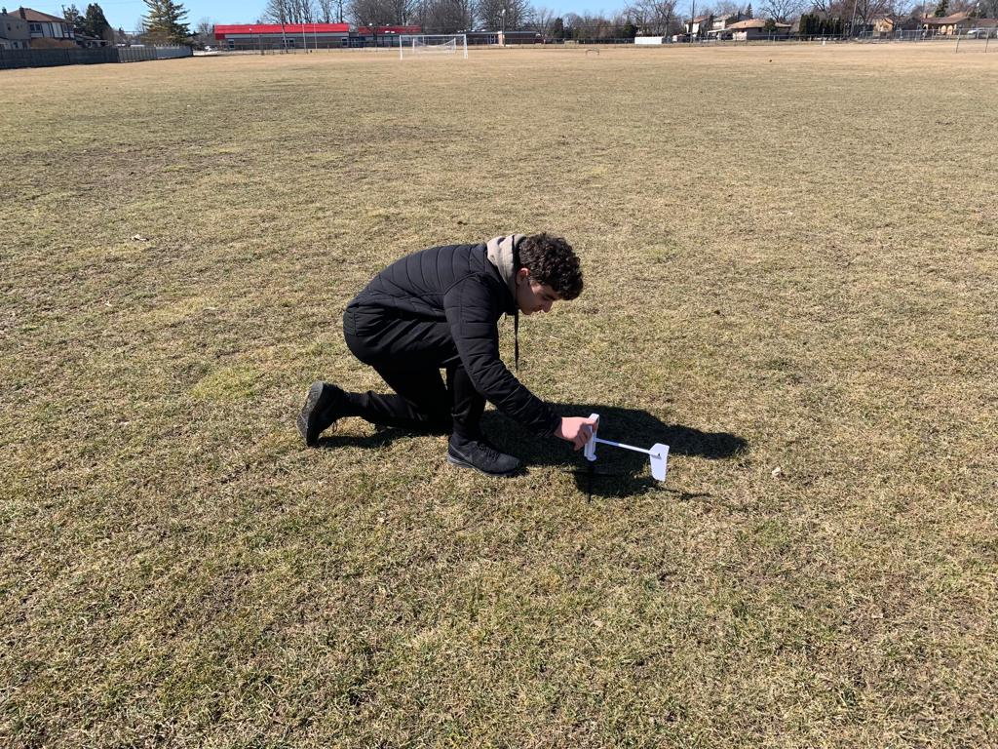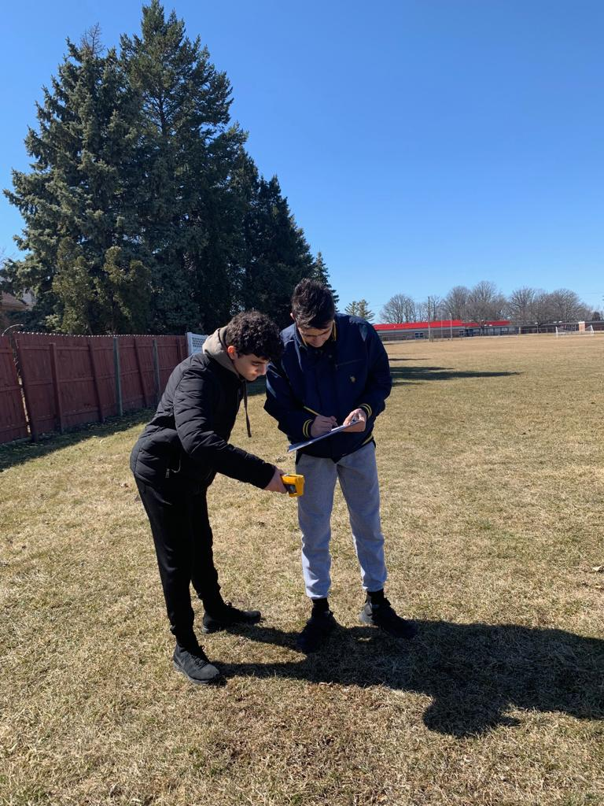
Figure 3-4: Figure 3 and 4 show the student researchers following the protocols in order to take the surface temperature.
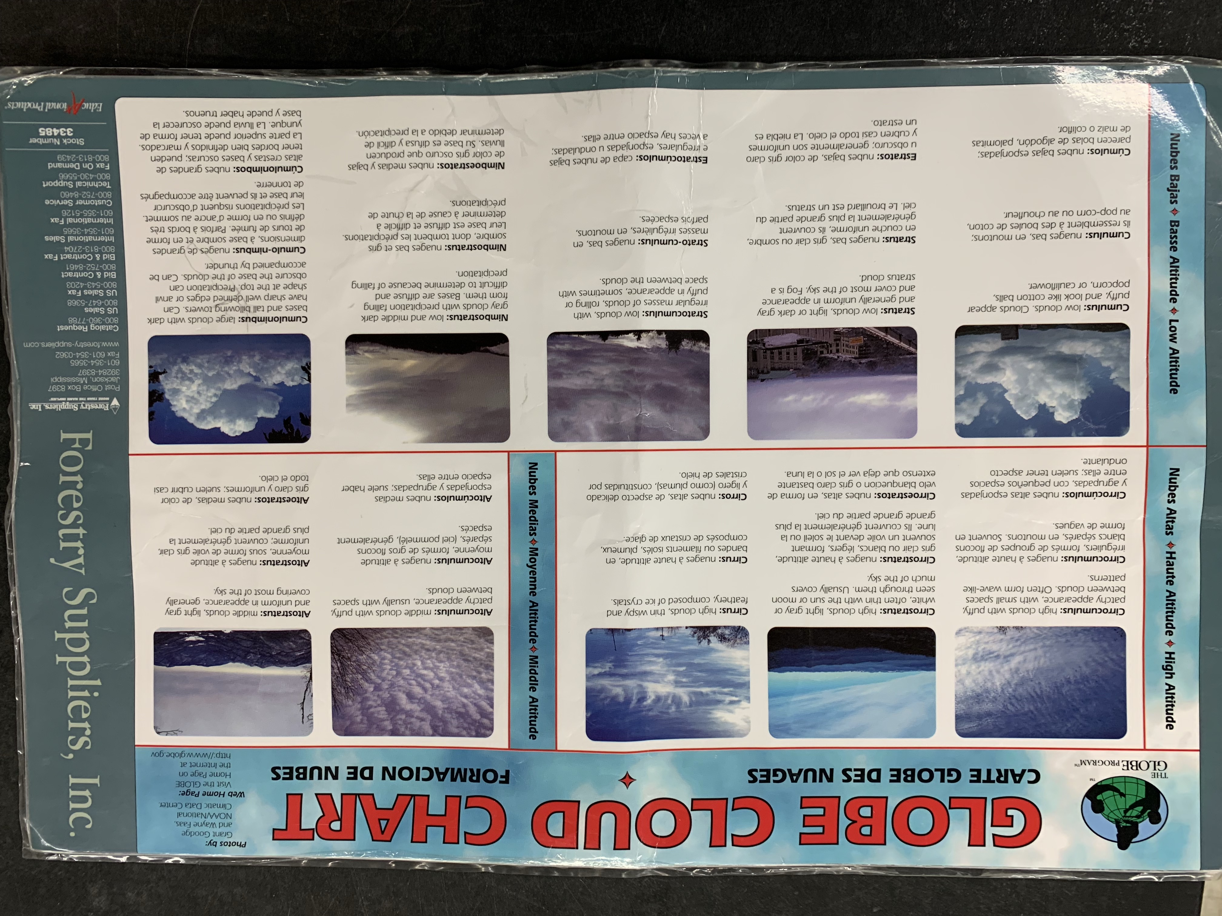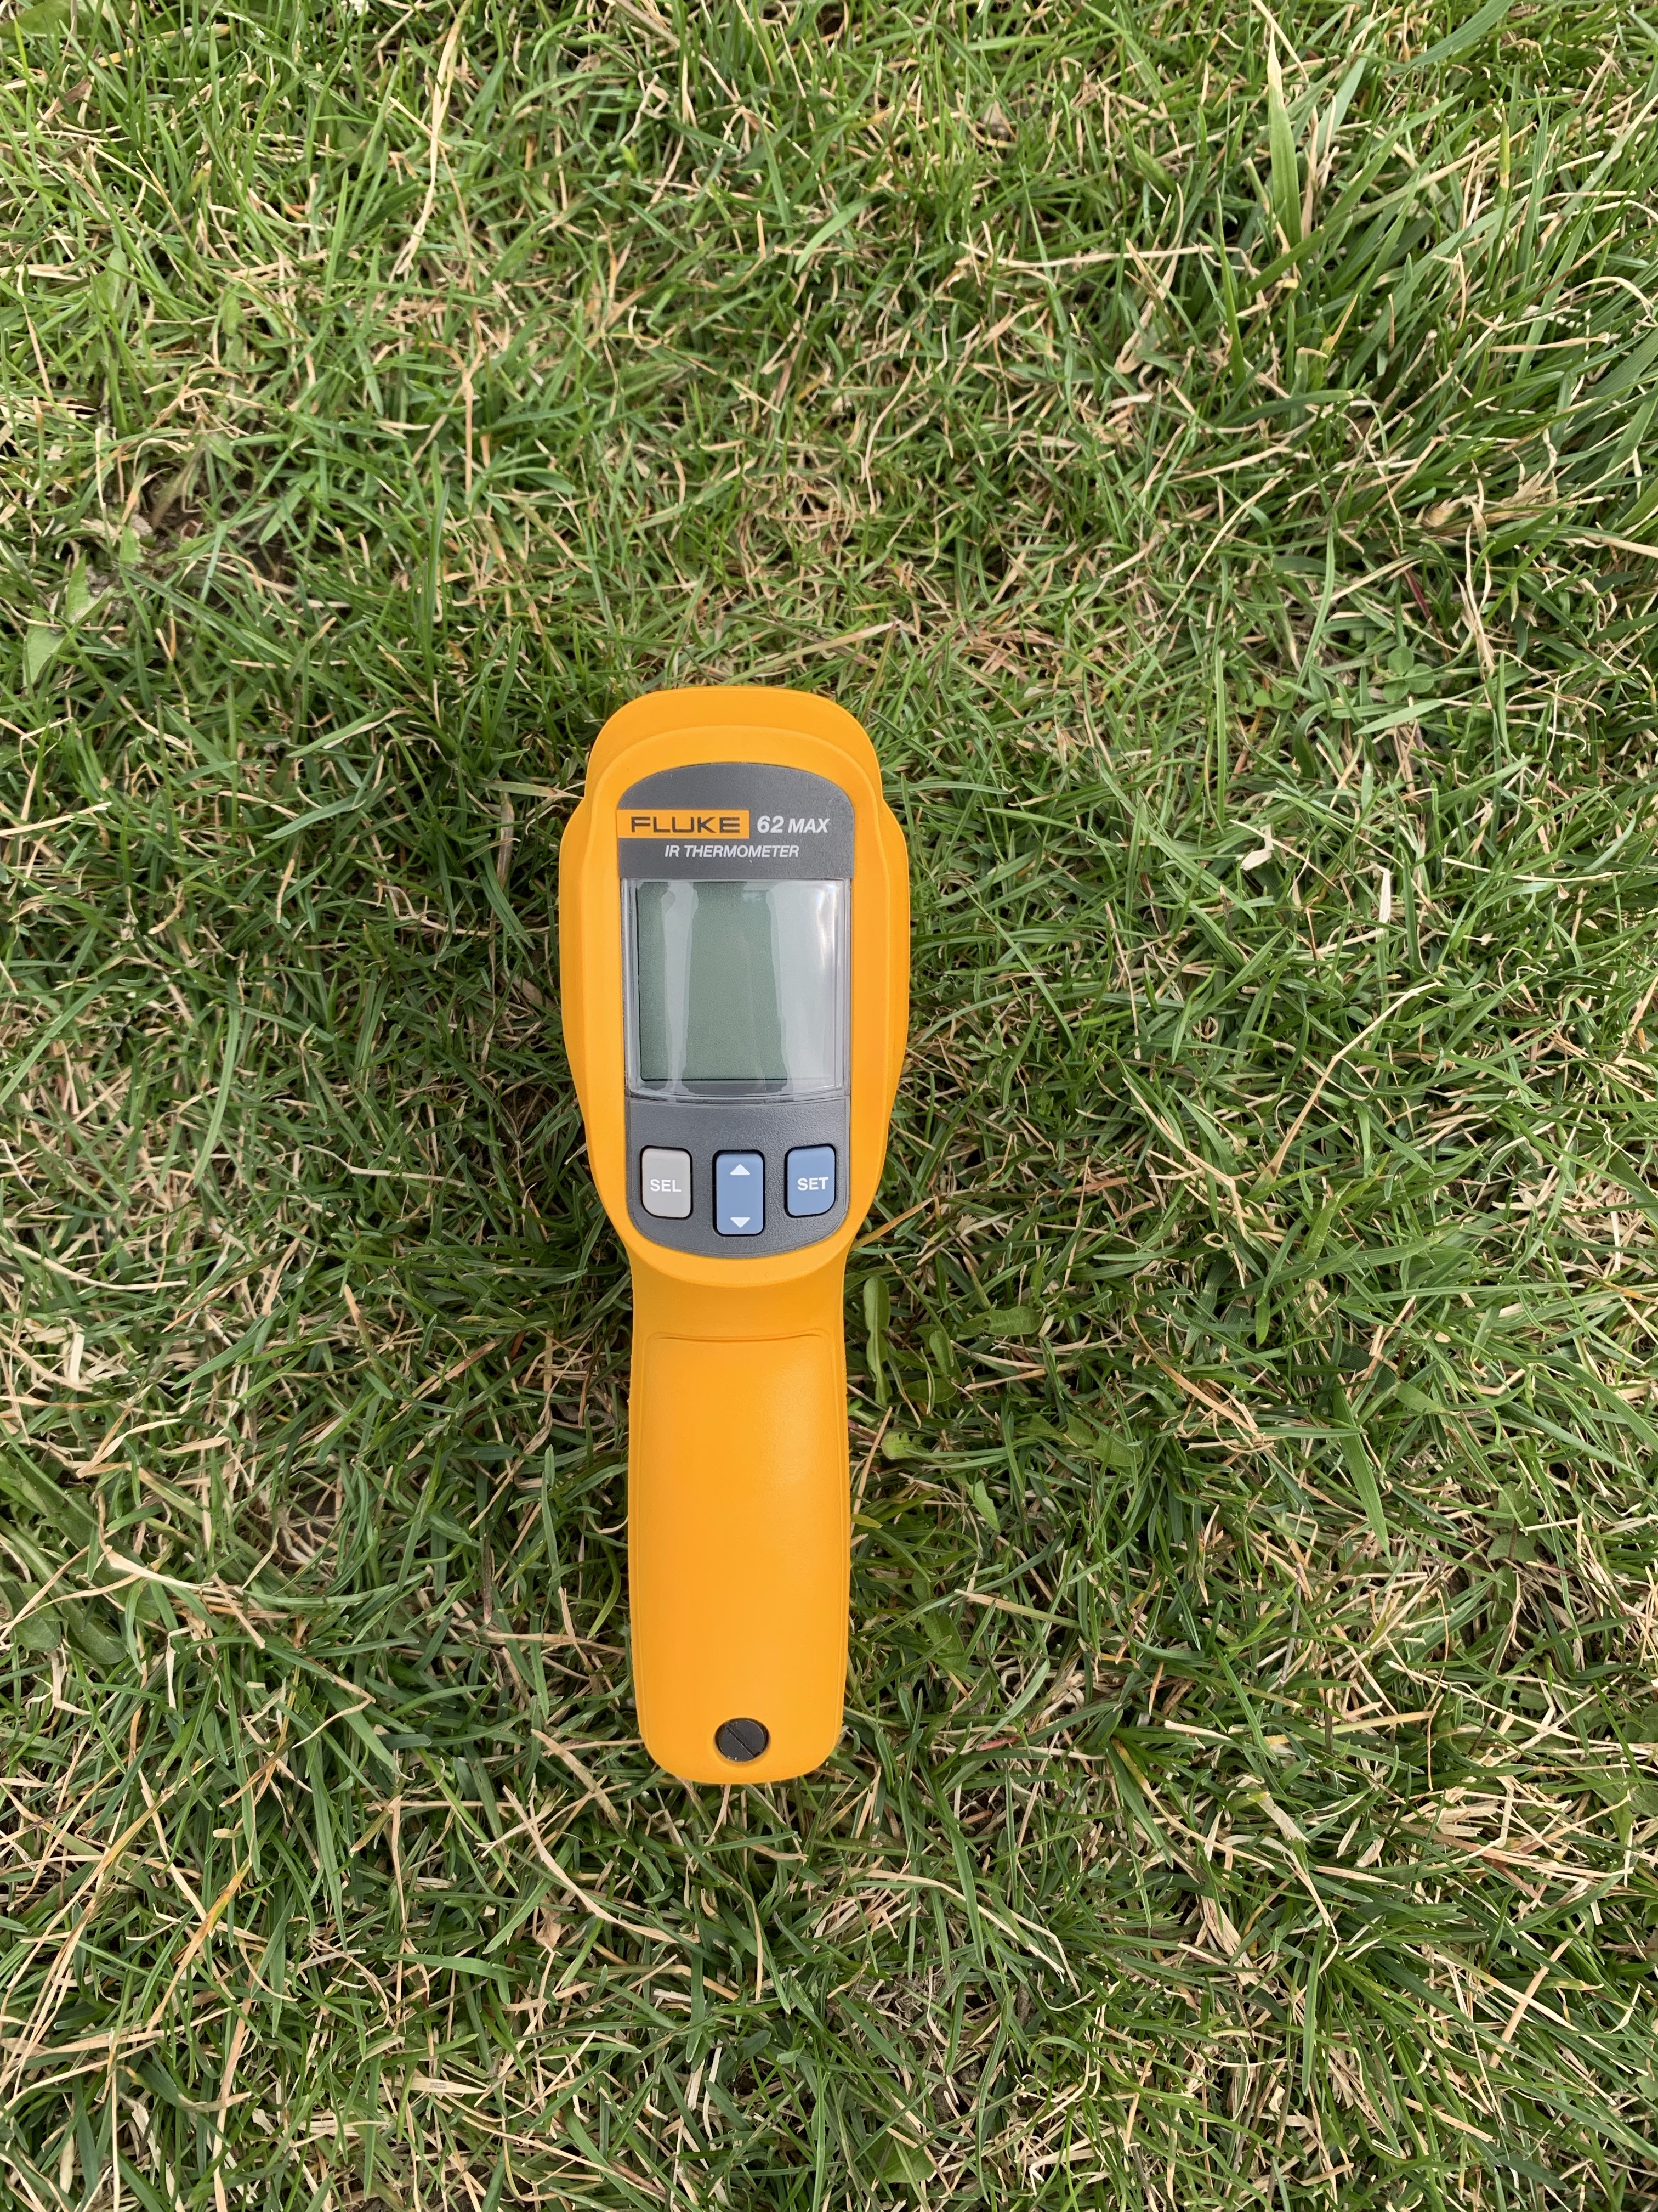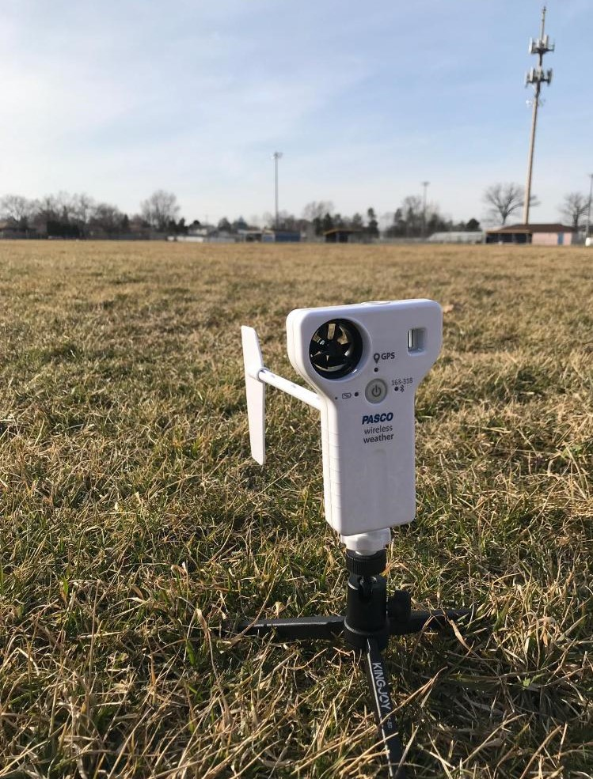
Figure 5-7: Figure 5, 6, and 7 are the materials we used to collect surface temperature daily.
We used the GLOBE Cloud Chart to identify the type of cloud we were observing. We used the two infrared thermometers to obtain Surface Temperature data. We also used the Pasco to record data on multiple weather factors.

Results

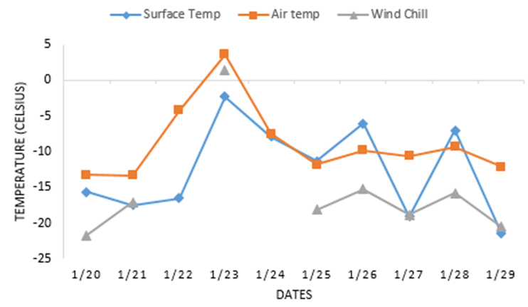
Figure 1. Temperature versus windchill. This graph compares surface temperature, air temperature, and windchill during the 2019 Polar Vortex. The correlation between surface temperature and air temperature is fairly proportional with the surface temperature consistently colder than the air temperature. Air temperature and wind chill have a direct relationship with each other except where missing windchill data (due to our automated weather station malfunction in the extreme cold weather) makes it difficult to analyze the entire period.
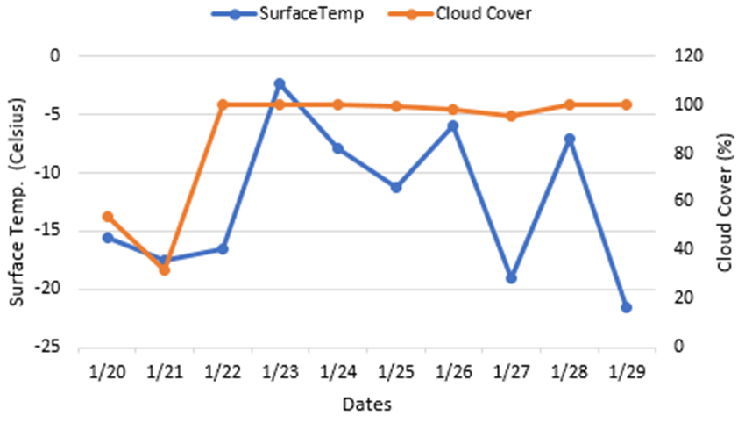
Figure 2. Surface Temperatures versus Cloud Cover. This graph compares surface temperature with cloud cover. There is no correlation between the two because the cloud cover stayed relatively the same while the temperature varied. If data was collected over a longer time period.
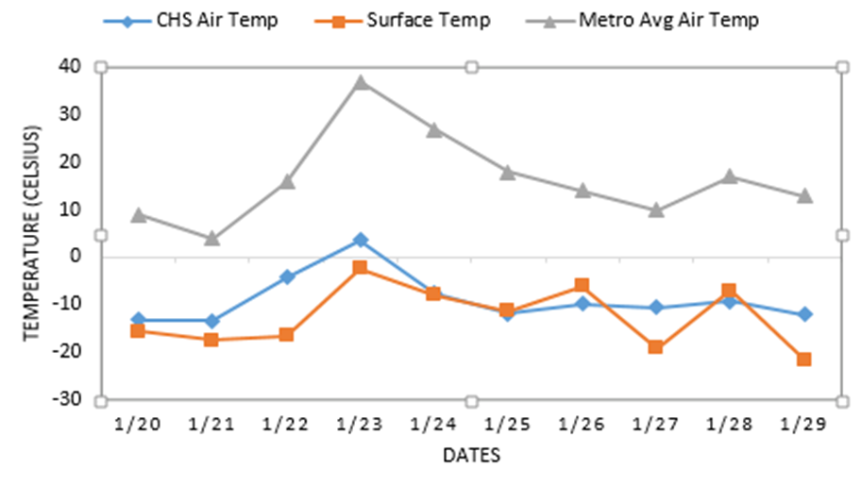
Figure 3. CHS Air and Surface Temperature versus Air Temperature of Detroit Metropolitan area. This graph compares the air and surface temperature of Crestwood High School and the air temperature of the Detroit Metropolitan area. There is a clear correlation between the two with the CHS temperatures being consistently lower because the recordings were taken much closer to the surface.

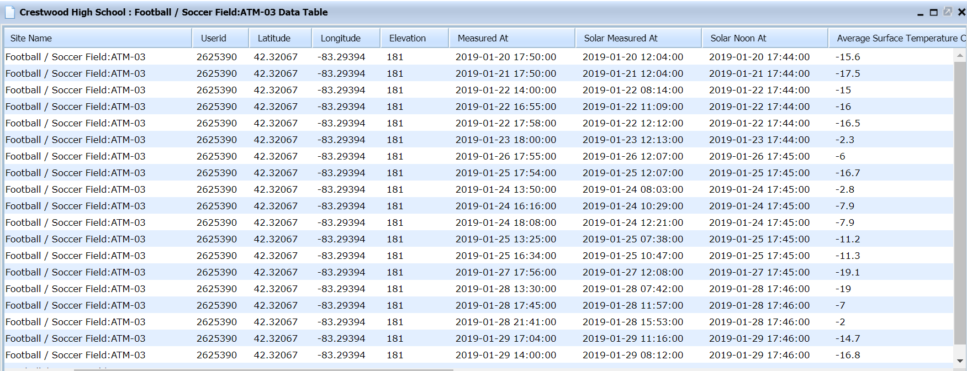
Table 1. Table 1 show Surface Temperature data we submitted in GLOBE during the Polar Vortex from January 20 through the 29th.

Discussion
Following the completion of their research on the effects of select weather factors on surface temperature, we were able to reject three of their four null hypotheses. It was found that There indeed was no correlation found between cloud cover and surface temperature. However, Null Hypothesis 1 was rejected because direct surface temperature and near surface temperature were observed to be proportional. Additionally, Null Hypothesis 3 was rejected owing to the findings that wind chill is directly proportional to surface temperature. The final Null Hypothesis, 4, was also proven false because the average air temperature of the Detroit Metropolitan area appeared consistently higher than Crestwood’s on the account that the recordings were taken at a higher elevation. Upon collecting the data, certain limitations arose leading to minor possible sources of error within the investigation. As a result of the measurements being collected during class, we were unable to head to the site and record data on certain days due to tests/quizzes, harsh weather, and important lectures. Malfunctions in the school’s WeatherBug station in the midst of extreme temperatures also led to incomplete data on particular occasions, as well faulty data collected by some students that could not be included.

Conclusion
Following the completion of our research, we have concluded that there appears to be a one-day time delay between the change in near-surface temperature and direct surface temperature. However, this is only true for when temperatures are increasing the first few days, as soon as temperatures began to fall and later stabilize the relative lag between the data is no longer present. Differences in results are caused by the approximate 10-meter height difference between the ground surface and our school’s WeatherBug weather station sensors positioned on above the school roof. Windchill directly correlated with both temperatures that were given. However, cloud cover did not appear to correlate with the surface temperatures, although more data may have been needed to confirm this due to consistent overcast conditions. A polar vortex is a low-pressure area—a wide expanse of swirling cold air—that is parked in polar regions. Global warming resulting in increased snowfall and frigid temperatures may sound paradoxical, however, there is evidence to back it. For example, warmer temperatures in the winter of 2006 caused Lake Erie to not freeze for the first time in its history. This actually led to increased snowfalls because more evaporating water from the lake was available for precipitation. In the past 5 years, Michigan has been plagued with a polar vortex every year in the past 5 years, 2019 being the worst of all. The collection of the daily measurements could have been more accurate by leaving the handheld infrared thermometers outside for its full suggested 60 minutes which we were unable to do as a result of tests, assignments, or lessons. Our research can be expanded on in a number of ways. One possibility that we had attempted to pursue was to compare our surface temperature data with other schools from select regions, however, we were unable to because we could not find a school that had input consistent data. Another prospect for research is to collect the same data in the summer to see if the same correlations exist in warmer temperatures. In addition, a comparison could be made between our surface temperature data and air temperature at different altitudes along with the recordings from our WeatherBug station positioned 10 meters above the surface.

Acknowledgments
We would like to thank Mrs. Johns for instructing us on how to complete the measurements and providing us with the necessary equipment and always being there to provide support, this would not have been possible without her. The other GLOBE researchers were also essential to the completion of this research as, without them, we would not have a large portion of the necessary data. Also, a big thanks to Sara Komaiha and Ali Eter for showing us how to access and use the Globe data in order to submit our data and properly analyze it. And a huge thank you to Tina Rogerson for providing necessary cloud cover data needed on short notice.

Badges
Data Scientist: Our collection of daily measurements of surface temperature, cloud type, visibility, etc. were all major contributions to answering our research questions and testing our hypotheses. We uploaded the data we collected to GLOBE’s visualization system then analyzed this data in the form of charts in graphs.

Collaborator: In order to collect sufficient data, we had trained other Crestwood students how to properly record data which played a big role because they often reported to the site and took necessary measurements at various times of day. Meeting with experienced GLOBE members from our school also allowed us to understand how to properly access and analyze data which was key. Our team of two proved to be efficient in completing and putting the research together, even under great time constraints.

Bibliography/ Citations

3. Retrieve and Visualize Your Data. #language Available at: https://www.globe.gov/get-trained/using-the-globe-website/retrieve-and-visualize-your-data. (Accessed: 10th April 2019)

GLOBE Science Data Visualization Available at:
https://vis.globe.gov/GLOBE/#. (Accessed: 10th April 2019)

US Department of Commerce & Noaa. Learn About the Polar Vortex. National Weather Service (2017). Available at: https://www.weather.gov/dlh/polarvortex. (Accessed: 1st April 2019)

Resnick, B. The Midwest is facing record-breaking cold. Blame the polar vortex. Vox (2019). Available at: https://www.vox.com/science-and-health/2019/1/29/18201196/polar-vortex-2019-des-moines-midwest-record-cold-windchill. (Accessed: 1st April 2019)

Arctic Weather Plunges into North America. NASA Available at: https://earthobservatory.nasa.gov/images/144489/arctic-weather-plunges-into-north-america. (Accessed: 1st April 2019)

Research on Urban Heat-Island Effect. Procedia Engineering (2016). Available at: https://www.sciencedirect.com/science/article/pii/S1877705816332039. (Accessed: 1st April 2019)

Global Warming. NASA Available at: https://earthobservatory.nasa.gov/features/GlobalWarming/page2.php. (Accessed: 1st April 2019)

Rowlatt, J. Polar vortex: What role does climate change play? BBC News (2019). Available at: https://www.bbc.com/news/world-us-canada-47078054. (Accessed: 2nd April 2019)(database)

