1.Marišćina - Waste or Garbage Management Center?
Students: Klara Mihelčić,12th grade(4E), Vujović Nikoleta,11th grade (3K), Dzhasambayeva Angela,10th grade (2K)
Mentors: Irena Sabo, Marina Pavlić
School: Prirodoslovna i grafička škola Rijeka

2.Abstract
The Marišćina County Waste Management Center is largest waste disposal for the city of Rijeka and its surroundings. Our students that live there told us about the bad smell they inhale almost every day. Last year, in our project "What do inhabitants in Marčelji inhale?" we investigated the quality of the air concerning hydrogen sulfide and particulate matter, due to the frequent complaints of the surrounding population on reduced environmental quality and bad smell. During 2019, the Ministry of Environmental Protection banned the work of Marišćina until the completion of the sanation works which would reduce environmental impacts. The research questions we investigated are: Has the bad environmental impact of Waste Management Center Marišćina's work activities been reduced after sanation works from mid-August to mid-September 2019.? Will the inhabitants in the area have better air to breathe and do they need to worry about respiratory diseases and poor general health as a result of air pollution? Our research shows, using our GLOBE data and data obtained by Institute for Public Health that the bad environmental impact has been only partly reduced after sanation and that inhabitants, in the long run, have a lot to worry about and will probably have more health problems in the future. We also found out that the plant project was not made according to professional, scientific and legal point of view, public Administration did not and does not do its work:The Law on Sustainable Waste Management and the Decree on Municipal Waste Management (LOM) is not applied in the part related to the obligation of separate collection and disposal of bio-waste so their waste management is illegal. What we do is contact and give lectures to Rijeka's population and show them the problems people living near Marišćina have and try to make them listen, recycle and make the City Major conscious of the problem and obey the LOM.
3.Research questions
In last year's project (What do inhabitants inhale?) we investigated the quality of the air with regard to hydrogen sulphide and particulate matter, due to the frequent complaints of the surrounding population on reduced environmental quality due to these pollutants. During 2019, the Ministry of Environmental Protection banned the work of Marišćina until the completion of the sanation works which would reduce environmental impacts. The research questions we want to investigate are:
Has the bad environmental impact of Waste Management Center Marišćina's work activities been reduced after sanation works from mid-August to mid-September 2019.?
Will the inhabitants in the area have better air to breath and do they need to worry about respiratory diseases and poor general health as a result of air pollution? [7] ,[8] ,[9] ,[10]
In our project: "What is airsoiling there?" in (2015), working with the community in Bakar to prevent pollution we found a lot of inhabitants with lung problems that come out of long exposure to air polluted with heavy metals and aerosols.
Hypothesis:
The sanation of Waste Management Center Marišćina had a positive effect on environmental quality and general health of the inhabitants.
4.Introduction
The Marišćina County Waste Management Center is largest waste disposal for the city of Rijeka and its surroundings. It is located approximately 8 km north to northwest of the city center of Rijeka, at an altitude of 463 to 515 m, in a karst area characterized by sinkholes partly filled with clay, dolomites, limestones in alternation with a lot of groundwater used for public water supply. The sources used for the water supply of Rijeka and the Rijeka Ring (Rječina, Zvir, Martinscica, Perilo, Dobra, Dobrica) are not endangered from the Marišćina area and the control of these water sources is carried out constantly. Preventively, a watertight layer and a drainage system were installed at the bottom of the cassette for drainage to be collected (source: Study of waste management company Ekoplus doo Rijeka[1] The Marišćina County Waste Management Center has been a central part of the Integrated Waste Management System in Primorje-Gorski Kotar County (PGŽ) since 2014. Mechanical and biological treatment of waste is carried out: bio-drying, separation of combustible components and treatment of biodegradable fraction in landfills. Last year in addition to monitoring pollutant concentrations in cooperation with the NZZJZ PGŽ, we monitored meteorological parameters and established a correlation with the exceeded limit values ​​of pollutants and wind direction[2]. According to the Air Quality Report by the Institution for Public Health of the Primorje-Gorski Kotar County (NZZJZ PGŽ), air in 2017 in Marišćina was quality 2 concerning particulate matter (PM10) and in 2018 concerning hydrogen sulfide.
In recent months, the Marišćina Waste Management Center has initiated several works to improve the functioning of the Center and to remedy unpleasant odors in the long run, improving the quality of life of the citizens of the surrounding settlements. Initial works were performed in April and May last year. Work on the overlay of the landfill and the degassing system (connected to a high-temperature torch) took one month (from mid-August to mid-September 2019). Due to the nature of the works, there were occasional periods of stink during the period.
In this year's project, we want to estabilish whether Marišćina Plant finally became a waste management center instead of a garbage can and will it continue to affect the general health of the surrounding population.

5) Research Methods and Materials
- GLOBE protocols:
Atmosphere:
- Air temperature (Daily Average Temperature-Digital Thermometer),
- Precipitation (Rain Gauge)
- Humidity(Digital Hygrometer)
- Air pressure ( Digital Barometer)
- Aerosols (Photometer)
Biometry
- Tree height and circumference( 50 m measuring tape, clinometer)
We tried to use GLOBE Observer app but the results were out of range, we think it was about wi fi connection (when we tred it at the school site it worked)
- Other:
- Lichen as bioindicators of air contamination
- Data from automatic air quality measurement stations on the website of the Institution for Public Health of the Primorje-Gorski Kotar County (air pollutant levels and olfactometric measurements at Marišćina station) [3] ,[4]
- Data from Croatian Environment and Nature Agency (Air Quality in the Republic of Croatia) [5]

Location: Marišćina
Coordinates N45°24'08" E14°23'18" elevation 447 m
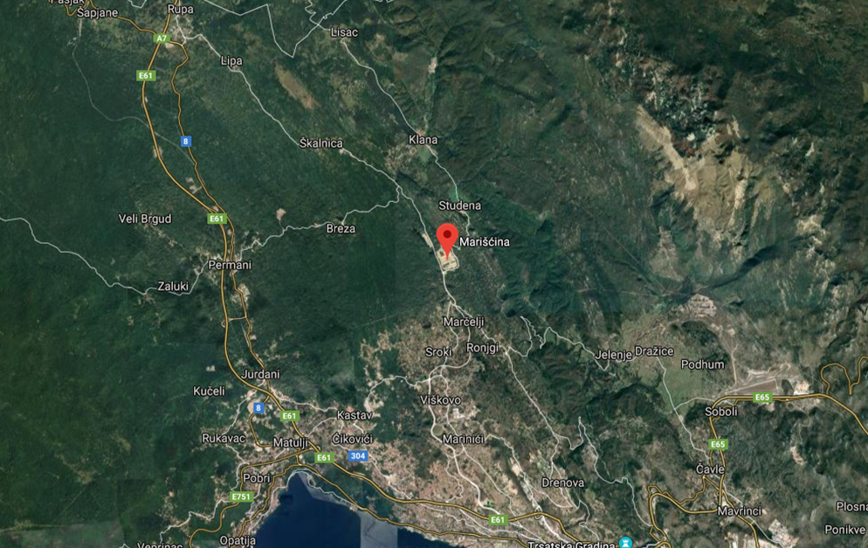
Picture1: Marišćina measuring site
6) Results

- GLOBE data
Average Temperature Daily
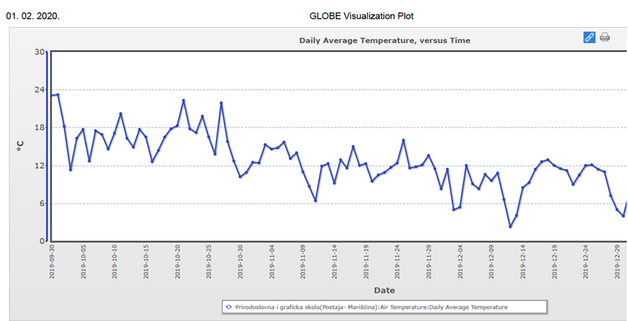
Figure 1.Average Temperature Daily, measured from 30.09.2019. to 29.12.2019. on Marišćina site

Solar noon temperature (from last year's project "What do the local inhabitants around Marišćina inhale?)
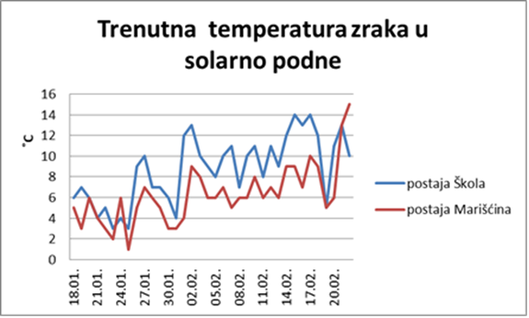
Figure 2.Noon Temperature measured from 18.01.2019. do 20.02.2019. on Marišćina site and Prirodoslovna i grafička škola site

Rain Depth
Figure 3.Rain depth measured from 30.09.2019.to 29.12.2019. on Marišćina site
Water vapor affects both rain and aerosol optical depth.
Olivier Boucher& Johannes Quaas[6] show that higher rain rates are associated with higher aerosol abundances Our photometer measures aerosols only wwhen less than 45% cloud coverage and we could not draw conclusions.

Humidity
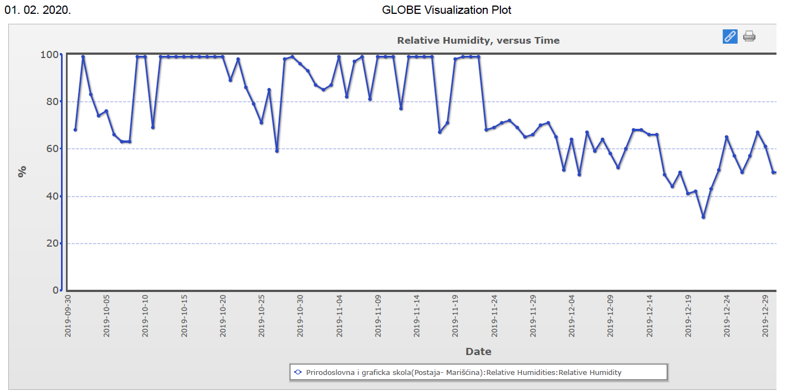
Figure 4:Relative Humidity measured from 30.09.2019. to 29.12.2019. on Marišćina site
We had known that indoor air quality depends on temperature and humidity but we could not find data to determine the outdoor effect of humidity on polluted environment.

Aerosol Optical Thickness in 2020.
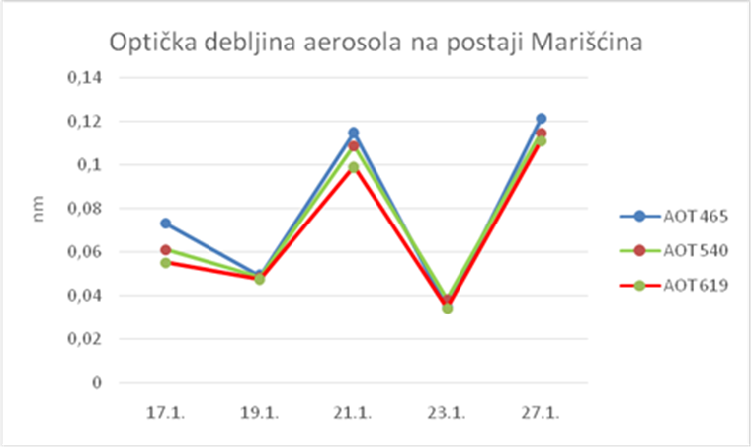
Figure 5:Aerosol Optical Thickness on Marišćina site measured from 17.01.2020. to 27.01.2020. on Marišćina site

Aerosol Optical Thickness in 2019.
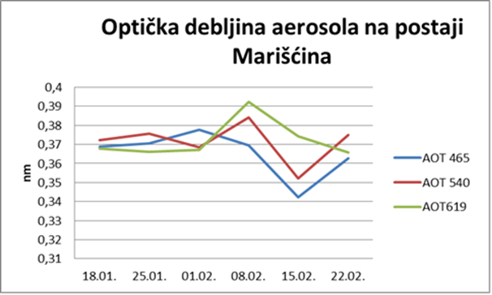
Figure 6:Aerosol Optical Thickness on Marišćina site measured from 18.01.2019. to 22.02.2019. on Marišćina site
Comparing fig. 5 and fig.6 we can observe that in 2019. Aerosol Optical Thickness on Marišćina site is signiﬁcantly higher. Lower Optical Thickness in 2020. could be the result of sanation works on the Plant.

green-coarse particles, PM 10, natural aerosols- (wind-borne dust, volcano emission, sea dust, plant emission-volatile organic compounds), particle diameter <10 µm red-fine particles, PM 2.5, (secondary aerosols, formed by chemical reactions between combustion products and organic compounds, metals), particle diameter <2.5 µm blue-ultrafine particles, PM 1.0 (combustion products: sulfur dioxide, nitrogen oxides, carbon monoxide, soot) particle diameter <0.1 µm
According to our data in a month period the greatest emission of particles was PM10 from dust, plant emission and PM2,5 secondary aerosols formed by secondary chemical reactions. We compared our measured data with data from the institute we cooperate with- NZZJZPGŽ.
- Other:
Determination of air quality by lichen
Type of tree: Quercus pubescens (oak ), north side of the trunk
6
5
4
3
2
1
Picture 2: Marišćina measuring site, six trees on which the lichens were tested

Table 1: Coordinates, tree height and circumference of oak trees we chose to test
TREE NUMBER | COORDINATES  N E |  | TREE HEIGHT | TREE CIRCUMFERENCE
1. | 45° 20´9,5˝ | 14⁰25ʹ32.3˝ | 25 m | 165 cm
2. | 45° 24´42˝ | 14⁰23ʹ26,5˝ | 22,4 m | 127 cm
3. | 45° 24´49˝ | 14⁰23ʹ30,9˝ | 37 m | 66 cm
4. | 45° 24´41,5˝ | 14⁰23ʹ12,7˝ | 18 m | 46 cm
5. | 45° 24´39,1˝ | 14⁰23,5ʹ9˝ | 8,6 m | 79 cm
6. | 45° 24´41,2˝ | 14⁰23ʹ5,7˝ | 15,6 m | 67 cm

We chose six trees with coordinates around the Marišćina site due to wind changing direction

Using lichen as bioindicators De Sloover & Leblanc [7] developed the Index of Atmospheric Purity (IAP). At each site, this method assigns numerical values to characteristics such as frequency and cover.

Table 2:Atmosphere Purity Indeks(IAP)
STEMS FREQUENCY a₁ a₂ a₃ |  |  | COVERAGE  c₁ c₂ c₃ |  |  | Atmosphere Purity Index  IAP
1 | 3 | 1 | 1 | 2 | 1 | 9
0 | 0 | 0 | 0 | 0 | 0 | 0
3 | 2 | 0 | 3 | 1 | 0 | 9
0 | 1 | 0 | 0 | 1 | 0 | 2
0 | 1 | 1 | 0 | 1 | 1 | 4
1 | 0 | 1 | 1 | 0 | 1 | 4
 | CLASS: 2/3  Contaminated / moderately polluted air |  | AVERAGE IAP: 4,6 |  | Σ IAP | 28

According to lichen coverage and stems frequency we determined that air quality on the site is between moderately polluted and contaminated, class 2/3.
Particulate matter P10 (data from the pages of NZZJZ PGŽ)
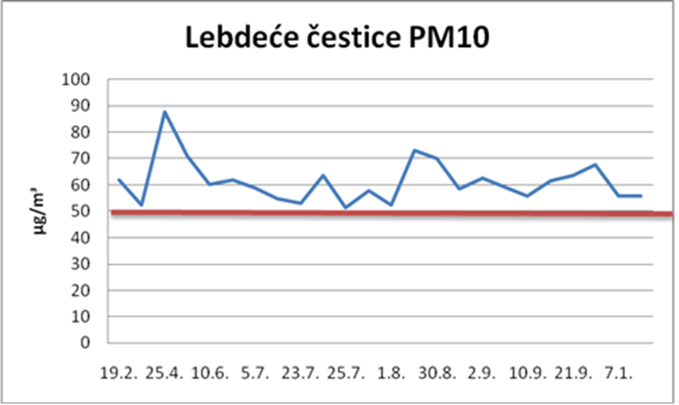
Figure 7: exceeded limit values (GV = 50µ / m³) for particulate matter during 2019./2020.
Based on source data for particulate matter (source: Croatian Environmental and Nature Agency), there were 25 daily exceedances in 2019. According to the Regulation on the amount of pollutants, the permissible number of annual exceedances for particulate matter is 35. Consequently, the air in Marišćina area would be 1.quality concerning PM10 particles. There is no accessible data for the measured concentrations of the smaller and more dangerous PM2,5 particles which we also detected with our photometer. We assume that the reasons for the increased concentrations of particulate matter during the year of 2019.is waste management in Marišćina and decreased concentrations in 2020. the sanation works.

Hydrogen sulfide (data from the pages of NZZJZ PGŽ)

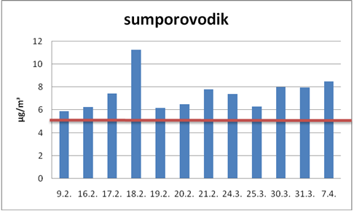
Figure 8: Limit values ​​(GV = 5µ / m3) for hydrogen sulfide (daily source data) exceedeed in 2019
From 07.04.2019. until 27.01.2020. :no exceeded daily values ​​for hydrogen sulfide at the Marišćina site.
The original data for hourly limit values: exceedings in the period up to 7.4.2019. for 59 times, mostly during April 2019. According to Regulative:permitted daily excess is 7. The concentration of hydrogen sufide was higher 12 times daily The air quality concerning hydrogen sulfide is 2nd category-polluted.
Positive trend: after finishing plant sanation August /September 2019. the daily pollution with hydrogen sulphide is significantly reduced (only three original daily excesses: December 27.; January 22nd and 26th). No excess has been registered from May 2nd to December 27th of 2019. Hourly original overruns have been reduced, but the total number during the year of 2019 is 290 and only 24 are allowed.
The reason for the decrease in the concentration of hydrogen sulfide is its combustion, where sulfur dioxide produced.
2H₂S+3O₂ 2SO₂+2H₂O
The concentration of the limit value for sulfur dioxide is relatively high but no concentration data is available for the site.
Olfactory data
The NZZJZ PGŽ conducts olfactometric measurements (monitoring of the occurrence of unpleasant odors in the environment of the Marišćina MSc by dynamic olfactometer)
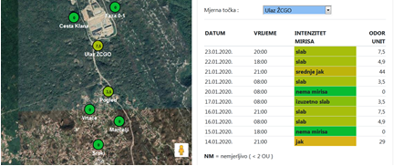
Figure 9: Results of olfactometric measurements (source: NZZJZ PGŽ)
The presented data is for part of January 2020. Daily changes in the influence of unpleasant odors of hydrogen sulfide, as well as odor dispersion at the site of Marišćina were observed. (Source: NZZJZ PGŽ)
7.Discussion
According to our local standards, there are two air categories in Croatia:
The first category -clean air
The second-polluted air
Marišćina trial work started on July 30, 2015.
NZZJZ PGZ reports:2015 and 2016. for all pollutants in Marišćina, the air is Category 1 From 2016. air quality is decreasing and for PM10 and Hydrosulfur is Category 2.
Additionally: Epidemiological field surveys were continued to determine the incidence of odors at three positions in the Marišćina MSc environment, and during July and August additional surveys were conducted in the evening and night hours at three existing and two additional positions.
An odor that could occasionally be felt has a distinctive sour-sweet odor characteristic of municipal waste landfills. It consists of a complex mixture of organic and inorganic compounds, products created by aerobic and anaerobic biodegradation of waste, which at the level of several molecules can cause a repulsive odor. For most of these compounds, no limit values are prescribed, although they cause a highly repulsive odor. Odor pollution can and is impairing the quality of life in and around the area of our Marišćina site. Management of Marišćina promised the inhabitants that at the end of the works on the site and the degassing system (connected to a high-temperature torch) from mid-August to mid-September 2019. there will be no stink. But the olfactometric measurements after the end of works showed a continuously increased volume of bad smells during November, December and, January. We cooperate with a local board, MO Marčelji, the inhabitants living near the site and citizen's committee founded to fight for clean air and environment (Association for Eco Crisis Marišćina ) Last year we conducted a survey among residents living nearby Marišćina about what is the quality of life in their town. All responded that the smells are terrible and the air is of low quality. They fear lung problems and other health problems for them and their children.
International Agency for Research on Cancer (IARC) [8] determined that outdoor air pollution and particulate matter in outdoor air pollution (mixture) is carcinogenic to humans. In 2013, a study involving 312,944 people in nine European countries revealed that there was no safe level of particulates and that for every increase of 10 μg/m³ in PM10, the lung cancer rate rose 22%. The smaller PM2.5 were particularly deadly, with a 36% increase in lung cancer per 10 μg/m³ as it can penetrate deeper into the lungs.[9] Worldwide exposure to PM2.5 contributed to 4.1 million deaths from heart disease and stroke, lung cancer, chronic lung disease, and respiratory infections in 2016.[10] Overall, ambient particulate matter ranks as the sixth leading risk factor for premature death globally.[11]
We also participated in the panel "Ecological management of biodegradable waste - Bio Logic 2020" organized by the Association for Eco Crisis Marišćina in cooperation with the County of Primorje-Gorski kotar. The panel presented all the problems of the existing waste management system, as well as the possibilities for improving the system of separation of biodegradable waste. The panel aimed to encourage local self-government units from the County of Primorje-Gorski kotar, as well as local municipal companies, to jointly provide citizens with legal and logistical preconditions for the separation of waste. We are reporting what County Mayor Zlatko Komadina said "Marišćina is a problem because it is the middle part of the system, which lacks the beginning and the end. Namely, neither previous separation nor bio-waste nor compost has been resolved. The placement of fuel from the waste has not been resolved, and unfortunately, the secondary raw materials, can't be used because the state has not built the promised four power plants, and it is obliged to do. The system is flawed because you cannot not have the first part of the system, have the middle one and not have the back up of the system.
Unfortunately, part of the local self-government units headed by the largest waste producer, the city of Rijeka, do not apply the Law on Sustainable Waste Management and the Decree on Municipal Waste Management in the part related to the obligation of separate collection and disposal of bio-waste so their waste management is illegal.

8. Conclusions
The air in Marišćina and its surroundings is polluted. Our data on air quality using lichen as bioindicators concurs with NZZJZ PGŽ data
-impact of aerosols Aerosol's thickness was more pronounced in 2019. than in 2020. We compared our measured data with NZZJZPGŽ data,fig.5 and fig.6 show aerosols pollution on the site. -Impact of Temperature on Aerosols We compared atmosphere temperature and aerosol thickness data in our research in 2018./2019. and concluded that temperature does not influence aerosol's quantity. We came to the same conclusion with this year's data (according to our measurements). From our past projects we are aware that temperature does affect aerosol's concentration but in this case temperature measurements are not relevant because we could not get day and night temperature oscillations (occurrence of temperature inversion and vertical airflow). Outdoor air pollution and particulate matter in outdoor air pollution (mixture) are carcinogenic to humans.
As we see it the problem is greater than we thought last year when we explored the problem of living in Marčelji with trash smell almost every day.
- Containers have been set for separate waste collection: the door-to-door collection of paper and glass, co-mingled collection for metal, plastic and tetra packs, and separate containers for remaining (mixed) waste. But they are not placed evenly and happens that they overflow before being transported away. Bio-waste, together with mixed municipal waste, is transported to landfills. Bio-waste should be separated from residual waste and composted at the site of occurrence. Therefore, the stench on Marišćina and the influence of Marišćina on the population and the environment would be avoided. The municipal company "Čistoća" should find suitable locations for the treatment of biodegradable municipal waste through composting or anaerobic digestion processes. Composting is the best method of biowaste management, which contributes to raising soil quality and achieving greenhouse gas reduction targets through soil carbon and nitrogen retention. We also recommend Pay As You Throw systems for people who own houses, to be charged according to the amount of waste they generate.
- Solve the fuel placement from waste. The mixture of plastic and paper is offered to the market as fuel. The energy value of the fuel depends on the share of plastics in the fuel. Unfortunately, the fuel does not find itself in the interest of the market (usually cement makers) because it is mostly low in energy value due to the high proportion of paper. That's why Eco Plus has to pay for low-energy fuel sanitation. For years, construction of Power plants been planned by the State, but nothing concrete has yet been done. It is necessary to build a Power Plant as soon as possible and with a good engineering project residents could have cheap heating.
- It is economically unprofitable to transport separate raw materials (metals), which is why it is not being exploited. The state should subsidize the exploitation of separate materials.
- We investigated and found out that the bring point waste collection has to pay to get rid of collected waste. Waste is sent to Austria to be disposed of. We also observed that there are not public containers for bio-waste and that even when people recycle the waste from all different bins finish up all together in Marišćina! These ideas were presented by the students to the Eco Crisis Society and the Communal Society "Čistoća". We asked the local County Waste and Recycling company Čistoća why there are no bins to collect bio-waste and why all waste is mixed together. They told us that the problem is with citizens of Rijeka and surroundings who throw their bio-waste everywhere. Čistoća is doing its best, teaching people to behave seriously: they delivered leaflets about recycling in every postal box and this year are organizing works in all kindergartens in our County. They are also buying a new sequencer which will help sort the waste.
Our actions:
-Last year when we realized the size of the problem we started organizing and organize panels for citizens with a PP presentation of how to collect waste (there were not a lot of people present) -In 2016. we organized a working presentation at the kindergarten we are cooperating with to show kids how to recycle-after two months when we came back to see the results a five- year-old girl told us"My mother doesn't listen to me, she puts all our waste in one bin!" -In 2019. organized a working presentation at the local elementary school
We aim to show how people around Marišćina live (we are chemical and ecological technicians) and can produce a harmless bad smell during our presentation, we will take this project to the newspapers and find a way to present it on TV too. We also plan to collect soil and air samples and in cooperation with NZZJZ PGŽ Rijeka analyze collected partilcles and determines the quantity of P2,5 particles and determine dangerous chemical compounds expelled by the Plant [12]. If the works on Marišćina are banned again Rijeka and its surroundings will have a big problem that citizens are not aware of..
Ultimately: Marišćina is not a Waste Management Center but only garbage container or nicely put Garbage Management Container, dangerous and smelly for all inhabitants living nearby and our hypothesis was wrong.

To complete this project we worked with STEM scientists from various Institutions:
-NZZJZ PGŽ Rijeka (dr.sc. Željko Linšak, dipl.ing, dr. Alenka Alebić i dipl.ing. Dušanka Ćuzela – Bilać) -Museum of Natural Sciences Rijeka ( mr.sc. Milvana Arko Pijevac, dr.sc. Marcelo Kovačić, dr.sc.Boštjan Surina) -Institution „Priroda” (dipl.ing.biologije Marko Randić) -County Waste and Recycling company "Čistoća" ( engineers in various departments) -Waste Management Company „Eko plus“ -Prirodoslovna i grafička škola Rijeka (dipl.ing Irena Sabo, mr.sc.Marina Pavlić, dipl.ing)

9. Bibliography/Citations
- https://www.ekoplus.hr/mariscina. Retrieved March, 10. 2019.
- Branka Penzar i suradnici: Meteorologija za korisnike, Školska knjiga, Zagreb, 1996.
- www.zzjzpgz.hr. Retrieved March10.2019.
- www.zzjzpgz.hr. Retrieved February 12.2019.
- www.haop.hr/hr. Retrieved February 12.2018.
- https://www.researchgate.net/publication/234058695_Water_vapor_affects_both_rain_and_aerosol_optical_depth, Retrieved February 25.2020.
- De Sloover, J. and LeBlanc, F. (1968) Mapping of atmospheric pollution on the basis of lichen sensitivity, in R. Misra and B. Gopal (eds.), Proc. Symp. Recent. Adv. Trop. Ecol, Banaras Hindu University, Varanasi, pp. 42–56.
- "List of Classifications, Agents classified by the IARC Monographs, Volumes 1–124". IARC Monographs on the Evaluation of Risk to Humans. IARC. July 7, 2019. Retrieved February 12, 2020.
- Dr Ole Raaschou-Nielsen et al.(10 July 2013.), Air pollution and lung cancer incidence in 17 European cohorts: prospective analyses from the European Study of Cohorts for Air Pollution Effects (ESCAPE), The Lancet Oncology. 14 (9): 813–22. Retrieved February 12.2020.
- US EPA, OAR (26 April 2016). "Health and Environmental Effects of Particulate Matter (PM)". Retrieved February 12.2020.
- State of global air/2018 a special report on global exposure to air pollution and its disease burden, Special Report. Boston, MA:Health Effects Institute,Retrieved February 12.2020.
- Gordana Delez, dipl.inž, Vlasta Obuljen, dipl.inž.: Kemijske štetnosti, Zagreb,1973.
The problem of Marišćina is a big problem not only for residents but also for all Rijeka's citizens: If the Plant closes all the waste will remain in town so we put our PP story on the school page
http://ss-prirodoslovna-graficka-ri.skole.hr/?news_hk=1&news_id=656&mshow=290#mod_news

Badge description:
Be a Data Scientist Our project began in the school year 2018./2019.when we become aware of the problem. As in our every project we cooperated with Institution for Public Health of the Primorje-Gorski Kotar County (NZZJZ PGŽ Rijeka), WeatherStation Kozala, accessed their data and the data from Croatian Environment and Nature Agency. We compared data explained limitations of our instruments, what data was relevant and what was not and explained why.
Be an Engineer Marišćina's Problem: terrible smell and cancerogenic aerosols residents inhale, the first and last part of the Wate Management Plant is missing Solutions: Work inside the County to help solve bio-waste ( first part of the Plant ), introduce the problem for everybody to know, on TV, newspapers, teach the people why it is important to separate waste. Make bad publicity for the State that did not solve the last part of the Plant-did not build the necessary Power Plant to solve the fuel placement. Instead of aerosols and stench residents could have free or cheap heating. The impact of these engineering principles would be positive for the environment-no carcinogenic aerosols, no bad smells, healthy living for all resident, cheap energy and saving money for not paying to export waste to Austria to be processed.
Make an Impact When our student, resident in Marišćina area described her everyday problem of living with terrible stink especially during the summer, we decided to help and find why. We discovered that there are not only exceedings in hydrogen sulfur concentration but also in aerosol concentration. We acted at once: went to the local Communal society "Čistoća" and found out about waste collection, collection problems and come out with some ideas we presented to them, and to Eco Crisis Society founded by Marčelji inhabitants. We started lectures in various Rijeka communities to teach citizens how to properly dispose of waste.

