The Effects of magnetic water on Plants

Khadija Banaama
Revan Baggazi
Wehad Garoot
97th secondary School

Teacher : Abeer Al-Zahrani

1
Abstract

Plants are the basis of all life on earth but many thing causes their death and water could be one of them. When water molecules form clusters with other water molecules. Many of them are sloughed off because they are too large which the plant reject. The hypothesis says that if the plants were watered with magnetized water it will reduce the possibility of its death. In order to prove it 2 epipremnum aureum were exposed to the same External factors except one of them was water with magnetized water rather than regular water. when the plant is irrigated with magnetized water the minerals is taken from the soil easily without creating a layer on top of the soil which lead to an increase in the agricultural productivity.
we suggest to Design a machine with a size of a hand palm to magnetize the water easily.

2
1- Research question and Hypothesis

Plants are the basis of all life on earth and They are the major source of oxygen and food. But sometimes even when they are watered with the right amount of water they die. It was found that the reason behind this is the water molecules do not travel alone. They form clusters with other water molecules. Many of them are sloughed off because they are too large which the plant reject. So what if the water was magnetized? Would it make any difference? And will it have bad effects?

The hypothesis says that if the plants were watered with magnetized water it will reduce the possibility of its death by breaking down the minerals into smaller particles and making them more bio-available to the plant cells.

This may stop the plants from dying which will help all kind of creatures due to their Importance to the environmental system as they release oxygen through photosynthesis.

The previous studies clarified that when the water form clusters with other water molecules by the attraction of a positive hydrogen of one molecule to the negative oxygen of another. As these water molecule clusters pass by the cell membrane many of them are sloughed off because they are too large or because of the toxins contained, which the plant is programmed to reject and die. Magnetic field further breaks down minerals into smaller particles making them more bio-available to the plant cells. Some studies showed the stimulatory impact of magnetic water may be ascribed to the increasing of root growth and stomatal conductance which increase absorption and assimilation of nutrients. And some suggested that magnetic water treatment could be used to enhance growth, chemical constituents and productivity of chickpea under green house condition.
3
2- Materials and methods

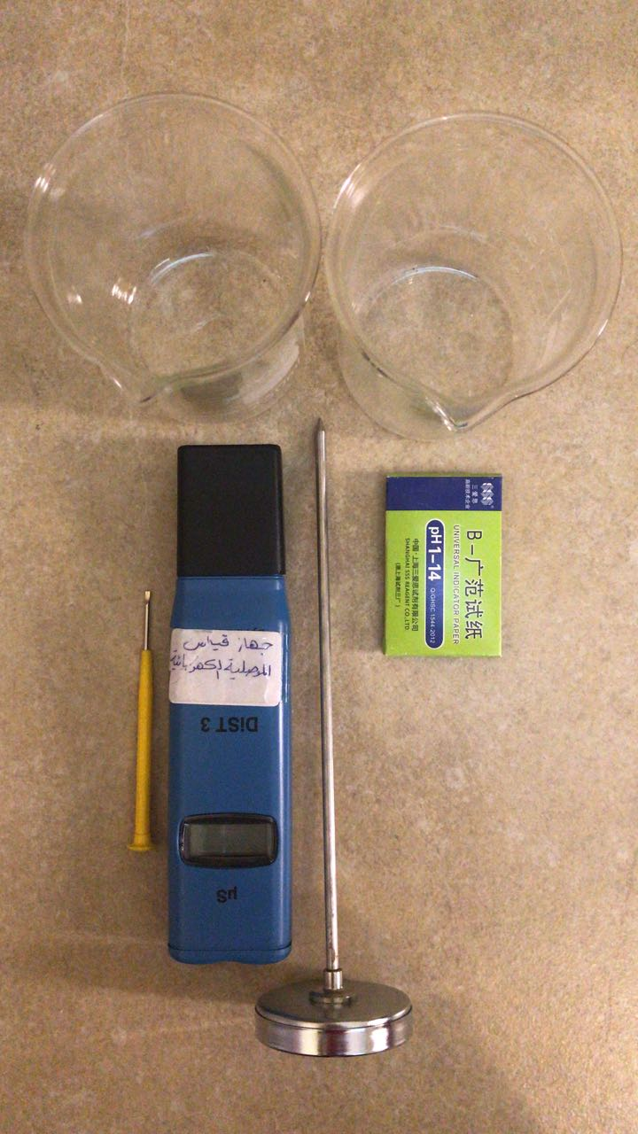
To prove the hypothesis, experiments have been done for four days where two epipremnum aureum were used. They both were exposed to the same external factors except one of them was watered with magnetized water rather than regular water. The experiment took place in the 97th secondary school background in Bani Malik. In the experiment, the PH Paper Meters Analyzers were used to check the acidity. And because the soil is not liquid it was mixed with distilled water to be able to measure the acidity. electrical conductivity meter was used to measure the difference between the electrical conductivity of a regular water and the magnetized one. And the soil test thermometer to measure the temperature. Finally the water was magnetized by rolling the glass with a pack of magnetic bars opposite of each other.

Figure1. The materials that were used.

4
3- Data summary and analysis

Figure2. The chart shows the plant throughout the 4 days (sample1 is the controlled sample which was watered with regular water. Sample2 is the one which was watered with magnetized water)

The previous chart illustrates that the plant’s height has been raising day by day when the plant was watered with magnetized water in the meanwhile when it was watered with regular water it got a little bit higher but as much as the magnetized one.
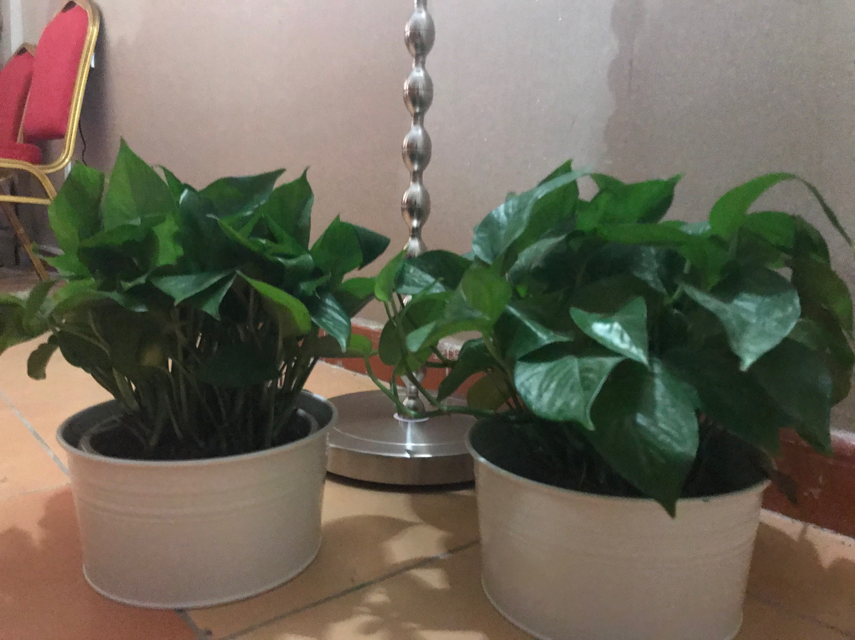

5
Figure3. The samples (on the left watered with magnetized water and on the right watered with regular water)
As the pictures show 4 days were not quite enough to show the results however it did show a little difference between the samples but not as much as it was expected. The magnetized water helped the plant to grow a bit faster than the regular water. Between the first and the last day the plant with the magnetized water had an increase in the height by 1.6 while the one with regular water only had 1.3. by looking to pictures sample1 seemed slightly dryer than sample2 and Wilted. The experiment will continue to follow up the increase in the height.

4- Results, Conclusions, and Discussion

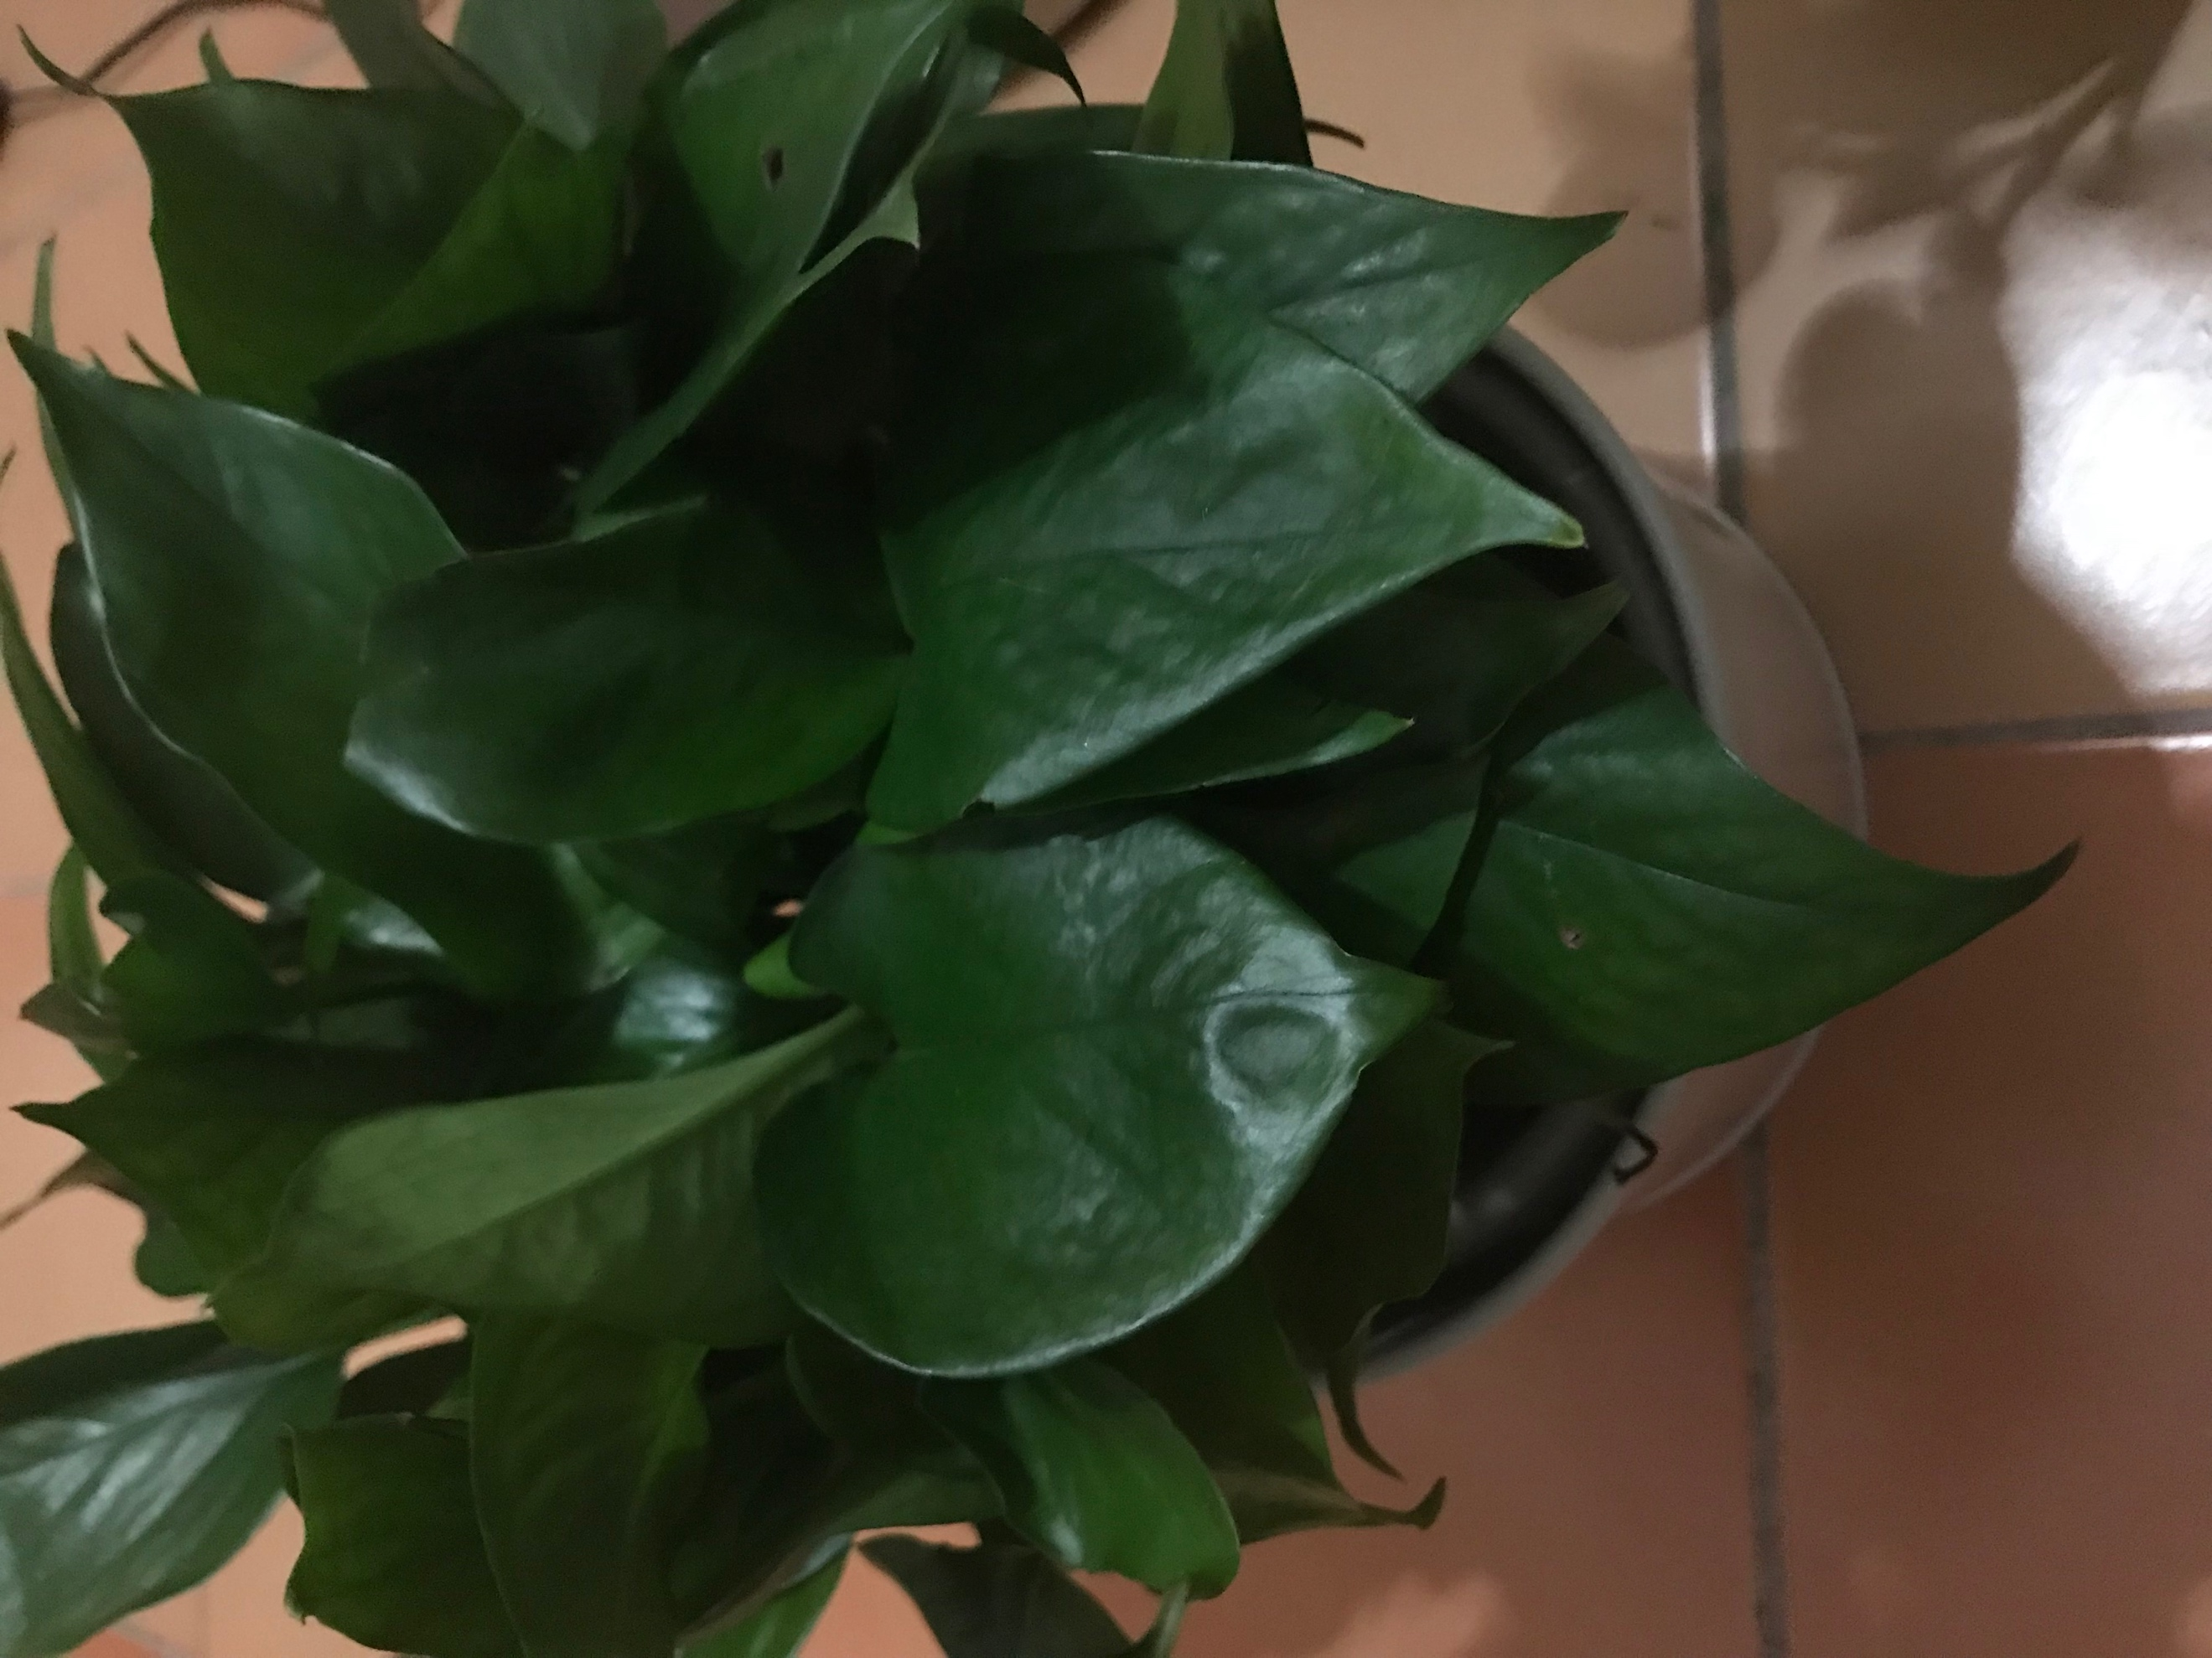
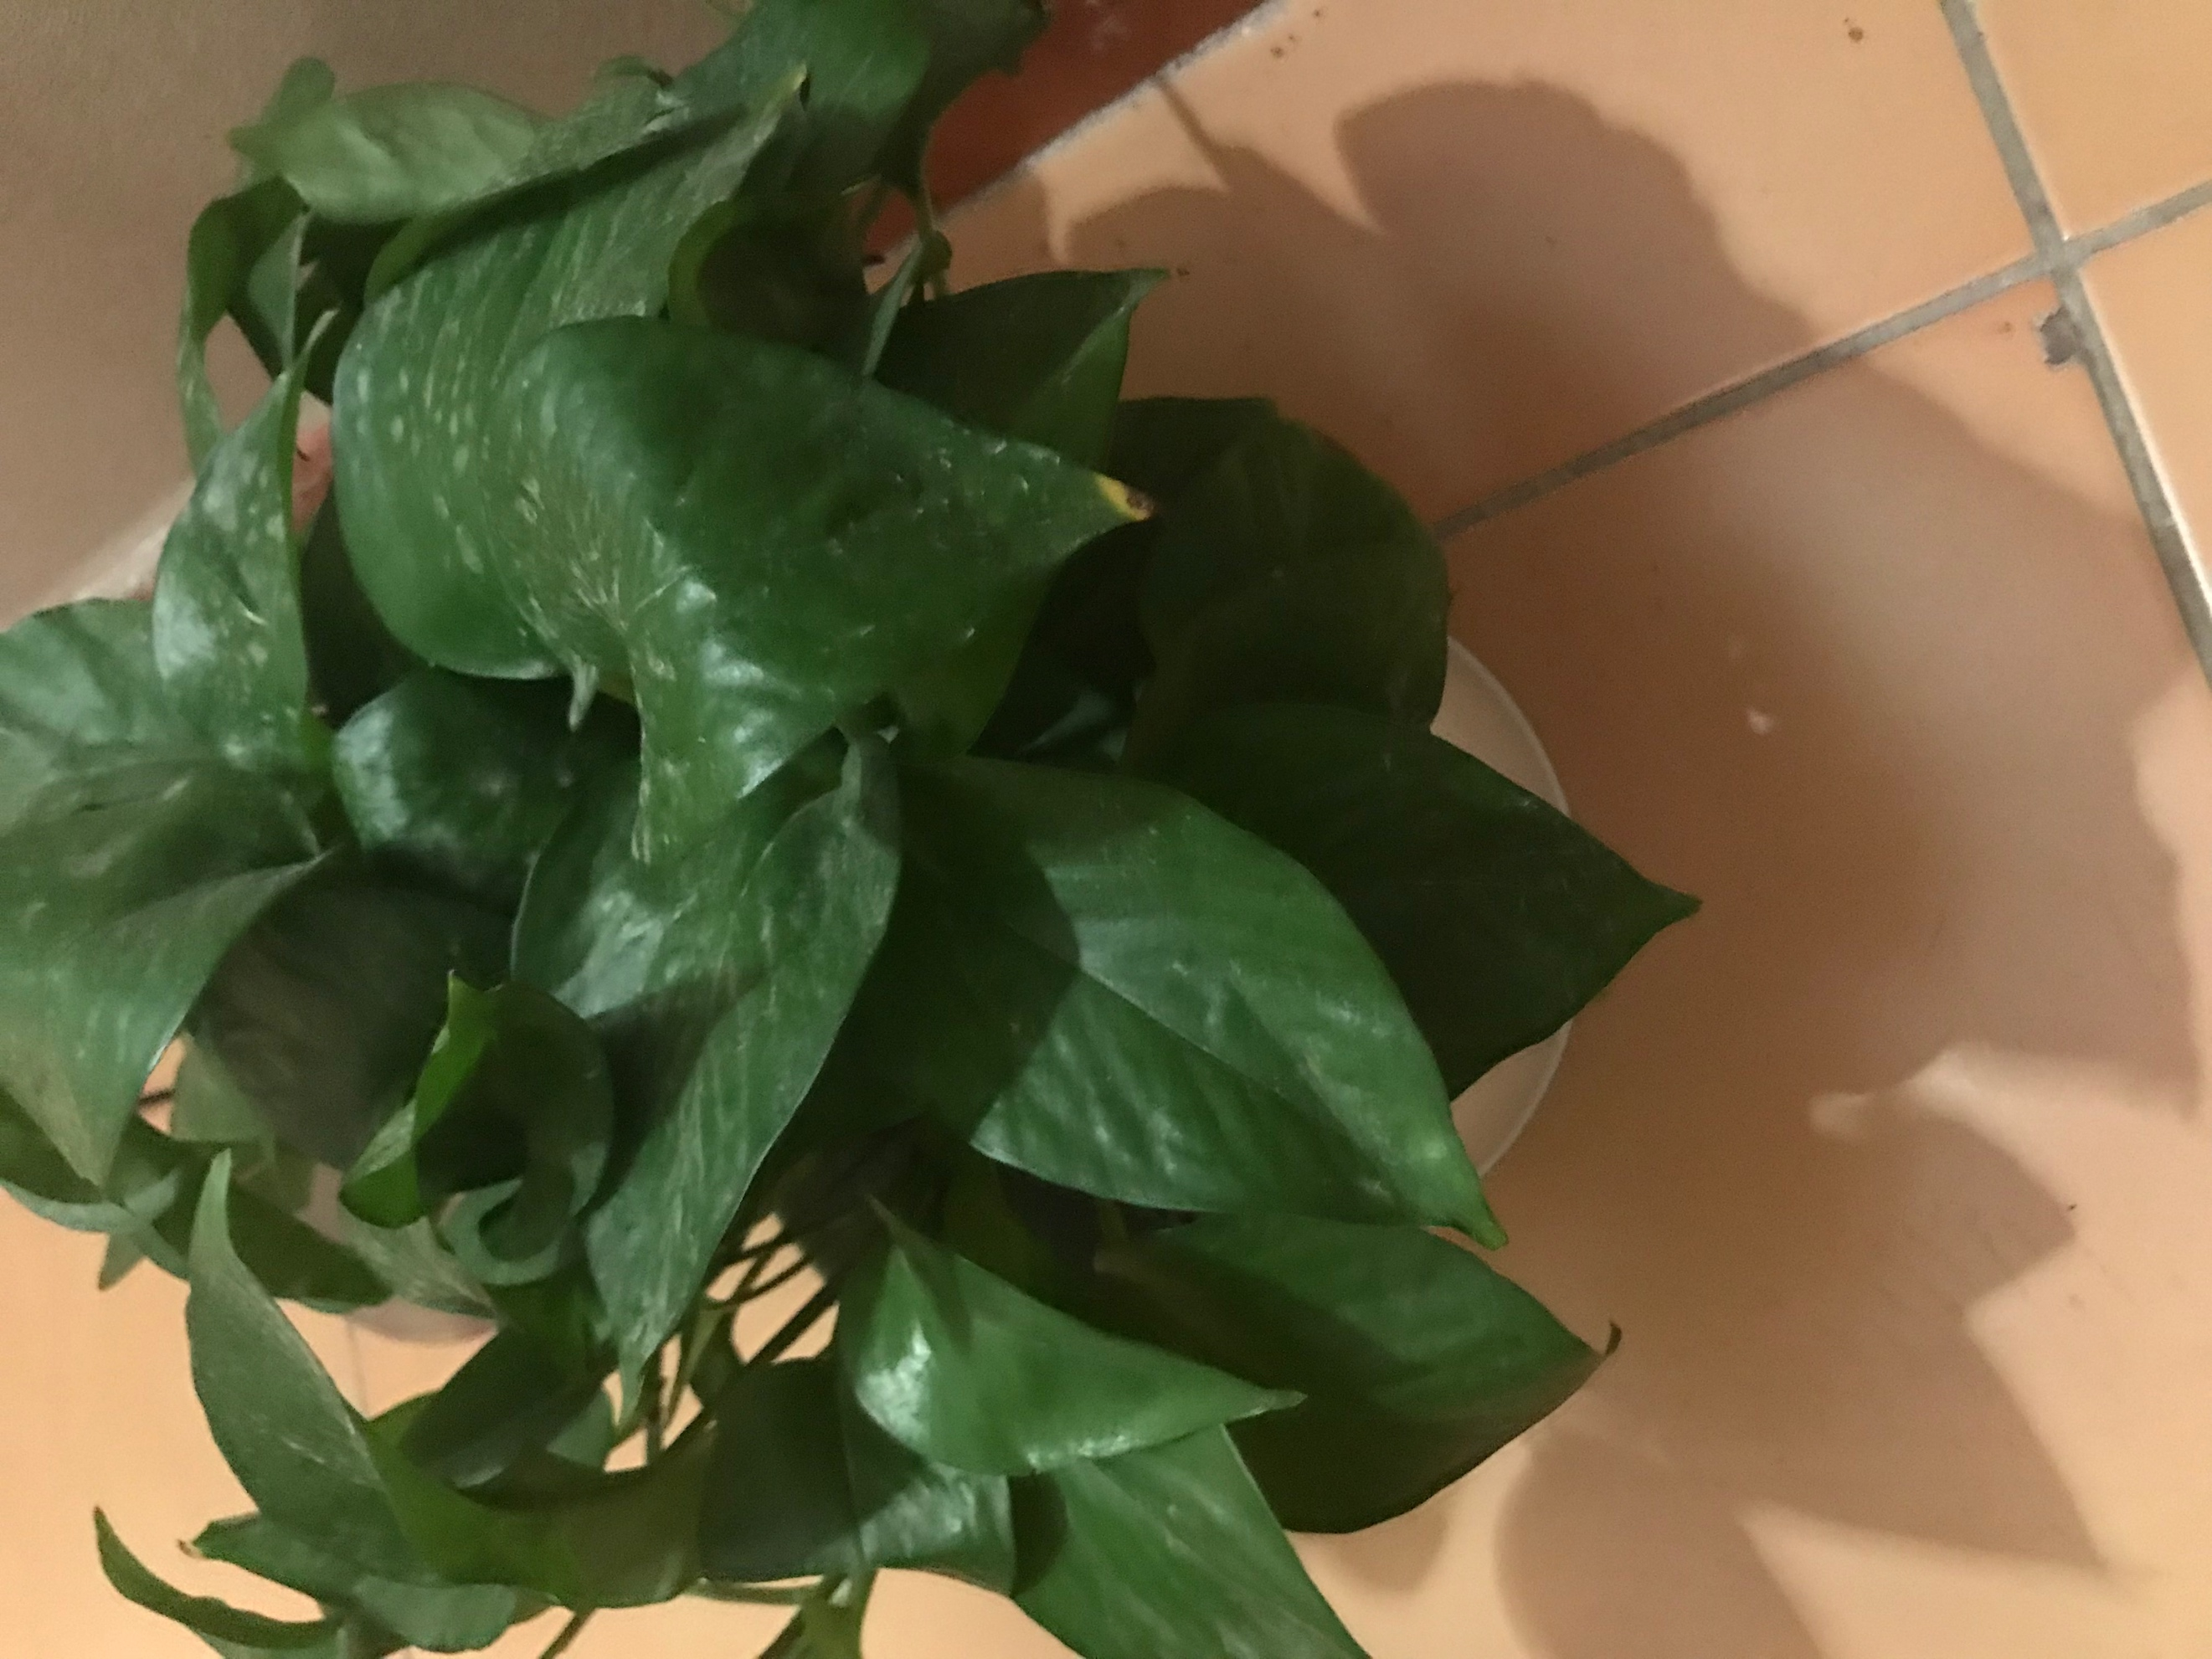

Figure4. the difference between the plants

As it was said before the 4 days clearly were not enough but it came with a result. Magnetized water had positive impacts on the plant as they helped in increasing the height of the plant and stop it from drying quicker and wilting. It has been known that plants in general need minerals to stay alive and do the photosynthesis. Either way plants are not able to use all the minerals from the soil, however when the plants are irrigated with regular water a small amount of these minerals decompose in the soil and be available for the plant, also using those minerals from the soil is so rare when the plant is growing and it requires much more minerals. The lack of these minerals and other elements in the soil is main reason for the decrease in the growth rate. Besides when the plant is watered with unmagnetized water a white layer is created on the soil top and this layer is in fact calcium bicarbonate and sodium bicarbonate which is then get washed away by the water and breakthrough the soil and then being kept in plant root. That process causes a decrease in the plant normal growth rate. Meanwhile when the plant is irrigated with magnetized water the minerals is taken from the soil easily without creating a layer on top of the soil which lead to an increase in the agricultural productivity.
6

irrigation with magnetic water can be used to improve plant growth, agricultural productivity, Without using chemicals, and genetic modification of agricultural production. plants irrigated with magnetic water must have increased photosynthetic rates due to the greater interception of light and the greater amount of assimilates available for vegetative growth, magnetic water increased stomatal conductance as compared to non magnetic water. Because of the close relationship between stomatal conductance and photosynthesis, thus lead to an increase in photosynthesis.

5-

Acknowledgments

We would like to acknowledge our school for giving us this opportunity and providing us with the space and tools to do our experiment. We would also like to thank our teacher Abeer Al-Zahrani for helping us with the experiment. And the STEM professional Shareefah Assiri.

7
References

1| Benefits of Magnetized Water | Water Saving Technology - Magnetized Water | Australia. (n.d.). Retrieved March 16, 2018, from https://www.omnienviro.com/magnetized-water/

2| Irrigation with magnetized water enhances growth, chemical constituent and yield of chickpea (Cicer arietinum L.). (n.d.). Retrieved March 16, 2018, from https://www.cabdirect.org/cabdirect/abstract/20103236575

3| Hameda El Sayed Ahmed El Sayed. (2014, January 02). Impact of Magnetic Water Irrigation for Improve the Growth, Chemical Composition and Yield Production of Broad Bean (Vicia faba L.) Plant. Retrieved March 16, 2018, from http://www.sciencedomain.org/abstract/2942

4| O., & P. (2013, January 21). Improving the growth of cowpea (Vigna unguiculata L. Walp.) by magnetized water[Pdf]. Tehran: Journal of Biodiversity and Environmental Sciences (JBES).

