Growth Challenge in Saline Soil

Algoiba Secondary Girls School
Saudi Arabia, Al-Hufof

Teacher: Mrs. Noura Mabark Al-Otaibi
27 March 2017

Student: Mounira Mbkhout Al Marri
Student: Hassa Salem Al Marri
Student: Day bagash Al Marri

Abstract
We tried several times planting some flowers in the front yard of our School, the flower remain for several days only and then die no matter what the situation-conditions is suitable for growing. We further suggest that the flower die because of high salt content that have seen on the soil surface. In contrast, some flowers cultivation observed on other parts of the soil of the school area.We have added date seed contains several minerals and I thought it would reduce this problem. The aim is to know which effect of fertilizer from dates seed on soil properties of the school area is. We further suggest that soils are calcareous soil due to the high calcium carbonate compound as well as high value pH.

Keywords: date seeds, Soil Salinity, Fertilizers, Calcareous soil.

1.Research Question and Hypothesis
We did this study to find out the real reason behind those dying plants around the school some plants grows near emergency exit whil the plants in our garden area are dying. The area around the school is considered an agricultural area.
We tried to understand the reasons why plants die because of their damage like financial losses, foil for student and if their any impact on the safety. Note that it was planted by farmer and he adds the manure in it. Maybe this is a new problem in a soil it will extent to nearby agricultural areas.
After careful study of the soil we found many reasons to damage the soil like polluted rain because of the smoke of factories (the factories is not so close. It is like 10 Km from our school) and the building materials used in the construction of school like cement, gypsum and pieces of iron which with the passage of time has affected the soil quality(http://www.fao.org/publications/en/) and the properties of calcareous soil and the salts it contains.
It is important to recognize that interactions between soil, water and plants are complex and unpredictable and vary with specific crops, the amount of rainfall falling and the characteristics and type of soil. It is necessary to consider both soil and water quality factors simultaneously. For more information on the interpretation of the results of water quality tests, see website https://www.nrcs.usda.gov/wps/portal/nrcs/main/national/technical/
.
In this paper, we will prove that the cause of death of the plants is salinity excess and we will prove that soil properties change when we add the the date seeds to it. Whereas the date seeds used in our local environment for the treatment of many skin diseases and as a health drink . We would like to prove the benefits of the soil especially. The date seeds is the waste that is found in every house because our region (Alahsa) is characterized by the cultivation of dates and palms.

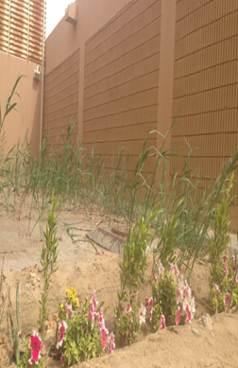
Figura 1. Picture of near emergency exit and yard of our School in Algoiba village, Al-Hufof, KSA, on 25 January2017.

2. Materials and Methods
First we took the observations the 10 cm soil day max temperature during two four-day periods, through two sequent month from (1-4) from January and Febreuary for our school and two another schools for from our school about 20 km, they are Alkifah Intermediate Girls School at Al-Hufof and Abdulah Bin Salam Secandary School at Al-Ahsa from the informations of globe site (Visualize Data). Also we compare of 50 cm soil day max temperature, from our school and Al-Anjal Intermediate School at Al-Ahsa, through the month of March form (14-18)…. Then we do these practical steps:

Part 1: Soil Sample Collection and Measuring
- Three different soil's sample have taken from different regions. One is taken from the school area, the other is from a farm close to the school and the last one is a far farm from school (agricultural area).
- Using a trowel, soil corer, or other digging device to lose the soil. Soil should be obtained from the top of the soil surface to the depth of pproximately 15 cm, see Table 1:
Sample | The sample code | Location by device  ( GPS )
Algoiba School | A | N 25.26191°  E 49.68986°
A Farm a close to Algoiba School | B | N 25.25005°  E 49.67566°
A Farm distant from Algoiba School | C | N 25.271396°  E 49.763068°
TABLE 1. Data soil's sample:

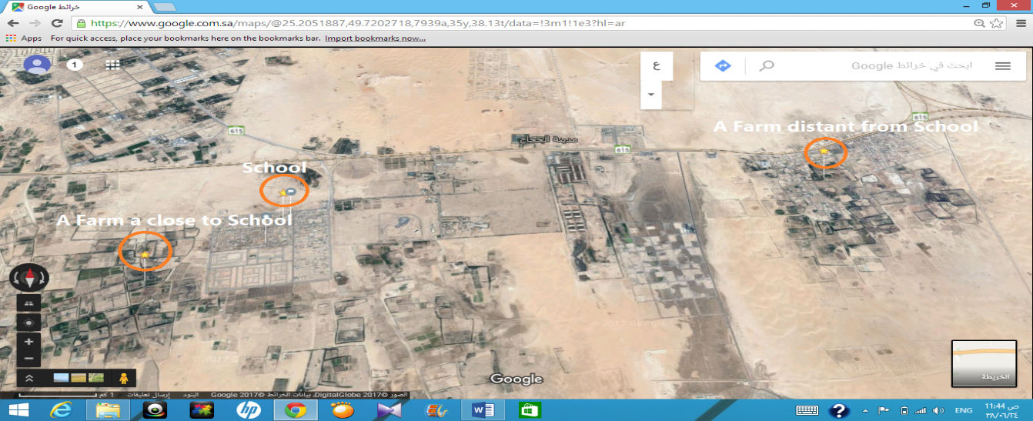
Figura 2. A Map showing the approximate locations of the school, A farm near school and A Farm far from school in the east of Hofuf.

3. Measuring electrical conductivity of the soil (EC) and pH meter by prepare the water-soil mixture in a 1:1 ratio and take 50 g from each Soil sampl into Beakers contain three code samples.
4. Add 50 mL of distilled water to the three beakers .
5. Stir both mixtures thoroughly and stir once every three minutes to 15 minutes waiting unti we see the two layers. Apply Steps 2–3 for the other samples.
6. Total salinity is measured by an Electrical Conductivity (EC) test.
7. Calibrate pH meter with calibration buffers place electrode in the soil slurry to measure pH. Measurement may be taken with or without continuous stirring. If measurement is made without continuous stirring, stir the sample with a stir bar before placing electrode in the sample. Allow adequate time for pH to reach a stable reading. Stability can be ascertained by pH meter settings for manual measurements. Rinse the probes in deionized water before measuring the next sample.
8. The preferred method is to place a sufficient amount of soil matrix material into a spot-plate depression, add 1 to 2 drops of 3 M HCl, observe the initial reaction, and wait about 2 minutes before assessing the final extent of effervescence, see Table 2.

TABLE 2. Soil Salinity Degree by EC, pH and Carbonates detection test Values :
sample | code | EC Metar  (μS/cm) | Degree of salinity | pH | Carbonate detection time  (min)
Distilled water | W_{d} | 157 | Slight | 7 | -
Normal water | W_{n} | 1130 | Medium | 7.1 | -
Algoiba School * | A | 1 | high | 7.8 | 2.50
A Farm a close to Algoiba School | B | 671 | Low | 7.1 | 1.13
A Farm distant from Algoiba School | C | 830 | Low | 7.3 | 2.12
*Note: If Electrical Conductivity (EC) Meter reading is over rang, the display will show ''1'' .
9. We do the flame test for the three samples to get the active element (ingredient ) for the soil so we dip the cotton stick which is wetted with distilled water in the soil and put it on the flame to get the color for the three samples. The orang-red color appears in the (sample A) and disappeard in the other sample.

Part 2: Synthesis and characterization of Fertilizer
- We collect the amount of date seeds about 2 Kg of several different types of dates, then wash, dry and mill in the form of powder.
- Mix the powder date seeds with 300 ml of distilled water each other, then we show the mixture in the sun for 24 hours so as to get the compost ..
- Preparation of different solutions from date seeds for measuring electrical conductivity solution (EC) and pH meter, see Table 3:

Table 3: Concentration of various solutions of date seeds :
Sample code | Mixing ratio | The amount of Distilled water  ( ml) | The amount of date seeds  (g) | EC  (μS/cm) | pH
D1 | 5:1 | 100 | 20 | 1800 | 4.4
D2 | 5:0.5 | 100 | 10 | 1300 | 4.7
D3 | 5:0.25 | 100 | 5 | 820 | 5.1
D4 | 5:0.05 | 100 | 1 | 393 | 6.6

We notice from the previous schedule the inverse relationship between EC and pH, it's be her to concentrate D4 in the sample because of the reduction of EC and high of pH which is fit to the soil salinity, unlike D1 with low pH (6.2-7.5) which is not suitable for plants growth and the high of EC, this make salts causing reverse on the plants growth.

Part 3: Cultivation of samples

- Take six A rectangle Plastic pot for plants size of 70 cm X 15 cm so that we take three of Code and keep in each basin sample of three samples with writing sample name and code on each pot.
- Put the A, B and C samples in the three pots, take the other pots that contains the same sample (A, B and C) with the fertilizer of date seeds, Adding a mount of fertilizer with 5 cm from the soil surface (5:0.05) that means 1g from fertilizer to 100 g from the soil and the code will be (A+D), (B+D) and (C+D) respectively.
- Planting different seeds such as barley and lepidium sativum seed in these pot.
- We make additional experience for a sample of soil from the school
(sampl A) using two different concentration of manure date seeds with planting the seeds of barley because it is resistant to soil salinity.
- Taking soil samples in 1000 g and the date seeds fertilizer 1 g and 0.01g respectively, to study the affect of diluted concentration of fertilizer which is made from date seeds on soil salinity. Using distilled water instead of normal water (to avoid the soil in the normal water ) to study the effect of fertilizer on the soil .
6- Put the basin in an agricultural reserve.

3. Data Summary and Analysis
a. . Effect of chemical elements in soil
The existence of calcium carbonate (CaCO₃) lead to rise the pH for the soil and this what we saw in the sample(A) until it reach to 7.8 and we improve that from detection experiment for the carbonate with the acid (HCl) which lead to rise the bubbles up because of rising of CO₂ from sample (A) compared to the other samples.
CaCO₃ + 2 HCl CaCl₂ + H₂O + CO₂

Metals change the colour of a flame when they are heated in it. Different metals give different colours to the flame, so flame tests can be used to identify the presence of a particular metal in the three samples, here the element united with carbonate is calcium with a flame test that shows orange-red according to the Figura 3:

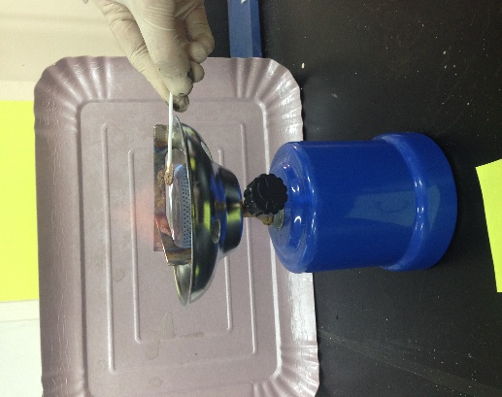  Sample C | 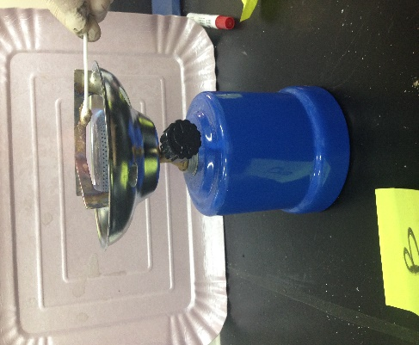  Sample B | 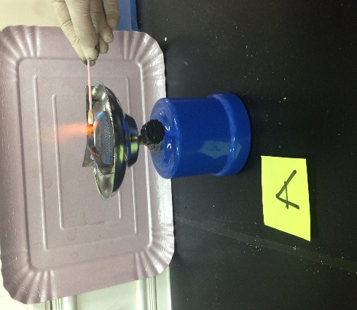  Sample A
Figura 3. The flame test carried out on three samples the characteristic orang-red color of the flame is due to the Calcium.

We know before that the characteristics of our soil that it is the Calcareous soils are the velocity dryness of the surface layer which decrease the moisture which the crops need and the upper brown layer has a white color, see the picture of our school soil (sample A) .

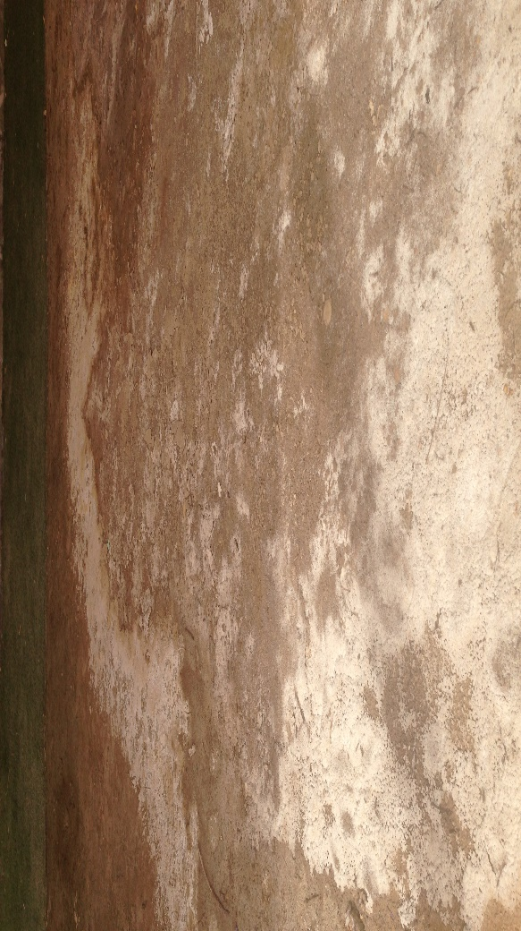
Figura 4. Saline patch on the soil surface of our School in Algoiba village, Al-Hufof, KSA, on 20 January2017.

Also from the characteristics of this soil that the content for this soil from the organic material is less than 1% so that the soil lose the alimentary food and the useful micro-organisms. So it was necessary to choose a fertilizer from an alimentary substance which has a quality of decreasing the acidic (pH ) for the soil so we use date seeds which is considered as a material that contain a useful chemical elements which have a medical and therapeutic uses in our local environment so we use a concentration from the fertilizer that decrease the soil pH and didn't help to increase the salinity for soil and the concentration was D4 is the suitable (see Table 3)

b. Effect of soil temperature
We observe raise max temperature degree in our school compared to the other schools. Unless the high of the soil was 10 cm or 50 cm which effects the physical and chemical properties for the soil. The change in the temperature of the soil daily or seasonal lead to expansion and shrinkage of the elements which the solid soil grains consists of that lead in the long periods to break and crumble the soil that we compared our school soil which located in an agricultural soil with another school which is not agricultural one.
Our explanation about increasing of the soil temperature is due to that it's a calcareous soils which consists of calcium carbonate and this compound is endothermic in which calcium carbonate decomposition to calcium oxide (CaO) and (CO₂) and this interact needs heat.
calcium carbonate (+ heat) calcium oxide(s) + carbon dioxide(g)
The above is endothermic because it needs heat to happen (hence thermal decomposition)
Figura 5. Comparison 50 cm soil daily Max Temperature during month of March (14-18) for our school and Al-Anjal Intermediate School at Al-Ahsa.

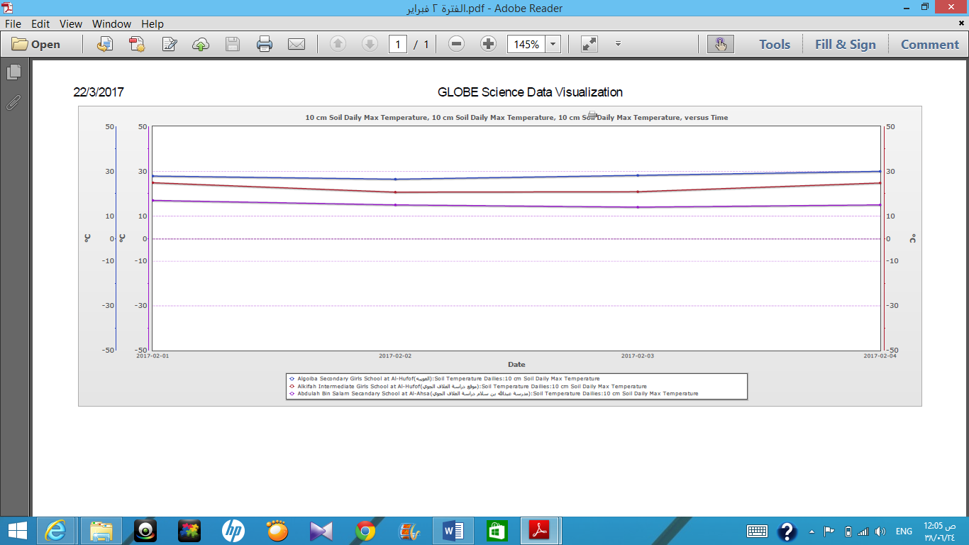
Figura 6. Comparison 10 cm soil daily Max Temperature during two sequent month from (1-4) from January and Febreuary for our school, Alkifah Intermediate Girls School at Al-Hufof and Abdulah Bin Salam Secandary School at Al-Ahsa from the informations of Globe site (Visualize Data).
4. Results, Conclusions, and Discussion
From the resulte of data analysis we observe the effect of the fertilizer which made from date seed on the Calcareous soils. We observe the growth of the plants from sample (A+D) compared to the sample (A) that doesn't contain the fertilizer and that the plants doesn't grow. From them was barley which resistant the high salinity for the soil.
Although the growth of the barley plant was little but it gives us the image of the effect of the fertilizer by the decrease of the pH for the Calcareous soils and maybe that comes back to existence of the different fatty acids in the date seed like Caproic acid which dissolves in water and relase the hydrogen ions which make the middle is acidic and decrease the pH of the soil and this help to get rid of the carbonate from the soil but because of the high of the salts it lead to the phenomena of dwarfism plant.
Also we observe that from the effect of the fertilizer in sample (B+D) growth of the plant more than the sample (B) because the sample (B) consists of less quantity of salts (see Figura 7).
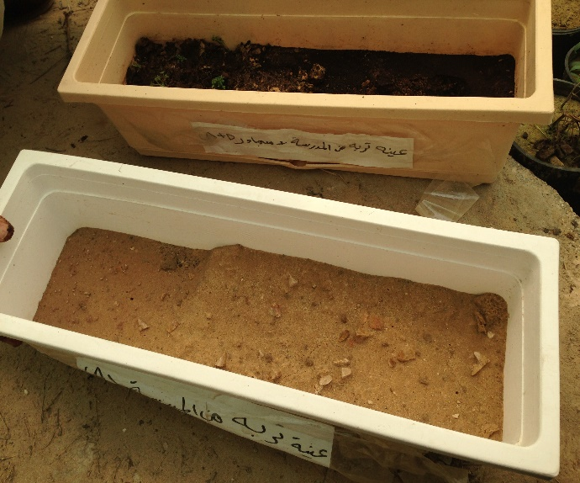 | 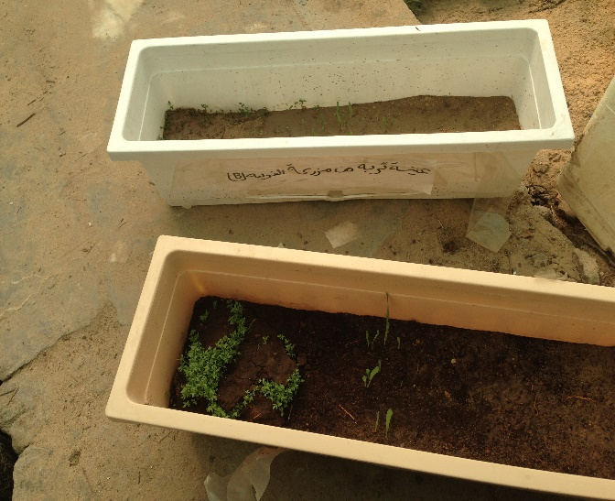
Figura 7. Picture of samples A and A+D (left; a) and the samples B and B+D (right; b) after 14 days of planting.

Sample (C) we observe that the growth of the plant in it was better than (C+D) and maybe because of the salinity of the soil is more than sample (B) and has more carbonat also ( see Table2) also the water maybe has salt (EC=1130).
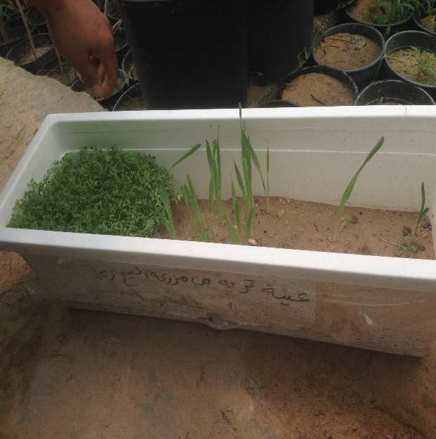 | 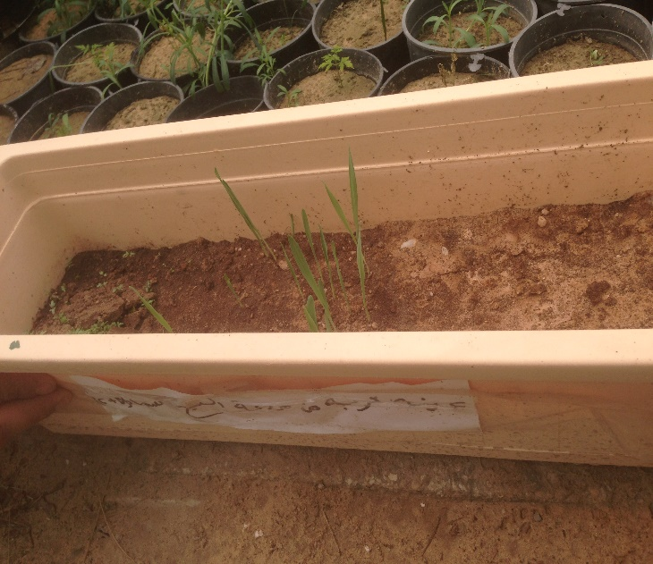
Figura 8. Picture of sample C (left; a) and sample C+D (right; b) after 14 days of planting.
We do another experiment to emphasis the previous results. That was the uses of dilute concentration from the fertilizer in the sample (A) also we use distilled water and the results was the growth of the barley in the sample that has 1g from the fertilizer is better than the growth in the sample that has 0.1 g from the fertilizer with the distilled water. From this small amount of fertilizer can improve the properties of calcareous soil.

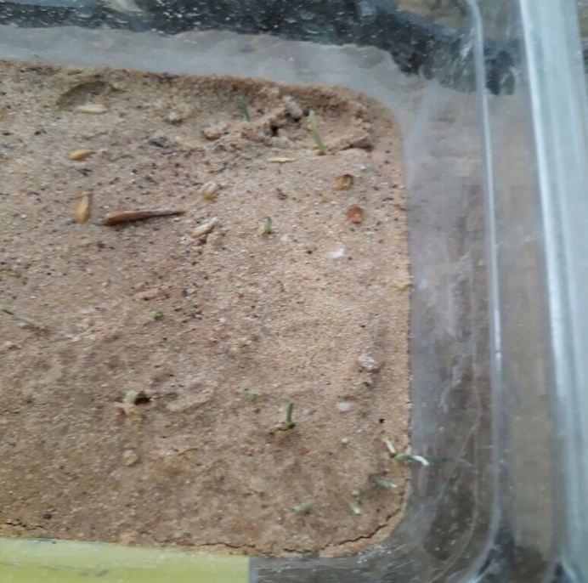 | 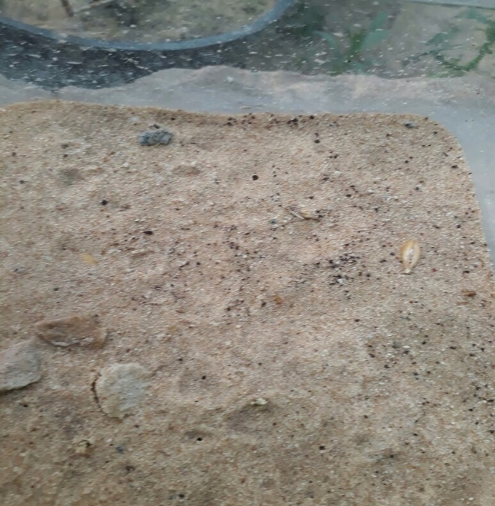
Figura 9. Picture large A large sample of the soil sample with a fertilizer concentration of 1 g (left; A) and a soil sample with a fertilizer concentration of 0.01 g (right; b) after 8 days of planting..

These results make us feeling optimism after the defeats that was infects us after the planting. We suggest in the future the application of using the fertilizer from date seeds on the school soil and planting plants resist the sality of the soil like Spartina, Blanket Flower, Daylily and Lavender Cotton, Also use a filter with water irrigation.

Acknowledgments. I wish to acknowledge the student who collect date seeds and Najla Almarri and Noda Almarri to bring samples from their farms and I would to thank their parents for allowing it, Ahmed Al-Zafer agricultural engineer. Finally, I would like to thank my former student Munira Almarri for translation the search into English.

5. References
1- Joint Research Centre. Soil Themes > Soil Salinization. Available online:
http://esdac.jrc.ec.europa.eu/themes/soil-salinization

2-Kahlown, M.A.; Azam, M. Effect of saline drainage effluent on soil health and crop yield.Agric. Water Manag. 2003, 62, 127–138.
3- Tanji, K.K. Salinity in the soil environment. In Salinity: Environment-Plants-Molecules ;Läuchli, A., Lüttge, U., Eds.; Kluwer Academic Publishers: Dordrecht, The Netherlands, 2002;pp. 21–51.
4- Mojiri, A. Effects of municipal wastewater on physical and chemical properties of saline soil.J. Biol. Environ. Sci. 2011, 5, 71–76.

