GLOBE Visualization ArcGIS Online

GLOBE measurement imagery layers can be imported into ESRI's ArcGIS Online in one of two ways: through the GLOBE WMS or as a predefined layer from ESRI.

Adding GLOBE layers via WMS
- Click the "Modify Map" button in the upper right corner, then "Add | Add Layer from Web"

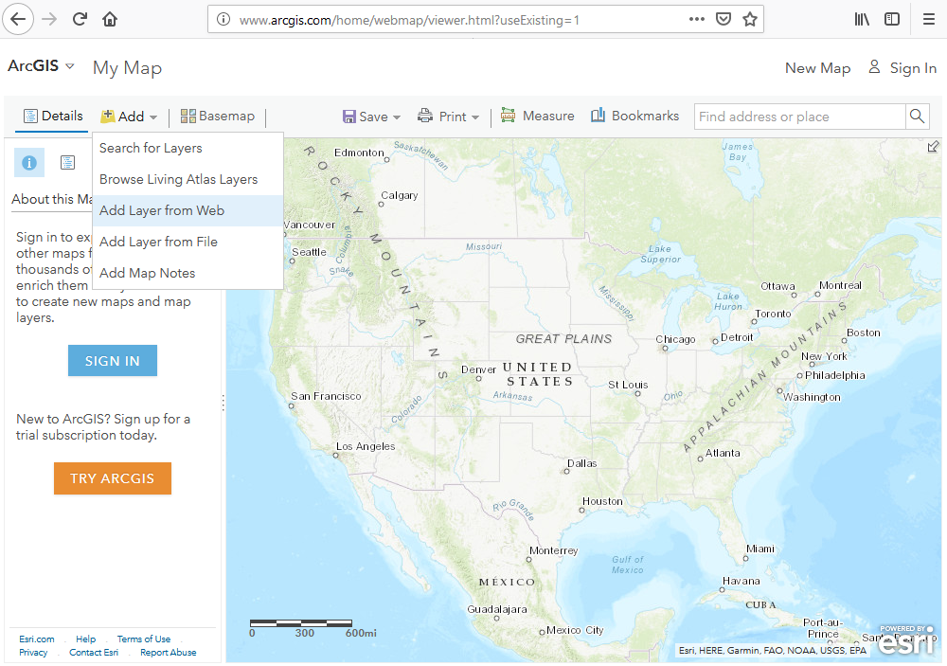

- Change the data type to a WMS OGC Web Service
- Paste GLOBE WMS endpoints into the "URL" field and press the "Get Layers" button
https://vis.globe.gov/geoserver/cite/wms?SERVICE=WMS&VERSION=1.3.0&REQUEST=GetCapabilities
- Deselect all of the layers (upper left "square") and select a layer you'd like to add. There are 3 categories of GLOBE layers you can create:
  - GLOBE Measurement Layers
  - GLOBE Contour Layers
  - GLOBE Data Count Layers
  - GLOBE Photo Layers

Adding GLOBE Measurement layers via WMS

Measurement Layers are available for the following list of protocols
dv_aerosols
dv_air_temp_dailies
dv_air_temp_max
dv_air_temp_monthlies
dv_air_temp_noons
dv_air_temps
dv_barometric_pressure_noons
dv_barometric_pressures
dv_carbon_cycle_summary
dv_conductivities
dv_dissolved_oxygens
dv_extremes
dv_freshwater_macroinvertebrates
dv_frost_tubes
dv_greenings_down
dv_greenings_up
dv_humidities
dv_humidity_monthlies
dv_humidity_noons
dv_hydrology_alkalinities
dv_hydrology_phs
dv_land_covers
dv_lilacs
dv_mosquito_habitat_mapper
dv_mosquitoes
dv_nitrates
dv_ozone_one_hour_after_noons
dv_ozones
dv_phenological_gardens
dv_precipitation_monthlies
dv_precipitations
dv_salinities
dv_sky_condition_noons
dv_sky_conditions
dv_snowpacks
dv_soil_characterizations
dv_soil_characterizations_horizon
dv_soil_characterizations_reference
dv_soil_densities
dv_soil_descriptions
dv_soil_fertilities
dv_soil_layer_descriptions
dv_soil_moisture_for_smap
dv_soil_moisture_via_gravimetrics
dv_soil_moisture_via_sensors
dv_soil_particle_size_distributions
dv_soil_phs
dv_soil_temp_dailies
dv_soil_temp_monthlies
dv_soil_temp_noons
dv_soil_temp_sub_days
dv_surface_temperature_noons
dv_surface_temperatures
dv_transparencies
dv_tree_heights
dv_volumetric_soil_moisture_monthlies
dv_water_temperatures
dv_water_vapors

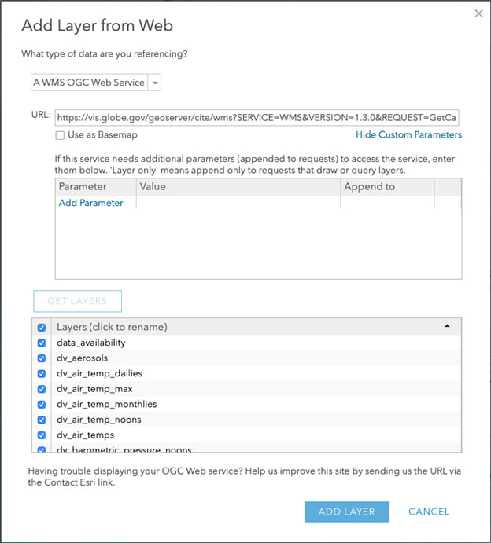

- Add a Parameter for "date" (must be lower case) and enter a MM-DD-YYYY Value for your desired date
- Add a Parameter for “STYLES” (must be upper case), for available style, please refer to the “Available Protocol List and Corresponding Styles” section in the GLOBE OGC Web Map Service Documentation. As an example, we are using the “dv_air_temp_dailies” protocol, with the “dv_air_temp_dailies_current_temp” style

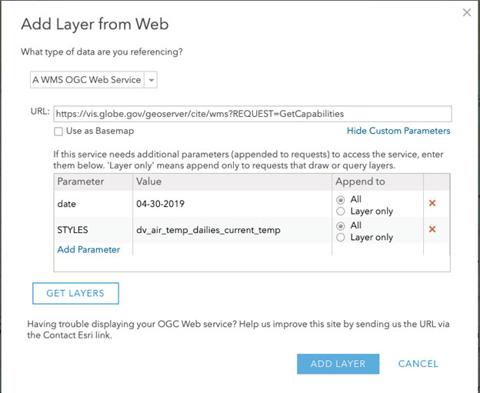

After the layer is created, the map should look like the following. You can use ArcGIS Online save map to save your map, or share your map.
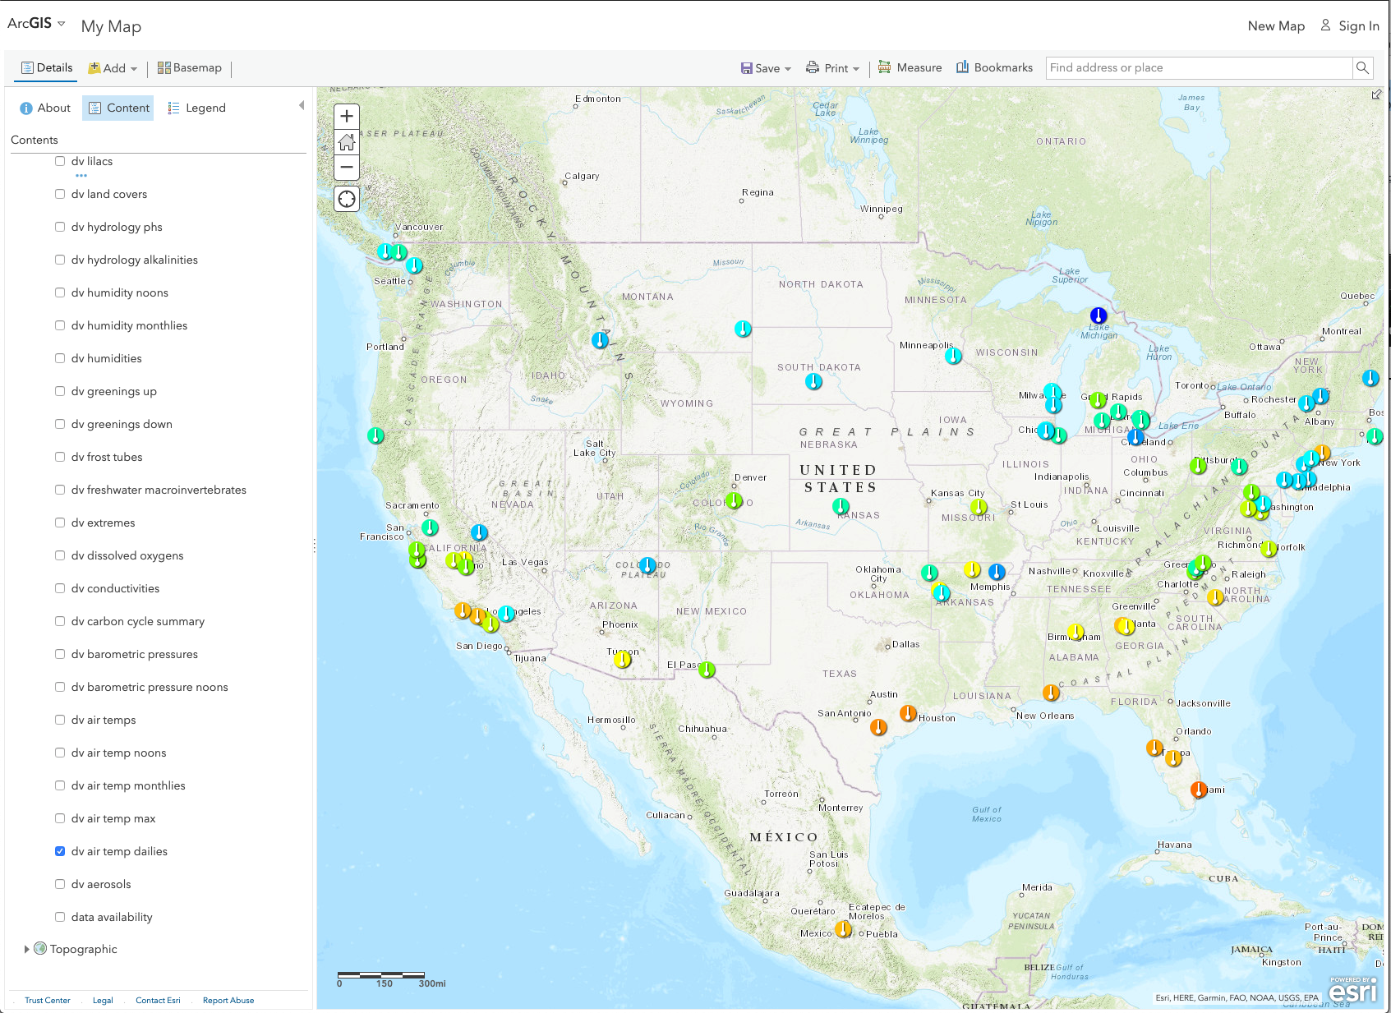
Figure 1 Sample of Air Temp Dailies measurement layer
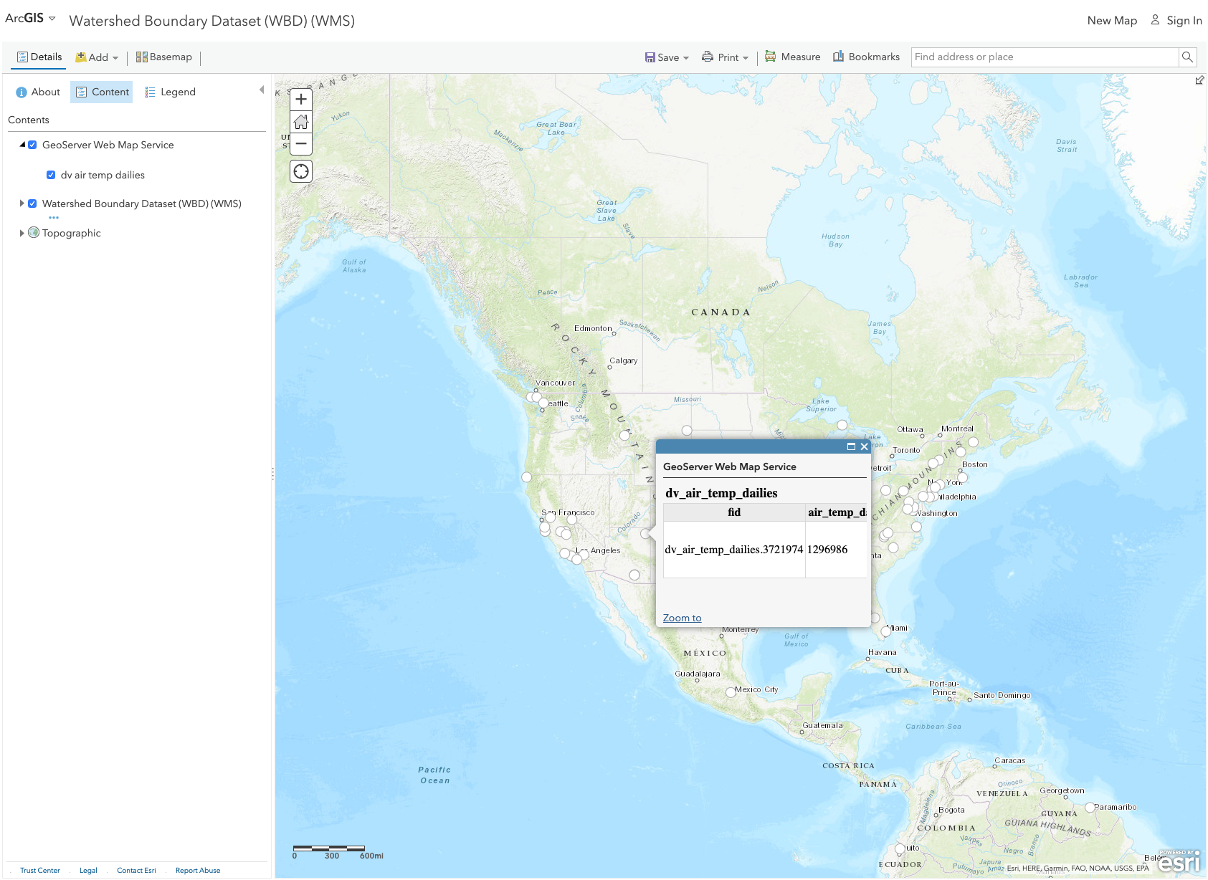
Figure 2 Enable Popup

Adding GLOBE Contour layers via WMS

Contour Layers are available for the following list of protocols:
dv_air_temp_dailies
dv_air_temp_monthlies
dv_air_temp_noons
dv_air_temps
dv_barometric_pressure_noons
dv_barometric_pressures
dv_humidities
dv_humidity_monthlies
dv_humidity_noons
dv_precipitation_monthlies
dv_precipitations
dv_snowpacks
dv_soil_moisture_for_smap
dv_soil_moisture_via_gravimetrics
dv_soil_moisture_via_sensors
dv_soil_particle_size_distributions
dv_soil_temp_dailies
dv_soil_temp_monthlies
dv_soil_temp_noons
dv_soil_temp_sub_days
dv_surface_temperature_noons
dv_surface_temperatures
dv_volumetric_soil_moisture_monthlies

- Add a Parameter for "date" (must be lower case) and enter a MM-DD-YYYY Value for your desired date
- Add a Parameter for “STYLES” (must be upper case), for available contour style, please refer to the “Available Protocol List and Corresponding Styles” section in the GLOBE OGC Web Map Service Documentation. As an example, we are using the “dv_air_temp_dailies” protocol, with the “dv_air_temp_dailies_current_temp_contour” style. The ending of the style name must match “<protocol>_<measurement>_contour” to bring up the contour map

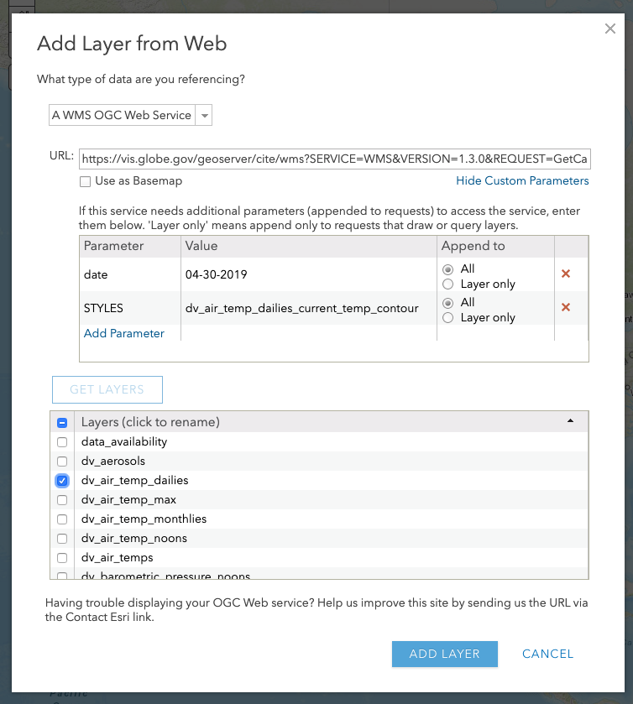
Figure 3 Using contour map style with Air Temp Dailies measurement

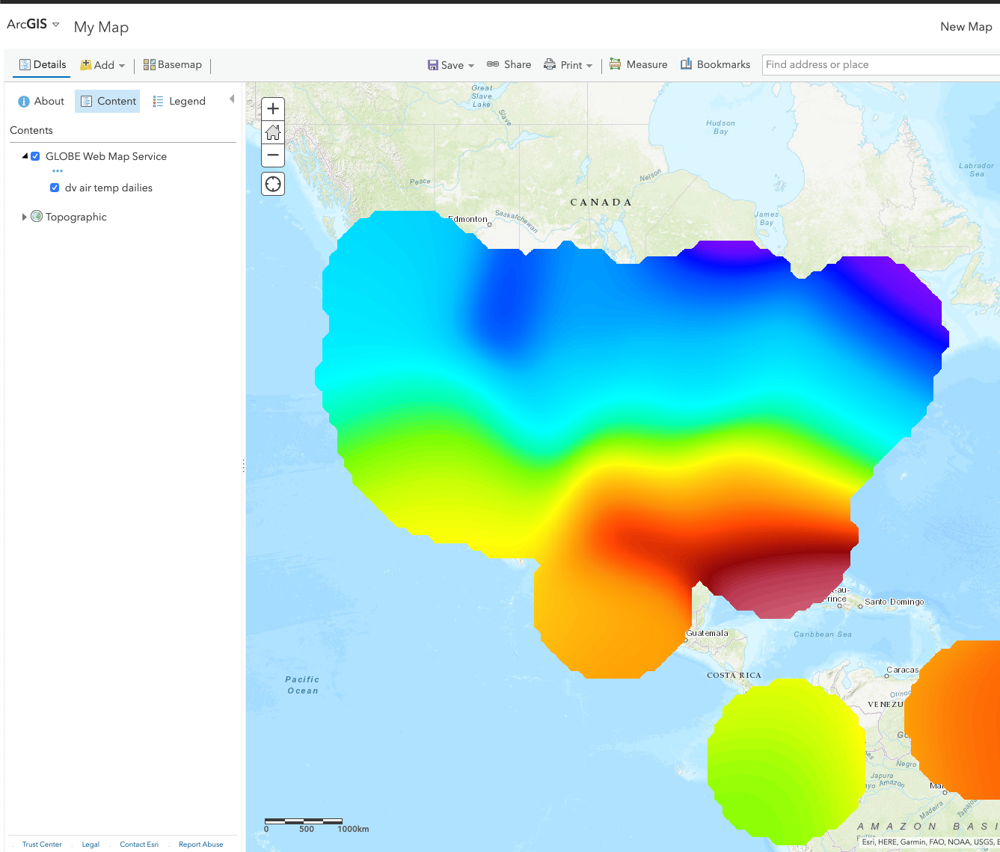
Figure 4 Air Temperature Contour Layer

The initial view of the default Contour Layer from GLOBE measurement will be brought up with 0% opacity. Layer Opacity can be fine tuned by clicking on the “…” next to the layer.

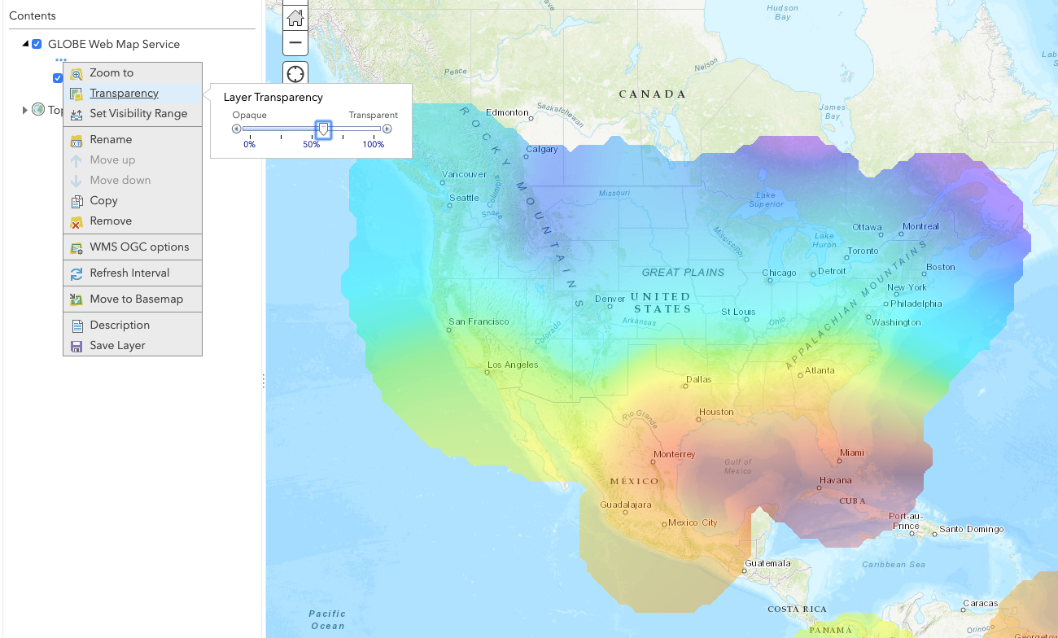
Figure 5 Contour Layer with less than 50% Opacity Layer Transparency

Adding GLOBE Data Count layers via WMS

Data Count Layers are available for all protocols, however, in order to bring up the Data Count layer, you must select the “data_availability” layer, and specify the protocol with a <protocol>_count style, for example:

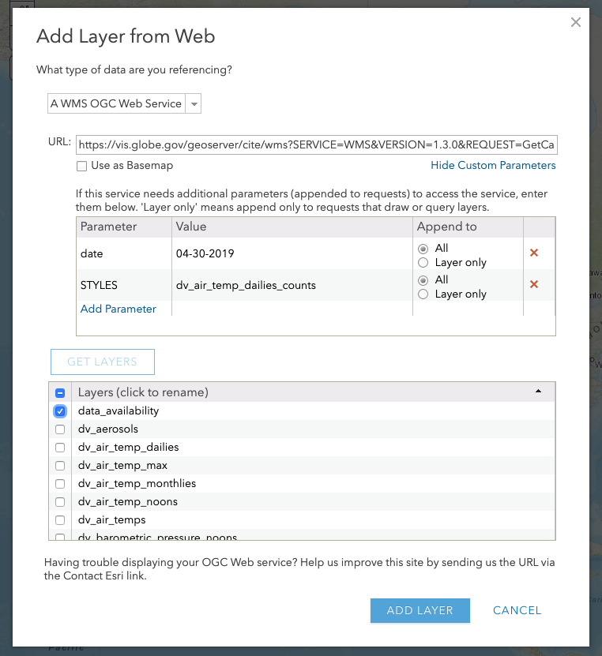
Figure 6 Data Count Layer of Air Temp Dailies

- Add a Parameter for "date" (must be lower case) and enter a MM-DD-YYYY Value for your desired date
- Add a Parameter for “STYLES” (must be upper case), for available count style, please refer to the “Available Protocol List and Corresponding Styles” section in the GLOBE OGC Web Map Service Documentation. As an example, we are using the “data_availabily” layer, with the “dv_air_temp_dailies_counts” style. The ending of the style name must match “<protocol>_counts” to bring up the Counts Layer map

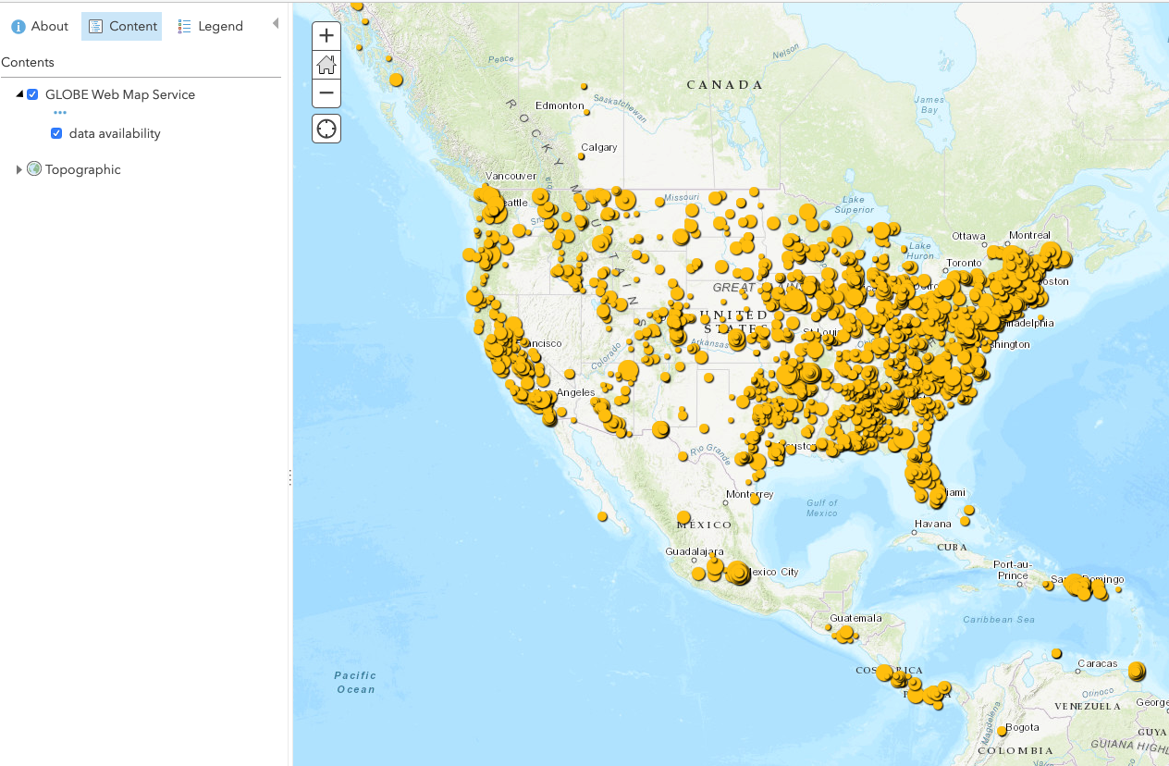
Figure 7 Data Count Layer of Air Temp Dailies protocol

Adding GLOBE Photo layers via WMS

Photo Layers are available for the following list of protocols:
dv_sky_conditions
dv_tree_heights
dv_land_covers
dv_mosquito_habitat_mapper

Figure 8 Mosquito Photo Layer
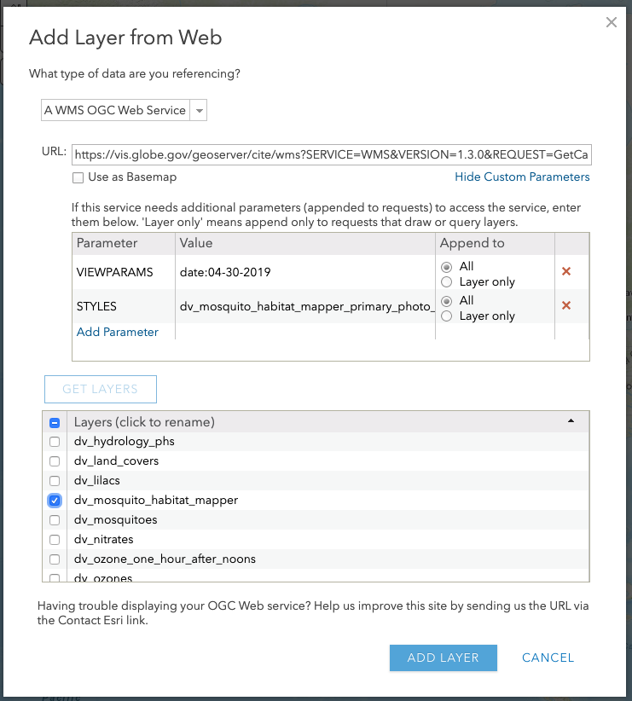
Figure 9 Mosquito Habitat Photo Layer
- Photo Layers Parameter is a bit different from before. Add a Parameter for “VIEWPARAMS” (must be upper case), with a value of "date:MM-DD-YYYY” Value for your desired date, as seen on above screenshot. Notice, there’s no space between the colon.
- Add a Parameter for “STYLES” (must be upper case), for available photo style, please refer to the “Available Protocol List and Corresponding Styles” section in the GLOBE OGC Web Map Service Documentation. As an example, we are using the “dv_mosquito_habitat_mapper” protocol, with the “dv_mosquito_habitat_mapper_primary_photo_url” style. The ending of the style name must match “<protocol>_<measurement>_primary_photo_url” to bring up the Photo Layer map

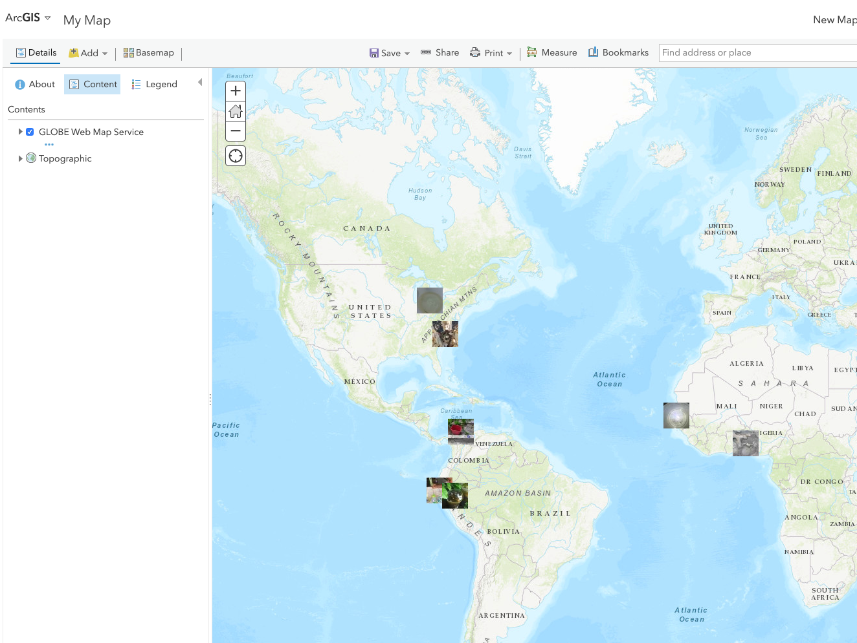
Figure 10 Photo Layer Example

