GLOBE INTERNATIONAL VIRTUAL SCIENCE SYMPOSIUM
Project Elements and Criteria

Theme: Environmental Problems and Solutions
Presentation: Poster
Team Name: Aguarico
Grade: 8
School: Ramey Unit School
Location: Aguadilla, Puerto Rico
Submission Date: March 1, 2018
____________________________________________________________________________

Improving the Drinking Water Quality after Hurricane Maria using Natural Resources

Abstract

On September 20, 2017, Hurricane Maria, a nearly category 5 storm, devastated Puerto Rico. It affected millions of people, and left the island without potable water or electricity. As a result, people were forced to drink hazardous, unsafe water from rivers, rooftops, and faucets that led to bacteria-related diseases.
Our research questions were: (1) How can we prevent bacteria-related diseases from water contamination during the aftermath of Hurricane Maria? (2) If we filter contaminated water using a modified solar water distiller and secondary filtration system, will the output water quality be safe for consumption? This problem developed into our hypothesis: If we filter contaminated water using a modified solar water distiller and secondary filtration system, then the output water quality will be potable. Therefore, the objectives were to (1) create a prototype to filter water using natural resources along with utilizing steam collected from a solar water distiller and (2) produce potable drinking water after a natural disaster.
A prototype was created using natural resources and tested to verify that pathogens in the water were reduced after filtration. In addition, this product was compared against five filtration systems used during the relief effort. The methods used to test our prototype and compare it with others included probes, sensors, and bacteria tests. The results were listed and organized on a spreadsheet.
In conclusion, our team created an effective prototype that distilled water and filtered it through a device using local materials. We compared our device with five others (commercial). Although city water (AAA) resulted in zero contaminants, the first results from the irrigation water did have contaminants. With each trial, better results were produced. In our last trial, our prototype had zero bacterial pathogens from the irrigation water. In the future, we would like to distribute our prototype throughout the island.
Key Words: Natural disaster, potable drinking water, filtration system, natural resources

Research Questions

Our research questions were: (1) How can we prevent bacteria-related diseases from water contamination during the aftermath of Hurricane Maria? (2) If we filter contaminated water using a modified solar water distiller and secondary filtration system, will the output water quality be safe for consumption?
When Hurricane Maria devastated Puerto Rico, residents struggled with the aftermath. One of the main conflicts that arose during the hurricane was the shutdown of water purification systems due to lack of electricity. This resulted in people receiving contaminated water straight from their faucets. As stated by John Shimkus, "Many (people) drank potentially contaminated water because water purification systems failed as of the storm." According to an article from the Los Angeles Times, people could not rely on receiving water from natural streams because many were polluted by fluids from sewers. Research conducted by CNN supported that, “499 deaths were claimed to have been caused by Hurricane Maria, many of which were water related.” Furthermore, the Washington Examiner supported on November 14, 2017 that, “several people still didn't have a reliable source of water a month after the storm.”
One of the main bacteria diseases that was spread during the hurricane was Leptospirosis, a deadly disease caused by animal urine and feces. According to CBS News, many residents were recommended not to drink the water from rivers, or even touch the water's surface. The governor of Puerto Rico, Ricardo Rossello, confirmed four deaths caused by Leptospirosis on October 12, 2017, just a month after the storm. In addition, the governor also stated that 10 more people were affected by the disease. There have also been reports stating that several sewer systems shut down due to the hurricane, causing raw sewage to flow into streams and rivers.
Prior to Hurricane Maria, water contamination was an issue in Puerto Rico. Many people such as Mr. Drew Koslow and Ms. Ruby Rivera, from the non-profit organization Ridge to Reef, stated, “We’ve come across many problems with water contamination even before the hurricane”. This was because the water treatment infrastructure wasn't reliable both before and after the storm. Natural Resources Defense Council stated, “More than 2.4 million people in the U.S. territory (Puerto Rico) draw their water from systems which contain harmful bacteria or other contaminants”.
Bottled water and filters were shipped to Puerto Rico. Such water filters included Sawyer, Aqua Cera (Cylinder, Long, and Short), and Brita. Although these options were effective, they were costly and not always available. People were not taking advantage of the many local natural resources that could be readily used.
Therefore, after experiencing the natural disaster of Hurricane Maria and not receiving electricity nor reliable water for over 60 days, our team decided to create an effective water decontamination and filtration system would provide relief during a natural disaster aftermath. The design would include natural resources and items that could be found in any household. One method many people used to sterilize water is boiling it. Our team designed a device that will go through two stages: sterilization and filtration. The primary sterilization system would be a device that would allow water to pass through and reach a boiling level to eliminate all bacteria. It will later pass through three different layers of filtration to ensure potable water. Once all the bacteria is filtered and destroyed, it will be accessible to the users through gravity-fed piping as an alternative and effective source of clean water.
Our two research questions tie directly to the problem we need to solve: Creating an option for reliable drinking water. Before we created the prototype, we finalized the following hypothesis: If we filter contaminated water using a modified solar water distiller and secondary filtration system, then the output water quality will be potable. Therefore, the objectives were to create a prototype utilizing steam collected from a solar water distiller and natural resources to produce safe drinking water.

GLOBE INTERNATIONAL VIRTUAL SCIENCE SYMPOSIUM—BADGES AND CRITERIA FOR 6–8
SCIENCE PROJECTS 6–8

Introduction

On September 20, 2017, Hurricane Maria devastated Puerto Rico and left many without clean drinking water. According to the CNN website, “The aftermath of this storm affected millions of Puerto Ricans” and left the entire island of Puerto Rico without available potable water or electricity. Without electricity, the regular water purification system did not function properly. The lack of safe drinking water affected many people, who were forced to drink hazardous, unsafe water from rivers, rooftops, and faucets. Based on the Natural Resources Defense Council (NRDC) website, “More than 2.3 million Puerto Ricans were given water that had positive testing for Escherichia coli and coliforms”. Water became increasingly infected with coliforms and spread of bacteria-related diseases such as Leptospirosis, a dangerous disease caused by animal urine. According to the Centers for Disease Control and Prevention, “Leptospirosis can lead to kidney damage, meningitis, liver failure, and even death”. Due to the lack of proper medical facilities, this became a major crisis in Puerto Rico. Based on these events, our team confirmed the urgency of this problem to formulate our problem statement: How can we prevent bacteria-related diseases from water contamination during the aftermath of Hurricane Maria? We worked directly with STEM experts and interviewed local residents and experts in engineering and science. We also read many articles that were about the current water situation in Puerto Rico since Hurricane Maria. This led us to hypothesize: If we filter contaminated water using a modified solar water distiller and secondary filtration system, then the output water quality will be potable. Therefore, our solution of first utilizing steam collected from solar hot water systems and then directing water to a secondary filter system may provide a reliable source of drinking water during a disaster and everyday use.
Research Methods

The methods used to test our prototype and compare it with other water filtration systems used in Puerto Rico included probes, sensors, and bacteria tests. The results were listed and organized on an excel chart. We analyzed our data based on our research questions: (1) How can we prevent bacteria-related diseases from water contamination during the aftermath of Hurricane Maria? (2) If we filter contaminated water using a modified solar water distiller and secondary filtration system, will the output water quality be safe for consumption?
Data was collected and evaluated based on the amount of total coliforms, enterococci, and E.coli bacteria present in the water samples collected. The protocols followed to collect data are the same used by the Environmental Protection Agency (EPA) to determine if our drinking water is free of bacteria and contaminants. In addition, we collected data such as PH level, conductivity, turbidity, temperature, and ORP Sensor.
We compared our data collected on February 1, 2018, February 20, 2018 , February 27, 2018, and February 28, 2018. Over the course of these tests, our filter’s performance improved. Originally, it did not eliminate all of the bacteria necessary to be effective. This data supported our idea to improve the overall performance of our filter. We could do this by following stricter sanitary procedures, testing new materials, changing our design, or creating a more efficient primary solar water distiller. On the last test, completed on February 28, 2018, zero coliforms, enterococci bacteria, or E.coli bacteria were present for one of our tests. This was significant because our prototype successfully sterilized contaminated water for the purpose of drinking. The improved effectiveness of our filter helped support our hypothesis: If we filter contaminated water using a modified solar water distiller and secondary filtration system, then the output water quality will be potable.

Study Site

Cibuco-Guajataca Watershed -- 21010002

Cibuco-Guajataca, Puerto Rico
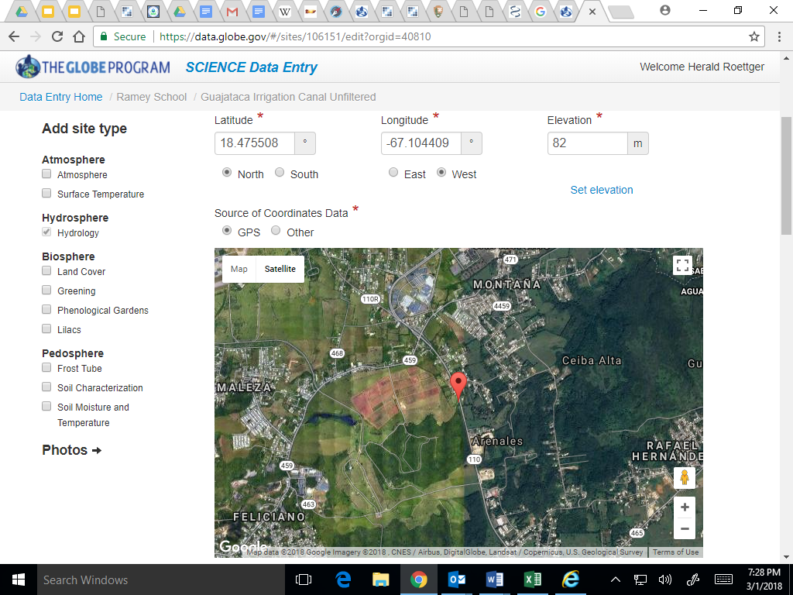
Latitude: 18° 23' 30.59" N
Longitude: -66° 55' 15.59" W
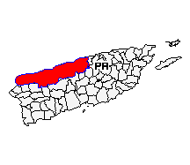

The water samples were taken directly from the Guajataca Irrigation Canal. This water source, the Cibuco-Guajataca Watershed comes from the Guajataca Lake
(Lago Guajataca) and was created by the Puerto Rico Electric Power Authority. It is a reservoir located between the municipalities of San Sebastián, Quebradillas, and Isabela in Puerto Rico. It is used for irrigation and potable water. The climate is Tropical Marine with an average temperature of 80 degrees Fahrenheit. Winds blow from the east and there is moderate rainfall. Hurricanes commonly occur between August and October.
The dam at Guajataca Lake experienced a structural failure on September 22, 2017 because of Hurricane Maria. This damage affected the drinking water quality.

Data collection

The GLOBE protocols used to help answer our research questions included: Dissolved Oxygen Probe (mg/L), Conductivity Probe, PH Sensor, Temperature, and bacteria tests for E Coli, Coliform, and Enterococci strands.
Sampling Method: Aguarica conducted four trials with two samples each to test our prototype and compare it with other water filters. Our first trial was conducted on February 1, 2018 using irrigation water samples from Guajataca Watershed and city water (AAA) collected from Ramey Unit School. During this session, we compared results from both water sources with five different water filters used in Puerto Rico. This activity was done at Costa Salud, a Community Health Center located in Rincon, Puerto Rico with Mr. Steve Tamar. Our second sample followed the same protocol and procedures and was conducted at Ramey Unit School located in Aguadilla, Puerto Rico with a new sample of irrigation water from Guajataca and new AAA sample from Ramey Unit School. Our third trial was done at Ramey Unit School and was supported by Mr. Herald Roettger with a new sample of irrigation water from Guajataca and a new AAA sample from Ramey Unit School. Our final trial was conducted at Ramey Unit School and was supported by Mr. Herald Roettger with a new sample of irrigation water from Guajataca and a new AAA sample from Ramey Unit School.

Print screen of data entry in the Web page of GLOBE
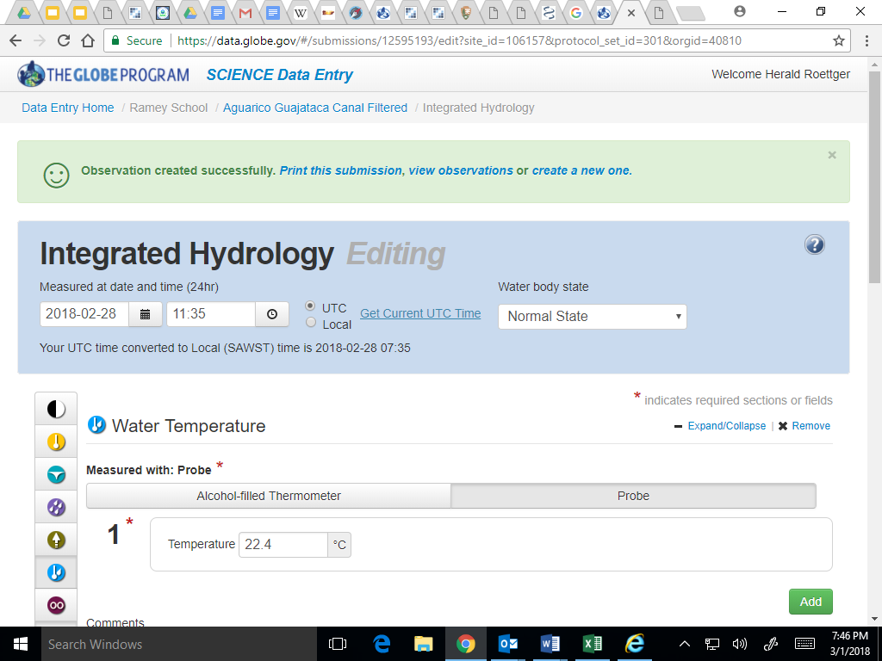

Data Analysis
In order to analyze data from our trials, we had to put it in a spreadsheet so we could compare it with other filtration devices. Using this spreadsheet, we could place our data in a scatterplot to observe how much our filter improves or worsens. Using this scatterplot, we could apply a trendline (or line of best fit/ regression line) and be able to predict how well our filter will do in the future if it keeps improving. Also, in order to keep our trials constant, we needed to keep our times and numbers constant as well. This means that we have to boil or bleach our materials for the same amount of time before every trial. It also means that we need to measure exactly how much charcoal, sand, and husks we were placing in our filter, and keep the same measurements for every setup. If we did this, we would be able to rule out irregularities in our data that could come from different boiling times, because not all of the bacteria may be killed. It could also rule out the possibility of different filtration times due to inconsistent measurements, meaning water could soak more in the filter during the first trial than the second if the measurements are off.

The data presented was sufficient to answer the research questions:

(1) How can we prevent bacteria-related diseases from water contamination during the aftermath of Hurricane Maria?
(2) If we filter contaminated water using a modified solar water distiller and secondary filtration system, will the output water quality be safe for consumption?

Data was sufficient because it allowed us to devise an effective filtration device and eliminate all coliforms and bacteria from a contaminated water sample. Our data also supported the conclusion that it was possible to create an effective decontamination and filtration device using natural and local materials. With future improvements, our filtration prototype may become something useful to all Puerto Ricans.

Results
Aguarico tested the coliform, enterococcus, and E.coli bacteria levels for all our prototype water samples. In addition, we tested the dissolved oxygen, conductivity, ph, and temperature of our final prototype water sample. We compared our results to the EPA safe drinking levels as shown below:
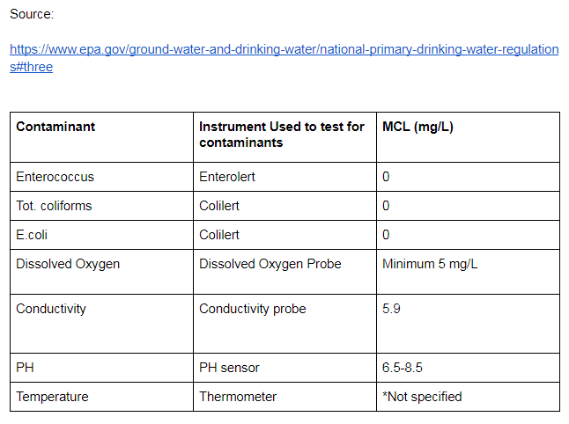
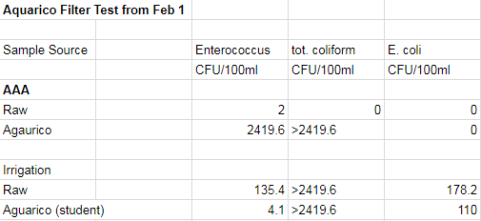
The results of our first test included running tap water (AAA) and irrigation water from Guajataca watershed through our prototype which is shown below:

Our second prototype included sterilizing all of our filtration materials, and transferring our filtration materials to one five-gallon plastic bucket. The results are shown below:
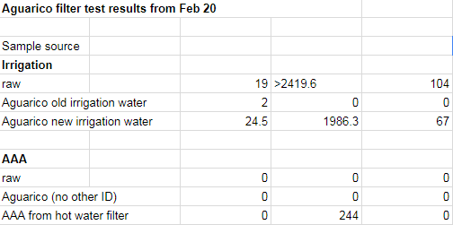

Our final test was conducted by testing four different filters, as shown below. According to the table, the sand/husk/regular charcoal proves to filter the water most effectively, and maintains EPA safe drinking levels.
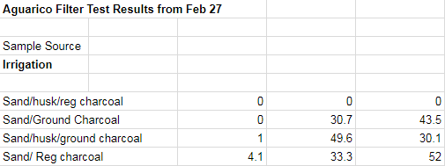

This final chart demonstrates the results for our final water filter test results:
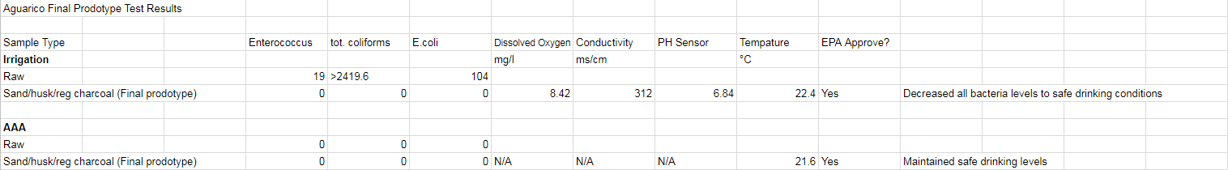

Final Test Charts Comparing the Four Different Filters

The table below shows that the sand/husk/regular charcoal and the sand/ground charcoal were the only two whose results met the EPA standards for safe drinking water.
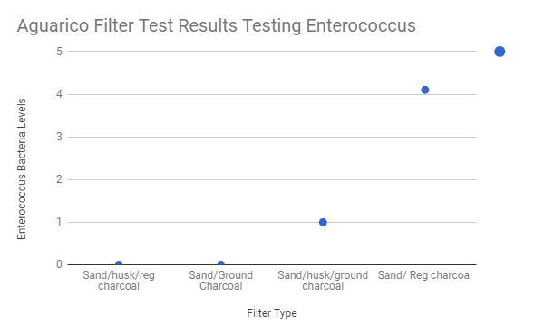

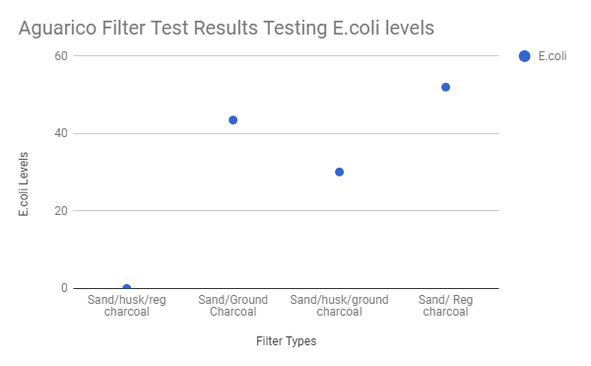
The table below shows that the sand/husk/regular charcoal was the only filter that passed the EPA levels for safe drinking water.

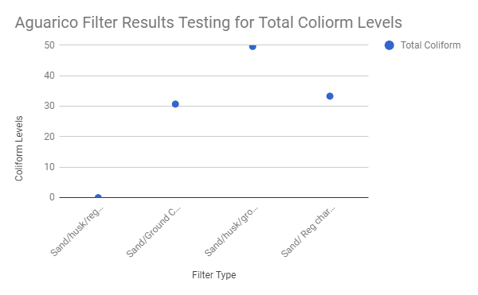
The following chart shows the total coliform levels for all filter types. According to the table, the sand/husk,regular charcoal, is the only filter that passes the EPA standards for safe drinking water.

The following graph represents the effectiveness of the different filters tested for enterococcus, coliform, and e.coli levels. This supports that the sand/husk/regular charcoal filter performs the best in filtering out the contaminants.
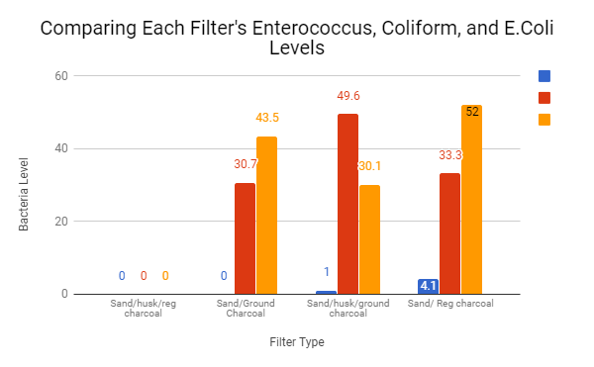

Print Screen of GLOBE Visualization Page

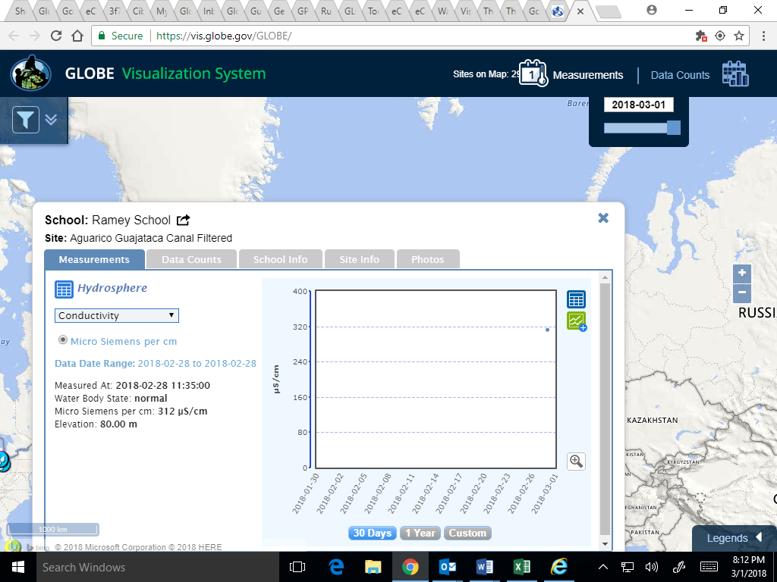

Discussion
According to our results, not only did we manage to improve our prototype with each trial, we were also able to succeed in eliminating all coliforms from both city (AAA) and contaminated irrigation water samples. Aguarico faced many problems during the process of our experiment, and our results show that we were able to get over challenges and continue working and refining. The results from our final trial were the best and most significant. This means that we reached our goal and supported our hypothesis of developing an effective filtration and decontamination device using local materials that could be used during the aftermath of Hurricane Maria.

Possible sources of error:
During the process of our project, we encountered some sources of contamination. In the first trial of our experiment, we did not properly sterilize any of our materials, which caused our bacteria count to increase dramatically. In order to improve after this, we created a set of protocols that would make sure all of our materials were clean. The second test we ran showed that the bacteria count dropped, meaning our filter was improving and the protocols we set were effective. However, when we ran our third trial, we discovered that outside contaminants had somehow affected our results, causing our bacteria count to once again increase. After this experience, we made sure all of our materials were completely clean, and on our fourth trial, we managed to bring our results down to zero, meaning no bacteria was detected.

Comparison with Similar Studies

Our team compared our filtration system to several other commercial filters that were distributed throughout Puerto rico during the aftermath of Hurricane Maria. These included: Sawyer, Agua Cera (Long), Agua Cera (Short), Agua Cera (Cylinder), and Brita.

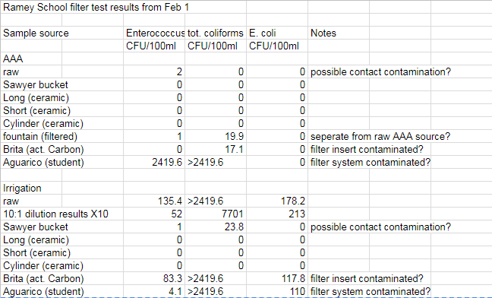
The first test included several events of cross contamination, which led to high results. The data from the first trial is shown below. Results from Sawyer, Aqua Cera, and Brita.

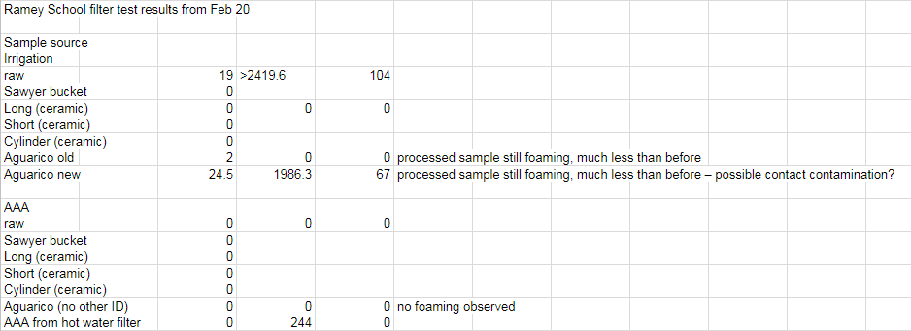
During the second trial, we sterilized our filtration materials more thoroughly, and had more precise safety measures. The AAA from hot water filter shown labeled on the graph shows the results from our steam collecting device that we attached form the solar water heater. The Aguarico old shows the results from passing old irrigation water through our filter vs. new irrigation water The results from the second trial are shown below:
The results answered the following research questions because our filter was operational and effective, and because these results gave us sufficient data on what may need to be improved, changed, or kept the same. They also told us that the output water quality would be valid as potable drinking water:
(1) How can we prevent bacteria-related diseases from water contamination during the aftermath of Hurricane Maria?
After we ran the tests to verify the effectiveness of our device, we realized the most effective way to prevent bacteria-related disease would be using our prototype that includes coconut husk, coconut charcoal, and sand.
(2) If we filter contaminated water using a modified solar water distiller and secondary filtration system, will the output water quality be safe for consumption?

Conclusion
In conclusion, our team succeeded at developing an operational filtration prototype. Our results show major improvement as each trial develops, as well as depicting how we gained more knowledge through our research. We connected with scientists such as Steve Tamar, who helped us perform almost all of our tests. We spent hours on end doing research, whether it was online, from books, or from interviews. Overall, the time that we spent working on this project made us smarter, stronger, and closer as friends. We worked almost every day, and we made sure we did everything to our highest potential. If not for the time we spent and the people we met and interviewed, we may not have been able to submit this project on time. Our team experienced the struggle of living on an island with no electricity, water, or true infrastructure. Our struggles and the struggles of other Puerto Ricans are what drew us to this particular idea. Our prototype works effectively, and we are proud of our accomplishments so far. We could still improve our project in a few ways. We could try to implement ceramic infused with colloidal silver, which is used in many commercial filters and is known to eliminate all bacteria. We could also expand our use of resources, or improve upon the sterilization methods of the device. Everything we have done so far, however, meets our objectives and answers our research questions. Our team’s project mentor has also been an inspiration to us. Mrs. Rapatz- Roettger has helped us in so many ways since the beginning of our project. She kept us on task, gave us meaningful advice on what we should complete and when, and scheduled research trips and meeting dates. Without her, we may never have known where to start with such a large task. She always encouraged us, and made sure we would be able to submit. Working with a project mentor improved our morale and helped us find our strengths and interests, then work with them to do our best work one hundred percent of the time. In general, we have reached the conclusion that, through help from STEM professionals, tons of research, late nights and early mornings, and our project mentor, we were able to develop an efficient and effective filtration device that could be used to help Puerto Ricans during the aftermath of the devastating effects of Hurricane Maria.

Bibliography/Citations

The following annotated bibliography was used to support our research. These resources include: articles, books, interviews, presentations, and websites. Attached to each citation is a summary. These resources helped us gather information for our project, to develop an efficient and cost-effective solar water heater and filtration system using local resources.

Journal Articles:
Barclay, Eliza. “Puerto Rico finally updated Hurricane Maria death toll to 34”. Vox.
December 12, 2017.

Chodosh, Sara. “Activated Bamboo Charcoal”. April 2017. POPSCI.com. December 16,
2017.
Bamboo charcoal works efficiently in purifying water and making it taste good. It can keep your water fresh for about a month, until you need to clean or replace it. It does not use any electric or solar power, although it could be harder to find for some people than for others.
Gelting, Rick. “ Battling a Waterborne Plague”. April 2017, Centers for Disease Control
and Prevention. December 16, 2017.
Chlorine is a water-cleaning system used by the US Centers for Disease Control in Haiti. It is an inexpensive product and incredibly effective. It can be used in both large community water systems and individual households.

Green, Tony. “Water Filters Remove Impurities”. August 6, 2017. January 16, 2018.
Coconut shells are a good cleansing agent for water. They filter through activated carbon, which eliminates contaminants within the water. Most activated carbon is comprised of coal or charcoal.
Murphy, Harlan. “Rain, Rain, Stow Away”. April 2017. December 16, 2017.
This articles explains how rain water may be collected and saved for drinking and household uses. It also explains how to capture rain and save it for times when needed.
Parker, K.T. “ Natural Materials Used for Water Filtration”. April 24, 2017. Sciencing.
January 17, 2018.
Many different types of natural materials are used to filter and clean water. These materials include sand, oysters, plants, charcoal, and coconut. These are resources that are renewable and easy to find.
Werner, Carol. “ Renewable Energy Fact Sheet”. May 2006. Environmental and Energy
Study Institute. January 17, 2018.
A solar water heater, which consists of a solar collector and a storage tank, can be used to heat water more efficiently and cheaper than an electric heater. There are many benefits to using a solar water heater, including money saving and environmentally friendly usage. Storing water can be a highly effective way to conserve and reuse natural resources. Rainwater and runoff can be decontaminated and used as drinking water. Greywater can be filtered and used as lawn irrigation.

Websites:
CNN.com. “Water from a polluted Puerto Rico Site ‘safe to drink’”. CNN. December
2017. January 16, 2018.
Over 1 million Puerto ricans were left without water after Hurricane Maria. Recently, three wells at a waste site were deemed potable. The EPA is testing that water and other supplies around the island.
News Week.com. “Puerto Rico’ Drinking Water Is Spreading Disease Due To Animal Urine And Hazardous Waste”. October 2017
Linley Sanders tells us about how there have been many cases of Leptospirosis. Kids have also been drinking from streams that have animal urine which is what causes Leptospirosis, since most people lack clear water. Illnesses will increase and water purification is not a long term solution.
All About Water Filters.com. “11 Unbelievable Ways To Filter Water With Plants”
The Article “11 Unbelievable Ways to Filter Water With Plants” told us about how to do filters with plants and fruit peelings. All these filters work effectively based on this article. The one that was most interesting was the fruit peeling because it was done with something that a lot of people have.
Popular Science.com “LA’s Faranging Roots” March 2017
The article “LA’s Faranging Roots” tells us about the water that is currently in Los Angeles, California. The water is in the Local Groundwater and other places, but that is where most people get there water. What they do is pump the water up to the surface, treat it, and send it flowing to the system.
Popular Science.com. “A Machine That Pulls Water Out If Thin Air. Literally” March 2017
This article tells us how you can pull water out of thin air. The machine pulls air and sends it underground where the cooler temperature will turn the water from gas to liquid. It can then be pumped to the top where you can collect it for yourself. This machine can provide 11 gallons a day in drier environments and 14 gallons in humid conditions.
Interviews:
Colon, Enrique. Ramey Unit School. Personal Interview. January 10, 2018.
Mr. Colon is a computer teacher at Ramsey Unit School. Our prototype design included using coconut charcoal, and he informed us that he had previously worked with making coconut charcoal for his own use. He worked alongside with us in creating the coconut charcoal, and explaining the benefits of using it.
Koslow, Drew. Ridge to Reef. Personal phone interview. January 18, 2018.
Drew Koslow is a biologist and conservationist who works for the nonprofit organization Ridge to Reef. He handed out water filters after Hurricane Maria, and discussed with us certain effective filtration materials. He also gave us information on our water treatment infrastructure, and his opinion on where Puerto Rico stands as far as infrastructure both before and after the Hurricane.
McFarland, Amy. Ramey Unit School. Personal interview. January 16, 2016.
Mrs. McFarland is a fifth grade teacher at our school. She and her husband handed out water filters after the hurricane. She helped us by telling us what the filters were made of and what was inside. She gave us information on what role each part of the filter played.

Rivera, Francisco. Ramey Unit School. Expert in the Field, Math.
Francisco Rivera is a math teacher at our school. He assisted us by helping us present our data in graphs, tables, and charts.
Rivera, Ruby. Ridge to Reef. Personal interview. November 18, 2018.
Ruby Rivera is a marine biologist who also works for Ridge to Reef. She was valued for her knowledge of Puerto Rico, as she is Puerto Rican herself. She talked to us about her work, handing out filters and supplies to the locals post-storm, and how the filters worked.
Roettger, Herald. Ridge to Reef. Expert in the Field, Science. November 19, 2018.
Herald Roettger is a MA Science teacher and has worked with the Surfrider Foundation in making water tests of water collected from local beaches near us. He provided us with the procedures in testing the water we would cooled from our filtration systems.
Roettger, Richard. Teacher at Ramey Unit School. Expert in the field
Richard Roettger is a High School teacher at Ramey Unit School. He is currently working with another group for the Globe Science Fair, and, along with his group, are working on studying and testing the effectiveness of several different water filters.
Sassar, David. Civil Engineer, Expert in the Field. January 21, 2018.
Mr. Sasscer visited our classroom to observe our presentations and give us feedback about being an engineer.
Zapata, Yesmin
Yesmin Zapata is a Community Scope Coordinator, who works in Costa Salud, in Rincon, Puerto Rico. She was able to provide us with feedback of our prototype design, along with a brief description of her role in the community.
GLOBE Materials Used: www.globe.gov : Protocols and data entry
GLOBE INTERNATIONAL VIRTUAL SCIENCE SYMPOSIUM-BADGES AND CRITERIA FOR 6-8 SCIENCE PROJECTS
Additional Badges (Up to 6-Optional)
B1: Collaboration
Aguarico is a group of four 8th grade students from Ramey Unit School located in Aguadilla, Puerto Rico consisting of Bria Roettger, Janeliz Guzman, and Kailey Aponte. Our team united after suffering from Hurricane Maria, a nearly Category 5 storm that devastated the entire island on September 20, 2017. This event and its aftermath provided an opportunity to support our community by creating an effective solution to filter contaminated water using local materials and natural resources.
In order to complete a successful mission folder, Aguarico set realistic goals because our basic resources were limited. Although we lacked consistent or reliable potable water, electricity, and internet service, we were motivated to complete our primary goal and create a solution to the water contamination in Puerto Rico, our chosen community. It was also important to identify each member’s strengths and interests to maintain a positive chemistry between team members. An additive amount of time was also invested to create our Team Norms that were revisited before each meeting to ensure we worked well together and stayed on task. Finally, because time was limited, we created a Team Action Plan to manage our time effectively so we could meet the deadline and confidently submit the completed mission folder.
Without electricity or internet use, we needed to adjust to new ways of learning and recording information. Unfortunately, the libraries at school and the United States Coast Guard Base Borinquen were flooded and many books were destroyed. Internet use was also not available. This was difficult at the beginning, but we quickly found solutions to gathering information so we could complete our project. Instead of using the libraries and the internet, we invested time communicating with and interviewing people, sharing personal experiences, reading local newspaper articles, reflecting on the many facts we learned, and focusing on opening and closing feedback and reflections at the beginning and end of every meeting. Motivation was very important because it inspired our team to keep working despite the many distractions that came our way. We motivated each other by reminding ourselves of the reason behind finding a successful solution to our problem: people needed and deserved reliable and potable drinking water. We all experienced the fear of not finding potable water and knew first-hand the urgency of this challenge. Our doubt was that we believed, as 8th graders, there was no way we could possibly make a difference; especially without the conveniences that we relied on before. Through snacks, motivational talks, and enjoying the time we had together as a group, we decided upon dividing work evenly based on our individual strengths, and agreed to complete the best work we could by the due date. We agreed on the understanding that we may not be able to finish and submit our mission folder in the allotted time we had left.
As a team, Aguarico created Group Norms to ensure productivity and successful completion of assignments. These norms included considering all ideas, trying our best to complete work by the due date, completing work to our greatest potential, dividing work evenly based on strengths and interests, and ensuring all team members take leadership and supportive roles to keep everyone on task and encouraged.
One method our team used to complete our project on time was to assign team roles and responsibilities to each team member. This ensured all work was divided equally and efficiently among all team members. Each member chose their role based on strengths and interests. One tool that helped us discover this information was the Multiple Intelligence Test, created by Dr. Howard Gardner. The results were graphed and used to assign each team member to their best team role.
Janeliz Guzman was our main organizer. She was in charge of creating and revising our monthly calendar. Also, she arranged interviews with experts in the fields of engineering, health, and education. In addition, she was the assistant spokesperson. This role is meant to help the main spokesperson prepare and present information. Janeliz’s final role was the attachment manager. As an attachment manager, she helped create and submit supporting materials for information collected through surveys and interviews.
Bria Roettger was the main spokesperson of the group. She was responsible for leading the group during presentations, expressing our ideas, and answering public questions effectively. Bria was also the main writer. She was in charge of combining ideas and drafts from all group members to help construct and finalize essays. She was also another attachment manager, and helped create PowerPoint presentations for our group.
Kailey Aponte was our team’s main editor. She went through all of the essays and made sure they were relevant to our topic, and that they had no grammar or spelling errors, as well as revising to make sure the essays are updated with the changes we make. She was also our lead analyst, providing mathematical knowledge when needed. She analyzes graphs and creates equations that can be used for making predictions and observing how well our prototype is operating.
In addition to each group member’s individual roles and responsibilities, we agreed to create a team leader role who ensured each team member would have an opportunity to lead the group and take responsibility over assigned work. We also included a team supporter, who would bring snacks to meetings and who would help others. Finally, we established the time keeper role to keep us on schedule and stay on task. These three jobs rotated every two weeks to give all team members the chance to participate.
Our team created and followed a Team Action Plan by using many strategies. One way our team verified all work was completed to its fullest potential and turned in on time was by creating calendars and timelines with all assignments and completion due dates. This timeline was crucial since it included dates and information for each task that needed to be completed. We also used helpful tools such as a Vision Board to organize our ideas and assignments we needed to complete. In addition, each team member created their Research Binder including monthly calendars, timelines, articles, interviews, rubrics, designs, and essays. These tools were helpful for all team members because we were able to keep track of all our requirements and how we were completing them. Overall, the Team Action Plan helped keep our group motivated, on task, and aware of deadlines to complete our best work possible.

B2: Community Impact
After the devastation of Hurricane Maria, the availability of potable water was very limited all over the island. Many people had to take desperate measures to get any water at all, much less water that was healthy or safe. Though several water filters were distributed to communities in need, the materials needed to manufacture those filters were not widely available to Puerto Rico. Our team decided that we had to do something to help our locals in need. We knew there had to be an efficient and reliable way to get clean water to hurricane victims, and we wanted to find and develop that way to create a useful and easy-to-make tool. Our device could provide a new and reliable source of safe drinking water for Puerto Ricans across the island. Because most of the resources used to construct our device were widely available throughout all of Puerto Rico, the production and distribution of our device would be more reliable than other commercial sold filters. It could quite possibly reduce the amount of deaths or illnesses that result from the consumption of contaminated water.
B3: Connecting to a STEM Professional
During our research, we connected with a few professionals who were experts in the field of STEM. We acquired useful information from Mr. Steve Tamar, a microbiologist who works the Surfrider Foundation as a water testing technician in Rincon, Puerto Rico. He taught us how to perform water testing for multiple coliforms, and helped us execute these tests. We visited Mr. Tamar at his laboratory temporarily located at Costa Salud, Community Health Center located in Rincon. In order to run our tests and he taught us what he knew about coliforms and waterborne diseases, and how to get rid of them. He also gave us background information on what he does for his work, studying water samples from all around Puerto Rico and educating the public about what contaminated water consists of. Another person who aided us with our project was David Sasscer, a mechanical engineer who gave us advice on how to complete our tasks on time. He told us that in order to complete something without rushing, we needed to set personal due dates and understand that, in order to work well, you had to know that it may not turn out perfect, and you just had to do your best to complete it by the date. We also connected with Mr. Herald Roettger, a science teacher at our school, Ramey, who helped us perform testing, design and build our prototype, and find our materials. He came to our classroom almost every day to assist us, and spent meaningful time helping us complete our project. We gained a lot of knowledge from him, and he kept us on task and working hard all the time. Mr. Roettger knew how important this project was to us, so he did everything he could to help us complete it to its fullest potential. The last person we met with was Mr. Enrique Colon, our school’s technology teacher. He taught us how to burn the coconut charcoal to change its state to activated carbon. This element was one of the main parts of our prototype. Thanks to him, we were able to implement the charcoal as a valuable part of our filtration device. Overall, we gained knowledge and information from a variety of people, who all helped us in different ways, and took some of their time to make sure our project was effective and completed with our best efforts. Not only were these people inspirational to us, they were generous and kind, and invaluable to our research and experimental design.

B4: Interscholastic Connection
For our interscholastic connection, our team worked with another team also doing the Globe project. We compared our data with theirs, as well as with their commercial filters. They helped us do the probe testing and taught us how to use the probes. We also used their commercial filters to create our standards for our device. We compared our data against data from the following commercial devices: Sawyer, Aqua Cera long and short cylinders, and a Brita. The probes we were taught to use by them were also the probes the other group used for their project. They were also with us when we went to Rincon to talk with Steve Tamar, a microbiologist. With them, we shared information about our prototype and they gave us some ideas and advice, which was useful in the experimental design process.

B5: Engineering Solution
After experiencing the natural disaster of Hurricane Maria and not receiving electricity nor reliable water for over 60 days, our team came to the conclusion that an effective water decontamination and filtration system would provide relief during a natural disaster aftermath. The design would include natural resources, or resources that could be found in any household. One method many people used to decontaminate water is through boiling it. Our team designed a device that will go through one stage of decontamination and filtration. It's primary decontamination system would be a device in which should allow the water to pass through it, and reach a boiling level, killing all bacteria. It will later pass through three different layers of filtration to ensure potable water. Once all the bacteria is filtered and destroyed, it will be accessible to the users through gravity-fed piping as an alternative and effective source for clean water.
Our second option for a decontamination system includes tapping into modern solar hot waters. The newest design includes a hole that releases steam form the storage tank. Our team came to the conclusion that collecting this steam and passing it through our filtration system, would ensure 100% distilled water.

B6: Exploring STEM Career
During the engineering and testing of our prototype, we encountered several STEM jobs that would be relevant to our project. First, environmental engineering involves the use of scientific and engineering for the protection of human population, environment and the improvement of the environmental quality. Knowledge could be gained about the composition of contaminated water, as in what it contains and how to sterilize it. Consulting with an environmental engineer would further improve our device. We would be able to point out the major faults in our materials, and possibly develop new ideas for improvement. In addition, the microbiology branch relates to the testing of the water samples collected from our filters. Using microbiology, we were able to analyze our data and perform valid tests. We learned about different types of coliforms, and in what environments they exist. This was useful throughout the entire course of our project, as we were able to pinpoint the right bacteria and eliminate it from our water. We used microbiology to understand our results from our testing, as well.

