U.S. Partner Forum
Terms of Reference
(Revised September 21, 2017)
Introduction
The GLOBE U.S. Partner Forum is established to provide an open forum for direct dialog with the federal sponsors of GLOBE (NASA and NSF) and other supporting agencies (e.g., NOAA, etc.), with a focus on issues and opportunities of specific interest to the U.S. Accompanying, but distinct from the Forum are the five GLOBE Standing Working Groups: Science, Education, Evaluation, Technology, and Communication; the purpose of the WG’s are to enhance the roles of the GLOBE U.S. and Country Partners in shaping the future of the GLOBE Program and supporting the development and implementation of GLOBE worldwide. See Appendix A for a depiction of the overall GLOBE program structure.

1. Purpose
The purpose of the GLOBE U.S. Partner Forum is to facilitate discussion of ways to enhance the contribution of GLOBE to the improvement of science, technology, engineering, and mathematics (STEM) education in the U.S. locally, regionally, and nationally. The Forum is convened by NASA and NSF in collaboration with NOAA and other supporting agencies of GLOBE, and with the support of the GLOBE Implementation Office (GIO).
2. Functions
The functions of the Forum are to:
- Seek, compile, and provide insight into the issues and opportunities of GLOBE implementation and systematic incorporation of GLOBE into formal and informal education in the U.S.
- Develop topical or issue papers when appropriate.
- Identify and deliberate on topics, events, or opportunities of interest to GLOBE U.S. Partners.
- Share relevant information and knowledge to promote increased participation in and overall effectiveness of GLOBE within the U.S..
- Collaborate and coordinate with each other and other educational or scientific organizations and programs as appropriate.
- Act as a conduit for two-way information exchange with the broader U.S. GLOBE community (or respective geographic area) and the specific constituencies (e.g., elementary and secondary, pre-service, and informal education, assessment, education administration, etc.).

3. Membership
The Forum shall have up to eight (8) members serving on a rotating basis, reflect the types of organizations that comprise GLOBE and the diversity the GLOBE community serves, as well as represent the six U.S. geographic areas. See Appendix B for the geographic areas.
Candidacy for serving on the Forum will generally go through a nomination process that is open to all GLOBE U.S. Partners; the U.S. Partners may nominate themselves or be nominated by fellow Partners to the Forum. Members of the Forum shall be appointed and may be removed by the GLOBE sponsors in consultation with the supporting agencies and the GIO Director.
Serving voluntarily without financial compensation, members of the Forum:
- shall have a strong knowledge of the GLOBE Program and the ability to understand and respect diverse points of view;
- shall have the relevant expertise in, and experience with, various aspects of the U.S. education system and framework for STEM learning;
- are to serve for a standard length of three years, and may serve two consecutive terms (if nominated and appointed); (Note that the lengths of service on the Forum will be staggered initially to establish the rotation; foundational members will be requested to accept a term that is either longer or shorter than the standard length of three years. If an existing member leaves the Forum for any reason, the sponsors and the GIO will identify an ad hoc member to continue the Forum business.)
- are expected to study the topics which come before the Forum in order to contribute to their resolution;
- are expected to participate in all Forum meetings and group activities;
- are expected to actively engage with the GLOBE U.S. Partners in the region they represent;
- should contribute articles or entries to the GLOBE blogs on a regular basis (at least one per year);
- One at-large member will be a US Partner from a NASA center.
NASA and NSF may, from time to time, invite observers or experts to participate on an ad-hoc or continuing basis.
4. Forum Officers
- The Forum shall have two officers: a chair and a secretary.
- A leadership team composed of the Chair, Secretary and US Country Coordinator will work together to create agendas for the meetings.
- The Chair and the Secretary are elected by members of the Forum by a simple majority; members can call for voting to be open or closed.
- The Chair and the Secretary serve for one year terms and are eligible for re-election.
- Officers will be elected at the first meeting of each new calendar year. The leadership team shall, with input from the other Forum members as well as the federal agencies and GIO, create the agenda for each meeting.

- The Secretary will work with the US Country Coordinator to arrange the electronic meetings and take minutes/notes from the meetings.
- The Chair will facilitate the meetings, monitor the work, and be responsible for the deliverables of the Forum.

5. Forum Operations
- The Forum operates under the purview of the program managers of the GLOBE sponsors. The program
- Sponsors and the GIO Director shall be ex-officio, non-voting members of the Forum.
- The Forum will meet electronically at least every two months and be supported for a face-to-face meeting once a year, pending availability of funds. The face-to-face meetings will typically be held either in the greater Washington, DC area, at a Partner institution, or in conjunction with the annual meetings.
- Electronic meetings will be limited to no longer than two hours.
- Discussion to obtain consensus will be the prevailing procedure used at meetings. Parliamentary procedure (Robert’s Rules of Order) will be used when a decision is to be recorded and transmitted as a recommendation.
- A quorum will consist of a simple majority of Forum members.
- Meeting minutes/notes will be distributed to members of the Forum for review before being added to the GLOBE website.
- All meetings are open to the US Partner community as observers.

6. Administrative and Technical Support
The GIO and/or the US Country Coordinator will provide administrative and logistical support to the Forum, including arranging electronic meetings (conference calls) once the secretary has confirmed the date, contacting technical advisors if requested, supplying appropriate background information that it may possess, and arranging travel for the face-to-face meeting.
7. Role of US Country Coordinator
The US Country Coordinator (CC) is a
- liaison between GIO and the US Partner Forum;
- voting member of the group;
- member of the leadership team

Appendix A
GLOBE Program Management Structure

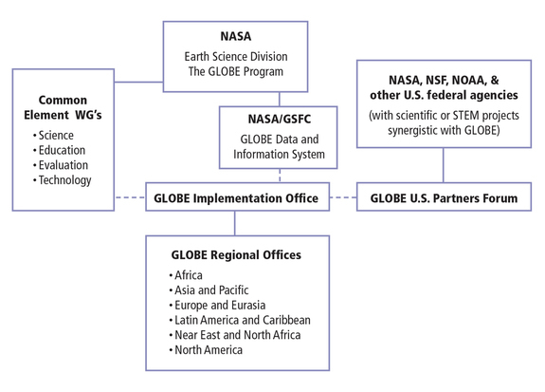

Appendix B
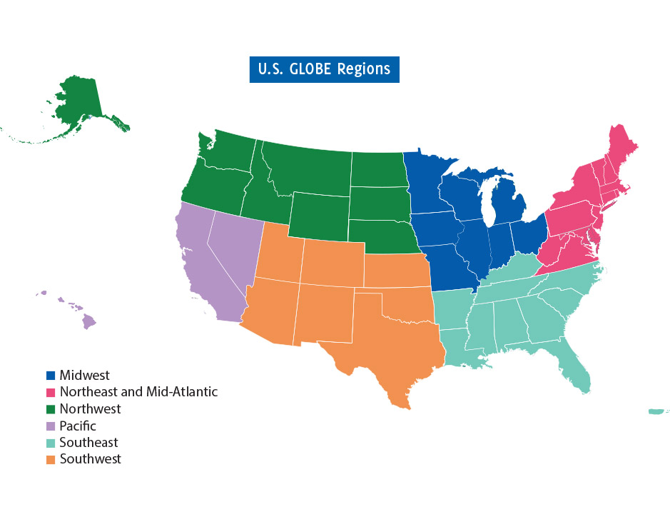
Pacific: California, Nevada, Hawaii
Midwest: Illinois, Indiana, Iowa, Michigan, Minnesota, Missouri, Ohio, Wisconsin
Northeast and
Mid-Atlantic: Delaware, DC, Connecticut, Maine, Maryland, Massachusetts, New Hampshire,
New Jersey, New York, Pennsylvania, Rhode Island, Vermont, Virginia, West Virginia
Northwest: Alaska, Idaho, Montana, Nebraska, North Dakota, Oregon, South Dakota,
Washington, Wyoming

Southeast: Alabama, Arkansas, Florida, Georgia, Kentucky, Louisiana, Mississippi, North Carolina, South Carolina, Tennessee, Puerto Rico Territory

Southwest: Arizona, Colorado, Kansas, New Mexico, Oklahoma, Texas, Utah

