إعداد الطالبات :

Study the effect of unsafe leakage of chemicals from school laboratories on soil and water
Done by:
Ftun Mubark AL-Drai
Sarah Khamis AL-Sawai
Bashair Alin AL-Julandi
AL-Rifaa School for Basic Education
Sultanate of Oman-Sharqia Governorate,South
The supervision of teacher:
SIham Rabia AL-Hasani

Contents:

Topic | The page | م
Summary | 3-4 | 1
Research question | 4 | 2
Introduction and review of the literature: | - 5 | 3
search methods: | 6-7 | 4
The study site | 8 | 5
Data collection and analysis | 9 | 5
Results | 10-11 | 6
Discuss the results | 12-14 | 7
Conclusion | 15 | 8
Thanks and appreciation | 16 | 9
References | 17 | 10
Entering data into the program's website | 18-20 | 11
Appendices | 21 الملاحق | 12

Study the effect of unsafe leakage of chemicals from school laboratories on soil and water
Done by:
Ftun Mubark AL-Drai - Sarah Khamis AL-Sawai- Bashair Alin AL-Julandi
AL-Rifaa School for Basic Education
The supervision of teacher:
SIham Rabia AL-Hasani
Summary:
- This research aims to study the danger of the unsafe leakage of toxic and dangerous chemicals to the environment, by studying the leakage of a sewage pipe into the school laboratory and the arrival of this leakage to the soil
- As well as studying the effect of expired chemicals in the school laboratory and accumulating them for a long period of up to long years. To achieve these goals, research questions were developed as follows:
- 1-What are the dangerous, toxic, and expired chemicals in school laboratories?
2-How does the leakage of toxic and dangerous chemicals affect environmental pollution?
- 3-What are the methods of measuring this pollution, and do the ratios present represent a real danger to the environment?
- 4-What are the scientific and innovative methods and methods that can be applied to address this problem?
- This study was applied in the South East Governorate in the Al-Rifaa School, targeting teachers, science teachers, technicians, and laboratory technicians from different schools through the distribution of an electronic questionnaire. A field visit to the Agricultural Research Center in Wilayat Al-Kamil and Al-Wafi to examine the soil.
- The results of the experiments indicated that the soil contaminated with chemicals leaking from the sewage pipes of the school laboratory and the presence of a rise in the soil salinity of 6 ds / m compared to the soil sample taken from a site far from the leakage of 2.9 ds / m as the soil needs a lower salinity ratio and the soil The pollutant gave a lower value to the pH = 4.3 (acid) compared to the soil far from the leakage site PH = 7.4, as the best rate of plant absorption of nutrients from the soil is at a higher level at acidity ranging between (6.5_7)
- According to the standard specifications.
The study recommends the need for the ministry to find effective solutions to this problem by the need to reduce throwing these materials into sewer pipes by placing special containers to dispose of these materials in laboratories or recycle them and use them to benefit the environment, such as using them to generate energy or use them as one of the fertilizers.

- Research questions:
- 1- What are the dangerous, toxic and expired chemicals in school laboratorie?

- 2-How is the laboratory technicians and teachers deal with these materials to include environmental pollution?

- 3-How does the unsafe leakage of toxic, dangerous and expired chemicals affect environmental pollution?

- 4-What are the methods of measuring this pollution, and do the ratios present represent an actual risk to the environment?
5-What are the scientific and innovative methods and methods that can be applied to address this problem?

- Introduction and review of the literature:
- The life cycle of any chemical begins with the receipt of this substance from its warehouse by the catalyst in laboratory courses. Chemicals have become an important component indispensable in school laboratories in order to apply some explorations and scientific experiments except that the use of these chemicals and compounds that result from chemical activity may It results in some risks in the event that methods of dealing with it are not known, and the surrounding local environment can be affected by the risk of such pollution. All it proved dangerous as several studies of these dangerous chemicals on the environment.

Perhaps the Sultanate of Oman is one of the most important countries that focuses on caring for the environment, and this appears in several laws where the Ministry of Environment and its efforts represent an important model for government interest in the environment.
The Ministry of Education has implemented an initiative to develop executive procedures to contain chemical waste in school laboratories, in cooperation with the Omani Holding Company for Environmental Services in 2013.
On the Arab and international level, there are many studies, guides and books in this field, we mention:
* A guide to the requirements for disposal of chemical waste from the preparation of El-Bassiouni supervision, where the guide indicated the classification of chemicals according to their severity and harmful and harmful chemical wastes and the most important scientific steps to deal with these wastes and the dangerous effects that may arise if these materials spread to the environment and people.

Shaima Ali's study, conducted in Iraq at Tikrit University, on methods of waste treatment and the importance of recycling, also indicated the most important methods of this treatment, including burial, recycling, converting solid organic waste into biogas, and converting waste into organic fertilizers and other treatments.
• King Faisal University in the Kingdom of Saudi Arabia clarified in its publication on its website on safety management the definition of waste and pointed to the chemical effluents in school and university laboratories and the seriousness of the importance of disposal.

search methods:
First: The research plan
We carried out scientific experiments in order to answer the research questions, and this was represented in taking samples of the polluted soil that the chemical materials leaked from the sewage pipes of the school laboratory as follows:

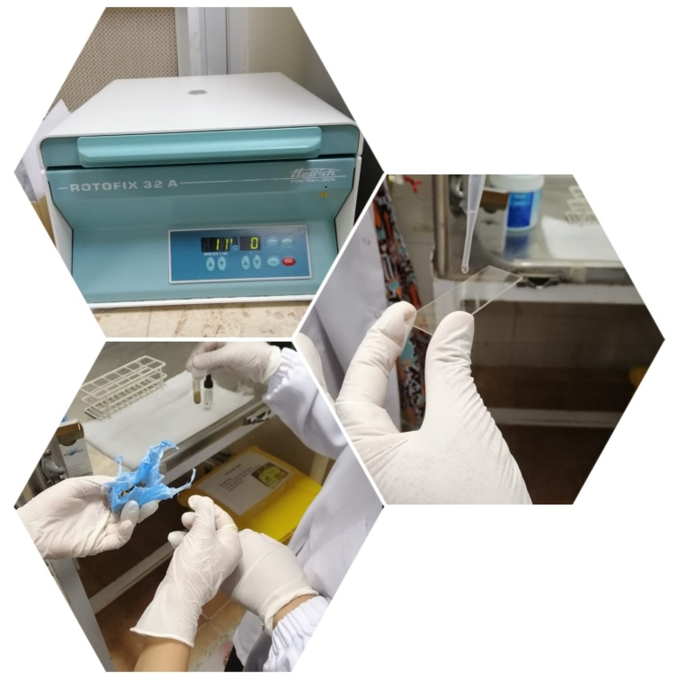
Samples of contaminated soil.
Quantities of water.
Using soil and water protocols by measuring (temperature - pH - salinity - dissolved oxygen amount)

Conducting a soil examination in cooperation with the Agricultural Research Center in Wilayat Al-Kamil and Al-Wafi.

• Interview with the laboratory technician.

• Doing an electronic questionnaire in order to answer the research questions, as they were published for a specific category, they are (laboratory technicians - teachers, chemistry
teachers, biophysics, science, supervisors and subject supervisors)
The timetable for the implementation of the research plan:

Time period | Implementers | The step
13/11/2019 | The GLOBE team | Collection of information and data
8/12/2019 | The GLOBE team | Sample collection(soil-water)
6/1/2020-7/2/2020 | The GLOBE team | Soil and water protocols
8/2/2020 | Basher AL-Julanta | Enter data into GLOBE site
5/2/2020 | Sara AL-Swai and Ftun AL-Dari | The interviews

Second: The study site:

• Sultanate of Oman (South Eastern Province), Jalan Bani Bu Hassan Governorate, January The weather is moderate (22 o Celsius). Soil and water protocol was used.
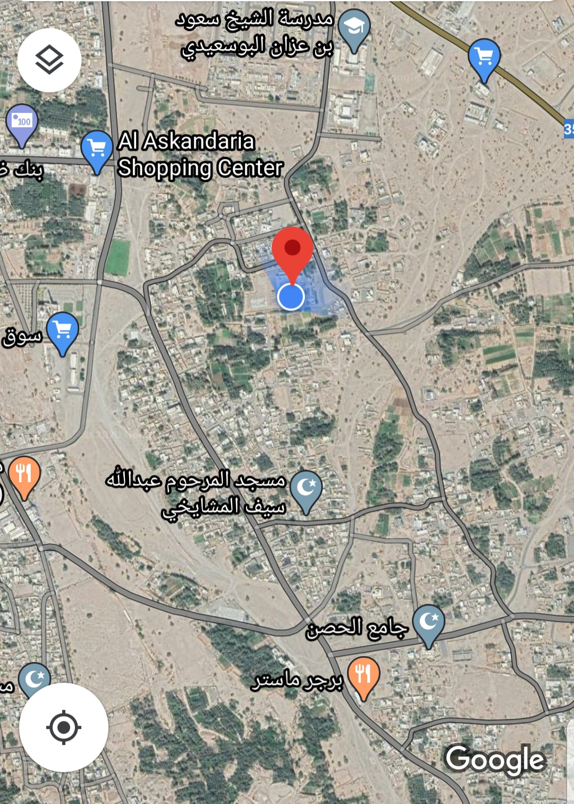
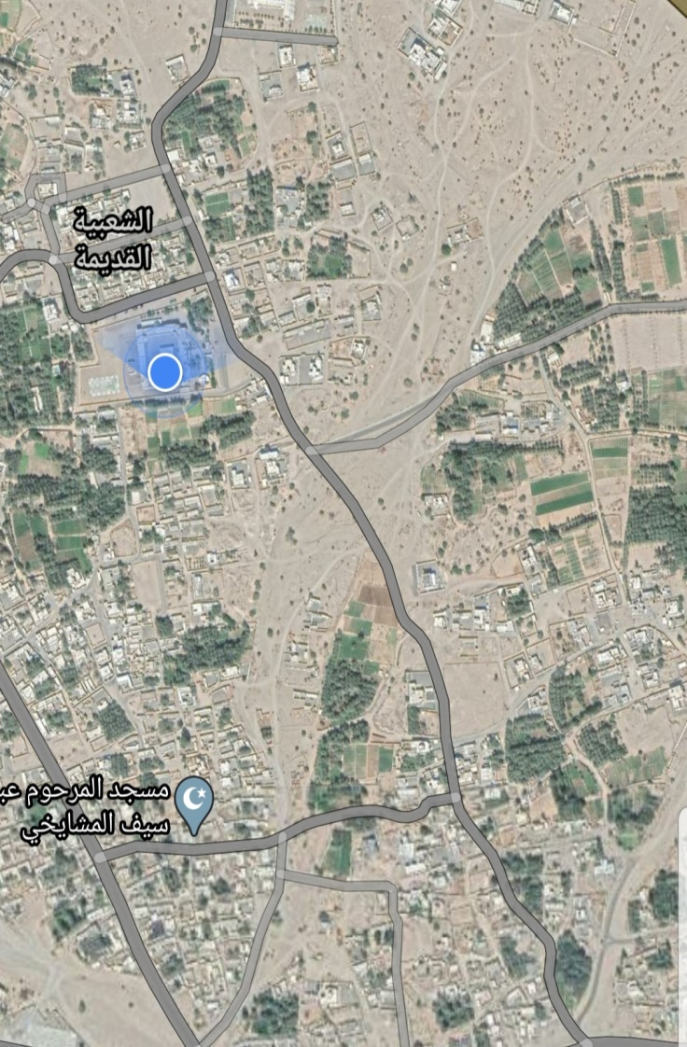

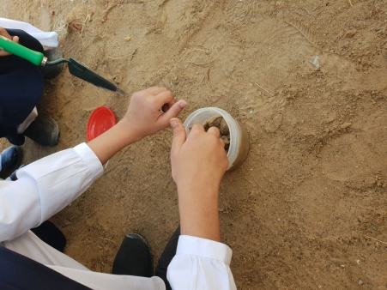
Data collection and analysis:
• An interview was conducted with the laboratory technician to answer the first question (knowing the dangerous chemicals present in the school laboratory).
• Publishing an electronic questionnaire on a specific category to answer the question (2-3 - 6).

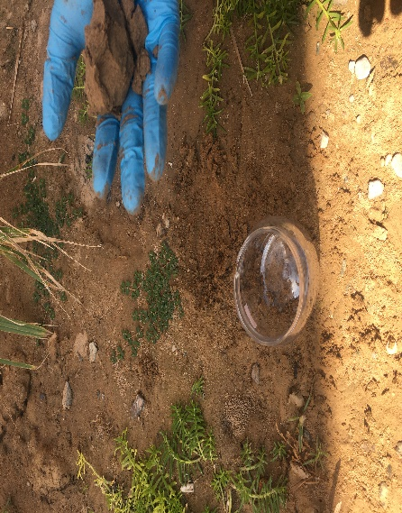
• Scientific experiments were conducted regarding the fourth and fifth question, where we took a sample of soil contaminated with chemicals and a sample from the same soil far from the site of leakage, to find out the effect of chemicals on the agricultural soil and its impact on the growth and properties of the plant. The second experiment consisted of two vials of water, one of which added expired chemicals (HCL acid - sulfuric acid H2SO4 - iodine - sulfur potassium hydroxide - ammonium hydroxide - ethyl alcohol - ammonia) and the other without additions to see the effect of expired chemicals on water, soil and study Their characteristics and comparison between them.
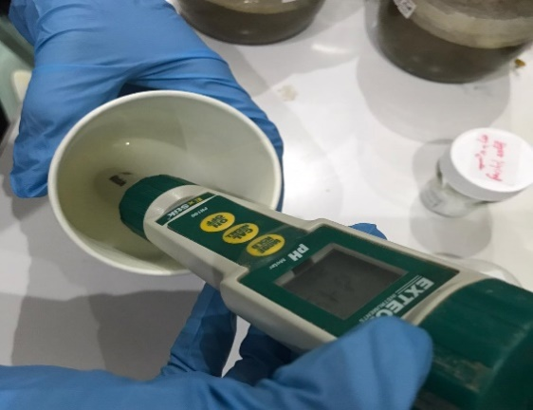

Rsults:
: Table(1) application of soil protocol

 | Sample1(soil away from leakage) | Sample2(soil contaminated with leaking chemicals)
soil type | Clay | Clay
temperature | 26 | 29
PH | 7.4 | 4.3
Salinity | 2.9 | 6
Organiic matter ratio% | 1.12 | 0.345
Plant growth rate(cm) | 13 | 3
The amount of carbonate | A few | A lot

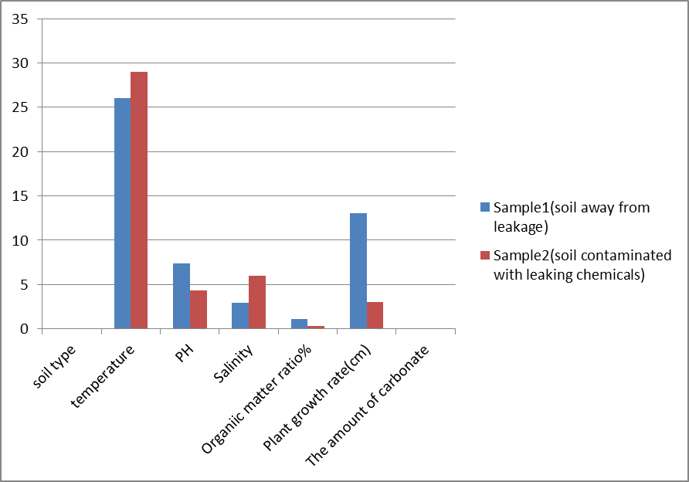
: Table(2) application of water protocol

 | Sample1(water without adding) | Sample2(water contaminated with expired materials)
The amount of dissolved oxygen | 10 | 6
temperature | 25 | 29
PH | 7.3 | 5.2
Salinity(ppm) | 546 | 887

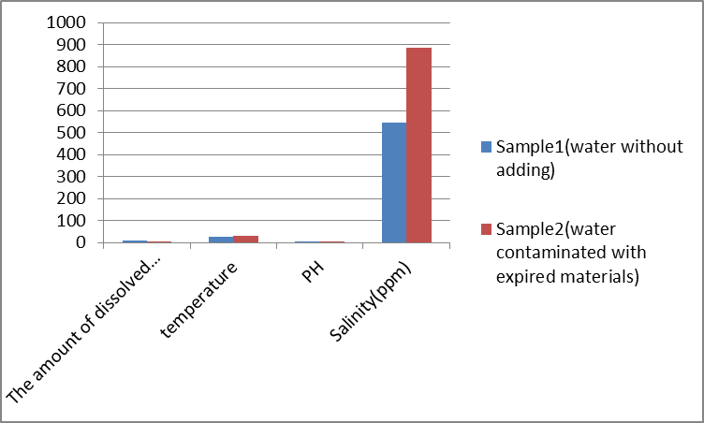

Discuss the results:

Through the previous results, we can answer the research questions
• Question 1: "What are the dangerous, toxic and expired chemicals in school laboratories?
Through the interview with the school's laboratory technician and the most dangerous materials were, the laboratory and the expired materials are:
Acids | Baes | Alcohol
Sulfuric acid-nitric acid-nhydrochloric acid  Potassium acid | sodium hydroxide- ammonium hydroxide | Ethyl alcohol
Acids- bases
Alcohol
Sulfuric acid - hydrochloric acid - nitric acid - iodine - ammonia - potassium hydroxide - sodium hydroxide - ammonium hydroxide. Ethyl alcohol.
(Also other compounds such as iodine, sulfur, and ammonia)
Question 2: "How are chemical technicians and teachers treated with these chemicals so as to ensure that the environment is not polluted?
Circular chart No. (2) shows that the percentage of those agreeing that the methods are effective is 55.2 while the percentage of those who do not agree that the methods by which these substances are disposed of are effective was 44.8. This result gave an indication that there is a category that does not agree with the methods for disposing of these substances in a healthy manner. It is more important that the percentage of those who approve of the disposal of these materials is 80-100%, in order to protect the environment.

• Question 3: "What awareness and training programs are offered for laboratory technicians as well as students to deal with these dangerous materials?

Through chart No. (5), it is clear that the percentage of those who agree to do educational sessions to deal with these materials is 44.8% by laboratory technicians, and the percentage of those who do not agree to do educational sessions is 55.2%, and it is important for the student to receive how to deal with these materials. That there are those who do not care to provide awareness sessions for the student about these materials more than the fans and those who agree to provide awareness sessions for the student about the methods of using and dealing with these materials.

Question 4: "How does the unsafe leakage of toxic, dangerous and expired chemicals affect environmental pollution?

Through the tables and graphs of the results of the soil and water protocol application, they were as follows:

1. Application of the soil protocol: Table (1) and the soil diagram show that the soil polluted by the chemicals leaked from the sewage pipes of the school laboratory. The height in soil salinity is 6 ds \ m compared to the soil sample taken from a site far from the leakage of 2.9 ds \ m where The soil needs a salinity of less than 4ds \ m according to the standard specifications, as the high salinity affects the absorption of water by the plant.
Also, the polluted soil gave a lower value to the pH = 4.3 (acid) compared to the soil far from the leakage site PH = 7.4, where the best rate of plant absorption of nutrients from the soil is at a higher level at acidity ranging between (7- 6.5) according to the standard specifications .

2. Application of the water protocol: We note in the table and diagram the water added to it has chemicals, in which the pH is reduced to 5.2, and the natural pH of water ranges between (6.5-7) according to the standard specifications. Also, the percentage of oxygen decreased due to the chemical consumption of oxygen far from natural water, and the percentage of oxygen was (6). Also, the salinity increased to (887). All of these measurements affect the properties of water if it is used, whether for wrong drinking, or for watering and irrigation, due to burial or burial, and its possibility to reach the groundwater.

• Question 6 and last: "What are the scientific and innovative methods and methods that can be applied to address this problem?
Through our review of many studies, scientific journals and specialized articles, our dialogue with laboratory technicians and some science teachers, these methods and ideas were reached, the most important of which are: recycling - containing it to chemical fertilizer - its use of solar energy.

Conclusion

Through our study of the research problem that revolves around the impact of unsafe soil of dangerous and toxic chemicals present in science laboratories and the importance of disposal in an effective, safe and periodic manner and the important research questions and methods and tools that were presented by the study to verify the hypotheses of the study we can say that the leakage of unsafe Hazardous and toxic chemicals and expired chemicals in laboratories for a long period of time up to many years still represent a real problem in our schools and therefore it affects the surrounding environment and student safety.
While the results of the soil and water protocol experiments confirmed that unsafe leaking chemicals affect the soil and change its properties.
Also, these substances played an important role on the water by changing the properties of water and its pollution in case it reaches the groundwater as a result of burial and burial.
These conclusions lead us to further investigation to study the effect of disposal of accumulated and expired chemicals from school laboratories, universities and colleges on the environment by the Ministry.

* Strengths: obtaining impressive results in soil and water testing.
Weaknesses: The research can be applied and the research area expanded by tracking how to get rid of expired chemicals by the ministry and going to landfills and burials and taking samples for study.

Thanks and appreciation

We are pleased to extend our sincere thanks and appreciation to Professor Siham Al-Hassani, Program Supervisor at Al-Rifaa Basic Education School, for the efforts made in helping us to accomplish this research. The thanks go to Professor Saeed bin Abdullah Al-Mundhiri for his continuous assistance and encouragement to prepare the research and direct it in the appropriate way. We also offer our thanks to the "Agricultural Research Center" in Wilayat Al Kamil and Al Wafi for the valuable information. We offer our gratitude to Professor Intissar Al-Jabri, the school's laboratory technician, for assistance and support in carrying out the research. We thank the central and local team of the Globe program for support and information.

References

• 1-Directory of Chemical Disposal Requirements, (2012), author Ashraf Bessouni.
• 2-Waste treatment methods and the importance of recycling them book, (2015 AD), d. Shaima Fateh Ali.
3-GLOBE Technical Office (2012) Soil and Water Protocol Note for GLOBE Teacher Training Program.
• Report on the Oman Environmental Forum, 2017 AD.4-
5-An electronic article entitled Chemical hazards and ways to prevent them
• 6-Directory of Chemicals in School Laboratories, (2010 AD), Ministry of Education.

Entering data into the program's website

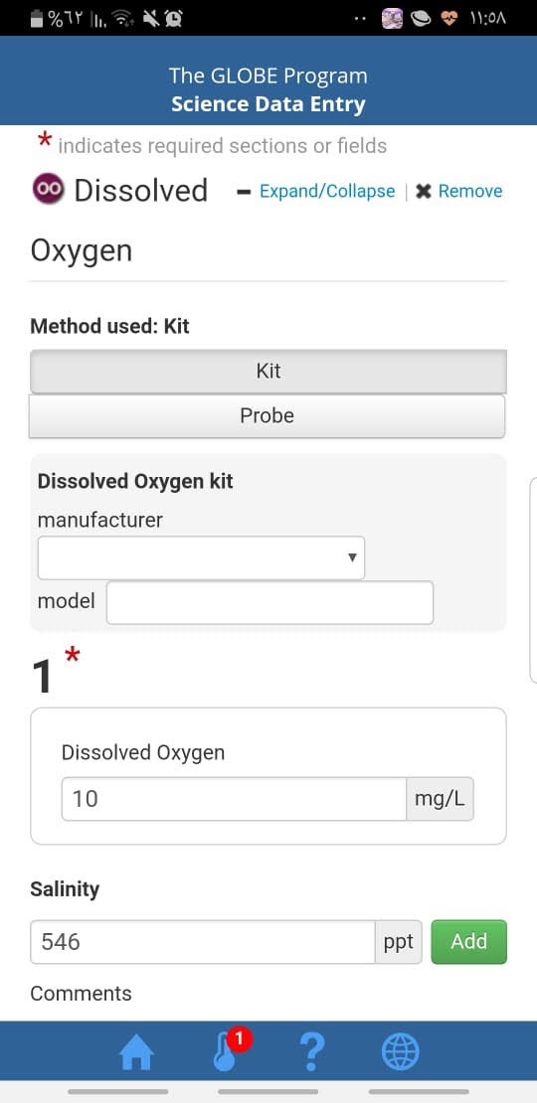

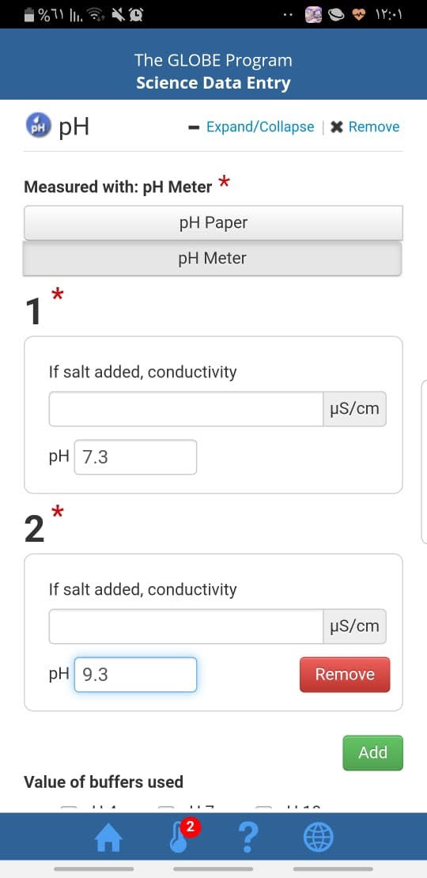

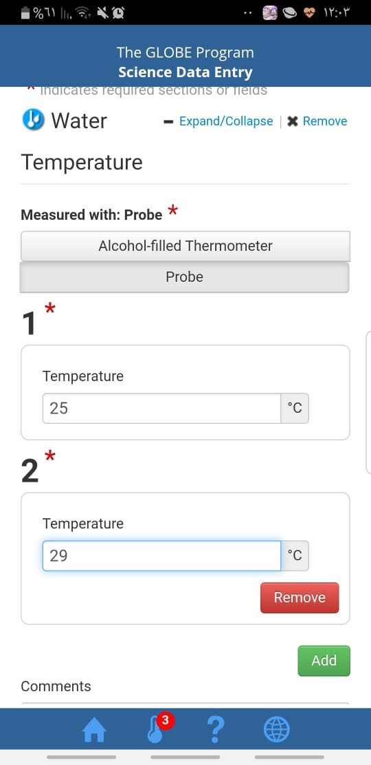

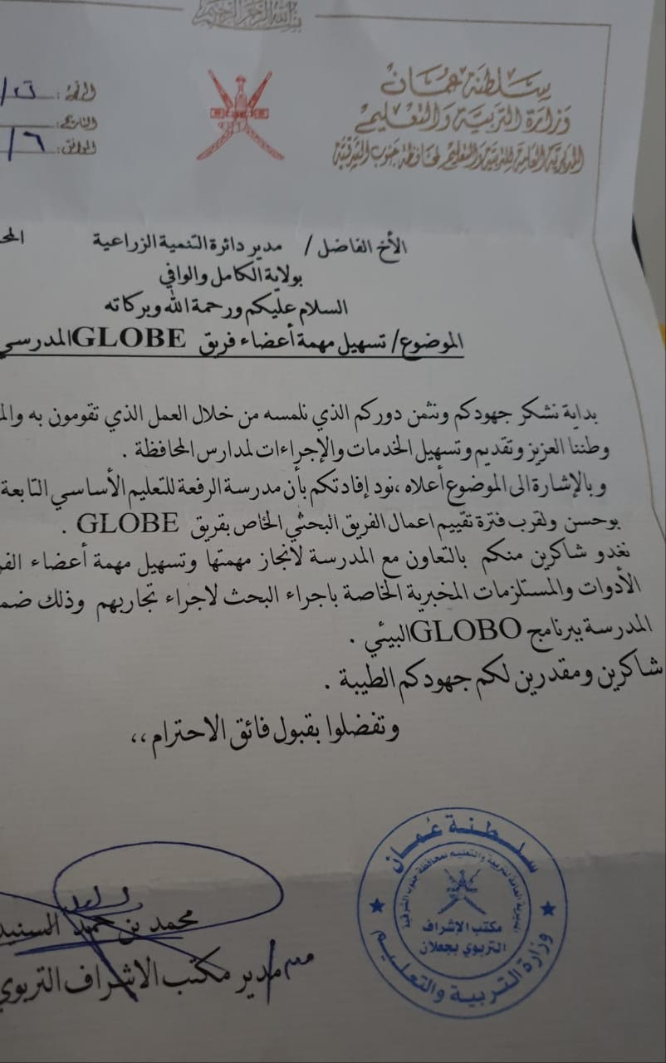
Appendices:

