Full name of school: OŠ „ Valentin Klarin“
Place (and postal code): 23 273 Preko
Adress: Cesta hrvatskih branitelja 39h
Phone number, e-mail of school : 0038523 286 115: vklarin@os-vklarin-preko.skole.hr
Name of teacher, phone number, e-mail: Jasminka Dubravica, 00385915722563, jdubravi@gmail.com
Students : Matia Pažanin ( 8 .), Sara Štrmelj ( 7 .), Paola Stanić ( 8.)

METEOROLOGICAL PHENOMENA IN PREKO IN 2017.

Project Summary:
The aim of our project was to monitor the meteorological phenomena in Preko in 2017. We started our observations on 1.01.2017, and lasted until 31.21.2017. We have selected the following meteorological changes: fog, frost, hail and thunder. We compared our data with us to the nearest meteorological station in Zadar. The questions are:
1.What conditions do the selected meteorological phenomena occur?
2. How often do they appear?
3.What annuals occur?
For the development of our project, we used the official web pages of DHMZ and the "Climate Atlas of Croatia". From the selected meteorological phenomena during the exploration period, we noticed the thunder, the frost, the hail, the dew, until we noticed it.
As we assumed the most common phenomenon was the thunder and the darkest rose. Our observations could not be performed for 24 hours and we probably missed it, especially those that happen early in the morning or at night. This is probably the reason why we only saw the dagger once, although according to the data closest to the weather station Zadar was a very common occurrence.
Our hypothesis that the most faded will be in the winter and that the most common occurrence will be the thunder we have confirmed, while the hypothesis of appearing beats and roses in spells and falls have not been confirmed. We have confirmed the fogging hypothesis at all seasons although according to HDMZ data it is not so. Probably because we do not always recognize the fog.
We saw the thunderstorm in all seasons, except in the spring. Frost, weed and dew we saw in winter and fog in all seasons.
Thunderstorms occur in high temperature conditions, high humidity and low pressure, fog in high humidity conditions and low morning temperatures, hail and frost in low air temperature conditions, and dew in low morning and high humidity conditions.
Purpose and Purpose of Work:

We have observed the meteorological phenomena in Preko, starting on January 1, 2017. We have chosen to observe the following meteorological phenomena: fog, frost, dew, hail, thunder and hail.

Research questions:

1.What conditions do the selected meteorological phenomena occur?
2. How often do they appear
3.What annuals occur?

Hypothesis:

We assumed that:
- Most of the frost and it is in winter,
- the most common occurrence is thunder,
- horns and diadems appear in spring and autumn,
- fog is most likely to occur in all seasons.

Research Plan:

For our project, we decided to analyze the meteorological phenomena in Preko in the period from 01.01.2017 to 31.12.2017. years. These values ​​are compared with data from the main meteorological station of the State Meteorological Institute (DHMZ) in Zadar.
Meteorological phenomena are the following: fog, frost, dew, hail, thunder.
We used the Internet to find out more about climate events in Croatia. They also helped us a lot in the official web pages of DHMZ and the "Climate Atlas of Croatia".

View and analyze data:
During the study period we recorded the meteorological events of those days when they were observed. We have been watching all day, and dudes just after school shift in the morning shift. Probably we have not been able to record all the occurrences because some disappear with the appearance of the Sun, such as a rose that we did not notice during the weekend, the holidays, or the afternoon shifts (because we later woke up). There is also the possibility that some occurrence occurred at night while we were asleep, such as thunder, thunder or fog, and we could not see them.
From the meteorological phenomena we noticed: fog, dew, frost, hail, thunderstorm.

Prior to the observation of the meteorological phenomena we have analyzed their definitions in order to determine them with certainty:

Fog - the appearance of very tiny drops of water floating in the air and reducing the horizontal visibility, ie the distance to which objects on the Earth's surface can be seen. The appearance is considered as a fog if it reduces horizontal visibility to less than 1 km from the observation point, but also vertical because the clouds or the sky do not see. The fog is white, but in large cities and industrial areas, smoke and dust may have a dirty yellow or grey color. Relative moisture humidity is usually close to 100%.

Dew - water droplets on objects on the ground or near the ground, especially plants, which are created by the condensation of water vapor in the surrounding air. Pink is most commonly formed in bright and silent nights on a relatively chilled substrate, and can occur even in cold and humid conditions when it comes into contact with a relatively cold substrate. Rose appears predominantly in open spaces and horizontal surfaces.

Frost (salt) - appears as ice crystals on soil and objects near the ground. When viewed close-up, these crystals are shaped like shells, needles, perches, or patches. The frost is formed in clear and quiet but cold nights, when the night cools the soil and objects near the ground cool below 0 ° C, so the water vapor near the ground sublimates into ice crystals.

Hail is the result of ice crystals deposits on branches and objects. It is created in very cold (about -2 ° C up to -10 ° C) and foggy weather.
Thunderstorm - the appearance of electric discharge in the clouds or between the clouds and the Earth. In this discharge, the electric spark leaves a broken and branched flame line of very short duration called the lightning. The bang that occurs in this case provokes the characteristic sound that we call bushing. Swaddling (city, ice) - precipitation in the form of balls or ice pieces of different shapes of diameter between 5 and 50 mm, sometimes larger. Grain beans are either completely transparent or are assembled alternately of blurry and transparent layers. They fall apart or lined in irregular shapes. Falling beats are usually followed by strong or long-term thunderstorms and never occur at temperatures below 0 ° C. Thunderstorm and thunderstorm are cumulonimbus-related occurrences, most commonly occurring in an unstable atmosphere by raising air from the ground or by glimpsing the air to the orographic obstacle.
Our observations are presented in table and graphic:
Table 1. - Annual walking of the number of days with meteorological events from 01.01.2017. to 31.12.2017.
 | I | II | III | IV | V | VI | VII | VIII | IX | X | XI | XII | Sumary
Thunderstorm | 1 | 2 |  |  | 2 | 2 | 1 |  | 6 | 1 | 1 |  | 16
Hail | 1 |  |  |  |  |  |  |  |  |  |  | 1 | 2
Fog | 1 | 3 | 1 | 1 |  | 1 |  |  |  | 5 |  |  | 12
Frost | 6 |  |  |  |  |  |  |  |  |  |  | 4 | 10
Dew | 1 |  |  |  |  |  |  |  |  |  |  |  | 1

Table 1 shows that the most common occurrences were thunder and fog.
The most common occurrence was a rose and was only observed in January. Fever and frost were observed in January and December, and the rose in January. We did not notice the appearance.

The frequency of the meteorological phenomena is prophesied and graphically:

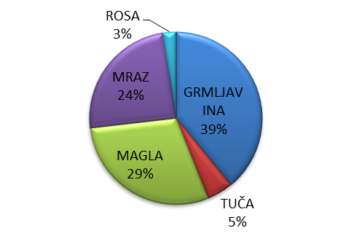
Graph 1. - Frequency of meteorological phenomena in the investigated period
From the graph we can see that most of our exploration period was thunderstorms, and the least rocks and rocks, as we expected. We have made graphs for each meteorological event:
Graph 2.-Annual run of the number of days with thunderstorm
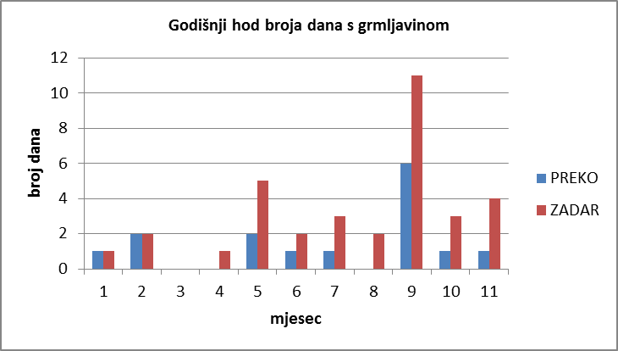
We have seen the thunderstorm in 8 months, almost in all seasons - except in the spring. By examining our data with the nearest station in Zadar, we see different results, probably because the thunderstorms occurred at night during sleep. From the experience we know we are banging regardless of the season. We wanted to investigate what was needed to get the thunder and we were investigating the days with thunder
Table 2. - Air humidity, mean daily air temperature and air pressure in thunderstorms
Date | Relative humidity  ( %. ) | Average daily air temperature  (°C. ) | Air pressure (hPa)
10.01.2017. | 100 | 11,8 | 1000
6.02.2017. | 90 | 12 | 997
7.02.2017. | 80 | 11 | 1008
15.05.2017. | 70 | 19 | 1006
21.05.2017 | 68 | 19 | 1018
14.06.207. | 68 | 25 | 1010
25.06.2017. | 62 | 25 | 1010
11.07.2017. | 63 | 29 | 1013
2.09.2017. | 68 | 25,5 | 1008
10.09.2017 | 81 | 23 | 1006
11.09.2017. | 100 | 20 | 1000
16.09.2017. | 70 | 24 | 1010
17.09.2017 | 90 | 22 | 1010
22.10.2017. | 95 | 19 | 1012
26.11.2017. | 68 | 11 | 1010

From the data we can see that air humidity ranged from 62% to 100% in the selected days, with a mean daily temperature of 11.8 ° C. to 29 ° C and air pressure from 997 hPa to 10013 hPa. We can conclude that thunderstorms took place in conditions of high temperature, low pressure and high humidity.

Graph 3.-year walk of the day with the frost

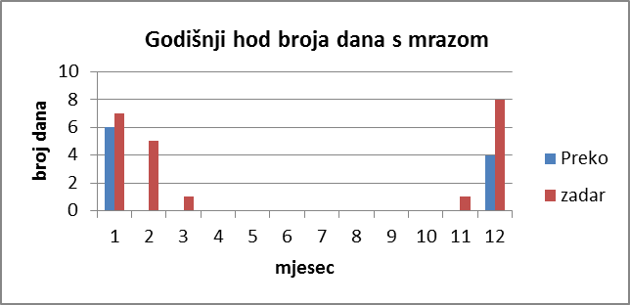
Frost appeared only in two months - January and December. After the data came to Zadar, frost appeared several times as we noticed because it probably appeared in the very early hours of the morning and we did not notice it. It was to be expected that frost would appear in the winter months, because the air temperature required for its formation is needed. We looked at the temperatures during this period and found that the lowest morning temperatures were -5 ° C to 1 ° C.
The hail appeared in the same period accompanied by thunder at low temperatures of -5 ° C to 10 ° C.
Graph 4.-Annual run of the number of days with hail
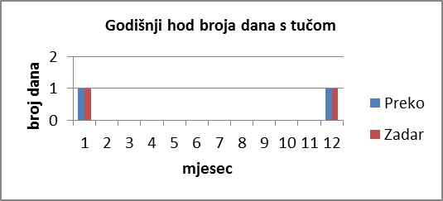
The hail appeared only in two months (January and December). Data from our closest weather stations show the same.

Graph 5.-The annual walk of the number of days with fog

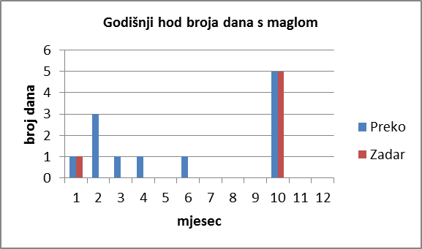

Fog showed up in seven months throughout the year. The fog was the most in October. We wanted to see what kind of atmospheric conditions were in the days that favored the development of the fog. The conditions in which the fog was formed were high humidity (80% to 100%) and low morning temperatures (9 ° C - 13 ° C).
According to the data closest to us, we can see that we have recorded the fog more than once, probably because we recognized some other phenomena as fog.
Graph 6.-Yearly Walk of the Day with Dew

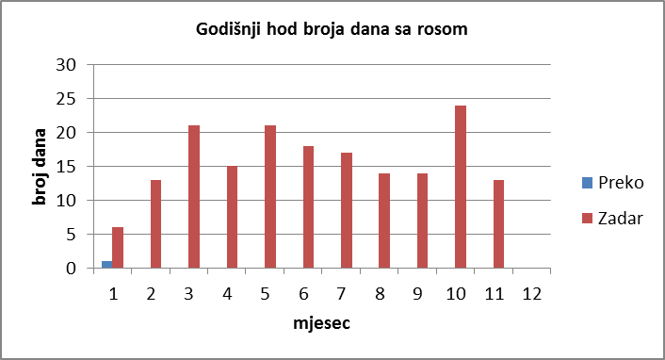

The dew appeared once during our observation, as opposed to the closest to us, the station that registered the daggers more frequently. The reason is probably that the rose appears late in the evening and early in the morning and we could not see it. The rose was created in conditions of high relative humidity (98%) and lower temperatures (4 ° C)

Conclusion:
From the selected meteorological phenomena during the exploration period, we noticed the thunder, the frost, the thunder, the dew, until we noticed it. As we assumed the most common phenomenon was the thunder and the darkest rose. Our observations could not be performed for 24 hours and we probably missed it, especially those that happen early in the morning or at night. This is probably the reason why we only saw the dagger once, although according to the data closest to the weather station Zadar was a very common occurrence. Our hypothesis that the most faded will be in the winter and that the most common occurrence will be the thunder we have confirmed, while the hypothesis of appearing beats and roses in spells and falls have not been confirmed. We have confirmed the fogging hypothesis at all seasons although according to HDMZ data it is not so. Probably because we do not always recognize the fog.
We saw the thunderstorm in all seasons, except in the spring. Frost, weed and dew we saw in winter and fog in all seasons. Thunderstorms occur in high temperature conditions, high humidity and low pressure, fog in high humidity conditions and low morning temperatures, hail and frost in low air temperature conditions, and dew in low morning and high humidity conditions.
Literature:
https://meteo.hr/ ;
D. Kraljev; K. Zaninović; M. Gajić- Čapka , 2010: U okrilju sunca i mora, Biblioteka Grad,Zadar,

