**CLIMATE VARIABILITY AND ITS CONSEQUENCES ON DAKAR COMMUNITY, SENEGAL**

**School** : Lycée Seydina Limamoulaye

Site-01 Atmosphere Limamoulaye

N  14.7769 W 017.37885 altitude +34 m

**Students** : KHadim ; Asmiou ; Madoye ; Souleymane ; Fary and team

**Level** : High School

**Teachers** : Mme Bousso ; M. Ndiaye and team

**Protocols** : Atmosphere

**Badge** : Community

Contents

Summary : 1

Research questions : 1

Research objectives 1

Research methods 1

Results and discussion : 2

Study area 2

Geographical location 2

Climate 2

Temperature and Rainfall variability 3

Conclusion and recommendations 4

References : 5

# Summary :

The variation of the temperature and the rainfall can have harmful consequences on the human populations. The consequences can be social, economic and psychological that can last for a long time. GLOBE atmospheric data, can be analyzed to inform us about climate variability and its relations with the floods that occur in the suburbs of Dakar. This project will enable us to carry out awareness-raising actions on adaptations to climate change and also create an early warning system that reduces the effects of climate variability.

# Research questions :

1. How important is GLOBE climate data in analyzing climate variability?
2. What is the relationship between climate variability and occurrence of floods in Dakar?
3. How can GLOBE climate data help to educate people about climate change and its consequences?

# Research objectives

* To determine the variability of rainfall and temperature using GLOBE data.
* Find out the relationship of climate variability and flood occurrence in Dakar
* Suggest strategies of educating Dakar community about climate variability and its consequences?

# Research methods

Atmosphere, temperature and rainfall protocols are used for this research. At each solar noon, students will collect data at the meteorological shelter located in the high school. The data are mentioned on the daily progress sheets. At the end of each month, students calculate average temperatures and total monthly rainfall. At the end of each year, annual temperatures and rainfall are calculated. During this study, complete data from 5 years of study from 2004 to 2008 were used.

# Results and discussion :

## Study area

### Geographical location

Found in west Africa, Senegal is bordered by Mauritania in the north, Mali to the east, Guinea to the south east and Guinea-Bissau to the southwest. Senegal also borders the Gambia, a country occupying a narrow silver of land along the banks of the Gambia river which separates Senegal’s southern region Casamance (figure 2) from the rest of the country. Senegal also shares a maritime border with Cape Verde. Senegal’s economic and political capital is Dakar.

### Climate

Senegal has a tropical climate with pleasant heat throughout the year with well-defined dry and humid seasons that result from northeast winter winds and southwest summer winds. The dry season (December to April) is dominated by hot, dry, harmattan wind. Dakar's annual rainfall of about 600 mm (24 in) occurs between June and October when maximum temperatures average 30 °C (86.0 °F) and minimums 24.2 °C (75.6 °F); December to February maximum temperatures average 25.7 °C (78.3 °F) and minimums 18 °C (64.4 °F).

Interior temperatures are higher than along the coast (for example, average daily temperatures in Kaolack and Tambacounda for May are 30 °C (86.0 °F) and 32.7 °C (90.9 °F) respectively, compared to Dakar's 23.2 °C (73.8 °F) ), and rainfall increases substantially farther south, exceeding 1,500 mm annually in some areas.

In Tambacounda in the far interior, particularly on the border of Mali where desert begins, temperatures can reach as high as 54 °C (129.2 °F). The northernmost part of the country has a near hot desert climate, the central part has a hot semi-arid climate and the southernmost part has a tropical wet and dry climate. Senegal is mainly a sunny and dry country.

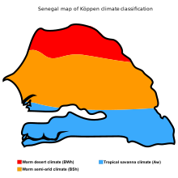

Figure 1 Senegal map of Koppen climate classification

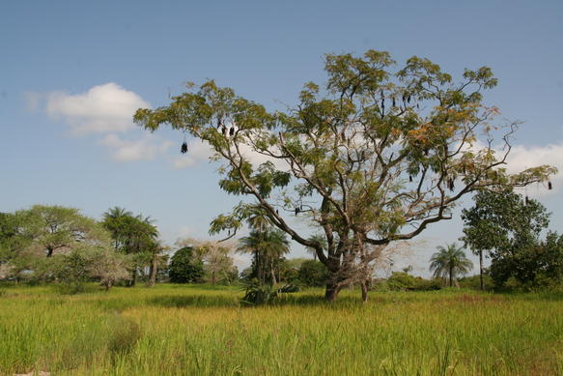

Figure 2 land along the banks of the Gambia river which separates Senegal’s southern region Casamance

### 

### Temperature and Rainfall variability

Table 1 shows that temperatures and rainfall has varied from year to year over the 5 years of sampling. We noticed the year 2005 was very hot with an average annual temperature of 26.90 ° C at the same time had a higher rainfall of 554.9 mm (see table 1). The data confirmed the low annual variability of temperature at our study site.

Tables 1 Annual temperature and rainfall at site-10 Atmosphere Limamoulaye

N 14.7769 W 017.37885 altitude +34 m

|  |  |  |  |  |  |
| --- | --- | --- | --- | --- | --- |
| Year | 2004 | 2005 | 2006 | 2007 | 2008 |
| Annual average Temperature ° C | 26.36 | 26.90 | 26.18 | 26.14 | 28.06 |
| Annual total Rainfall in mm | 253.2 | 554.9 | 291.9 | 218.63 | 361.3 |

Table 2 shows the variability of monthly temperatures and rainfall in 2005. There is also a change in climate during this year. 2005 is the year that caused the largest floods in the suburbs of Dakar, capital of Senegal. On a total rainfall of 554.9 mm, the 382.7mm or 76.54% of the rains were recorded in the months August and September (see table 2 and Fig 3). It was the accumulation of rainwater in 2 months that led to the flooding of the suburban base areas or low lands while the areas on the sand dunes and the Dakar plateau were not flooded. On average Dakar did not receive extreme rainfall, but because the land in the low areas has been badly utilized it caused floods. Other towns in the same climate belt received higher rains but it did not cause hazards like that experienced in 2005 around Dakar. Many people were displaced and their property was destroyed which required government to provide emergency services.

Table 2: Monthly distribution climate at site-01 atmosphere Limamoulaye

N 14.7769 W 017.37885 altitude +34 m for 2005.

|  |  |  |  |  |  |  |  |  |  |  |  |  |  |
| --- | --- | --- | --- | --- | --- | --- | --- | --- | --- | --- | --- | --- | --- |
| Month | J | F | M | A | M | J | J | A | S | O | N | D | Total |
| Temp °C | 23.3 | 21.6 | 24.2 | 23.8 | 27.6 | 28.5 | 29.2 | 29.4 | 28.8 | 29.7 | 28.3 | 28.06 |  |
| R/fall mm | 0 | 0 | 0 | 0 | 0 | 14.4 | 91.8 | 227.6 | 155.1 | 66 | 0 | 0 | 554.6 |

Figure 3. Monthly variation of temperature and rainfall Limamoulaye, 2005

# Conclusion and recommendations

The arguments are well founded, there is variability of the climate. The effects of climate change have adverse effects on populations. Students used climate data from their study site to conduct awareness campaigns on climate change adaptation. The floods are caused by an increase and bad distribution of the rains but especially to a bad management and occupation of the space. Low humid areas or low-lying areas, with urban extension, have been repacked and constructed. The students used the publication of these results, during the World Environment Day to inform populations and scientists about climate variability and to well understand the floods of 2005. Visualization of results gives more meaning to the flood risk area in Dakar (not shown here). This hazard greatly affected the low lands of Dakar. Being an economic city, it is congested and sometimes unplanned building are causing a negative feedback by causing floods. The key massage we give as pupils is to avoid building houses in low areas. Globe data continuously collected can assist in constructing an early warning system in future and also understand other areas in the country that are susceptible to floods. Globe protocols are also capable of informing communities about the quality of water during this season (not investigated). It is strongly advised the population to use low lands for farming than construction.

Slogan "No to the degradation of the environment! Yes to the protection of the environment! ", through applying GLOBE techniques.

# References :

The following were the reference resources used in this research ;

* GLOBE webside ([www.globe.gov](http://www.globe.gov))
* National management plan

# Appendices





