An Analysis of Photic Flashing in Photinus pyralis
to Light Pollution and Select Weather Parameters

Student Researchers:
Jenna Baydoun, Sarah Gargouri, and Zahraa Najaf

School:
Crestwood High School, Dearborn Heights, MI 48127

High School Science Teacher:
Mrs. Diana Johns

Table of Contents
____________________________________________________________________________
Abstract……………………………………………………………………………….….……1
Research Question…………………………………………………………………….….…...2
Null Hypotheses………………………………………………………………………….….. 2-3
Introduction and Review of the Literature………………………………………………..…..3-5
Investigation Plan……………………………………………………………………….…….5
Research Methods and Materials……………………………………………………….…….5-9
Results……………………………………………………………………………………..…10-13
Discussion………………………………………………………………………………..….. 13-14
Conclusion…………………………………………………………………………….…..….14-16
Bibliography/citations ……………………………………………………...……….………..16
Badges….………………………………………………………………………………….… 17
Acknowledgements……………………………………………………………………….….18

-Abstract:
Fireflies begin their mating season during early to mid-June in Southeastern Michigan but exact phenology varies year to year due to atmospheric, hydrologic, and other seasonal variations. Fireflies from two sites were sampled prior to beginning data collection in order to identify the specific species used throughout the research. After observing the firefly phenology, both specimens were identified as Photinus pyralis, a species indigenous to Southeast Michigan. Data collection began on June 18th, 2018 at two separate study sites. Site 1 was on a brightly illuminated main road located in a suburban neighborhood. Site 2 was farther off in a secluded area near a large grouping of mature trees, and where a significantly less amount of light pollution was evident. A variety of GLOBE weather data was collected daily including air temperature, air pressure, daily rainfall, humidity, etc., along with readings of light pollution using a “Sky Quality Meter (measures the brightness of the night sky in magnitudes per square arcsecond). Researchers would head out daily to count the number of flashes and record GLOBE data around dusk. Information was then entered into the GLOBE database website and entered onto an Excel spreadsheet for future reference. An analysis of the data found a positive correlation between firefly flashes and light pollution, humidity, temperature, and precipitation. Fireflies were chosen for this research because of their potential sensitivity to light pollution and climate change. It’s hoped that this research can serve as a benchmark for local studies to see how populations of similar species might be impaired by habitat and climate change. For future references, it would be better to find a way to count the actual number of fireflies in each site as opposed to evaluating their flashing activity, allowing us to precisely pinpoint where population densities are present.
Key Words: Photinus pyralis, light pollution, humidity, suburban, flash frequency
-1-

-Research Questions:
(1) Do select parameters such as light pollution, rainfall amounts, humidity, and temperature play a role in firefly population numbers or fewer firefly flashes?
(2) What could be the possible underlying causes of recent firefly decline in the past few years? (3) How do these two select sites differ in select atmospheric parameters and firefly flashes?
Fireflies and their summer glows have captivated the interest of children and adults in many places around the world for thousands of years. Fireflies are actually beetles belonging to the insect order Coleoptera and the beetle family of Lampyridae. In the United States alone, there are at least 170 different species belonging to the Lampyridae family. The species studied in this research, Photinus pyralis live anywhere from 5 to 30 days. Certain firefly species produce photic flashing while others do not. Scientists are concerned about firefly populations as they are a very visible bio-indicator of the decline in overall numbers of insects; a phenomenon that appears to be happening in many places around the world and commonly coined as the Insect Apocalypse. An additional goal of this research study is to inspire GLOBE students around the U.S. and world to pursue similar projects so that population data on this beloved insect can be used to help promote a better understanding of firefly habitat requirements and sensitivities to light pollution. In order for us to test the validity of these questions, for approximately three consecutive months, we constructed a plan to go through the process of data collection, requiring us to measure certain weather parameters necessary for data analysis.

-Null Hypotheses:
(1) Light pollution does not play a role in the decreased abundance and distribution of the
-2-
Photinus pyralis firefly population.
(2) There is no difference between air temperature, humidity, light pollution throughout the two study sites.
(3) There is no difference between the firefly flashes frequency and numbers observed in Site 1 and Site 2 on a daily basis.
-Objective(s):
This research sought to determine to what extent light pollution, localized atmospheric, and hydrologic conditions affect the population numbers of a formerly abundant firefly population.

-Introduction and Review of the Literature:
With an increase in night time light usage throughout the United States, the idea of photopollution, first coined by FJ Verheijen in 1958, has become rampant throughout our nation. (Rich 2). NASA satellite pictures of light pollution around the globe are good indicators of how humans have altered the formerly dark night. Dearborn Heights, like many local Southeastern Michigan communities, has seen a dramatic increase in night illumination around their homes with the development of LED lightning. Very few individuals in this community lit their homes at night because of the considerable energy costs involved. With inexpensive LED lighting available, homes have installed extensive night lighting, highlighting their home and its landscaping. Although firefly populations sometimes go through “natural booms and busts” in their numbers, this research was a great opportunity to take into account firefly flash patterns and
potential factors impacting their appearance (Bodin). The intial interest of this study was the impact of light pollution on several nocturnal species, but this is often difficult to observe due to
-3-
equipment requirements and other sampling requirements. From these limitations, the group of researchers decided to focus on light pollution and its correlation with firefly flash patterns. From her studies, Catherine Rich states that “foreign illumination may be detrimental because of signal intrusion” (352). A recent publication by Faust provided substantial guidance on scientific research in this area. No recent published research on fireflies exists for Southeastern Michigan leaving a big gap in our understanding of this once common insect. Due to the seemingly diminishing number of fireflies as each year passes on, taking accurate and precise measurements will have a large impact in determining whether or not the abundance and distribution of fireflies has decreased locally. This research chronicles just one summer of research, it is hoped that future students will continue and build upon and learn from this research as they plan their own investigations. The data collected during the Summer of 2018 will serve as a foundation upon which to continue and grow the local body of knowledge of Photinus pyralis. Many species of fireflies are considered bioindicators of environmental quality. Habitat loss, light pollution, disease, pesticides, and climate change are all often cited as reasons for the worldwide decline in fireflies as well as other species of insects. Many of the reasons for firefly decline may be synergistic in nature making their population losses difficult to study. Without solid data to support this anecdotal decline it is essential that students from many different locations both in the U.S. and around the world collect data that can be analyzed empirically. The data collected from many parameters such as light pollution (using a Sky Quality meter), air temperature, humidity, or even lunar illumination play a role in the final decision of whether or not firefly flashes are affected by it. Firefly flashes play a role in deciding around how many fireflies could be present that certain day. Although each firefly flashes many
-4-
times and the number of flashes do not equate how large the population is, the flashes do provide a general indication of activity. Although we took site specific weather data, it was always compared to our nearby school’s WeatherBug weather station.

-Investigation Plan:
A group of student researchers took daily measurements on air temperature, humidity, precipitation, and light pollution readings beginning on June 18th and continuing August 23, 2018. Researchers attempted to make measurements at dusk that varied throughout the summer especially after the summer solstice. It was also important to have an adult accompany us so that introduced some variation in our measurements. Photic flashing was evaluated for 5 minutes at each site to serve as a visual indicator of firefly activity. A spreadsheet was then made and with all the data recorded and then entered into the GLOBE website to compare with any similar research being conducted around the world. When students from our school returned from the GLE in Ireland they told us about a similar project completed by students in Thailand. We hoped to speak with them regarding their research but they did not respond to our inquiries. The Thailand project was titled: “Impact of Environmental Factor to Firefly Density”. We started our project before we were aware of their research but were heartened to discover that other like-minded students are attempting research similar to ours in other places around the world.

-Research Methods and Materials:
Both research sites were picked in a suburban neighborhood close to our high school. We created a GLOBE site for each location to input data into. Each site was carefully chosen for the
perceived difference in artificial lighting versus natural light, as well as other factors such as the
-5-
abundance of trees and localized microclimates. Rainfall data was collected from the rain gauge we have at school. Sky darkness (light pollution) was measured using Sky Quality Meter. and Kestrel Drop. Firefly populations were sampled in order to identify what species of the fireflies were present in the research area. We connected the Kestrel Drop to an app on our phone called the Kestrel Link and the WeatherFlow device on the Wind and Weather Meter for Ag. The Kestrel Drop was used in comparison to the WeatherFlow device as to verify accuracy. We also used the Light Pollution Map-Dark Sky and found that the Dearborn Heights/Detroit area was a moderate to high concentrated area of light pollution. When dusk fell and after the moon or sun could no longer be visible in the sky as to affect the Sky Quality Meter, we then went out and went first to Site one and walked across from the beginning of the street to the end. We counted firefly flashes along the first sites’ road and each site took 5 minutes. We wrote down our measurements on a spreadsheet located in our binder and came to the two sites daily from June 18th to August 23rd. Over the summer for each site, approximately 1,500 measurements were recorded and compared to Crestwood High School’s WeatherBug Weather Station to verify accuracy. We were unable to use the school’s WeatherBug system (except remotely) for most of the summer due to construction at our school. This also led to having to use other devices than our weather station to collect data with since the weather station was frequently down as they repaired our school’s roof throughout the summer.

-6-
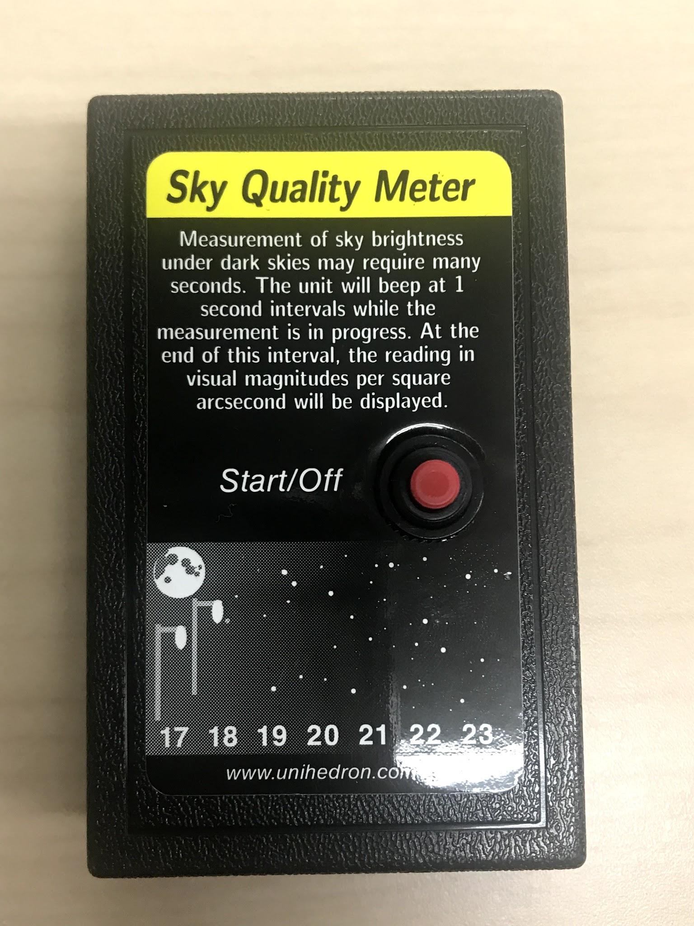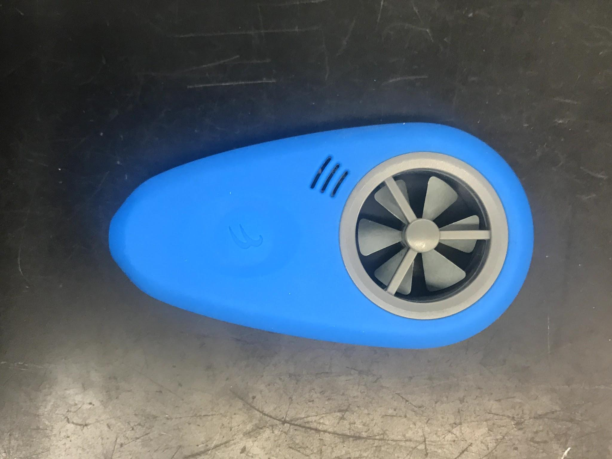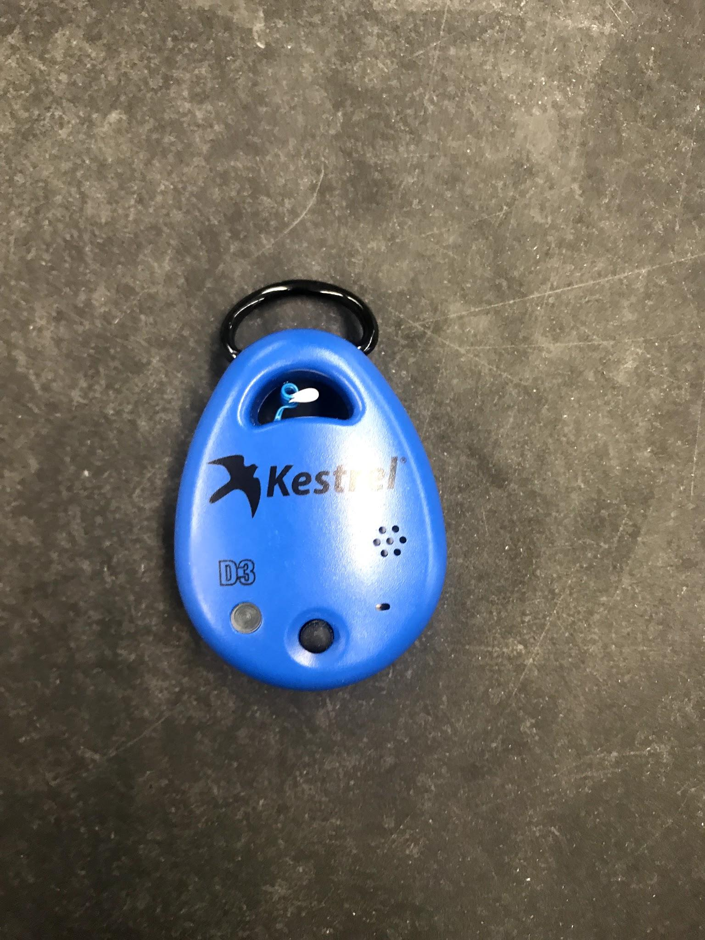
Figures 1-3: Figures 1, 2 and 3 (left to right) are the devices used to collect some of the research data. From left to right: Sky Quality Meter (no GLOBE protocol exists for light pollution, WeatherFlow (No GLOBE protocol exists for wind speed), and a Kestrel Drop to compare data with the WeatherFlow device.
Figures 4-6: Figures 4, 5, and 6 show the apps that were on our phones in correspondence to the devices used to collect measurements. Note that the Light Pollution Map was initially used to see if Dearborn Heights had significant levels of light pollution.
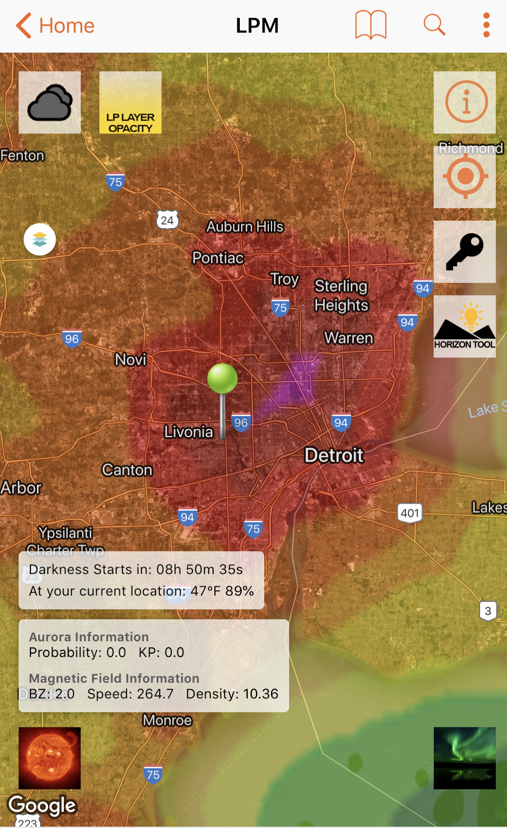
Figure 7: Figure 7 (below) shows a “Light Pollution Map” from our phones and Dearborn Heights and around the Detroit area where red means that a significant amount of light pollution.

-7-
Note that the data collected on the app is from 2016 which means it most likely is even more
concentrated in light pollution in 2018. Also note that the shade ranges from pink to blue with pink being the most light polluted and blue being the least light polluted. This can be verified because on another light pollution map; Detroit and the area around has a lower magnitude/sec^2 than surrounding areas meaning it’s more light polluted.

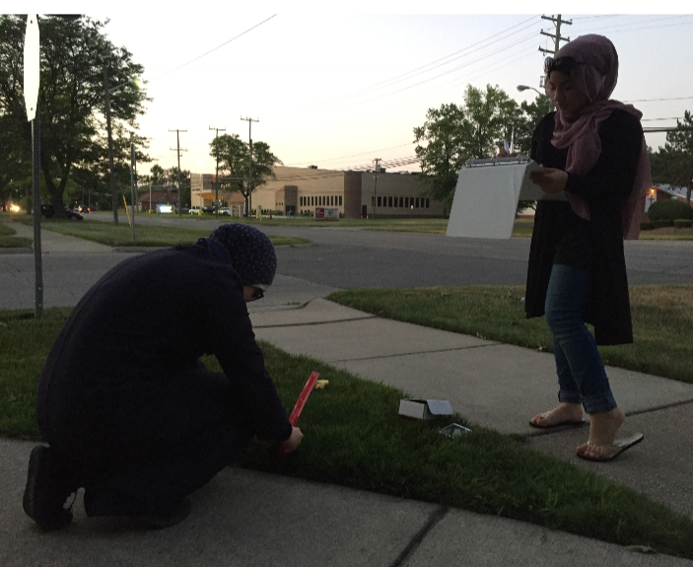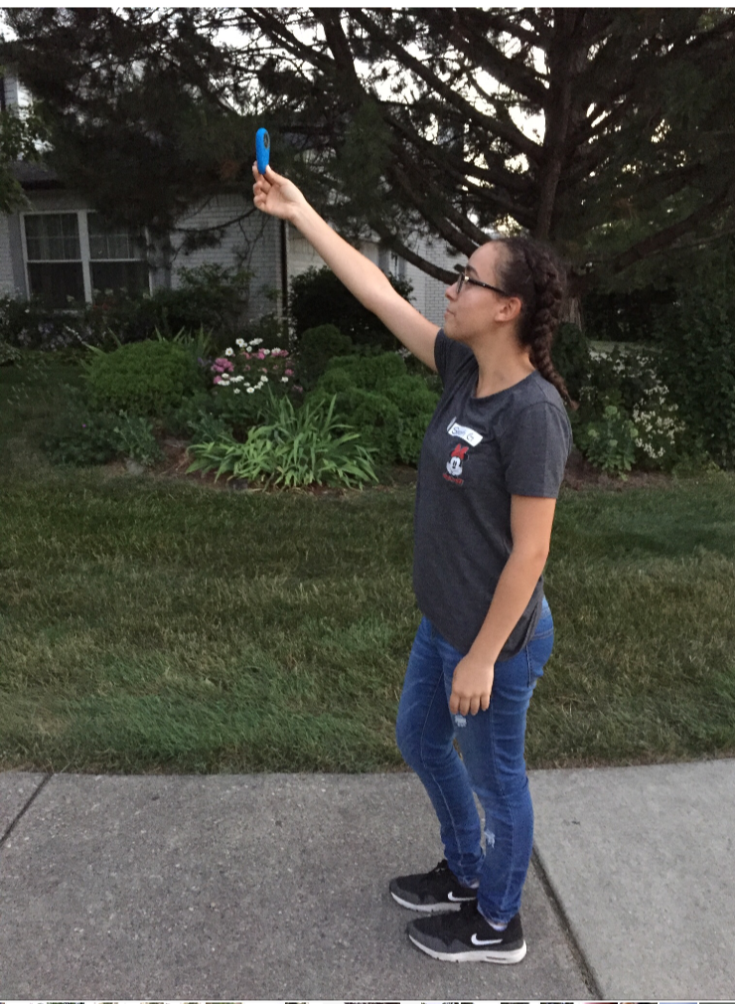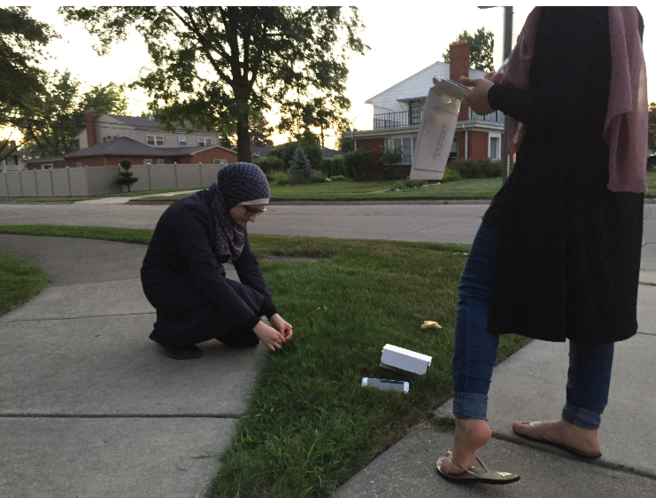
Figures 8-10: Figure 8, 9, and 10 (left to right) show student researchers collecting measurements like grass length, sky quality readings, and wind chill at Site 1.

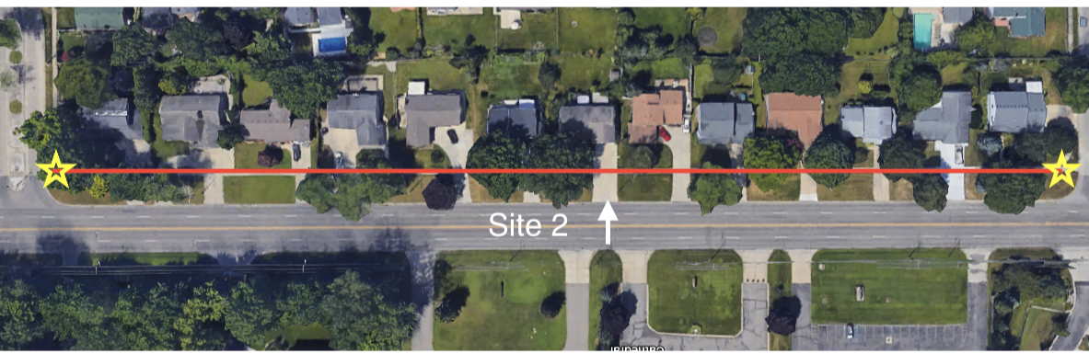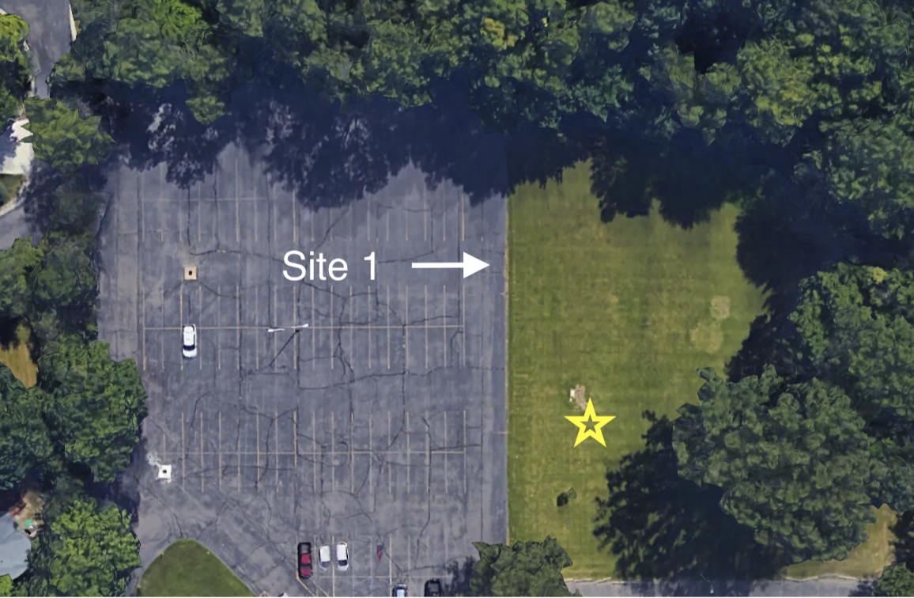
Figures 11-12: Site locations; Site 1 (left) and Site two (right) from Google Earth. The stars are where the researchers stood to take data and the long line in Site 1 is where they walked to count data. The researchers thought both the sites were about the same size although the size was not measured.

Over the course of the summer, data was entered into a paper spreadsheet and then later onto the Excel spreadsheet and after, the measurements inputted into the GLOBE website. This was guarantee that the results were safely stored and across multiple mediums.

-8-
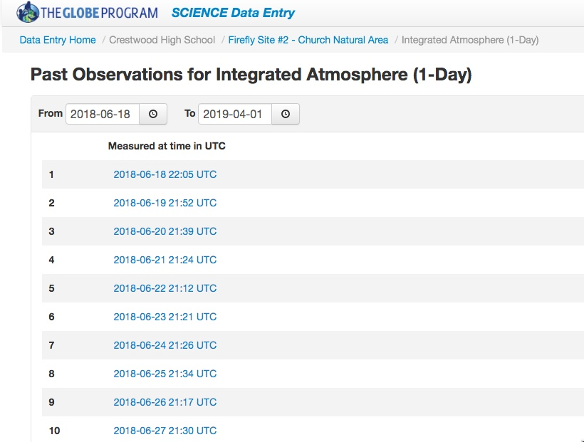
Table 1: Table one shows part of the measurements that was stored onto the Excel spreadsheet for analysis and for GLOBE entry between the two select sites. This was before separation of Site 1 and 2 and also before converting.

-8-

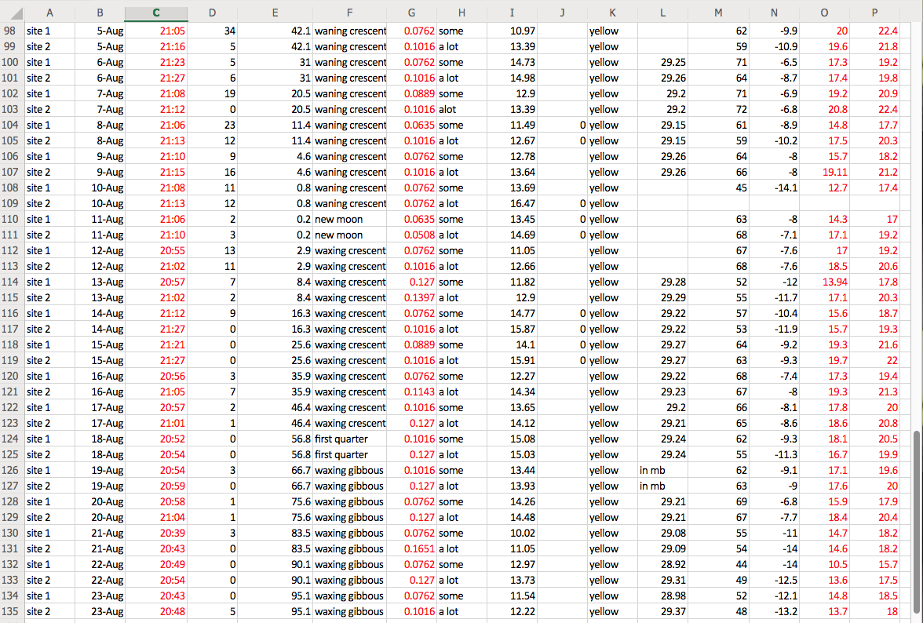

-9-

-Results:
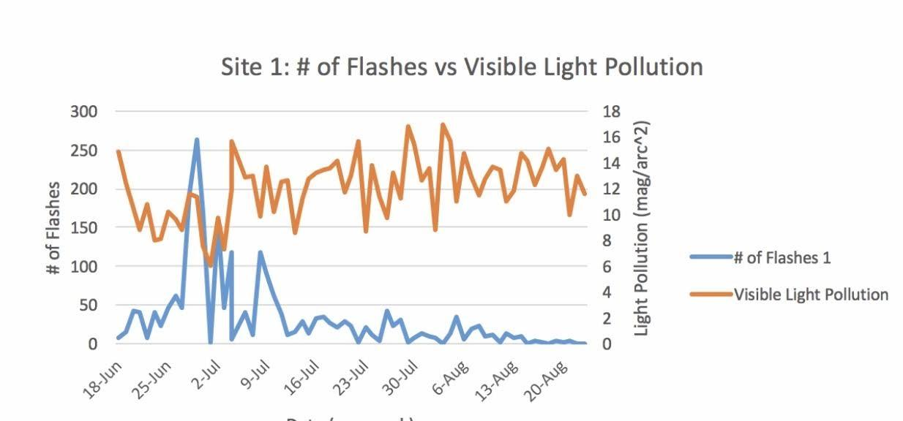
Figures 13: Figure 13 shows the number of firefly flashes present during the “prime” week in Site one; note that as the magnitude of light pollution drops, the number of flashes skyrockets.

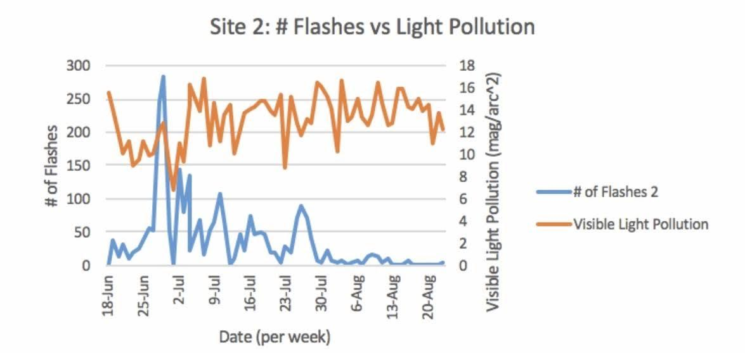

Figure 14: Figure 14 shows the number of firefly flashes present during the “prime” week in Site 2; note again that as the magnitude of light pollution drops, the number of flashes skyrockets as well.

Note again (Figures 13-14) that between Site one and Site two during the same week when firefly flashes were at a high, Site one tended to keep a range from 25-250 while Site two was mostly between 50-300. Therefore, Site two exhibited more firefly flashes; possibly because of the larger numbers displayed on the sky quality meter in Site 2.

-10-
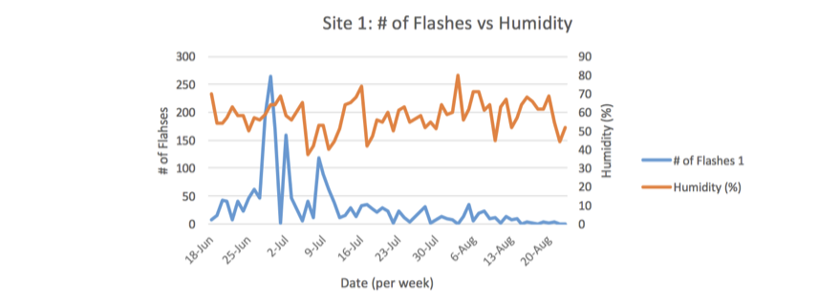
Figure 15: Figure 15 shows a correlation between humidity and flashes in Site one. Humidity ranged from 50-70% and when humidity stayed at around 60%, the number of flashes shown seemed to increase a little.

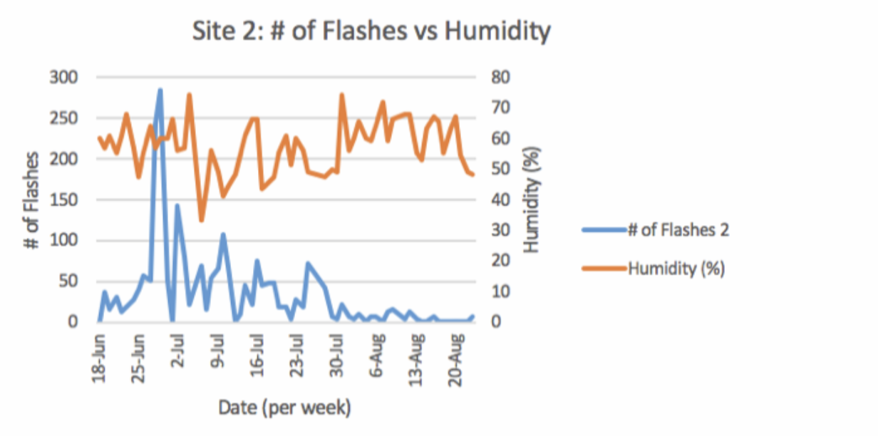
Figure 16: Figure 16 shows a correlation between humidity and firefly flashes(Site 2).

-10-
Humidity kept at a range between 50-70%. Furthermore, it seems as when the humidity stayed between 50-60%, the number of flashes seemed to spike up a little. Therefore, between Figures 13-14, it seems that an increase in the percentage of humidity affect the abundance of fireflies by increasing the number of flashes.

`
Figure 17-18: Figure 17 (bottom left) shows a correlation between flashes and temperature. (Site 1). Although temperature is fairly constant even though the number of flashes are changing, it must have some influence because when the temperature drops on July 19th-and there was no precipitation that day-the number of flashes drop as well. Again with Figure 18 (bottom right) whenever the temperature was above 25 °C numbers peaked.

-11-
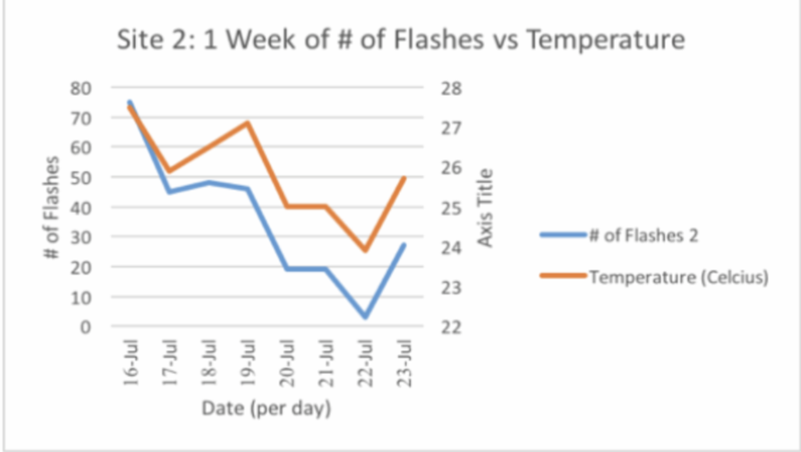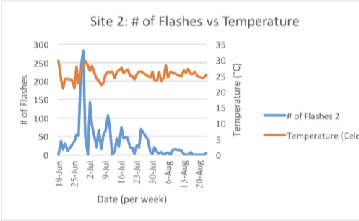
Figures 19-20: Figure 19 (bottom left) shows a week whereas the temperature decreased and increased, there seemed to be a direct correlation with firefly flashes. (Site 2). Figure 20 (bottom right) shows the overall months of data collected and overall, the temperature maintained over 25 °C and the number of flashes seemed to increase when temperature increased.

Overall, Site 2 had a higher overall temperature than Site one did all summer even though it was surrounded by woods. Site two also had a higher number of flashes as well which demonstrates that firefly numbers seemed to increase when the temperature increased.

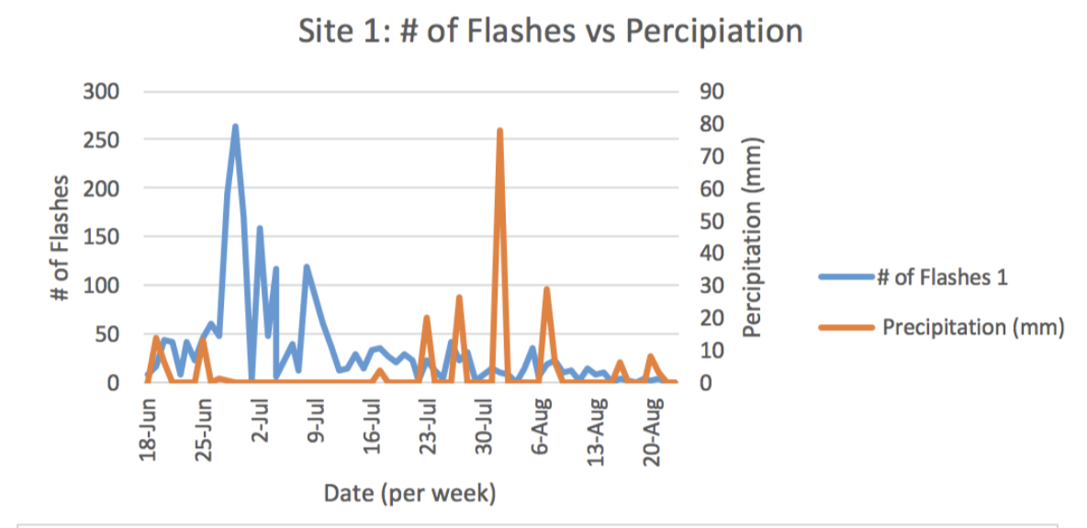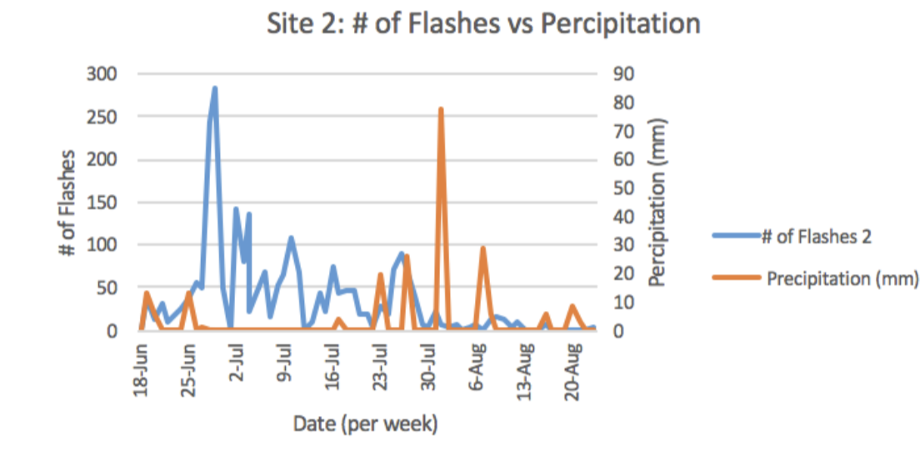

Figures 21-22: Figure 21 (bottom left) and Figure 22 (bottom right) show the correlation between the number of flashes and precipitation (mm). As the precipitation decreases, the number of flashes increases and vice versa for both sites.

-12-
Note that both figures convey precipitation over the course of the project as there wasn’t that much precipitation.

In order for us to properly analyze the data, we converted certain parameters to configure to the GLOBE unit requirements. This allowed us to compare specific factors of our data with others on the GLOBE database; therefore, enabling access to different factors that could have potential in affecting firefly activity.

Discussion:
After conducting research on the distribution and abundance of firefly populations using such parameters of air quality and humidity, the student researchers were able to reject all the null hypotheses. We have found a correlation between the firefly flashes and light pollution as Site 2 generated more firefly flashes than Site one. This could be because of the artificial lighting in Site one that causes light pollution as we saw on the Sky Air Quality meter. Site one generated lower readings on the Sky Quality Meter which meant that there was more lighting in the area and is accurate as it was surrounded by streetlights and other artificial lighting. However, there could be potential errors that may have affected our results. For example, the times we went out every day weren’t exact as we followed when dusk started and we measured Site 2 after Site 1, possibly rendering our results to make them inaccurate and could be a pliable reason for the few possible outliers in our graphs. However, the Kestrel Drop as well as the WeatherFlow Weather Meter correlated with similar measurements as Crestwood High School’s WeatherBug data so the data aspect is accurate. In addition, we observed that Site one had shorter grass and lesser

-13-
abundance of trees than Site 2, thus resulting in why Site 2 had higher occurrence of firefly flashes. Humidity and temperature seemed to play a role as well by having around 60% roles inducing spiked firefly flashes. Same could be said for precipitation as an little to none gave a fairly high number of flashes compared to having precipitation. The student researchers understand the data that they have collected, as these results could be used for further references by scientists to further reach a conclusion on whether the firefly population has been on the decline. As this topic of research does not have many publications, there wasn’t a wide range of studies to compare findings with. In specific, we focused on the works of naturalist Lynn Frierson Faust who from her book Fireflies, Glow-Worms, and Lightning Bugs, goes on to elaborate on specific glow characteristics of fireflies indigenous to the United States of America. With the results of this study, we can safely say that we reject our null hypothesis and accept our hypothesis, which includes the four main factors affecting firefly distribution and abundance.

Conclusion:
After gathering some measurements on air quality, humidity, temperature and even precipitation, significant differences can be seen between the two sites as Site one-the site with artificial lighting and in a suburban neighborhood-had noticeably less firefly flashes as the second site. Thus, air quality or the light pollution in the two sites proved to be one of the driving factors in the abundance and distribution of fireflies. This rejects our null hypotheses as there was a
noticeable difference in firefly flashes between the two sites as well as rejecting our first null hypotheses as light pollution seemed to have an effect. The second null hypotheses is also

-14-
rejected as temperature and even humidity seemed to play a role in the lesser abundance of firefly distribution. As shown from Figures 11-12, observations were made that Site two may have had an increase in the number of flashes than Site one because of the greater magnitude the Sky Quality Meter picked up and also meaning that it was darker and less light-polluted. Humidity seemed to play a bit of a role in flashes as well because as shown in Figures 13-14, and increase in humidity overall generated in spike in numbers. Site two generally had a higher percentage of humidity and also a higher number of flashes than Site one giving way that keeping around 60% humidity helped keep the abundance of fireflies up. In addition, temperature also had a role in firefly abundance because as shown in Figures 17-20, an increase of firefly flashes seemed to generate from an increase/ constant temperature around 25℃. Precipitation could also have an impact on firefly flashes as well as there seemed to be a direct relationship between no occurrence of rain-more fireflies- and vice versa in both sites. The student researchers accept their hypothesis as air quality, humidity and other parameters could have an effect on the distribution and abundance of fireflies. Overall, this research could be used in the future to compare between other species’-including us!- biological clocks from the effect of light pollution. The additional air parameters could also be utilized in the future for aerosols as the student researchers even collected data on wind chill, wind speed, etc. In addition to that, monitoration of nocturnal species circadian rthyms can also be viewed as a result of this data collection. Although we tried our best to gain the most precise data possible, certain limitations that could be avoided in the future arise. By increasing our firefly count precision and by collecting data at the same moderate time frame we could in the future account for a larger sum
of more accurate data findings. Following improvements to methods, future protocals that could

-15-
be added to correlate between firefly density and firefly flashes rather than exact population numbers. As firefly flashes don’t exactly correlate with exact population numbers, it was difficult to get an exact firefly counts due to the rate at which fireflies flash in six second intervals, making it impossible for a naked eye to catch every flash accurately. Without the help of our project mentor Mrs.Diana Johns, we would have not been able to follow through in a certified manner of data collection that adheres to GLOBE protocols.

Bibliography/ Citations:

Literature Cited:

Bodin, Madeline. “A Field Guide for Flickering Fireflies” Popularmechanics.com, 5 Jul. 2012.
https://www.popularmechanics.com/science/animals/a7726/a-field-guide-for-flickering-fireflies-9077287/

Faust, Lynn F. Fireflies, Glow-Worms, and Lightning Bugs. Athens, University of Georgia Press,
2017.

Lewis, Sara. Silent Sparks: The Wondrous World of Fireflies. Oxfordshire, Princeton University Press.2016.

Rich, Catherine, and Travis Longcore. Ecological Consequences of Artificial Night Lightning.
Washington DC, Island Press, 2009.

“Using Sky Quality Meters to Measure Sky Brightness” Globeatnight.org.
https://www.globeatnight.org/sqm.php

Source: “Dearborn Heights” 42.315728, -83.291742. Google Earth. 2016. March 23, 2019.

-16-
Badges:

Be a Collaborator- We tried to compare our data with Ms. Jintana Motong from Thailand as they did a similar study on fireflies but unfortunately were not able to get a hold of them. The group that conducted this research consisted of three members who all contributed to this project. Jenna Baydoun and Zahraa Najaf inputted the data onto the GLOBE website and Jenna created the graphs between the two sites. Zahraa Najaf created the spreadsheet with the data collected in the summer 2018. Sarah Gargouri created the research paper and together with Zahraa Najaf, created a presentation for the research poster.

Be a Data Scientist- The student researchers were able to find correlations between factors such as light pollution, humidity, precipitation, temperature and firefly flashes when analyzing graphs. Limitations of this research resulted from extended time frames of data collection and certain challenges coming from exact flash counts. For future events, introduction of methods for more precise data collection can increase the credibility of this project, positively affecting the accuracy of the data collection process. Without a wide range of published works to infer from, we weren’t able compare and contrast readily with other availabe data resurces.

Make an Impact- Prior to conducting research on fireflies, the student researchers reminscensed the times when they used to count fireflies in their backyard as children. Years later, it seems although that the firefly population has diminished, this research could contribute to a positive impact on the firefly community by providing insight and taking action into the average person to spread awareness on this beloved insect population.
-17-
-Acknowledgments:
A special thank you to the GLOBE Program and our school’s two local partners, Mr. David Bydlowski (AREN-Wayne RESA) and Dr. Kevin Czajkowski (Mission Earth-University of Toledo) for providing access to equipment used in this research. Without the funding and support of these individuals and their organizations, we would not have been able to accurately collect data. We are also appreciative for the opportunity to conduct research and share it with others around the world through the GLOBE program. Our trip to present at the GLOBE 2019 Midwest Science Research Symposium was totallly transformational. We are hopeful that others will find it interesting and will choose to collaborate with us in future research projects. We would also like to thank our science teacher, adviser, supporter and inspirer Mrs. Diana Johns who made this scientific pursuit possible by guiding us in the right direction. It’s been a wonderful learning experience that has enriched us in many ways.

-18-

