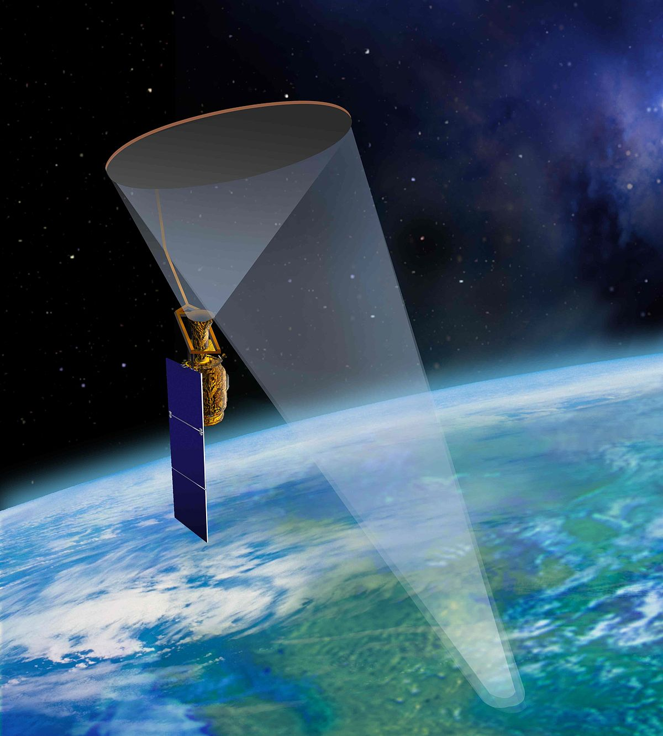  comparing soil moisture  Comparing the moisture of soil between forested and unwooded soil | Abstract  In this report, the difference in soil moisture of soil in a forest and soil outside of a forest will be discussed. There is a prediction that there is not a lot of soil moisture in a forested area, because of the trees that absorb and block the water, and more in an unwooded area. This research was done by getting a soil sample from a forested and unwooded area and drying it. By weighing the difference before and after drying, the soil moisture could be determined. After performing the research, it was calculated that the soil in a forested area consists for 9,1% of water and in an unwooded area for 12,3%. This means that the hypothesis is correct and that the soil moisture indeed differs between unwooded and forested areas, with unwooded areas being more moist.  School: Het Heerenlanden  Teacher: Bert van den Berg  Date: 10-4-2019

Index
Research Question and Hypothesis￼ 2
Materials and Method￼ 3
Data Summary￼ 4
Analysis and Results￼ 5
Conlusions￼ 6
Discussion￼ 7
Bibliography￼ 8

Research Question and Hypothesis

What is the difference between soil moisture in forested areas and unwooded areas?
This research was done in order to find an answer to the research question above. This research is of great importance as we are calibrating National Aeronautics and Space Administration (NASA)’s Soil Moisture Active Passive (SMAP) satellite. This research will also help the National Aeronautics and Space Administration to understand how SMAP can be useful.
SMAP is making measurements of the soil moisture across the entire Earth. These measurements help NASA to get a better insight into the carbon, energy and water transfers. Correct weather prediction relies heavily on information about these transfers. SMAP also helps to monitor floods and droughts. It gives a high-quality map of Earth every two to three days. This map is mostly used to distinguish the freeze and thaw states of the soil (which is used for predicting floods). If a lot of soil moisture is detected in a mountainous area, it can mean that there will be a landslide there. SMAP is also used for national security and health, as in that it can warn people for slippery streets and predict the probability of a failed harvest in regions such as South Asia and sub-Saharan Africa.
There have been several other approaches to measuring soil moisture, such as SkyLab [1970s] and the European Soil Moisture and Ocean Salinity (SMOS) [2009] mission. Most of these are inferior to SMAP, as SMAP has a higher penetration depth and does not need to deal with high attenuation in the presence of vegetation. Because this research helps to calibrate this high-quality satellite, it is of great importance.

HYPOTHESIS
We think that there is less water inside soil from forested areas, because of the trees that block the rain from entering the soil and because the trees absorb the water, which is not the case in an unwooded area.

Materials and Method
The Soil Moisture Measurement Protocol (see Bibliography) was utilized in order to gather data. A sample in a forested area and a sample in an open area was gathered.

Materials
- Shovel
- Two cans
- Weighing scale
- Permanent marker
- Heating lamp
- Notebook
- Pen
- Plastic bags

Method
- Measure the mass, height and ray of the empty containers.
- Take notice of the surroundings and make observations.
- At the site, clean the ground where the sample will be taken with the shovel.
- Use the shovel to gather ground and insert the ground into one of the cans.
- Using the permanent marker, mark where the sample was taken on the can (in a forested or an unwooded area).
- Measure the mass of the container and its contents.
- Repeat step two to six for any other samples.
- Seal the cans in plastic bags for transportation.
- Take the cans out of the plastic bags and heat them (using the heating lamp) at 60˚ Celsius for ~72 hours, at a distance of twenty to forty centimetres from the heat source.
- After heating the cans, measure the height and ray of the containers, and the mass of the container and its current contents.

Data Summary
Table 1: Mass Measurements
The mass of the container and its contents under different situations
 | Empty Container (g) | Filled Container (g) | Dried Container (g)
Container 1 (Unwooded) | 170,0 | 653,1 | 572,6
Container 2 (Forested) | 170,0 | 579,3 | 526,4

Table 2: Time and Location
The time and location of the measurements (Source: Google Maps)
 | Time (y/m/d) (UTC) | Latitude (˚) | Longitude (˚) | Elevation (m)
Container 1 (Unwooded) | 2019/4/2, 09:18 | 51,90069 (N) | 5,07963 (E) | -1,0
Container 2 (Forested) | 2019/4/2, 09:28 | 51,90148 (N) | 5.08050 (E) | -1,0

Table 3: Container Size
The size of the container before and after drying
 | Height (Before drying) (cm) | Ray (Before drying) (cm) | Height (After drying) (cm) | Ray (After drying) (cm)
Container 1 (Unwooded) | 10,0 | 4,3 | 10,2 | 4,4
Container 2 (Forested) | 10,0 | 4,3 | 10,2 | 4,4

Table 4: Sampling Site
The characteristics of the sampling site
 | Cover Type
Container 1 (Unwooded) | Short Grass
Container 2 (Forested) | Closed Forest, Leaf Litter

Analysis and Results
With the information gathered (See ‘Data Summary’), various, other pieces of information could be calculated.
Wet mass could be calculated via the following formula:
$$m_{wet}=\left(m_{filled container}-m_{empty container}\right)-\left(m_{dried container}-m_{empty container}\right)$$
The gravimetric water content could be calculated via the following formula:
$$\%_{water}= \frac{m_{wet}}{m_{dry}}×100$$
The gravimetric soil moisture could be calculated via the following formula:
$$\frac{m_{wet}-m_{dry}}{m_{dry}-m_{empty container}}$$
The soil sample bulk density could be calculated via the following formula:
$$\frac{m_{dry}}{V_{initial, container}}$$
The volumetric soil moisture could be calculated using the following formula (it was assumed that ρ_{water} = 1 g/cm³):
$$(Gravimetric Soil Moisture)×(Soil Sample Bulk Density ÷ ρ_{water})$$
The initial and final volume could be calculated via the following formula:
$$V= π ×r^{2}×l$$
Table 5: Calculations
Various calculations made with the data in ‘Data Summary’
 | Wet mass (g) | Gravimetric Water Content (%) | Gravimetric Soil Moisture (g/g) | Soil Sample Bulk Density (g/cm³) | Volumetric Soil Moisture (cm³/cm³) | Initial Volume (cm³) | Final Volume (cm³)
Container 1 (Unwooded) | 80,5 | 12,3 | -1,12 | 0,83 | -0,93 | 580,9 | 620,4
Container 2 (Forested) | 52,9 | 9,1 | -1,29 | 0,70 | -0.90 | 580,9 | 620,4

According to table 5, the sample taken in the forest relatively contains less water than the sample taken in an open area. This is most likely due to trees absorbing water in order to sustain themselves. The trees also block rainwater from entering the soil.

ConClusions
With the measurements and calculations, it has been discovered that the soil in unwooded areas contains more water than the soil in forested areas. In unwooded areas, the soil contains a water percentage of 12,3% while the soil in forested areas contains only 9,1% water. The answer to the research question: “What is the difference between soil moisture in forested areas and unwooded areas?” is clearly that the difference is that the soil in forested areas contains less water because the roots of the trees absorb most of the water in the ground to grow and stay alive and obviously in unwooded areas this is not the case as there are no trees there.

Discussion
If the project were to be repeated there would be improvements, which could be made in measuring the soil moisture. One improvement is that the samples could have been under the heat lamp longer as well as measuring a few more times. The impact of the research beyond the classroom is that SMAP can use the data to predict floods, droughts and the weather in the researched area and help people adapt in advance to the prediction with this. Comparing the collected measurements to the measurements of SMAP it shows that the results are quite reliable seeing that SMAP measured about 90,8 grams and the measurements were rather close to that data.

Bibliography
SMAP Soil Moisture Measurement Protocol via:
https://www.globe.gov/documents/352961/bd487244-d864-41bd-965a-61743033c29b
Google Maps via:
https://www.google.nl/maps/dir//%20/?hl=nl
The Soil Moisture Active Passive (SMAP) Mission via:
https://dspace.mit.edu/openaccess-disseminate/1721.1/60043

