Through the results, we note that there are specific types of clouds formed on the city of Jeddah and that the temperature was close during the days in which the type of clouds was determined and taking measurements and may not have much influence on the type of clouds formed, while we find that the percentage of humidity was very different with note that the pressure Its values were very close, which confirms the validity of the alternative hypothesis that moisture affects the amount of clouds formed.

The effect of temperature change on the type of clouds formed in Jeddah, Saudi Arabia

Batool abed AL-harbi

The 50th Secondary Girls School
Jeddah, Saudi Arabia
Teacher: Mrs. Maryam Almashei
5 March 2020

Contents

Abstract 3
Research Question 4
Hypothesis 6
Materials and Method 6
Data Summary and Analysis 10

Results, Discussion and Conclusions 13
Identification of Additional Badges to Search 14

Gratitude 15
References 16

ABSTRACT

This research aims to study the effect of temperature on the type of clouds formed in Jeddah, Saudi Arabia as a basic hypothesis
An alternative hypothesis was also developed to study the effect of humidity on the type of clouds formed
A site has been identified in the city of Jeddah and monitoring the type of clouds for 12 days with measuring temperature, humidity, and pressure using Globe devices and devices. Measurements have also been entered in the Globe website.
We found that there are specific types consisting of clouds on this city with a convergence in temperature and a variation in humidity values, which confirms the validity of the alternative hypothesis.

- Research Question

In this study, we noticed that the city of Jeddah is characterized by the presence of different types of clouds daily, noting that it has a mild climate in winter and hot in summer and with high humidity. I was wonder
What is the effect of the temperature change on the type of clouds formed in the city of Jeddah?
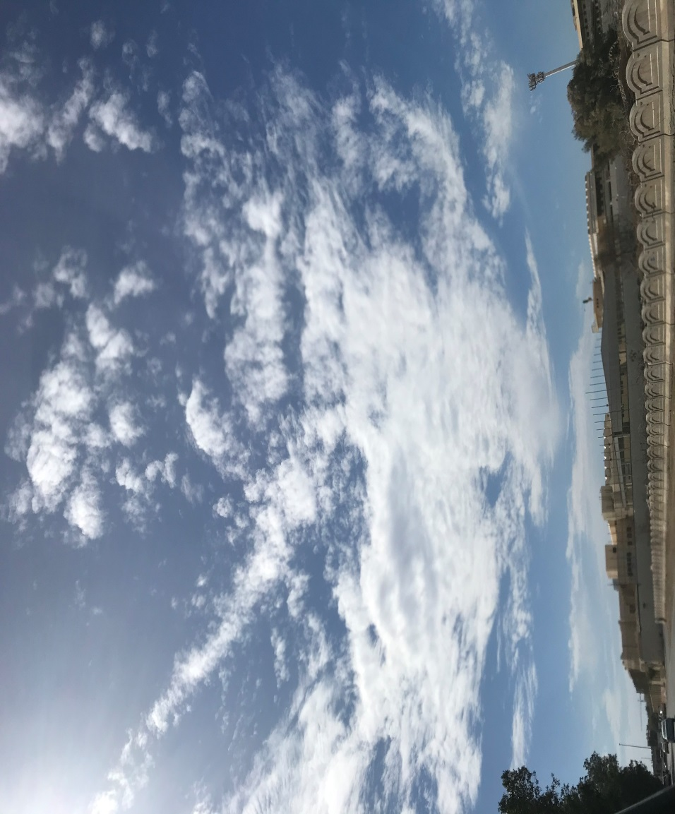
Figure 1. Picture to be clouds on the city of Jeddah

Clouds represent a partial condensation of water vapor in the form of fine water atoms that do not allow their spreading and light weight to fall off. Clouds arise as a result of the water-saturated air rising up and spreading and then cooling according to the lack of air pressure associated with its height. ⁽²⁾

The current international system of Latin-based cloud classification dates back to 1803, when amateur meteorologist Luke Howard wrote a book called Essay on the Modification of Clouds.
The International Cloud Atlas recognizes the ten major genera of clouds, each of which is defined according to their place in the sky and their approximate form.
Usually high clouds have a base at a height of approximately 5,000 meters (16 500 feet); while the average clouds base is at an altitude between 2000 and 7000 meters (6500 to 23,000 feet); and low clouds do not exceed the height of its base 2000 meters (6500 feet) Foot).
Most of the names of the clouds contain Latin prefixes and suffixes that indicate when meeting the nature of the clouds, including:
Furrow / alignment: flat, stratified, smooth
Aggregate / Overlay: stacked and swollen
Smack / Smack: light from small lumps
Al-Muzn / Muzni: Rain bearer
- higher: average height (alto Latin if high means)
These ten genera are divided into subtypes that show the shape and internal composition of clouds, and into groups that show the transparency and coordination of clouds. In all, there are approximately 100 combinations.
The International Cloud Atlas includes a new class of clouds, volutus (Latin word meaning cabbage), that is, rolled clouds.
The atlas also proposes a number of new "special" clouds, such as Homogenitus (from the Latin word homo that means human, and the word genitus, meaning made or verb). An example of this type of retracting clouds (abbreviated to condensation effect) that sometimes occurs as a result of aircraft engine exhaust.
The recently inserted special term for clouds, which is caused by ignition (Aggregate caused by ignition), Serra de Alvorge, Portugal. ⁽¹⁾

2-Hypothesis.

- The basic hypothesis: We assume that the temperature change affects the type of clouds formed on the city of Jeddah by 50%

- The alternative hypothesis :We assume that the Humidity change affects the type of clouds formed on the city of Jeddah by 50%

3.Materials and Methods
The tools that we will be using the GLOBE clouds chart, digital humidity meter, barometer, and Digital Multi Day Max/Min Thermometer. ⁽³⁾

Methodes:
To study the hypothesis of this research and apply its experiments, the following steps were taken:
1- Determine the geographical location in which the type of clouds will be monitored daily and measure the temperature, pressure, and humidity for 12 days at 10 GMT. It is the location that has coordinates of latitude 21.6264, longitude 39.1598, height 15 m, SITE_ID: 45516
2 - Continue to measure the type of clouds daily at 10 am GMT, by determining its type through the GLOBE clouds chart
3- Follow-up to the measurement of air temperature daily at the same time by using the Digital Multi Day Max/Min Thermometer
4- Follow-up to the measurement of humidity daily at the same time, using a digital humidity meter
5- Follow-up to daily pressure measurement at the same time, using a barometer
6- Record all results in Globe website
7- Compare the results, record them in tables, then analyze them to conclude the result
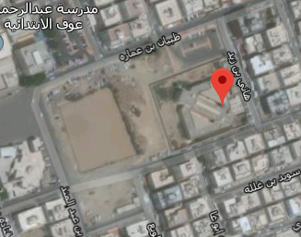

Type 1/ zone1

Figure 2. The location at which the measurements were taken.

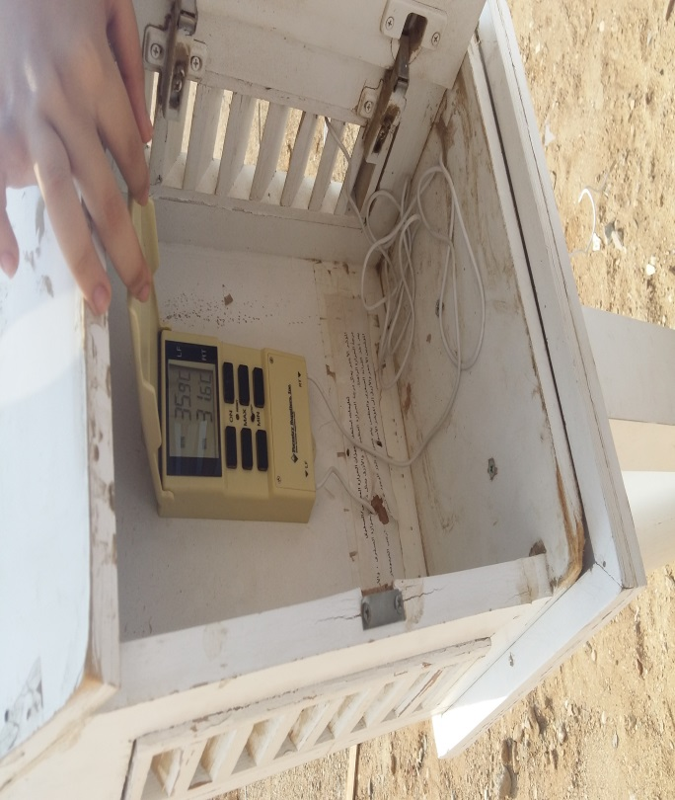

Figure 3. Follow the air temperature measurement using the Digital Multi Day Max/Min Thermometer.

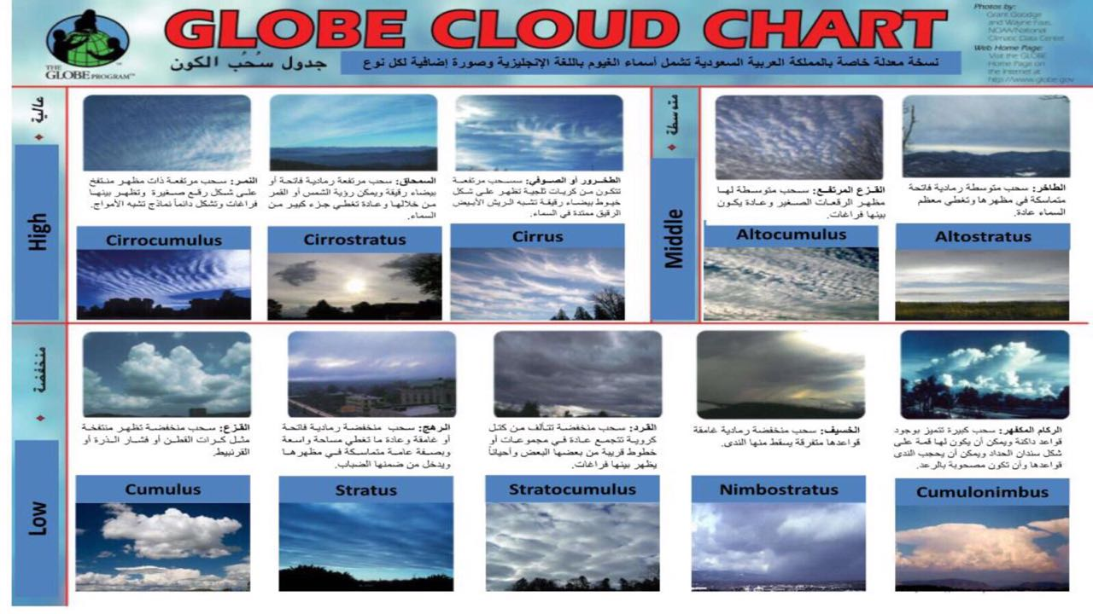

Figure 4. Continue determining the type of clouds formed by the GLOBE clouds chart .

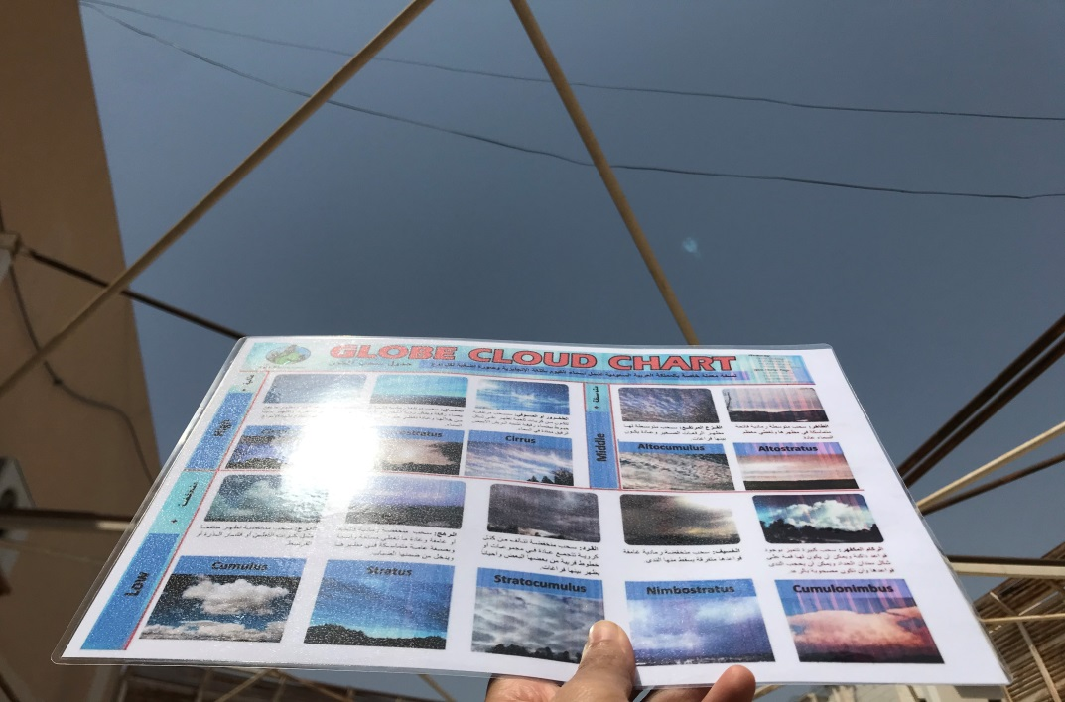
Figure 5. Determining the type of daily drawing for the city of Jeddah through the GLOBE clouds chart .

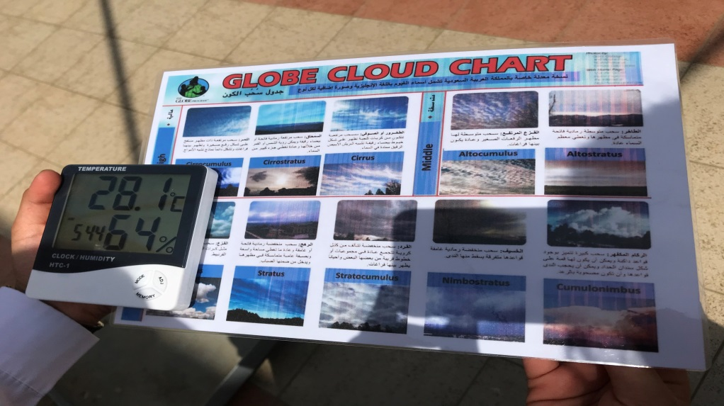
Figure 6. Moisture measurement daily on the city of Jeddah using a digital humidity meter .

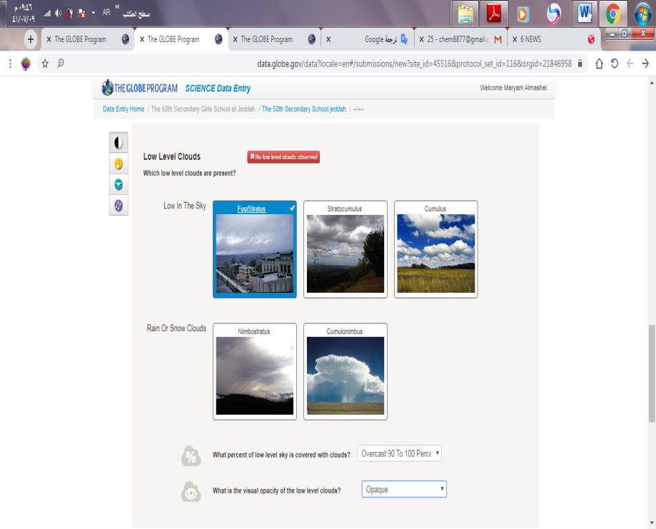

Figure 7. Enter the withdrawal type on February 24 at the Globe website.

4.Data Summary and Analysis
The table 1:
Pressure | Humidity | Temperature | The type of clouds formed | Day and date
1015 | 20% | 26 | Fog/Stratus | 20-2-2020
1013 | 43% | 26 | No clouds | 21-2-2020
1014 | 45% | 27 | No clouds | 22-2-2020
1012 | 47% | 27 | cirrus | 23-2-2020
1011 | 57% | 26 | Fog/Stratus | 24-2-2020
1015 | 43% | 24 | cirrus | 25-2-2020
1013 | 41% | 26 | Altocumulus | 26-2-2020
1015 | 30% | 29 | No clouds | 27-2-2020
1012 | 50% | 29 | No clouds | 28-2-2020
1012 | 56% | 27 | No clouds | 29-2-2020
1015 | 35% | 28 | Cirrocumulus | 1-3-2020
1012 | 36% | 29 | No clouds | 2-3-2020
A table1 : showing the relationship between the temperature and the type of clouds formed.

The table 2:
29 | 28 | 27 | 26 | 24 | Temperature
No clouds | Cirrocumulus | No clouds ,cirrus | No clouds ,Fog/Stratus,Altocumulus | cirrus | The type of clouds formed

A table2: Diagram showing the effect of temperature on the type of clouds.

The table 3:

57 | 56 | 50 | 47 | 45 | 43 | 41 | 36 | 35 | 30 | 20 | Humidity
Fog/Stratus | No clouds | No clouds | cirrus | No clouds | No clouds, cirrus | Altocumulus | No clouds | Cirrocumulus | No clouds | Fog/Stratus | The type of clouds formed

A table3 : Diagram showing the effect of Humidity on clouds type .

5.Results
After following us with measurements of temperature and humidity, their relationship and their effect on the type of clouds formed, we find from the results of graphical analysis that in most cases clouds do not form in the city of Jeddah and when the temperature drops, clouds are formed:
- Fog/Stratus
- Altocumulus
- Cirrus
- Cirrocumulus
The most common type of clouds is Fog/Stratus.

6.Conclusions
We conclude that the type of clouds formed on the city of Jeddah at moderate temperatures and at low humidity can be Fog/Stratus, Altocumulus, Cirrus, Cirrocumulus
Also, the type of clouds affected the change of humidity more than the temperature change, because the humidity was very different, while the temperature was the rate of increasing it by one or two degrees per day.
And on most days when the temperature rises or the humidity increases, the formation of clouds decreases or clouds do not form.

7.Discussion
Through the results, we note that there are specific types of clouds formed on the city of Jeddah and that the temperature was close during the days in which the type of clouds was determined and taking measurements and may not have much influence on the type of clouds formed, while we find that the percentage of humidity was very different with note that the pressure Its values were very close, which confirms the validity of the alternative hypothesis that moisture affects the amount of clouds formed.

Identification Of Additional Badges To Search

The impact of society | Interaction with GLOB | Explore STEM careers
Through this study, I learned about the types of clouds that form in the city of Jeddah and the factors that affect that. I can sensitize the surrounding community around me and introduce them to the types of clouds that form on my city until the culture of scientific research spreads and the community members become aware of what is around them. | In this study, we dealt with Globe program devices such as  the GLOBE clouds chart, digital humidity meter, barometer, and Digital Multi Day Max / Min Thermometer.  The steps in the air protocol were also followed to define measurements and enter data on the Globe website. | In this research, (STEM) was achieved through the use of graphs, mathematical tables, and scientific devices such as a temperature gauge, barometer, or digital humidity gauge. The technology was also used by determining the location in which the study is carried out or entering data into the Globe website.

Gratitude

- Teacher: Mrs. Maryam Almashei.
Teacher of chemistry, Supervisor of Globe Environmental program and supervisor of scientific research of the program.
She followed all the research steps and all the scientific
Experiments I had.

REFERENCES

- https://public.wmo.int/ar/2017

2- Al-Sheikh, A. A. (2004). Meteorological. Mansoura.

3-A book of the basic protocols of the Globe Environmental Program

