Aerosols

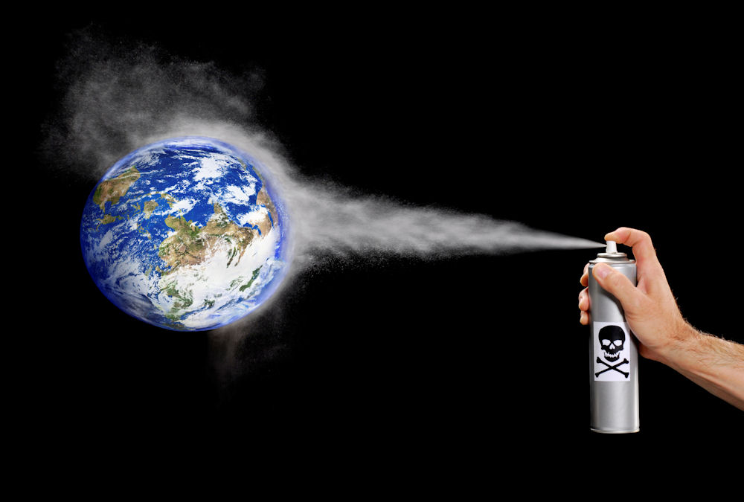

Aerosols in the atmosphere

The aerosols influence on the temperature

Names: Elise van Sterkenburg

Hannah van Zanten

Class: 4VT

Subject: Science

Teacher: BER

Date: 14-05-2016

Table of contents

1 Introductory remarks ....................................................................................................3
2 General information ......................................................................................................5
3 Hypothesis .....................................................................................................................6
4 Sub question 1: What is the difference between light absorbing and light scattering aerosols? ……………….......................................................................................................7
5 Sub question 2: What is the relation between relative humidity and the concentration of aerosols? ...................................................................................................................8
6 Sub question 3: How does the concentration of the aerosols (in both amount and type) in the atmosphere influence the formation and lifetime of clouds?..................10
7 Sub question 4: Is there a difference in the concentration of aerosols over the course of the day? If so, do peaks occur and what is the cause of it?.................................... 12

8 Main question: How do aerosols influence the temperature? ................................... 14
9 Epilogue .......................................................................................................................15
10 Sources ........................................................................................................................16
11 Logbook ...................................................................................................................... 17

1 Introductory remarks

We decided to do the assignment about aerosols for our Practical Assignment. We did not know anything about aerosols, so before we could make a main and sub questions we had to do some research. After this, we thought of a main question to answer our own remaining questions. Along with this main question we made four sub questions to make answering the main question easier.

During our project, we had contact with Jos van Geffen. He works as a contact person at the KNMI. Amongst other things, we mailed him about our research question and sub questions, about the material we were working with and about the data. He helped us a lot. His colleague Deborah Stein also helped us by improving our research questions.

We had some difficulties with the material of our research. The material we used, the meter, did not work properly. Because we didn’t know what values should be shown on the meter, we did not immediately know that the meter did not work. Eventually, we sent an e-mail to Jos van Geffen to make sure our measurements were correct. It turned out that our meter did not work correctly which made our measurements unusable. We still wanted to do our own (correct) measurements which we could use for our practical assignment, so our teacher went to the KNMI to switch the meter for another one. When we did our measurements with the new meter, we had the same problem as with the old one; the value given on the screen was way too low. It was almost as low as the value given on the screen when doing the ‘dark’ measurement.

As a result of this, we did not have any correct data of ourselves. This is why we decided to use the data from the GLOBE. After searching a school which had all the data we needed, we found the Christiaan Huygens College. Unfortunately, there was no recent data which we could use. The only data which we could use was the data from 2014.

When we were processing the data we discovered that the Christiaan Huygens College had done measurements which included the relative humidity for only two days. We tried to find the relative humidity on sites like www.knmi.nl and http://www.meteoroodeschool.nl, but we only data we could find on these sites were from 2014. This is why we decided to answer sub question 2 ‘What is the relation between the relative humidity and the concentration of aerosols?’ with average numbers.

For sub question 4 ‘Is there a difference in the concentration of aerosols over the course of the day? If so, what is the cause, when do peaks occur?’ We could not use the data of the Christiaan Huygens College. We had to use data from different point in time, and not an average number. Luckily we did have this data, but we did not have any data from the relative humidity and that is why we decided to leave it out of the question. We know that the relative humidity could be an important cause for the difference in the concentration of aerosols over the course of the day, but if we would have used this data, our answer to the sub question would be incorrect. Furthermore, we did take a look at the sky clarity, its colour and the temperature.

Exact location school:

School: Christiaan Huygens College

City: Eindhoven

Latitude: 51.4833

Longitude: 5.475

2 General information

Aerosols are tiny particles present in the atmosphere. It is impossible to see aerosols with the bare eye, but they certainly are present in the atmosphere. There are two main types of aerosols; aerosols which are smaller than 10 micrometer and aerosols which are between 10 and 100 micrometer big. Aerosols which are smaller than 10 micrometer belong to the section fine particulate matter. Aerosols between 10 and 100 micrometer are simply called aerosols. Apart from these two types, aerosols can be divided into five categories: dust, soot, sulphate, sea salt and organic aerosols.

These five different types of aerosols each have their own way of responding when sunlight falls on them. For example, sea salt reflects sunlight back into the universe, while black carbon particles, which derive from burned wood or fossil fuels, absorb most of the sunlight.

Aerosols can be created in both a natural and a human-kind way.

Some examples of natural appearances of aerosols:

- The condensation and freezing of water

- Volcano eruptions

- Evaporation of seawater

Example of human kind appearances of aerosols:

- The combustion of biomass (wood, leaves, manure)

Scientists think aerosols influence the climate change. This has to do with light absorbing and light reflecting aerosols. Unfortunately, many more research has to be done on order for the scientists to understand the exact purpose of the aerosol and their effect. People have created a website on which scientists and students can upload their measurements and see data from other students, schools and scientists.

3 Hypothesis

Sub questions:

What is the difference between light absorbing and light scattering aerosols?
We think that light scattering aerosols reflects sunlight and that light absorbing aerosols absorbs sunlight.
What is the relation between relative humidity and the concentration of the aerosols?
We think that the more the air is filled with clouds and the higher the percentage of humidity, the higher the concentration of the aerosols.
How does the concentration of the aerosols (in both amount and type) in the atmosphere influence the formation and lifetime of clouds?
Since aerosols are a part of clouds, we think that when more aerosols are present, more clouds can be formed and that their lifetime will be longer.
Is there a difference in the concentration of aerosols over the course of the day (diurnal variation)? If so, what is the cause, when do peaks occur?
Yes, we think that a peak occurs around noon. The temperature is at its highest point then, and we think the temperature plays a big part in the concentration of aerosols. Another cause could be the relative humidity and the traffic.

Main question:

How do aerosols influence the temperature?
We think that when there are a lot of aerosols, the temperature will be lower because aerosols create clouds.

4 What is the difference between light absorbing and light scattering aerosols?

An aerosols effect on light mainly depends on the composition and colour of the particles. Bright coloured and translucent particles tend to reflect radiation. Most aerosols reflect sunlight. These light scattering aerosols reflect the sunlight in all directions, including back into space. It could be said that light scattering aerosols act as little mirrors for the sunlight. Light scattering aerosols cool the climate of the Earth by reflecting the sunlight back into space.

Light absorbing aerosols, or dark aerosols, absorb enormous amounts of light. Whether an aerosol is light absorbing or scattering depends on their physical properties, like their size and composition. Absorption of solar radiation by dark aerosols warms the air directly instead of allowing sunlight to be absorbed by the surface of the Earth. Thus, light absorbing aerosols warm the climate. Aerosols are also able to absorb the infrared radiation which the Earth emits.

Another difference between the aerosols is that some exert a ‘pulling’ force on the water, and other aerosols have an water repelling force. This is why aerosols influence the formation of clouds. Aerosols which exert a pulling force cause small cloud droplets, which makes the lifetime of the cloud longer and its colour whiter.

- The minority of the
aerosols are light
absorbing
- Warm the air
- Mainly water repelling
aerosols
Light scattering aerosols
- The majority of the
aerosols are light
scattering
- Cool the planet
- Mainly aerosols which
exert a pulling force on
water
Light absorbing aerosols
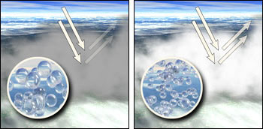

Source: http://earth.rice.edu/mtpe/atmo/atmosphere/topics/aerosols/aero_clouds.jpg

5 What is the relation between relative humidity and the concentration of aerosols?

Like we mentioned before, we are going to use average numbers for this sub question. The average amount of aerosols is derived from all the measurements on that day.

We used dates from different months:

January: March: May:

31-01-2014 04-03-2014 04-05-2014

05-03-2014 05-05-2014

06-03-2014 06-05-2014

08-03-2014

09-03-2014

Date | Humidity in % | Transmission in % | Aerosols (AOT)*
31-01-2014 | 79 | 84.2 | 0.1717
04-03-2014 | 81 | 87.9 | 0.1288
05-03-2014 | 83 | 77 | 0.2621
06-03-2014 | 71 | 77.2 | 0.2592
08-03-2014 | 72 | 72.6 | 0.3266
09-03-2014 | 60 | 84.3 | 0.1715
04-05-2014 | 62 | 63.4 | 0.4719
05-05-2014 | 54 | 72.9 | 0.317
06-05-2014 | 72 | 78.5 | 0.2415

* Aerosol Optical Thickness

There is a clear connection between aerosols and transmission; the larger the amount of aerosols, the smaller the percentage of transmission becomes. This could have to do with clouds, because when there are a lot of aerosols present in the air, more clouds are formed. However, this is just an estimation.

The relation between the humidity and the amount of aerosols is not very clear. We put the data in a table to see whether there is a relation between these two. We ranked them from the lowest percentage of humidity to the highest percentage.

Date | Humidity in % | Transmission in % | Aerosols Optical Thickness (AOT)
2014-05-05 | 54 | 72.9 | 0.317
2014-03-09 | 60 | 84.3 | 0.1715
2014-05-04 | 62 | 63.4 | 0.4719
2014-03-06 | 71 | 77.2 | 0.2592
2014-05-06 | 72 | 78.5 | 0.2415
2014-03-08 | 72 | 72.6 | 0.3266
2014-01-31 | 79 | 84.2 | 0.1717
2014-03-04 | 81 | 87.9 | 0.1288
2014-03-05 | 83 | 77 | 0.2621

Transmission in %
Humidity in %

As can be seen, there is no connection between the humidity and the amount of aerosols. The dots are spread all over the diagram without a fixed pattern.

6 How does the concentration of the aerosols (in both amount and type) in the atmosphere influence the formation and lifetime of clouds?

Aerosols play a key part in the formation of clouds. When a cloud is formed, water vapour condenses on aerosol particles. Aerosols are the nuclei of the cloud condensation. Cloud condensation nuclei can also be seen as tiny ‘seeds’ which are necessary to form a cloud. If there weren’t any aerosols, no cloud could be formed. Every water droplet is formed on one aerosol, and therefore the number of aerosol particles affect the number of water droplets contained within a cloud. When there are many aerosols in the atmosphere, a high number of cloud droplets are formed and a cloud is formed.
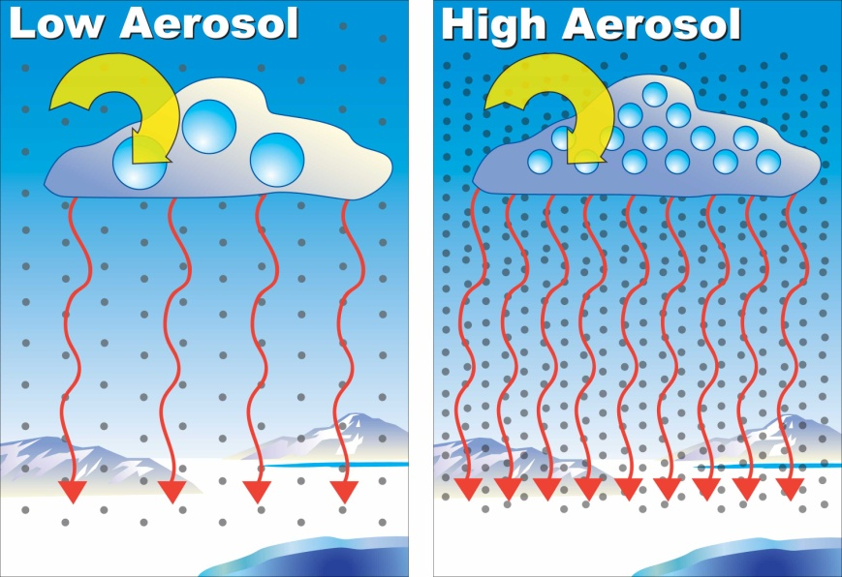
When there are a lot of aerosol particles present in a certain area of the atmosphere, the cloud droplets that are produced will be smaller than when there are less aerosol particles present in that area. This is due to the fact that there are more aerosol particles to divide the water amongst. Clouds which consist of small cloud droplets are less likely to produce precipitation. Another effect of the many aerosols present is that larger clouds can be formed before the cloud contains too many cloud droplets and becomes too ‘full’. When a cloud contains a lot of aerosols its colour will be darker because of the higher density of the cloud droplets. These clouds will cause more rain. Because it takes longer for the cloud condensation nuclei to become too heavy, and thus because it takes longer before it is going to rain, the lifetime of a cloud is longer when many aerosols are present. The formation of clouds is also influenced by the number of aerosols in the atmosphere. Clouds will become larger as more aerosols are serving as a cloud condensation nucleus. Light scattering aerosols tend to brighten the colour of the cloud and make its duration last longer.
Source: https://www.bnl.gov/bnlweb/pubaf/pr/photos/2006/aerosol-300.jpg

Clouds cause a reduction of the average rate of the warming of the climate because they reflect the sun beams back into space. Hence, the formation of more clouds cause the average temperature of the Earth to increase slower. This is one of the ways in which aerosols influence the climate indirectly.

7 Is there a difference in the concentration of aerosols over the course of the day? If so, do peaks occur and what is the cause of it?

The dates we used to answer our sub question are as following*:

05-03-2015

06-03-2014

08-03-2014

09-03-2014

04-05-2014

05-05-2014

Date | Time | Temperature in °C | Clouds | Observed sky clarity | Observed sky colour | Aerosols
05-03-2014 | 10:30:00 |  | Nimbostratus | Clear | Light blue | 0.3002
05-03-2014 | 12:02:00 | 11.7 | Cumulus | Clear | Blue | 0.2388
05-03-2014 | 12:30:00 | 11.7 | Cumulus | Clear | Blue | 0.2472
06-03-2014 | 09:36:00 | 9 | Cirrostratus | Clear | Light blue | 0.2499
06-03-2014 | 11:11:00 | 11.6 |  | Clear | Light blue | 0.2843
06-03-2014 | 11:34:00 | 11.6 |  | Clear | Light blue | 0.2519
06-03-2014 | 13:10:00 | 13.3 |  | Clear | Light blue | 0.2506
08-03-2014 | 10:56:00 | 13.3 | Cirrostratus | Clear | Blue | 0.2162
08-03-2014 | 13:00:00 | 16.3 |  | A bit hazy | Blue | 0.437
09-03-2014 | 11:01:00 | 15 | None | Clear | Light blue | 0.1916
09-03-2014 | 11:44:00 | 18.6 |  | Clear | Light blue | 0.1636
09-03-2014 | 12:04:00 | 18.7 |  | A bit hazy | Light blue | 0.169
09-03-2014 | 13:45:00 |  | Cirrostratus | Clear | Light blue | 0.1616
04-05-2014 | 10:52:00 | 5-12** | Cumulus | Clear | Blue | 0.2916
04-05-2014 | 12:45:00 | 15.1** | Cirrostratus | Clear | Light blue | 0.6522
05-05-2014 | 10:00:00 | 18.2 | Cirrostratus | Clear | Light blue | 0.2795
05-05-2014 | 13:29:00 | 20.3 |  | Clear | Light blue | 0.3544

* Not all the data was filled in by the students of the Christiaan Huygens College, which is why we have left some blank spaces in the table.

** The data is from the KNMI website, and not measured at the Christiaan Huygens College. However, these measurements are made in Eindhoven. We looked them up, because of the large difference in the amount of aerosols. The temperature at 10:52:00 is between 5 and 12 degrees; the exact temperature is not known. The other point of time, 12:45:00, was measured at the KNMI station.

The Aerosols Optical Thickness (AOT) is in general the same in almost all the measurements. However, there is one day, the 8th of March, 2014, which shows quite an increase in the AOT compared to the other days. We wanted to know the cause of this increase, so we looked at other factors which had changed. We already looked at the sky clarity, so now we wanted to take a look at the temperature. The temperature had increased with 3 °C. We started to wonder if the increase of the temperature could have a connection with the increase of the AOT, and the other way around. On the 4th of May, 2014, the temperature as well as the AOT increased a lot as well. Thus, the temperature might influence the Aerosol Optical Thickness, or the other way around, but to prove this we would have to have more information which we unfortunately do not have.

Our assumptions are that the sky clarity also has something to do with the amount of aerosols present in the atmosphere. Two measurements have been done when the sky was a bit hazy. The first one was on the 8th of March. When it was a bit hazy, the AOT increased significantly. The other measurement done when it was a bit haze showed a very small increase in the AOT. Even though it is a small increase, it still is an increase, but this could also just be a coincidence. To make sure that it wasn’t, we took a look at other measurements from the year 2014 to see whether there is a connection between the sky clarity and aerosols. Our suggestion turned out to be correct. There is a big chance that the amount of aerosols and the sky clarity influence each other.

Summarized answer to the sub question

The amount of aerosols changes over the course of the day. The number of aerosols is never the same throughout the whole day. There could be several reasons for that. Two things that most certainly play a part in this, are the temperature and the sky clarity. Furthermore, the amount of aerosols do not really have a peak around a regular time, for example at noon. It can have its peak in the morning, around noon or in the afternoon.

8 Main Question:

How do aerosols influence the temperature?

Aerosols affect the temperature by influencing the way clouds behave. The majority of aerosols are light scattering; they reflect the sunlight in all kinds of directions, including back into space. Clouds act as a barrier for sunlight. When sunlight falls onto the cloud, it cannot fall on the surface of the Earth. This makes the temperature on Earth drop. However, certain types of aerosols, light absorbing aerosols - which often have come to existence thanks to human kind -, absorb sunlight and make the atmospheric temperature rise. Another way in how aerosols make the temperature rise is by absorbing infrared radiation which the Earth emits. Fortunately, there are less light absorbing aerosols than light scattering aerosols. Furthermore, light scattering aerosols cause the lifetime of a cloud to last longer. This means that the temperature cools down for a longer period of time.
If the humidity of the air influences the aerosols, and thus the temperature, is not clear. The main way how aerosols influence the temperature is by acting as cloud condensation nuclei, and by influencing the behaviour of the clouds.

9 Epilogue

This project has taken several months to finish. At the beginning of the project, we immediately started to measure and we thought that our data was correct. However, it turned out to be incorrect due to our meter which didn’t work. Unfortunately, we had already done a lot of measurements during our braeks, which became unusable. Due to other activities (the test week, our exchange and the May holiday) we weren’t able to measure for quite a long time. When we finally had time to start with the measurements again, the new meter gave the same results as the old one. It was too late to change our meter again and do our own measurements, so we had to use data from other schools.
We decided to use the data which can be found on globe.gov. However, it was quite hard to find usable recent data. Often, there were not enough measurements done, or the measurements did not include all the kinds of data we needed. It took us a lot of time to find all the data which we had to use. We spent a lot of time on this because we still wanted (and had to) use measurements in our report.
We would recommend this project to other people. However, we would also tell them that they have to make sure that their material is working correctly. Our project went wrong because of the equipment, but if we would have had equipment which did work from the beginning on, this project would have been quite nice.

10 Sources

Front page

- https://teensturninggreenblog.files.wordpress.com/2016/03/climate-debate.jpg

- http://www.redorbit.com/media/uploads/2013/06/aerosols.jpg

General information

- https://www.nasa.gov/centers/langley/news/factsheets/Aerosols.html

- GLOBE files

- http://earthobservatory.nasa.gov/Features/Aerosols/

- http://www.aerosol.org/

Sub question 1

- http://earthobservatory.nasa.gov/Features/Aerosols/page3.php

- https://www.wmo.int/pages/themes/climate/causes_of_climate_change.php

- http://www.wmo.int/pages/prog/arep/gaw/aerosol.html

Sub question 2

- http://projects.knmi.nl/klimatologie/daggegevens/index.cgi

- http://www.meteoroodeschool.nl/dagrapporten/dagrapporten-januari-2/

- http://vis.globe.gov/GLOBE/#

Sub question 3

- http://earth.rice.edu/mtpe/atmo/atmosphere/topics/aerosols/aero_clouds.html

- http://www.windows2universe.org/earth/Atmosphere/clouds/aerosols.html

- http://www.windows2universe.org/earth/cmmap/cmmap_portal.html

- http://earthobservatory.nasa.gov/Features/Aerosols/page4.php

- http://www.windows2universe.org/earth/climate/cli_aerosols.html

Sub question 4

- http://projects.knmi.nl/klimatologie/daggegevens/selectie.cgi

- http://vis.globe.gov/GLOBE/#

- http://projects.knmi.nl/globe/educatie/pdf/les_docenten.pdf

11 Log
We made a log which describes what we exactly did during this project. On the next page we made a short version, to show what we individually have done.
What | Who | Deadline | Time spent | Comments
Read about the topic | both | 29-01 | 50 minutes
Read about topic + schedule | both | 12-02 | 50 minutes
 | both | 19-02 | 80 minutes | Working on another assignment of science
Practice with measurements | both | 19-02-2016 | 20 minutes
 |  |  |  | Holiday
Schedule | both | 29-02-2016 | 15 minutes
Main question (give to teacher + mail scientist KNMI) | both | 29-02-2016 | 35 minutes
Background/ general information | Hannah | 29-02-2016 | 50 minutes
Measurements during the breaks | both | 11-03 – 17-03 | 70 minutes
 |  | 18-03 | 100 minutes | Working on another assignment of science
 |  | 28-03 – 08-04 |  | Learning for the test week
 |  | 11-04 - 15-04 |  | Exchange week with Goslar
Finding data, working on Introductory Remarks, General information | Hannah | 02-05 | 230 minutes
Working on sub question 1, finding data | Elise |  | 230 minutes
 |  | 23-04 - 08-05 |  | Holiday
Working on sub question 1 & 3 | Elise | 11-05 | 100 minutes
Trying to find data and making the document | Hannah | 12-05 | 80 minutes
Working on general information, Introductory Remarks, sub question 2&4, monologue, document | Hannah | 14-05 | 8 hours
Working on sub question 1& 3, checking our work, document, research question | Elise | 14-05 | 6 hours
Research question, finishing off everything | Elise | 15-05 | 3 hours
Log | Hannah | 17-05 | 30 minutes
Minutes in total |  |  | +/- 3670 minutes

Names | Tasks
Elise  (alone) +/- 870 minutes | Main question  Sub question 1 & 3  Hypothesis  Document (style) & checking grammar, structure, order
Hannah  (alone) +/- 870 minutes | Introductory Remarks  General Information  Hypothesis  Sub question 2&4  Epilogue  Document (style)

