Project Summary

Project Title: Dunboyne Clean Air Campaign

Dunboyne Senior Primary School is a Healthy Ireland Health Promoting school, an Active school and a Green School. We place a high priority on the promotion of health and well-being throughout our whole school community. We established a STEM team in the school in recent years and this team meets at lunchtimes and works to promote STEM education in our school. Ongoing projects include partnership work with community groups to enhance our local community as a pollinator-friendly environment. We are particularly interested in Environmental Education STEM projects relating to the Global Goals for Sustainable Development and have adopted a multidisciplinary approach to all our STEM projects to ensure that all team members have opportunities to develop individual talents and learn new skills.
This year our students, along with hundreds of students across Europe, are participating in the GLOBE Air Quality Campaign: An Investigation of Air Pollution Near Schools. Our research question is: How Clean is the Ambient Air in our School Environment? Through this project we have the following objectives: to promote awareness about local and wider air pollution and to explore the links between climate change and unsustainable forms of transport. We also have an objective to educate our school community about the Global Goals for Sustainable Development and how our actions in our school and community will help to achieve some of these goals. As with our ongoing work on pollinators, we are partnering on this project with neighbouring schools and various community organisations including our local Library, Scouts, Tidy Towns, Rehabcare, local businesses and other community and sporting organisations. We are also partnering on this project with a broader network of organisations to ensure the message has a wider impact: Eco-Unesco, Irish Aid, Asthma Society of Ireland, DCU Open Schools for Open Societies (OSOS) programme, the Tephra Bag Experiment with Trinity College and University College Dublin, Climate Detectives ESA programme, Climate Ambassadors programme, Science Blast 2020, GLOBE programme and ongoing work with twinning schools: Regio Parco school in Turin, Italy and Passe-Partout school in the Netherlands.

Introduction

There are often wide variations in local air quality going undetected that can have significant impacts on the health and wellbeing of local communities. Our school is beside a very busy road which our staff and students pass by every day on their way in to and out of the school. We discovered that children are more vulnerable to the effects of air pollution. As a health promoting school, our STEM team decided to investigate the levels of air pollution around our school. The health effects of air pollution are serious – one third of deaths from stroke, lung cancer and heart disease are due to air pollution. Air pollution is closely linked to the burning of fossil fuels and climate change. Air pollution affects children and can have a particularly detrimental effect on children with asthma. As asthma is particularly common in Ireland, where over 380,000 adults and children have the condition, we felt it was important to link our project to the recent Asthma Society of Ireland #OwnOurAir Schools competition which aims to educate young people on the harmful effects that poor air quality has on their health, while simultaneously encouraging students to take action against air pollution.

Methods and Materials
We are investigating the quality of the air around our school and are exploring the links between unsustainable forms of transport and climate change. Working with the school STEM team, our pupils are collecting important traffic-related air pollution data around our school with the research question: How Clean is the Ambient Air in our School Environment? We were given diffusion tubes by the GLOBE programme to measure the average levels of nitrogen dioxide in the air around our school in a four-week period in September/October 2019. Nitrogen dioxide is a pollutant produced by vehicles and some industrial processes. We were surprised at how small the tubes were when they arrived! We installed the three nitrogen dioxide diffusion tubes in three suitable locations around our school including: near a main busy road, at a drop-off parking point and in a sheltered area away from cars and traffic. These tubes were in place in these three locations for 4 weeks and they were then taken down, sealed and sent to a certified lab for analysis with the results of average nitrogen dioxide levels coming back to us via the GLOBE programme. In our STEM class we made predictions about which location would have the highest, middle and lowest levels of air pollution. Our students researched many aspects of air pollution individually and in groups and we learned about how internal combustion engines work. We looked at how clean the air is in Dunboyne in the EPA Air Quality Index which indicated that air quality is generally ‘Good’ in Dunboyne. We took the opportunity to talk about our project to as many students and community groups as possible and we developed resources to help spread the word about our project. We participated in Clean Air Week with the Green Schools programme and developed art-work to amplify our message about the importance of clean air to health.

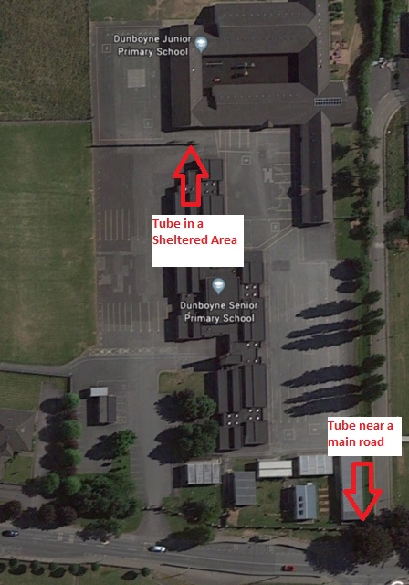
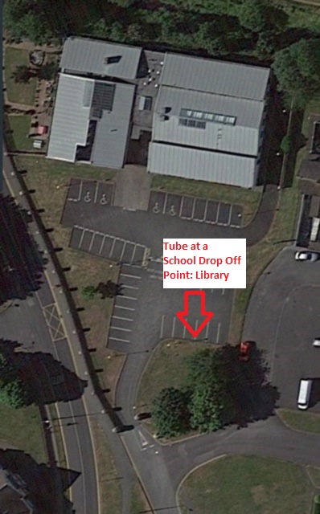

Figure 1: Location of diffusion tube at our local library which is a park & stride school drop off point
Figure 2: Locations of diffusion tubes on our school campus

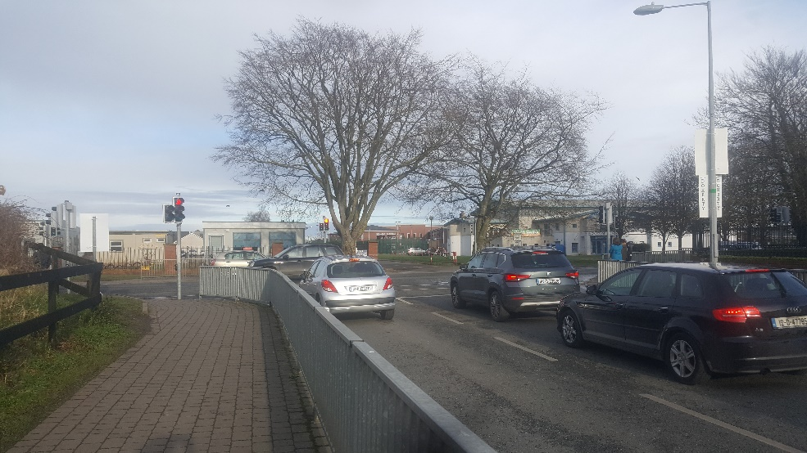
Figure 3: Busy road intersection outside our school

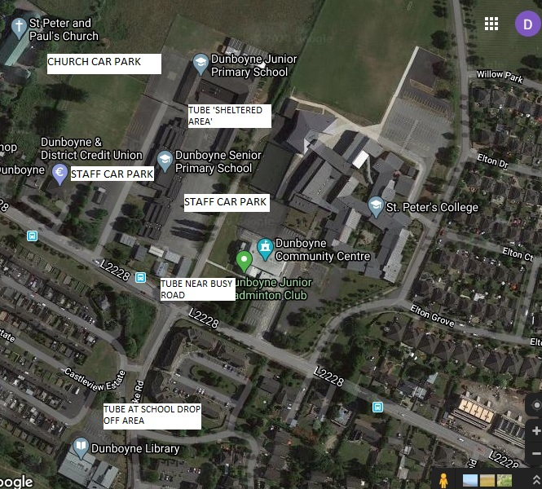
Our study site is the area around our school; Dunboyne Senior Primary School. Here is a weather report from our nearest Met Éireann weather station at Dunsany, Co. Meath. In Dunboyne, the summers are comfortable and partly cloudy and the winters are long, very cold, windy, and mostly cloudy. Our climate in Dunboyne has a warm season which lasts for 3.0 months from June 11 to September 11 with an average daily high temperature above 17° celcius and low of 11.6° celcius. The cool season lasts for 4.1 months from November 15 to March 17th with an average daily temperature below 10 ° celcius.
Figure 4: Study Site
Results

Our results were somewhat surprising: the measurement at the sheltered area at the back of the school (16.40 µg/m3), was slightly higher than the measurement from the school drop-off point at the local library (15.34 µg/m3). The result for the ‘Near a busy road’ reading was the highest of the three readings at 20.27 µg/m3. We compared the results from our school with those of the other schools in the programme (see figure 7) and also compared our results with those schools in the ‘Town 5,000 to 9,999’ population category (see figure 6). We found the sharing of data from all participants in the GLOBE programme to be very beneficial to our broader understanding of air pollution in terms of population size, location etc (see Figures 6 & 7). We also found quite useful the provision by the GLOBE programme of a table to explain the findings in simple terms for use in presentations to community partners etc (see Figure 8).

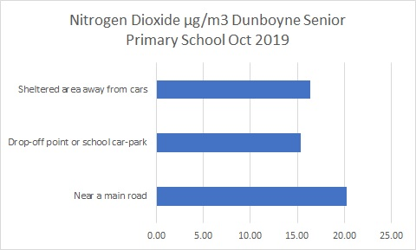

Figure 5: Average nitrogen dioxide levels for Dunboyne Senior Primary School October 2019

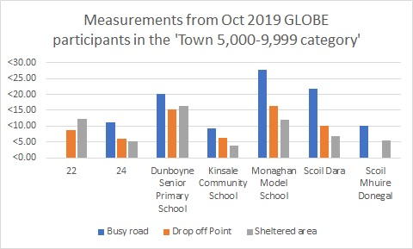

Figure 6: Measurements from GLOBE Oct 2019 participants in the 'Town 5,000 - 9,999 category’

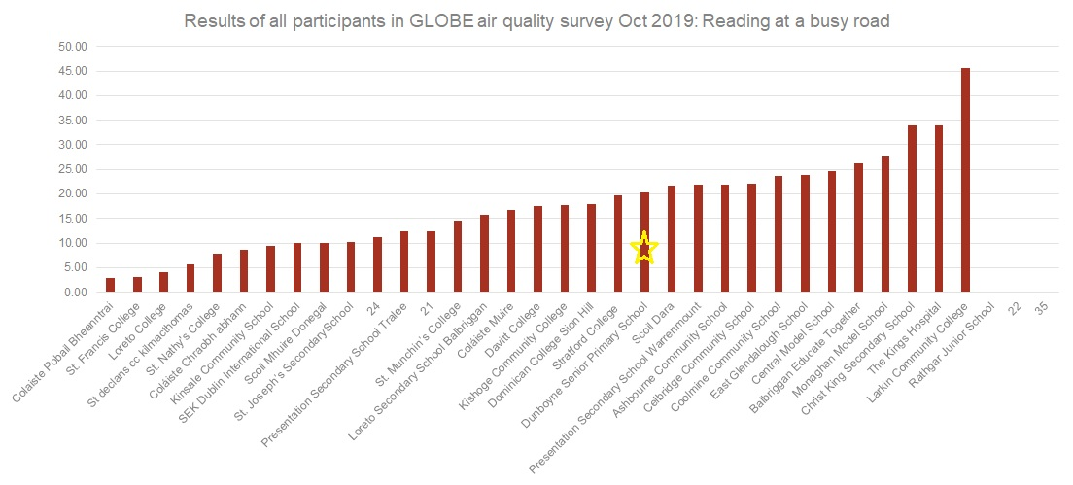

Figure 7: Results of all participants in the GLOBE air quality survey Oct 2019: Readings at a busy road

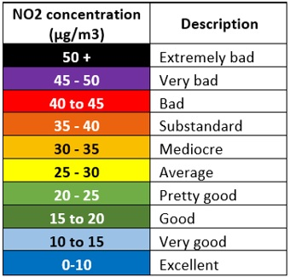
Figure 8: Table provided by GLOBE to explain average nitrogen dioxide readings in terms of air quality

Discussion
As part of our STEM activities we made predictions at the start of the project about what the results might be. When the results came back we were surprised at the results for the sheltered area at the back of the school which was higher than the result for the school drop off area. It is possible that the proximity of that location to the staff car park and church car park may be a factor. We have since erected ‘No Idling’ signage in the school car park and around the school and have informed the bus drivers using the car park of our project objectives. The highest recording of nitrogen dioxide (20.27 µg/m3) met our STEM class predictions; we predicted that the reading at the busy road would be the highest. From our analysis of the results from all schools involved in the project and those in the ‘Town 5,000-9,999’ category, we saw that our school results came about in the middle of the overall results which means that there is definite room for improvement in our local air quality. We realised that while our results were not the highest from among all participants in the programme, we could certainly improve the air quality in our school. Based on the above results and analysis, we launched an air quality campaign #DunboyneCleanAir to encourage our school and wider community to do the following:
- Walk, scoot and cycle to school (This is proven to be good for health and student concentration levels too)
- Park + Stride (our school has designated drop off points in the local community)
- Always turn off engines when parked (No Idling Poster campaign throughout Dunboyne)
- Raise awareness of the risks to health associated with air pollution.
STEM team pupils visited classes in the school to raise awareness of the research project. We created an information notice board in the school hall and invited classes to post messages and artwork on the school notice board to celebrate National Clean Air Week (see Figure 11). We were delighted with the excellent responses from all the classes. We also discovered some very helpful tips to promote our key messages about the importance of having clean air in our school and local environment. We informed Dunboyne Tidy Towns about our research project and they were very impressed with our plans. The Tidy Towns Committee are fully supportive of our project and have greatly helped us to access resources and to forge links with our local and wider community. This has helped us to reach out to organisations such as our local GAA club, Dunboyne Athletics club, Dunboyne Soccer club, Dunboyne Scouts, Dunboyne Community Centre, Dunboyne library, Rehabcare, local businesses, schools, second and third level colleges and more. All of these organisations are supporting our clean air campaign and the “Idle Free Zone” posters we developed based on student art-work are displayed in key locations including at neighbouring schools, the playground car park, third level college, the doctors surgery, pre-school, local library and businesses around our community and by the above community groups (see Figures 9, 10 & 12). Through our outreach to the school and wider community we aspire to achieve an IVSS ‘I make an impact’ badge. In association with Dunboyne Tidy Towns we launched our Clean Air campaign in our school hall and classes in the school were invited to a presentation along with representatives from our local and wider school community. It was a wonderful opportunity to share our project with our community. We adopted the Open School model where pupils’ projects meet real needs in the community outside of school. They are presented publicly and draw upon local expertise and experience. This fosters learner independence and interdependence through collaboration, mentoring and through providing opportunities for pupils to understand and question their place in the world. The Open schooling approach will also support our efforts to gain an IVSS ‘I am a STEM Storyteller’ badge.

We created a research poster which will be displayed on the Globe website thus ensuring that our project reaches a wider audience (see Figure 15). We are also submitting this report to the GLOBE International Virtual Science Symposium (IVSS). We are a champion school for Open Schools for Open Societies and will be sharing our project on the OSOS European portal (see Figure 14). Our project has been selected for the Climate Detectives Competition 2019/2020 (ESA) and we look forward to sharing our project on this portal. We are engaging with the Climate Detectives competition and will be participating in a webinar with Mr. Thorsten Fehr, Head of Atmospheric Section at European Space Agency (ESA) on the 10th March 2020. This activity is in keeping with our efforts to be considered for an IVSS badge on collaborating with a STEM professional. This will be an exciting opportunity to interact with an Earth Observation expert and to discover more about the connections between our changing climate and air pollution. We are looking forward to sharing our project with other schools participating in the Climate Detectives project. We exhibited our project at the Science Blast national exhibition at the RDS Dublin on the 3rd of March (see Figure 13) and thirty of our students were able to attend the exhibition and interact with the judges and other exhibitors. We will also be submitting our project to the Discover Primary Science and Maths award in association with Science Foundation Ireland. We repeated the same measurements in February 2020 and will be interested to see if our awareness raising about air quality and our air quality campaign #DunboyneCleanAir will help change behaviour and make an improvement in our local air quality. We are awaiting these results.
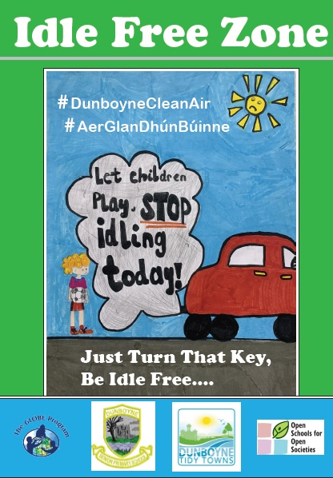
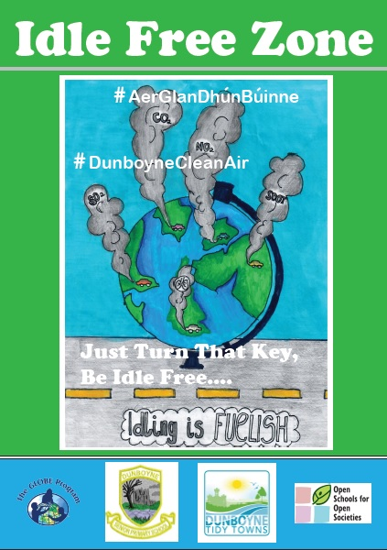

Figure 10: Samples of our 'No Idling' Resources
Figure 9: Samples of our 'No Idling' Resources

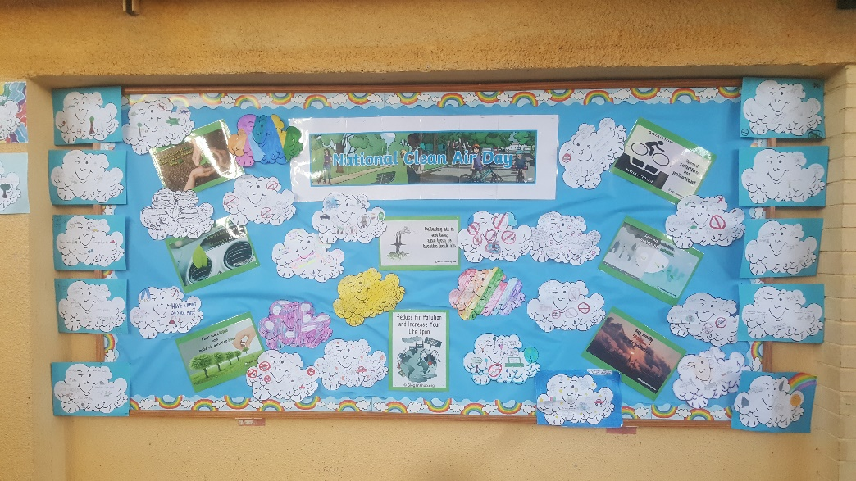

Figure 11: Our Clean Air Week Poster, Nov 2019
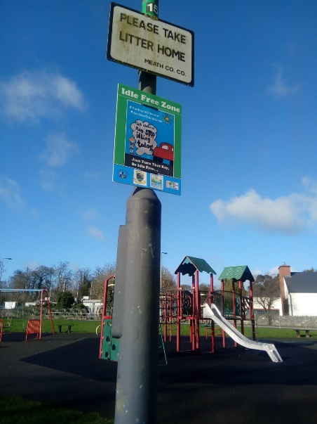
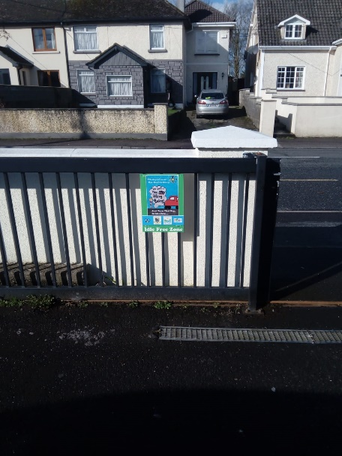
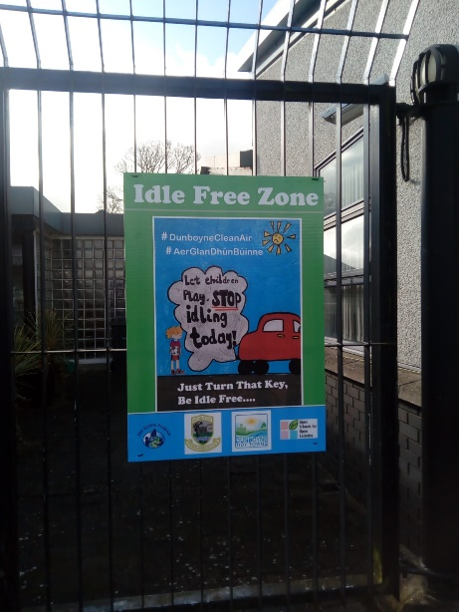
Figure 12: Examples of our ‘No Idling’ posters in place in our community at a playground, library and GP surgery

Conclusion
We want this investigation to be empowering and inspiring and will share our findings and solutions through a variety of means including; as a research poster on the GLOBE website, Dunboyne Tidy Towns Facebook page and Information Hub, the Young Environmentalist Awards, Asthma Society of Ireland #OwnOurAir schools programme, Climate Detectives 2019/2020 (European Space Agency), the Open Schools for Open Societies European Portal, the Climate Ambassador Program (An Taisce Education Unit), Irish Aid Awards, Discover Primary Science and Maths awards and at the ESB Science Blast Expo in March 2020. The investigation provides a valuable opportunity for our school to collect local data, analyze scientifically accurate data and to share solutions to improve air quality locally and nationally. The project links to the strand "Environmental awareness and care" of Social Environmental and Scientific Education in the Irish Primary School Curriculum.
We repeated the measurements in February 2020 to see if our campaign has helped to improve air quality in our school and local environment and are awaiting results. We are also considering the role of weather and are investigating how this variable can impact our readings. Mr. Gerry Murphy, a meteorologist with Met Éireann, Irelands meteorological service, visited our school to meet with the STEM team and deliver a workshop on this subject on March 4th. We enjoyed sharing our project with him and gained a better understanding about the links between weather and air pollution through participating in this workshop. This opportunity to interact with a meteorologist will hopefully assist in our efforts to achieve the aforementioned IVSS badge on collaboration with a STEM professional.

IVSS ‘I Make an Impact’ Badge
Our school is a Healthy Ireland Health Promoting school, an Active School and a Green School. We place a high priority on the promotion of health and wellbeing throughout our whole school community. Having considered the impacts of air pollution on health and especially on the health of children and people with asthma and other conditions such as cardiovascular and respiratory diseases, we decided to gather local data to determine the quality of the air that we breathe each day with the research question: How Clean is the Ambient Air in our School Environment? We considered that what can be measured, can be managed and that armed with scientifically accurate data on the quality of our local air, we could share this information with our school and wider community in order to bring about behavioural change. Ireland’s population is particularly affected by asthma with 380,000 people in Ireland currently diagnosed with the illness. We considered that a school-led campaign to raise awareness about the importance of air quality could have a wider impact if shared both locally and through wider channels. To achieve this we made efforts to recruit local partners to promote our air quality campaign; #DunboyneCleanAir. Our local partners include the following: neighbouring schools and various community organisations including Tidy Towns, Rehabcare, local businesses, our local GAA club, Athletics club, Soccer club, Scouts, Community Centre, Dunboyne library, Rehabcare, local businesses, second and third level colleges and more. We also took opportunities to inspire and inform a wider audience through various channels such as at Science Blast 2020, through the GLOBE IVSS, Open Schools for Open Societies and through the Climate Ambassadors programme, the Climate Detectives Programme, The Tephra Citizen Science Experiment, the Eco-Unesco Young Environmentalists Award for which we have so far reached semi-final position and the Irish Aid Awards. We spoke on local radio, LMFM, on Feb 18th highlighting our project. This broad-spectrum approach will help ensure that our project has both a local and more global impact.
IVSS ‘I am a STEM Storyteller’ Badge
Our school has been invited to participate in the research study “An Investigation into sustaining open schooling collaborations in STEM Education” which is being carried out in 100 Irish schools. Students (aged 10-12 years) develop scientific skills to solve real-world environmental issues in their community and in a global context. Our students have examined the following; the health effects of air pollution, the links between air pollution and climate change, how children are particularly affected by air pollution and how human activities are impacting on air quality locally, nationally and globally. Students engage with the scientific method in this inquiry-based activity in the school and the local and wider community and are encouraged to take ownership of the project. They develop leadership and communication skills by engaging with the GLOBE program, Climate Detectives (ESA), the school community and Dunboyne Tidy Towns in a common goal. By working with their families and community and sharing their work, students bring science and STEM education to the community. Students present their projects in the school, on the school website, on the GLOBE website and at the ECO-UNESCO Young Environmentalists Awards which will take place in late March 2020. Students hosted an open science day in the school to launch our #DunboyneCleanAir campaign in association with Dunboyne Tidy Towns. Students adopt an interdisciplinary approach to the research project as our STEM team members investigate the levels of air pollution in and around our school. Students record their investigations through photography, art, writing, poetry, digital logbooks, PowerPoint and iMovie. Students participate in The Tephra Citizen Science Experiment with the research question: Can use of volcanic ash reduce the amount of CO2 in the air? This project explores the possibilities of negative carbon emission technology for climate change in association with Trinity College, Dublin and University College Dublin.
Students and student involvement are integral to this project. Students designed posters with a particular focus on idling cars to raise awareness of this important health promotion initiative and the posters are placed in prominent locations in our community with the support of parents, the Parents’ Association, neighbouring schools, our local Library, Scouts, Tidy Towns, Rehabcare, local businesses and other community and sporting organisations. Students also shared their project at a national science exhibition, Science Blast in early March 2020, receiving very positive feedback from the exhibition judges.
IVSS ‘I am a STEM professional’ Badge
The subject of ‘air pollution’ was a new one to us and early on in the project we felt that gaining the input of various professionals would be of benefit to us in ensuring that we took our project in a positive direction. We wanted to broaden the scope of the project beyond the local to place the issue of air pollution within a broader context of, for instance, climate change and unsustainable forms of transport. To achieve this objective we applied to get involved with the European Space Agency’s Climate Detectives programme. We were delighted to be accepted onto the programme and after submitting a progress report on our project, we received valuable feedback from a scientist, Mr. Thorsten Fehr, who is working on atmospheric satellite projects at the European Space Agency’s centre in the Netherlands. The feedback directed us to consider for instance the transport of nitrogen dioxide from the centre of Dublin and nearby industrial areas, smaller power plants etc. The feedback highlighted the impact that even long-range transport from the UK can have on local air quality and urged us to consider keeping a register of local weather and Easterly winds. We were directed by this feedback to further sources of information such as the Copernicus Sentinel-5P satellite which is measuring nitrogen dioxide and other pollutants from space and also to the European Environment Agency Air Pollution monitoring programme.

We are participating in a Climate Detectives webinar on March 10th and have submitted a question for consideration at the webinar based on our research: What are the connections between our changing climate and air pollution? We look forward to participating. We have found the engagement with scientists on the Climate Detectives programme to be very beneficial in broadening the scope of our project and in placing our project within a wider context of climate change, long range air pollution, unsustainable forms of transport etc. We also felt that our work to promote local air quality and encourage behavioural change within our community was validated by the positive words we received from the ESA scientist as they urged us to ‘talk to as many people as possible’ about our experiment. We had a workshop from Gerry Murphy, a meteorologist with Met Éireann, Ireland’s meteorological service, in March and used the opportunity to ask questions based on our project and the connections between air pollution and weather. Our interaction with Gerry Murphy was particularly beneficial in that it pointed us to an issue that had been puzzling our team; how were our readings for average nitrogen dioxide levels slightly higher in the ‘sheltered area’ at the back of our school compared to those from the ‘drop off area’ which sees a lot of car traffic every day (see Figure 5). Gerry suggested that the ‘sheltered area’, which is between the Junior School and the Senior School buildings, might have acted as a ‘trap’ for the air pollution with little chance for air to circulate and disperse the pollutants. This interaction with a STEM professional enhanced our understanding of our project data.

We are pleased to have had further interaction with a STEM professional through our involvement with the Tephra Bag experiment (see Figure 16). The Tephra Bag experiment focuses on a citizen science research that involves the development of a volcanic ash tea bag kit necessary for a preliminary experiment that will be carried out by the general public. The project aims at collecting data on chemical weathering of volcanic ash concerning different Irish soil types as a new carbon-emissions reducing technology. It aims at engaging with the members of the public (primary school children and families) and educating citizens on the possible reduction of carbon dioxide in the atmosphere. We had a workshop with Kamila Kwasniewska and Dr Anthea Lacchia from UCD who delivered a powerpoint presentation and two demonstration workshops on how to carry out this citizen science workshop including taking soil and water samples which the STEM students have taken ownership of as a weekly task.

We received very positive feedback on our Science Blast exhibition from Dr Nicola Broderick and Peter O’Hagan, Science Blast judges. The feedback praised our project and research question as being very relevant to today’s society and highlighted our stakeholder engagement as beneficial to the reach of the project. Students who spoke to the judges were identified as being ‘clearly passionate’ about the subject matter.

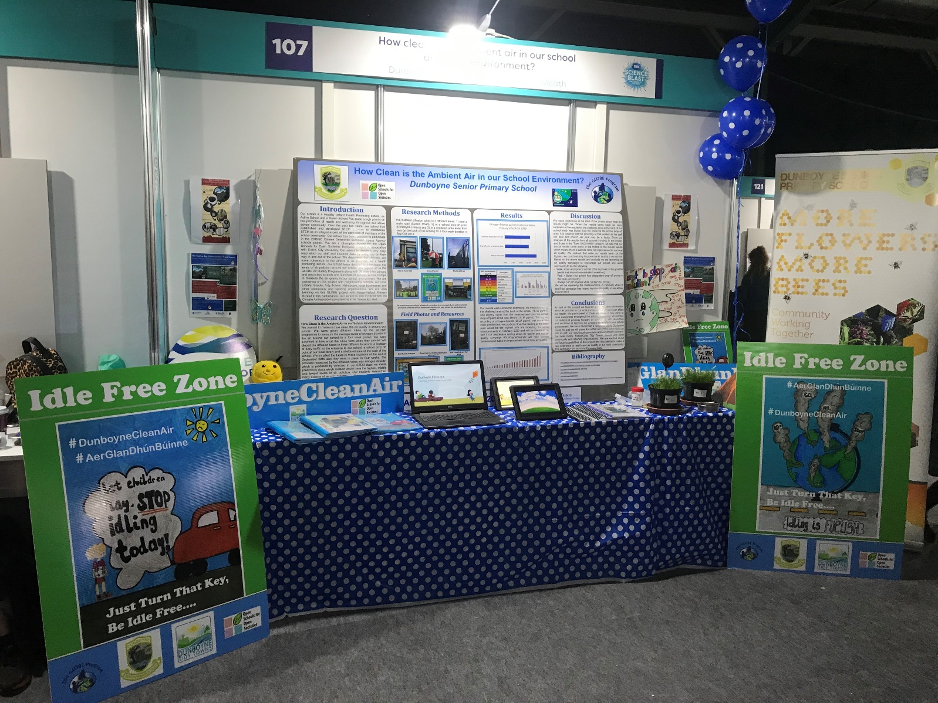

Figure 13: Our Science Blast 2020 Stand, March 3rd 2020

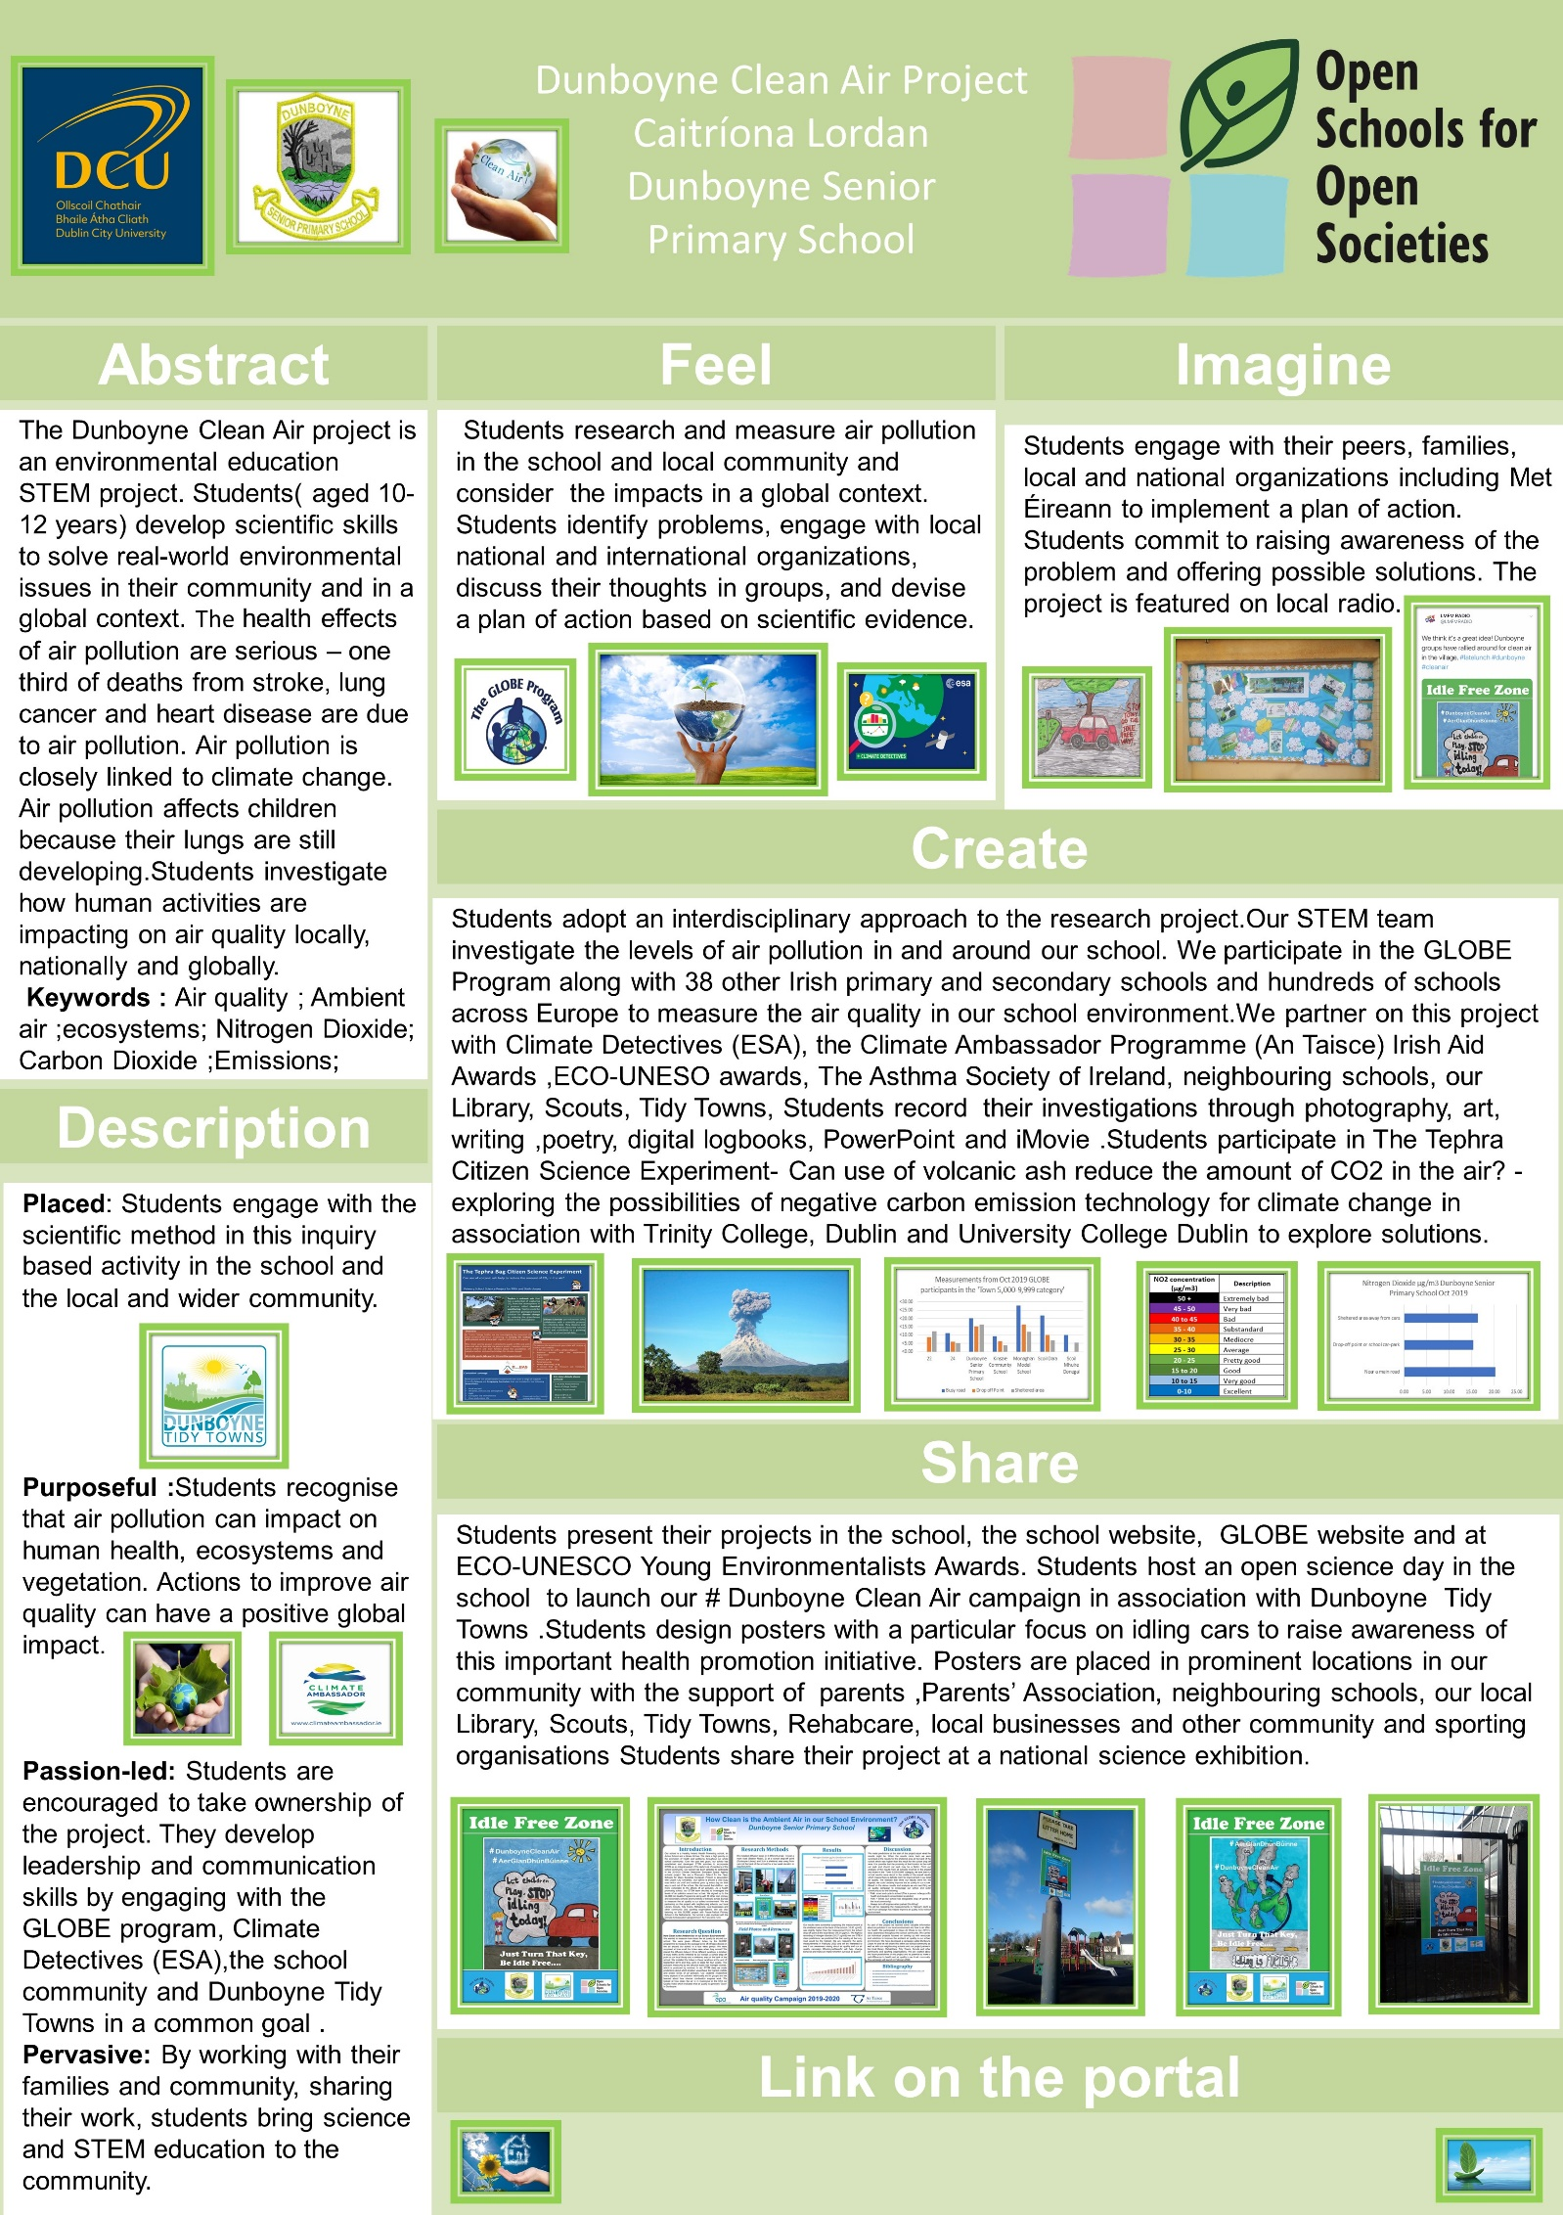
Figure 14: Our Research Poster for OSOS
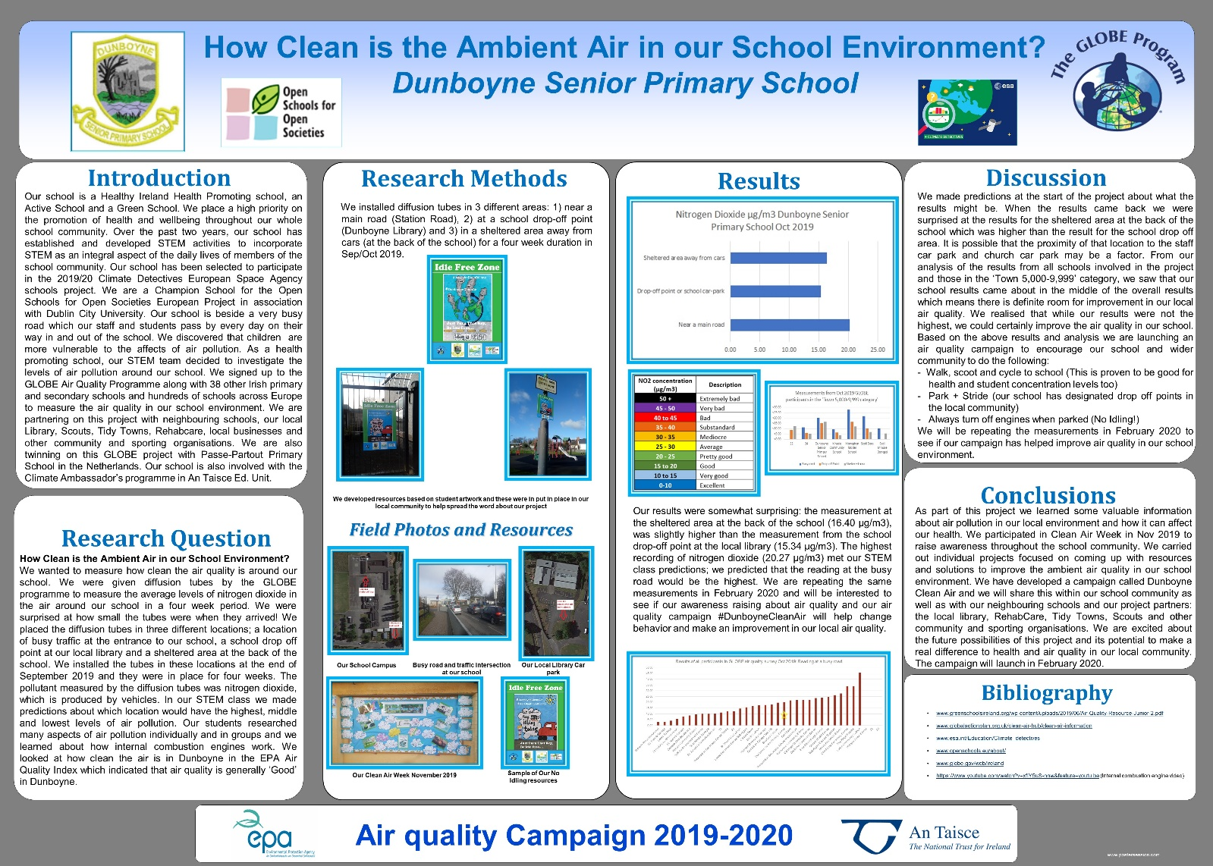
Figure 15: Our GLOBE research poster

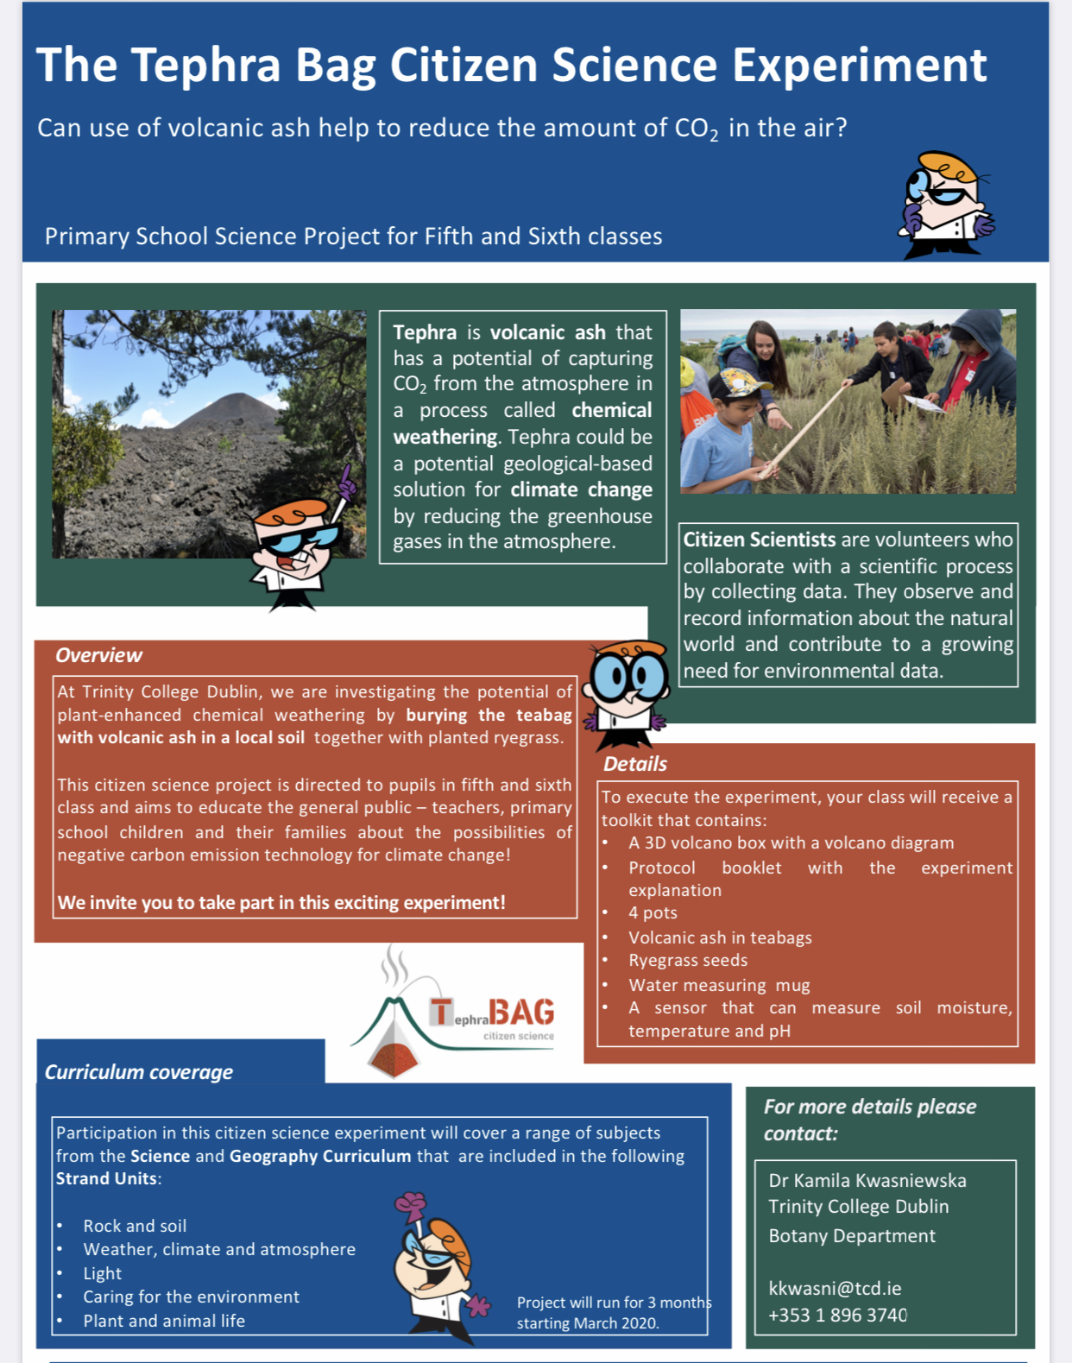

Figure 16: Tephra Bag Experiment Poster

References

Active Schools – More Schools, More Active, More Fun, n.d. URL https://activeschoolflag.ie/ (accessed 3.2.20).
admin, n.d. Green-Schools [WWW Document]. Green-Schools. URL https://greenschoolsireland.org/ (accessed 3.2.20).
Air Quality Campaign - GLOBE.gov [WWW Document], n.d. URL https://www.globe.gov/web/air-quality-campaign (accessed 3.2.20).
Average Weather in Dunboyne, Ireland, Year Round - Weather Spark [WWW Document], n.d. URL https://weatherspark.com/y/33843/Average-Weather-in-Dunboyne-Ireland-Year-Round (accessed 3.9.20).
Climate Ambassador - A Programme from An Taisce’s EEU [WWW Document], n.d. . Climate Ambassador. URL https://climateambassador.ie/ (accessed 3.2.20).
Climate detectives – Climate detectives [WWW Document], n.d. URL https://climatedetectives.esa.int/ (accessed 3.2.20).
Irish Aid Awards, n.d. URL http://www.ourworldirishaidawards.ie/ (accessed 3.2.20).
Monthly Data - Met Éireann - The Irish Meteorological Service [WWW Document], n.d. URL https://www.met.ie/climate/available-data/monthly-data (accessed 3.9.20).
OSOS Community | ODS Portal [WWW Document], n.d. URL https://portal.opendiscoveryspace.eu/en/osos (accessed 3.2.20).
#OwnOurAir: Schools Competition | Asthma Society of Ireland [WWW Document], n.d. URL https://www.asthma.ie/ownourair-schools-competition (accessed 3.2.20).
Science Blast 2020 [WWW Document], n.d. . ESB Science Blast. URL http://www.esbscienceblast.com/ (accessed 3.2.20).
The Global Goals [WWW Document], n.d. . The Global Goals. URL https://www.globalgoals.org/ (accessed 3.2.20).
www.healthpromotion.ie, n.d. www.healthpromotion.ie [WWW Document]. www.healthpromotion.ie. URL https://www.healthpromotion.ie/health/schools (accessed 3.2.20).
Young Environmentalists Awards - Eco-Unesco - Youth Organisation, n.d. . Eco-Unesco. URL https://ecounesco.ie/young-environmentalists-awards/ (accessed 3.2.20).

“#OwnOurAir: Schools Competition | Asthma Society of Ireland.”
https://weatherspark.com/y/33843/Average-Weather-in-Dunboyne-Ireland-Year-Round

