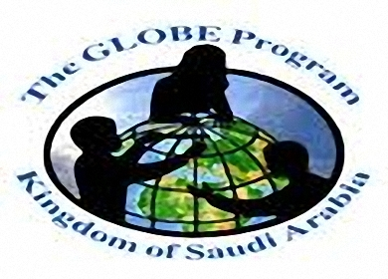

Kingdom of Saudi arabia

Ministry of education

General Administration of Education in AL Bahah

Al-Afous Secondary School (Credits System )

**تلوث البحار**

Seas Pollution

**عمل الطالب:** توفيق عبد الله سعيد دقاس

By :- Twfeeq Abdullah Saeed Daqass

**الصف:** أول ثانوي

First secondary grade

**المدرسة:** ثانوية العفوصِ

Alofous secondary school

dray

المملكة العربية السعوديةِ

وزارة التعليم

إدارة تعليم منطقة الباحة

ثانوية العفوص مقررات

|  |  |  |
| --- | --- | --- |
| **N** | **Title** | **Page** |
| 1 | Pollution | 2 |
| 2 | Sea Pollution | 2 |
| 3 | Causes of sea water pollution | 3 |
| 4 | Sources of sea water pollution | 4 |
| 5 | Risks of Sea water pollution | 4 |
| 6 | Effect of sea water pollution on Fish Wealth | 5 |
| 7 | Ways to protect the sea from pollution | 5 |
| 8 | References | 6 |

**Index of Contents:**

1

**Pollution:**

Is the first reason that will lead to the elimination of humankind and life in general on the planet, where the levels of pollution since the industrial revolution levels are unprecedented in the history of the globe and the volume of destruction resulting from the use of resources is a record in the killing and genocide Many forms of life on the planet. Water pollution is one of the most serious aspects of current pollution. It is known that the proportion of water in the planet reaches eighty percent, which means that the planet depends on the existence of water that cannot live without it

**Sea Pollution:**

 God created the universe and chose the planet to be the planet of life on which humans and living beings live, and where the causes of life are deposited, such as: the atmosphere, and the various surface topologies, such as the seas and the oceans, Because it hosts many aquatic organisms and is a suitable medium for living in peace. Its water absorbs heat, softens the climate and absorbs large quantities of harmful carbon dioxide. The water of the seas and oceans has been exposed to pollution, which means changing the physical or chemical properties of water, becoming unusable and causing serious diseases. This pollution has become a serious problem affecting the aquatic wealth in which it affects human beings.

2

**Causes of sea water pollution:**

studies have indicated that man is the main cause of sea pollution; as a result of his passive activity,

**Causes of this pollution include:**

• Man throwing waste, where it is thought that this sea can clean itself, and that these wastes will not appear as a result of small size compared to the size of the sea.

• Oil leaks during deep sea and ocean extraction processes. Human discoveries have led to the presence of oil in the water regions. It has been produced using modern equipment. Despite extreme concern, some quantities of oil may leak and cause water pollution. It can leak from the tankers as they pass through the water.

• Physical and chemical waste buried deep in the sea; these wastes are mostly hazardous radioactive materials.

• Acid precipitation that contains a high percentage of harmful impurities and salts, and when it falls over the sea, it

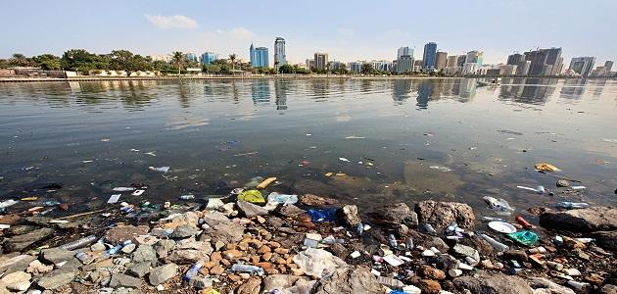• Dumping of factory waste in the sea, and this is evident in industrial areas where factories are abundant.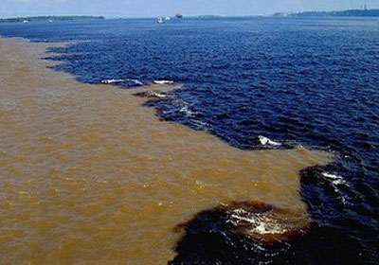

3

**Sources of Sea Pollution:**

1. Rainy rain water

2. Sewage

3. Industrial waste

4. Nuclear reactors

5. Insecticides

6. Chemical, organic and inorganic fertilizers

**Risks of sea water pollution:**

- Loss of large amounts of fish wealth in the sea water, which is an essential element in human food.

- Harmful health effects on human health.

- The environmental pollution of the sea waters to the environmental disturbance of the natural water cycle on the surface of the earth.

- Changing the composition and physical, chemical and biological properties of sea water.

- Damage to economic activity and tourism based on sea water such as fisheries, fisheries, beaches and tourist villages.

- Impede development and life on Earth.Water Pollution Man loses an important source of seawater desalination industries to become potable and agriculture.

4

**Impact of Sea Pollution on Fish Wealth:**

Fish are one of the most important sources of water wealth. People have been dependent on food since ancient times, but this wealth is in danger due to pollution of the sea. This pollution leads to:

• Death of large numbers of fish, and their water on the surface of water.

• Fish are affected by some pollutants. Studies have shown that the presence of oil in water, even in small quantities, negatively affects the hearts of fish embryos, as the shape of the heart changes, and reduces the ability to swim.

• Pollution of fish with heavy metals, such as mercury, cadmium and lead, and when humans feed on these fish, the proportion of these elements increases in the body and causes significant damage.

**Methods of protecting the sea from pollution:**

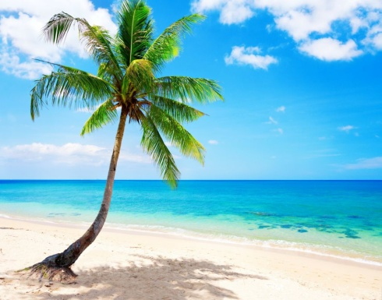• Issuing laws requiring people not to build near the sea, especially chemical plants.

• Awareness and education campaigns on the risks of sea pollution.

• Regular maintenance of oil tankers for fear of oil spill in the seas and thus destroy the marine wealth.

5

**References:**

1- mawdoo3.com

2- www.almrsal.com

3- www.eekn.net

6