The energy in our earth

Second High-scool of Jazan
Written by: Nora Ahmadiny , Shatha Azyabi ,
Jana Albor ,
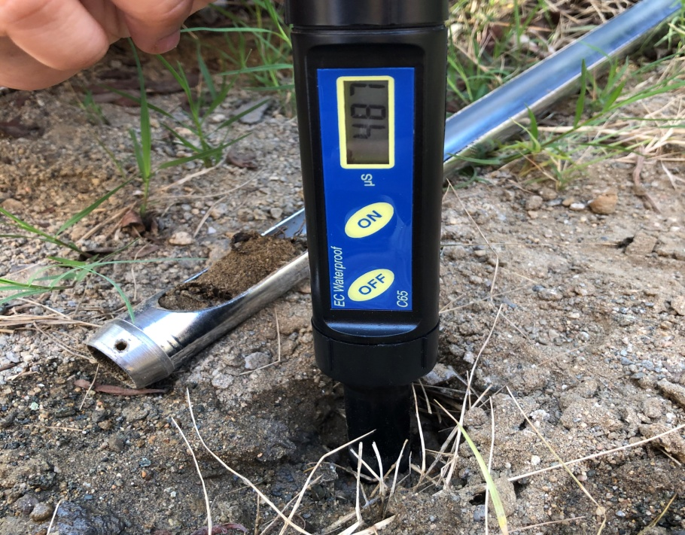

Adviser: T.Salwa Ahmed Alharby
Academic adviser: Entsar Aaraby
(1441-2020)

Abstract:
The goal of this research is using electrical soil energy as a alternative for oil , the research problem revolves around our goal which is not using electrical soil energy as an alternative to oil.
Hypothesis :
the absence of electrical energy in the ground in general in the soil.
We did a experiment which is checking if different kind of soils have electrical energy and we found out that 500g of coast soil has 1146 and dry soil has 419 and in the research there are different kind of soils which helps achieve in our vision 2030.
Thanks

The earth in our energy
Abstract:
The research title was our light in our land, a clear address that addresses what we wanted to reach first, as the research began with the question: Does the earth produce enough energy to replace oil with it? After we put the questions, we turned to the core of the research, which is the problem, and the problem was the lack of energy consumption of the soil, taking into consideration an alternative source of oil, and we assumed several assumptions.
Possibility of electrical energy in the ground or lack of energy
The possibility of using it as an alternative to oil or not using it
To support our hypotheses, we tested the presence of energy by conducting experiments on several types of soils, through which it became clear that there is electrical energy in the soil in different proportions according to the type of soil. Accordingly, our conclusion was that the amount of electrical energy varies between different soil types and that the more soil is wet The amount of energy is higher and it became clear at the end of our experience that the solution to our research problem is the consumption of the electrical energy of the Earth as a renewable alternative energy for oil energy according to Vision 2030
Research questions:
Does the earth produce enough energy to replace oil with it?
Can it be used to use it to convert the non-arable land to fertile land?
Can we conserve waste energy in becoming an alternative energy supplier?
Research problem:
Not consuming soil energy as an alternative to oil
Hypothesis :
he possibility of electrical energy in the ground in general in the soil
The absence of electrical energy in the ground in general in the soil ...
It cannot be used as an alternative oil resource
Samples:
Marine soil
Agricultural soil
Desert soil
School garden soil
Experiment controls
Constant Adjustment: the amount and thickness of the soil
Variable adjustment: soil type
Independent control: the amount of electrical energy in the soil

Electrical conductivity scale | Dig a hole 20 cm deep  Laying the device in the soil  Record measurements without water  Record measurements of the presence of water
500g of coast soil |  |  | 1144
500g of agricultural soil |  |  | 473
500g dry soil |  |  | 419
500g of school garden |  |  | 413
Experiment tool steps conclusion observation

Soil measurements experiment
Argicultrual soil without water agriculture soil with water
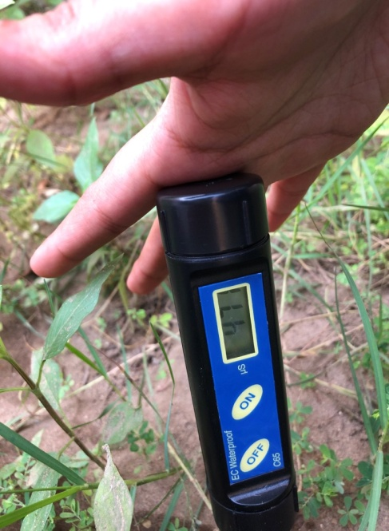
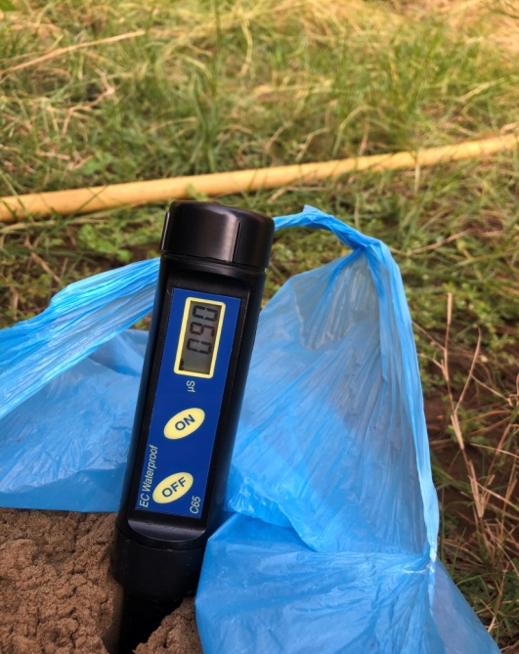
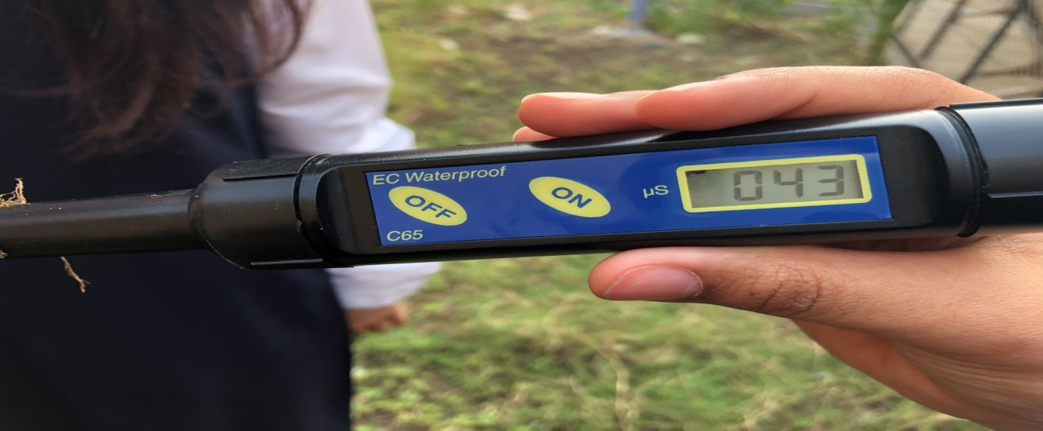
Soil measurements experiment
School garden soil with water school garden soil without water

413

Soil measurements experiment
Dry soil with water dry soil without water
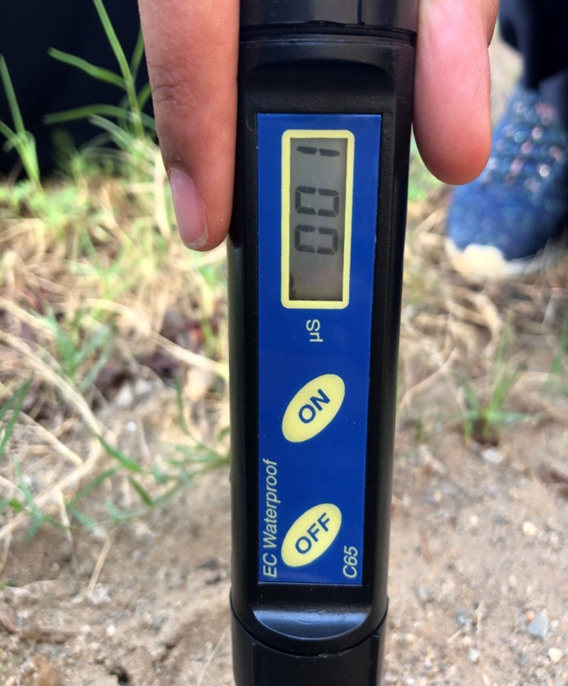
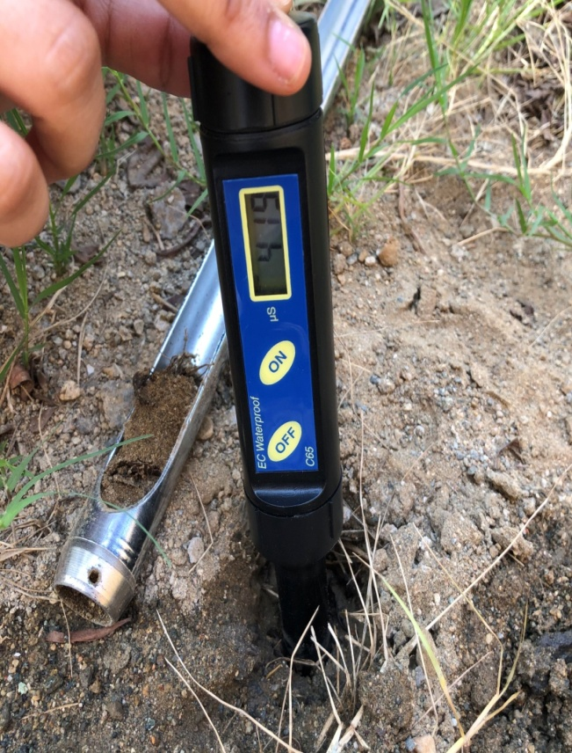

Soil measurements experiment
Coast soil with water coast soil without water
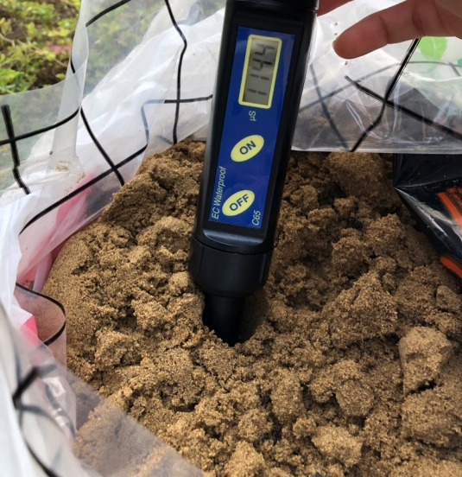
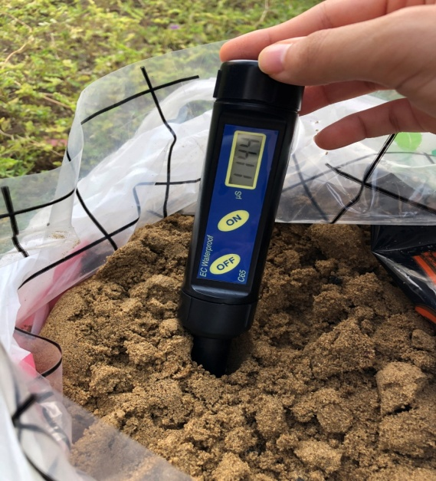

Type of soil | Electrical energy without water | Electrical energy with water
Agriculture soil | 90 | 471
Coast soil | 1144 | 1144
Dry soil | 1 | 419
School garden | 43 | 413
Results of the field study

Conclusion

The amount of electrical energy varies between different types of soil
The more moist the soil, the more energy
Solution for the problem:
Consumption of electrical energy in the earth is renewable alternative energy for oil energy according to Vision 2030
Recommendations :
Based on what we summarized at the end of the research about the possibility of using soil energy as an alternative source of costly electrical energy, we recommend the following:

Using electric energy from the soil to light the farms
Lighting the desert road through the soil
Create games for children on the coast that depend on electric power

Refrences :

- Corwin, D. L., and S. M. Lesch. 2005. Apparent soil electrical conductivity measurements in agriculture. Computers and Electronics in Agriculture 46(1-3): 11-43.
- Dabas, M., and A. Tabbagh, 2004. A comparison of EMI and DC methods used in soil mapping – theoretical considerations for precision agriculture. http://www.geocarta.net
- Sheets, K. R., and J. M. H. Hendrickx. 1995. Noninvasive soil water content measurement using electromagnetic induction. Water Resources Research 31(10): 2401-2409.
- Sudduth, K. A., S. T. Drummond, and N. R. Kitchen. 2001. Accuracy issues in electromagnetic induction sensing of soil electrical conductivity for precision agriculture. Comput. Electron. Agric. 31(3): 239-264
- ttps://ar.wikipedia.org/wiki/%D9%85%D9%82%D8%A7%D9%88%D9%85%D8%A9_%D8%A7%D9%84%D8%AA%D8%B1%D8%A8%D8%A9
- https://neonsci.com/%D8%A3%D8%B3%D9%84%D8%A7%D9%83-%D9%86%D8%A7%D9%86%D9%88%D9%8A%D8%A9-%D8%A8%D9%83%D8%AA%D8%B1%D9%8A%D8%A7-%D8%A7%D9%84%D8%AA%D8%B1%D8%A8%D8%A9-%D8%A7%D9%84%D9%85%D8%B9%D8%AF%D9%91%D9%84%D8%A9-%D9%88/

