The Effects of California’s Camp-Fire on Aerosol Measurements in Kingsburg, CA

Saneh Kahlon
Ajmeet Pama-Ghuman
Judith Reyes
Jillian Sasaki

Kingsburg High School
Kingsburg, California
Advisor: Mrs. Leigh-Ann Olsen
April 28, 2019
Abstract:

Aerosols are particulates, both naturally and anthropogenically produced, capable of affecting the passage of sunlight. This is measured in the form of Aerosol Optical Thickness readings, or AOT. Typically, increased presence of particles results in a higher reading. Combustion, which is the burning of substances, releases soot and other chemicals. Smoke from wood releases carbon dioxide, carbon monoxide, nitric oxide, nitrogen dioxide, sulfur dioxide, and much more, including even formaldehyde. In other words, the burning of organic materials can result in the release of mass amounts of particulates into the air. They can then be transported by the wind over large distances, as was observed in the AOT readings at Kingsburg. Aerosol Optical Thickness (AOT) reading collections were taken and analyzed in order to observe a possible correlation with the California Camp Fire which occurred within the duration dates in which AOT readings were taken. Certain anomalies were observed within the data and the causation possibly stemmed from active burning of the Camp Fire due to the nature of the fires and correlating dates of occurrence with data collection. Analysis and observations suggest that higher average AOT readings were observed on the days of which the Camp Fire actively burned.

With the help of Mrs. Olsen’s 3rd and 4th period Honors Biology classes, this cloud data was obtained by manual collection alongside calitoo collections by the authors of this study.

Research Question:

Originally, the question was: How does industrialization and agriculture affect aerosol patterns in Kingsburg CA? However, this study was set in motion after a trend was observed in weather data collected from the weather station in Kingsburg, CA located at the Latitude 36.519, Longitude -119.546, and Elevation 129.5. Based on these patterns, a question was proposed: Are the recorded Aerosol Optical Thickness (AOT) anomalies a result of the Camp Fire that burned in Paradise, CA, in 2018? Kingsburg is located about 275 miles away from the burn site, and typically has compromised air quality due to its geographical location within the Central Valley and agricultural activity.

Hypothesis:

A possible result of the effects of California’s Camp Fire on Aerosol measurements in Kingsburg, CA, that can be put forth is the presence of higher average Aerosol Optical Thickness (AOT). AOT readings collected concurrently with the dates on which the California Camp Fire actively burned will possibly be significantly higher than the average AOT readings taken on the dates in which there was not an active presence of wildfires. A null hypothesis would imply that the outliers in the data recorded around the time of the fire were coincidental. The alternative hypothesis would state that any outliers in the data are, in fact, caused by an outside event. Due to the extent and magnitude of the Camp Fire, along with an inversion layer of warm air characteristic of valleys that tends to trap pollutants/particulates for prolonged periods of time, there is a high likelihood that the oddities observed within our data collection could be caused by the activity of the Camp Fire.

Investigative Plan:

In order to determine a correlation, data was collected based on weather clearings on school days in Kingsburg, CA.

- Throughout the months of October to March, data was collected at the Kingsburg High School Science Building Weather Station.
- This data consisted of current air and soil temps, barometric pressure, humidity, cloud coverage, precipitation amounts and pH, along with aerosols.
- Collected data was submitted to the GLOBE website and through the GLOBE app along with aerosol data collection using a spreadsheet. The aerosol values were collected in groups of 5 per day and the average of each day that was collected was then placed onto the spreadsheet.
- Using the averages per day, we graphed the values into a dot plot. We also created a box and whisker plot in order to determine the general distribution of expected aerosol results from a date.
- These values were then analyzed to determine the correlation between outlier aerosol values and Camp Fire dates.

Research Methods:

Observations were made using data from the KHS Science Building weather station that collected daily air temp, including current, min, and max alongside relative humidity, cloud data, and precipitation. Typically, data collection occurred within an hour (at max) of solar noon, as per GLOBE atmosphere protocols. These observations were collected through a series of processes beginning with placing a hygrometer in the station 30 min before collection, then collecting the time/temperature from the station and barometric pressure from a barometer. Aerosols were collected on clear days suitable for AOT measurements that were also school days, typically taken around solar noon. Five readings were taken on each collection day in order to formulate accurate data. After all of these observations were written down--as automatic input does not exist yet at our station-- the GLOBE observer app and online Data Entry Forms were utilized to send in both cloud and aerosol observations. Precautions were established to avoid any obstructions in order to take the best possible images and make the most accurate observations.

GLOBE Data:

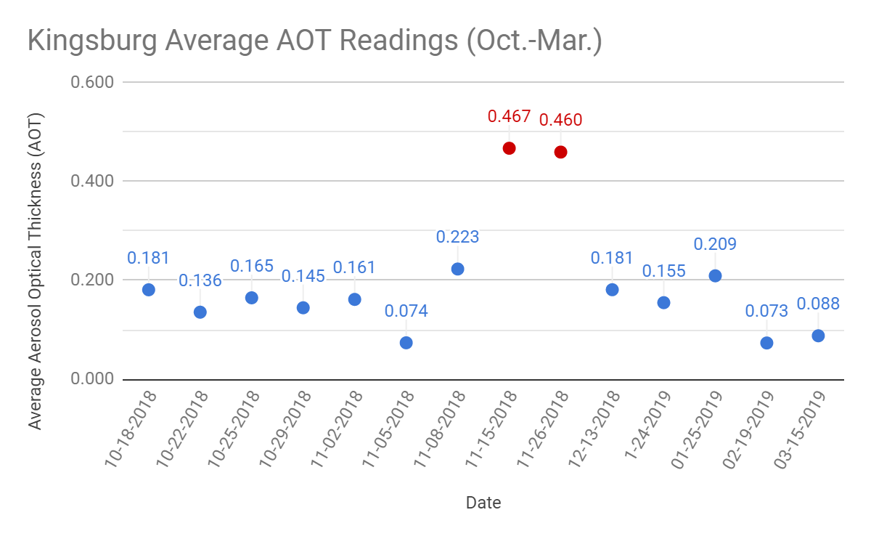
Figure 1: This graph illustrates average AOT readings with outliers highlighted in red.
Figure 2: This graph displays where the majority of average AOT readings fall in comparison to the outliers recorded.

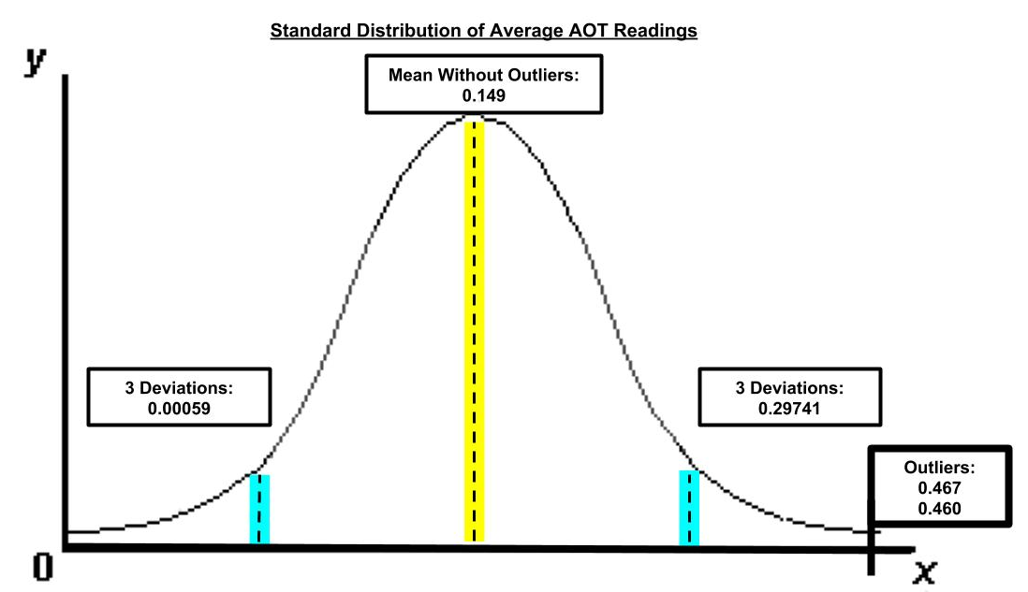
Figure 3: This diagram represents three standard deviations and outliers which support our hypothesis.

Data Summary:

Figure #1 displays averaged AOT readings from the October 18th, 2018 through March 15th, 2019 data collection period. The mean of the average AOT readings, excluding outliers, is 0.149. The outliers dated 11-15-2018 and 11-26-2018 are highlighted in red with an average reading of 0.467 and 0.460, respectively. The mean, including the outliers, is 0.194.

Figure #2 shows a box and whisker plot of the average AOT readings collected, including the outliers. The minimum is 0.073 and the maximum is 0.467. The median of the data is 0.163. The Q1 is 0.136 and the Q3 is 0.223, representing the middle fifty percent of data. The majority of data is located between the points 0.0055 and 0.3535, which are the boundaries for the data excluding outliers. The outliers cause a left skew of the box and whisker.

Figure #3 illustrates the graph of the average AOT readings without including the outliers, and it can be seen to have a normal distribution. The mean is 0.149 without the outliers. Three standard deviations left is 0.00059 and three standard deviations right is 0.29741. Based upon the curve created without the outliers to skew the data the outliers fall outside three standard deviations with values of 0.467 and 0.460.

Data Analysis:

Within the data collection, outliers were observed on November 15th, 2018 and November 26th, 2018. The average reading was noticeably greater than other collection dates. These data points correspond to the Camp Fire, which began November 8th, 2018 and was completely contained November 25th. The outliers are prevalently abnormal as viewed throughout the graphs. Based upon the dot plot these outliers are unusual, but are not mere coincidences as proven by statistical analysis.

The box and whisker plot data represents the extremity of the outliers, one of which was the maximum visible on the plot. The majority of the data lay in closer proximity of the minimum, which resulted in a significant difference between the Q3 and the outliers. This shows that the event which caused these outliers was severe enough to alter the aerosol average extensively.

The standard distribution diagram shows three standard deviations, which is the basis for accepting the alternative hypothesis and rejecting the null hypothesis. The null hypothesis, if representative of the data, would mean that the outliers are coincidental. The null hypothesis was disproved since the outliers measured were so abnormal that they fell outside the range of three standard deviations, which is beyond the boundary of being acceptable for the null hypothesis. Thus allows for the alternative hypothesis to be acceptable. In doing so, this shows that an event occured to cause these unusual data points. The most likely culprit is the Camp Fire which occurred during the period which the outliers were measured.

The Camp Fire’s aerosols were likely transported during this time period by air flow circulating through California. The area experienced northerly winds the date data was collected, however, in both cases the day prior experienced southerly winds, which likely contributed to aerosol distribution in the Kingsburg area. The 2018 California wildfire season had unusually high carbon dioxide emissions, an estimated 68 million tons, which in turn likely means that other emissions were of higher quantity, due to large fires like the Camp Fire. The fire’s aerosols were likely a mixture of volatile and semi-volatile organic materials and nitrogen oxides, as well as toxic pollutants, all transported by the wind. Particulate matter is also a product of such fires, specifically smoke and soot which predictably traveled in this region along with the other aerosols.

Conclusion:

Based on the data collected and research done, it is apparent that the Camp Fire significantly impacted average AOT readings collected in Kingsburg, CA. Aerosols, both naturally and anthropogenically produced, affect the passage of sunlight. This is measured in the form of AOT. The burning of organic materials can result in lots of particles making their way into the air. They can then be carried by the wind over large distances, as was observed in the AOT readings at Kingsburg. Due to the nature of the wind patterns and the overall magnitude of the Camp Fire, it can be concluded that the emissions from the fire altered the AOT readings for Kingsburg, CA and resulted in higher average collections. The time span of the active duration of the Camp Fire correlated with the dates in which AOT average readings were significantly higher than those observed on dates not included within Camp Fire activity or duration. Due to the observance of abnormally higher average AOT readings with the simultaneous occurrence of the Camp Fire, there is a strong conclusive lean towards a correlation between the abnormal AOT readings and their causation stemming from the Camp Fire. Overall, the release of mass amounts of particulates, as expected from a large fire like the Camp Fire, severely altered air quality in Kingsburg, CA. Wind patterns shifted the movement of the particulates towards the Central Valley with southward winds, promoting the collection of these aerosols in the area. This greatly differed with average expected AOT readings of this region, producing glaring outliers amongst the collected data. The correlation between the Camp Fire dates and average AOT readings from this region support the idea that mass burning of biomass can largely increase aerosol concentrations, well represented by our data.

Limitations/Sources of Error:

During the collection of data, a limitation which occurred was the amount of aerosol data collected throughout the gathering for the project. Fourteen days of aerosol data were collected, in total, due to cloud formation preventing extensive data collection, which was only possible on school days. This limited source of data may have skewed the results of the project. Additionally, the calitoo utilized for data collection was not handled correctly, which caused a loss of data due to inaccurate measures, a total of four days of data were lost in this way. The time which data was collected with the calitoo may have also caused a minor skew, while the measurements were generally taken at solar noon, the data was sometimes taken at approximately an hour’s time apart. The Woolsey fire in Malibu was also taking place during the time frame which our data was collected, November 8th, 2018 through November 21st 2018, so aerosols from southerly winds possibly could have passed over the mountains and into the Kingsbury area affecting AOT measurements. If such a study were to be progressed over a large expanse of time, average AOT readings could be speculated to be increasing alongside the impacts of natural occurrences such as precipitation, fog, fires, and wind patterns, as well as anthropogenic impacts such as agriculture. If wind patterns were to be tracked or monitored, they could be utilized to determine particulate origins and movement with a greater degree of accuracy. Computerized collection of data will likely stabilize the inconsistency of collection of days along with providing more substantial evidence. Taking into consideration the fluctuations in surrounding regions can also help solidify the proposed hypothesis.

Bibliography:

“2018 Agricultural Burn Decision.” California Environmental Protection Agency Air Resources Board, www.arb.ca.gov/smp/histor/history18/history18.htm.
“Aerosols Protocol.” GLOBE, GLOBE, 2014.
Bartels, Meghan. “How Satellites Are Tracking Devastation of California Wildfires from Space.” Space.com, Space Created with Sketch. Space, 15 Nov. 2018, www.space.com/42439-satellites-tracking-camp-fire-california-wildfires-damage.html.
California, State of. “California Statewide Fire Map.” Camp Fire News Releases, State of California, http://cdfdata.fire.ca.gov/incidents/incidents_details_newsreleases?incident_id=2277.
California, State of. “California Statewide Fire Map.” Camp Fire General Information, http://cdfdata.fire.ca.gov/incidents/incidents_details_info?incident_id=2277.
“Camp Fire.” NASA , NASA Landsat 8 Operational Land Imager , https://upload.wikimedia.org/wikipedia/commons/b/b1/Camp_Fire_oli_2018312_Landsat.jpg.
“Hanford, CA History.” Weather Underground, TWC Product and Technology LLC, www.wunderground.com/history/daily/KHJO/date/2018-11-8?req_city=Kingsburg&req_state=CA&req_statename=California&reqdb.zip=93631&reqdb.magic=1&reqdb.wmo=99999.
“Health Officer Hazard Advisory.” Butte County Recovers, https://buttecountyrecovers.org/health-officer-hazard-advisory/
Lara, et al. “Aerosol and Precipitation Chemistry Measurements in a Remote Site in Central Amazonia: the Role of Biogenic Contribution.” Atmospheric Chemistry and Physics, Copernicus GmbH, 7 June 2012, www.atmos-chem-phys.net/12/4987/2012/.
“New Analysis Shows 2018 California Wildfires Emitted as Much Carbon Dioxide as an Entire Year's Worth of Electricity.” U.S. Department of the Interior, 21 Mar. 2019, www.doi.gov/pressreleases/new-analysis-shows-2018-california-wildfires-emitted-much-carbon-dioxide-entire-years.
Niles, Robert. “Standard Deviation.” Robert Niles, Robert Niles, www.robertniles.com/stats/stdev.shtml.
“The Impact of Wildfires on Climate and Air Quality.” NOAA, NOAA ESRL Chemical Sciences Division, www.esrl.noaa.gov/csd/factsheets/csdWildfiresFIREX.pdf.
“Updated NASA Damage Map of Camp Fire from Space.” NASA, NASA, 19 Nov. 2018, www.jpl.nasa.gov/news/news.php?feature=7287.
“Visalia, CA History.” Weather Underground, TWC Product and Technology LLC, www.wunderground.com/history/daily/us/ca/hanford/KVIS/date/2018-11-15.
“Visalia, CA History.” Weather Underground, TWC Product and Technology LLC, www.wunderground.com/history/daily/us/ca/visalia/KVIS/date/2018-11-26.

