CEDAR, symbol of longevity and power!

Students: Borna Fable, Nensi Nadarević & Emili Šegon
Mentors: Olivera Tadić & Čeda Perko
Secondary school Mate Blažine Labin,Croatia

CONTENT
 | Abstract | 2
 | Research questions | 2
 | Introduction | 3
 | Research methods  4.1. PERIOD OF WORK  4.2. PARTICIPANTS  4.3. ASSOCIATES :  4.4. Stage of work and methods | 3  3  4  4  4
 | Results  5.1. DETERMINATION COORDINATES OF THE PARK  5.2. MEASURING SURFACE OF THE PARK  5.3. DETERMINATION TYPES OF COVER  5.4. DETERMINING THE AGE OF TREES  5.5. DETERMINING POSITIONS OF HEAT PUMPS AND TYPE OF MATERIALS  5.6. DETERMINATION HEIGHT, CIRCUMFERENCE AND treetop DAMAGE  5.7. ANALYSIS OF SOIL | 4  4  4  4  4  5  5  5
 | Discussion | 6
 | Conclusion | 7
 | Bibliography | 7
 | Acknowledgements | 8
 | Attachment | 9

1. Abstract
In front of the school is a park with seven cedars planted 1982g. One day began the installation of geothermal park. Will this affect the damage of cedars?
The results showed:
Cedars age is 34 years, MUC is 94, Latitude: 45.0913 N Longitude: 14.1217 E Elevation: 263 m. Corresponding to our Globe site.
After installation situation is:
Part 1 - 323.753 m2 - 4 cedars, 11 holes filled with different soil, sand, limestone, dolomite.
Part 2 - 276.755 m2 - 2 cedar, 1 hole filled with cement and 2 water tanks.
Increase in height and volume is expected,damage of crown has increased, one cedar is dry.
Analysis of soil at two positions: type of soil is same, permeability is increased, pH value crossed from acidic to alkaline. Increasing the concentration of ammonium, iron, nitrate, nitrite and sulphate ions in particular in position 2. Changes in soil properties may have been caused by dissolution of materials from holes with action of rain.
One year is a relatively short period in the life of cedar, but we concluded it is possible that installation of geothermal park affected to slowed the growth and development of cedars.
We will follow cedars still hoping to survive.
Keywords: Cedar (Cedrus libani), GEOTHERMAL PARK

2. Research questions
In a small park in front of our school grows seven trees cedar. We are happy because the cedar tree is not common in our area.
One day begun the installation of GEOTHERMAL EDUCATIONAL PARK.
We followed works and research question is:
Will the installation of GEOTHERMAL PARK affect the damage of cedars?
To answer this question we need to explore:
- Will damage of the roots and bark affect the growth and development of cedars??
- Will there be a change in the composition of the soil because of acting rain?

3. Introduction
Cedar (lat. Ceddrus) is a genus of evergreen trees belonging to the family of pine (Pinaceae). (www.blueplanetbiomes.org/lebanon_cedar.htm)
Cedar is a tree with a very long history and one of the oldest spices in the history of mankind. The oldest records refer to the most famous type of cedar: Cedrus libani, a symbol of greatness, strength and durability, fertility and dignity. Used from the Sumerians and Babylonians, and Egyptians, except for health and beauty, for embalming and protection of papyrus from insects. (www.2020site.org/trees/lebanon.html)
According to legend, Noah after the flood expressed his gratitude to the gods making a sacrifice burnt offerings consisted of cedar and myrtle.
Although there are still very old Lebanese cedar tree, and the oldest is even about 2500 years ago, most of its forests has long been reclaimed.
In our school park grown cedars, so we decided to devote a little more attention on it, especially as in the park one day appeared machinery and began work on digging holes.
We asked what was going on and we found that in our small park sets GEOTHERMAL EDUCATIONAL PARK. (www.labin.com/web/vijest.asp?id=24521, www.irena-istra.hr/index.php?id=4125)
Heat transfer will take place with the heat exchangers in the form of baskets with spiral wound hoses length 60 to 80 m. They set the twelve baskets and two tanks of water in the holes depth of two meters, and each is filled with different kinds of soil or building materials. The primary goal is for students to measure the thermal conductivity of the soil to find out exploitation potential. (energy.gov/energysaver/geothermal-heat-pumps)
Stages of labor
1. digging holes and removal of soil
2. damaged roots, and bark
3. setting basket in the hole
4. filling holes with different materials
5. marked holes

4. Research methods
4.1. PERIOD OF WORK :
Works on geothermal park began in the summer of 2015. and ended in November 2015.
First measurements we conducted in September and October 2015. to get a basic information.
The measurements were repeated in November 2016. to determine if has been a change after one year.
We will analyze our results and we hope to find the answer to our two questions posed at the beginning of the project.

4.2. PARTICIPANTS:
- GLOBE GROUP: 21 members
- OTHER STUDENTS : 27 students
4.3. ASSOCIATES :
- IRENA - Istrian Regional Energy Agency
- Croatian Forest Research Institute
- Utility company “1. May”, Labin

4.4. Stage of work and methods
Table 1. Stage of work and methods
STAGES OF WORK | METHODS
1. DETERMINATION COORDINATES OF THE PARK | Globe GPS protocols
2. MEASURING SURFACE OF THE PARK | ARKOD browser, measuring
3. DETERMINATION TYPES OF COVER | Globe MUC protocols
4. DETERMINING THE AGE OF TREES | THE TREE RING protocols
5. DETERMINING POSITIONS OF HEAT PUMPS AND TYPE OF MATERIALS | Globe GPS protocols, visually (attachment 1.)
6. DETERMINATION HEIGHT, CIRCUMFERENCE AND treetop DAMAGE | Globe biometric protocols Instructions Forest Research Institute (attachment 2.)
7. ANALYSIS OF SOIL | Globe soil protocols
8. ANALYSIS OF RESULTS | Globe protocols

5. Results

5.1. DETERMINATION COORDINATES OF THE PARK
Latitude: 45.0913 N, Longitude: 14.1217 E, Elevation: 263 m

5.2. MEASURING SURFACE OF THE PARK
ARKOD browser: 736 m² , measurement with measuring tape: 727.00 m²
DIFFERENCE: 9 m²
REASON FOR DIFFERENCES: ARKOD browser include the part of the sidewalk.

5.3. DETERMINATION TYPES OF COVER
MUC COD - 9 city building land; 94 other (park)

5.4. DETERMINING THE AGE OF TREES
Cedars were planted 1982. year
We have examined the two trees: Alex - at least tree, Momčilo - the largest tree
We have confirmed the age of 34 years on both trees.
5.5. DETERMINING POSITIONS OF HEAT PUMPS AND TYPE OF MATERIALS
Part 1 - 323,753m2 where there are 4 cedar trees and 11 geothermal holes filled in various materials (different types of soil, sand, limestone, dolomite ...).
Part 2 - 276,755m2 where there are two cedar trees 1 geothermal hole filled with cement and 2 water tanks. (See Attachment 1.)

5.6. DETERMINATION HEIGHT, CIRCUMFERENCE AND treetop DAMAGE

Table 2. Mean values of three measurements in height, circumference and treetop damage

No | Name | 2015. |  |  | 2016.
 |  | Height  (m) | Circumf.  (cm) | Degree of damage | Height  (m) | Circumf.  (cm) | Degree of damage
1. | Maroslaw | 14,3 | 175 | 0 | 14,9 | 178 | 1
2. | Cedromir | 19,3 | 146 | 0 | 20,1 | 150 | 1
3. | Pahuljica | 17,9 | 205 | 1 | 18,5 | 210 | 2
4. | Momčilo | 21,5 | 210 | 0 | 21,5 | 210 | 2
5. | Arabella | 10,4 | 115 | 0 | 10,5 | 115 | 3
6. | Alex | 6,8 | 80 | 2 | 5,4 | 70 | 4
7. | Ante | 17,5 | 268 | 0 | 17,6 | 270 | 2
(See Attachment 2.)

5.7. ANALYSIS OF SOIL

Table 3. Mean values of three measurements of soil properties

property | Before installing the geothermal PARK |  | AFTER installing the geothermal PARK
 | 2015. /1 | 2015. /2 | 2016./1 | 2016./2
Clay %  Sand %  Silt % | 64,5 34,4 1,1 | 64,1 34,7 1,2 | 60,0 22,2 17,8 | 66,8 31,0 2,2
Type of soil | Clay | Clay | Clay | Clay
Permeability of soil % | Very low | Very low | Low | Low
Carbonate % | ‹ 1 | ‹ 1 | ‹ 1 | ‹ 1
pH-value | 5,1 | 5,2 | 7,8 | 7,6
Ammonia (NH₄⁺ mg L⁻¹) | 7,5 | 7,8 | 10,0 | 60,0
Nitrates/Nitrites (N mg L⁻¹) | 4,5 | 4,5 | 5,0 | 10,0
Phosphates (P mg L⁻¹) | 20 | 20 | 20 | 20
Chlorides mg L⁻¹ | 0 | 0 | 0 | 0
Sulfates mg L⁻¹ | ‹ 200 | ‹ 200 | ‹ 400 | ‹ 400
Iron mg L⁻¹ | 3 | 3 | 3 | 10
Metals (Cu,Pb,Hg) mg L⁻¹ | 0 | 0 | 0 | 0

6. Discussion

- In front of our school is a green area of ​​727 m² on which grows seven cedars (Cedrus libani) which were planted in 1982.
- According to the protocols THE TREE RING project we have confirmed their age of 34 years.
- According GLOBE protocols MUC COD is 94 urban land.
- Coordinates of the plot are Latitude: 45.0913 N Longitude: 14.1217 E Elevation: 263 m, corresponding to our Globe biometric school station.
- In cooperation with the agency IRENA on plot is set GEOTHERMAL EDUCATIONAL PARK and current state of the plot is:
Part 1 - 323,753m² where there are 4 cedar trees and 11 geothermal cave filled with various materials (different types of soil, sand, limestone, dolomite ...).
Part 2 - 276,755m² where there are 2 cedar trees 1 geothermal cave filled with cement and 2 water tanks.
- During digging a hole the roots and bark of trees was damaged. This worried us and encourage to this work.
- By measuring the height and volume of the treetop damage we found that: - Increase of height and volume expected, ,
- The degree of damage to the treetop has increased,
- Alex has completely dried up.
This results indicate the potential negative impact of the works.
- By analyzing the physical and chemical properties of the soil at two sites we found:
- Type of soil has remained the same with a slightly higher proportion of powder in particular in position 1.
- Permeability of soil is slightly increased, in both positions.
- The pH crossed from acidic to alkaline, in both positions.
- Increasing the concentration of ammonium, nitrate and nitrite ions especially in the position 2.
- Increasing the concentration of sulfate ions, in both positions.
- Increased concentration of iron ions in position 2.
Such changes in the chemical properties of the soil may have been caused by dissolution and leaching of materials which was buried in holes of geothermal park with action of rain.

7. Conclusion
In the end, we can conclude that we get answers to the questions at the beginning of our research.

One year is a relatively short period in the life of cedar, but we think it is possible that damage the of the roots and bark and change of chemical properties of the soil as a result of placing the geothermal EDUCATIONAL PARK affected on slowed the growth and development of our cedar trees.

We have asked the opinion of the city utility company that takes care of the green spaces in our city, but they do not see a way to make the situation now could change.

We will follow cedars, hoping to be adapted to the new conditions and that will not all follow the footsteps of little Alex.

MEMBERS ACTIVITIES
- We regularly publish our results on school web pages www.ssmb.hr/426/skola-za-okolis-school-environment in the media and on the Globe web pages with the aim to sensitize more people on our Planet.
- In 2015 we joined The international "Day of tree" and observations we published on www.globe.gov/web/srednja-skola-mate-blazine-labin/image-gallery
Therefore our cedars deserve a big hug as a sign of our concern about them!

8. Bibliography

- www.globe.gov
- www.arkod.hr
- www.blueplanetbiomes.org/lebanon_cedar.htm
- www.2020site.org/trees/lebanon.html
- web.utk.edu/~grissino/ ULTIMATE TREE-RING WEB PAGES
- www.sumins.hr
- www.sumfak.unizg.hr/download.aspx?file=/Upload/sec_001/ins_002/
- www.irena-istra.hr/index.php?id=4125
- energy.gov/energysaver/geothermal-heat-pumps

9. Acknowledgements
- We thank the members of our group and other students for their dedicated work through that and learned a lot of environmental factors in the environment

- We thanks our mentors for their support
Mira Hrvatin, Globe teacher & teacher adviser, Graduate Engineer of biotechnology , working on environmental issues for 35 years
Olivera Tadić, Globe teacher & teacher mentor, Graduate Engineer of chemically technology, working on environmental issues for 15 years
Čeda Perko, Globe instructor, Graduate Engineer of agronomy, working on environmental issues for 25 years
- Thanks to scientists from
IRENA - Istrian Regional Energy Agency, Pula, Croatia
Croatian Forest Research Institute, Zagreb, Croatia
Utility company “1. May”, Labin, Croatia

- From a number of projects that we have worked through our nineteen years in Globe program we want to point up the project
«ARE THE PINE FORESTS AROUND LABIN DYING?» which is by importance to the local community and by methods similar with the project of this year. With this project our group represented Croatia in the GLOBE Learning Expeditions (GLEs) 2003 - Šibenik, Croatia

10. attachment
attachment 1.
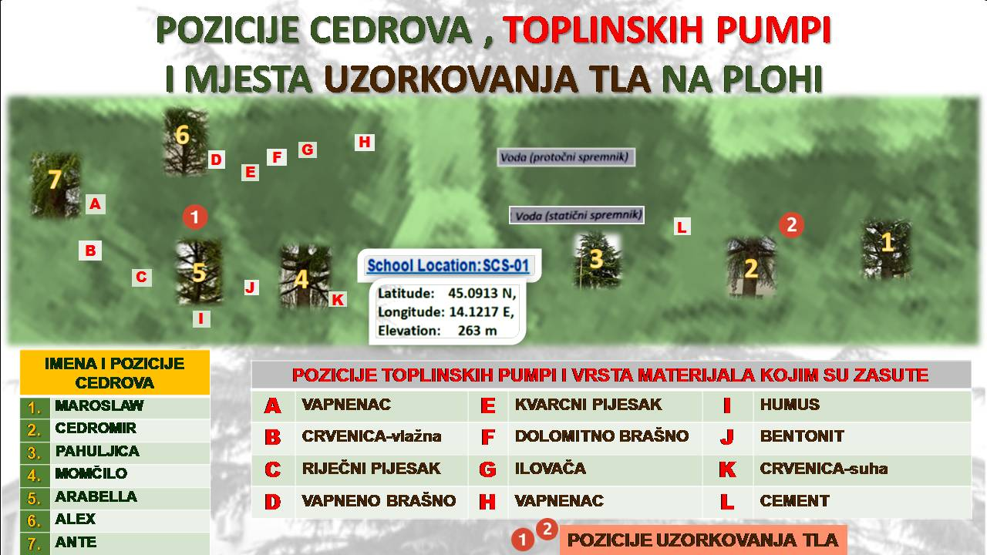

attachment 2.
