2018 GLOBE International Virtual Science Symposium
Middle School Jules Valles
Portet sur Garonne
FRANCE
Students: BAZILE Aurélien; BERNARD Alexandre; BERNARD Paul; BONHOMME Agathe; BOUYSSOU Paul; CAHUZAC Anthelme; CASTILLON Louis; CINTAS Lison; DE BLIC Julien ; DOUMENG Aurélien ; DZIKI Sami ;ESSOUKI Mathys ;GRISONI Cécile; HAUBERT Kyan; LARRIEU-LACOSTE Aurélie; LARRIEU-LACOSTE Julie; LEMARQUAND Augustin; MAGNAT Frédéric; MARCHAND Félicie; MAURIEGE Rémi ; NEDJARI Sabrina ; PUJOL Eléonore; VILLERS Noëlie ;

GLOBE Teachers: Sandrine Larrieu-Lacoste – Thierry Lourmière – Célia Burroughs-

- Title
Garonne, a river under surveillance
- Abstract

As part of the CNES’s environmental awareness of young people program, the middle school participates in the new Argohydro project, which focuses on the water cycle.
Thus, we have chosen to study the problem of climate change on the hydrological cycle of the river that crosses our city: the Garonne.
First of all, we have been sensitized to this problem through the Adour Garonne file entitled "Garonne 2050", which warns about global changes in the Garonne basin, and on the need to monitor the water level in the Garonne.
As a first step, in order to verify the hypothesis of climate change, a group of students carried out a statistical analysis of climate data for the Toulouse agglomeration using data available on the website called of infoclimat and GLOBE data from our weather station.
CNES's Earth Observation Space Missions enable the acquisition of very important data to understand the climatic machine that forms the water cycle. A group of students studied the operation of the Jason 3 altimeter satellite.
Then, to monitor the Garonne level, and to check the satellite in-situ data, two groups of students conducted a project to construct a water level sensor using two different technologies.
One group chose to use a pressure sensor to measure water level and the other one chose to use an ultrasonic sensor.

Keywords: global warming, rainfall, water level, water cycle, CNES

3. Research questions

In the prospective study "Garonne 2050", which focuses on the needs and on the water resources of the greater basin of the Garonne by 2050, the experts of the Adour Garonne Water Agency have carried out hydrological simulations predicting a reduction in the flow of the Garonne river from 20 to 40%, especially in summer and autumn.
After reading this study, we drew up a mental map to synthesize the different research questions related to the impact of global warming on the Garonne's water level and particularly on the city of Toulouse.

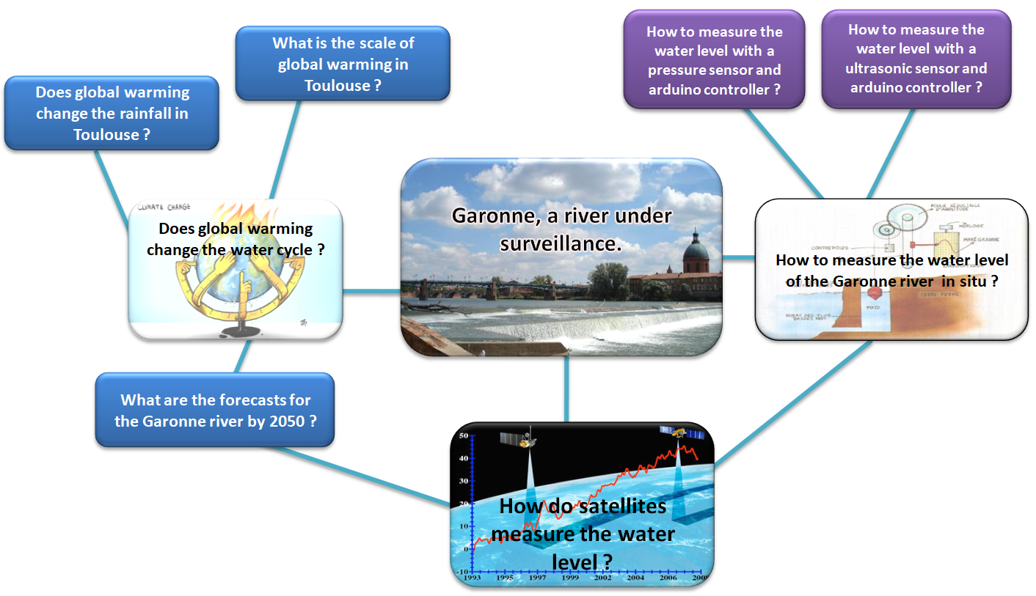
4. Research methods
GLOBE protocols:
- Air temperature
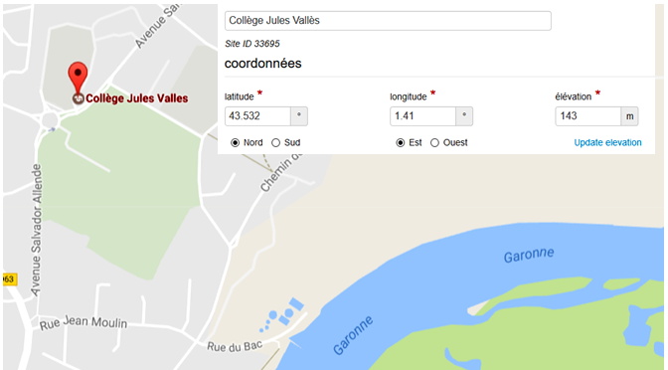
- Precipitation / rainfall

Data taken from other protocols
5. Water level Garonne river

Location
Measurement locations: College Jules Vallès de Portet sur Garonne-France, next to the city of Toulouse

The team:The 26 students are 13-14 years old

From the GLOBE database, we have downloaded our Temperature and rain Depth measurements for the years 2016 and 2017. Then, we have completed this data base by adding the data of the Météo France agency.

- Graph1: Average temperature (2016-2017) versus years

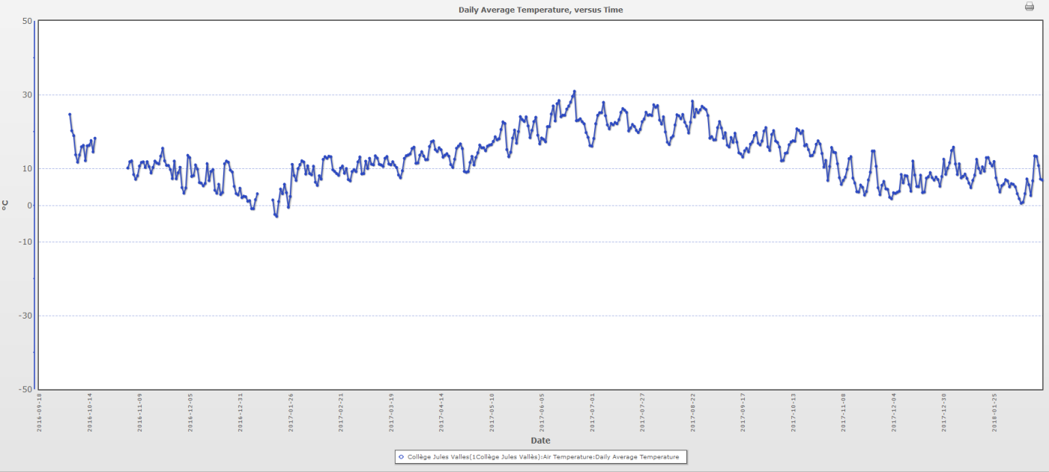
Graph 2: Rain depth (2016-2017) versus years

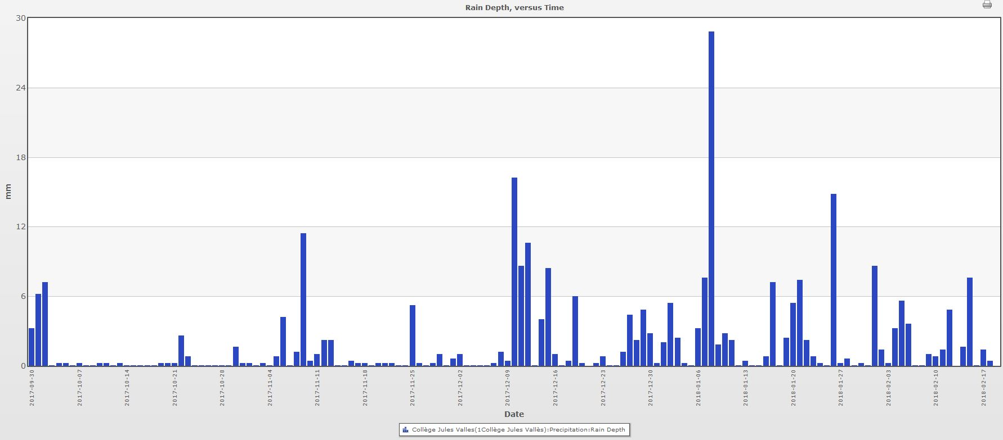

5. Results

First Goal: What is the scale of global warming in Toulouse?

Hypothesis:

We assume that climate warming has begun in Toulouse.

- Graph 3: Average temperature and difference from normal (1981-2010) versus years from 1997 to 2017.
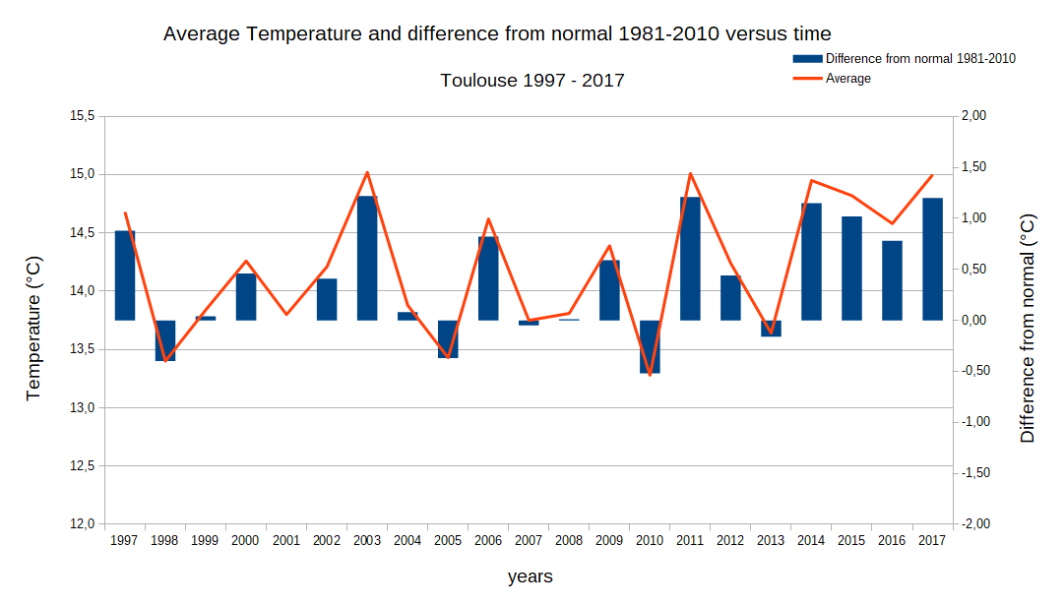

This document allows us to confirm that there is global warming in Toulouse. Over the past four years, we have noticed a global warming whose value is situated between 0.75°C and 1.25°C.

Second Goal: Does global warming change the rainfall in Toulouse?

Hypothesis:

We assume that warming causes more evaporation of the oceans, rivers... and leads to more precipitations (rainfall).

- Graph 4: Cumulative level and difference from normal (1981-210) versus years from 1997 to 2017.
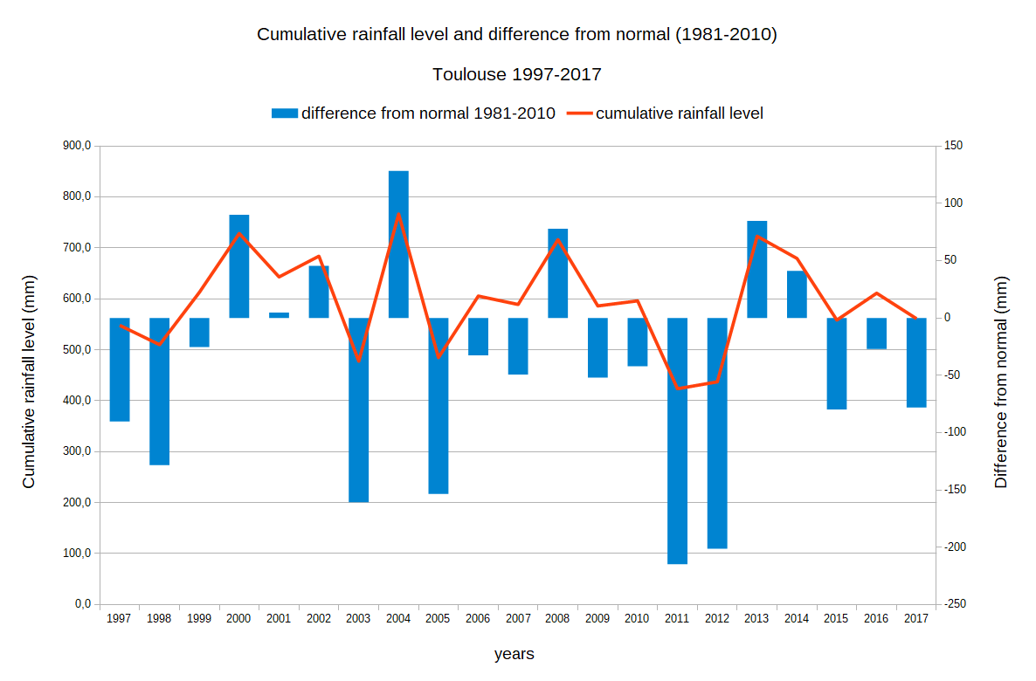

- Graph 5: Difference from normal precipitation (%) versus saisons from 1997 to 2017 in percent.
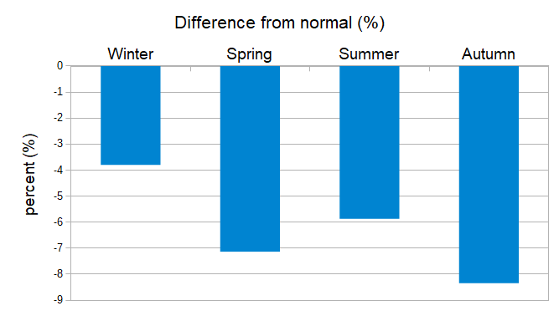

Contrary to our hypothesis, the graph shows that only 35% of the rainfall over 20 years are above the normal (1981-2010), and that, as a consequence, 65% are below the normal. We deduce that there is a decrease in rainfall in Toulouse. This decline is most pronounced in autumn and spring (-8%).

Third Goal: What are the projections of climate change and its impacts on the Garonne river?

Hypothesis:
Increasing temperatures will lead to increase the evaporation of water.
The drying of soils due to the increase in temperature will lead to a faster runoff of rainwater.

- Graph 6: Potential evapotranspiration at Portet near Toulouse in 2016 versus month.
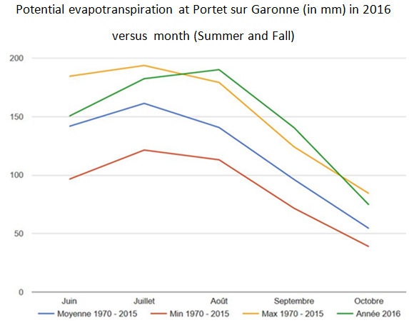

- Graph 7: Climatic projection – soil moisture in 2035 (DRIAS)
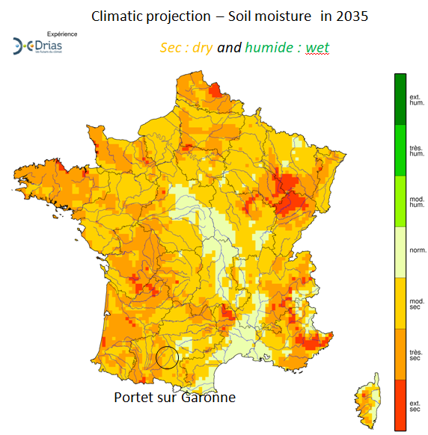

- Graph 8: Hydrologic pattern of Garonne river at Portet near Toulouse in 2016.
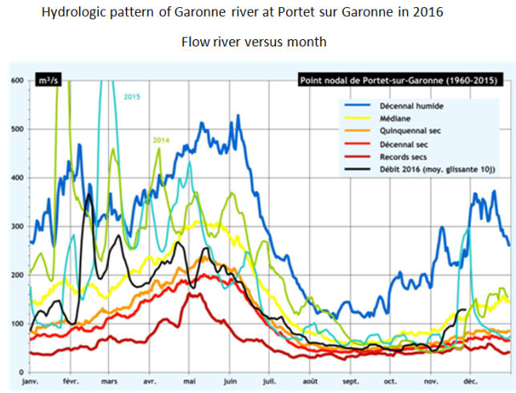

- Graph 9: Comparison between Climatic projection in 2050 and current data in Tonneins (downstream of Portet).
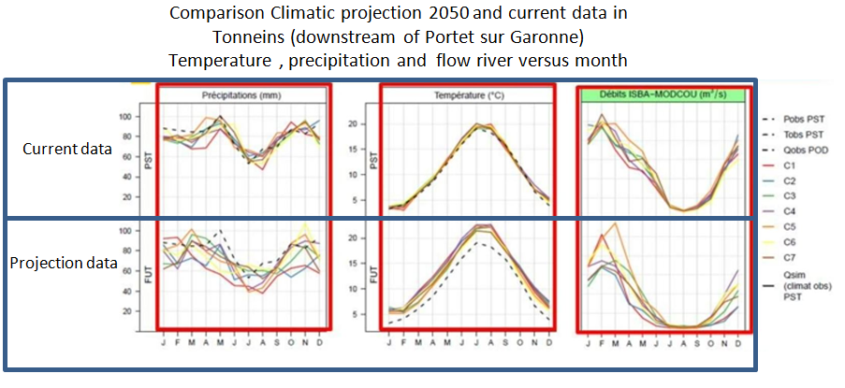

According to Graph 6, in 2016, evapotranspiration has increased and is very close to the peaks observed since 1970.
On the graph 7, representing the hydrological profile of the Garonne at Portet in 2016,we see that the river flow is low from July to November and that the maximum flow took place in mid-February.
The climatic projection of document 7 shows that soil moisture will decrease in the Portet sur Garonne region.
Document 9 shows the projected 2050 forecast of precipitation, temperature and flow data for the Garonne at Tonneins downstream of Portet. As shown in graph 8, we observe a very low Garonne flow in summer and autumn and an increase in February and March.

Discussion
The rise in temperatures leads to an increase in evapotranspiration, a decrease in soil moisture, and earlier melting of Pyrenean snow in the year. These changes will lead to a major change in the hydrological profile of the Garonne River, namely:
- a longer and more severe period of low water in summer and autumn
- increased runoff and reduced infiltration.
- change from a nival to a rainfall regime (snow melt is rapid, which can lead to increased flooding in winter and droughts in summer).

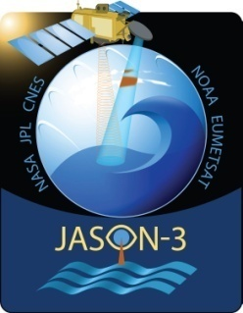
Fourth Goal: How do satellites measure the water level of rivers?

Since January 2016, the Jason 3 satellite has been measuring the sea level, but also the one of some lakes and rivers.
The time of return of an electromagnetic wave emitted by the satellite after reflection on the sea surface is measured.
- Document 10: The aim of altimetry measurement:

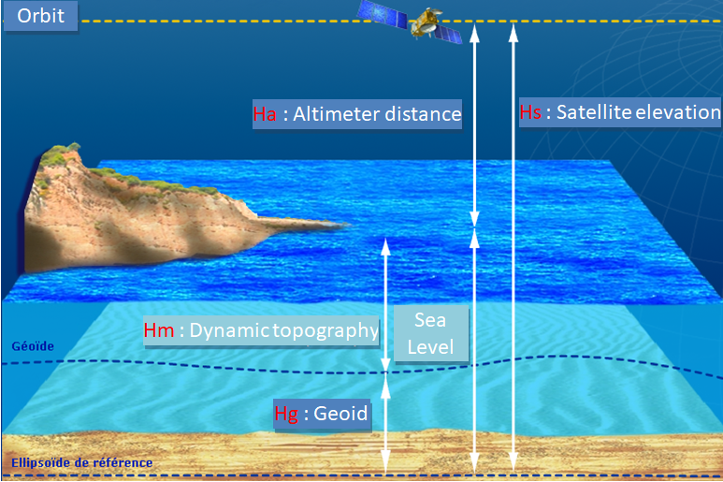

The relative value of sea level H_{m} is given by the following formula:
H_{m} = H_{s} - H_{a} - H_{g}

- Document 11: Floor trace of Jason 3 in FRANCE:
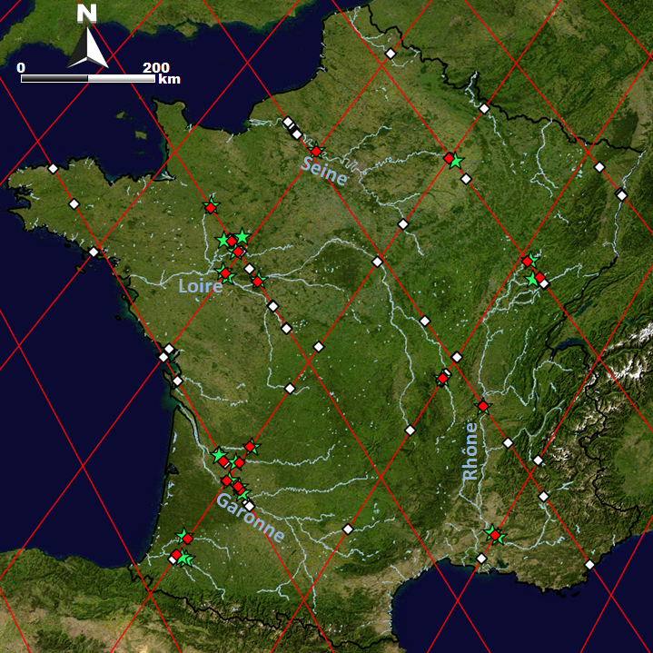
Portet sur Garonne near Toulouse
Floor trace of Jason 3

As the satellite does not go through our city, we were unable to compare our data with the one of the satellite.

Fifth Goal: How to measure the water level with a pressure sensor and an Arduino microcontroller?

First, we looked on the Internet for a way to measure water height using an Arduino microcontroller and a pressure sensor. Then, we have tried to understand how, by measuring the pressure, we can deduce the height of water.

The pressure is: $Pressure=\frac{Force}{Area}$ For the water we have:
Force = Weight = mass × gravity

also weight = density × volume
force = density × volume × gravity also volume = area × height

hence $Pressure=\frac{ density ×volume × gravity}{area}$ = $\frac{ density ×area × height× gravity}{area}$

For the water, gravity is equal to 1 000kg/ m³ and gravity is equal to 9,81 m/s².

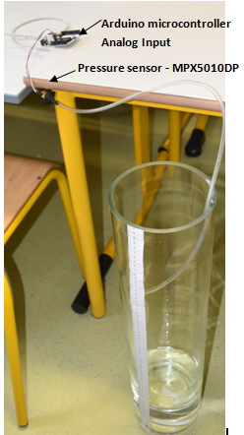
The pressure varies in proportion to the water level. The water level can therefore be measured using a pressure sensor.

We've done this setup:

The measurements obtained are

Water level (cm) | Vdigital (Input AO)
0 | 47
10 | 125
20 | 221
30 | 300
40 | 392
50 | 465
60 | 531

After calculations, we obtain the following linear function:

Water level (Vdigital) = $0,12×Vdigital-5,73$

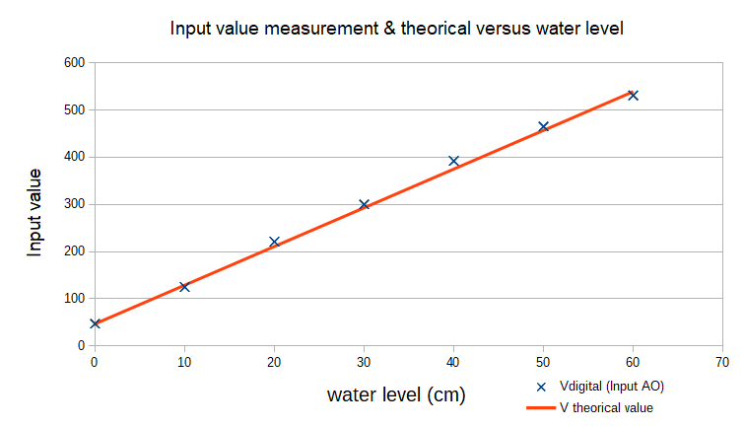

To complete our sensor, we have compiled the following equipment list:

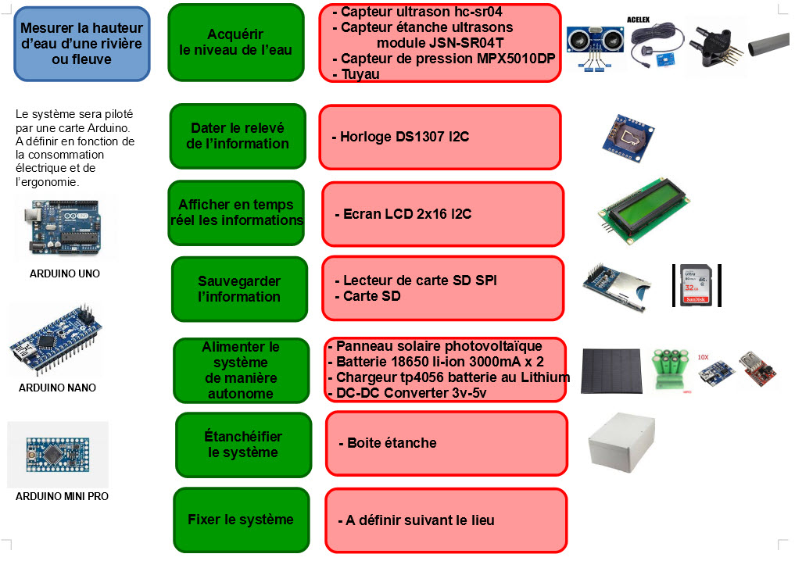

6- Conclusion

The data from the GLOBE stations are not all complete, because we only bought our weather station recently. Nevertheless, the graph 3 confirms global warming in our region.
The consequences on precipitations are still too uncertain, the slight decrease observed in recent years has been contradicted by a very rainy January and February months in our region in 2018.
In France, the floods of winter 2018 and the multiplication of droughts in summer and autumn show us that global warming has consequences on the water cycle.
In our project, we built a new water-level sensor to facilitate the monitoring and management of rivers.
Also, uncertainties remain about the mechanism of this change, so it is very important for the understanding of such phenomena to acquire new satellite and in situ data.
As shown in document 10, the Jason 3 satellite does not scan all the rivers and lakes.In 2021, the new spatial mission SWOT (Surface Water and Ocean Topography) and the development of in-situ measurements will allow the acquisition of data never collected before, such very important data that will revolutionaries the understanding of water cycle.

7- Bibliography/quotes

- Garonne 2050
(http://www.eau-adour-garonne.fr/fr/grands-dossiers/la-garonne-2050.html).

- Global change and hydrological cycle a regionalization study over France", University of Toulouse
(thesesups.ups-tlse.fr/227/1/Boe_Julien.pdf)

Evolution climatique de l'eau (30 Mars 2004), conférences de l’observatoire Midi Pyrénées – Robert Kandel (L.M.D –IPSL – Paris)
(https://youtu.be/F1ANDQWYZ8M)

Quotes :
http://www.donnees.midi-pyrenees.developpement-durable.gouv.fr/diren_ovh/sites/portail/index.php?p=ovh&mod=meteo&date=2016-10-21&annuel=1
http://www.observatoire-garonne.fr/page.php?p=2-1-4
http://www.drias-climat.fr/decouverte/cartezoom/scenario/CLIMSEC_ELAB/ARPEGE_RETIC/A1B/H1/NORSSWI/A1#
http://www.donnees.midi-pyrenees.developpement-durable.gouv.fr/diren_ovh/sites/portail/?p=ovh&mod=graphedebit&station=O1900010&date=2016-9-1
http://www.observatoire-garonne.fr/page.php?p=2-2-1
https://www.infoclimat.fr/climatologie/annee/2016/toulouse-blagnac/valeurs/07630.html
https://cnes.fr/fr/un-peu-de-vulgarisation-laltimetrie
8- Materials
-Davis Station vantage Vue with data logger connected by weatheling to GLOBE website.
- A water level sensor using an Arduino micro controller and a pressure sensor.

