Kingdom of Saudi Arabia

Ministry of education

Education Department in TAIF

Globe Environmental Program

Fifth secondary school

**Geographical location effectuation on Properties of drinking water**

**By:**

Lujain Monayf AL-malki and Rawan Ahmed AL-sufeaini

Students in department science -in the third secondary

**Supervised by**

**Globe's teacher:**

Amaal AL-amraiti

2020/1441

Translated by:

Fatima Babiker

A student in department science-in the third secondary

Index

Subject page

First chapter

Introduction………………………………………………………………………………..5

Research plan………………………………………………………………….………….6

Research Title……………………………………………………………………………..6

Research problem……………………………………………………………………….6

Research goals…………………………………………………………………………….6

Research importance……………………………………………………………..……6

Research questions………………………………………………..……………………7

Hypotheses of study……………………………………………….…………….…….7

Research limits…………………………………………………………..……………….7

Research terms……………………………………………………………….………….7

Second chapter

Theoretical framework and previous studies……………………………….9

Third chapter

Research procedures…………………………………………………………….……11

Research Methodology………………………………………………………………11

Scientific Research Tool………………………………………………....……….…11

Statistical methods………………………………………………………….…………...11

Fourth chapter

Results……………………………………………………………………….…………………19

Fifth chapter

Conclusion………………………………………………………………………….…………20

Appendices…………………………..……………………………………………….………23

Thanks and Appreciation

For who teach me, for all who illuminate me the way to succeed, for who guiding us

We give thanks for our great teacher/ Amaal Al-amraiti

Who helps us doing this project which we work hard to be the

Best as much as it can be.

Introduction

In the name of Allah the Merciful

(Praise is to Allah, who gave us knowledge and made it a light to guide us)

Imagine life without water? It will be dry until we can’t live. That’s why Allah says in the holy Quran (And we made from water every living thing)

Because it’s the basic component in all of the living creatures and it’s the most widespread chemical compound on earth.

And the water molecule consists of a central oxygen atom, to a covalent bound forming $H_{2}$ O.

Fresh water makes up only 2.75% of the earth’s water; including 2.05% frozen water in Glaciers and 0.67% groundwater and 0.011% surface water in lakes and rivers, freshwater lakes and especially Lake Baikal in Russia and the great lakes region, which capture seven eighths of this fresh surface water, and the swamps take over the rest of the proportion with only a small amount in the rivers, most notably the Amazon River. The atmosphere contains 0.04% water.

As for the areas where there is no fresh water it draws water from rain because the few intensity of the rain makes it floats on salty groundwater, generally most of the fresh water frozen is in form of ice sheets, the main freshwater source is rain, ice and mist in the atmosphere . The water falls in form of rain or pieces of ice containing dissolved materials from the atmosphere, the sea and the lands that the rain-laden clouds passed through. In coastal areas, freshwater may contain high concentrations of salts derived from the sea because drops of the rain water rise to rain clouds if the weather is stormy, this cycle increases the concentrations of sodium, magnesium ,chloride, sulfate , and many other compounds with the same concentration. In desert areas or areas with poor or dirt soil, wind laden with rain may carry some sand and dust to other areas, causing rain contaminated with solid, insoluble materials and soluble molds from that soil as well.

It is possible to transfer good quantities of iron with this wind, which leads to heavy rain in Brazil due to sandstorms in the big desert in North Africa so that geographical location from water effects significantly in its properties that’s why preserving water as an environmental component is keeping pure the continuity and purity of life.

**Research plan**

**Research Title:**

Geographical location effectuation on Properties drinking water

**Research problem:**

How Geographical location effect on Properties drinking water?

**Research goals:**

The goals of the research are:

Knowing the characteristics of water in Taif and Jeddah, and the difference between them:

*salinity

*conductivity

*ph

* Knowing Geographical location effectuation on Properties drinking water.

**Research importance**

*know the relationship between the salinity of water and its conductivity

*know the relationship between the aqueous solution of alkali salt and ph

**\*** Know Geographical location effectuation on Properties water.

**Research questions**

-What is the relationship between the salinity of water and its conductivity?

-What is the relationship between the aqueous solution of alkali salt and ph?

-What is the influence of the geographical location on the properties of water?

(Water salinity, water salinity, water conductivity, ph)?

**Hypotheses of study**

The study is based on a hypothesis

Assume that the difference in geographical location affects (the salinity of the water, the conductivity of the water, the value of ph)

**Research limits**

Place limits: Taif city and Jeddah city

Time limits: the second semester of the year in 2020/1441

**Research terms**

**Water meaning in the language:**

The word water is unique, in its pronunciation and unique in its meaning, without a synonym for it.

**The word water in the Qur’an**

The word water came in the holy Quran sixty-one times.

**The scientific definition of water:**

**Water is:** the transparent liquid chemical compound that consists of two hydrogen atoms, and one oxygen, and its symbol chemical ($H_{2}$ O)

**Salinity is:** the contact in dissolved salt in water which uses to explain different levels of salts such as sodium hydroxide, magnesium, calcium sulfate and bicarbonate salts.

**An electrical property is:** a physical property that indicates how well a particular substance conducts electricity.

**Ph:** It is the measurement that determines whether a liquid is acidic, basic or neutral.

**Geographical location:** The geographical location is defined as the description that was named

  And dependence by scientists on a place on the surface of the globe by determining it on longitude and latitude, or through what is known as the unit of measurement of geographical length, and this identification is known as the coordinates of the place or location.

**Second chapter**

**Theoretical framework and previous studies:**

* **First study: titled:**
* (Quality of Local and imported Bottled water in Saudi Arabia)
* **Year:** 2013
* **Second study: titled:**
* (Defining watersheds using geographical information systems)
* **By:** Husain Zaidan Ali
* **Year:** 2013

**First study details**

**\* Abstract:**

The water quality of twenty-three local and seven imported bottled water brands were evaluated during the first half of the year 1442 Hijri in the city of Riyadh –Saudi Arabia, and the results were compared with bottled water standards set by the Saudi Arabian Standards Organization, the international Bottled water Association, and the U.S. Food and Drug Administration. The evaluation included the following physical, chemical, and microbiological parameters: pl-l, turbidity. Total dissolved solids, total hardness, calcium, magnesium, sodium, fluoride, nitrates, sulfates, chlorides, iron, manganese, and total coliforms. The levels of quality parameters of local and imported brands were in compliance with the different standards except for PH in one local brand, fluoride in 15 local brands, and manganese in 12 local and 6 imported brands. Fluoride concentrations in two local and 6 imported brands were below the lower limit recommended by the Saudi standards. Statistical analysis of the data revealed that levels of (Na, F, SO4, and NO3) in local brands were higher than imported brands and the two bottles analyzed for the same brand revealed a substantial variation in the parameter values, ranging from 00/0 to 75% and that the reported label values of most parameters do not reflect the real content of bottles.

**Second study details**

**\* Abstract:**

Water resources have become an important element of international concern, particularly in dry and semi-arid areas where they are dangerous environmental concepts. A watershed is a geographical area where all precipitation or any type of precipitation flows towards lakes, Rivers or other water bodies.

The watershed or running water in the leaching area is the most important administrative unit for wetlands and water resources. When watersheds made up, GIS assumes that the water will simply flow down the low. Watersheds are determined physically by the area above the slope at a low point, which is usually separated by elevated areas. Before the watershed can be managed, it is necessary to define its boundaries, using the Geographic Information Systems program and hydrological analysis tools.

**Third chapter**

**Research procedures:**

**Experimental research method**

The methodology of this research is based on empirical research so that the experiment is tested; the results are extracted and analyzed

**Research tool**

It is experimental scientific studies represented in a graph

**Statistical methods**

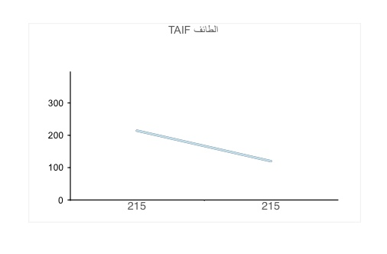

**Diagram of the relationship between salinity and conductivity in Taif**

|  |  |  |
| --- | --- | --- |
| TAIF | |  |
| Water conductivity | Salinity of water | WATER |
| 215 | 119 | Tap water  5-1-2020 |
| 215 | 119 | Tap water  12-1-2020 |
| 215 | 119 | Tap water  19-1-2020 |

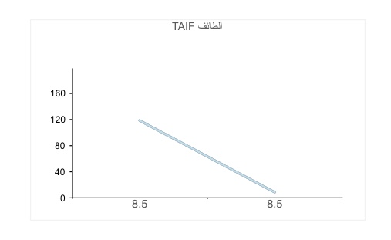

|  |  |  |
| --- | --- | --- |
| TAIF | |  |
| PH | Salinity of water | WATER |
| 8.5 | 119 | Tap water  5-1-2020 |
| 8.5 | 119 | Tap water  12-1-2020 |
| 8.5 | 119 | Tap water  19-1-2020 |

**Diagram of the relationship between Salinity and PH in Taif**

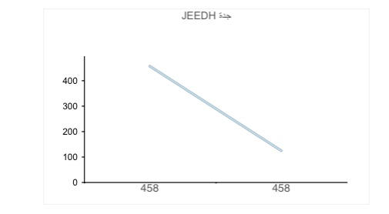

Diagram of the relationship between salinity and conductivity in the city of Jeddah

|  |  |  |
| --- | --- | --- |
| JEDDAH | |  |
| Water conductivity | Salinity of water | WATER |
| 458 | 126 | Tap water  5-1-2020 |
| 458 | 126 | Tap water  12-1-2020 |
| 458 | 126 | Tap water  19-1-2020 |

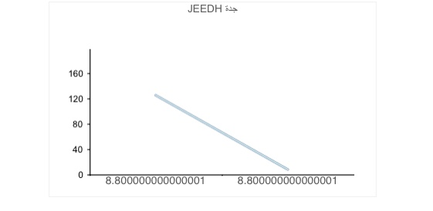

"Diagram of the relationship between Salinity and PH in Jeddah."

|  |  |  |
| --- | --- | --- |
| JEDDAH | |  |
| PH | Salinity of water | WATER |
| 8.8 | 126 | Tap water  5-1-2020 |
| 8.8 | 126 | Tap water  12-1-2020 |
| 8.8 | 126 | Tap water  19-1-2020 |





|  |  |  |  |  |  |  |
| --- | --- | --- | --- | --- | --- | --- |
| JEDDAH | | | TAIF | | |  |
| PH | Water conductivity | Salinity of water | PH | Water conductivity | Salinity of water | WATER |
| 8.8 | 458 | 126 | 8.5 | 215 | 119 | TAP WATER  5-1-2020 |
| 8.8 | 458 | 126 | 8.5 | 215 | 119 | TAP WATER  12-1-2020 |
| 8.8 | 458 | 126 | 8.5 | 215 | 119 | TAP WATER  19-1-2020 |

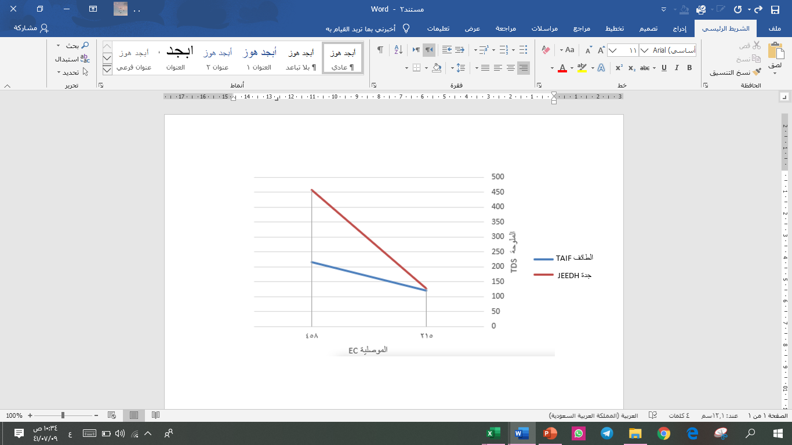

Diagram of the relationship between salinity and conductivity in the cities of Taif and Jeddah

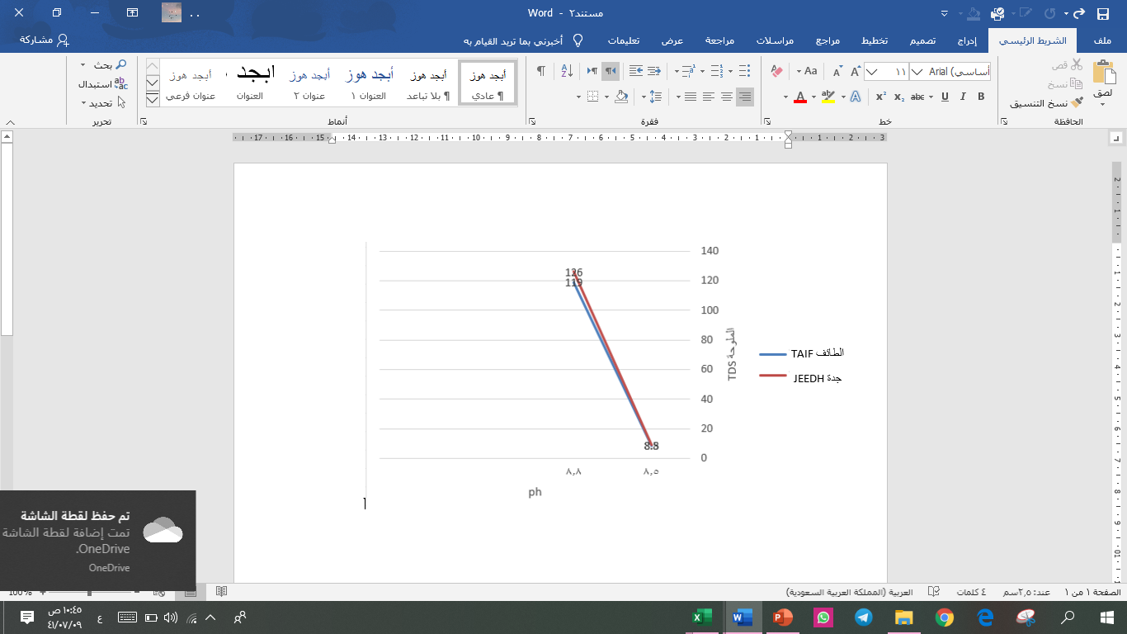

"Diagram of the relationship between salinity and PH in the cities of Taif and Jeddah"

His eye was taken from the tap and examined on different days

DAY 5-1-2020

DAY 12-1-2020

DAY 19-1-2020

The data was monitored on the NASA space site in the "hydrological" water research.

In Taif city, the sample was taken from the "Jury" website.

In Jeddah, the sample was taken from the "Lyn" website.

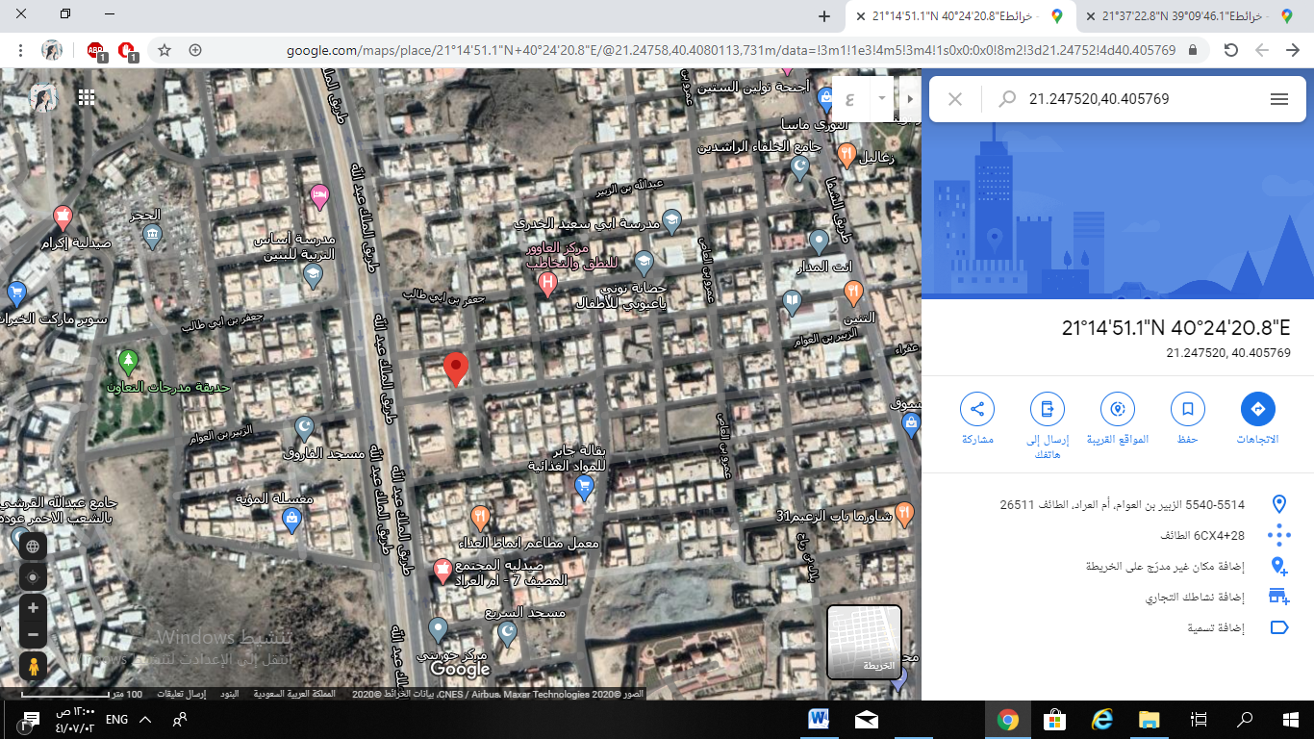

Source: Al Zubair Bin Al Awam, Umm Al Arad, Taif 21 ° 14'51.1 "N 40 ° 24'20.8" E in 2020

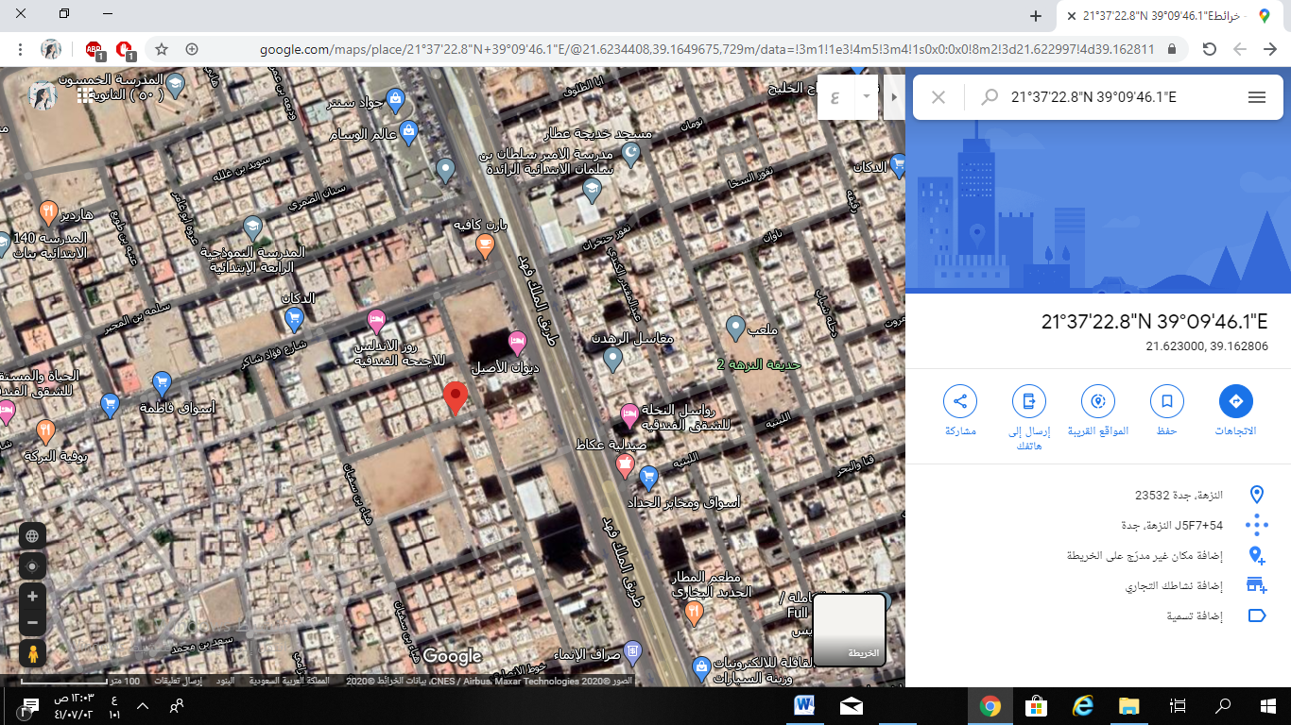

Source: Al-Nuzha, Jeddah 21 ° 37'22.8 "N 39 ° 09'46.1" E 2020

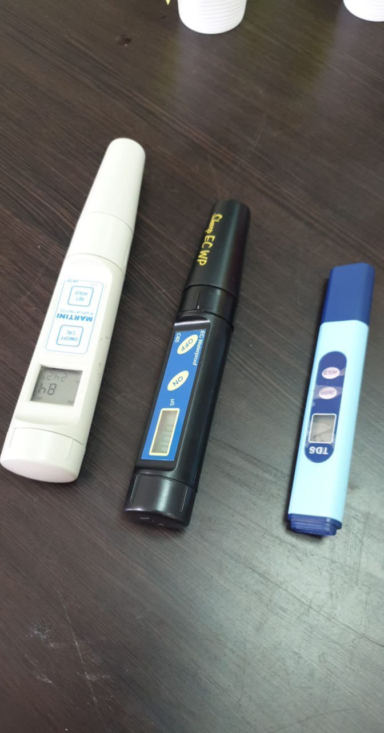

Devices used to measure data 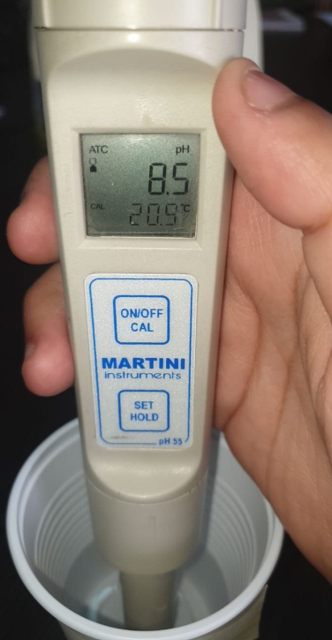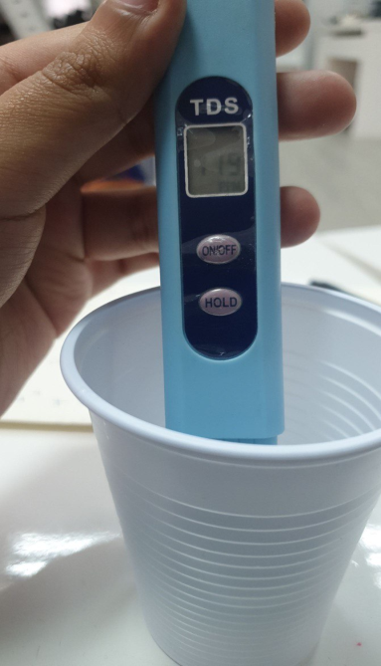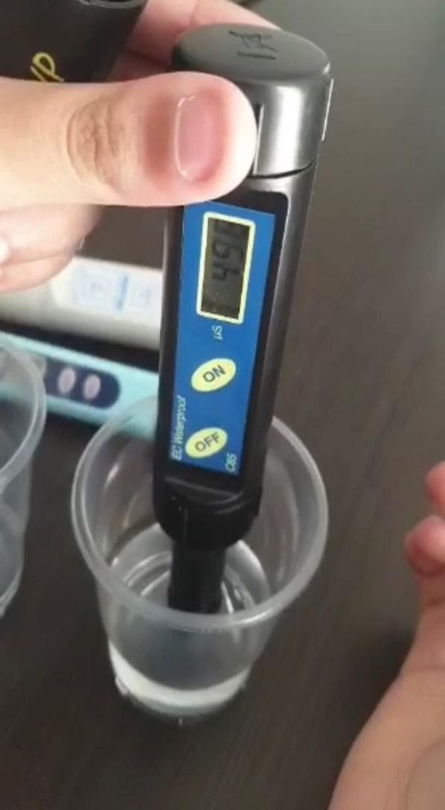

Measuring data

**Forth chapter**

**Results:**

**The total results of the study lie in the following:**

- It became clear to us that there is a direct relationship between the salinity of water and its conductivity. The higher the salinity of water, the greater its conductivity.

- It became clear to us that there was a direct relationship between the alkaline aqueous salt solution and the PH value.

- The geographical location in the coastal areas, such as the city (Jeddah), where is the salinity in water increases there.

- The geographical location affects the areas high and far from the coast, such as the city of (Taif), where the salinity is low.

**Fifth chapter**

**Recommendations and proposals:**

1- Measuring the salinity of the water before using it to determine whether it is suitable for drinking or watering ... etc.

2- Know the acidity and basicity of water and how to balance it.

3- Preserving water and not wasting it, as it is an environmental component that preserves the continuity and purity of life.

4 - Study the geographical locations where the water is and conserve it.

5- Continue to use Globe devices and protocols that work to benefit the environment.

**Finally:**

We ask God to benefit us from what he taught us and to teach us what is beneficial to us and to make science an argument for us and not an argument against us, and to provide us with guidance and devotion and chastity.

**Sources and references:**

**Meaning of water in language:**

  (Journal of Islamic Consciousness - Issue: 613 - p. 43).

**The word water in the Qur’an:**

  (Indexed dictionary of the words of the Qur’an - p. 684).

**The scientific definition of water:**

       (The Book of Water between Knowledge and Faith)

**Definition of geographical location:**

https://mawdoo3.com/

**PH:**

https://ar.m.wikipedia.org/wiki/

https://sotor.com/

**Waterproof electrical conductivity:**

https://ar.m.wikipedia.org/wiki/

**Water salinity:**

https://ar.wikipedia.org/wiki/%D9%85%D9%84%D9%88%D8%AD%D8%A9

**Studies:**

http://agris.fao.org/agris-search/search.do?recordID=AV20120157202 https://www.iasj.net/iasj?func=article&aId=86917

**The appendices**

**Summary of the research**

**Research Title:** Geographical location effectuation on Properties of drinking water

**Research problem:**

How can the geographical location affect of drinking water properties?

**Experimental Curriculum Tool:**

It using the experimental method and enables for experimentation

**Results:**

- It became clear to us that there is a direct relationship between the salinity of water and its conductivity. The higher the salinity of water, the greater its conductivity.

- It became clear to us that there was a direct relationship between the alkaline aqueous salt solution and the PH value.

- The geographical location in the coastal areas, such as the city (Jeddah), where is the salinity in water increases there.

- The geographical location affects the areas high and far from the coast, such as the city of (Taif), where the salinity is low.

**Recommendations and proposals:**

1- Measuring the salinity of the water before using it to determine whether it is suitable for drinking or watering ... etc.

2- Know the acidity and basicity of water and how to balance it.

3- Preserving water and not wasting it, as it is an environmental component that preserves the continuity and purity of life.

4 - Study the geographical locations where the water is and conserve it.

5- Continue to use Globe devices and protocols that work to benefit the environment.