**2017 GLOBE International Virtual Science Symposium**

**Middle School Jules Vallès**

**Portet sur Garonne**

**FRANCE**

**Students:** AMADIS Arjuna ; AVRILLAUD Jade ; BERGER-MARIN Hugo ; BERNARD Alexandre ; BERNARD Paul ; BOUMAHDI Zeyd, CANTARANO Suzanne ; CINTAS Lison ; COQUEREL Stéphanie ; COQUERY Even ; CRUAUD Maxence ; DANIEAU Martin ; DOUMENG Aurélien ; DUFAUT Paola ; ESSOUKI Mathys ; FAGES Kélian ; LOPEZ Thibault ; HORGUEDEBAT Julien ; MAURIEGE Rémi ; NEDJARI Sabrina ; NGUYEN Walter ; VANNET Julien ; TRAN Emilie ; ZACCANTI Pauline.

**GLOBE Teacher:** Sandrine Larrieu-Lacoste

1. **Title**

**What are the meteorological conditions that cause the formation of clouds of fine particles? What is the part of black carbon particles in these clouds of fine particles? And what is the health impact?**

1. **Abstract**

In the winter of 2016-2017, Europe and France experienced episodes of pollution with fine particles causing the premature death of 48,000 people per year in France. These episodes seem to be more frequent in the winter.

In a first time, with the atmospheric data from GLOBE, we have seen that when the atmospheric pressure is high, there is no precipitation and the temperature is low and we observe a thermal inversion. Then, we discovered that this situation is the key for the formation of fine particles clouds.Subsequently, we decided to investigate about the composition of particle clouds. For this investigation, we measured several components of air pollution as 'Aerosol Optical thickness' and concentration of 'Black Carbon'. This new measurement protocol enabled us to realize the importance of the pollution on our atmosphere. The second part of our project was the automation of this new sensor using an arduino microcontroller.

**Keywords**: atmospheric measurement, GLOBE, Black Carbon, Aerosol optical thickness, Calisph’Air, CNES, Atmospheric pollution

1. **Introduction**

Each year, air pollution is responsible for 48,000 premature deaths in France (400,000 for all of Europe). By improving air quality we can help drastically reduce this number. Thus, we wanted to investigate one of the biggest murderers of the century. In December 2016 and January 2017, France experienced episodes of pollution with exceptionally frequent fine particulate clouds. To protect ourselves from this pollution, it is necessary to learn about it. The fine particles also called aerosols are solid or liquid particles or both, suspended in air with diameters between about 0.002μm to about 100 μm. Aerosol particles vary greatly in size, source and chemical composition.

They may also be composed of ‘Black Carbon’ (BC). It is compose largely of graphite and come from incomplete combustions of fossil fuels. These aerosols can react with other produces and produce complex and sometimes toxic substances.

At a global scale, the part of the Black Carbon contributes strongly to the warming of the atmosphere due to the effect of the solar radiation (because of the black color which absorbs the light). Thus, to better know our atmosphere and the pollution, we decided to investigate the following issues: What are the meteorological conditions that cause the formation of clouds of fine particles? What is the part of black carbon particles in these clouds of fine particles?

1. **Research methods**

GLOBE protocols:

1. Barometric Pressure
2. Air temperature
3. Precipitation
4. Aerosols

Data fromotherprotocols

5. Average wind

6. Concentration of Black Carbon

7. Index air quality

8. Concentration PM10 (Particulate Matter)

The center in charge of the air quality of Toulouse (ORAMIP) gave us more data to complete our work (index air quality and pm10).

Location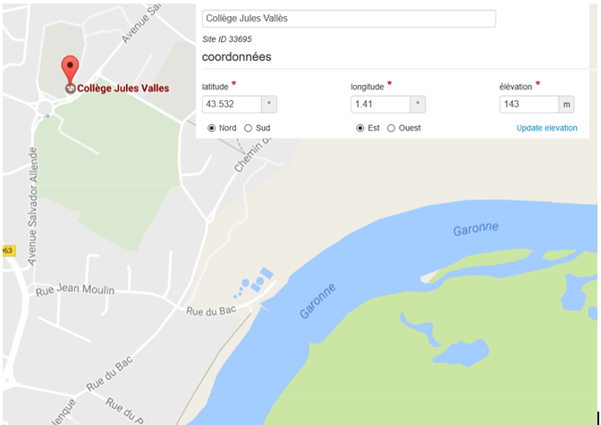

***Measurement locations:*** Collège Jules Vallès de Portet sur Garonne-France

***The team:***The 24 students are 13-14 years old

***Time period:***We made our measurements during the autumn and the winter time 2017

1. **Results**

* *Graph1: Barometric pressure from GLOBE website*

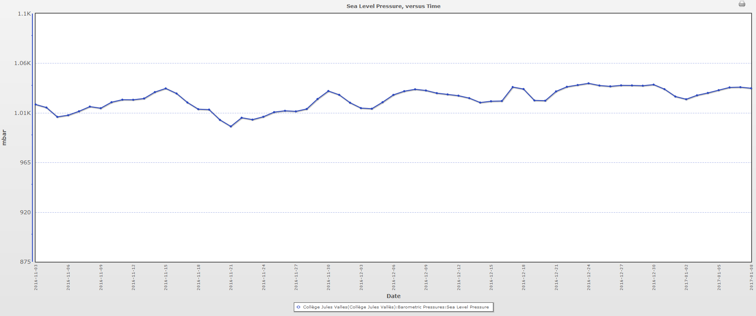

The graph shows barometric pressure from 2016 November 3, to 2017 January 8.

* *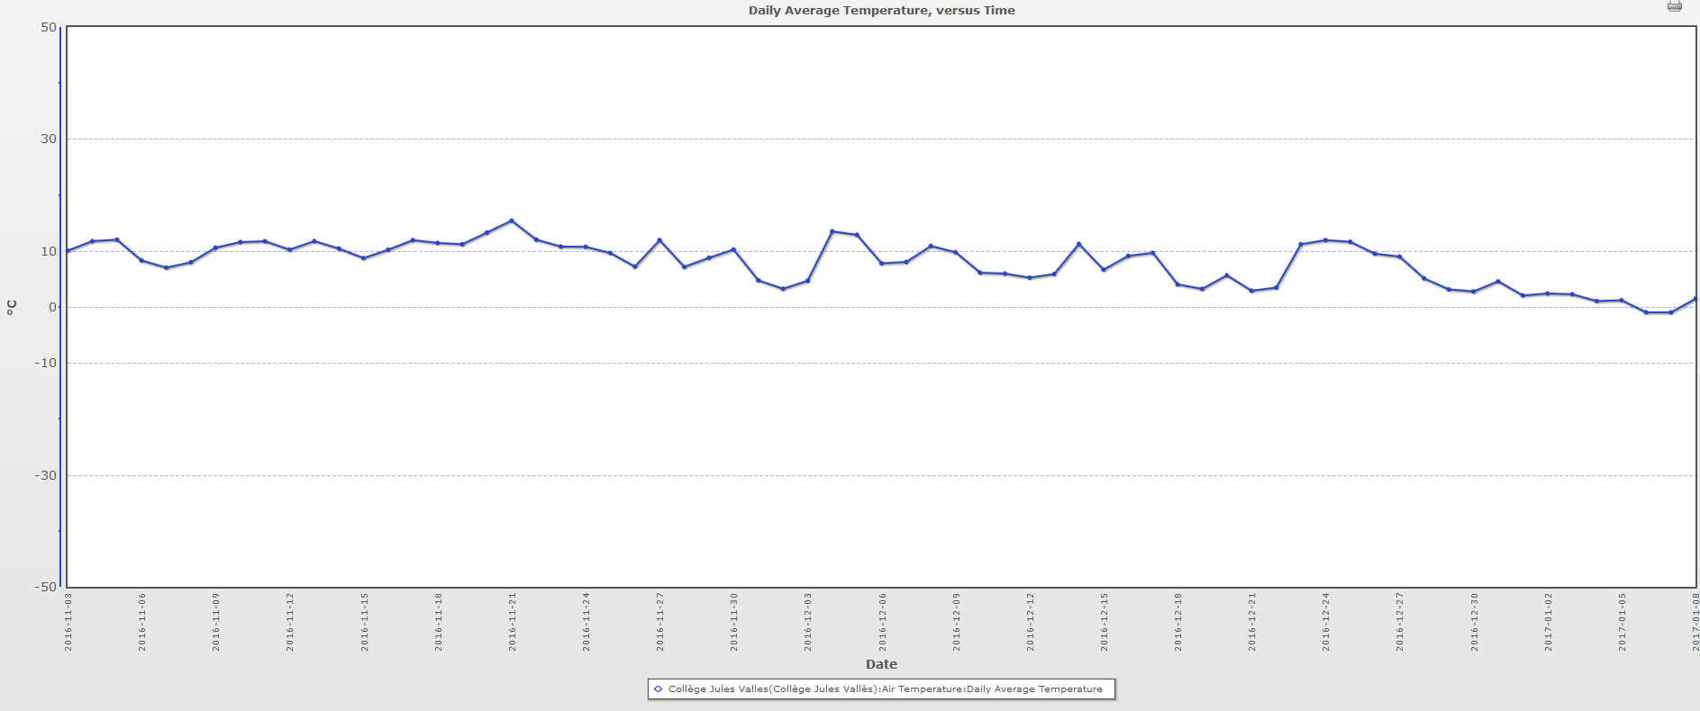Graph2: Daily Average Temperature from GLOBE website*

The graph shows the daily average temperature from 2016 November 3, to 2017 January 8.

* *Graph3: Average wind from website meteo à l’école (*[*http://www.meteoalecole.org/college-jules-valles-portet-sur-garonne*](http://www.meteoalecole.org/college-jules-valles-portet-sur-garonne)*)*



The graph shows average wind from 2016 November 3, to 2017 January 8.

* *Graph4: Rain depth from GLOBE website*

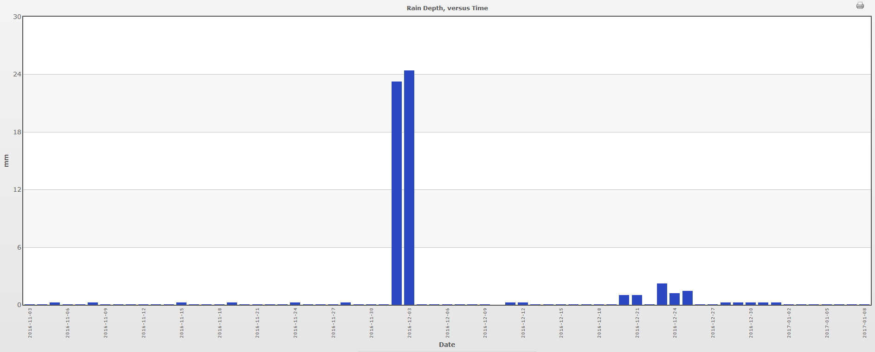

The graph shows rain depth from 2016 November3, to 2017 January 8.

* *Graph5: Aerosol optical thickness from website GLOBE*

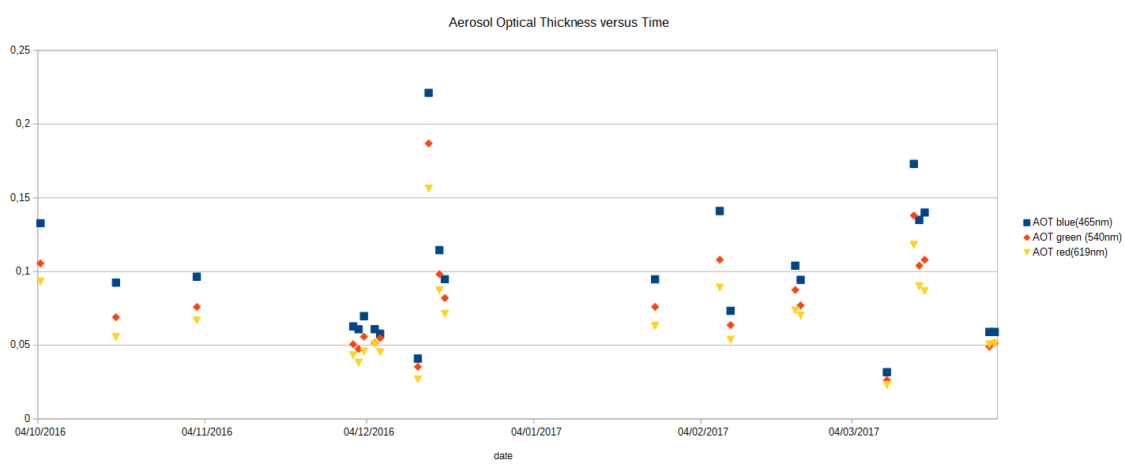

The graph shows Aerosol Optical Thickness from 2016 October 4, to 2017 march 30.

* *Graph6:Atmo index air quality*

The graph shows Atmo index air quality from 2016 November3, to 2017 January 8 (Data from State Air quality (ORAMIP)).*The Atmo Index is a daily indicator of air quality, defined on a scale from 1 to 10. The higher the index is, the worse the air quality is.The Atmo Index is calculated every day from the concentrations of four pollutants:Sulfur dioxide (SO2); Nitrogen dioxide (NO2); Ozone (O3);Aerosols (PM10). Then, a note is calcutated which varies between 1(very good air quality) to 10(very bad).*

* *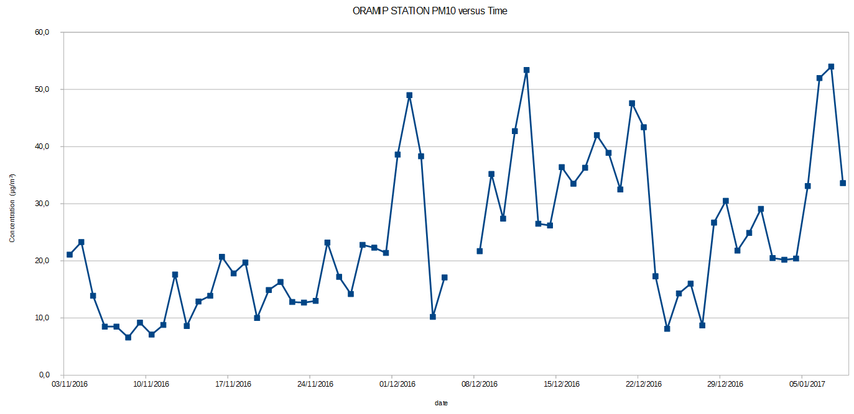Graph 7: Concentration PM10 (ORAMIP agency)*

The graph shows PM10 concentration from 2016 November 3, to 2017 January 8.

* *Graph 8: Concentration PM10 (ORAMIP agency) and Black Carbon (sensor STANEO)*



The graph shows Black Carbon (Blue) concentration and particles PM10 (Red) concentration from 2017 January 5, to 2017 march 15.

* *Graph 9: Concentration PM10 (ORAMIP agency) and Black Carbon (sensor STANEO)*



The graph shows the ratio of Black Carbon and particles PM10 from 2017 January 5, to 2017 march 15.

1. **Discussion**

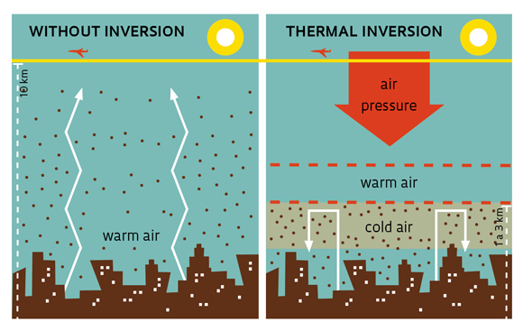According to Figures 1, 2, 3 and 4, when the air quality index is equal to 8 (peak pollution occurring with fine particles), we observe that the atmospheric pressure is really high and match with an anticyclonic situation. When we have this situation, the wind is weak and the precipitation is almost zero. We can observe a really low temperature which corresponds to a cloudless night.

Usually, air temperature decreases with altitude (in the lower layers of the atmosphere). The warm air full of pollutants is normally dispersed vertically.

When the groundcools during the night (with a clear weather in winter) and the temperature at a few hundred meters of altitude is higher than the soil temperature we can observe a phenomenon of ‘Thermal inversion’. Therefore, the pollutants are blocked by this mass of hot air at this layer more commonly called ‘layer of inversion. (couche d’inversion in French)’

In the second part of our study, we made experiences to see the proportion of particles of Black Carbon in the measurement of fine PM10 particles (less than 10 μm).Thanks to the Graph 9, we observe that the concentration of Black Carbon varies between 4% and 35% of PM10 particles

* Possible sources of error concern the following points

- BC-EDU (Sensor Staneo) prototype has not been calibrated as a reference instrument yet

- PM10 (ORAMIP) measurements are performed at a distance of 1000 meters from the weather and BC measurements measured by our middle school.

- The BC measurements are discontinuous. This may be a problem since BC must be considered as an indicator of local pollution source, which varies rapidly.

* Comparison with similar studies

Our results show that the high aerosol concentration is correlatedwith anthropic activities and weather conditions. This is a very useful observation when dealing with aerosols in urban areas.

We have also measured a BC/PM10 ratio of 4-35 %, this is also in rather good accordance with commonly observed values (e.g. document Airparif et Pérez *et al.* 2010).

* Discuss whether results answer the research question or not, and how

Our results bring new enlightens to our starting questions: we now understand that the fine particles clouds are first produced by anthropic activity but their dispersion are controlled by the weather conditions. Also, the ratio BC/PM10 has been measured under various weather condition and it seems that we also have an important impact of the weather conditions on the ratio. In particular, it seems that windy weather helps to minimize the absolute PM10 and BC concentration but also the ratio BC/PM10. Cold stable atmosphere on the contrary will make people produce more BC due to the combustion of biomass and fuel for heating houses and drive cars for example. The lack of wind will let the BC and PM10 in the atmosphere of urban areas. Warm stable atmosphere will finally lead to a mixed situation: the BC/PM10 production source will be the transport (that still exists under cold weather) but the lack of wind will prevent the PM10 and BC to disperse.

1. **Conclusion**

The study was motivated by the 48,000 premature deaths in France due to atmospheric pollution. We wanted to understand why the pollution episodes where so important and frequent during winter. We finally found that the problem is very complex: weather conditions have an impact on the source of pollution and also on the dispersion of PM and BC.

The multifactor and multi-scale character of the PM and BC pollution shows a big complexity in this system and shows that we need more measurements to better understand the phenomenon. This understandingis required in order to take the right decisions to efficiently minimize or prevent the pollution and improve the air quality that we breed.

To go further, we used new protocols to measure BC as a part of PM10. This protocol provides data that help to understand the relationship between anthropic activity, weather, and air quality. In a few times, we will make an automatic system in order to get continuous datasets. This pint will be really useful to understand the short term variation of the pollution. Thanks to those data, we now have a better understanding about our environment in order to make the good choices for our future.

1. **Bibliography/citations**

* Variability of Particle Number, Black Carbon, and PM10, PM2.5, and PM1 Levels and Speciation: Influence of Road Traffic Emissions on Urban Air Quality

(<http://www.tandfonline.com/doi/abs/10.1080/02786821003758286>).

* AirParif Actu : Le carbone suie ‘Enjeu présent et futur’

<http://www.airparif.asso.fr/_pdf/publications/NUMERO42.pdf>

* La qualité de l’air en nouvelle-aquitaine : ‘L’influence de la météo’

<http://www.atmo-nouvelleaquitaine.org/article/influence-de-la-meteo>

* Lig’Air ‘Les influences météorologiques’

https://www.ligair.fr/la-pollution/les-influences-meteorologiques

1. **Matérials**

-Davis Station vantage Vue whith data logger

-Calitoo (<http://www.calitoo.fr/> )

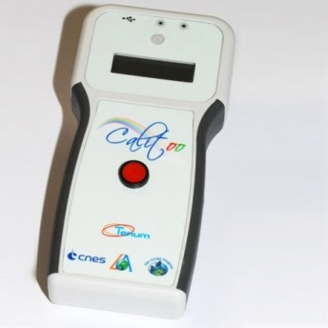

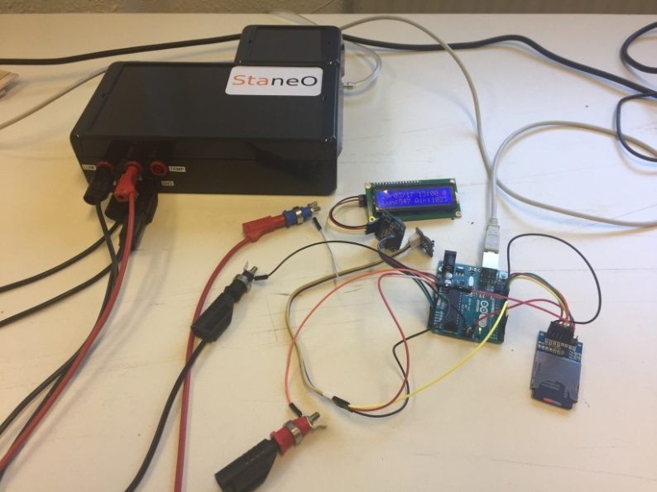

-Sensor BC-EDU Staneo

( <http://www.staneo.fr/en/BC-EDU.php> )and automation using an arduino micro controller