Mesoscale Precipitation Nowcasting Experiment Based on ConvLSTM Model

Students: Chi Hsiao, Yi-Ta Tsai, Ting-Yi Lai, and Ying-Lung Liu
School: The Affiliated Senior High School of National Chung Hsing University
Teacher: Mr. Shih-Chao Lin and Mr. Chi-Chung Chang
Email: shichao.lin@gmail.com
Country: Taiwan, R. O. C.
Date: March 10, 2020

Abstract
Climate change has increased the rate of short-term severe weather change and the difficulty and uncertainty of weather nowcasting. Therefore, the way to predict short-term rainfall with precision has become an important research topic.
This research is aimed to increase the precision of precipitation nowcasting by combining image processing with neural networks in machine learning. The ConvLSTM model we used is trained with large amounts of doppler radar images, and by using the Marshall–Palmer relation, we can calculate the converted rainfall at a given point, thus predicting the rainfall.
Results show that the model has over 60% hit rate up to forecasting 60 minutes to the future when trained with 30 days of radar images for 250 epochs. And through calculating the values of a and b in the Marshall–Palmer relation (dBZ=10×log(a)+10(b)×log(Rainfall)) below the altitude of 800 meters in central Taiwan, we found that with a equaled to 87.97±0.35 (R²=0.52) and b equaled to 1.32, the model can predict rainfall the most accurately.

Keywords: Precipitation, nowcasting, Deep learning

Table of Contents

Abstract 2
Table of Contents 3
Research questions 4
Environment 4
Research Method 5
Data Pre-processing and Analysis 5
Finding the Values of a and b in the Marshall–Palmer relation 10
Radar Image Prediction 10
Precipitation Prediction with Radar Images 10
Data Summary 10
Discussions 16
Conclusions 17
Acknowledgements 17
Reference/Bibliography 17

Research questions
- What are the values of a and b in the Marshall–Palmer relation in central Taiwan under the altitude of 800 meters? (dBZ=10×log(a)+10(b)×log(Rainfall))
- By using deep learning neural networks, how does epoch (50, 100, 150, 200, and 250) and training set size (10 days, 20 days, 30 days, and 40 days) affects the accuracy of the model?
- How accurate can we predict rainfall through combining radar image prediction and the modified Marshall–Palmer relation?

Environment
OS:
Windows10
Software:
Anaconda 2019.10
Python 3.6
Pytorch 0.3.1(CUDA 8.0)

Research Methods and Materials (Including GLOBE Data)

Data Pre-processing and Analysis
First of all, we analyzed the rainfall events in central Taiwan in the year of 2019 (5/18, 5/20, 6/11~6/14, 8/9~8/20) (Figure 1), and retrieved Globe’s daily precipitation data at SHCH-Globe during the same time period (Figure 2). We also downloaded all the rainfall data of 2019 from Taiwan’s Central Weather Bureau and 2019’s 10-minute doppler radar images in the Data Bank for Atmospheric and Hydrologic Research. Originally, we meant to predict Frontal rain and Orographic rain, which usually happens in May, June, and August, but found that SHCH-Globe station was missing rainfall data from August. Therefore, we used the automated rainfall data of Dali station from the Central Weather Bureau in August to replace the missing data.
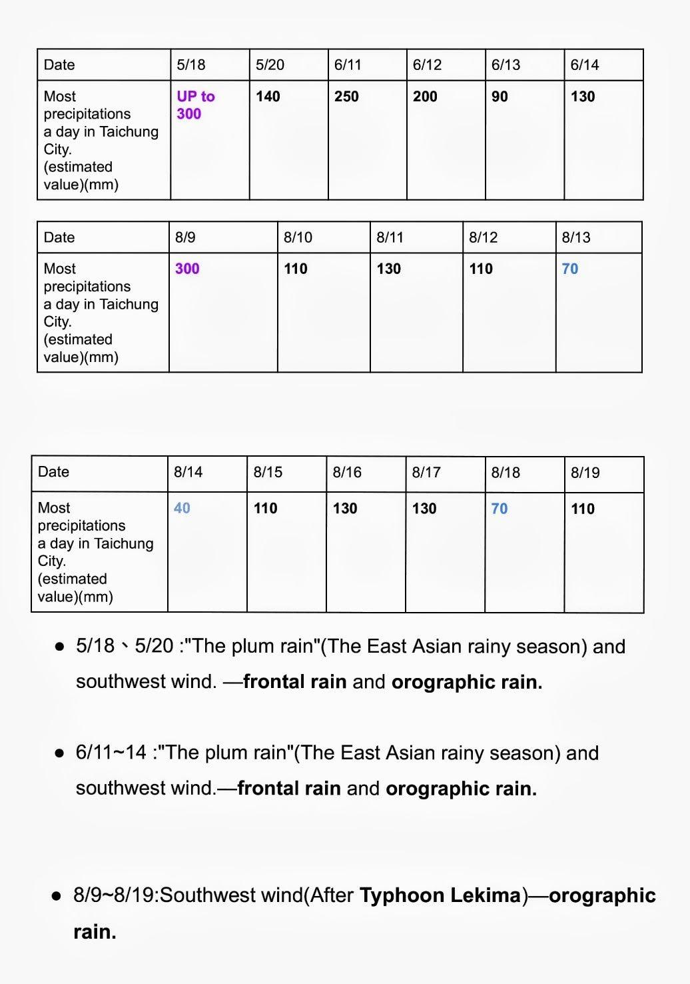
Figure 1: Rainfall events in central Taiwan in 2019. (this study)

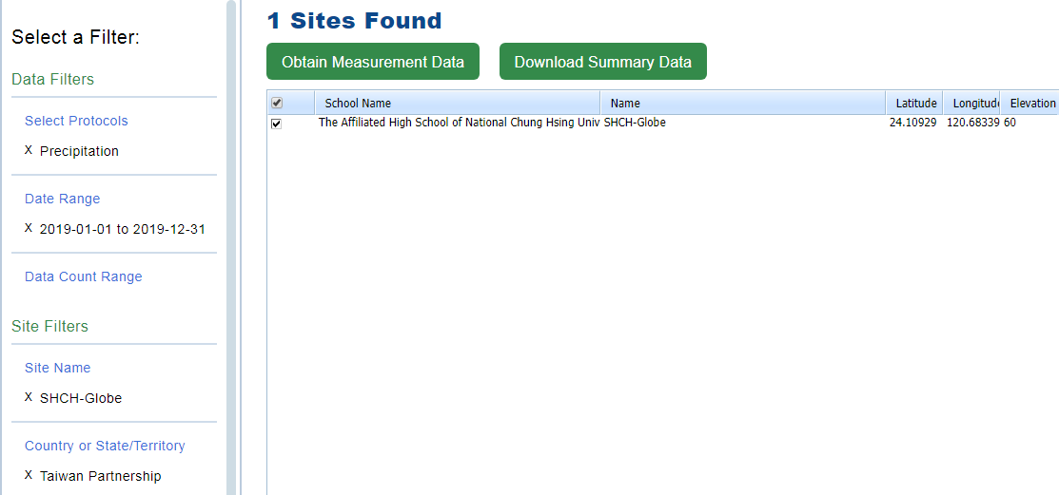
Figure 2: SHCH-Globe data in 2019. (http://www.globe.gov)

Then, in order to prepare the radar images for the ConvLSTM model, using Python’s PIL and numpy module, we converted each pixel in the image to a corresponding gray scale value from 0 to 255, with 65 dBZ converted to 255, being the whitest, and the effect of the background map creating lost data, which can influence the model, is eliminated by filling in the pixels where the map outline covers the dBZ values with averaged values of the left and right side of the missing pixels. (Figure 3)
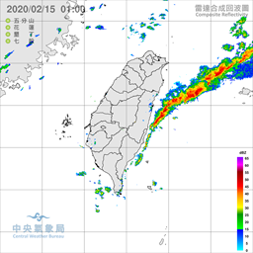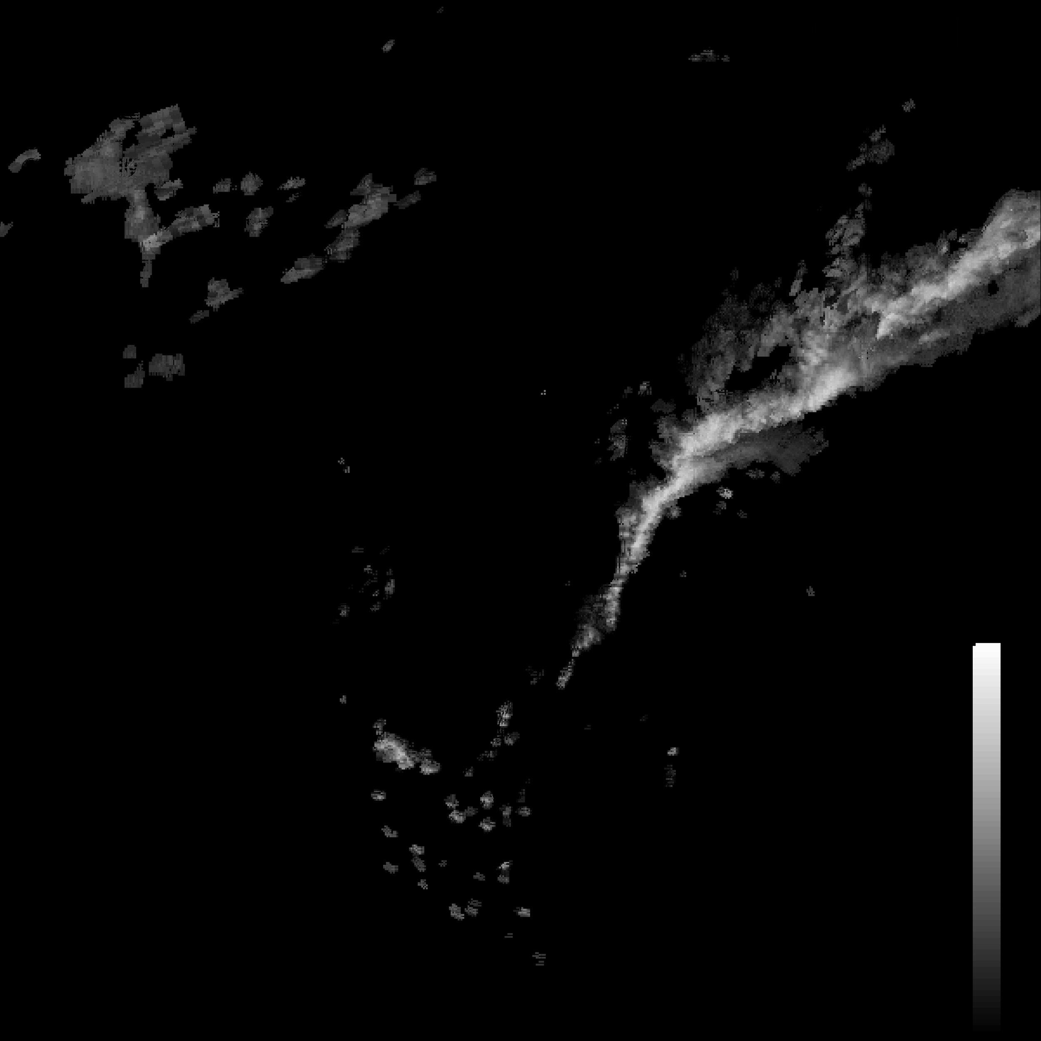
Figure 3: The left is a raw radar image from the Central Weather Bureau (CWB), the right is the converted image with the map outline removed.
The doppler radar images that we chose are images composed of four doppler radars, from Wufen Shan, Hualien, Kenting, and Qigu (22~25 °N) in Taiwan. The reason we chose the composite radar image is because a single radar source often has spatial misalignment and is also more likely to have lost data, and the Central Weather Bureau’s radar will be calibrated regularly to ensure data quality. After, we cropped the composite radar image, which is 3600 by 3600 pixels, into an 800 by 800 pixels image, starting with 1187 pixels from the left and 1035 pixels from the top. (Figure 4)

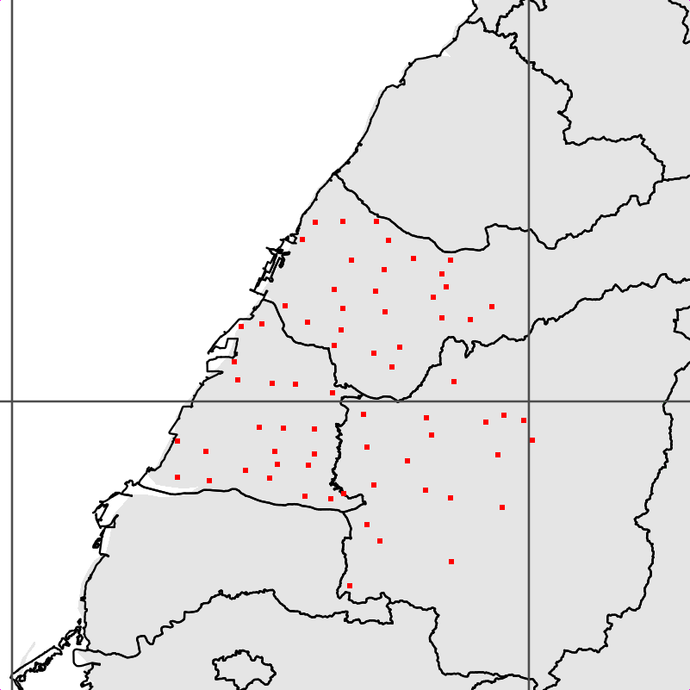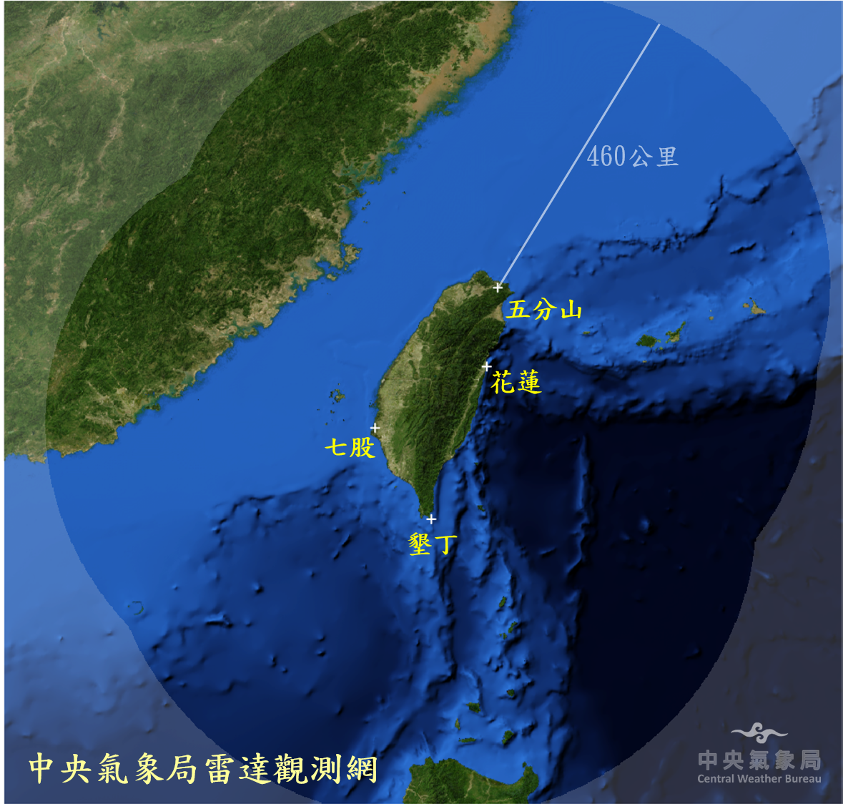
Figure 4: Left - the boundary of the cropped 800 by 800 range. The dots represent the weather stations used in this study. Right - The range of the four doppler radars in Taiwan.

For each of the weather stations, we calculated the corresponding pixel in the radar image according to proportion (the original image coordinate is 118~124°E, 20.5~26.5°N) and saved it to a file, allowing us to get the dBZ value for any of the stations at any given time.

Finding the Values of a and b in the Marshall–Palmer relation
In the paper by Marshall and Palmer^{[3]}, the relation of dBZ and rainfall is found to be 10×log(a) + 10×b×log(Rainfall), where a and b are constants that can differ in different areas.
With rainfall and radar image data in 2019 in the area of central Taiwan, a total of 38729 pieces of data, we first filtered out the ones without any rainfall, then created pairs of x (dBZ values, taken from the radar image with the longitude and latitude conversion above) and y (hour rainfall), and brute forced a and b to find the best fitting Marshall–Palmer relation line.
We chose the variance of the difference between dBZ and the calculated 10(b)×log(Rainfall) as our loss function because through using this loss function, we can ignore the presence of 10×log(a), leaving us with just one unknown variable that needs to be solved (b). After finding the value of b with the minimum loss, we can compute the previously ignored 10×log(a) by averaging all the differences between known dBZ and the modified Marshall–Palmer relation (dBZ=10(b)×log(Rainfall)).

Radar Image Prediction
LSTM is a special model structured from RNN (Recurrent Neural network), and combined with convolution, ConvLSTM can be applied to time-series forecasting due to its memory-based model. The ConvLSTM model we used was based on paper by Shi et al^{[2]}(Figure 5), which added spatial dependency to the conventional FC-LSTM model that only has time dependency. This is achieved by replacing matrix multiplication with convolution operation.
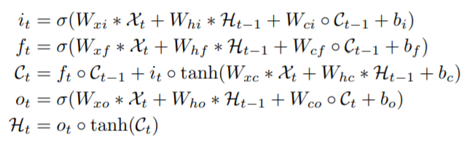
Figure 5: Key equations of the ConvLSTM model in paper by Shi et al.^{[2]} ‘*’ denotes the convolution operator, ‘◦’ denotes the Hadamard Product.

Figure 6: Example of radar images from prediction in this study . (The original radar image-left one followed by the predicted images for 10, 20, 30, 40, 50, 60, 70, 80, and 90 minutes)

For the predictions, we compared the effects of training set size (10 days, 20 days, 30 days, 40 days) and epoch (50, 100, 150, 200, 250) on the precision of the model with FAR (False Alarm Rate), POD (Probability of Detection), and CSI (Critical Success Rate) in order to find the best combination of training set size and epoch for the most adequate nowcasting method. FAR represents False Alarm Rate, which is more desirable when it’s lower, while POD and CSI are more desirable when they’re higher.
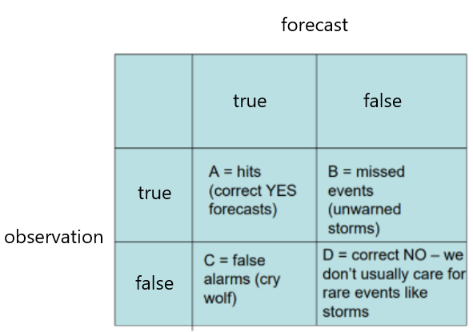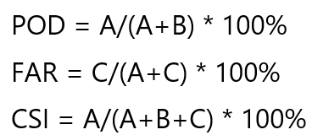

Figure 7: Table for the definition of POD, FAR, and CSI. (*True means the data is bigger than the threshold, False is smaller than the threshold in the table)

Precipitation Prediction with Radar Images
After the model outputs the predicted radar image, we can then use the calculated values of a and b to convert the dBZ value at a given station to its according hour rainfall. We selected all the 10 minute predictions for predicted rainfall data. The accuracy is calculated in two ways, Threat score and absolute difference of actual rainfall and predicted rainfall.

Threat score is the number of correct warned events out of all warnings issued and unwarned events. We calculated the Threat score of rainfall/no rainfall prediction and heavy rain predictions, with the threshold set at 1 mm/hr and 40 mm/hr.

The other method used for measuring how well rainfall is predicted is by taking the absolute difference between the predicted rainfall converted from the radar image with that from the Central Weather Bureau and SHCH-Globe station during May, June and August, using the GLOBE Precipitation protocol. For the Central Weather Bureau’s hour rainfall data, we added up the absolute difference of every ten-minute rainfall prediction in an hour. As for the SHCH-Globe station, since it only has daily rainfall data, the ten-minute rainfall predictions were summed up to one day and compared.

Results
- We calculated the correlation coefficient between dBZ and log(Rainfall) to be about 0.72, which means they are linear relational. For the calculation of the Marshall-Parmer formula, as seen in Figure 8c. , with a equaled to 87.97±0.35 and b equaled to 1.32, the loss comes to its lowest at 41.04.
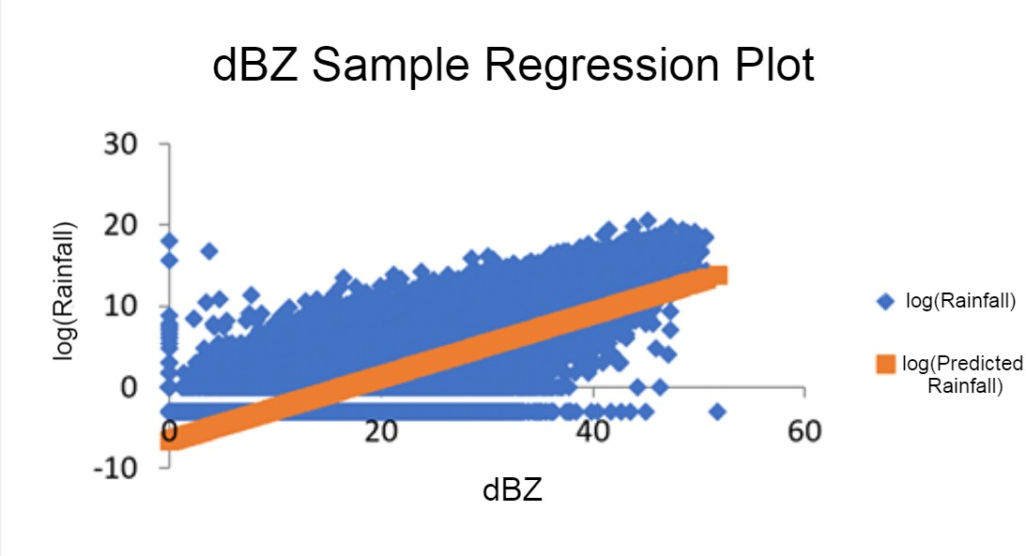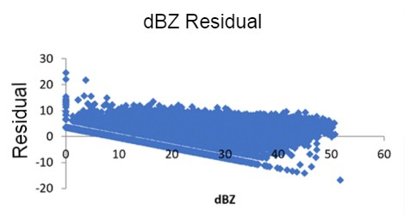
(8a.) dBZ Residual (8b.) dBZ Sample Regression Plot
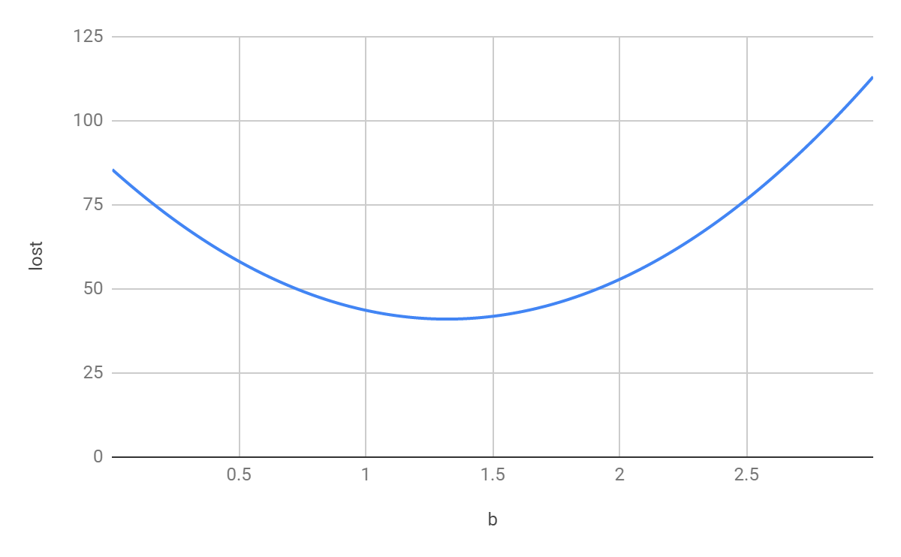
(8c.) b - loss diagram
Figure 8: dBZ Sample Linear Regression Plot and b - loss diagram

- We can see that the performance of the 10-day training set size is relatively worse than the others, with the 30-day training sets size resulting the highest CSI and POD, and the 10-day training sets size with the lowest FAR, due to the 10-day model not as likely to output higher dBZ values than the other models. We reason that the obvious difference between the 10-day model and other models is because of the lack of diversity in weather system’s characteristic information included in the training set. And the best result is the 30-day model not the 40-day model because the 40-day model included more of the weather system’s variety that didn’t appear in the prediction time range.
(9.a)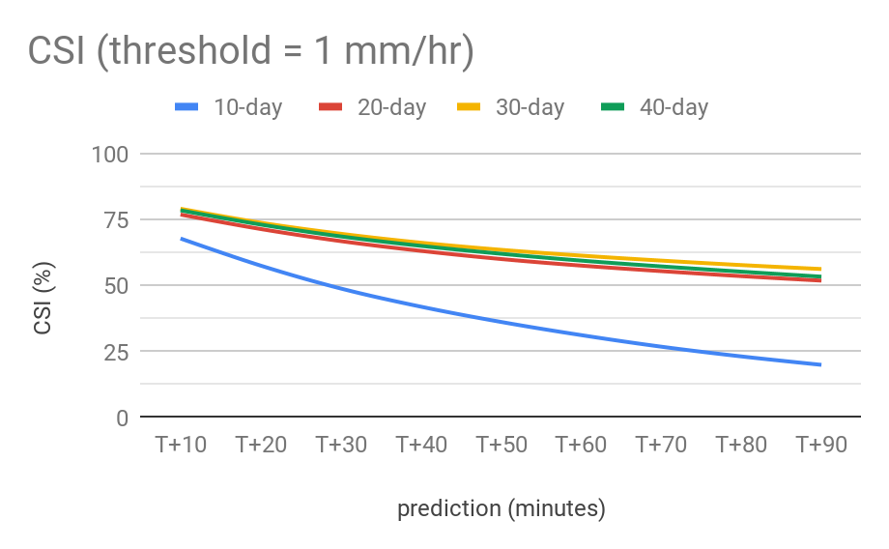(9.b)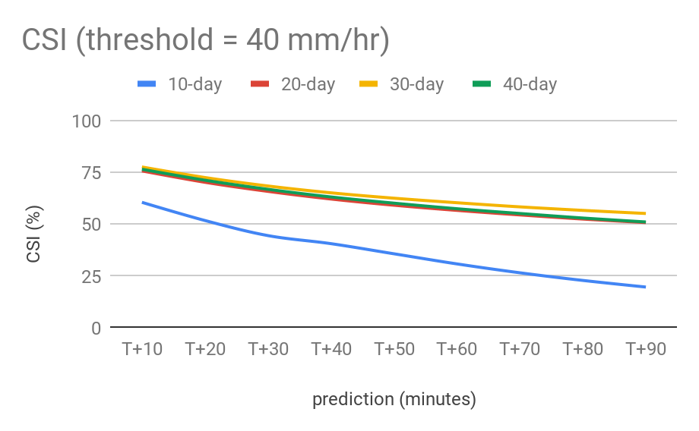
CSI value with the threshold at 1 mm/hr and 40 mm/hr for different training set sizes (10 ~ 40 days) in 9.a and 9.b.

(9.c)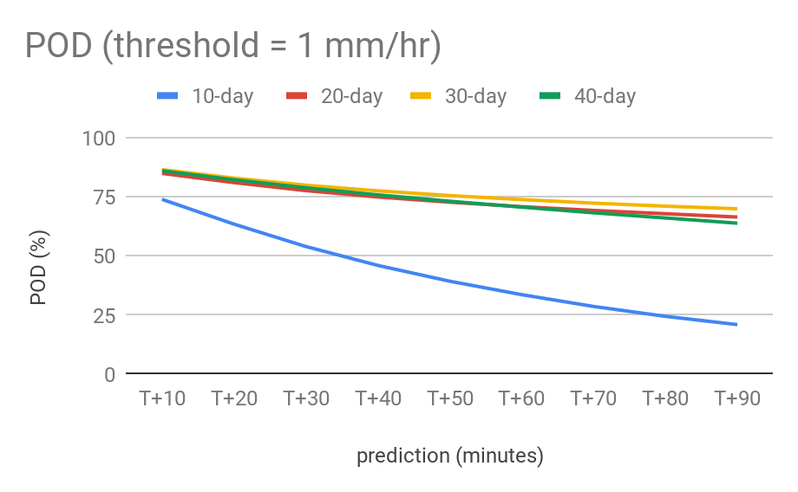(9.d)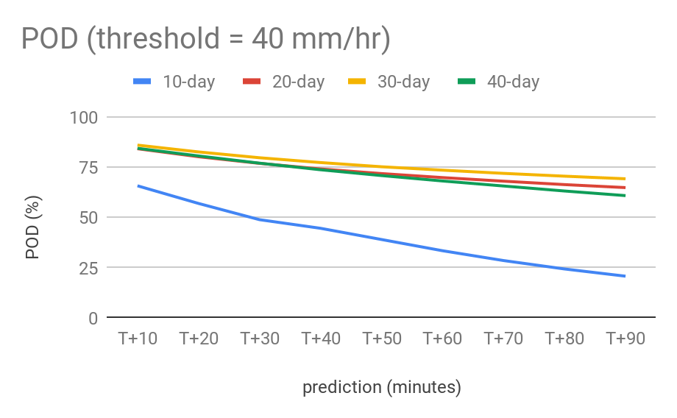
POD value with the threshold at 1 mm/hr and 40 mm/hr for different training set sizes (10 ~ 40 days) in 9.c and 9.d.
(9.e)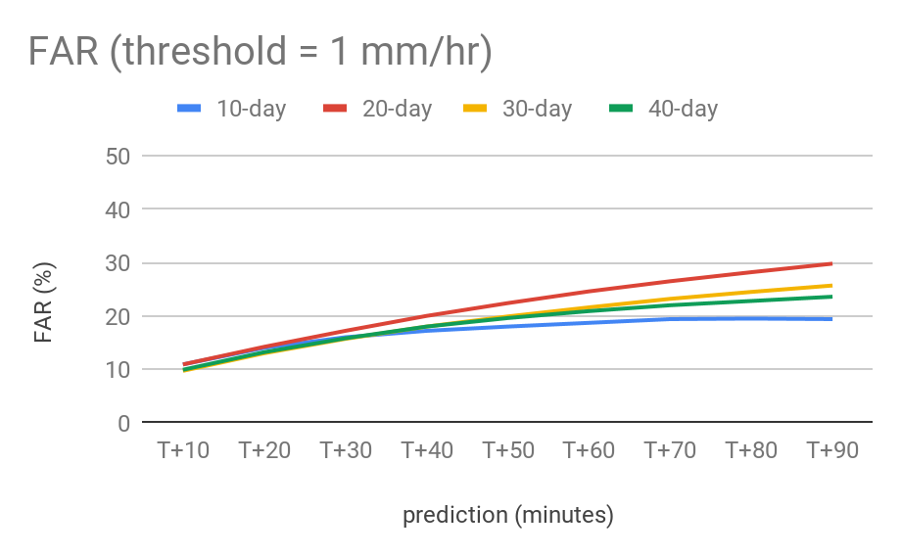(9.f)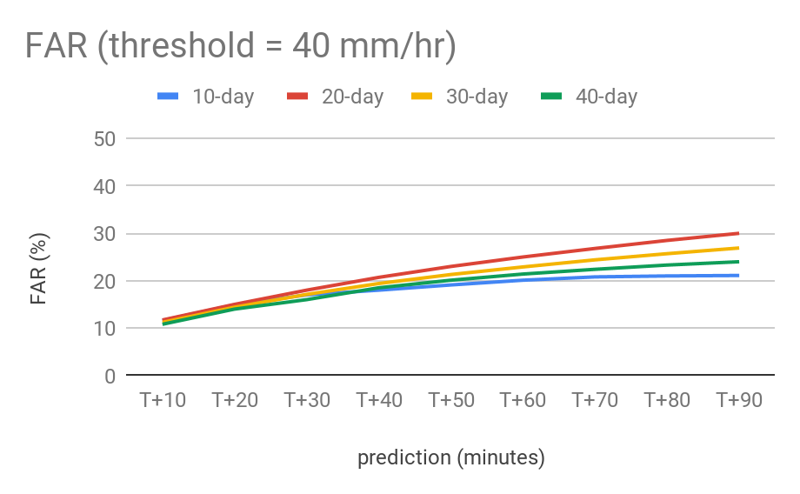
FAR value with the threshold at 1 mm/hr and 40 mm/hr for different training set sizes (10 ~ 40 days) in 9.e and 9.f..
Figure 9.a ~ 9.f: CSI, POD, FAR over 10 to 90 minutes for different training set sizes.

- 150 epochs has the best result in CSI and FAR in Figure 10.a ~f), but its POD is lower than the others, so we consider 250 epochs as the best choice overall because even though it has a similar CSI and FAR values to 150 epochs, its POD is relatively higher.
(10.a)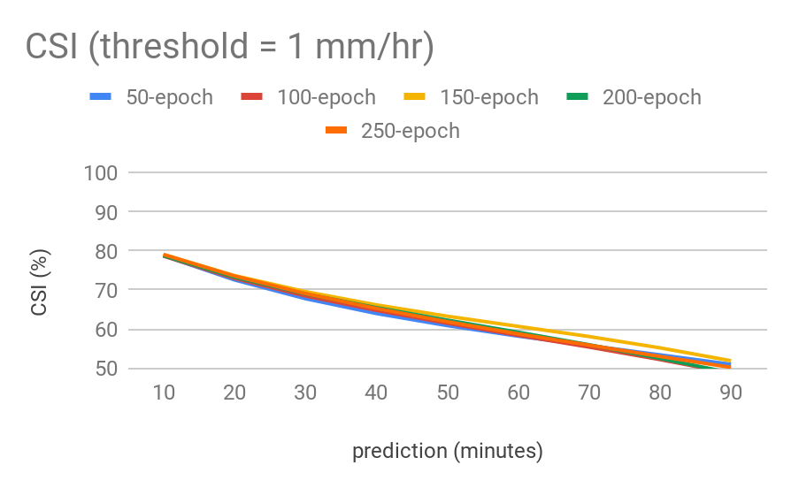(10.b)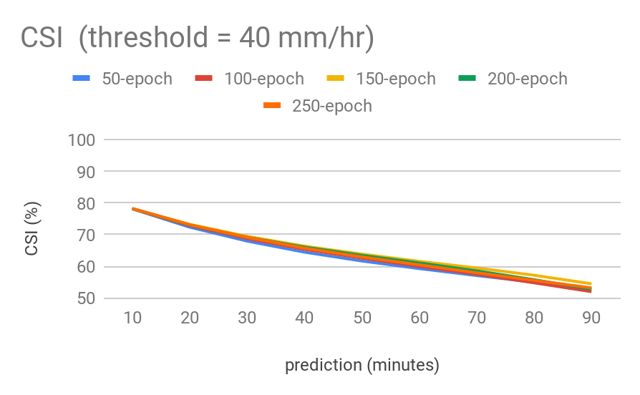
CSI value with the threshold at 1 mm/hr and 40 mm/hr for different epochs (50 ~ 250) in 10.a and 10.b.

(10.c)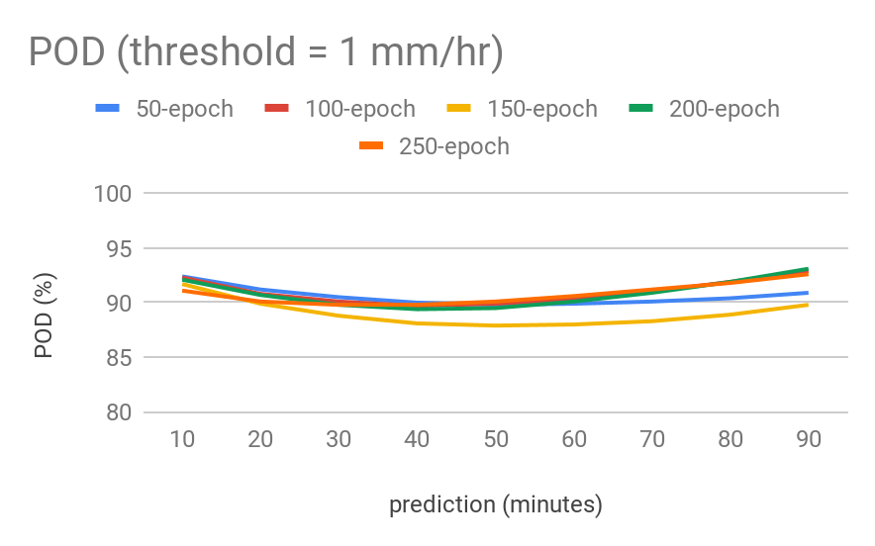(10.d)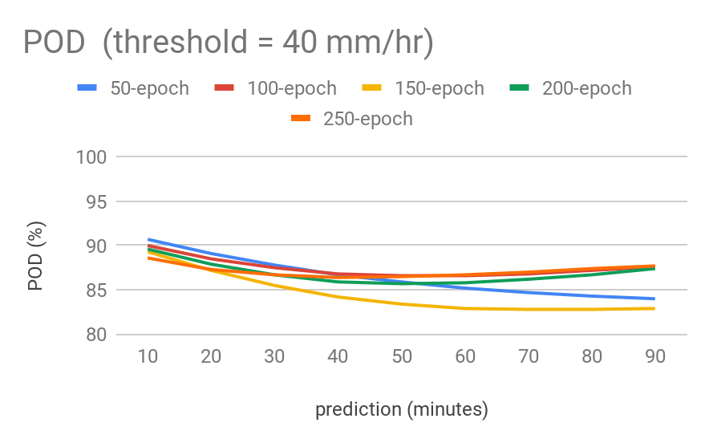
POD value with the threshold at 1 mm/hr and 40 mm/hr for different epochs (50 ~ 250) in 10.c and 10.d..

(10.e)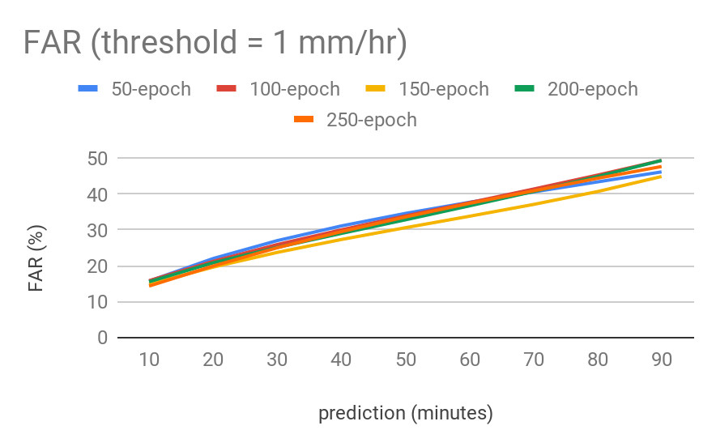 (10.f)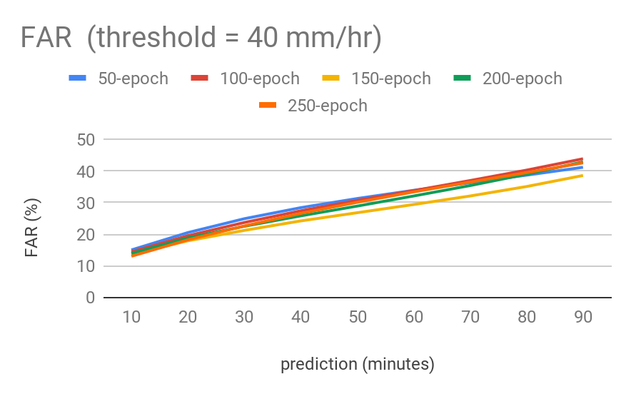
FAR value with the threshold at 1 mm/hr and 40 mm/hr for different epochs (50 ~ 250) in 10.e and 10.f..
Figure 10. a ~ f : CSI, POD, FAR over 10 to 90 minutes for epochs (50 ~ 250), with
1 mm/hr and 40 mm/hr threshold.

- Below are tables of the average absolute difference for 10 to 90 minute rainfall nowcasting (mm) (Figure 11), the blue line is calculated only with days that have rainfall, and the red one is calculated with all data. We can see as time goes on, the model’s underestimation increases, the maximum at almost 5 mm in August.
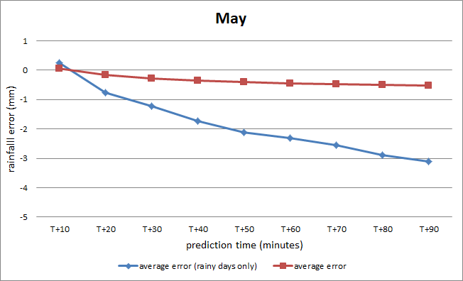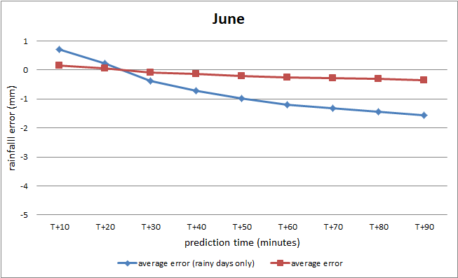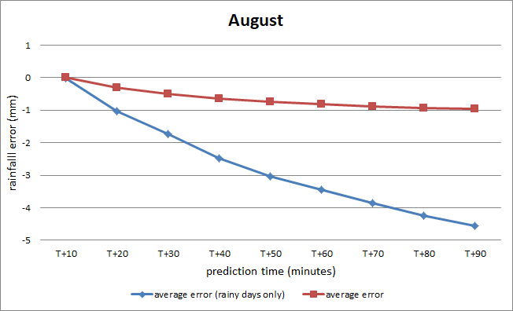
Figure 11: Prediction error (mm) compared with Central Weather Bureau’s data in May, June, and August in 2019.

- The following are comparisons between the observed Globe SHCH’s daily rainfall and our predicted rainfall (T+10 ~ T+90 min) in Figure 12 and Figure 13. From diagram (Figure 13), we can visualize that the model’s underestimation.
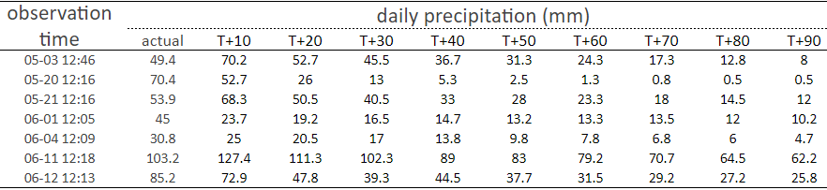
Figure 12: Globe SHCH’s daily rainfall and our predicted rainfall table comparison
in 2019. (T+10 ~ T+90 min)
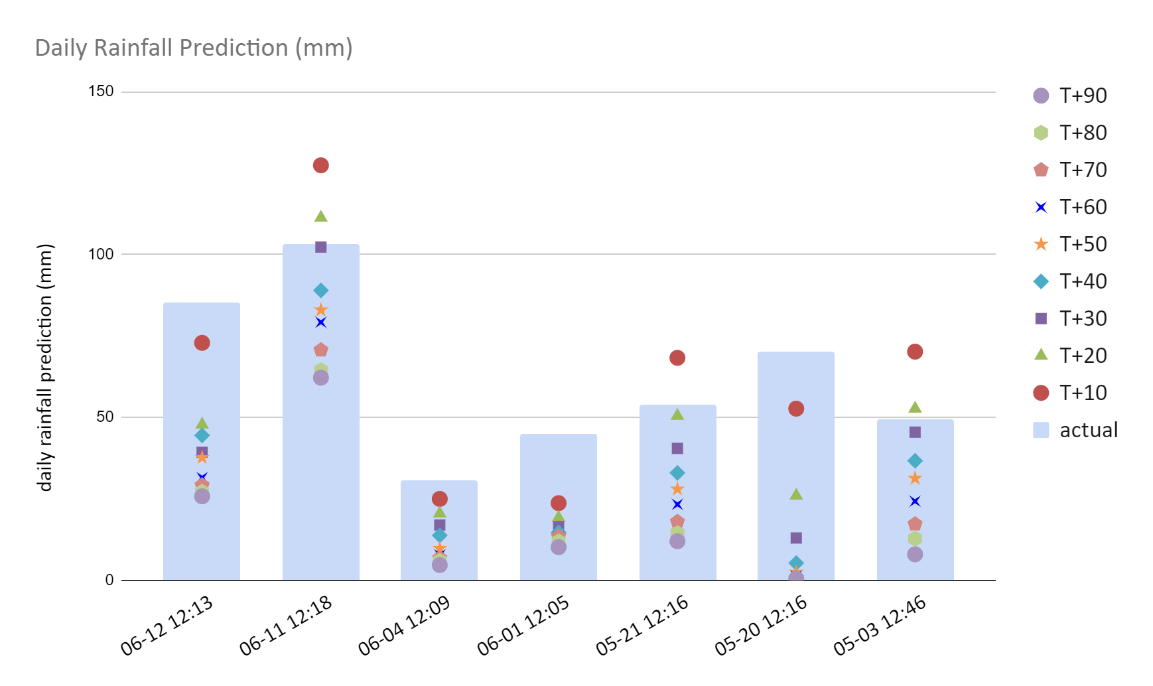
Figure 13: Globe SHCH’s daily rainfall and our predicted rainfall graph comparison (T+10 ~ T+90 min). The the observed rainfall is the blue columns and the points represent daily rainfall predictions added up for every T+10 to T+90 min.

Discussions
- The correlation coefficient between dBZ and log(Rainfall) is about 0.72, it shows that the relation between dBZ and log(Rainfall) can be approximated using the Marshall-Palmer relation^{[3]} .
- According to the paper by Guo^{[1]}, this model can also be used in the middle latitudes, it may be capable of nowcasting different places.
- The model tends to output “unsharp” radar image predictions. Finding a way to increase sharpness while not increasing loss would be a great advance in the model (Figure 6).
- Seen from the average absolute difference for 10 to 90 minute rainfall nowcasting comparison (Figure 11), the season in tropical and subtropical zone may be a factor in the model’s prediction accuracy.
- Possible sources of error is the accuracy of Globe’s rainfall measuring (Figure 14), since it’s not automated like the Central Weather Bureau’s stations.
- Comparison of CSI, FAR, and POD between the two models at 0.5 hr mark (Our model (ConvLSTM), ConvGRU by Guo et al (2019)^{[2]}): Since FAR is better with lower values and POD and CSI are better with higher values, as shown in the table (Figure 14) , our model has a lower FAR than the GRU model and higher values for POD and CSI , hence, this study is relatively well done in the mesoscale heavy rainfall prediction

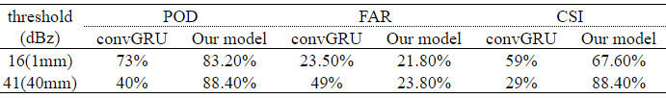
Figure 14: Table of comparison between the model we used (ConvLSTM) and the model used by Guo(2019)^{[2]} (GRU).

Conclusions
- We found that when a = 87.97 and b = 1.32, dBZ-Rainfall has the minimum loss, so we used these values to fit in the Marshall–Palmer relation formula.
- When the training set size is 30 days and the epoch is 250, the model has the most accurate prediction.
- With the new a and b values in the Marshall–Palmer relation, we can predict future 90 minutes hourly rainfall within 5mm error compared with Central Weather Bureau’s data.

Acknowledgements
The authors would like to thank the service from the Ministry of Science and Technology & Chinese Culture University, Data Bank for Atmospheric and Hydrologic Research.
We would deeply like to thank Globe for providing the rainfall data used in this study.
Also, special thanks to cxxixi for the ConvLSTM code, which is adapted from https://github.com/cxxixi/Precipitation-Nowcasting.

Reference/Bibliography
[1] Guo Hanyang et al., 2019, High resolution nowcasting experiment of severe convections based on deep learning. Acta Meteorologica Sinica, 77(4): 715-727
(http://html.rhhz.net/qxxb_cn/html/2019036.htm?fbclid=IwAR2wFmKwyU3zuL1eW2iUZLpJG5xIGokfDiBelf5JlVS-2-JVo9Ohv1lZPgQ)

[2] Xingjian Shi et al., Convolutional LSTM Network: A Machine Learning Approach for Precipitation Nowcasting
(https://arxiv.org/pdf/1506.04214.pdf?fbclid=IwAR22qaRvTp_F8YXpUflucsNLDMovwVrHnyOwRhpVWdfCiBVPgCt2W28UxUA)

[3] J. Marshall and M. Palmer, 1948, The distribution of Raindrops with Size, J. Meteorology, August.
(https://journals.ametsoc.org/doi/pdf/10.1175/1520-0469%281948%29005%3C0165%3ATDORWS%3E2.0.CO%3B2)

