FILLABLE WIDESCREEN GLOBE EVENT BANNER TEMPLATE
- FYI: Template can be exported as a PNG or PDF to be printed at ~2.5 by 1.5 feet
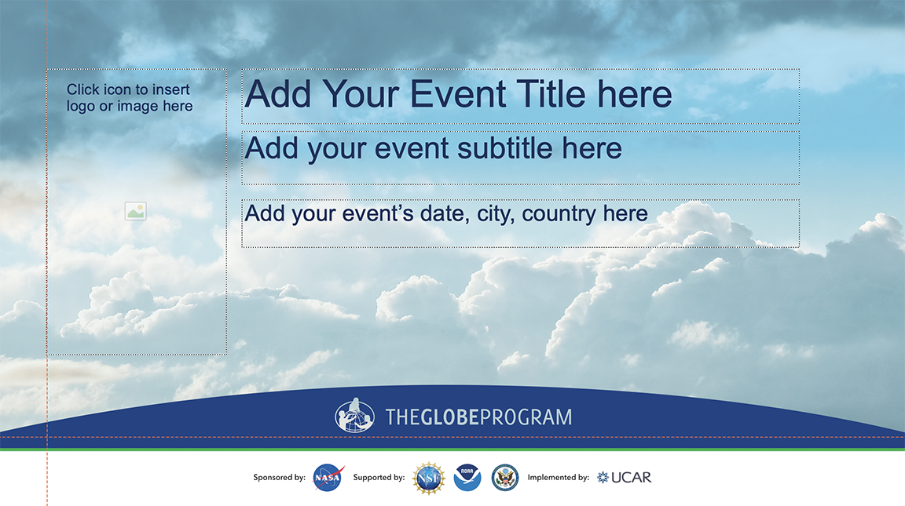

REGISTRATION TABLE DROP IN TWO COLORS
28”
30”
24”
FYI: Dimensions of a typical folding table, and screenshot of a narrow table banner

