Melia Azedarach (AZ) as a natural insecticide: The effectiveness of the Azedarach leaves and fruit extracts on the drosophila fly

- Abstract

Melia azedarach is a special tree with a natural pesticide advantage. In this study, we examined its ability to eliminate or inhibit the reproduction of pests. Our model organism was drosophila melanogaster.
We made two different extracts from the azedarach tree: fruit and leaf extract. The extracts sprayed on drosophila flies for 20 days. Activity and mortality rate of drosophila examined.
We found that both extracts are efficient for use as natural (organic) inhibitor of drosophila. Fruit extract was more effective rather than leaf extract.

- Research question

1- Can the natural insecticide of the Azedarach be efficient against insects that are harmful? .
2- Will the Azedarach extracts from fruit and leaves limit the spreading of insects that could be harmful by spreading diseases among organisms such as human, plants, and animals?
3- Which extract will be more efficient against the drosophila melanogaster; the leave’s extract or the fruit extract?

- The research hypothesis:

There is a relationship between the Azedarach tree extracts and the reduction of some insects’ growth.

- Introduction
Melia azedarach, known by many names, such as chinaberry tree, Pride of India, Persian lilac and Indian lilac, it is a species of deciduous tree in the Meliaceae family.
It is typically a medium-sized tree, which can reach up to 20 m tall with a diameter to 60 cm, its leaves fall in winter, they grow in spring up to 50 centimeters long, and its leaflets are dark green in its upper side and lighter green in the lower side. (Gupta, 1993)
Soon after the growing of the leaves, the flowers appear. They are small and fragrant, with purple petals, growing in clusters. Whereas, the fruit is a drupe, marble-sized, it starts its growing as green, then turns into light yellow at maturity, hanging on the tree all winter, and gradually becoming wrinkled and almost white.
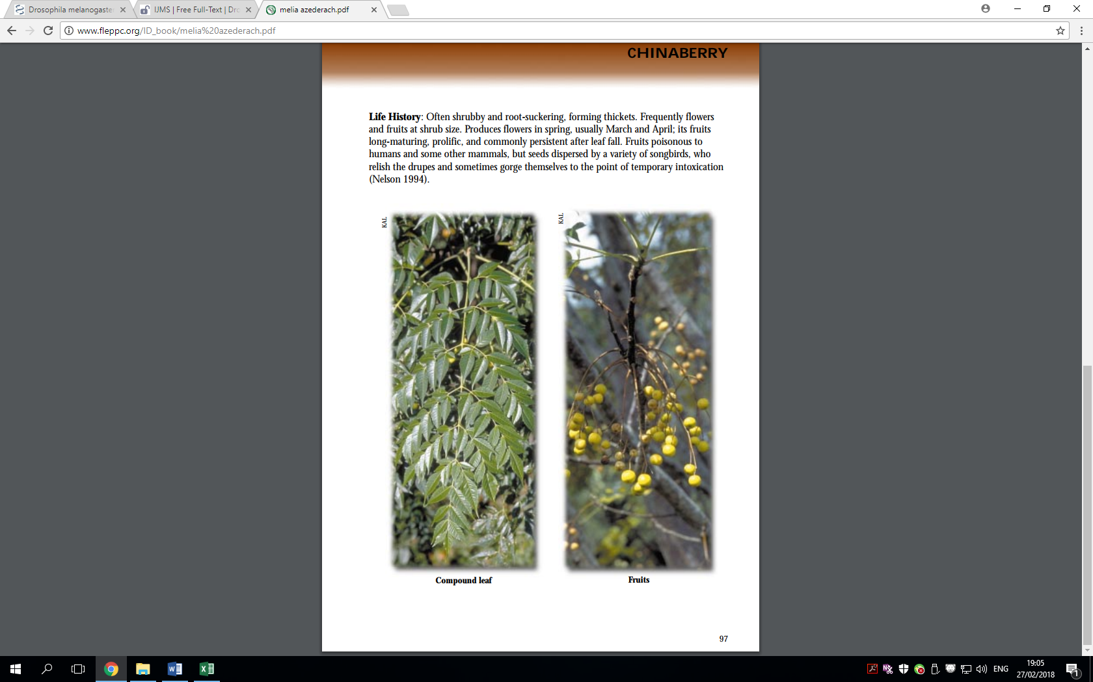

Toxicity
All parts of the tree are toxic to human and other mammals; the fruit contains the most concentrated toxin inside its seed, the leaves used as natural insecticide, against moth, the root peel used in traditional medicine as a toxin that cause diarrhea and vomiting. A glycopeptide called meliacin isolated from the leaves and roots is responsible for inhibition of in-vitro replication of various DNA and RNA viruses, for example the poliovirus (Mabberley et al., 1995)
Fruit contain two parts that are different in their toxicity; the non-toxic ripe flesh of the fruit and the toxic seed, which is enclosed in a hard, fluted endocarp. Fruit have evolved to be eaten by animals, which eat the flesh surrounding the hard endocarp or ingest the entire fruit and later vent the endocarp. If the endocarp crushed or damaged during ingestion or digestion, the animal will be exposed to the toxins within the seed. The birds that are able to eat the fruit spread the seeds in their droppings. However, the toxins are neurotoxins and unidentified resins, found mainly in the fruit.
Leaves have been used as a natural insecticide for food preservation, but it must not be eaten, as they are highly poisonous. Leaf extracts of A. indica were more effective in protecting tomato fruits from fungi than M. azedarach (Sharma and Sharma, 1995). The degree of rotting was lower in treated fruit when compared with untreated fruit.
Chinaberry fruit was used to prevent insect larvae from growing in the fruit. By placing the berries in drying apples and keeping the fruit turned in the sun without damaging any of the chinaberry skin, the fruit will dry and not have insect larvae in the dried apples. The extract from M. azedarach fruit can limit the life cycle of cotton leafworm Spodoptera littoralis
(Salam and Ahmed, 1997).

Drosophila melanogaster as a model organism
D. melanogaster is easy to handle, afford and deal with. It is a small animal, with a short life cycle of less than two weeks, cheap and easy to keep in large numbers. Mutant flies, with defects in any of several thousand genes are available, and the entire genome sequenced.
The egg takes about one day after fertilization for the embryo to develop and hatch into a worm-like larva. The larva eats and grows continuously, molting one day, two days, and four days after hatching (first, second and third instars). After two days as a third instar larva, it molts one more time to form an immobile pupa. Over the next four days, the body is completely remodeled to give the adult winged form, which then hatches from the pupal case and is fertile within about 12 hours. (timing is for 25°C; at 18°, development takes twice as long.)

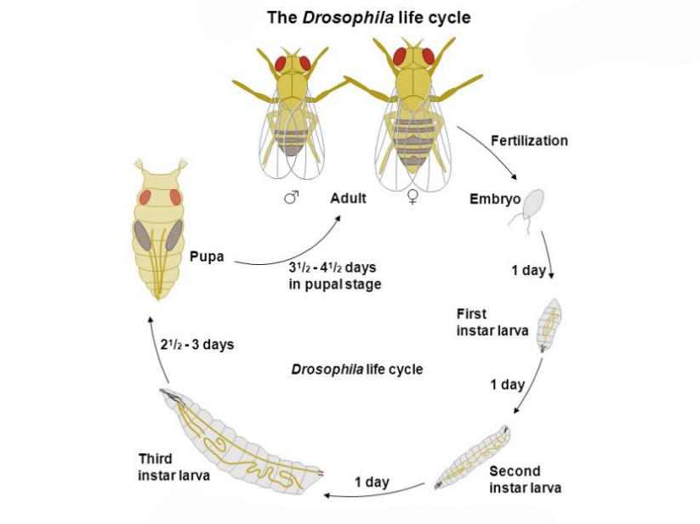

Community and environmental Relevance:
We have noticed that the Azedarach tree is planted around the houses in our school’s neighborhoods as an ornamental tree however, no one used it as food or befitted from it, it is not edible and it had no uses. While considering insects, it is also the same case that even insects do not feed on it that the fruit remains on the tree until it ripens and matures; therefore, we thought that this tree could not be favorable for the insects and birds. Specifically, according to our observations and relating to some previous studies we concluded that it is not a favorable tree for the insects and birds. Therefore, we decided to examine the reason why it is not.
As an example, in Africa, the spreading of insects affects negatively on the environment and it could lead to some organisms’ extinction.
Comparison between bio( natural ) insecticide VS chemical insecticide
Bio(natural) insecticide | Chemical insecticide
Friendly to non-target species | Harmful to non – target species
Don’t cause pollution | Serious pollution to the environment
Relatively cheaper | Relatively expensive
Pests never develop resistance | Pests eventually become resistant
Less effective but have least side effects on humans | More effective but have negative serious effects on humans “diseases” , like D.D.T insecticide

- The Research method:

We adopted the experimental design in our research.
First of all we looked for the Azedarach tree location , our students collected its leaves and fruit, they planted a tree at the school, then we decided on the most suitable organism which we can work on, finally, the drosophila fly, was our model organism .

Our Climate and Land Cover at School :
Our school “Al Faruk” is located to the southern east of Jerusalem specifically, in Jabal AL Mukkaber village, that is located on one of the highest hills to the southern east of Jerusalem
it is almost 795 m. above the sea level , it has a hot Mediterranean dry-summer subtropical climate, the average air temperature degrees in winter is (4-14) and in summer is (17 - 29). Our total annual precipitation average is 590 mm (23.2 inches) which is equivalent to 590 of rainfall per year or 49.2 mm per month. Our land cover is represented in bathas and herbaceous vegetation to tropical savannoid vegetation .

The research took place at our school in Jabal al Mukkaber in Jerusalem city. Despite the fact that we are in Winter we tried to simulate the weather conditions of Spring and Summer in order to accommodate it with the Drosophila’s best growing conditions. Therefore, we chose a room at our school, which was supplied with an air condition that helped keeping a stable air temperature degree “25-30”.

At this point, we as a school collaborated with another national Israeli school, we brought the drosophila fly from them and learned how to prepare the suitable nutrient for them, however, this school is not included within the GLOBE schools.

The instruments:
In the experiment, we used four transparent containers, gauze, rubber bands, sprayers and tapes.

The Drosophila nutrient

In order to prepare the nutrient for drosophila we mix;
- 1- 0.5 L distilled water ,
- 2- 59 gr. corn flour,
- 3- 4.56 gr. Agar ,
- 4- 10.4 gr. dry yeast , and
- 5- 53.5 white sugar gr
blend together, then we heat them until boiling, we take them off the heat source, put 0.3 Methyl paraffin and blend. Finally, we left them 10 minutes within the room temperature then move to the refrigerator to cool down.
After preparing the nutrient we divided it into four containers with an equal amount, we moved the drosophila flies into them, finally we closed the containers with gauze in order to allow the process of gases exchange.
During the experiment, we were very keen to provide all of the required conditions for growing drosophila. Moreover, we used transparent containers made of glass to allow us to account, we made a small opening in the gauze to allow spraying the extract of fruit and leaves, and then we closed the opening with a tape.
In our experiment, we used sprayers instead of using plates to avoid the possibility of flies sinking into the liquid “the fruit and leaves’ oil”.
In our experiment there were four containers; three referred to the experimental group and the last one was the control group, specifically, the first experimental container was sprinkled with the leaves oil, the second with the fruit oil and the last with water, on the other hand, the fourth one was left without any addition. It is worthy to note that we used a small sprayer to spray the drosophila once a day for twenty days. However, our experiment lasted for twenty days, because the life cycle of Drosophila lasts for twenty days.

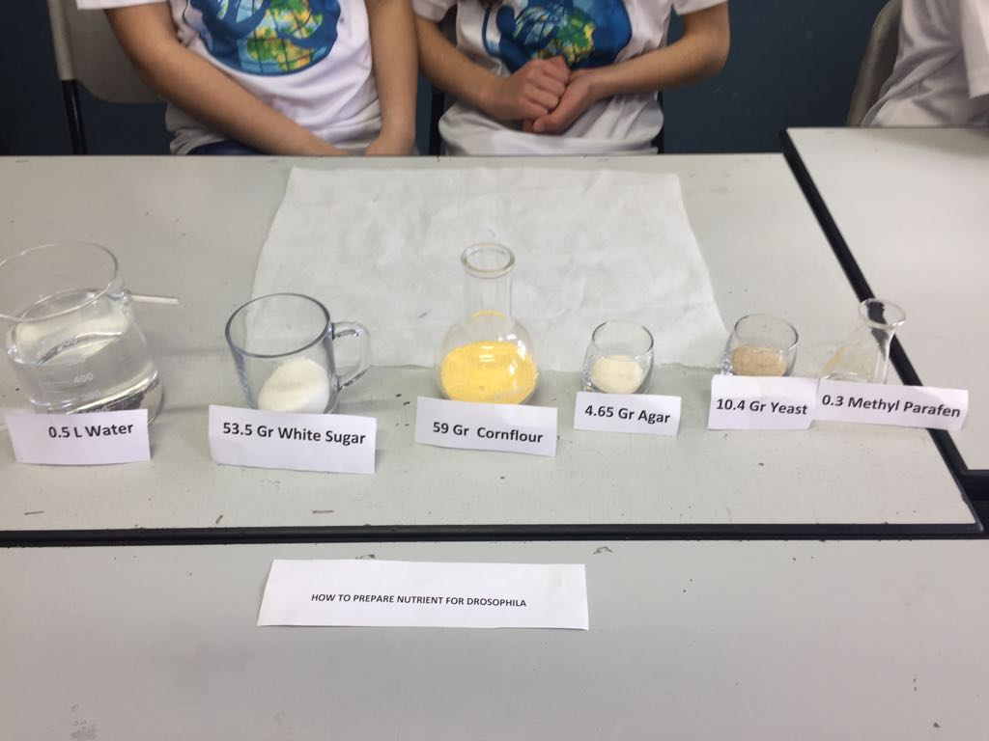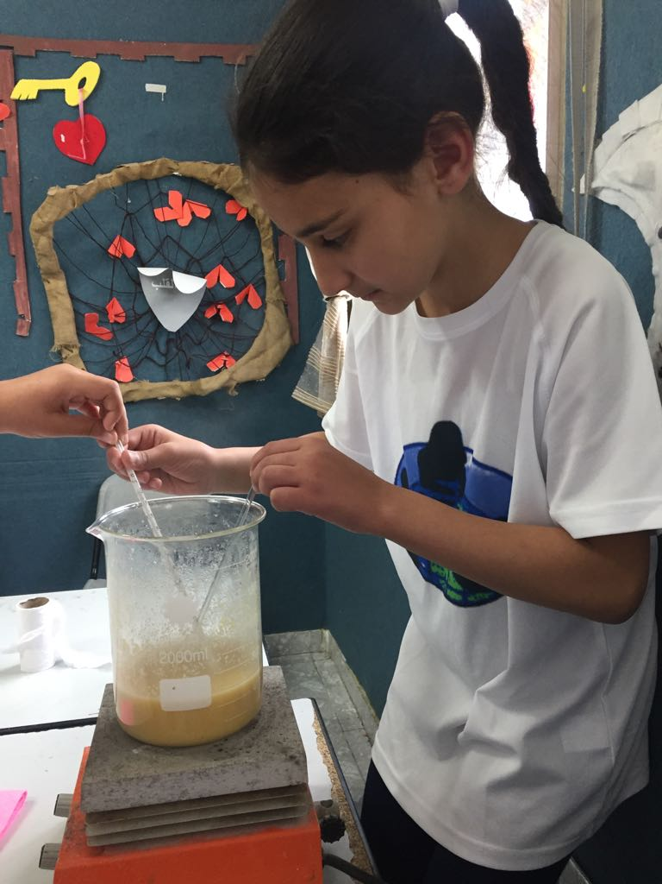
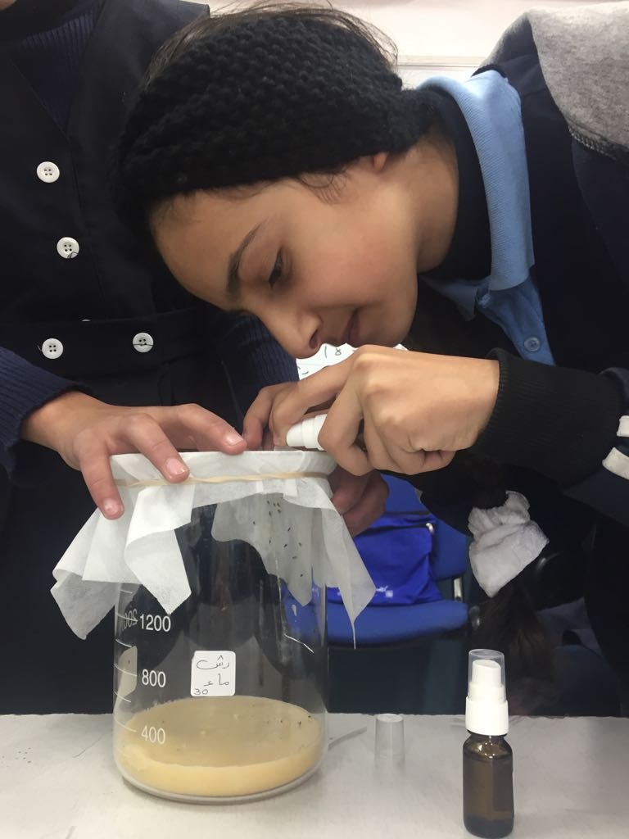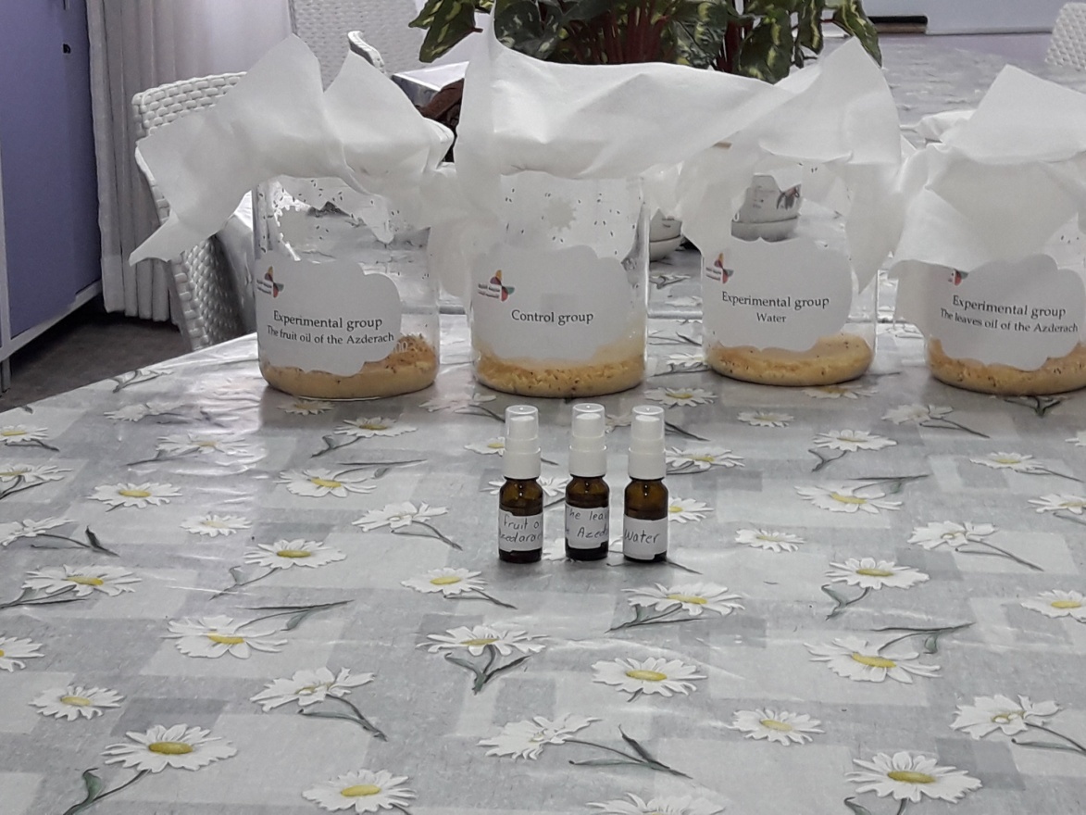
The measurements:
Our basic measurement in this research was the activity of drosophila; we took a 5cm space of each container and counted the number of flies that were moving in 60 seconds “the same students made the measurements”, analyzed twice for those who dead and for those who still alive, and we will describe the flies mortality rate in the results.
Extraction of fruit and leave oil
In our experiment, we used a machine that works on the same principle of a pressure cooker that is evaporation and condensation. First, water is placed at the bottom of the cooker then when it starts evaporating upward it blows the vesicles, which are inside, between the cells then it carries the oil out of the existing plant, and separate it in a tube. Second, the cold water from the outer tube condenses the steam into liquid that could be oil or aromatic water.
How does the device work?

The device that we used in our experiment was similar to a pressure cooker; however, it consisted of a metal strainer basket, which was lifted up to the top of the cooker.
In order to extract the aromatic oil from any plant, first, we fill the cooker with water until it reaches the metal basket, we put the plant, which we want to extract the aromatic oil from, the amount should be about 2.5 – 3 kg. , then we close the cooker firmly.
After this we attach the distillation device, which is a basic part of the whole device, we put the cooker on a thermal source in order to boil the water , this leads to a quick and intense evaporation process for the water. While the water vapor is going upward it confronts with the plant, which is being extracted, it heats the plant, boils the cytosol and the intracellular fluid, and evaporates the aromatic oil, which exists in the vesicles between the cells or on the plant’s surface according to its kind.
Afterward, the water vapor moves to the distillation device holding the aromatic oil with it, and starts to condensate when it touches the cold-water tube. Relying on the principle of “fluid density difference”, the condensed vapor and the aromatic oil move to a tube, which separates the aromatic oil from the water, and the oil floats over the water, while the excessed water is taken out in another tube, finally, we take out the aromatic water, which was produced.
In our experiment, we put 3kg of both the Azedarach leaves and fruit separately; specifically we got almost 3cc aromatic oil out of the leaves, while we got almost 6cc out of the fruit. The concentration of the extracted oil was 100%.
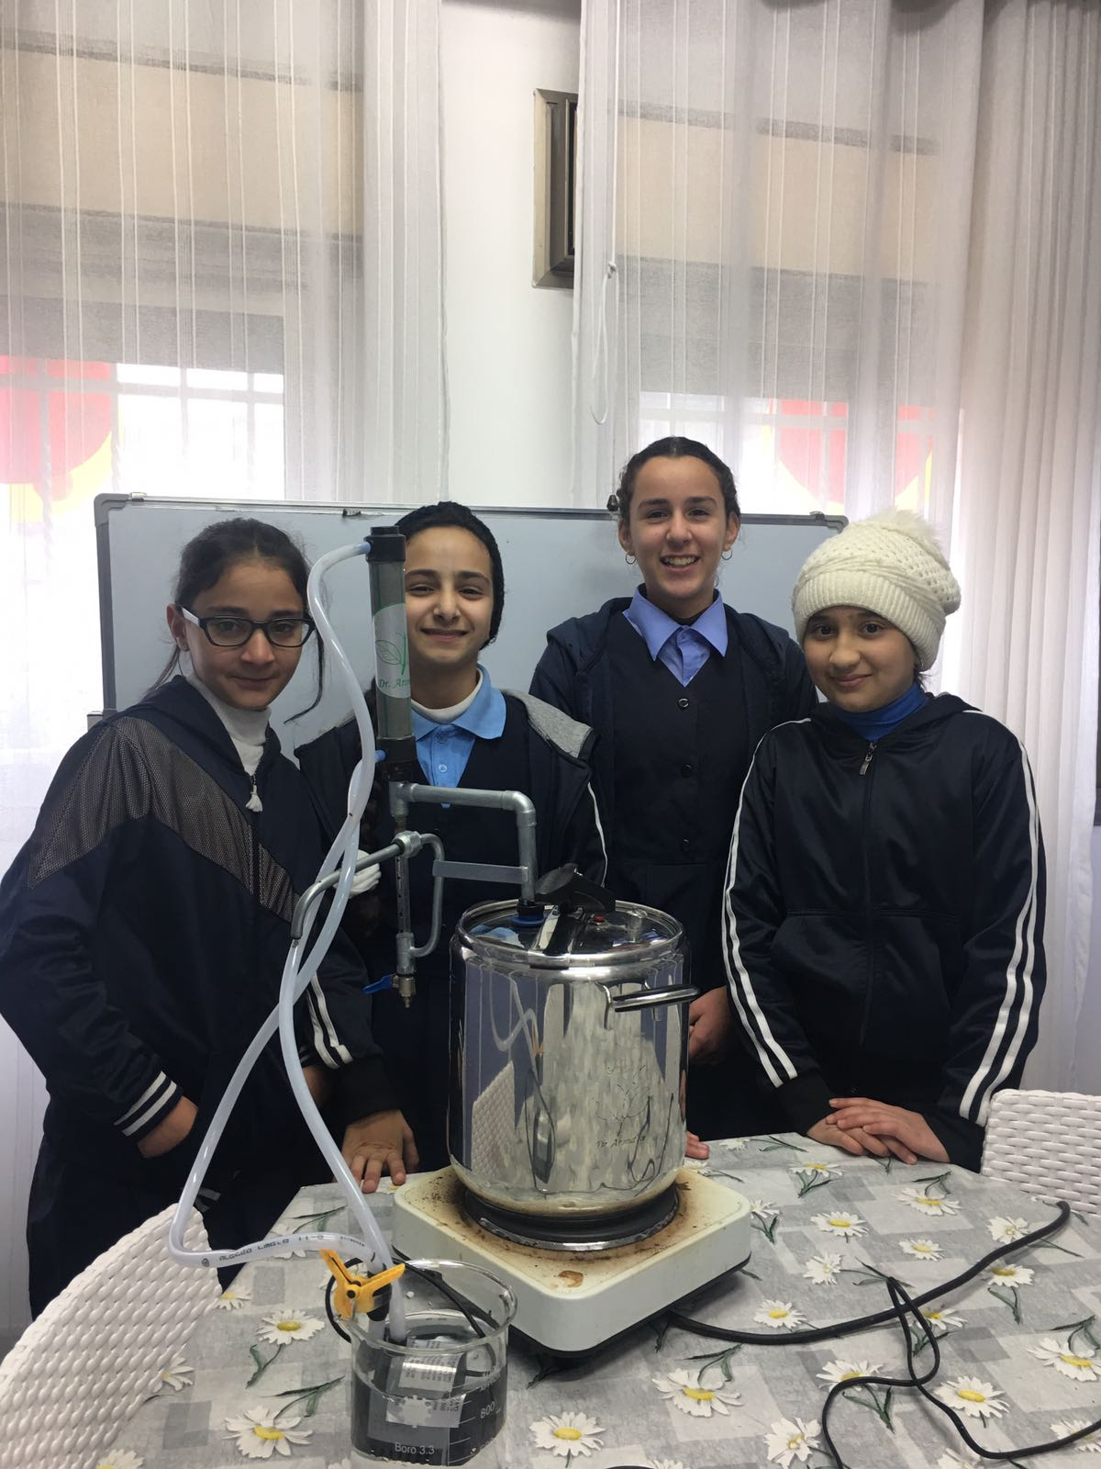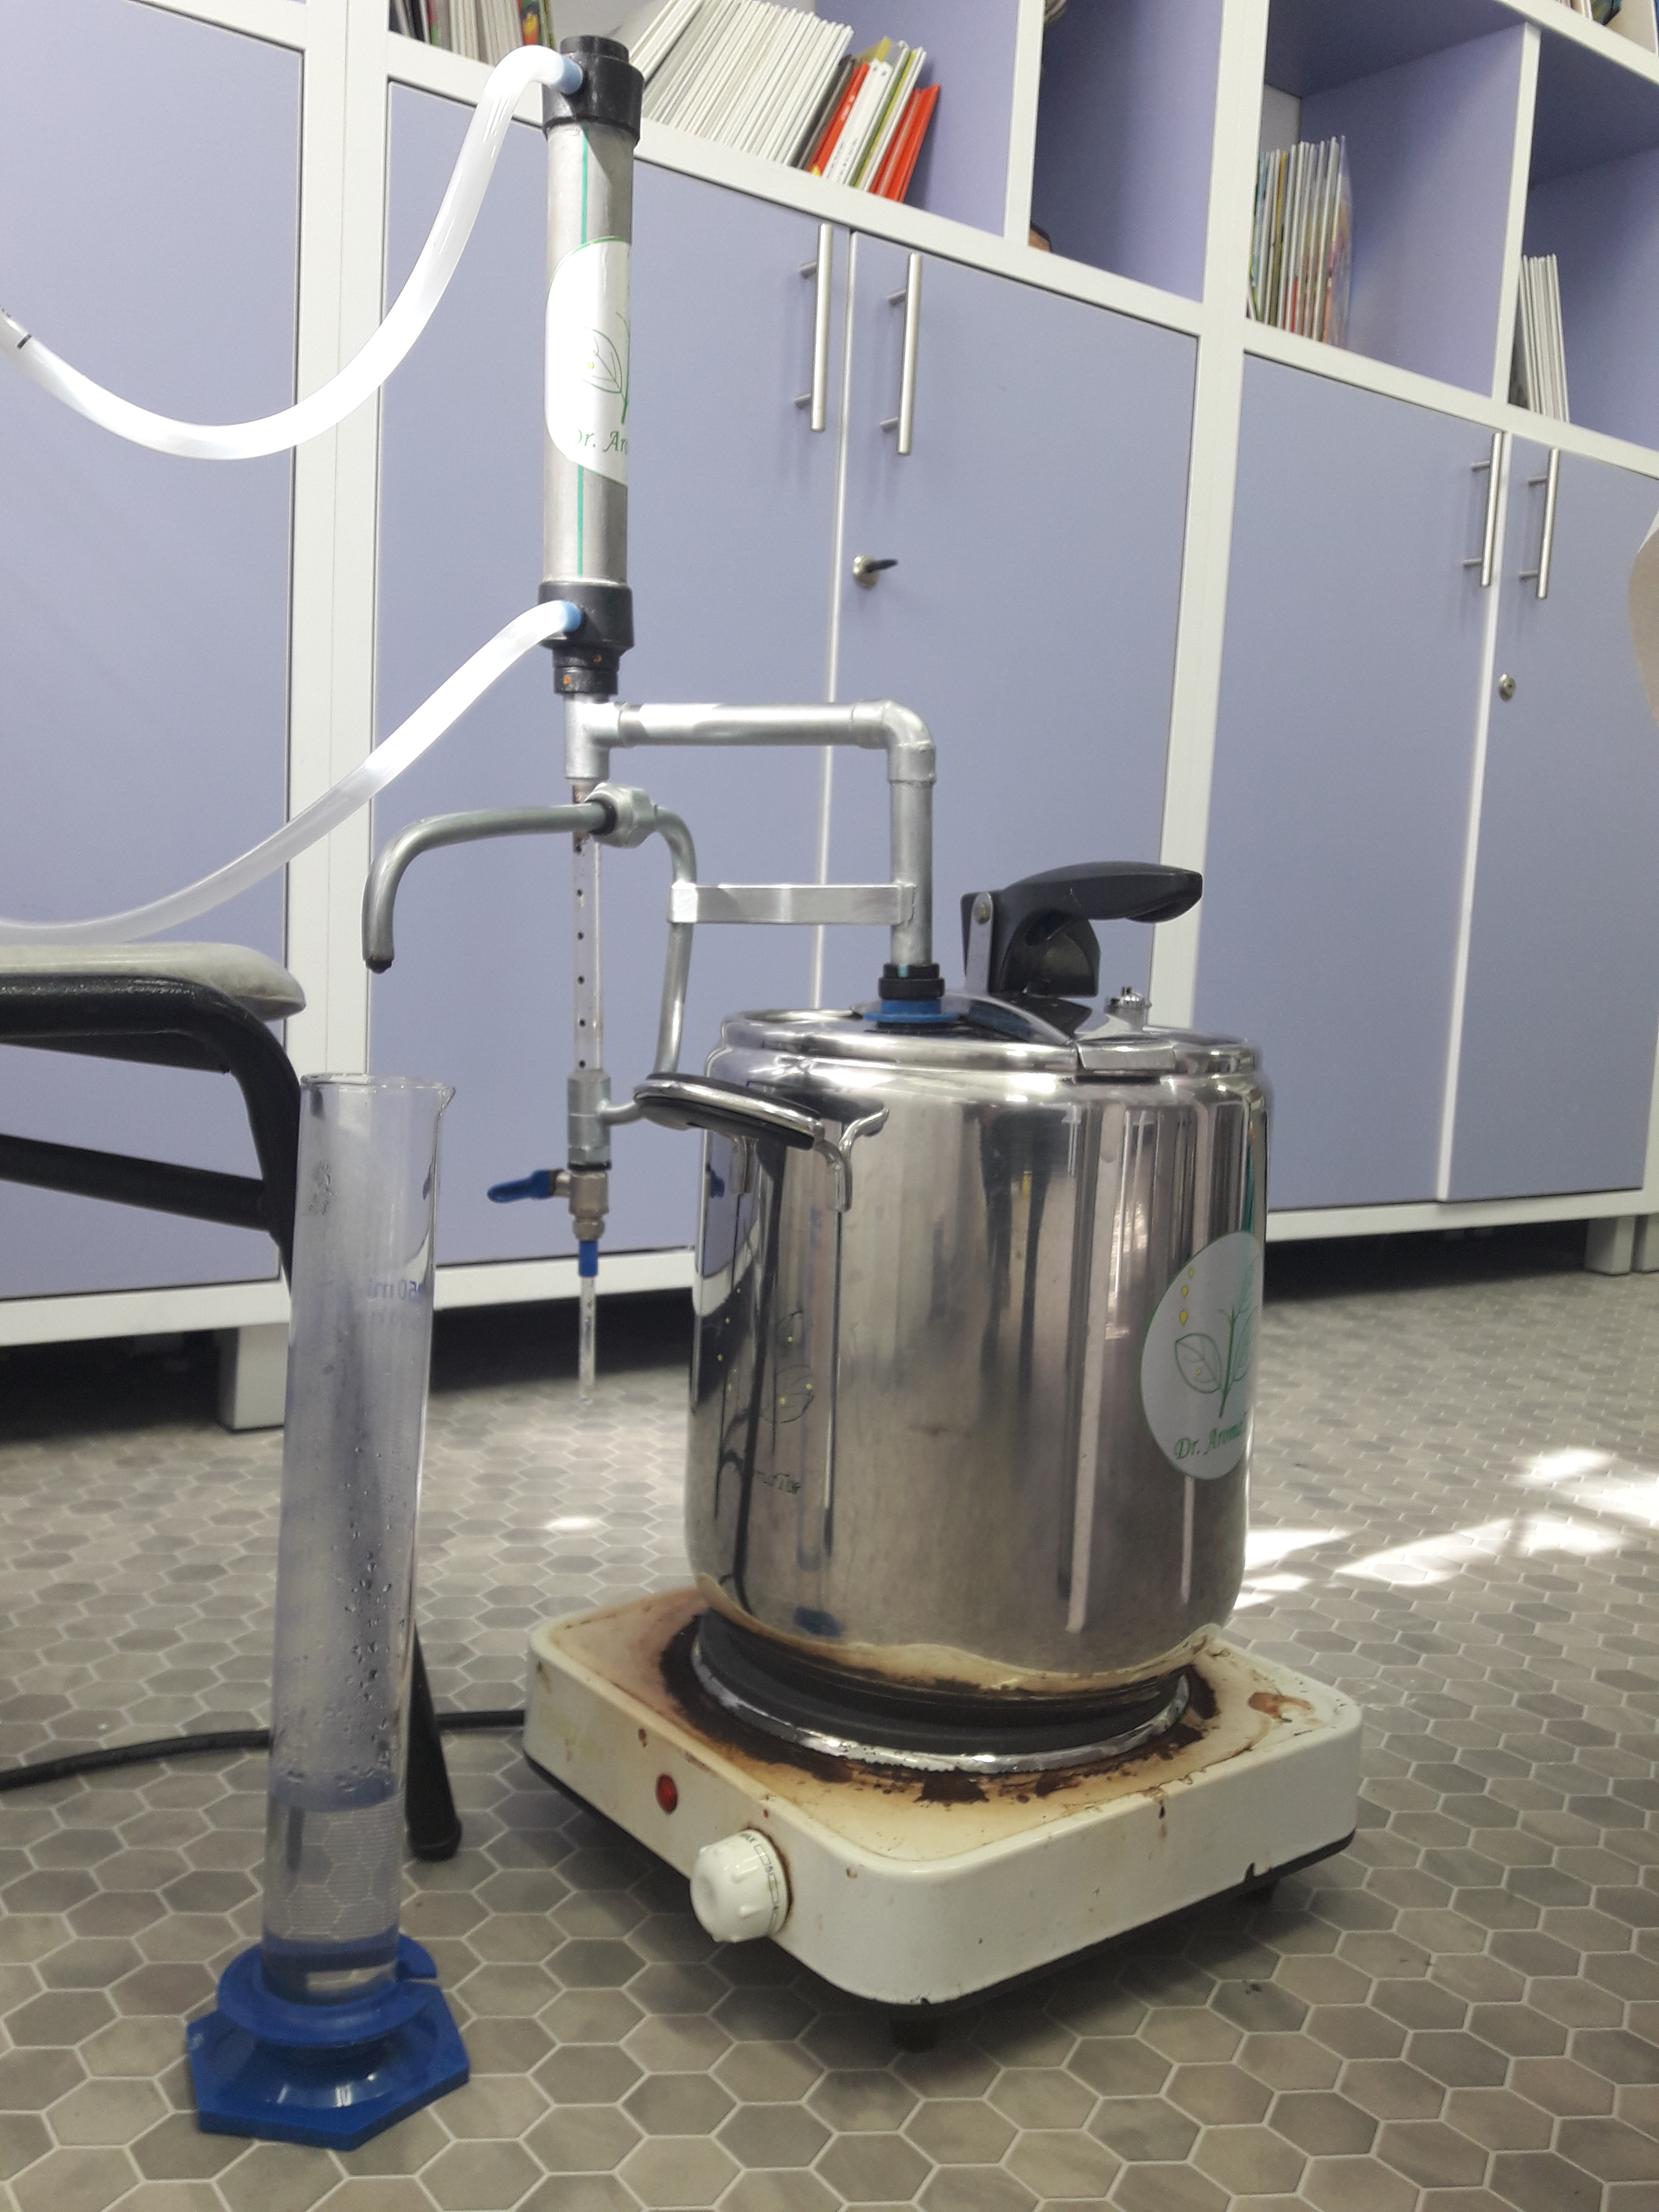

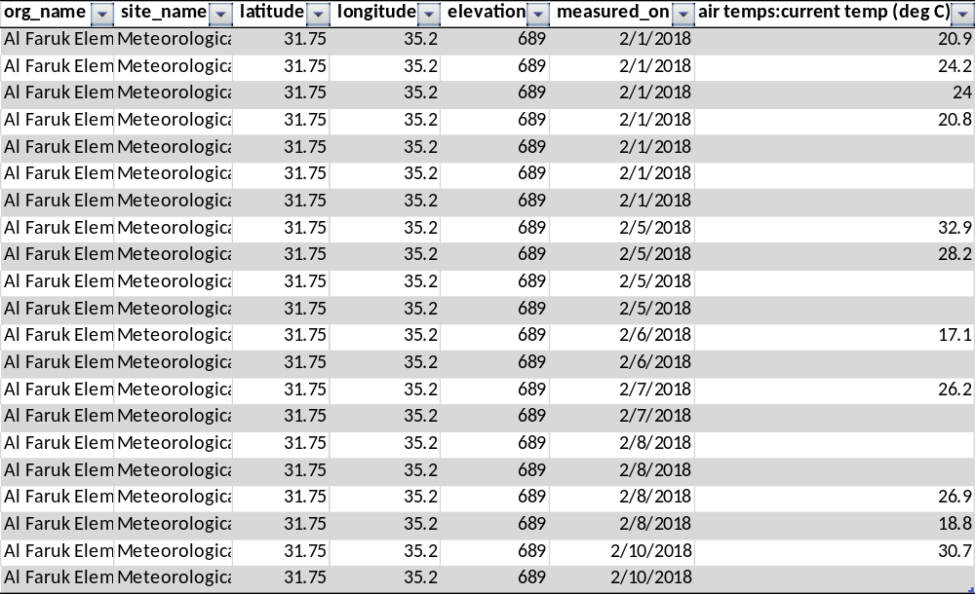
This table shows the air temperature within a week which was entered through the “Data Entry Application”

(6) Results
In order to check the effectiveness of Azedarach extract on drosophila flies, we tested the vitality of Drosophila after the exposure to the different extracts of the tree; the leaves’ extract and the fruit’s extract for 20 days.
Drosophila was divided into two groups; the control and the experimental group in different containers with rich media as shown in Research Methods part; the first group received no treatment, while the second group received different extracts. Specifically, the experimental group was divided into three containers , the first one received a tap water spray once a day, the second one received 100% concentration of the Azedarach leaves extract once a day, and the third experimental container received 100% concentration of AZ fruit (Yellow Mature fruit) extract once a day.
The independent variables were the extracts from the different parts of the tree; the fruit and the leaves. While the dependent variables were the activity and the mortality of the Drosophila flies, (relative to control group).
Evaluation methods of independent variables:
Drosophila activity was measured by counting the number of its movement, during 60 seconds in different days all over the experiment. Mortality of the drosophila was measured by counting the number of viable and dead flies.

Graphs below show the mortality of DR flies in different groups:
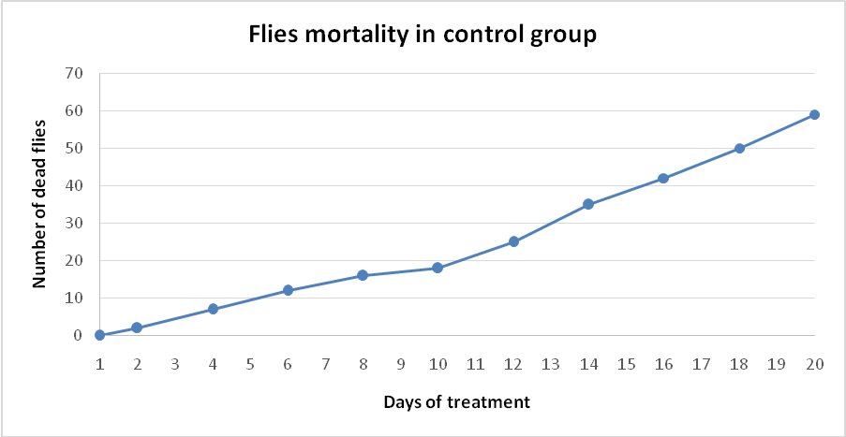
Graph 1 shows the flies mortality in the control group with no treatment for 20 days.

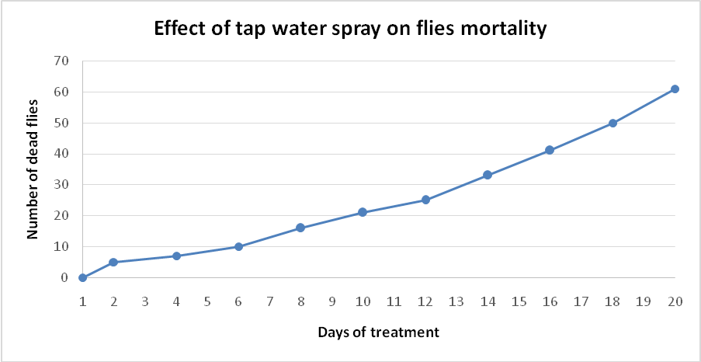
Graph 2 shows the flies' mortality after exposure to tap water spray once a day for 20 days.

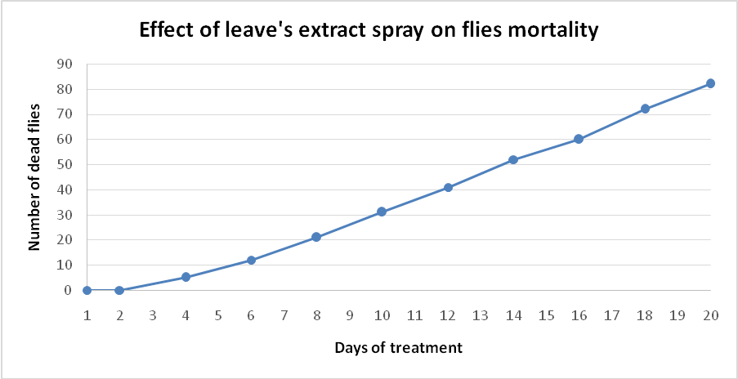
Graph 3 shows the flies mortality after exposure to leave extract spray once a day for 20 days.

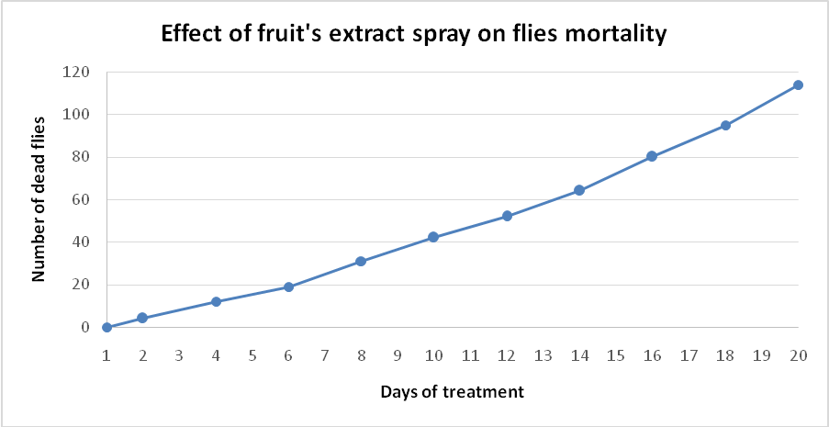
Graph 4 shows the flies' mortality after exposure to fruit extract spray once a day for 20 days.

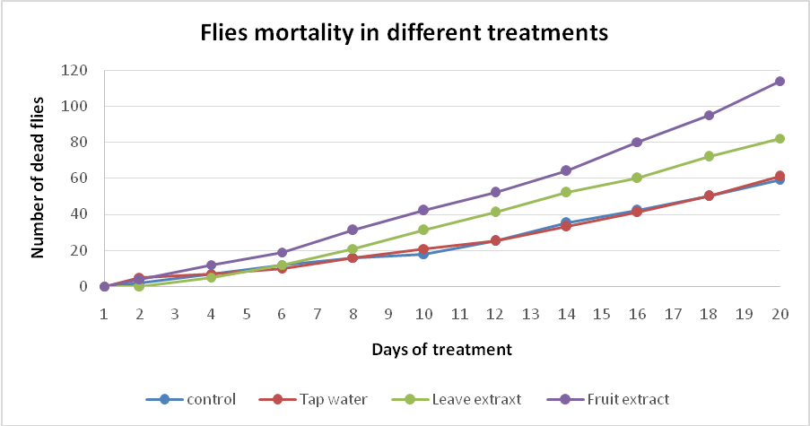
Graph 5 shows the flies’ mortality comparison in the different groups for 20 days.

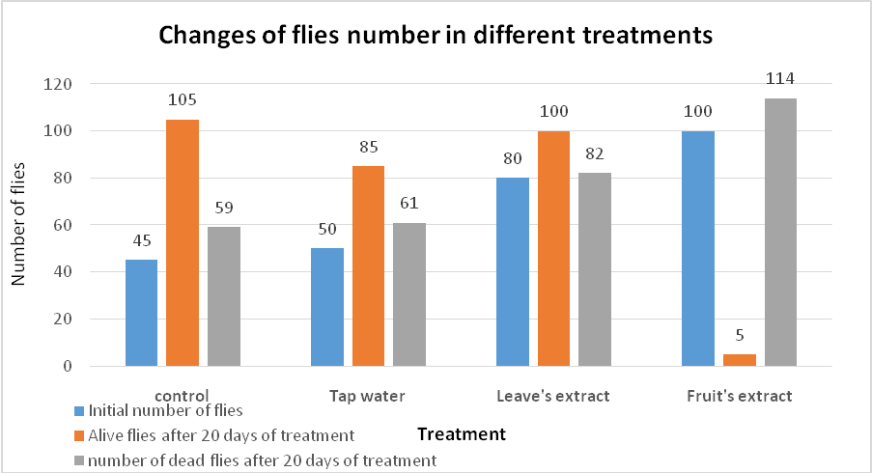
. Graph 6 shows the number of alive flies in the first day of experiment, alive and dead flies after 20 days of treatment in all groups.

Based on data from graph 6, we calculated the reproduction rate of drosophila in 20 days in the control group in order to compare it with other groups. We calculated the ratio of the total produced flies’ number with the initial number of flies as a reproduction rate of flies.
We can conclude that the total number of flies consists of; 105 which represents the total number of the original and the multiplied flies , while 59 represents the number of dead flies. (164=105+59)
Reproduction rate of flies number in control group is = (105+59)/45 = 3.6
Reproduction rate of flies number in tap water group is = (85+61)/50 = 2.9
Reproduction rate of flies number in leaves’ extract group is = (100+82)/80 = 2.3
Reproduction rate of flies number in fruits’ extract group is = (5+114)/100 = 1.2
In addition, we did another comparison to check the rate of dead flies . To do so, we divided the dead number of flies over the whole number of flies (alive and dead after 20 days) in each container.
Death rate of flies number in control group is = 59/(105+59) = 0.36
Death rate of flies number in tap water group is= 61/(85+61) = 0.42
Death rate of flies number in leaves’ extract group is = 82/(100+82) = 0.45
Death rate of flies number in fruits’ extract group is = 114/(5+114) = 0.96

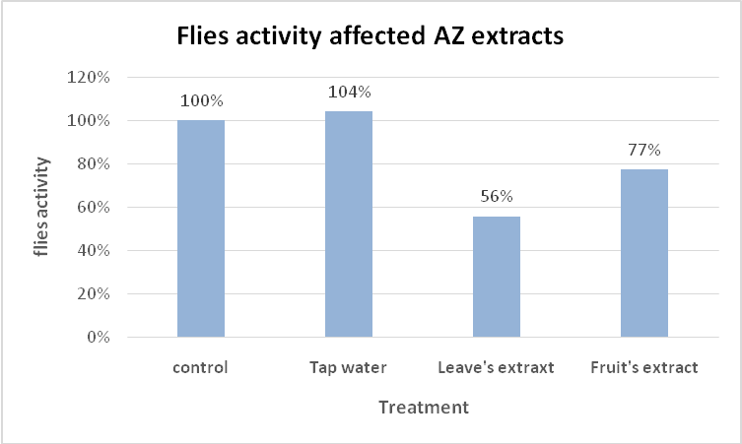
Graph 7 shows the activity percentage of the flies in different treatments (water, leaves’ extract and fruit's extract) relative to flies with no treatment. (The activity percent was specified as 100%)
*Same group of students measured the activity of flies in all groups.

Flies activity was measured as described above. Activity was in correlation to the number of movement of flies, from one place to another, inside the container. The activity was calculated by dividing the number of flies’ movement in each container within a fixed period (60 sec.) over the number of alive flies. This measurement was repeated once each two days, and an average was calculated.
The activity of the control and the experimental groups was normalized to reach 100% at the beginning of the experiment.
(7)Discussion and conclusion
The experiment held for 20 days depending on lifecycle of the flies as mentioned above. Beside the AZ extract spraying groups, we used two more groups in this experiment. The first group that is the control group, that had no treatment, determines the reproduction and the death rate of the flies as shown in graphs 1 and 6 in order to compare with other groups.
The second group of drosophila flies was exposed to tap water spray in order to determine whether the act of spraying could affect the flies activity and mortality or not.
The graphs 1-4 shows an increase in the number of dead flies upon time in all groups.
Graph 5 shows a comparison among the other four groups. We can see that the number of dead flies in the groups with the AZ extract was the highest among all. This led us to believe that the AZ extract could inhibit the reproduction of the flies or even actively kill them.
To support this belief we need to discuss the values of reproduction and death rate of the flies in the groups depending on graph 6. The rates data normalized to flies number in each container as explained in the above. We can see that the reproduction rate in flies’ number was maximal in the control group when compared to the other groups, in addition to the death rate that was minimal. This fits our hypothesis because there is no treatment at this group. All other groups showed lower reproduction rates and higher death rates than the control. The water groups showed a decrease of 20% in the reproduction rate with a value of 2.6, this could be explained by the fact that the water maybe reduced the temperature and increased humidity in the cntainer, making worse condition to grow, compared to control container.
Based on graph 6, we can see that the dead number of flies in water and in the control group are almost the same (59 and 61 respectively), and the initial number of flies in both groups is almost the same (45 and 50). This data lead us to conclude that the water did not increase the dead number of flies actively, however, it decreases the number of alive flies at the end of the experiment (85) compared to 105 in the control group.
The AZ extract groups showed a low reproduction rate and high death rate. This can support our hypothesis that it could inhibit the reproduction of flies.
The leaves’ extract group showed a 36% decrease in reproduction rate (2.3) and a 25% increase in death rate (0.45) compared to the control group ,based on graph 6.
In addition, there was a decrease of 44% in the flies’ activity in this group compared to the control group as shown in graph 7. We conclude that the leaves’ extract limit the reproduction and activity of drosophila flies and can be used as a natural insecticide.
The fruit extract group showed a 66% decrease in the reproduction rate (1.2), while the death rate (0.96) was doubled 2.7 times compared with control, based on graph 6. In addition, there was a decrease of 23% in the flies’ activity at this group compared to control group as shown in graph 7. We conclude that fruit extract can limit and even eliminate drosophila flies actively. Starting with the initial number of 100 drosophila flies, there was only 5 alive drosophila flies after 20 days of receiving the Azedarach fruit extract.
We believe that the fruit extract is more efficient than the leaves’ extract against drosophila and maybe against other pests.
Further prospects: to use the fruit extract on other types of pests.

Because our product “the extracts of the Azedarach tree” has different uses therefore we examined their requirements then turned them into appropriate products , which were the following:
- Making small bags out of the dried fruit pulp, which is similar to the tea bags, we add hot water on in order to activate its effective substance which keeps the insects away from the birds farms.
- Making diluted sprayers from the leaves oil with the intention of keeping insects away from the home gardens.
- Making saturated- aromatic oil stripes out of the fruit” which is similar to the perfume stripes”, and hanging it inside the toilets, public restrooms, and public toilets.
- Making aromatic dried bags filled with dried leaves and fruit inside the wardrobe and the shoe closet to keep the insects, parasites and mites away.
- Using the aromatic water, which was produced through the process of extracting the aromatic oil by the pressure cooker, and filling it in a flask, which contains wooden absorbent sticks to facilitate the process of evaporating the effective substance, these flasks, can be placed in the animals’ cages, the zoo and in the animals’ corners at schools.

Limitations:
The experiment was applied in winter when there were less suitable growing conditions for the Drosophila fly, as a result, this affected the initial number of the flies in the beginning of the experiment.
Moreover, we wanted to repeat the experiment two more times in order to make more accurate statistics , but there were no enough drosophila to start with.
Moreover, we intended to use the greening up category in the GLOBE site for our tree “The Azedarach” since we planted it in our school backyard and include its related data in the research; however, we did not manage to because of some problems in the “GLOBE” site.
(9) Bibliography

- Gupta RK, 1993. Multipurpose trees for agroforestry and wasteland utilization. New Delhi, India: Oxford & IBH
- Mabberley DJ; Pannell CM; Sing AM, 1995. Meliaceae. Flora Malesiana: Series I, Spermatophyta. Volume 12, part 1, ii + 407 pp.
- Sharma N; Sharma N, 1995. Effect of leaf powder/extract of neem and persian lilac on post-harvest diseases of tomato fruit. National Academy Science letters, 18(1-2): 11-14.
- Salam ALA; Ahmed AAI, 1997. Evaluation of using the extract of chinaberry fruits, Melia azedarach L. In the control of the cotton leafworm, Spodoptera littoralis in Egypt. International conference on pests in agriculture, 6-8 January 1997, at le Corum, Montpellier, France. Vol. 3. Assoc. Nationale pour la Protection des Plantes, Paris, France. 1159-1162.
- Andrade-Coelho CA¹, Souza NA, Gouveia C, Silva VC, Gonzalez MS, Rangel EF Effect of fruit and leaves of Meliaceae plants (Azadirachta indica and Melia azedarach) on the development of Lutzomyia longipalpis larvae (Diptera: Psychodidae: Phlebotominae) under experimental conditions. J Med Entomol. 2009 Sep;46(5):1125-30.
- Anthony J.F.; Wessler, Susan R.; Lewontin, Richard C.; Gelbart, Willi Griffiths. An Introduction to Genetic Analysis, tenth edition
- Anthony J.F.; Wessler, Susan R.; Lewontin, Richard C.; Gelbart, Willi Griffiths. An Introduction to Genetic Analysis, tenth edition

Thanks
- high school of Mevvesirt
- DR Moshe balsas ( Dr. Aromate),PHD in genetic Engineering of plants.
- Mahmoud Mustafa, M.Sc. in biology.

