The IMPACT Of The Solar Wind And Earth's Magnetic FIELD On Temperature

Student: blqees alkobidan
School: fourth Secondary
Supervisor: Alya Alsharari

Contents

Page |  | Content
3 |  | Introduction
4 |  | Research Problem
4 |  | Scientific background
4 |  | Research questions
4 |  | Purpose of the research
4 |  | Hypothesis
5 |  | Experience
6 |  | Conclusion
7 |  | Proposals
8 |  | References ]
9 | thanks

Introduction:
The solar wind launches plasma and particles from the sun into space, although the wind is constant, but its properties are variable . So, what causes these flows? And how does it affect the Earth?
The Coronet (The corna) is the outer layer of the Sun, the temperature up to about 2 million degrees Fahrenheit (1.1 million Celsius), and at this level, the Sun's gravity could not resist particles that move fast, thus, they flow ( particle) across streams away from the Sun component Solar winds and when its moving away from the Sun, they bear charged particles and magnetic clouds. When emitted in all directions, part of the solar winds storm our planet constantly, resulting in that interesting effects..
What is the Earth's magnetic field? Physicists define the magnet that a substance produces invisible power lines between polarity, and when we try to define the globe in a general physical form so this definition applies significantly, which it is a big magnet emits its own magnetic field between polarity , the Earth's magnetic field that surrounds the planet called as the magnetosphere extends to over 36,000 miles into space
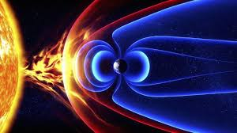

.

Research Problem:
when a ground magnetic field stopped the solar wind , Does the temperature change significantly on surface of Earth?
Scientific background:
A magnetic field of the Earth exists to protect the earth and especially protect organisms from the solar wind that comes to earth always loaded with harmful charged particles. And when those particles close to the Earth dislocated by magnetic field to space atmosphere away from the earth.
Research questions:
what is the impact of solar wind on the Earth? And specially on the temperature?
Research objectives:
1. to increase knowledge about the Sun and emissions of solar wind. 2. knowing the magnetic space and its role in protecting the Earth. 3. knowing the impact of solar wind on the temperature.

Hypothesis:
1.If the magnetic field stopped the solar wind, the Earth's temperature rises.
2. the solar wind has no effect on temperature.
Experience:
My experience was generally based on observation and survey and temperature gauge, where it was used temperature recordings that we did in the environmental GLOBE , and to know if my hypothesis is correct or not I did what is coming:
1- I searched for a day that took place of solar wind emissions heading to Earth.
The city | The temperature on 3 April 2019 | The temperature on 3 February  2019 | The temperature on 4 February 2019 | The temperature on 5 February 2019  The day of occurrence the solar wind
Sakaka | Great degree 36 c super degree: 23c | Great degree 37 c super degree: 21c | Great degree 37 c super degree: 19c | Great degree 34 c super degree: 19c
Moscow | Great degree 1 c super degree: -2c | Great degree -2 c super degree: 12c | Great degree 11c super degree: -15c | Great degree -11 c super degree: -16
New York | Great degree 1 c super degree: 9c | Great degree 8 c super degree: 1c | Great degree 4 c super degree: -3c | Great degree 3c super degree: -3c
Marrakesh | Great degree 15 c super degree: 4c | Great degree 15 c super degree: 2c | Great degree 12 c super degree: 2c | Great degree 12 c super degree: 5c

Conclusion:
what has been observed is that the temperature is not affected by the sun wind which stopped by the magnetic field and this means that the second hypothesis is correct,

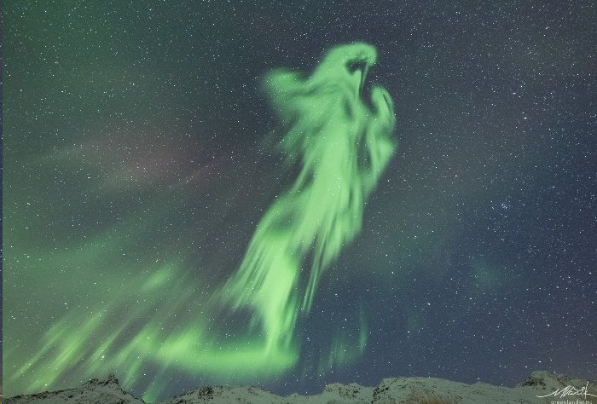

This picture on 5February in Norway with Trmoso skies of course there was no animal physiological phenomenon, when the Solar wind comes to the earth, the magnetic field stopped it and keep away from entering Earth's atmosphere by scattering into space and at the same time some of the wind landed on the Poles away from Inhabited places on Earth, this thing explains the phenomenon of polar twilight and the Earth's magnetic field protects organisms from the harmful particles to life.

Proposals and other information:
I wish put satellites in the Earth's magnetic field contains complex collecting some of solar wind and converts it into energy to benefit of it.

The Earth's magnetic field is the strongest among the planets of the solar system and of things that distinguish it, without this feature, life on Earth would be impossible and not originated on the planet, when scientists studied the rest of the planets in the solar system, they found that most of them do not have magnetic like that on the ground, for example, Mars has no magnetic field, and therefore is not protected from the solar wind approaching it and penetrate easily which leads to high temperatures on its surface to several hundred degrees.
It also affects the transfer of electrical energy, which can cause strong solar winds disrupted the flow and transfer of electrical power to our homes and our businesses, because the current flow of power lines responds to different external streams in the upper atmosphere, when solar storms which hit the Earth's atmosphere cause overload on electrical transformers, causing combustion or heat the surrounding structures with transformers, sometimes electrical cutters has a certain resilience, when increased load cut off causing interruption of electricity.
It Effects on wireless communication: because many wireless communication based on high frequency in the range 1 to 30 MHz, and when the solar wind hits the atmosphere causing ionization air what causes confusion or prevent connection.

Sources and references:
1-NASA site https://nasainarabic.net/main/articles/view/solar-wind.
2-the Wikipedia site https://ar. Wikipedia. org/wiki/magnetic _ floor..
3-the light of knowledge website http://al3elm-noor. com/home/what-is-area-magnetic-Earth-what-she-VA.

Thanks and appreciation:
thanks to Allah first and last
thanks to environmental globe teacher Alya Alsharari

