**Why doesn’t grass grow on our**

**school playground?**

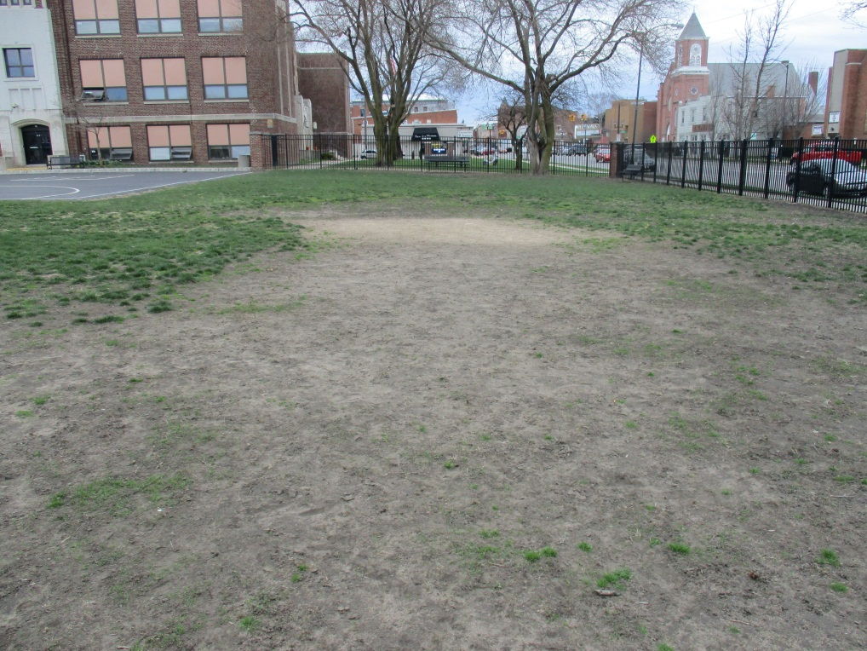

Main Street Intermediate School Playground

Canon Powershot 160 – 3/2017

Main Street Intermediate School

Norwalk, Ohio USA

N41.24 latitude

W-082.61 longitude

March 2017

**Contents**

Abstract ……………………………………page 3

Purpose and Background ………………page 4

Hypothesis ……………………………….page 6

Materials and Procedures …………… page 6

Data charts…………………………………page 9

Conclusion ………………………………...page 11

Questions for further study ……..……page 12

Resources ………………………………… page 12

Badge Criteria Met ……………………….page 13

**Summary**

Main Street Intermediate School is located in the uptown district of Norwalk, Ohio. For more than a decade a large part of the playground is bare. Grass will not grow. This creates a problem of limited space for students to play and dirt and mud gets tracked into the school building. It also looks very bad. This project will help solve the mystery. Soil samples were taken in the area where grass grows and in the area where grass does not grow. The soil texture and nutrients were compared for each area. After looking carefully at the data, I concluded that the soil has good nutrients and organic material to help grass grow. The problem seems to be that the soil does not hold water and drains very fast so the grass does not get enough moisture to grow. Additional work needs to be done to figure out what can be done to help the soil on the playground hold water longer to support a health crop of grass.

This research project was completed by a sixth grade student at

Main Street Intermediate School in Norwalk, Ohio, USA.

**GLOBE Mentor Teacher**

Ms. Marcy Burns

**Student**

Annabelle Ortner

Purpose and Background Information

The purpose of this project is to find out why the grass does not grow in one section of the playground. This is important because without grass there would be a great deal of mud. If there is a bundle of mud then the community cannot use that section of the playground. The results of this project can help our school and community have a better place to play.

Since I have started this project, I have learned a lot about soil. Some things I have learned are very vital to this project. That vital information includes facts about the different colors and types of soil. I have learned that soil is formed by the combination of physical, chemical, and biological processes in which huge rocks are broken down into smaller particles over a long period of time. Rocks undergo a process of expansion and contraction in which they expand during the day and contact during the night due to the constant change in temperature. However, not all rocks of a rock undergo expand and contract at the same rate, resulting in the formation of cracks. Gradually, these cracks cause the rocks to break down into smaller pieces. With time, these smaller pieces convert into particles and form soil. Water plays an important role in soil formation. Water that gets collected in the cracks of rocks, sometimes freezes. This helps in widening the cracks of the rocks. Flowing river water helps in the wearing down of rocks over time. This results in the formation of soil. Strong blowing winds also rub against rocks and helps in wearing them down. Some living organisms, like lichens, that grow on rock surfaces release certain substances. These substances cause rock surfaces to powder down and form a thin layer of soil.

I have also learned about the layers of soil and what they contain. The very top layer is 0 Horizon. This layer is dark in color. 0 Horizon consists of decomposed leaves, humus, and organic matter. Decomposed leaves, humus, and organic matter helps make soil fertile. The next layer down is A Horizon. A Horizon is commonly know as “top soil”. A Horizon is a soft porous layer. It is rich in humus and nutrients. This layer shelters living organisms. Plant roots also grow in A Horizon. The next layer down is B Horizon. This layer is generally known as “sub soil”. B Horizon is a hard and compact layer. Roots of bigger plants extend until this layer. B Horizon consists of various minerals. After B Horizon, comes C Horizon. Slightly weathered parent rocks are located in C Horizon. The slightly weathered parent rocks have cracks and crevices. The final layer is Bedrock. This layer is very firm and strong. Bedrock consists of unweathered parent rocks.

Soil also has nutrients that help plants grow. Nitrogen, phosphorus, and potassium are common nutrients that are tested to see the health of soil. As a result of testing the soil samples for levels of nitrogen, phosphorus, and potassium, I have learned a lot about what they are and why soil needs them. I have learned that the average nitrogen level should be about medium (10-20 ppm). The phosphorus level should also be medium (20-40 ppm). Lastly, potassium should be medium (150-250). Organic material in soil is important for healthy plant growth. Soil can be tested with different types of kits with similar results.

**Hypothesis**

When students play soccer or football on that section of the playground, the seeds, if there are any, get pushed down into the soil and then they can´t grow. The problem could also be caused by compaction of the soil from recess activity.

**Tools and Materials**

* GPS
* Notebook for notes and data
* Shovel
* Zip-lock bags & Permanent marker for labeling
* Boring Probe & Bucket
* Test Kit: LaMotte N.P.K. (soil kit code: 3-5880)
* Soil survey book of Huron County, Ohio
* GLOBE Protocol data sheets

**PROCEDURES**

1. I read background information about soils and soil testing.
2. I learned how to collect and test soil samples using GLOBE protocols.
3. I collected soil samples on the “grass” and “no grass” study sites on Main Street Intermediate School Playground.
4. I found out the soil types and textures of each sample.
5. I matched the color of the soil samples using the GLOBE Soil Color Book.
6. I tested the nitrogen, potassium, and phosphorus levels of the “grass” and “no grass” samples following the directions in the test kit. Data was entered into the GLOBE website.
7. I emailed Mr. Chad Stang about helping me with my project.
8. Mr. Stang showed me how to use a soil boring probe and we dug eight inches into the ground for more “grass” and “no grass” samples.
9. Mr. Stang took the samples to Huron Co. Extension lab.

10. I organized the data into charts and looked carefully at the results.

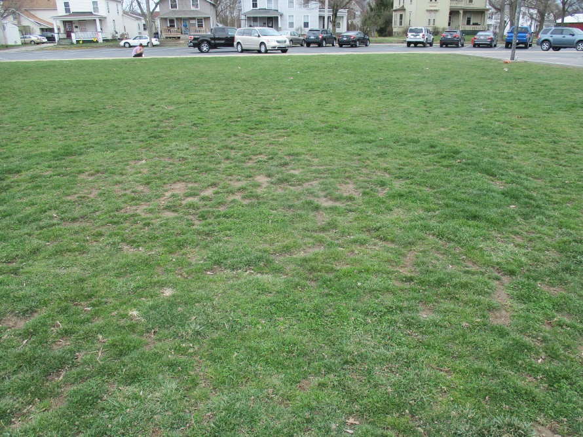

Main Street School Playground where grass grows

Canon Powershot 160- 3/2017

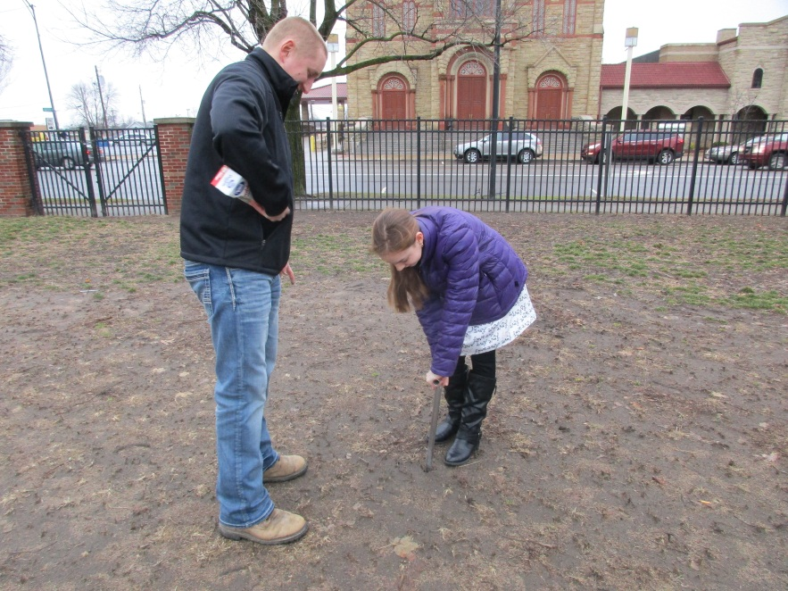

Using soil bore to get soil samples

Canon Powershop – 1/24/2017

|  |  |  |
| --- | --- | --- |
| **Area With Grass**  Soil texture is granular with some roots.  The soil color is 7.5YR:6/2  Top soil added after building demolition. | | |
|  | **LaMotte NPK**  **Kit 3-5880** | **Huron County Extension Lab #1684** |
| **Nitrogen** | Low |  |
| **Phosphorus** | Low | 58 |
| **Potassium** | High | 290 |
| **Organic Matter** |  | 2.55% |

|  |  |  |
| --- | --- | --- |
| **Area Where Grass Will Not Grow**  Soil texture is single grained and sandy.  The soil color is 7.5YR:5/2  Soil Survey Book: SpB Spinks loamy fine sand/ has low ability to store water | | |
|  | **LaMotte NPK**  **Kit 3-5880** | **Huron County Extension Lab #1684** |
| **Nitrogen** | Low |  |
| **Phosphorus** | Medium | 282 (very high) |
| **Potassium** | High | 188 |
| **Organic Matter** |  | 3.15% |

Conclusion

This project has allowed me to find out the reason that the grass doesn’t grow in one area of the playground. The problem on the playground is that the grass won't grow in one section of the playground. This is a problem because it looks bad, students track mud into the building, and there is no place to play. I thought that the answer to the problem was that when the students play soccer or football on the grass then the seeds, if there are any, get pushed down into the soil and they can't grow. I also think that the soil has no nutrients and that is why the grass does not grow in that section of the playground.

The data from December 20, 2016 shows that the nitrogen level and the phosphorus level in all of the grass samples was low. It also showed that the potassium level was high. I have learned that the average nitrogen level is medium (10-20 ppm). The phosphorus level should also be medium (20-40 ppm). Lastly, potassium should be medium (150-250).Additionally, I have tested the no grass samples on the same day. I found out that the nitrogen level was low like the grass sample. The data also shows that the phosphorus level in the grass samples was low. The phosphorus level for no grass samples was medium. Finally, the potassium level in the grass samples and the no grass samples was high.

I have also received more complexed results from Mr.Stang. He has tested my soil on February 8, 2017. His results show that the phosphorus level was 58 for my grass samples. The phosphorus level was 282 (very high) for my no grass samples. The potassium level for my grass samples was 290. The potassium level for my no grass samples was 188. Mr. Stang did not test for nitrogen, but the organic matter in the area with grass is 2.55% and the area with not grass it was surprisingly high at 3.15%.

I have learned that there is enough nutrients in the soil for grass to grow. A closer look needs to be taken at the soil type where the grass does not grow. It is SpB type that has a low ability to store water. Further study needs to be done to find out ways to add other types of soil to the area where grass will not grow so that it will hold the water better. Further study is also needed in finding the best type of grass to plant.

**References**

* Soil Survey Book of Huron County, Ohio
* “The Scoop On Soils” – Storybook published by The GLOBE Program
* GLOBE soil data sheets
* www.globe.gov
* Mr. Chad Stang, Manager - Huron County Soil and Water Conservation District office, Norwalk, Ohio
* Ms. Burns – Grade 5 Science and GLOBE Teacher

**Questions for Further Study**

* What is the best type of grass to plant on the playground?
* How will a grass playground affect the surface temperature?

**BADGES**

**Collaboration**~

I collaborated with two adults during this project. Ms. Burns, fifth grade teacher and GLOBE teacher showed me how to use the GLOBE protocols for getting soil samples and testing the samples. She helped me get soil from Main Street Playground. After she helped me take samples, she showed me how to safely test the nitrogen, phosphorus, and potassium levels with LaMotte N.P.K. soil test kit. Ms. Burns’s role in this project supports my role by helping me learn more about the soil sampling and testing.

Mr. Chad Stang, manager of the Huron County soil and water conservation district helped me to understand the test results. Mr. Stang let me borrow a soil survey book about Huron County, Ohio. The soil survey book allowed me to learn about the dig site. The book told me that the dig site will not pond or flood. The book also told me that Main Street Playground’s natural drainage class is well drained. This data tells me that the soil cannot hold a lot of water. The grass will not grow as marvelous in the “no grass” section of the playground, unlike the “grass” section, where grass grows more satisfying. Mr. Stang also showed me how to use a soil bore and we took new samples in January on the “grass” and “no grass” sites. The soil samples were sent to a lab at Huron Co. Extension. The results of those tests show that there is very good nutrients in the soil samples. We now think that the problem of might do with the drainage of the soil. Mr. Stang’s role in this project helps my role because without him I could not have tested my samples with a professional lab to compare with my December samples. Mr. Stang shared resources to help me learn more about soil on our playground.

**Community Impact**~

This project is important because without it than the students and community might not be able to use one section of the playground. I plan on presenting my results to the principal of our school and to the Norwalk City School Board so that we can solve the problem and have a healthy crop of grass on our playground in the near future.

**Connecting With A STEM Professional~**

Mr. Chad Stang is a STEM professional. He has helped me with a lot of my project. He has helped me understand more about soils. Chad’s profession is the manager of the Huron County Soil And Water Conservation District. He has a college degree in agricultural business.

**Exploring STEM Careers~**

Mr. Stang’s job has him doing a lot of things. These things include helping with soil nutrient management issues. Some soil nutrient management issues have to do with animal manure. Mr. Stang also helps farmers with waste storage. Mr. Stang does many activities to help the farmers in our county as the manager of Huron County Soil And Water Conservation District.