ASSESSING THE IMPACT OF AEROSOLS ON THE URBAN HEAT ISLAND EFFECT

Heather Ratcliff
Courtney Adkins

Huntington High School
Richard Sharpe
March 12, 2018

Abstract:
Surface temperature is the best indication of the Urban Heat Island Effect. How does cloud cover, barometric pressure, relative humidity, and air temperature influence surface temperature, therefore the UHIE? To find this out, five different protocols were used. The first one is cloud cover. To find this, the team looked at the color of the sky, determine if there is low-level, mid-level, and/or high-level clouds, find the percentage of cloud cover, determine whether or not there are contrails, and what the conditions of the surface are. Surface temperatures were found by using an Infrared Thermometer (IRT). The IRT will be pointed to the ground’s surface, after making sure it is not pointing at a shadow, and then, after clicking the button, the surface temperature will be shown in Celsius (°C). Then the barometric pressure, air temperature, and relative humidity had to be determined. Barometric pressure measures the atmospheric pressure. Relative humidity determines the moisture. Air temperature measures the temperature in the air. All of these were found using a Kestrel 5500 weather meter. After taking all of the measurements and calculating the correlation, it was discovered that there is no relationship between air temperature and surface temperature (-0.04978), barometric pressure and surface temperature (-0.07582), or relative humidity and surface temperature (-0.37473). There is, however, a moderate relationship between cloud cover and surface temperature (0.476207). This means that air temperature, barometric pressure, and relative humidity have no effect on surface temperatures, therefore no effect on the UHIE. Cloud cover is the only factor that has an effect on surface temperatures, and the UHIE. Of course, there could have been errors due the several days the team couldn’t take observations, the fact that the human eye can’t measure cloud cover precisely, and the IRT’s could have been 1° or 2° off.

Research Questions:
Surface temperatures is the best indication of the Urban Heat Island Effect. How does cloud cover, barometric pressure, humidity, and air temperature influence surface temperature and therefore the UHIE? The Urban Heat Island Effect is when temperatures are often a few degrees higher in cities than they are in rural areas. It causes extreme heat waves in the summer, which inevitably leads to certain parts of the population (elderly, sick, poor, etc.) being highly affected by heat-related illnesses. Also, loss of vegetation (caused by building new cities) means there will be a lack of evapotranspiration. The UHIE causes issues globally and locally. The local issue would be the short-term effects from the absorbed light being trapped within the atmosphere, which inevitably leads to heat being trapped in cities. The global issue would be caused from the heat trapped in the lower atmosphere (i.e. UHIE), which would cause the Greenhouse Effect, and will inevitably lead to global warming. The UHIE is caused from the modification of land. Big cities are being added, which causes there to be little country; this is a problem, because it is hotter in those cities due to the Urban Heat Island Effect.

Introduction and Review of the Literature:
UHIE is influenced by the sun. Albedo is the proportion of light that is reflected by the surface. If the surface color is dark, then it absorbs heat and reflects very little sun. If the surface color is light, heat is barely absorbed and more sun is reflected off. The cooler the air temperature causes barometric pressure to rise creating areas of high pressure at the surface. Humidity decreases when the surface temperatures rise. The earth is heated from the sun if the skies are clear then more heat reaches the surface. As radiation is absorbed the surface temperature increases until ambient air temperatures increase through convection.

In the early 1800s, a chemist from Britain named Luke Howard discovered London was warmer than its surrounding cities. He concluded that the crowded population and large structures held more heat in the city. This opened the door for other scientists and researchers to investigate the Urban Heat Island Effect. Scientists have discovered that the increasing peak energy demand, air conditioning costs, air pollution and greenhouse gas emissions, water quality and air quality, and heat-related illness and mortality tend to be the effects of the UHIE. Some of the causes of those effects would include: properties of materials, lack of vegetation, the Urban Canyon Effect, waste heat, albedo, thermal plume, and pavement reflection. Communities should be interested in reducing the UHIE so the intensity of global warming will decrease and storms/changes caused by global warming will occur less often.

In China, researchers are looking at how environmentally friendly the streets are. Streets can become more environmentally friendly through the materials the pavement is created from, the color of the pavement, things surrounding the streets, albedo, pollution, and even population density. The environmentally friendly materials produce oxygen, absorbs pollution, and mitigation of UHIE.

Research Methods:
Surface temperatures were taken from six areas which are all different and affect surface temperature differently. The tennis court is made from roof. The lighter the paint the more sunlight is reflected and the darker the paint the more heat is absorbed. The tennis court is dark and it holds an extreme amount of heat which causes the surface to crack and grass starts growing out of those cracks. The bus loop made from concrete. The concrete is a light color therefore the more sunlight is reflected. The softball field is bare earth so it depends on if the ground is dry or wet. If the ground is wet the more sun is reflected off and if it’s dry the more heat is absorbed. The student parking lot is made from asphalt, which is a dark material that reflects very little to no light. The football field is made of turf, or artificial grass. The color is light, so it would be able to reflect light, but the materials it is made from prevents it from doing so. The last site is the practice field. It’s made up of short grass. Short grass has a higher albedo, so it reflects a lot of light and heat compared to some of the other sites.

There are have five protocols that has to be followed during the process of retrieving surface temperatures. The first one is cloud cover. To find this, the team looked at the color of the sky, determine if there is low-level, mid-level, and/or high-level clouds, find the percentage of cloud cover, determine whether or not there are contrails, and what the conditions of the surface are. The second one found is surface temperatures. These are determined by using an Infrared Thermometer (IRT). The IRT will be pointed to the ground’s surface, after making sure it is not pointing at a shadow, and then, after clicking the button, the surface temperature will be shown in Celsius (°C). Then, the barometric pressure, air temperature, and relative humidity needs to be determined. Barometric pressure measures the atmospheric pressure. Relative humidity determines the moisture. Air temperature measures the temperature in the air. These are all found by using a Kestrel 5500 weather meter.

Results:
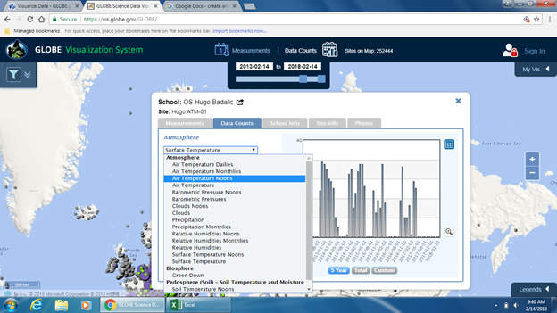
visualization system
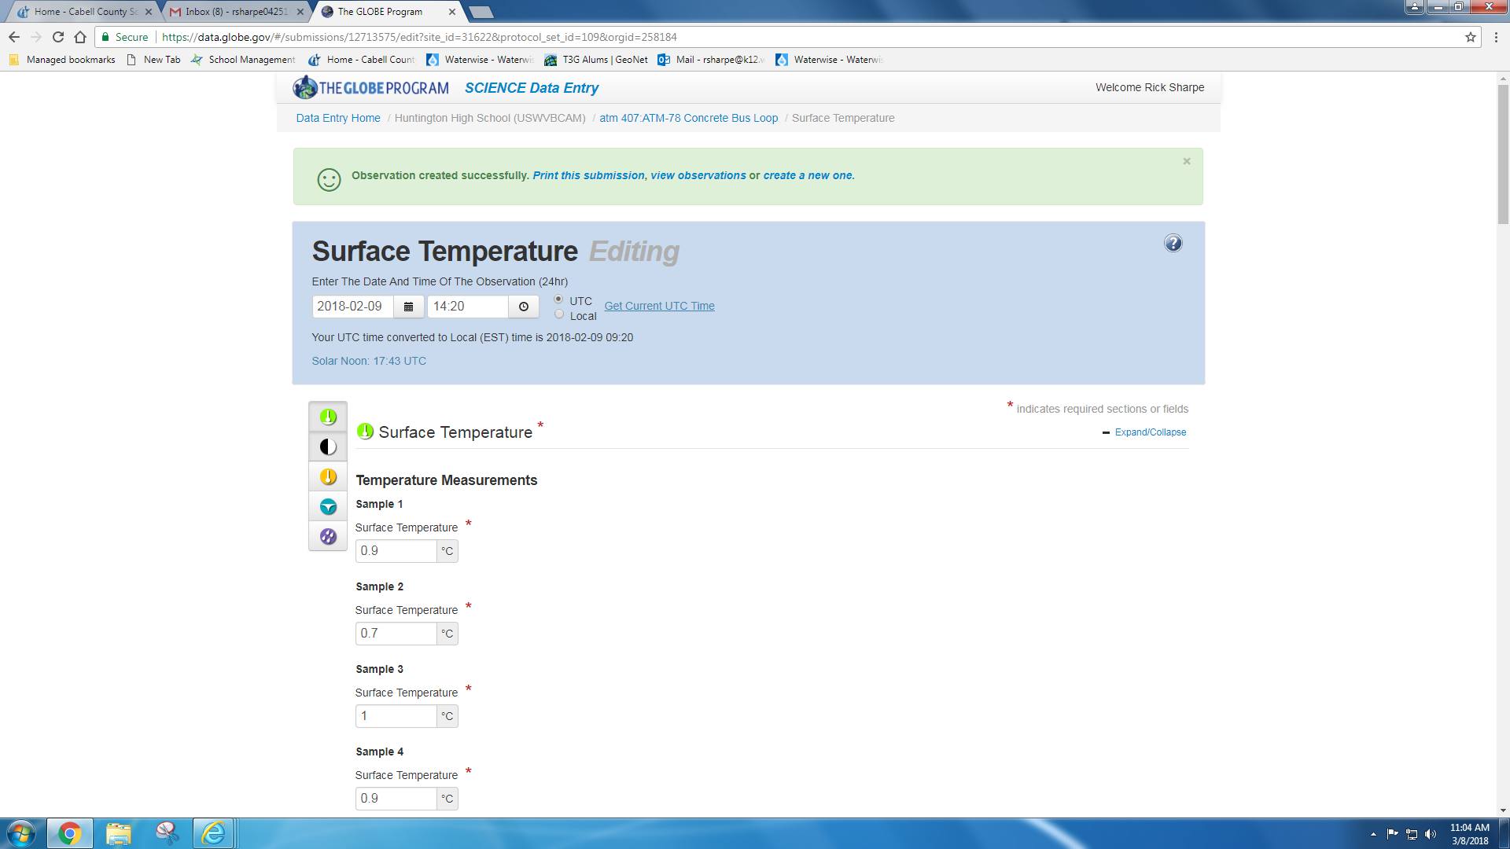
data entry
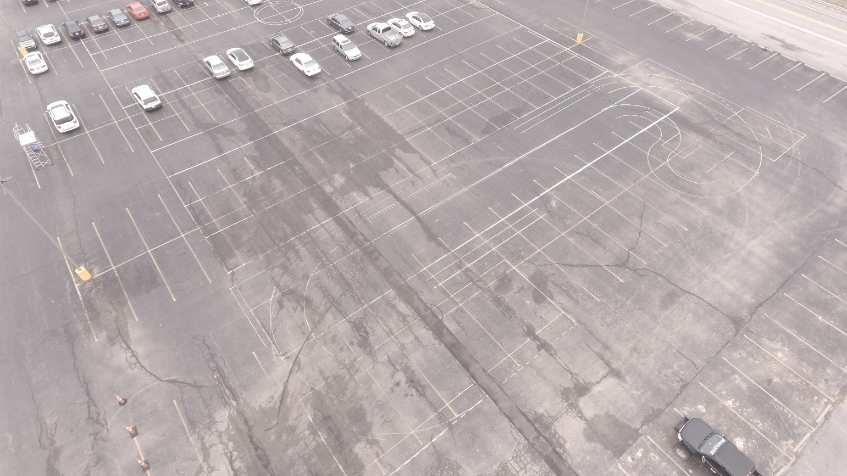

student parking lot

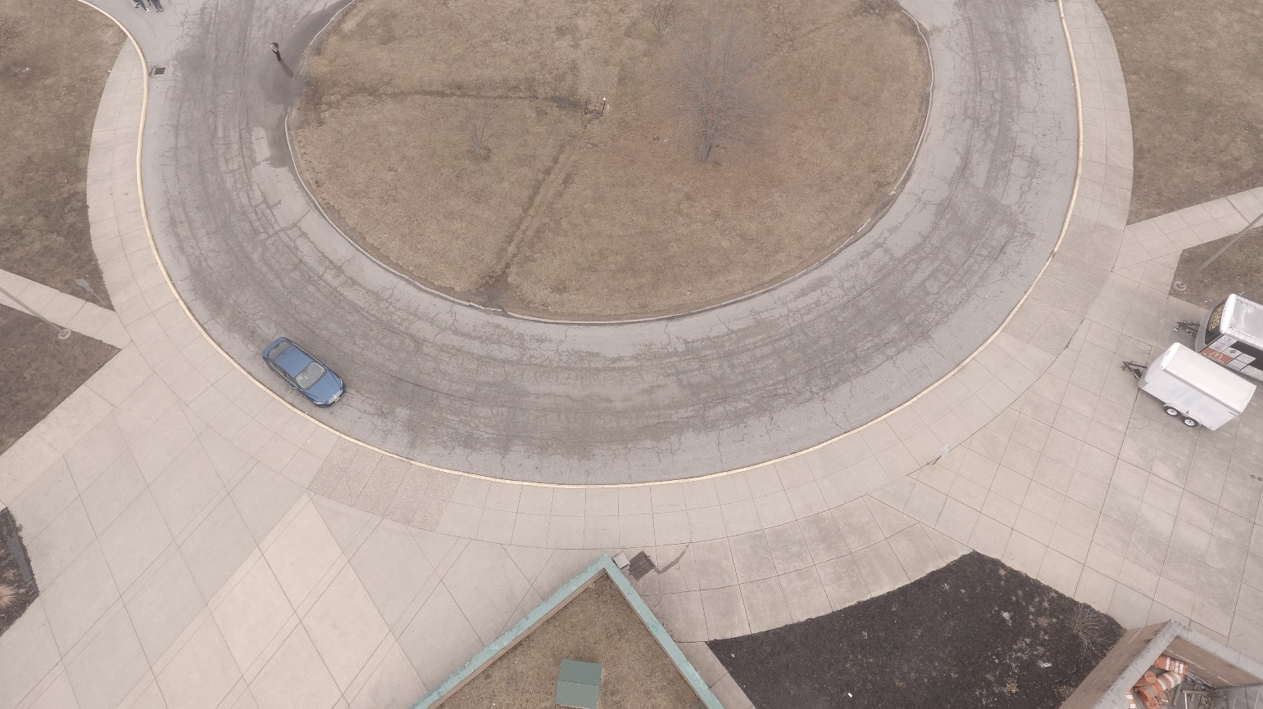

bus loop

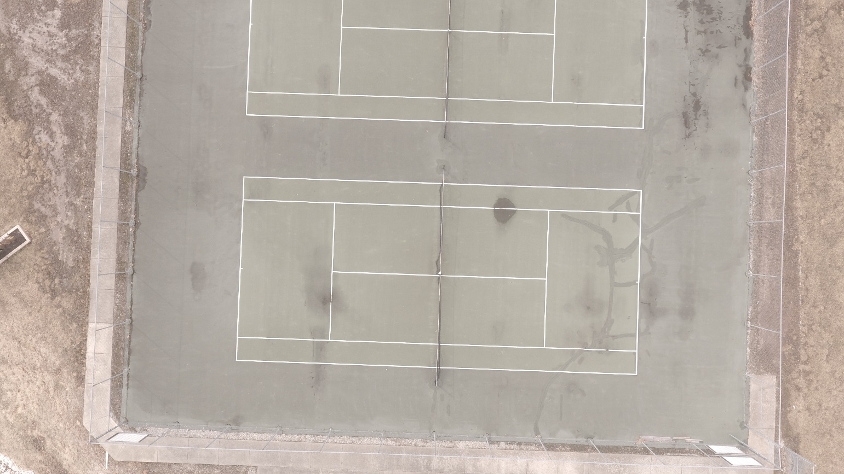

tennis court

practice field
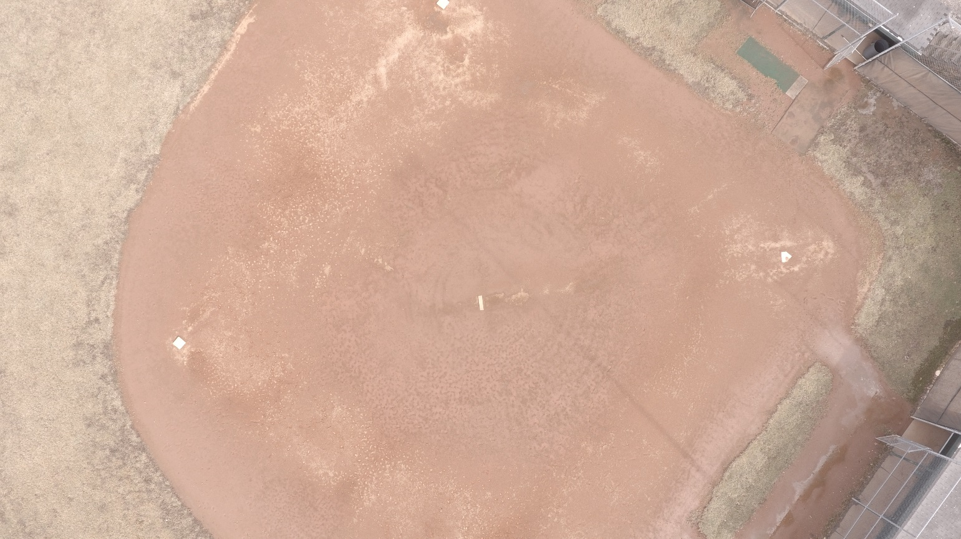
softball field
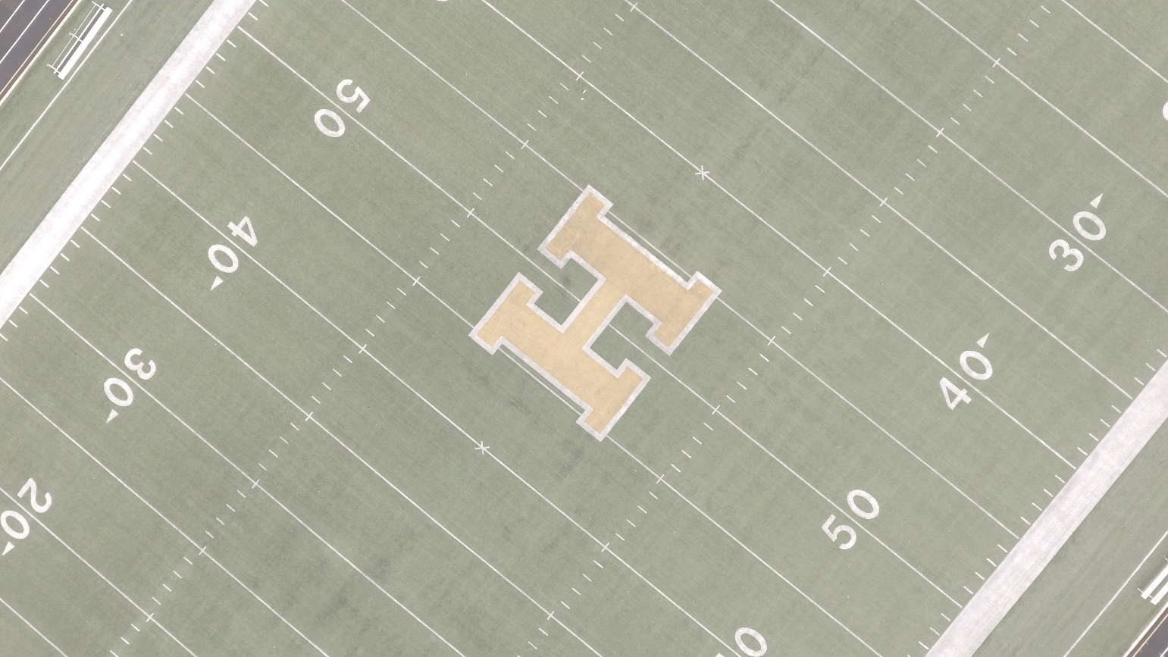
football field

Air Temperature (°C) | Surface Temperature (°C)
7 | 7.8
7 | 8.7
9 | 11.2
11 | 10.2
9 | 8.8
6 | 7.6
6 | 6.8
5 | 6.6
6 | 5.4
6 | 6.2
9 | 5.4
9 | 7.9
11 | 4.8
8 | 10.4
11 | 11.8
6 | 10.6
8 | 7.4
11 | 8
13 | 5.4
14 | 5.6

Barometric Pressure (mb) | Surface Temperature (°C)
1024 | 7.8
1021 | 8.7
1019 | 11.2
1019 | 10.2
1014 | 8.8
1025 | 7.6
1027 | 6.8
1028 | 6.6
1026 | 5.4
1025 | 6.2
1023 | 5.4
1027 | 7.9
1025 | 4.8
1004 | 10.4
1019 | 11.8
1016 | 10.6
1018 | 7.4
1002 | 8
1001 | 5.4
995 | 5.6

Relative Humidity (%) | Surface Temperature (°C)
78 | 7.8
94 | 8.7
71 | 11.2
86 | 10.2
91 | 8.8
95 | 7.6
96 | 6.8
96 | 6.6
96 | 5.4
94 | 6.2
84 | 5.4
94 | 7.9
82 | 4.8
65 | 10.4
88 | 11.8
89 | 10.6
85 | 7.4
88 | 8
88 | 5.4
87 | 5.6

Cloud Cover (%) | Surface Temperature (°C)
37 | 7.8
17 | 8.7
17 | 11.2
100 | 10.2
100 | 8.8
70 | 7.6
100 | 6.8
0 | 6.6
0 | 5.4
0 | 6.2
37 | 5.4
100 | 7.9
0 | 4.8
100 | 10.4
100 | 11.8
100 | 10.6
70 | 7.4
100 | 8
70 | 5.4
70 | 5.6

Discussion:
The relationship between air temperature and surface temperature is nearly non-existent, with a correlation of -0.04978. There is also no relationship between barometric pressure and surface temperature, since the correlation is -0.07582. The same situation occurs with the relationship between relative humidity and surface temperature, since it only has a correlation of -0.37473. Cloud cover, however, actually has a moderate relationship with surface temperature, due to the correlation of 0.476207. It’s safe to say that air temperature, barometric pressure, and relative humidity has no effect on surface temperature, therefore it has no effect on the Urban Heat Island Effect.
There are a few things that could have caused errors, though. For example, the IRT’s used could have been 1° or 2° off. Another thing that could cause error would be the lack of consecutive observation days. During the project, there were several days were the team could not go take temperatures and measurements due to heavy snowfall. Also, using the human eye to estimate cloud cover is full of room for error. Cloud cover is measured in a range, that the human eye cannot be exact on.

Citations:
- Long, Y., & Liu, L. (2017, February 14). How green are the streets? An analysis for central areas of Chinese cities using Tencent Street View. Retrieved March 07, 2018, from http://journals.plos.org/plosone/article?id=10.1371%2Fjournal.pone.0171110#sec018

