Research Report:
Hot water exotics
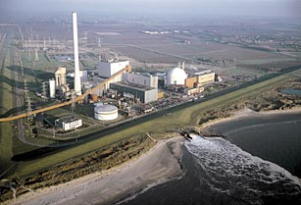

Are there hot water exotics present near the exhaust pipes of the nuclear power plant of Borssele ? And if so, which ones ?

Participating students:
Simone de Jonge
Lian Storm
Randy Germing
Merel Zuijdweg

School:
Pontes het Goese Lyceum in Goes, location Oranjeweg
Grade level:
High school (10)
Submission date:
15th of May 2016

Abstract
The aim of this study is to examine whether there are hot water exotics present at the exhaust pipes of the nuclear power plant in Borssele. The animals found on the structures at the exhaust pipes and on the structures at the checkpoint are compared. GLOBE protocols were used to study the temperature and the Ph-value of the water at the exhaust pipes and the checkpoint. We worked on this project since the beginning of January till halfway of May. Our conclusion is that our hypothesis cannot be verified. We can conclude this because we do not have results. This could be because of various reasons, which we included in our analysis and results in our report.
Table of Contents
Research questions and Hypothesis 4
Materials and Method 5
Measuring the temperature of the sea water: 5
Measuring the PH value of the water: 5
Data Summary 6
Analysis and Results……………………………………………………………………. .8
Conclusions 9
Sub-question 1, What are hot-water exotics?
Sub-question 2, How did Hot water exotics come there, if they are present?..........9
Sub-question 3, Which structures can we design? 9
Sub-question 4, What materials can we use for our structures? 10
Sub-question 5, Which materials are overgrown the most? 10
Sub-question 6, Design a structure: 10
Sub-question 7, What does already live in the Westerschelde? 11
Sub-question 8, Where will we place the structures? 18
Sub-question 9, How can we make sure the structures do not wash away? 19
Sub-question 10, How can we easily find the structures back and make sure
nobody touches them? 19
Sub-question 11, How many metres from the land should we place the structures? 19
Sub-question 12, How many degrees warmer is the water near the exhaust pipes in comparison to the second place? And what’s the difference in PH-value? 19
Answer to our main question. 19
Discussion 20
Acknowledgements 21
References/Bibliography 22

Research questions and Hypothesis
Our research question is: Are there hot water exotics present near the exhaust pipes of the nuclear power plant of Borssele? And if so, which ones? We came to this research question when our client, Inez Flameling, brought up this idea. She is a marine biologist who has heard stories of men finding exotics near the exhaust pipes and she would like us to find out if these stories are true.
The importance of the research in a greater context is quite clear. There are people from all over the world who are going to do the same kind of research. Those people work for NIOZ, the Royal Netherlands Institute for Sea Research. NIOZ conducts worldwide fundamental and frontier-applied scientific research on important processes in delta areas, coastal seas and oceans. NIOZ is creating artificial reefs at different spots in the water and they are researching what grows on it. We are doing the same thing so our outcomes will be part of a bigger, global, research.
Our hypothesis is that we are not going to find any hot water exotics near the exhaust pipes of the nuclear power plant of Borssele. The time that we have to do this experiment is too short. We think that the water flow is very strong so the hot water exotics cannot grow that fast. Together with the limited amount of time that we are given, we think we cannot find any hot water exotics in the Westerschelde.
Before we could answer our research question, we made up some sub-question to help us understand the research question better which automatically results in a more sufficient way of doing research.

- Sub-question 1, What are hot water exotics?
- Sub-question 2, How did the hot water exotics come there, if they are
present?
- Sub-question 3, Which structures can we design?
- Sub-question 4, What materials can we use for our structures?
- Sub-question 5, Which materials are overgrown the most?
- Sub-question 6, Design a structure.
- Sub-question 7, Which animals do already live in the Westerschelde?
- Sub-question 8, Where will we place the structures?
- Sub-question 9, How can we make sure that the structures do not wash
away?
- Sub-question 10, How can we easily find the structures back?
- Sub-question 11, How many metres from the land should the structures
be?
- Sub-question 12, How many degrees warmer is the water near
the exhaust pipes in comparison to the second place? And what’s the
difference in PH-value?

Materials and Method
We used different materials and procedures to measure the temperature of the Seawater and the PH-value of the sea water. In this part we will explain how to measure both of them.

Measuring the temperature of the sea water
To measure the temperature of the water you need a special thermometer that can handle salt water and won’t break. When you have such a thermometer you need to take the measurements. First you put the thermometer in the water and keep it there for 3 minutes. Than you have to put it back in the water for another minute and check if you get the same temperature as the first measurement. If not put it back for another minute. Important Is that you do 2 measurements after each other and if they differ continue till you have a steady temperature. Don’t throw the thermometer in the water because their might be small rocks that may damage or even break the thermometer. This method of measuring temperature comes from Globe water protocol B4.

Measuring the PH value of the water.

To measure the PH-value of the water you need a box of PH measuring strips with materials on it that react different and get different colors when putting it in fluids with different PH-values. On the box of the PH-strips there is a set of colors for all different PH values. When you have the PH strips you need to take the measurements. First put 1 PH-strip in the water and hold it there for about a minute and check with the sets of colors on the box which PH-value the water has. Important is to compare the colors carefully with the ones on the box and when you are not sure take another strip because not all strips are perfect. This method of measuring the PH-value comes from Globe Water Protocol B7b.

Data Summary
Table 1:
 | Week 1 | Week 2 | Week 3 | Week 4 | Week 5 | Week 6 | Week 7
Exhaust pipes | 17 °C | 14 °C | 16 °C | 18 °C | 17 °C | 16 °C | 18 °C
Checkpoint | 7 °C | 7 °C | 11 °C | 10 °C | 10 °C | 10 °C | 10 °C
Table of the temperature of the water near the exhaust pipes of the nuclear power plant and the temperature of the water from the checkpoint.
Table 2:
 | Week 1 | Week 2 | Week 3 | Week 4 | Week 5 | Week 6 | Week 7
Exhaust pipes | 6 | 6 | 7 | 7 | 7 | 7 | 7
Checkpoint | 6 | 6 | 7 | 7 | 7 | 7 | 7
Table of the PH-value of the water near the exhaust pipes of the nuclear power plant and the temperature of the water from the checkpoint.

Graph 1:

Graph of the temperature of the water near the exhaust pipes of the nuclear power plant and the temperature of the water from the checkpoint.
The temperature difference between the two spots is pretty big, as you can see in the table and graph. The average difference of the water temperature is 7,3 °C. This was not unexpected because of the large amount of hot water coming out of the exhaust pipes from the power plant.

Graph 2:

Graph of the PH-value of the water near the exhaust pipes of the nuclear power plant and the temperature of the water from the checkpoint.
The PH-value is not constant. It starts with a value of 6 which is a bit acidity. Later on the PH-value changes into a value of 7 which is basic. The cause of this change is unclear to us. We think it could be false measurements but it could also be a external factor that influencing the is PH-value, for instance, rain or the direction of the wind.

Analysis and Results
Unfortunately we have got no end results. Our structures have moved and do not lay in the water anymore. This could be because of a couple of reasons:
- Vandalism
- The police or EPZ maybe removed the structures
- The stream underneath the surface might have been to strong and the structures could have floated away.
- The structures could have been to heavy and be covered under the sand
- Fisherman might have caught the structures and threw it away
- The baskets we put the stones in might have been too weak
- The knots could have been too loose so the structures cannot be found back
- The research on the structures could have been too superficial
We do not know exactly what happened but these are the reasons why it could have gone wrong.
As said before, the temperature difference between the two spots is pretty big. The average difference of the water temperature is 7,3 °C. This was not unexpected because of the large amount of hot water coming out of the exhaust pipes from the power plant.
The PH-value is not constant. It starts with a value of 6 which is a bit acidity. Later on the PH-value changes into a value of 7 which is basic. The cause of this change is unclear to us. We think it could be false measurements but it could also be a external factor that is influencing the PH-value, for instance, the weather or wind direction.

Conclusions
Sub-question 1, What are hot-water exotics?
Exotics species means a plant or animal species introduced into an area where they do not occur naturally. It is a species living outside its native distributional range, which has arrived there by human movement, it can be on purpose or accidental. Other words for an exotic species are: An introduced, alien, non-indigenous, or non-native species.
Hot water-exotics are introduces species, which normally occur in hot water and since we don’t have hot water in the Netherlands (in the Westerschelde it's about 7 degrees Celsius), it is obvious that they are not from here but from other waters. Near the exhaust pipes of the nuclear power plant in Borssele, the water is hotter than the regular 7 degrees Celsius because heated water comes out of those pipes. In conclusion, what we are searching for are species that normally do not occur in the cold water of the Netherlands but do occur near the exhaust pipes of the Westerschelde where the water is hotter than the regular water temperature in the Netherlands.

Sub-question 2, How did Hot water exotics come there, if they are present?
Hot water exotics in the Westerschelde are introduced species. A species will be considered introduced when its transport into an area outside of its native range is human mediated. Introduced species can be transported accidentally or intentional.
An example of how species are introduced accidentally is on ships that sail from their native range to another destination like Europe. The organisms hold on to the bottom of the ship and release themselves somewhere outside their native range.
An example of how species are introduced intentionally is when people think the species will live in a beneficial way to humans they get some organisms from their native range, bring them home and release them.

Sub-question 3, Which structures can we design?
As structures we can use artificial reefs. These are manmade structures that may mimic some of the characteristics of a natural reefs.
Artificial reefs are made with several designs.
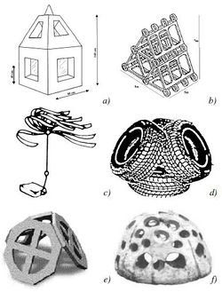
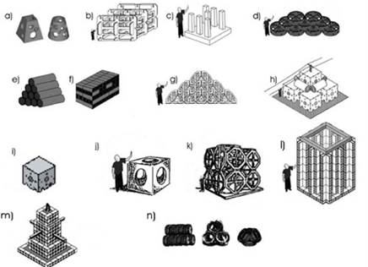

Sub-question 4, What materials can we use for our structures?
Artificial reefs can be built in several ways. Many reefs are built up by using existing materials. For instance, this can be done by sinking oil rigs (through the Rigs-to-Reefs program), scuttling ships (such as the USS Oriskany), or by deploying rubble, tires, or construction debris. Other artificial reefs that are built are for instance made of ASR or reef balls or from PVC and/or concrete. Beneath, we have a table about types of materials used for artificial reef construction.

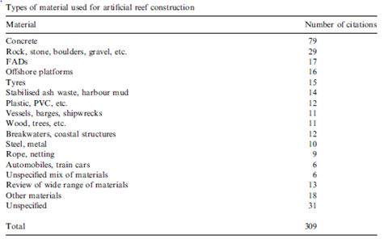

Sub-question 5, Which materials are overgrown the most?
On the internet was no information about which material is overgrown the most. But because concrete is used the most, we think this material is overgrown the most out of all materials.

Sub-question 6, Design a structure:
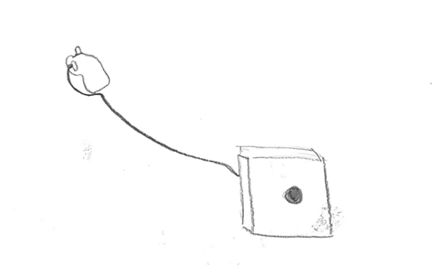
Our structures are as followed:

The material of these structures is concrete and the basked is made of goat netting. We chose these materials and structures because a lot of things will probably grow on them and the structures we designed were relatively easy to make.

Sub-question 7, What does already live in the Westerschelde?
Sponges:
Pale peaks sponge
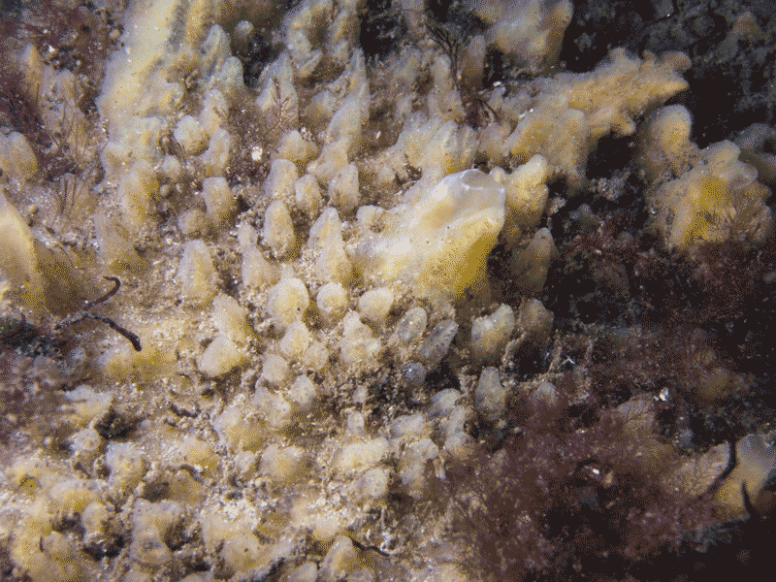
Yellow vein sponge
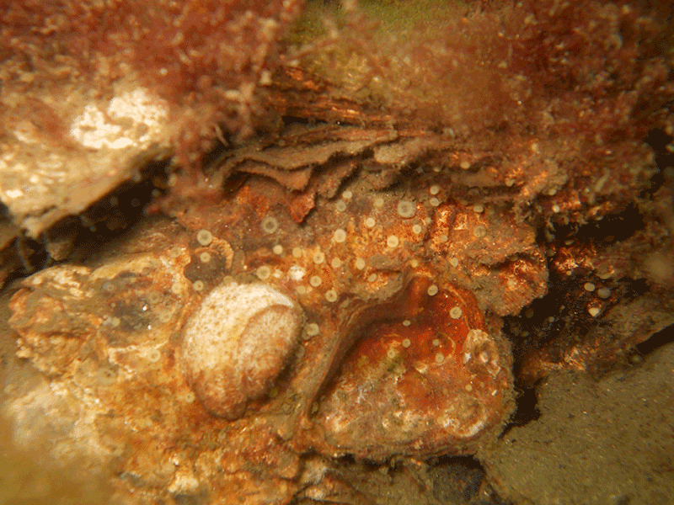
Yellow wart sponge
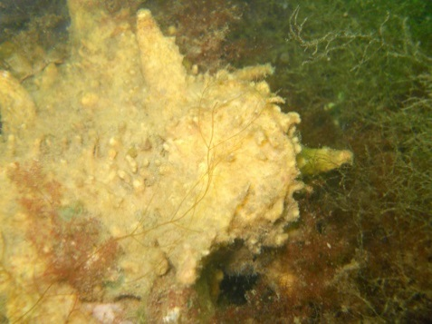
Antler sponge
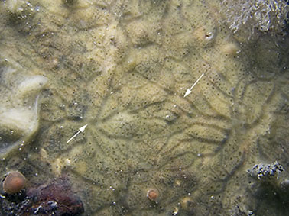

Lobjes sponge
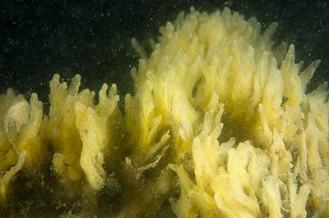
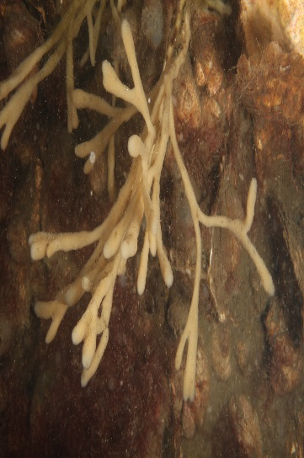
Purple tubes sponge

Soft sponge balls
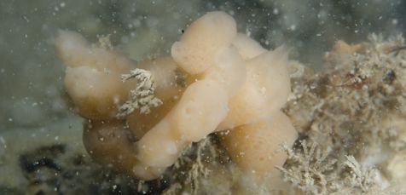

tubes sponge
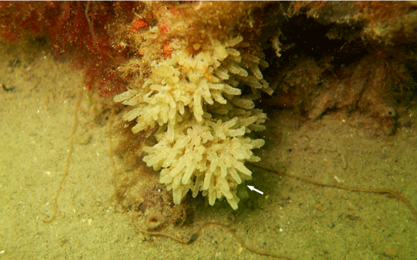

Phylum cnidarian:
Breakwater Anemone
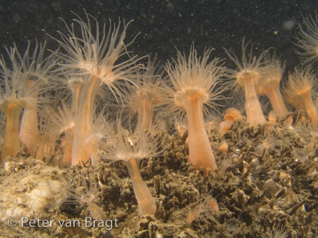
Gargle pipe polyp
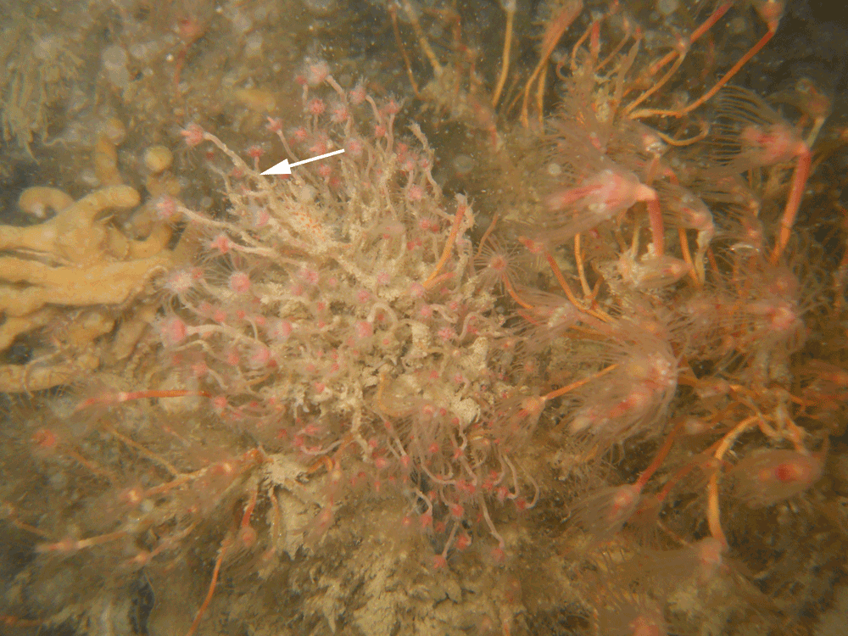
Clapper Bell
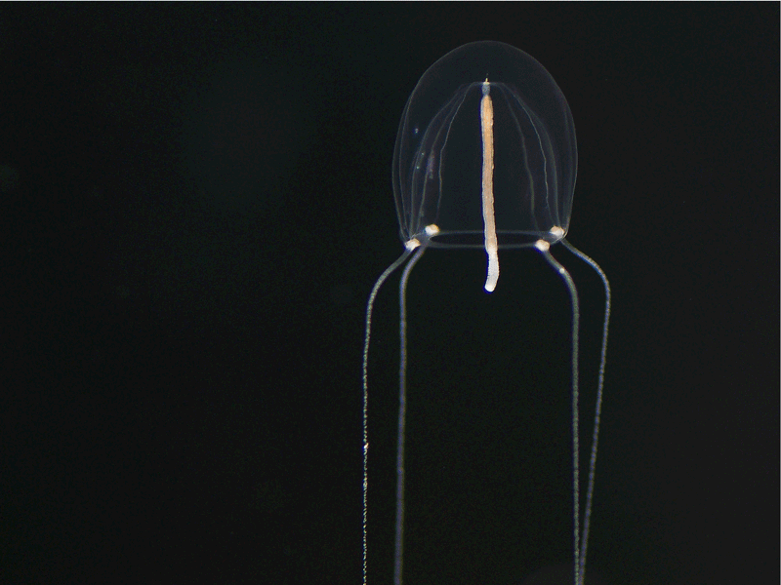
Kruiskopkwalletje
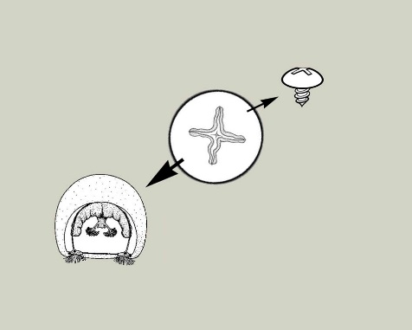

Long seathreat
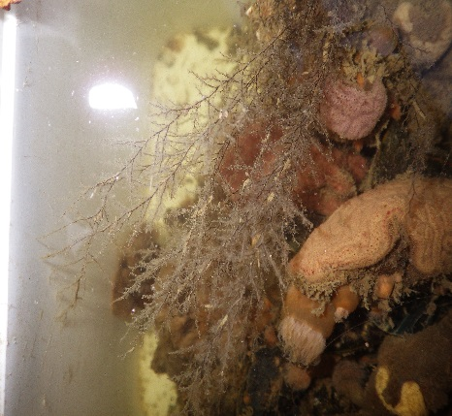
Sea tree
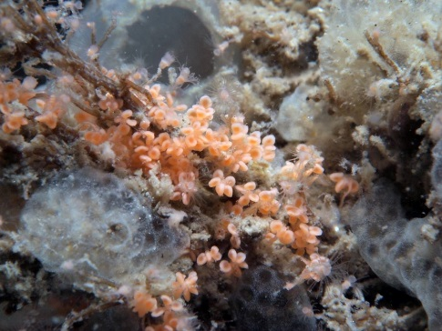
Fresh water jelly fish
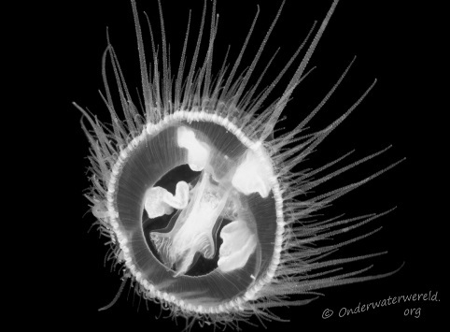
Mollusks:
Brown fold snail
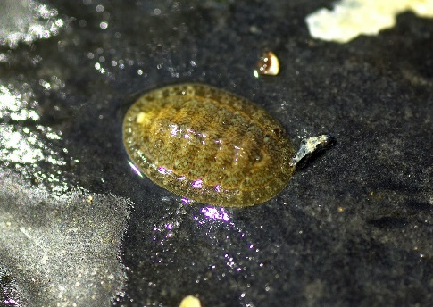

Japanese Spine Bugel
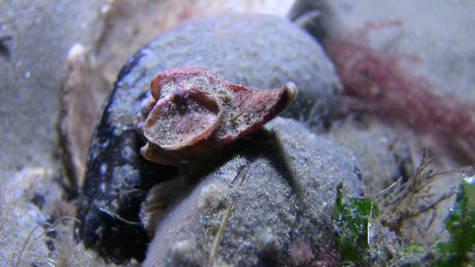
Jenkins water bugel
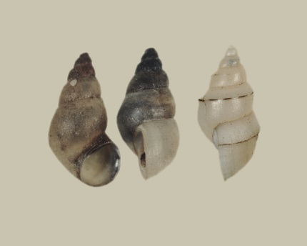
Small Astarte
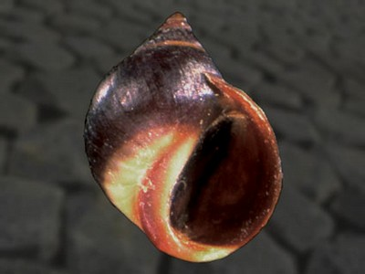
Brush Worms :
Velvet sea mouse
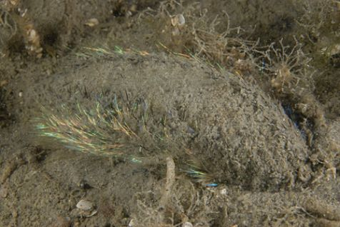
Gladschubbige zeerups
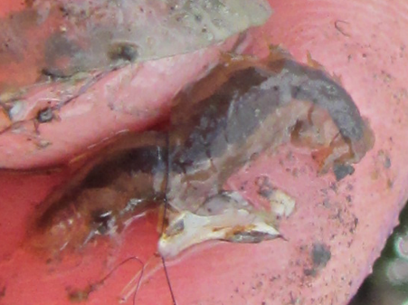
Green bladkieuwworm
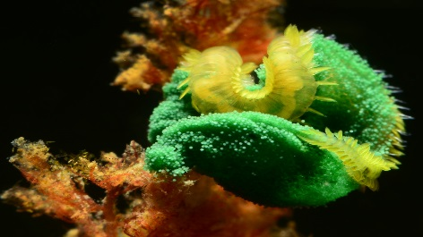
Fan tube worm
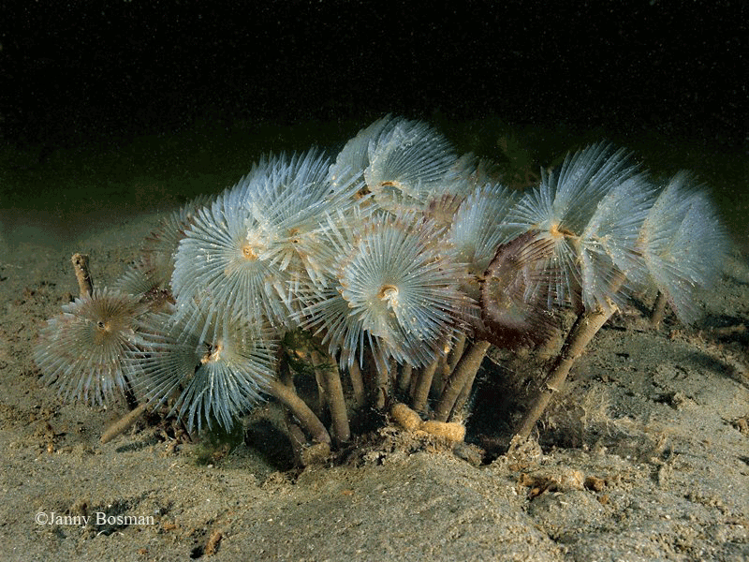
Lug
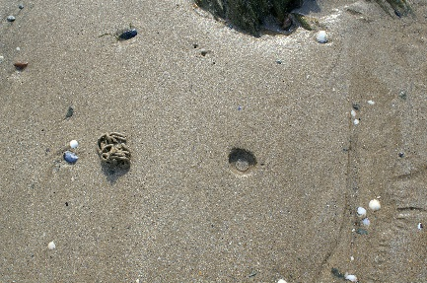
Crabs :
Velvet swimming crab
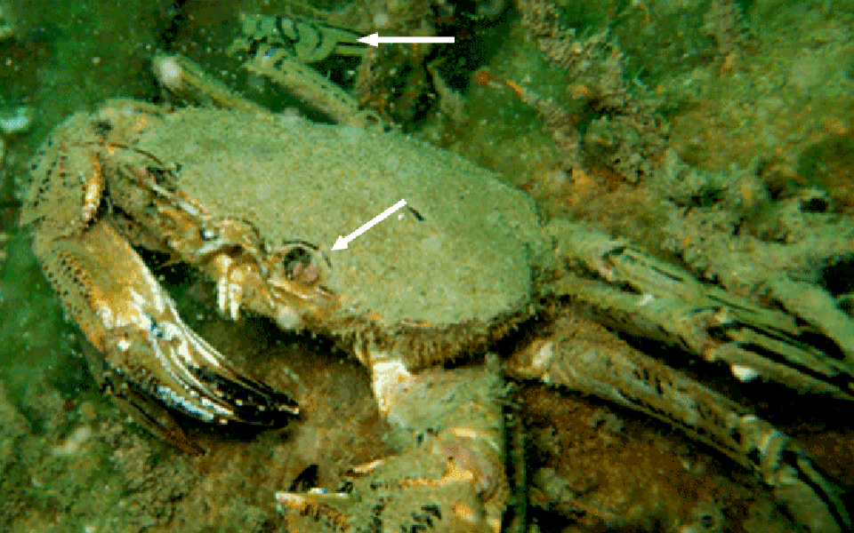
Hairy porcelain crab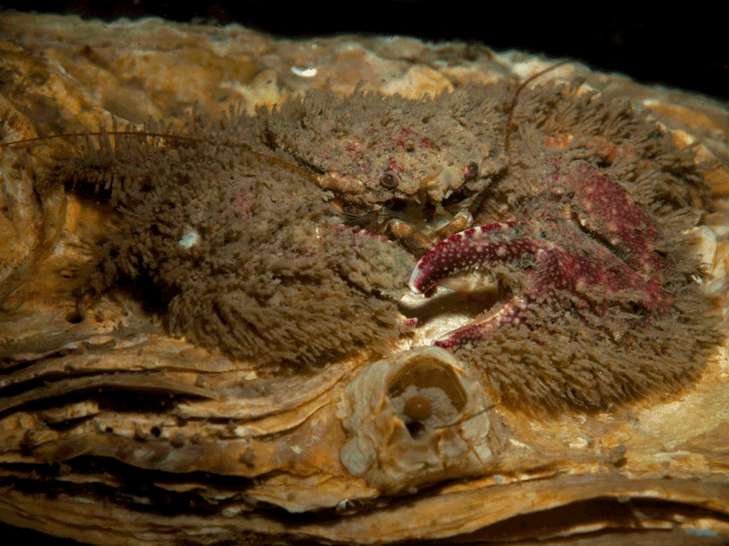

Small hay wagon crab
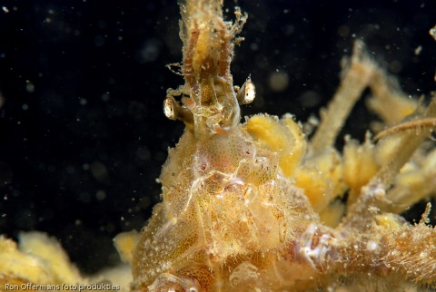

Paintbrush crab
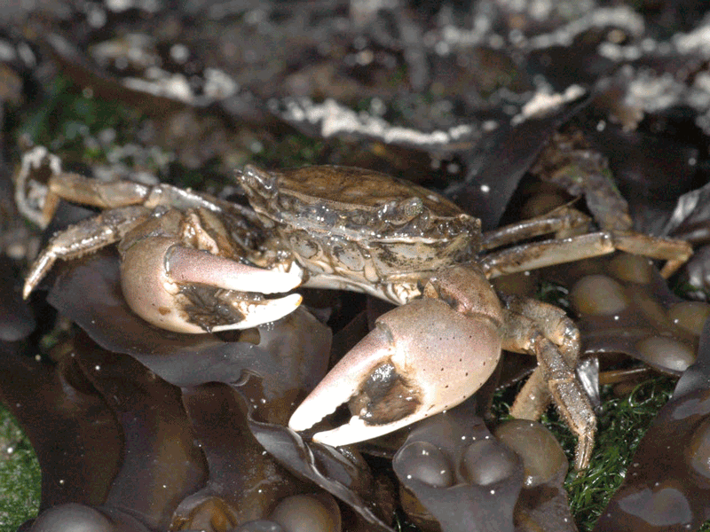
Lobsters :
European sea lobster
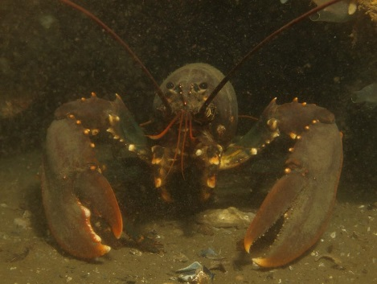
Mottled American crayfish
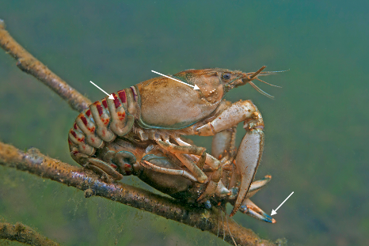

Hairy ghost lobster
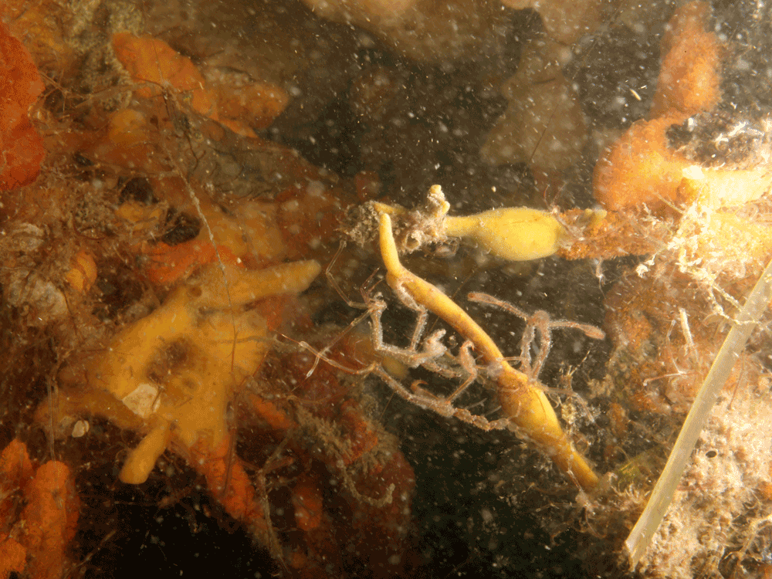
Shrimps :
Brackish Water Prawn
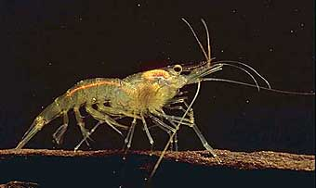

Moss animals :
Bryozoans
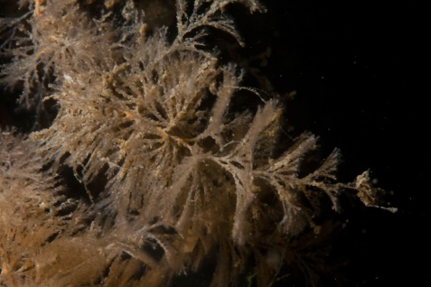
Spiral Moss animals
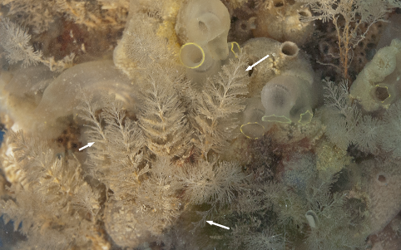

Echinoderms :
Brittle star
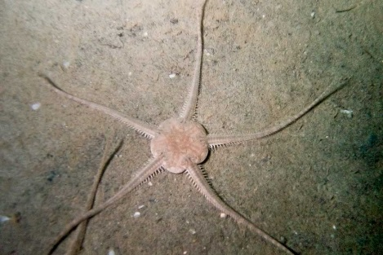

Starfish
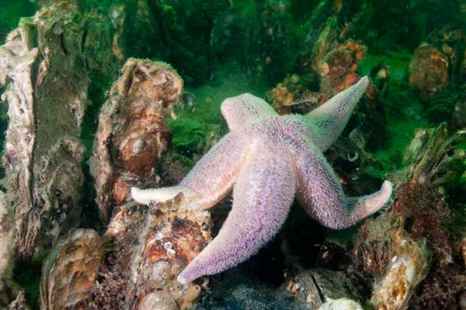
Sea squid :
Chilean sea squid
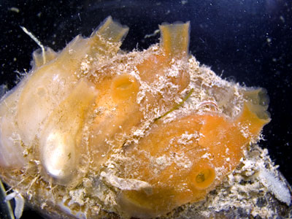
Garland sea squid
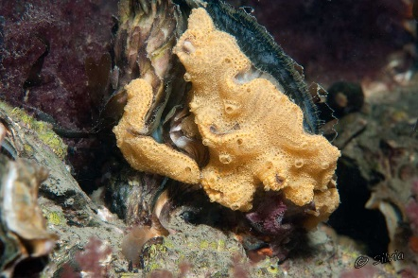

Fish :
Poor cod
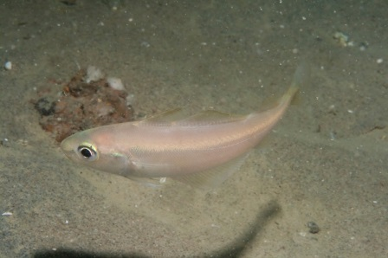
Spined loach
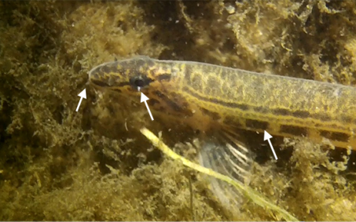
Taurulus bubalis
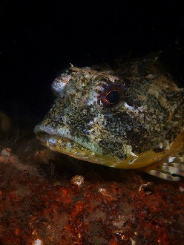
Eelpout
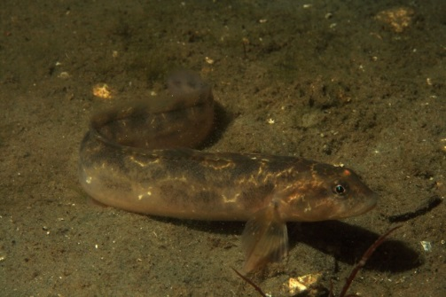
Plaice
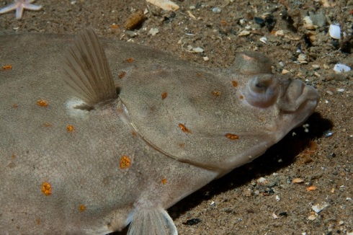
Shorthorn sculpin
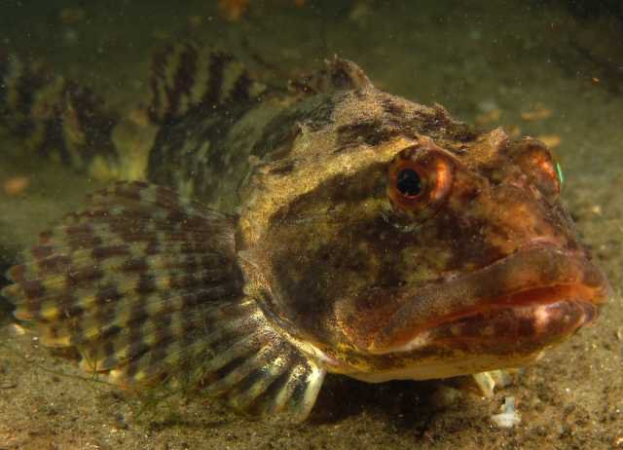
Corkwing wrasse
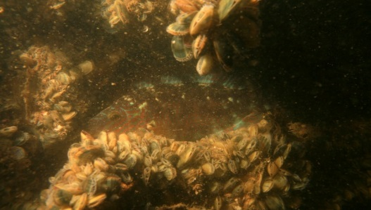
Red algae :
Irish moss
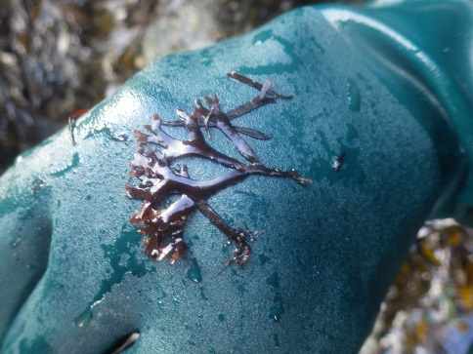
Much branched panicle whose
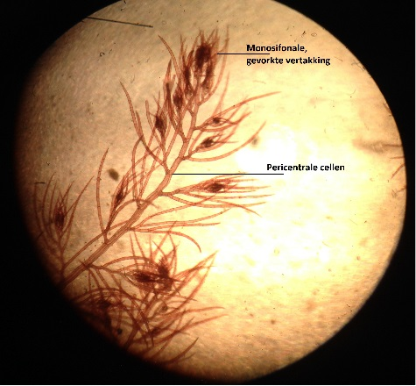

Green algae :
Bowel Weeds
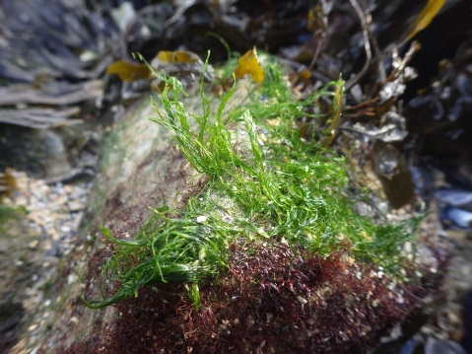
Rock Wier
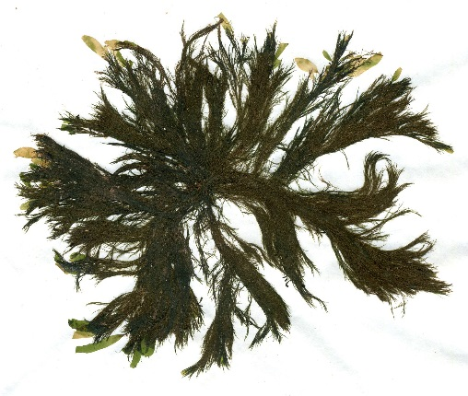
Featherweight Wier
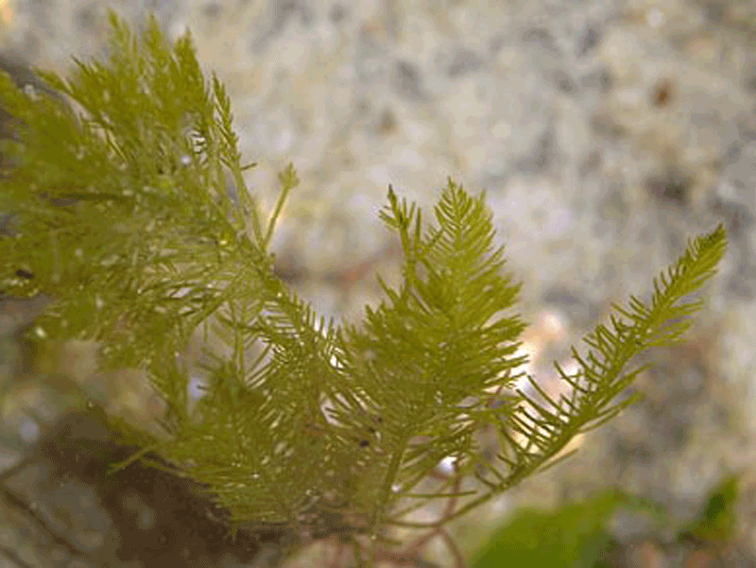
Laver
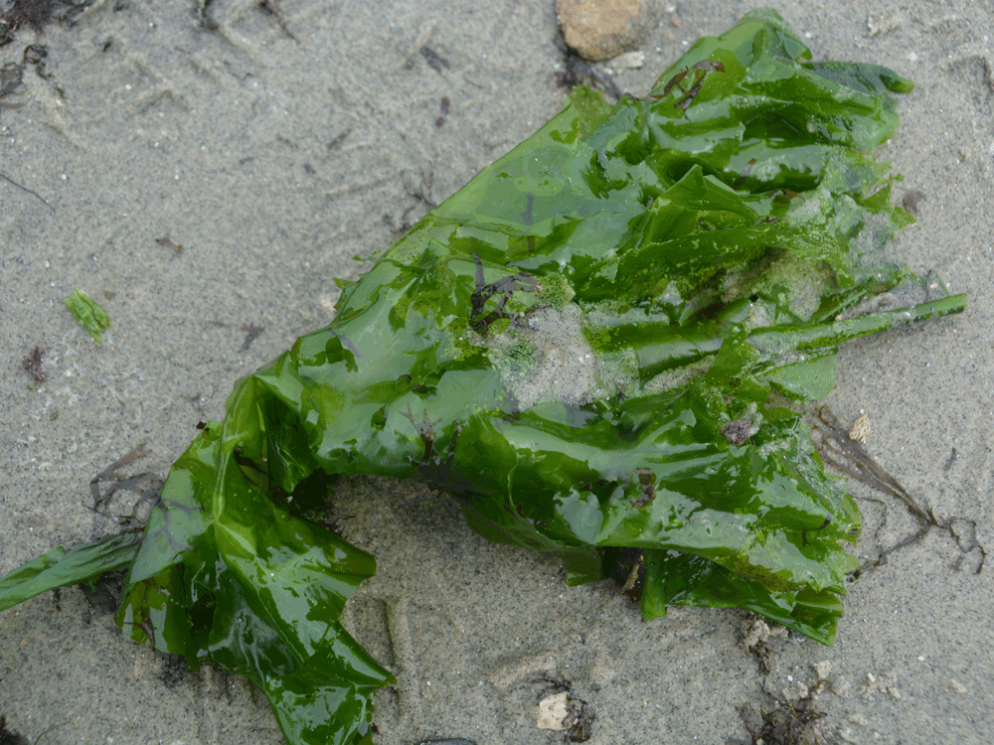

Brown algea :
Wrack
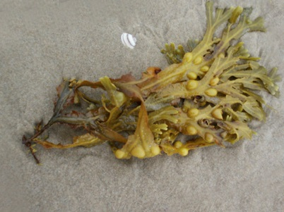
Sea - sawed oak
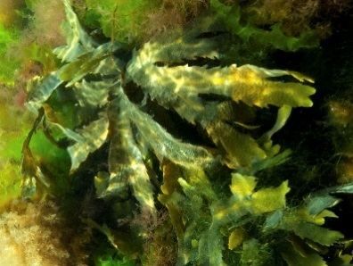

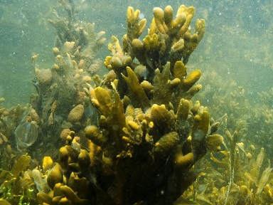
Fucus spiralis

Sub-question 8, Where will we place the structures?
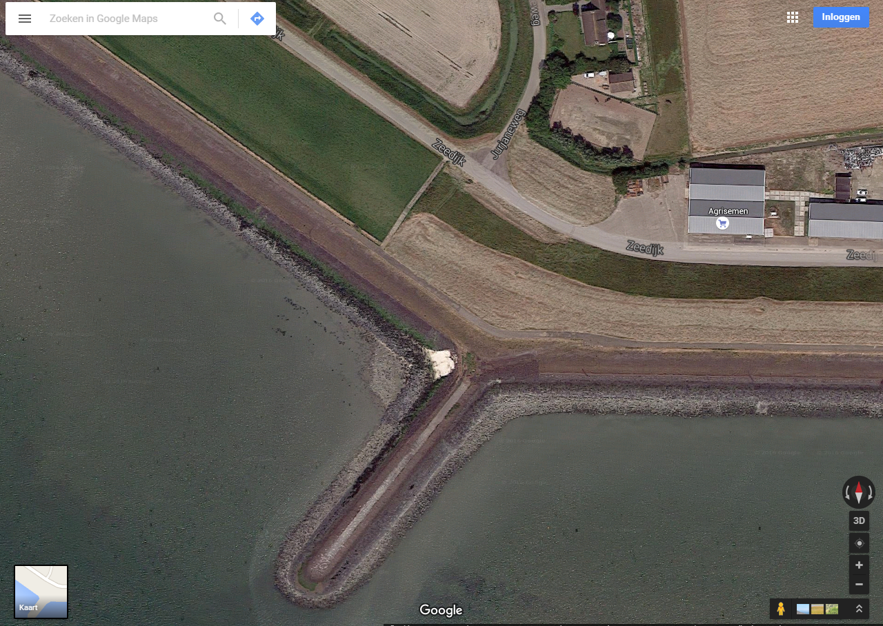
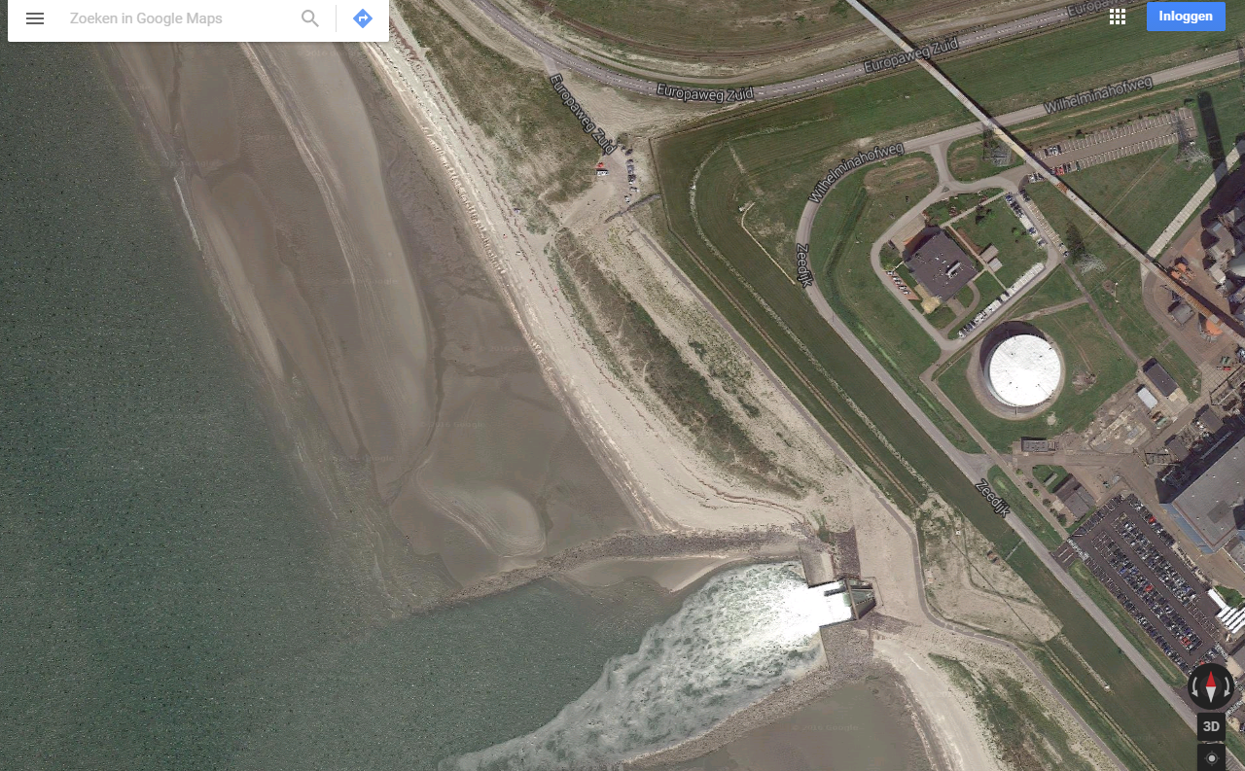

Sub-question 9, How can we make sure the structures do not wash away?
To make sure that the structures do not wash away because of the flow of the water the structures should heavy enough to stay on the ground. If the structures are not heavy enough they should be made heavy by a weight attached to the bottom. It is also possible to attach the structures to a landing- stage for certainty.

Sub-question 10, How can we easily find the structures back and make sure nobody touches them?
When we place our structures in the sea, we have to make sure we don’t lose them. A solution for this is to firmly knot a rope to the structure with a buoy tied to the end. The buoy will float on the water and we can follow the rope back to the structure under water. To make sure that nobody touches the structures while we are gone, we will write on the buoy that nobody may touch it because it is an biological experiment. We could also place a pale with the message near the structures but on the land.

Sub-question 11, How many metres from the land should we place the structures?
The structures should be completely under the water and on the bottom of the Westerschelde. We should be able to properly get the structures out without being too far in the water so the structures may not be too far away from the land. When we go to the pipes, we will have a clear overview of the situation and we can determine where to place the structures.

Sub-question 12, How many degrees warmer is the water near the exhaust pipes in comparison to the second place? And what’s the difference in PH-value?
See our chapter data summary.

Answer to our main question
Our conclusion is that our hypothesis cannot be verified. We can conclude this because we do not have results. This could be because of various reasons, which we included in our analysis and results in our report.
Discussion
For this project there are lots of improvements to be made in how the structures can be sealed on their place and how we can make sure they stay there for a few months. We should have had more contact with the EPZ and the police guarding the Nuclear Power plant so they knew what we were going to do and they can keep an eye on the structures when are not there. We also could have sealed the structures to the bottom at different places, place more structures and make more control posts.
The result of this project would have been shared to organizations that are doing research on how different sea organisms grow on different materials and the rate at which they grow. We also used an bio plastic structure from NIOZ in Yerseke designed to grow muscles on and we would have shared with them if muscles and other organisms grow on that structure. The measurements of temperature and PH value will be shared with the Globe Database.
This project will probably be done again next year by different students that will try to do this project with the recommendations in this report.

Acknowledgements
We would like to thank Mrs. Inez Flameling for giving us this assignment and for her help with placing the structures and doing research. We would also like to thank the research institute NIOZ (Royal Netherlands Institute for Sea Research) for providing our their structures. Furthermore we would like to thank Ms. Remijnse for the workshop she gave about contact with a client through different ways. Also we would like to thank our teachers from Technasium and the TTO department, Ms. Robyn, Mr. Groot and Ms. Pserhof, for guiding us through this project. Lastly, we would like to thank our fellow students for helping us with designing our poster, creating our stand, making our video and doing some of the measurements.

References/Bibliography
Wikipedia Free Encycolpedia. (2016). Introduced species. Retrieved 19 January, 2016, from https://en.wikipedia.org/wiki/Introduced_species
National geographic. (2015). Invasive species. Retrieved 19 January, 2016, from http://education.nationalgeographic.org/encyclopedia/invasive-species/
Hoovedesigns. (2016). Types of Wood. Retrieved 19 January, 2016, from http://www.hoovedesigns.com/woods.html
Sciencedaily. (2016). Artificial Reefs. Retrieved 2 February, 2016, from http://www.sciencedaily.com/terms/artificial_reef.htm
Anemoon. (2016). Flora and Fauna in the Westerschelde. Retrieved 2 February, 2016, from http://www.anemoon.org/flora-en-fauna/gebieden/id/623/westerschelde
Google maps. (2016). Nuclear Power Plant. Retrieved 19 January, 2016, from https://www.google.nl/maps/place/N.V.EPZ/@51.4324962,3.7151996,877m/data=!3m1!1e3!4m2!3m1!1s0x47c4851448da97a1:0x45317a449f471b5e!6m1!1e1
Ons Zeeuwen. (2016). Watertemperatuur in Zeeland . Retrieved February 9, 2016, from http://people.zeelandnet.nl/delooffaj/watertemperatuurzeeland.html
National ocean service. (2016). What is an artificial reef?. Retrieved 15 February, 2016, from http://oceanservice.noaa.gov/facts/artificial-reef.html
R.L. Sherman, D.S. Gilliam, and R.E. Spieler. (2002, no-date). Artificial reef design: void space, complexity, and attractants. Retrieved 15 February 2016, from http://www.artificialreefs.org/ScientificReports/reefball_voids.pdf
Wikipedia Free Encyclopedia. (2016). PH. Retrieved 29 February, 2016, from https://en.wikipedia.org/wiki/PH
Wikipedia Free Encyclopedia. (2010). Flow of the water. Retrieved 29 February, 2016, from https://nl.wikipedia.org/wiki/Stroomsnelheid
Wikipedia Free Encyclopedia. (). Volumetric flow rate. Retrieved 1 March, 2016, from https://en.wikipedia.org/wiki/Volumetric_flow_rate
Baine, M. (2001). Artificial reefs: A review of their design, application, management and performance. Ocean Coastal Management, 44(-), -, 241-259. Retrieved February 29, 2016, from www.elsevier.com/locate/ocecoaman

