Determining the presence of heavy metals in the air by using GLOBE protocols
for aerosols, conductivity and pH
Students:Dino Bešić , Sarah Butigan
Mentor:Marina Pavlić
Prirodoslovna i grafička škola Rijeka,Croatia
1.Abstract
Aerosols are solid or liquid particles or both, suspended in air with diameters between about 0.002 µm to about 100 µm. Aerosol particles vary greatly in size, source and chemical composition. Some of the components are heavy metals, wich can be measured by GLOBE protocols. We used the method of moist sedimentation to aquire a sample of air in Bakar, and then analysed it with GLOBE protocols. We were inspired to use this methods when the citizens of Bakar invited us to see the big black blot in the middle of The Bakar Bay and the black particles in their homes. As we collaborated with them investigating the sea,soil and the bottom of the sea in our previous projects,we determined that the pollution was comming from the air. We decided to investigate the quantity of suspended particles(aerosols) in the air and determine their chemical composition. Analysing the sample's we concluded that the sample with heavy metal's had higher pH and conductivity levels than normal. By tracking the: aerosols, air temperature and rainfall our data showed that the aerosols are highest when temperature and rainfall levels were low. This method's could help more GLOBE reaserchers to study heavy metals in air.

2.Research questions
Bakar is a small marine town situated 16 km from our school,Prirodoslovna i grafička škola,Rijeka, Croatia.
In the summer of 2014. the citizens of Bakar invited us to see the big black blot in the middle of The Bakar Bay and the black particles in their homes.As we collaborated with them investigating the sea,soil and the bottom of the sea in our previous projects,we determined that the pollution was comming from the air.In and around Bakar there is a scattered cargo plant,oil refinery and crude oil power plant.
We decided to investigate the quantity of suspended particles(aerosols) in the air and determine their chemical composition.
The citizens collected the samples near their homes and we used GLOBE protocols and chemical analysis to investigate the problem.
Aerosols are solid or liquid particles or both suspended in air with diameters between about 0.002 µm to about 100 µm. Aerosol particles vary greatly in size, source and chemical composition.
Primary atmospheric aerosols are particulates that emitted directly into the atmosphere ( sea-salt, mineral aerosols (or dust), volcanic dust, smoke and soot, some organics). Secondary atmospheric aerosols are formed in the atmosphere by chemical processes (sulfates, nitrates, some organics).A significant fraction of the atmospheric aerosols is anthropogenic in origin, from human activities.
They have an effect on the energy balance of the atmosphere either by directly scattering and absorbing radiation, by serving as condensation nuclei during cloud formation, and by influencing precipitation. Their presence also affects photosynthesis and agricultural production. These same particles that affect climate also impact the quality of the air that we breathe and the health of all living organisms.
In our work we found out the hightened concentrations of heavy metals and PAHs.
Our work was put on the GLOBE pages in July ,2015. by Ms.Bara Semerakova with whom we are collaborating on other projects.
3.Hypotesis
In one of our past projects we determined that we can predict the heavy metals pollution in the soil by using GLOBE protocols for conductivity and pH.
This autumn we recieved a sun photometer in donation from YLACES.
Using GLOBE protocols for aerosols, conductivity and pH we can predict the heavy metal pollution in the air.

4.Student- led investigation plan
The amount of suspended particles in the air depends on:
- Direction and intensity of the wind
- Air temperature
- Moisture
- Rainfall
- Cloud coverage
- Insolation
- Stability of the troposphere
1.In our past work we determined that the wind scattered aerosols from Oil refinery and Power plant directly to the center of the town(about 8 000 inhabitants)
2.Lower temperatures cause more aerosols in the air because on higher temperatures(summer) the aerosols decompose.
3.If the concentration of liquid particles becomes high enough to affect visibility, it is then called fog. A particular form of fog is smog. Smog forms when natural moisture in the air interacts with human-produced components, such as smoke and other combustion products, to form chemically active materials.
4. Most clouds owe their existence to aerosols that serve as the tiny “seeds,” called cloud condensation nuclei.We think that there would be more rainfall in the regions with more aerosols
5.The sun photometer can not measure when there is more than 45% of cloud coverage.
*NOTE:We measure the air temperature on our site“ Iza škole I:Atm-04“ daily, and enter all data but there are „holes“ in our graphs.We asked the helpdesk to help.We miss other data too.

5.Research metods
GLOBE protocols:
- Aerosols
- Air temperature
- Moisture
- Rainfall
- Conductivity
- pH
We asked for help with Bakar data the State Meteorological institute.
- Location
PICTURE 1
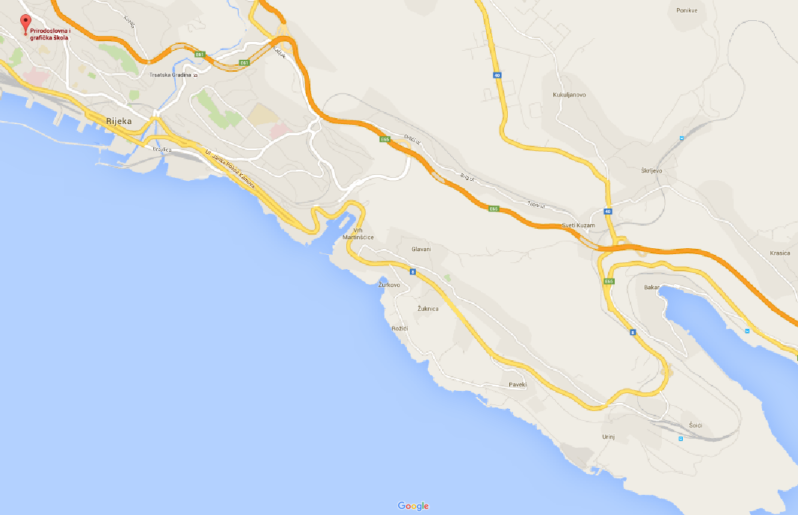
Prirodoslovna i grafička škola
( our school)
Bakar
Measurment locations:Prirodoslovna i grafička škola Rijeka-school and Luka Bakar

We chose the two sites because our last project showed major pollution on Luka site in Bakar and our school as control site
- Time period
We choose the autumn time period because in our next projects we are going to ivestigate the season influence on aerosols. In our first work we investigated in the summer season.
Other measurements:chemical analysis
Because of our hypotesis we need to know the composition of aerosols
6.GLOBE data and data entry
GRAPH 1:Aerosol optical thickness
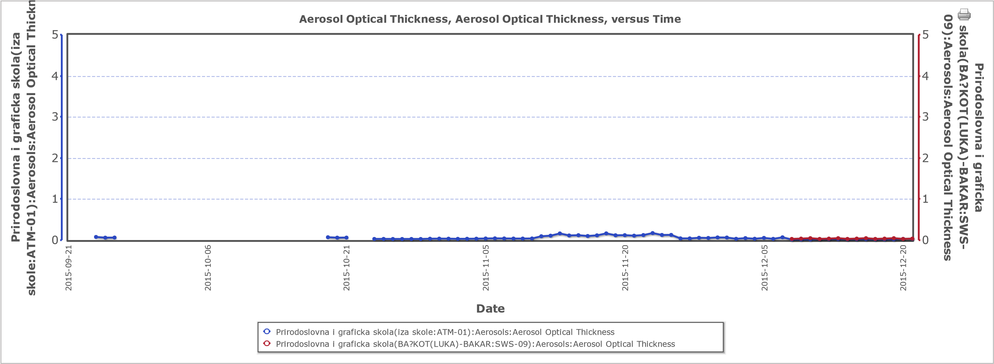
The graph shows aerosol thickness on school and Luka Bakar site

GRAPH 2:Solar noon temperatures daily school
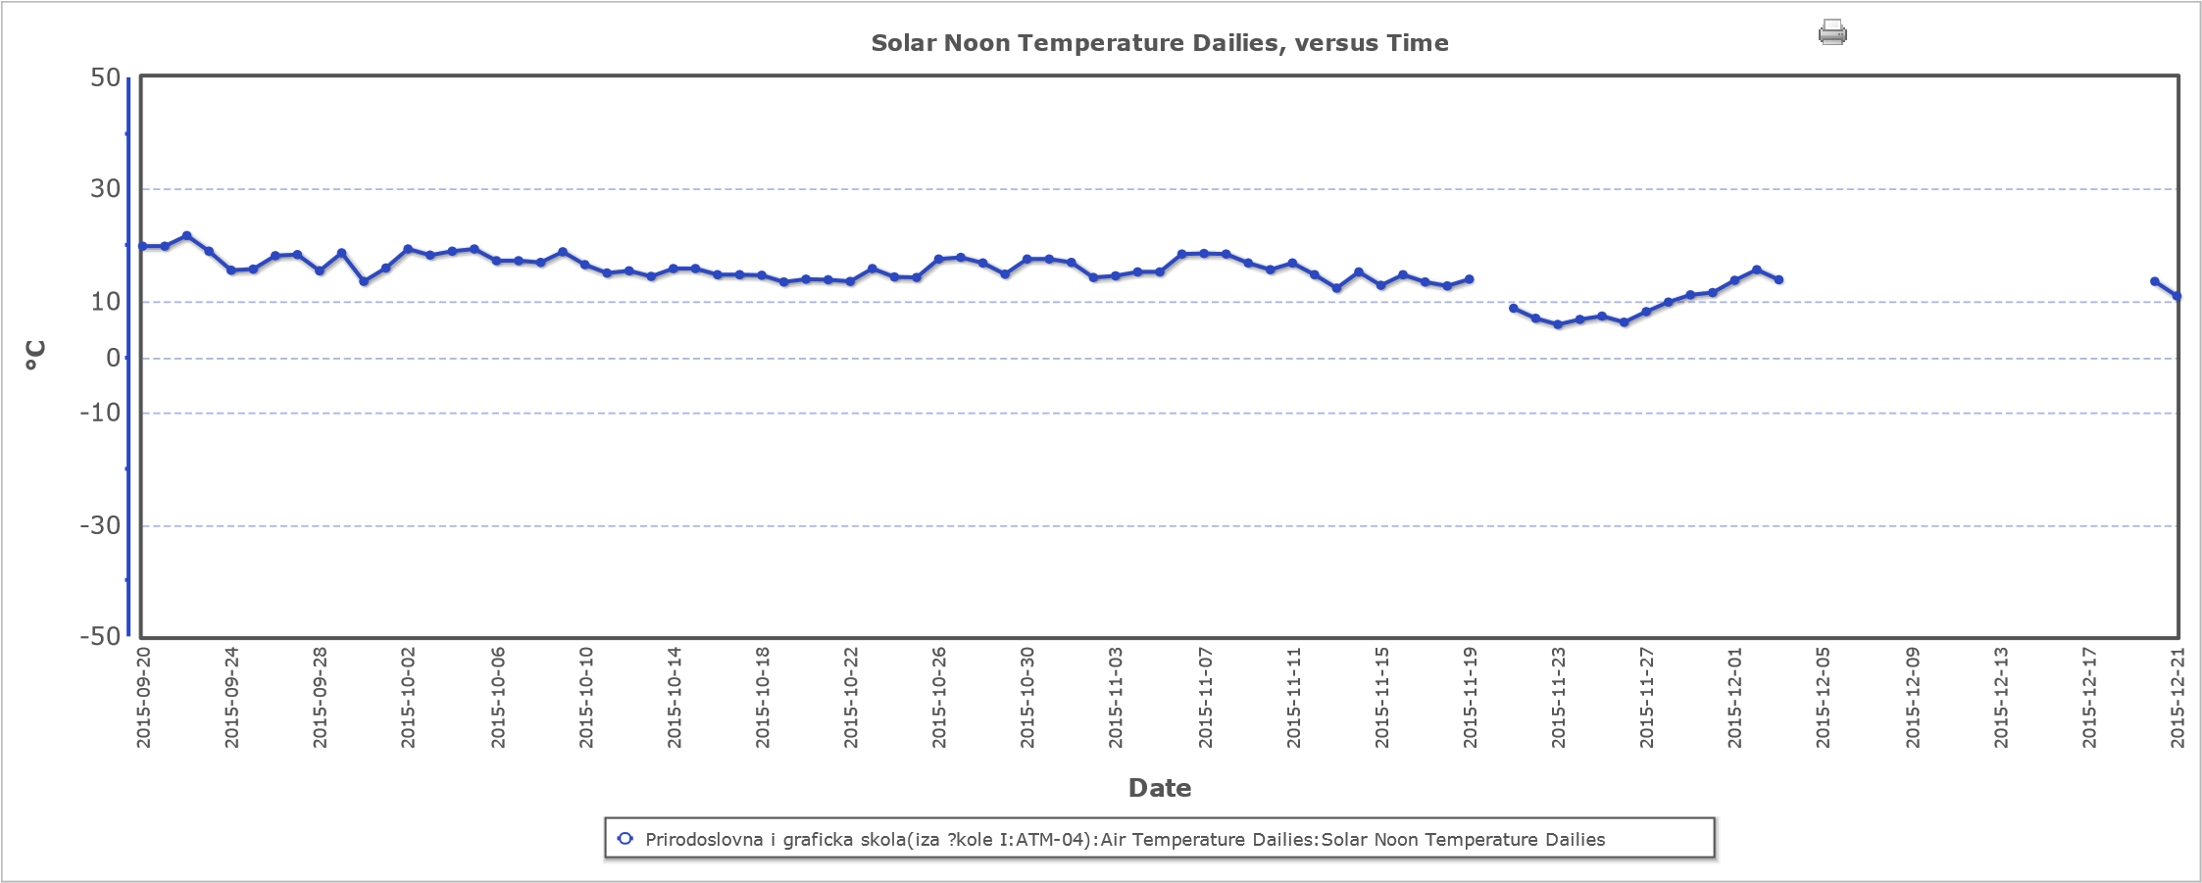
The graph shows temperatures on school site from September 23, to December,21.*

GRAPH 3:Average temperatures in Bakar

The graph shows average temperatures in Bakar in the months September,October,November and December(obtained by State Meteorological Institute)

GRAPH 4:Air moisture at school
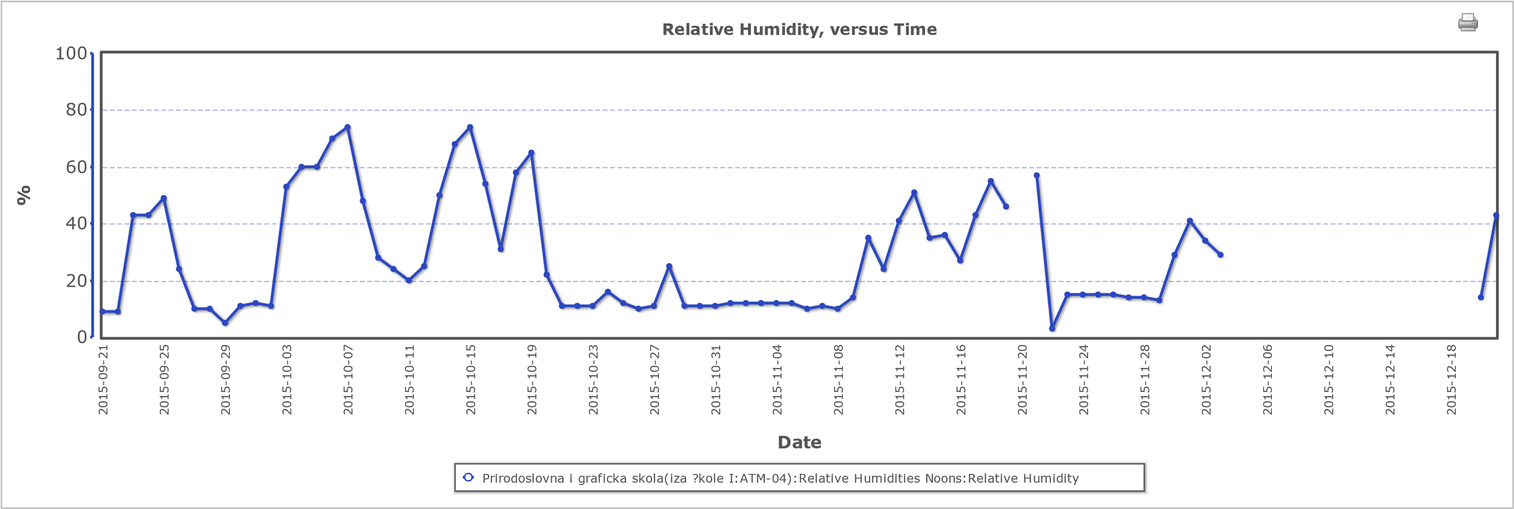
The graph shows relative humidity at school site from September 23. to December 21.*
GRAPH 5:Air moisture at Bakar
The graph shows the average humidity in Bakar in the months September,October,November and December(obtained by State Meteorological Institute)
GRAPH 6:Rainfall in school

Shows monthly rainfall levels at our school

GRAPH 7:Rainfall in Bakar

Monthly rainfall levels in Bakar

5. Conductivity
TABLE 1:Average conductivity
Location | Conductivity μS/cm
Bakar | 663
PiGš | 97,6
The table shows average conductivity levels

6. pH
TABLE 2:Average pH
Name of location | pH
Bakar | 7,6
PiGš | 7
Table of average pH levels of samples

7.Data sumary
TABLE 3:Conductivity and pH

 | September | October | November | December
Name of location | Conductivity μS/cm
Bakar | 663 | 665 | 661 | 663
PiGš | 70,6 | 62,4 | 85,2 | 97,6
 | Measured pH
Bakar | 7,7 | 7,5 | 7,6 | 7,6
PiGš | 7 | 7 | 7 | 7
Table of monthly measured pH and conductivity levels in samples

TABLE 4:Heavy metals
Name of heavy metal |  | Pb | Cd | Cu | Zn | Fe | Ni
 |  | μg/L | μg/L | μg/L | μg/L | μg/L | μg/L
measurments acquiered in one month | Bakar | 16,15 | 0,406 | 35 | 77 | 734 | 14,1
 | PiG school | 0 | 0 | 0 | 0 | 0 | 0
Maximum alowed concentration |  | 1 | 0,005 | Not defined | 0,02 | Not defined | 20
Samples analysed in NZZJZ institute

8.Data analysis
The first table shows the pH and conductivity analysis trough several months. There is a dramatic difference betwen the conductivity levels, and a slight diffenrence in pH levels among School and Bakar data.
The next table is from the NZZJZ institute who helped us mesure the amonutnts of heavy metals in our samples. It is visible that the sample from Bakar has a significant amount of heavy metals which impacted the conductivity and pH levels. The conductivity in the sample from Bakar is much higher becouse the total concentration of heavy metals is very big.

We could not prove the use of aerosols protocol because we could not calculate the Ångstrom exponent.What we know is that the pH of the natural salt solution is 7
NaCl=Na⁺+Cl⁻ pH =7
Out data shows the correlation amongst conductivity and the amount of heavy metals.In our work: Environmental mark on the soil of Kostrena and its surroundings we concluded that there are heavy metals in the soil samples when conductivity reaches the amount of 250 ty μS/cm.

We can combine the conductivity with pH data because of the chemical reactions in the air:
Burning fuel releases great quantities of sulphur oxydes in the air.Combined with water they produce sulphuric acid.

2SO₂+O₂=2SO₃
SO₃+H₂O=H₂SO₄ pH <7

Heavy metals have basic reactions in water solutions
PbO+H₂O= Pb(OH)₂
Pb(OH)₂=Pb²⁺+2OH⁻ pH>7

9.Conclusion
By using the method of moist sedimentation we conclude that the air in Bakar contains more suspended particles of heavy metals than our reference station( our school Prirodoslovna i grafička škola), wich is visible by the higher pH and conductivity. This occured because there is a greater amount of heavy metals in the air of Bakar then around our school. Also our data shows that the aerosols are highest in November when the temperature was in one of the lowest points and there were very small amounts of rainfall.
Comparing our chemical analysis data with conductivity and pH we can prove our hypotesis: measuring conductivity and pH we can predict the presence of heavy metals in the air.This is important because they are toxic and can cause alergic reactions in people.
Chemical analysis are expensive and measuring conductivity and pH one can determine what samples to analyse.
Our fututre research: Using photometer data it is possible to obtain some information about the size distribution of the measured aerosols by calculating the Ångstrom exponent. This could give us some indication about the general sources; whether they are mostly small and thus likely urban or industrial, or larger, suggesting the presence of natural aerosols such as for instance sea salt or dust.
We will continue measuring aerosols,conductivity and pH in spring, summer and next winter, calculate the Ångstrom exponent and find out how they correlate with chemical analysis.
We will also continue working with the inhabitants of Bakar to reduce the pollution.

10. Discussion of measurement limitations including possible sources of error
Our conductivity and pH measurements are precise.
Limitation of our measurements:
We do not have 2 digit pH meters but we used strips too to controll the measured values.
The specimens can be lost, the winds or people can scatter the bottles with specimens, a lot of rainfall can owerflow the specimens.
We have been cooperating with Bakar inhabitants for six years and they proposed to collect and guard the specimens.
We can not measure aerosols with more then 45 % of cloud coverage.

11. Bibliography /Citations
Perina I.,Mihanović B.1988:Ispitivanje onečišćenja zraka.Zagreb:SKTH/Kemija u industriji1 Nastavni zavod za javno zdravstvo Primorsko-goranske županije, Rijeka. Jasminka Pilar Katavić i suradnici 2003.: Prostorni plan uređenja Bakra. Urbanistički institut Hrvatske, d.d., Zagreb Državni hidrometeorološki zavod Agencija za zaštitu okoliša Gladyshev I.2002: Biophysics of the Surface Microlayer of Aquatic Ecosystems ,IWA Publishing,London Zrak: http://httpgeol.pmf.hr/.../01-Oneciscenje.atmosfere.i.globalno.zagrijavanje.pdf Onečišćenje atmosfere i globalno zagrijavanje: http://httpgeol.pmf.hr/.../01- Oneciscenje.atmosfere.i.globalno.zagrijavanje.pdf
http://www.scienceclarified.com/A-Al/Aerosols.html Regional radiative effects due to anthropogenic aerosols: https://www.google.hr/url?sa=t&rct=j&q=&esrc=s&source=web&cd=3&cad=rja&uact=8&ved=0ahUKEwiimo-V2LHLAhXsPZoKHd69D6sQFggsMAI&url=http%3A%2F%2Firina.eas.gatech.edu%2FATOC3500_Fall1998%2FLecture25.pdf&usg=AFQjCNFdMQcPXmD43RE3rHEnD14t1r8JlA NOAA: Aerosols: Climate and Air Quality Questions: https://www.google.hr/url?sa=t&rct=j&q=&esrc=s&source=web&cd=6&cad=rja&uact=8&ved=0ahUKEwiimo-V2LHLAhXsPZoKHd69D6sQFghFMAU&url=http%3A%2F%2Fwww.esrl.noaa.gov%2Fresearch%2Fthemes%2Faerosols%2F&usg=AFQjCNHYdPywsGpxQQ0zEwec_XeZ9rsFAA

12.Consulted scientists

Marianne Tronstad Lund

Aerosol specialist, Cicero, Oslo
Dr.sc.Željko Linšak NZZJZ Rijeka,Croatia For chemical analysis
Marina Pavlić,MSc, chemical engeneer Prirodoslovna i grafička škola Rijeka working on enviromenmental problems for 20 years
Irena Sabo, chemical engeneer Prirodoslovna i grafička škola Rijeka working on enviromenmental problems for 15 years
Ms.Pavlić&Ms.Sabo student's environmental projects for the Communities of Kostrena and Bakar:
- Živjeti u Kostreni(2008)-Living in Kostrena

- Kostrena u moru-more u Kostreni(2009)-Kostrena in the sea-the sea in Kostrena

- Moć tla u bojama Kostrene(2010)-The power of soil in Kostrena colors

- Ekološki otisak na tlo Kostrene i okolice(2011)-Environmental mark on the soil of Kostrena and its surroundings

- Ča more va Bakru more(2012)-What can the sea in Bakar do

- Odraz tla u mirisu ružmarina(2013)-Reflection of the soil in the scent of rosemary

- Zaron u podmorje bakarskog zaljeva(2014)-Diving under the Bakar bay

- Što to tamo lebdi(2015)-What is aerosoiling there

We thank all the consulted scientists and Mr.Dixon Butler for the donation of the sun photometer.

*NOTES by the mentor:We have a lot of problems vith our data.We enter data and when we want to visualise, the data is not there(see graphs 2 and 4).We entered data for three times and we still miss it.We also miss other data and we asked for help and this is the answer we got:
As you can see we got millions of data (not ours, measures we never did-snow(there is no snow in our town,perhaps once every year,if),mosquitoes,we have no soil moisture sensor yet but we have 14521571 measurements.
We only want the data that we entered , and the students lost their motivation, they enter data and when they want to visualise it is not there.
This Science fair was a motivation and we use GLOBE protocols in our subjects and we hope that you will find someone to improve the program for data entering.
Other schools miss the data too and some of teachers stopped doing GLOBE because of it.I am this year's part of MT Teachers group and some other teacher have problems with missing data too.
I contacted helpdesk several times but got only one answer:they found some of our green up data , but the name of the site they put it is different from the original and no green down data,this year my students entered green down for four times .It says that from 2008-09-15 to 2015-11-19 we have only 61 data but we enter this number(cca) every year.
Mentor
Marina Pavlić,MSc

