Sultanate of Oman
The Ministry of Education
Al Thabti School for Primary Education
North A’Sharqiyah region

A Study on the Effect of Frankincense Fumes on the Properties of Drinking Water

Prepared by:
1-Duaa Al-Gazi
2- Ibtihaj Al-Reyami
Supervised by:
1-yosra Al-Dhawi
2-Safia Al-Mussellhi
February 2020

Table of Contents
Topic | Page Number
Summery | 3-4
Key Terms | 4
Research Questions | 4
Introduction and Literature Review | 5-6
Research Methodology  - Research plan | 6-7-8
Research Methodology  - Research location | 8
Research Methodology  3- Collection of data and analysis | 8-9-10
Interview | 10
Results | 10-11-12-13
Discussion | 14
Conclusion | 15
Acknowledgments | 16
References | 16

Summery
This research aims to study the effects of smoke resulting from the burning of frankincense on the properties of drinking water. This is achieved by answering the following questions
- What results from burning frankincense using the charcoal method?
- What is the effect of frankincense fumes on the properties of drinking water?
- Is that water safe for consumption after its exposure to the fumes of frankincense?
This research was conducted in Ibra, which is s governate in the South A’Sharqiyah region in Oman. The fumigation of drinking water with frankincense is a prevalent custom in this region, for this reason this research aims to determine if this custom has a positive or negative effect on the water. This will be achieved by conducting practical experiments to investigate the results of burning frankincense, by passing the fumes resulting from the burning process to lime water.In addition,a sample of drinking water will be exposed to the frankincense fumes. Then the properties of water such as temperature, pH levels, salinity and conductivity will be compared with the properties of pure water by applying the water protocol.Lastly,an interview will be conducted with the Head of the Water Quality Department in the North A’Sharqiyah region.
The results of this research indicated that frankincense is an organic hydrocarbon derivative(Chemistry Book 11,a practical experiment).The burning of frankincense releases carbon dioxide(CO₂) gas, which has the ability to dissolve in water which creates a carbonic acid (Nelson, 2011). This leads to a reduction in the pH of water after its exposure to the fumes.The water becomes acidic which is deemed unsuitable for drinking (Omani standard specifications for non-bottled drinking water,2012).However, it is safe to expose pure drinking water with a pH between(7.5-8.5) to the fumes to obtain the frankincense flavor. It should be noted that the other properties of pure drinking waters such as temperature, salinity and conductivity changed slightly after the fumigation process.
Based on these findings the researchers have prepared the following recommendations:
- Relevant authorities should spread awareness in the community about the effect of frankincense fumes on drinking water and pay attention to knowing the pH of water before exposing it to frankincense fumes.
- Further research should be conducted on the effect of frankincense fumes on the biological properties of water.
- People should take care to cover drinking water while fuming the rooms of the house with frankincense.
Key Terms
Frankincense: A tree from the botanical kingdom of the Burseraceae family.Its scientific name is Boswellia Sacra.This type of trees contains channels in the cortex that secrete gum juice.

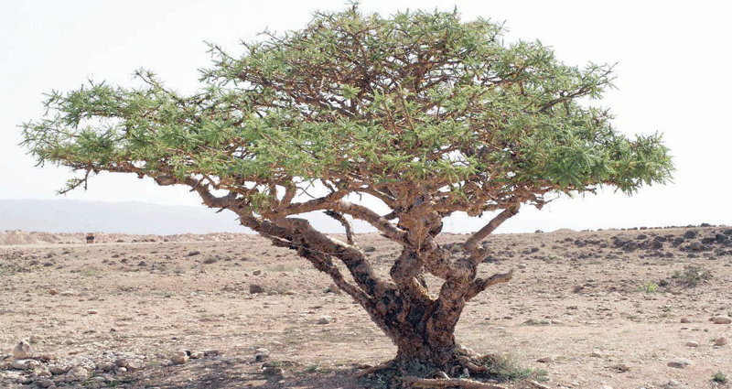
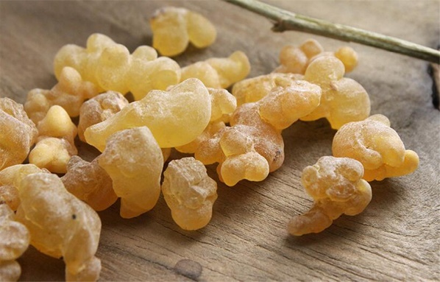

Image(1)frankincense
Image(2)frankincense tree

Lime water:It is a calcium hydroxide solution used to detect carbon dioxide (CO₂).
Combustion:It is a chemical reaction in which the hydrocarbon combines with oxygen to give carbon dioxide(CO₂),water vapor and energy.
Organic hydrocarbon derivative:It is a chemical compound consisting mainly of carbon and hydrogen.Other elements may include in its composition such as oxygen,nitrogen,chlorofluorine,iodine and bromine.
Research Questions
- What results from burning frankincense using the charcoal method?
- What is the effect of frankincense fumes on the properties of drinking water?
- Is that water safe for consumption after its exposure to the fumes of frankincense?
Introduction and Literature Review:
There are many customs and traditions prevalent in our local community, especially in middle eastern countries.An example of this is the Hijaz region in the Kingdom of Saudi Arabia (Al-Jaber,2017).The locals of this region have adopted the custom of smoking kitchen utensils with fumes that result from the burning gum materials.The locals in some governorates of the Sultanate of Oman adopted this same custom.The fumigated gum material that is widely used in this region is frankincense.This is an organic, sticky, opaque and liquid material that is secreted from the frankincense’s tree trunks after a cutting process. This liquid is then hardened to create the frankincense that is used to fumigate drinking water(Oman Encyclopedia,2013),in order to produce water with a frankincense flavor.
The method of fumigation consists of igniting charcoal and putting a quantity of frankincense on it. Then the fumes from the burning process of frankincense are directed in a container until it is filled. After a few minutes has passed drinking water is poured in the container. This integration results in Frankincense flavored drinking water.
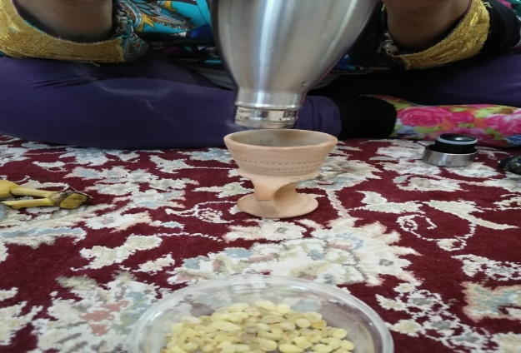
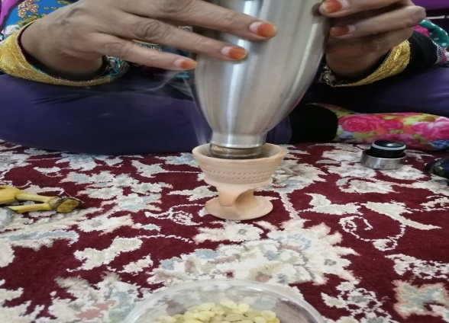

Image(3)and(4)The fumigation of water container

This custom has become widespread in Oman and its neighboring countries which led us to question the impact it has on the properties of drinking water. Drinking water must have certain specifications to be deemed safe for consumption(Omani standard specifications for non-bottled drinking water, (2012)which are:
-The pH of the water must range between 6.5-8.5.
-The total of dissolved solids must be between 120-600 mg/l.
The effect of frankincense fumes on these specifications is the main factor that has led to the execution of this research. This is due to the fact that these findings will determine the validity of this custom.

Research Methodology
1-Research Plan
Table(1)Time Frame for the research plan
Month | Work-plan
Determine the research question and the equipment required to conduct the research | November 2019
Collection and analysis of data | November and December 2019
Reach conclusion, recommendation and produce a written format of the research | January 2020
Present research | February 2020

Table(2)Allocation of roles between researchers in relations to the preparation of equipment and field work
Work | Researcher
Determine the research question and the equipment required to conduct the research | Duaa and Ibtihaj
Collection of Data:  -Practical experiments  -The application of the water protocol by entering the data onto a website  - A field visit to the Public Authority for Electricity and Water "Deem" | Duaa and Ibtihaj
Conducting an analysis based on the collected data.  Reaching a conclusion and producing a written format of the research | Duaa and Ibtihaj

Table (3) The logistics of the research plan

Location | Work
Al Thabti School | Carrying out an experiment to detect carbon dioxide(CO₂)from the combustion of frankincense.  Study the properties of water by applying the water protocol to two samples:  - A Sample pure water.  - A Sample of water that is exposed to frankincense fumes.
The Public Authority for Electricity and Water "Deem" | Conducting an interview with Salim Al-Abdili, the Head of the Water Quality Department in the North A’Sharqiyah region to understand Oman’s standard specifications for drinking water.

The appropriate equipment required to carry out the research consist of:pH meter,positioning device,salinity and conductivity measuring device,thermometer,testers,cups,lime water,test tubes,frankincense,charcoal,electronic scale,paper,pen,computer,pure water and water exposed to frankincense fumes.
It should be noted that the research plan also included the collection of information from various sources in order to gain more insight which will enable the researchers to conduct a thorough analysis. These sources include:
- World Wide Web(internet)
- Notes from the Globe program on the water protocol
- Chemistry book(Grade 11)
- Oman encyclopaedia
- References and sites
Data associated with the application of the water protocol and the atmosphere were entered in www.GLOBE.gov
An interview was conducted with Salim Al-Abdili,the Head of the Water Quality Department in the North A’Sharqiyah region to discuss the experiment results,reach a conclusion and recommendations
2-Research location
This research was executed in the North A’Sharqiyah region,specifically the governorate of Ibra.In the months December and January,during these months the temperature ranges between 8 and 36 degrees Celsius.The water protocol was applied to the two samples of water during this period at room temperature.
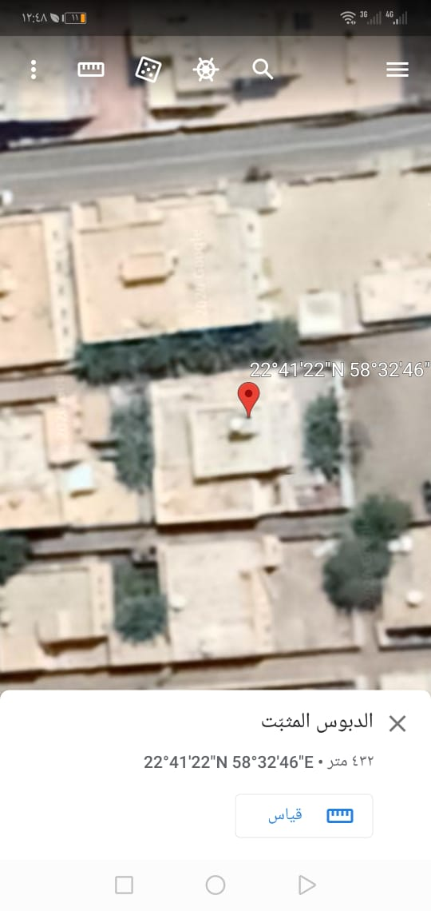
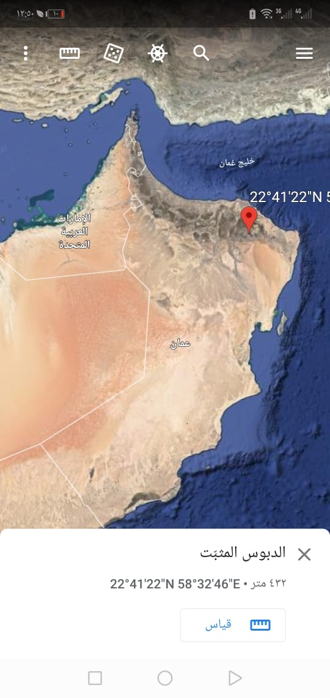

Image(5)and(6)Research Location

Collection of Data and Analysis
The methods of data collection relating to the first question:
Practical experiment which consists of the following steps:
- Placing 2 g of frankincense in a test tube.
- Placing 40 ml of lime water in a test tube.
- Install the device as shown in the corresponding figure(Image 8).
- Mildly heating the frankincense and taking notes.
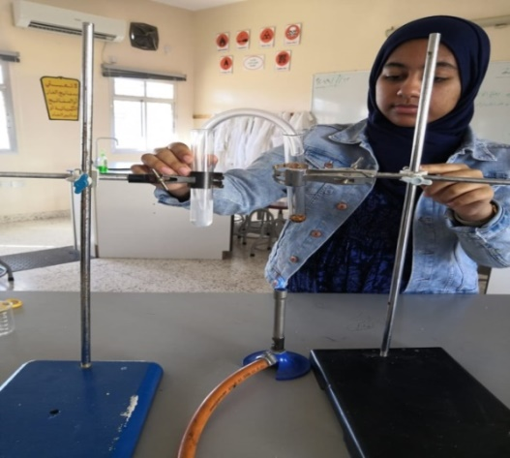
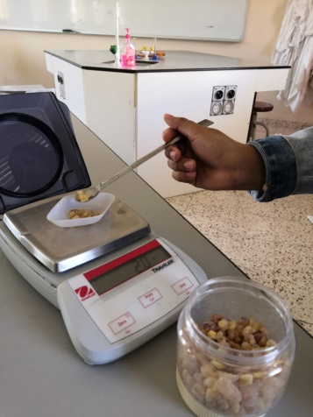

Image(8)frankincense composition detection device
Image(7)measuring the mass of frankincense

The methods of data collection relating to the second question
Data was collected by exposing a sample of drinking water to the fumes of frankincense.Then the properties of the water(temperature,pH,salinity and conductivity)were compared with the properties of a sample of pure water by applying the water protocol.This was process was repeated 4 times to ensure the accuracy of the results.

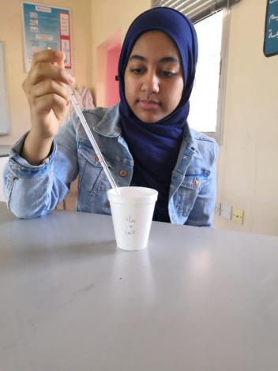
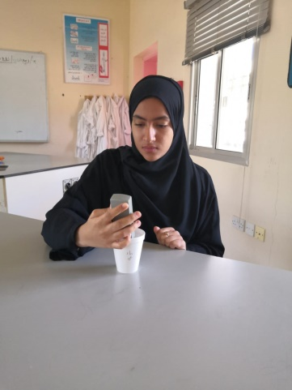

.

Image(10)pH measurements
Image(9)temperature measurements

The methods of data collection relating to the third question
Data was collected by conducting an interview with Salim Al-Abdili,Head of the Water Quality Department of the North A’Sharqiyah region.Information on Oman’s standard specification for non-bottled drinking water were collected.
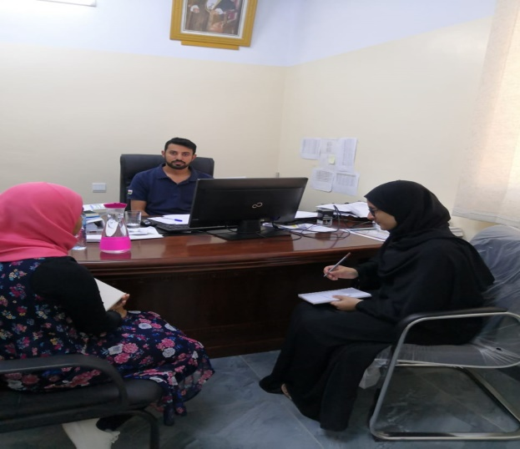

Image(11)Interview with Salim Al-Abdili

Results
The results relating to the first question
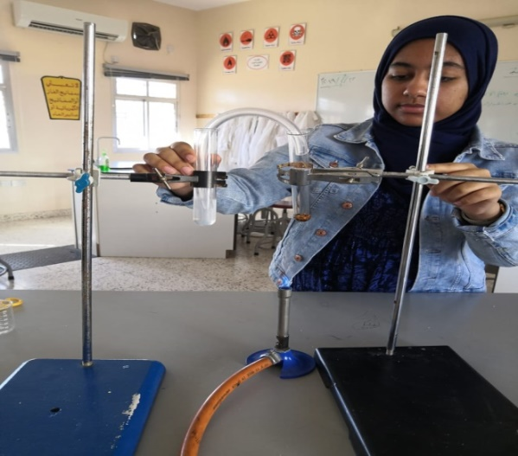
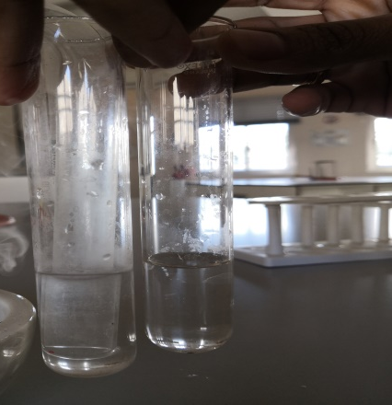
The following picture shows the lime water after the burning of frankincense. The lime water has transformed from a transparent colour to a milky colour.In addition,condensed water vapor is present on the test tube’s glass.
Image(12)frankincense composition detection device
Image(8)the murkiness of lime water

The results relating to the second question
The following tables show data describing the properties of pure water and the fumigated water in four samples:

Table(4)Sample 1
Properties | Pure water | Fumigated water
Temperature | 22.5⁰C | 22⁰C
Salinity | 122PPM | 122.1PPM
Conductivity | 57.3 | 64.4
pH level | 7.1 | 6.4

Table(5)Sample 2
Properties | Pure water | Fumigated water
Temperature | 22.5⁰C | 22.7⁰C
Salinity | 122 PPM | 122.1PPM
Conductivity | 58.2 | 63.1
pH level | 7.1 | 6.5

Table(6)Sample 3
Properties | Pure water | Fumigated water
Temperature | 23.7⁰C | 21.5⁰C
Salinity | 122PPM | 122.1PPM
Conductivity | 70.5 | 63.1
pH level | 7.2 | 6.4

Table(7)Sample 4
Properties | Pure water | Fumigated water
Temperature | 23.5⁰C | 21.5⁰C
Salinity | 122PPM | 122.1PPM
Conductivity | 63.9 | 63.1
pH level | 7.3 | 6.4

The following graphs show the average temperature,salinity,conductivity,and pH level of the pure water samples and the fumigated water samples.

Graph(2)
Graph(1)

Graph(3)
Graph(4)

Globe.gov was used as the data entry program for this research
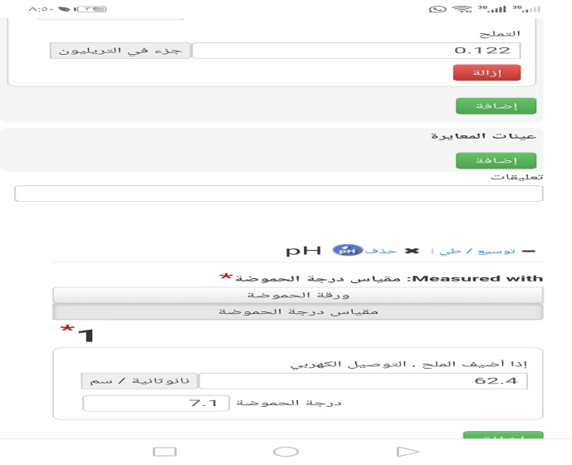
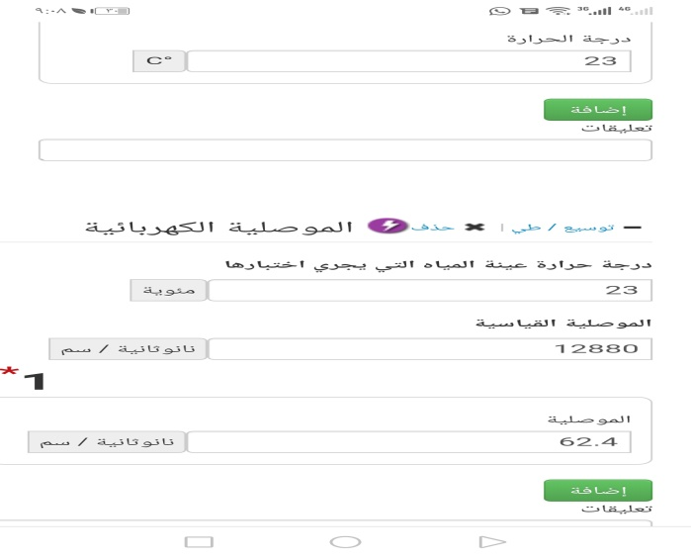
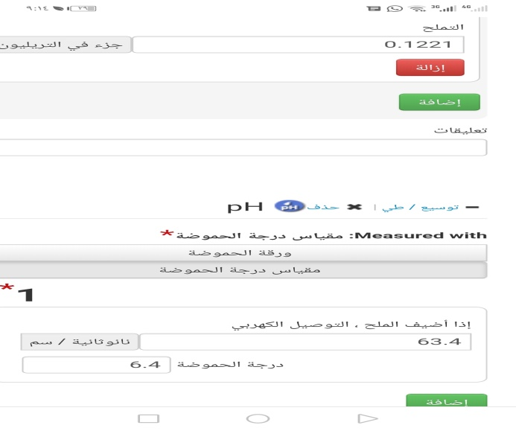
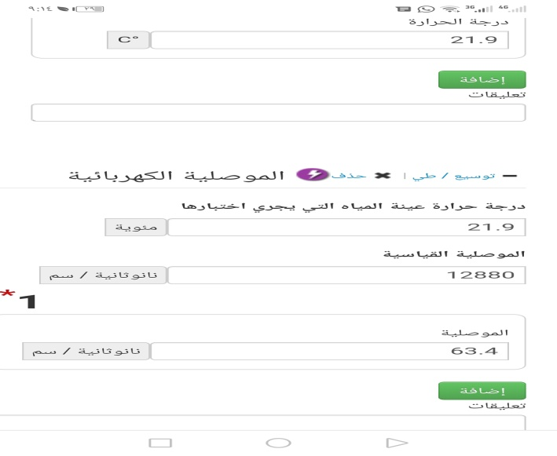

The results relating to the third question
The following table shows the Omani standard specifications for non-bottled drinking water.This was provided Salem Al-Abdali during the interview.

Table(8)standard specifications for non-bottled drinking water
Properties | Quality limitations
Temperature | No specific temperature
pH level | 6.5–8.5
Total dissolved solids | 120-600mg/l

Discussion
The answer for the first research question
It can be concluded through image(13)that frankincense is an organic compound extracted from a living organism.As a result,its combustion will lead to a release of carbon dioxide(CO₂),water vapor and thermal energy.This is evidenced by the transformation of lime water from transparent to a milky white color and the condensation of water vapor on the sides of the test tube (Helwa,2016).The chemical formula of this reaction is
Frankincense hydrocarbon +O₂ Energy+CO₂ +H₂O.
The answer for the second research question
Tables(4,5,6,and 7)and graphs(1,2,3,and 4)has constantly showed that the pH of the fumigated water samples has decreased from 7.1 to 6.4.This indicates that the water has become acidic, this is due to the melting carbon dioxide gas, which is released during the combustion process. The integration between the water and the melted CO₂ results in the formation of carbonic acid(Nelson, 2011).The chemical formula of this reaction is
CO₂+ H₂O H₂CO_{3.}
There was only a slight change to the other properties of water(temperature,conductivity and salinity after the fumigation of frankincense.
The answer for the third research question
It was concluded from the conducted interview that non-bottled drinking must have a pH between(6.5 and 8.5)Consequently,the fumigated water is not suitable for drinking because it does not fall within this range.After exposing the sample to frankincense’s fumes,the pH level has decreased to 6.4However,fumigated water can be safe for consumption if the pH level prior to the fumigation ranges between(7.5-8.5)This level of pH will prevent the water from becoming too acidic after the fumigation process.This means that this fumigated water is safe for consumption,because its pH will fall within the range stated by the Omani standard specifications for non-bottled drinking water.

Conclusion
The aim of this research is to study the effect on frankincense smoke on the properties of drinking water.The fumigation of drinking is a custom that is prevalent in Oman and its neighboring countries like the Kingdom of Saudi Arabia.Through various research methods(interview and practical experiments)it was concluded that the burning of frankincense leads to a release of Carbon dioxide(CO₂).This gas has the ability to melt in the water during the fumigation process,as a result a carbonic acid is created by this process.The carbonic acid will consequently decrease the pH level of the water.The water then becomes unsuitable for consumption based on the Omani specification standards for non-bottled water.However,it is safe to drink fumigated water if it has a high pH level(7.5-8.5)prior to the fumigation process.The carbonic acid will still decrease the pH level,but it will be at a level that is considered safe by the specification standards.The research has also determined that the other water properties were not significantly affected by the fumigation process.
Based on these findings the researchers have prepared the following recommendations:
- Relevant authorities should spread awareness in the community about the effect of frankincense fumes on drinking water and pay attention to knowing the pH of water before exposing it to frankincense fumes.
- Further research should be conducted on the effect of frankincense fumes on the biological properties of water.
- People should take care to cover drinking water while fuming the rooms of the house with frankincense.
One of the main strengths of this research is the fact that it is successful in obtaining influential results on a custom that is prevalent in this region.In addition, there is no previous studies on this topic.As a result,there are no available sources to compare the results of this study.However,this should be viewed as an asset due to the originality of this topic.

Acknowledgment
We would like to extend our gratitude to our teachers, Yousra Al-Dawa, and Safiya Al-Maslihiya for their assistance and efforts in helping complete this research. We also owe a special thanks to Salim Al-Abdili, the Head of Water Quality Department for his prominent role in providing us with the Omani standard specifications for non-bottled drinking water.

References
Arabic References
Al-Balushi, Yaqoub.(2016).An Explanation of the Water Protocols for the Globe’s Environmental Teacher Training Program,Bureau of International Educational Programs.
General Directorate for Standardization and Metrology(2012),Omani Standard Specifications for Non-bottled Drinking Water(Binding Omani Specifications), Ministry of Trade and Industry.
Helwa,Omar Jabr(2006),The Key to Creativity in Organic Chemistry,Treasures House of Scientific Knowledge for Publishing and Distribution,p.15,90
Ministry of Heritage and Culture.(2013).Oman Encyclopedia,Volume VIII,First Edition, Sultanate of Oman, Muscat,p.3046
Ministry of Education.(2009),Chemistry Book for the Eleventh Grade, Experimental Edition,p.202
Online Article
Al-Jaber,Hasan.(2017),Why are the Hijazis keen to Fuming Cups during Ramadan?Retrieved on 01/13/2020 www.Alarabiya.net
English References
Clark, Jim.(2009).Edexcel International GCSE and Certificate Chemistry,British Library Cataloguing, p.58
Nelson,Peter G.(2011).Introduction to Inorganic Chemistry.

