Study on risk of dengue outbreak in Don Chan district To devise a device to cut out
the mosquito life cycle.
Researcher Miss Siriyaphon Kamprathueng, Mr. kritsada Maungnakrong, Miss Atchariyakon Kanpitsamai
Level upper secondary
Teacher Mr. Chumpon Chareesaen,
Donchanwittayakom school kalasin Thailand
,.
Abstract
From the information provided by the Don Chan District Public Health Office. Districts with dengue fever rates The highest number of people in Donchan subdistrict was 150.65 per 100,000 population, followed by Sa-adchaisri subdistrict and Na-champa Subdistrict 55.05, 41.57. The research and analysis of the index. Of Donchan subdistrict Sa-adchaisri subdistrict and Na-champa Subdistrict It was found that HI values ​​of two mosquitoes were greater than 10 BI values ​​were greater than 50 and CI values ​​were greater than 1. It was concluded that all three areas were vulnerable to the spread of dengue. In order to cut down the life cycle of mosquitoes, we have devised a device to cut mosquito life cycle. The mesh fabric must be placed higher than the bottom of the container 2 cm. To catch mosquito larvae. And cut the mosquito life cycle. The larvae can trap 14 larvae. And from the study of lure from rice straw and blue light waves in mosquito equipment. The average number of mosquitoes was 41.66.
Keywords (Key Word) Dengue mosquitoes, life cycle mosquitoes

Introduction
The dengue situation is out breaking. It has been reported that dengue fever has spread to all 18 districts and the number of patients is increasing. According to the data of Donchan District Health Office (2560) The highest number of people in the district was Donchan. The rate was 150.65 per 100,000 population, followed by Sa-adchaisri subdistrict, and Na-champa Subdistrict the rate was 55.05, 41.57 respectively. From the problem. The team has the idea to explore mosquito larvae. Identification of mosquito larvae for risk analysis. The mosquito in the district. The highest outbreak. To publicize this information to people in Donchan district. It also offers a way to block the invasion by the invention of a complete mosquito trapping device. To trap mosquitoes that cause disease that is harmful to people. The research team conducted research. Study the risk of outbreak. Dengue fever in mosquitoes to produce life cycle devices.

Research Questions
1. Do Donchan District have the risk of dengue outbreak?
2. How can mosquito trapping devices be used to trap mosquitoes?
Hypotheses
1. Don Donchan District has a high risk of dengue fever.
2. Complete mosquito trapping device can effectively trap mosquitoes.
objective
1. The risk of dengue outbreak in Don Chan district.
2. The invention of a complete mosquito trap. And can trap mosquitoes effectively.
Methodology
1. Determine the study site in the survey. Don chan Sub distric of 9 villages, 2,128 houses, 354 houses, according to the schedule, Taro Yamane sample size at 95%
There are Sa-adchaisri subdistrict have 8 villages, 1,051 houses, 300 houses, Taro Yamane sample size, 95%
There are Na-champa Subdistrict have 9 villages of 1,419 houses, of which 299 houses are used. Taro Yamane's sample size is 95%
The researcher selected 3 sub-districts from Don Subdistrict Public Health Office (2560). The highest percentage of the population was Don Subdistrict, The rate was 150.65 per 100,000 population. The rate of illness was 55.05, 41.57, respectively.
2. Conduct a survey of mosquito larvae according to GLOBE protocal.
3. Classify, count and send the completed information. https://www.globe.gov/globe-data/data-entry

Principles of mosquito larval trapping
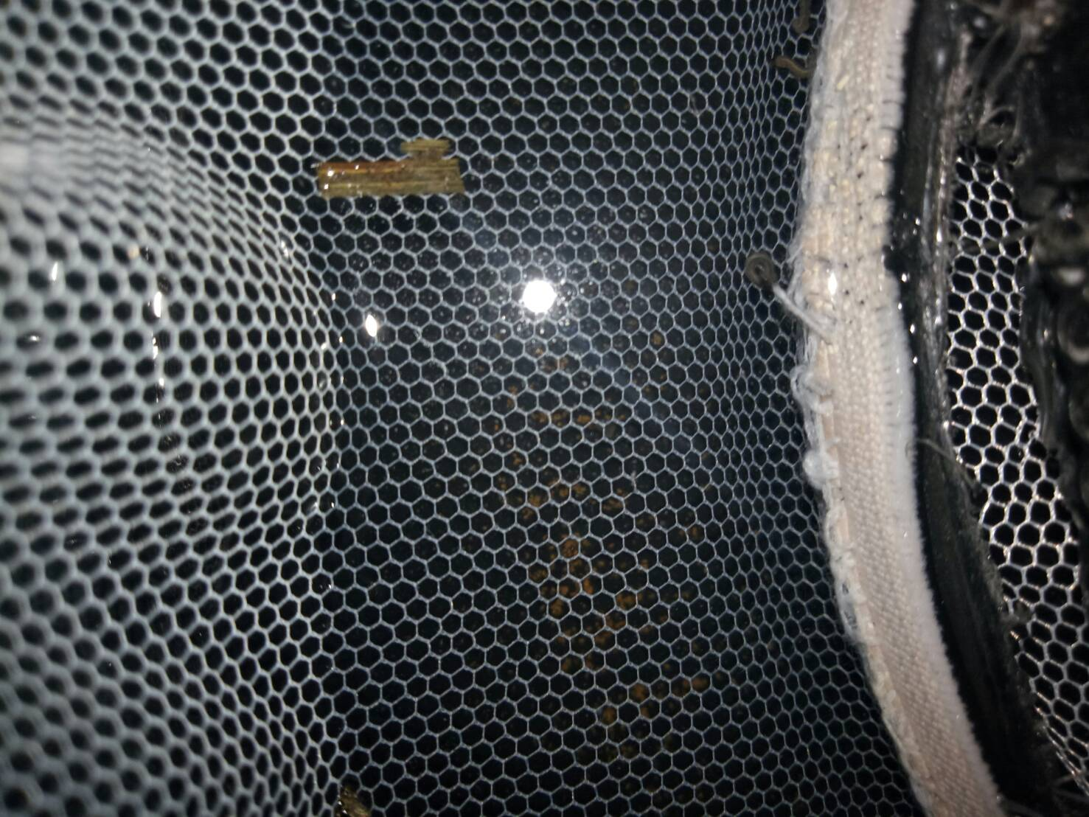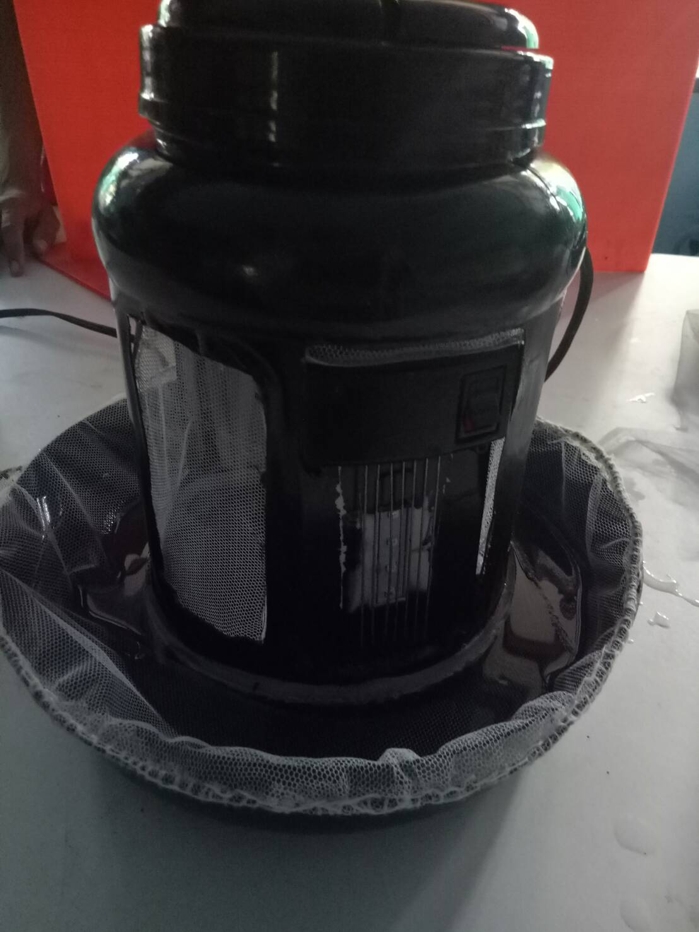

When to put strawberry juice. Fermented for 7 days in a black container. Add 4 cm straw water to the muffler. Then covered with mesh cloth. Allow the mesh to drop below 4 cm in the water. And lower than the position of the water lost in the experiment. When mosquitoes come empty eggs go through 7 days when eggs hatch. The water will evaporate. The larvae that hatch out, it will stick to the net and dry it out or after 7 days, we can bring these fish to fish.

Principles of mosquito shot equipment.
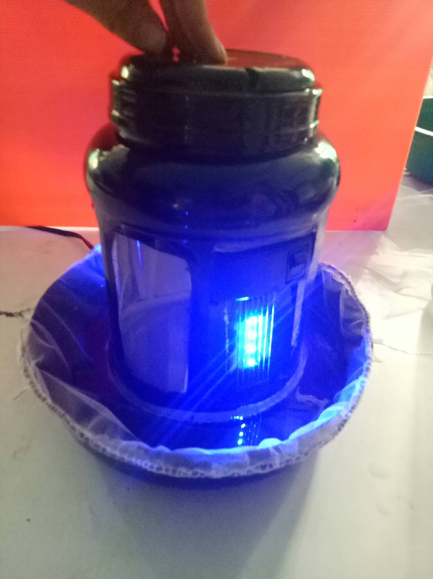
When the purple LED light on the mosquito will go down. The mosquito litter is fermented. Mosquitoes, it will die.

Research Result
Table show information on mosquito larvae survey : Don-chan Subdistrict.

Village | Researching house quantity |  |  |  |  | Researching house quantity | All of the house
 | Ae. aegypti | Ae. Albopictus | Mansonia spp. | Culex spp. | Anopheles spp.
1 | 7 | 7 | 0 | 2 | 1 | 7 | 18
2 | 0 | 8 | 0 | 3 | 2 | 9 | 21
3 | 6 | 11 | 0 | 5 | 2 | 12 | 28
4 | 3 | 6 | 0 | 1 | 1 | 6 | 12
5 | 3 | 7 | 0 | 2 | 2 | 13 | 22
6 | 0 | 5 | 0 | 1 | 1 | 5 | 5
7 | 2 | 13 | 0 | 6 | 5 | 16 | 22
8 | 1 | 7 | 0 | 3 | 2 | 10 | 22
9 | 3 | 7 | 0 | 1 | 1 | 8 | 15
Include | 24 | 71 | 0 | 24 | 17 | 86 | 165

Village | Number of containers found mosquitoes/All of containers
 | Ae. agypti | Ae. albopictus | Mansonia spp. | Culex spp. | Anopheles spp.
1 | 14/72 | 28/72 | 0 | 21/72 | 7/72
2 | 0 | 45/84 | 0 | 9/84 | 9/84
3 | 24/140 | 96/140 | 0 | 84/140 | 72/140
4 | 12/48 | 24/48 | 0 | 24/48 | 12/48
5 | 52/88 | 65/88 | 0 | 26/88 | 0
6 | 0 | 40/25 | 0 | 35/25 | 25/25
7 | 32/88 | 80/88 | 0 | 48/88 | 48/88
8 | 20/88 | 40/88 | 0 | 40/88 | 10/88
9 | 8/15 | 24/15 | 0 | 24/15 | 16/15
Included | 162/539 | 442/539 | 0 | 311/539 | 199/539

Analyze venturing from Mosquito larva index.
Mosquito larva index | Ae. agpyti | Ae. Albopictus. | Mansonia spp. | Culex spp. | Anopheles.
HI | 14.54 | 42.03 | 0 | 14.54 | 10.30
CI | 30.05 | 82.00 | 0 | 57.69 | 36.92
BI | 98.18 | 267.87 | 0 | 188.48 | 120.60

From researching andanalyze all index of Donchan Subdistrict. HI index of 2 aedes app. over than 10 and BI index over 50. From information, in Donchan subdistrict area venture to spread dengue fever.

Table show information on mosquito larvae survey : Sa-adchai-sri Subdistrict
Village | Researching house quantity |  |  |  |  | Researching house quantity | All of house
 | Ae.aegypti | Ae. albopictus | Manbonia app. | Culex spp. | Anopheles spp.
1 | 3 | 5 | 0 | 3 | 4 | 5 | 12
2 | 3 | 4 | 0 | 0 | 2 | 5 | 9
3 | 7 | 0 | 0 | 0 | 0 | 8 | 14
4 | 0 | 4 | 0 | 3 | 0 | 4 | 12
5 | 0 | 0 | 0 | 4 | 0 | 6 | 11
6 | 2 | 3 | 0 | 2 | 2 | 3 | 11
7 | 4 | 6 | 0 | 5 | 4 | 6 | 6
8 | 0 | 0 | 0 | 0 | 7 | 8 | 8
Included | 19 | 22 | 0 | 17 | 19 | 45 | 83

Village | Number of containers found mosquitoes/All of containers
 | Ae.aegypti | Ae. albopictus | Manbonia app. | Culex spp. | Anopheles spp.
1 | 10/60 | 25/60 | 0 | 25/60 | 10/60
2 | 5/18 | 10/18 | 0 | 0 | 10/18
3 | 8/14 | 0 | 0 | 0 | 0
4 | 0 | 12/36 | 0 | 8/36 | 0
5 | 0 | 0 | 0 | 6/11 | 0
6 | 6/44 | 12/44 | 0 | 9/44 | 9/44
7 | 12/30 | 30/30 | 0 | 30/30 | 18/30
8 | 0 | 0 | 0 | 0 | 8/8
included | 41/166 | 89/166 | 0 | 78/166 | 55/166

Analyze venturing from Mosquito larva index.
Mosquito larva index | Ae.aegypti | Ae. albopictus | Manbonia app. | Culex spp | Anopheles spp.
HI | 22.89 | 26.50 | 0 | 20.48 | 22.89
CI | 24.69 | 53.61 | 0 | 46.98 | 33.13
BI | 49.39 | 107.22 | 0 | 93.97 | 66.26

From researching andanalyze all index of Sa-adchaisri Subdistrict. HI index of 2 aedes app. over than 10 and BI index over 50. From information, in

Sa-adchaisri subdistrict area venture to spread dengue fever.

Table show information on mosquito larvae survey : Na-jampa Subdistrict.

Village | Researching house quantity |  |  |  |  | Researching house quantity | All of the house
 | Ae.aegypti | Ae. albopictus | Manbonia app | Culex spp | Anopheles spp.
1 | 3 | 4 | 0 | 2 | 3 | 4 | 9
2 | 5 | 6 | 0 | 4 | 5 | 6 | 10
3 | 9 | 8 | 0 | 6 | 4 | 10 | 12
4 | 0 | 14 | 0 | 9 | 0 | 14 | 19
5 | 4 | 4 | 0 | 3 | 5 | 5 | 12
6 | 8 | 7 | 0 | 6 | 5 | 8 | 17
7 | 4 | 5 | 0 | 3 | 3 | 5 | 11
8 | 10 | 9 | 0 | 6 | 7 | 10 | 16
9 | 8 | 10 | 0 | 6 | 7 | 10 | 17
included | 51 | 67 | 0 | 45 | 39 | 72 | 123

Village | Number of containers found mosquitoes/All of containers
 | Ae.aegypti | Ae. albopictus | Manbonia app | Culex spp | Anopheles spp.
1 | 4/36 | 16/36 | 0 | 20/36 | 16/36
2 | 18/60 | 24/60 | 0 | 24/60 | 12/60
3 | 30/120 | 50/120 | 0 | 5/120 | 10/120
4 | 0 | 56/76 | 0 | 16/76 | 0
5 | 56/60 | 20/60 | 0 | 20/60 | 5/60
6 | 24/136 | 40/136 | 0 | 32/136 | 24/136
7 | 10/80 | 20/80 | 0 | 5/80 | 5/80
8 | 10/48 | 40/48 | 0 | 20/48 | 20/48
9 | 20/51 | 40/51 | 0 | 20/51 | 10/51
Included | 172/591 | 306/591 | 0 | 162/591 | 102/591

Analyze venturing from Mosquito larva index
Mosquito larva index | Ae.aegypti | Ae. albopictus | Manbonia app | Culex spp | Anopheles spp.
HI | 41.46 | 54.47 |  | 36.58 | 31.70
CI | 29.10 | 51.77 |  | 27.41 | 17.25
BI | 139.83 | 248.78 |  | 131.70 | 82.92

From researching andanalyze all index of Na-jampa Subdistrict. HI index of 2 aedes app. over than 10 and bI index over 50. From information, in

Na -jampa subdistrict area venture to spread dengue fever.

experiment2

Measuring experiment | Remaining water from 2,828 cm3 | Water height  (cm.) | Number of mosquito
round1 | 1,414 | 2.10 | 10
round2 | 1,338 | 1.89 | 19
round3 | 1,368 | 1.96 | 13
Average | 41.66 | 1.98 | 14
From the table, putting mesh fabric should high from container floor about 2 cm, for trap mosquito larva and cut Mosquito Life Cycle The larvae can trap 14 larvae.
Table shows the number of mosquitoes caught.
Measuring experiment | number of mosquitoes caught.
round1 | 44
round2 | 32
round3 | 49
Average | 41.66

From the table, the number of mosquito which has caught research lure from fermented straw water and blue light in cut Mosquito Life Cycle. Start at 7.00 AM for 24 hour do triple . the average of mosquito is 41.66.

Conclusion

From researching andanalyze all index of Donchan subdistrict, Sa-adchaisri subdistrict and Na-champa Subdistrict. HI index of 2 aedes app. over than 10 and bI index over 50. All of 3 researching area venture to spread dengue fever.In order to cut down the life cycle of mosquitoes, we have devised a device to cut mosquito life cycle. And the quality is putting mesh fabric should high from container floor about 2 cm, for trap mosquito larva and cut Mosquito Life Cycle The larvae can trap 14 larvae.

Discuss the results.

From experiment.c researching andanalyze all index of Donchan subdistrict, Sa-adchaisri subdistrict and Na-jampa Subdistrict. HI index of 2 aedes app. over than 10 and bI index over 50. All of 3 researching area venture to spread dengue fever. According to the data of the Don Chan District Public Health Office (2560). The highest number of people in Don chan district was 150.65 per 100,000 population, followed by Chachoengsri, Na Champa, 55.05, 41.57. So publicizing this information will make more surveillance. More ever inventing cut mosquito life equipment will reduce mosquito quantity. . from researching lure from fermented straw water and blue light in cut Mosquito Life Cycle. Start at 7.00 AM for 24 hour do triple . the average of mosquito is 41.66.

