How does elevation
affect surface temperature?

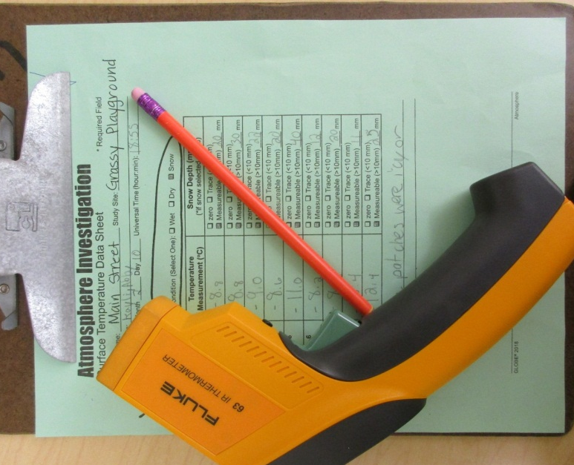

Main Street Intermediate School
Norwalk, Ohio USA
N41.24 latitude
W-082.61 longitude
March 2019

Contents

Summary ……………………..………………page 3
Purpose and Hypothesis ……..……….…page 4
Materials ……...............................…… page 4
Procedures ………………………………… page 5
Map showing data locations ……………. page 6
Data graphs …………………..….…………page 7
Conclusion …………………………..……...page 9
Questions for further study ……..…..…page 10
Resources …………………………..………page 10
Our data entered into GLOBE for project …page 10

Summary

Our school has been measuring surface temperature during the month of December each year since 2006. We thought it would be interesting to compare surface temperature data taken at schools at different elevations. We found 8 schools in addition to our school that collected data at the same time on study sites with grass. We thought the schools at the higher elevations would have colder surface temperature and the lower elevations would show warmer surface temperatures. We learned from the data that, for the most part, that our hypothesis was correct. However, the data also suggests that other things may also affect the data. More research needs to be done to find out how air temperature, distance from the equator, and landforms might also affect surface temperature data.

This research project was completed by fifth grade students at
Main Street Intermediate School in Norwalk, Ohio, USA.

Students
Brynn Prack, Brooke Elizabeth Heyman, and Kayli Bergman

Purpose and Hypothesis

We want to find out more about how surface temperature data is affected by elevation. We thought it would be interesting to compare data from different schools that collected surface temperature data during December of 2018 on grassy sites. We think that when there is a lower elevation the surface temperature is warmer and when the elevation is higher the surface temperature is lower. Air temperature is warmer at lower elevations and colder at higher elevations, so we think that surface temperature data might follow that same pattern

Materials:

- Computer/Chrome book
- GLOBE Surface Temperature Data Sheet
- www.GLOBE.gov to enter our school’s data and to find data from other schools.
- IRT- Infrared Thermometer FLUK 63
- Clipboard
- Glitter (for poster)
- Notebook
- Construction Paper

Procedures

- Learn about surface temperature and how to collect data using the scientific GLOBE protocol. We took surface temperature measurements during the month of December 2018.

- Enter data into www.globe.gov for our school.

- Use www.globe.gov to find data from schools around the world that was taken on the same dates that we collected our data during December 2018. The schools were located at a variety of elevations.

- Use the visualization tool on www.globe.gov to create line graphs for each school and also made stacked line graphs so that we could compare all of the data.

- Display data on a poster to share with others

- GLOBE schools and elevations used in this project:

  - Zenska opca gimnazija Druzbe sestara milosrdnica s pravom javn- Croatia 89 m.
  - Main Street Intermediate School-Ohio, USA 296.4 m
  - Shumate Middle School-Michigan, USA 176.7 m
  - OS Djuro Pilar-Croatia 98 m
  - III. osnovna skola Varazdin- Croatia 202 m
  - Houjia Junior High School – Taiwan 24.4 m
  - Crestwood High School-Michigan, USA 181 m
  - PEACE Schools Network-Japan 26.41 m
  - National Kinmen Senior High School- Taiwan 22 m
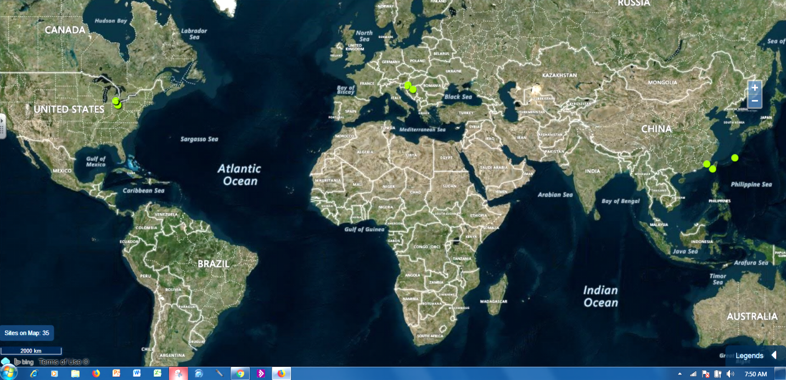
Project GLOBE School Sites
Map produced using the GLOBE website visualization tool

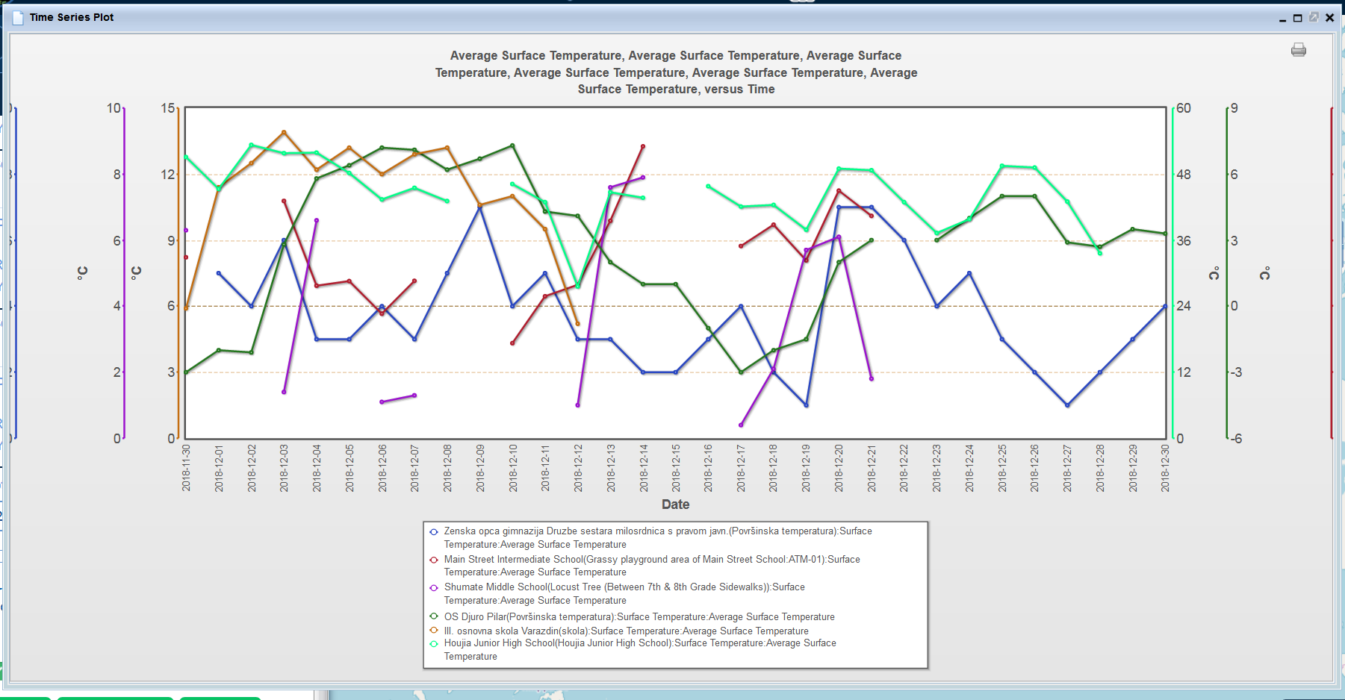
Surface Temperature Data
Data Source: www.globe.gov

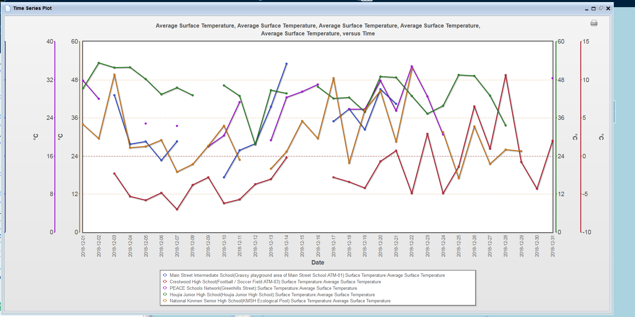
Surface Temperature Data
Data Source: www.globe.gov

Conclusion

The purpose of our project was to find out more about surface temperature and elevation. We wanted to see if elevation affects the surface temperature data by increasing the surface temperature when the elevation is lower. So when we looked at our hypothesis it was right. Our hypothesis stated that when there is a lower elevation the surface temperature is warmer and when the temperature is lower the elevation is higher.
One of the schools that we borrowed data from is Houjia-Taiwan has a warmer surface temperature and the elevation is 24.4 m. Another school, Crestwood- Michigan USA, has an elevation of 181 and the surface temperature is lower. Zenska’s-Croatia elevation is 89 m and their temperature data is moderate. III osnovna- Croatia has an elevation of 202 m, but its temperature is on the higher end. National Kinmen- Taiwan has a lower elevation and a higher surface temperature. Our school´s elevation is 296.4 m and our temperature is in the middle, but higher than Zenska’s. With higher elevation the surface temperature seems to be lower because the air at higher elevations is usually colder.
Some of the data did not fit what we concluded, though. Some areas that had a higher elevation had a higher surface temperature and some areas with a lower elevation had a lower surface temperature. Some things that may affect the data are nearby landforms, the weather and the distance from the equator. To improve this research we would look more closely at what is around each school location and the daily weather conditions at each school when the data was taken.

Questions for further study:

- Does the amount of snowfall affect the surface temperature during all of the year?
- How much does the air temperature affect the surface temperature on grassy areas and pavement areas?

Resources for Project

- www.globe.gov for protocol data sheet, and for finding surface temperature data taken by other schools during December 2018
- Ms. Burns, our science teacher taught us how to do the surface temperature protocols and how to find and think about data from other GLOBE schools. She gave us guidance in how to do a research project.

GLOBE surface temperature data
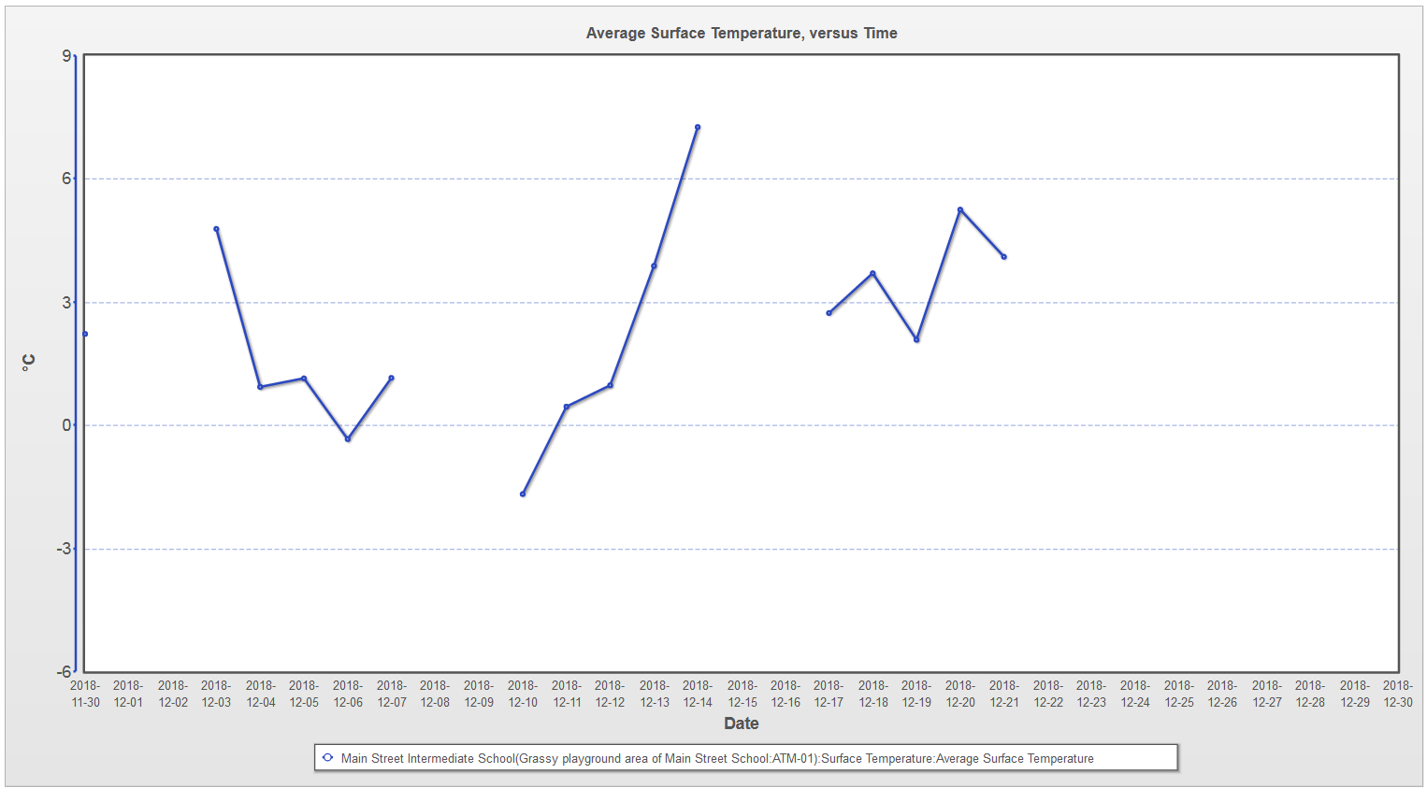
entered for project

