How have Macroinvertebrate populations in Norwalk Creek changed between
Fall 2015 and Fall 2018?

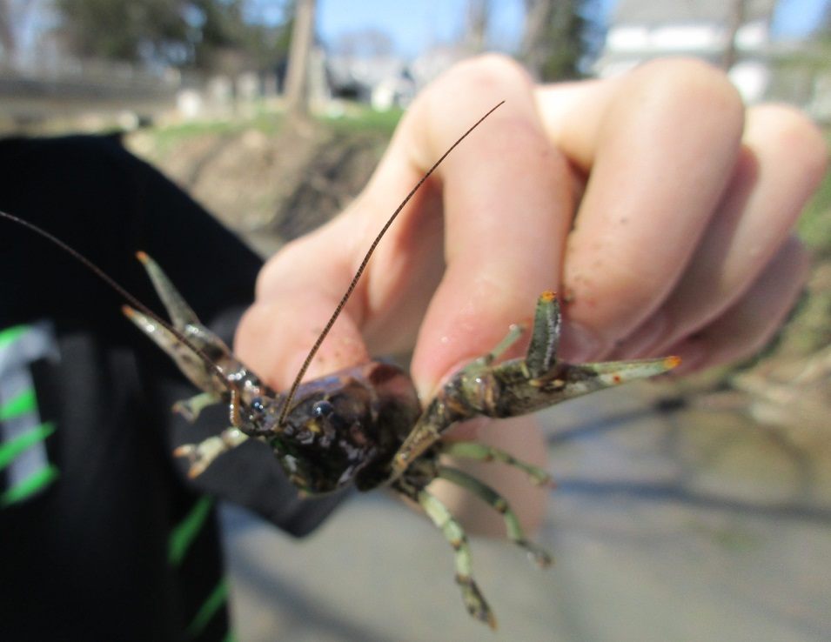

Main Street Intermediate School
Norwalk, Ohio USA
N41.24 latitude
W-082.61 longitude
April 2019
Contents

Summary ……………………..……………page 3
Purpose and Hypothesis ……....……….…page 4
Materials ……....................................…… page 4
Procedures ………………………………… page 5
Map showing data sampling site.………. page 6
Data charts …………………..….…………page 7
Conclusion …………………………..……...page 9
Questions for further study ………..…..…page 9
Resources ………………………..………page 10
Our data entered into GLOBE for project …page 10

Summary

Fifth grade students at Main Street Intermediate School investigated how water quality in the creek that flows through their town has changed using macroinvertebrates as bioindicators. Comparing GLOBE data taken in October of 2015 and in October of 2018, students concluded that the water quality in their creek has improved because more pollution sensitive macroinvertebrates were found in the 2018 sample. More research could be done to find out what caused the positive results so that the Norwalk Creek water continues to improve.

This research project was completed by grade 5 students at
Main Street Intermediate School in Norwalk, Ohio, USA.

Students

Evelyn Welschenbach, Emerson Ulery-Story, Ireland Ulery-Story,
Carly Pickering, Aldynn Metzger

Purpose and Hypothesis

Our school has been sampling macroinvertebrates as indicators of water quality in the same location in Norwalk Creek for several years. Norwalk Creek runs through the center of our town. The sampling site is at a small city park. We want to find out if the water quality has changed in a positive way in the creek over time. In this project we are looking at samples taken in October 2015 and comparing the data with the samples our group took in October 2018. We thought that even though there is a lot of grass and plant growing along the banks and in the creek so we think the water quality may have gotten more polluted over the years. We hoped this is not true because we want children and pets to be safe when they play in the creek.

Materials

- Macroinvertebrate data sheets

- Macroinvertebrate identification chart telling which is pollution sensitive, somewhat pollution intolerant, and pollution tolerant from www.vitalsignsme.org

- D-nets, white ice cube trays, hand lens, forceps, white dish pan

- www.globe.gov

- boots

Procedures

- Learn about what macroinvertebrates are and how they can be indicators of water quality.

- Learn how to sample macroinvertebrates in the creek using GLOBE protocols

- Plan a trip to the creek after school and collect samples using D-nets.

- Sort macroinvertebrates in ice cube trays, identify and count them and record on data sheet.

- One group member will have to keep watch over the macros so they do not escape or eat each other.

- Return macroinvertebrates to the creek.

- Enter data into www.globe.gov.

- Retrieve data from the GLOBE website for macroinvertebrate samples taken in 2015 at the same place in Norwalk Creek.

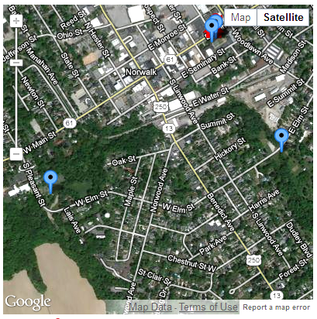
- Record sampling results on a chart to compare

Bremser Park

Our School
GLOBE Study Site along Norwalk Creek at Bremser Park
Google Earth map from www.globe.gov
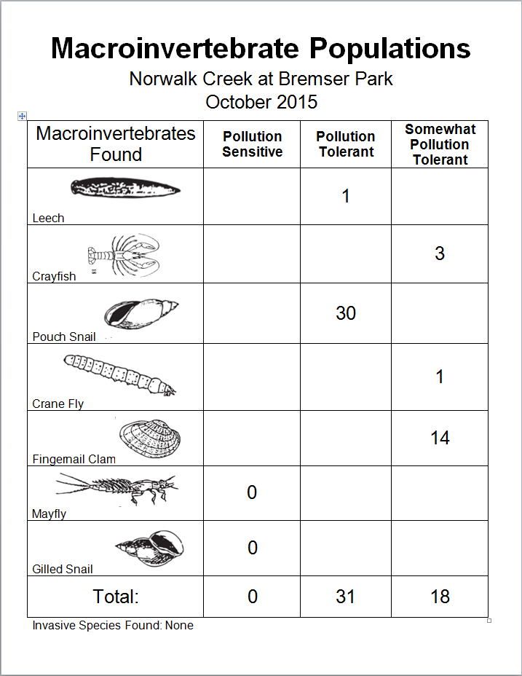

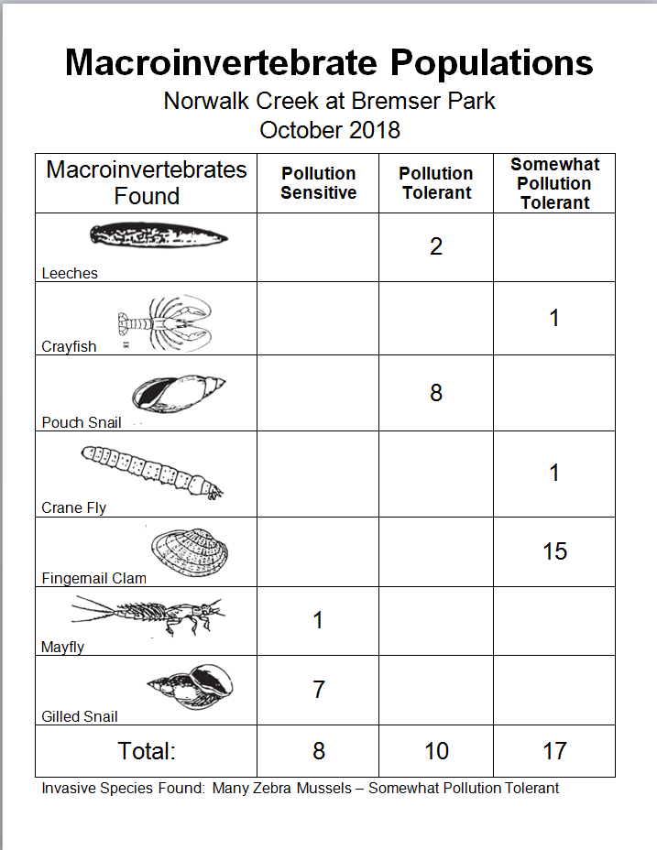
Conclusion

The purpose of our project was to find out if the water quality of Norwalk Creek at Bremser Park has change since October of 2015. We compared the 2015 data with our sampling we did in October of 2018. We thought the water quality might be worse than in 2015. We are glad that our hypothesis was not correct.
Our data shows that there were no pollution sensitive macroinvertebrates found in 2015 at this location in the creek. There were also many pollution tolerant species found including leeches and pouch snails. However, in the 2018 sample we found mayflies and gilled snails which are both pollution sensitive. This indicates that the water quality in this part of the creek has improved!
Two things that may have caused us to find more pollution sensitive macroinvertebrates is that there is more grass and plants growing along the banks and in the water. Our school did a creek cleanup for Earth Day in 2016.
Some things that can improve our research is to not splash in the creek so much when sampling with D-nets. We could also compare chemistry test data for water quality to see if that data gives us similar results that we found with using macroinvertebrates as indicators.

Questions for further study
- How will the macroinvertebrate populations compare at different locations along our creek?

- How do the macroinvertebrate indicators for water quality compare with the chemistry tests for water quality? (pH, turbidity, nitrates, dissolved oxygen, temperature, phosphates)

Resources for Project
- www.globe.gov for learning GLOBE protocols, data sheets, and entering macroinvertebrate data

- www.vitalsignsme.org for macroinvertebrate identification chart and categories for water quality indicators

- Ms. Burns, our science teacher for helping us learn how macroinvertebrates can indicate levels of pollution in streams

GLOBE macroinvertebrate data
entered for project
