Abstract
In order to investigate the correlation between PM_{2.5} and various factors in the air in the Keelung area in winter, the Arduino development version was used to make the air box to observe the value of PM_{2.5}, and the original data and standardized data were used to compare the air condition. The value of the factor is to explore whether thePM_{2.5} in the Keelung region will change due to environmental factors, and then determine the scope of influence according to the change of the situation. The comprehensive analysis will assess whether the source of PM_{2.5} in the Keelung region is from overseas or It is the impact of domestic activities.
The results show that the PM_{2.5} in winter in Keelung has different degrees of relationship with temperature factors such as temperature, humidity, rainfall, and wind direction. According to the relationship between wind direction, rainfall, and PM_{2.5}, it can be judged whether it is from overseas pollution. This experiment gives us a better understanding of the impact of special geographical conditions in the northeast corner of Keelung on PM_{2.5} pollution and it’s sources.

( Keywords: PM_{2.5}, Arduino, Air Factor)

1.Research motivation
In recent years, global warming has become increasingly serious, leading to many serious changes in the global environment. Among them, the pollution of airborne particles can be said to be the first harm. Because the Keelung area has been affected by rainfall for many years, the data value of PM_{2.5} is slightly lower than that of other parts of Taiwan. However, it is located at the northernmost tip of Taiwan. The Keelung in winter is affected by the northeast monsoon and is a good source for overseas input. The gateway city, therefore, we want to explore the correlation between PM_{2.5} and our environmental wind field, temperature, humidity, and rainfall, find out the changes in PM_{2.5} concentration at different factors to determine the impact of pollution in our territory. Or caused by overseas transmission.

2. Research purposes
a. Observing the data of the Keelung station
b. Analysis of data from the Environmental Protection Agency's(EPA’s) station and self-made air box observations
c. Analysis of the correlation between Keelung air factor and PM_{2.5}
(1) Exploring the direction of wind and PM_{2.5}
(2) Exploring the relationship between rainfall and PM_{2.5}
(3) Exploring the relationship between temperature and PM_{2.5}
(4) Exploring the relationship between humidity and PM_{2.5}
(5) Photographing visibility photo analysis and air factor correlation

3.Research equipment
a.software program:
(1) Excel: Organize data.
(2) Little painter: screenshot, cropping pictures, drawing.
(3) Fritzing: draw a wiring diagram of the homemade air box.
(4) Google Map: draw the location of each station.
(5) Arduino: Design program.
(6) Word: Produce a description of the work.
b.Observation equipment
In this study, a total of three self-made observation stations were set up. Table 1 shows all the equipment parts used in this study in triplicate and placed in three observation sites of A, B, and C respectively.

Table 1 Observation equipment list
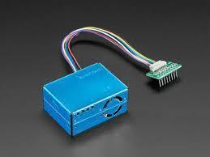 | 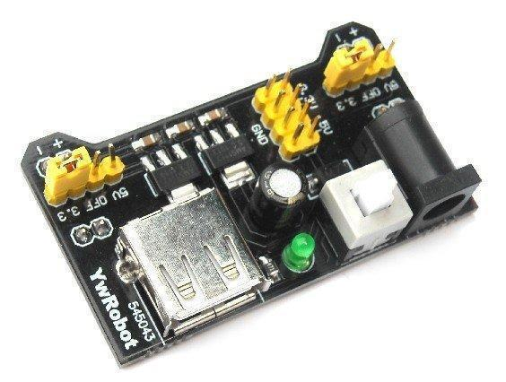 | 
PM_{2.5} sensor | Breadboard power supply module | Arduino MEGA board
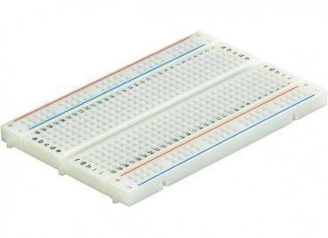 |  | 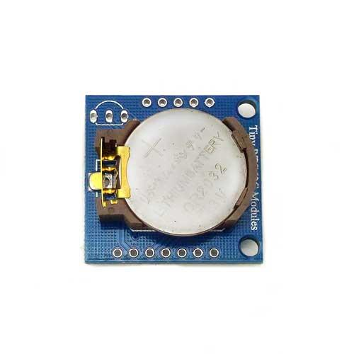
Breadboard | Arduino development board USB cable | DS1307 time module
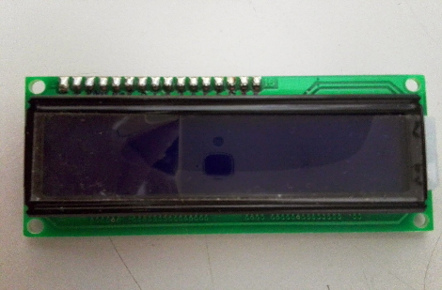 | 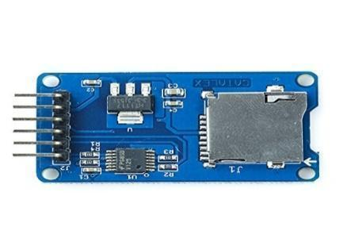 | 
LCD display LCD1602 | SD memory card module | Temperature and humidity module

c. Airbox wiring location map:

We made it out using Fritzing drawing software, including the placement of
our modules and the wiring pins.
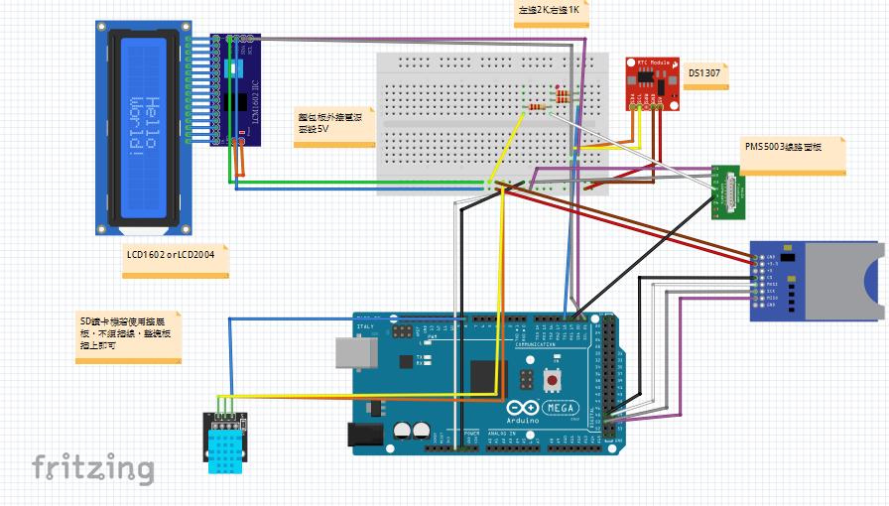
Figure 1

4.Research process or method

a.Foreword:
It is mentioned in the literature that when the wind speed is low, high temperature may cause the increase of air pollutant volatilization, accelerate the photochemical reaction, and increase the concentration of PM_{2.5} (中央研究院，2017). In addition, the concentration of PM_{2.5} in specific regions is susceptible to wind direction. The effects of wind speed, precipitation and humidity will also vary. For example, when the north winds in the Kinmen area, the value of PM2.5 will be high, so the value of PM_{2.5} in winter (northeast wind) is generally high. It is understood that the Kinmen area is mainly affected by overseas sources. (金門縣科展，民96), and high of the data is in Taiwan is the Keelung City, PM_{2.5} is polluted by overseas countries up to 63% of the city, cause to the city's overseas pollution the highest (see Table 2) (余國賓，2018 ).

Table 2 Domestic primary, derivative and overseas transmission contribution tables
of municipalities, counties, and cities

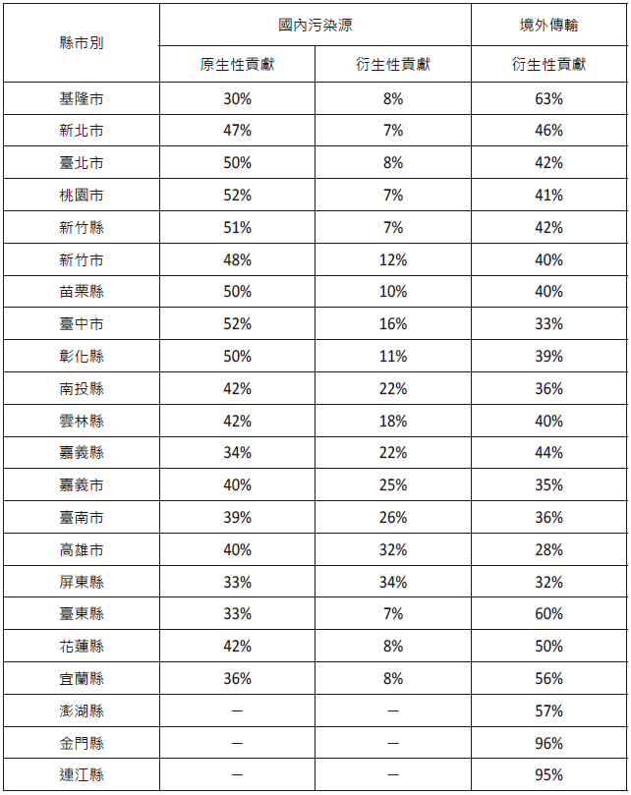

b.experimental design:
(1) Comparing with the EPA’s information
We first designed the Arduino instrument to observe the suspended particles, temperature and humidity, and set an observation every 15 minutes.
After that, we will find relevant trends from the data and use the EPA , Central Meteorological Administration and Keelung City respectively.
The information of the weather station in the Anle High School assists in the availability of our observations.
1. Observation time 2/12-3/27 days (six weeks).
2. The location of the Arduino observer is shown in Table 3.
(2). Observation location:
1. When the LCD screen is offline (about 5 seconds), the power is turned off, and the system is closed. Then take off the SD card uses the card reader to copy the text file (test.txt) to the computer, and open the text file with EXCEL to make use of it. The "space" separation setting converts the text data into fields in EXCEL.
2. After reformatting the memory card (using FAT or FAT32 format, not NTFS
format), insert it back into Arduino. After reconnecting the power, record the
new Arduino

Table3 Self-made air box station list
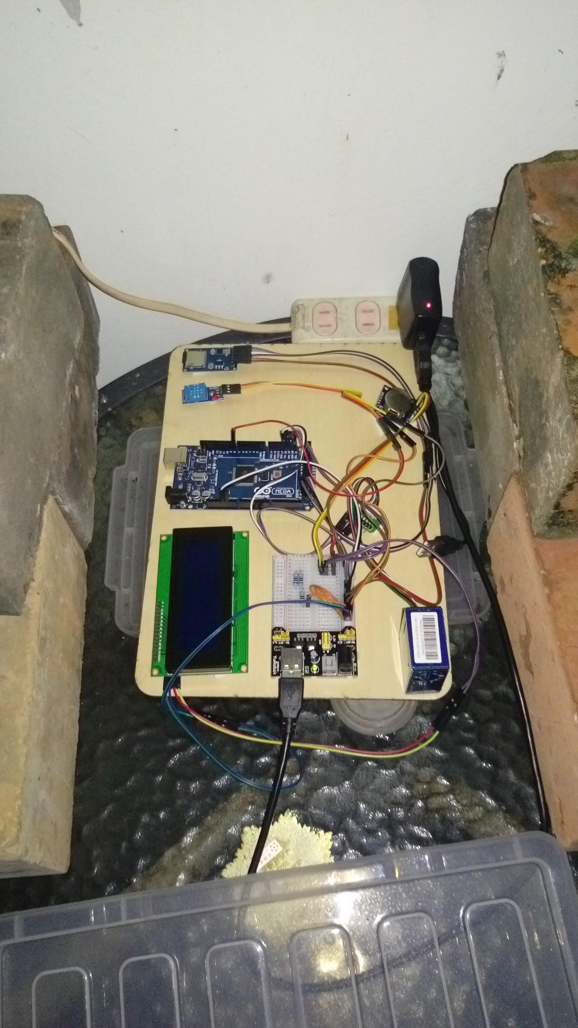 | 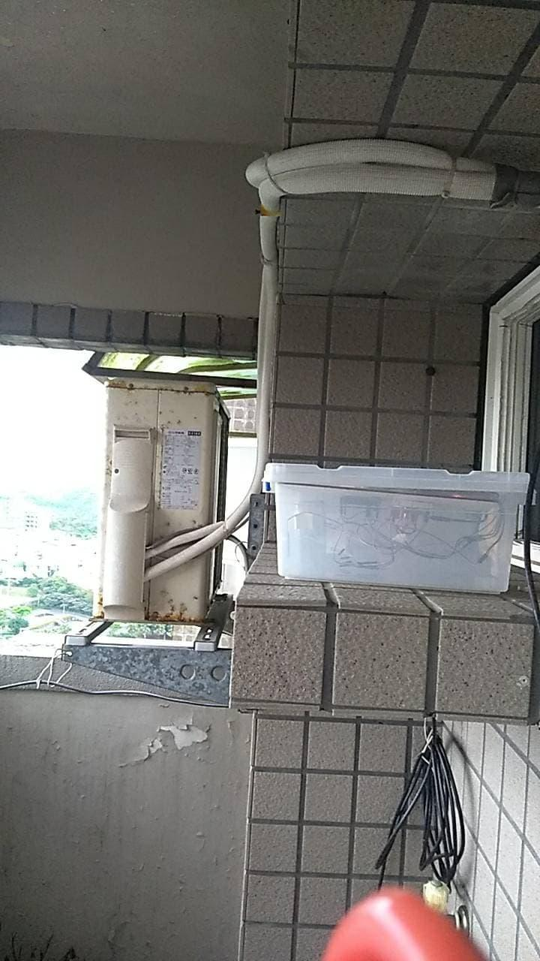 | 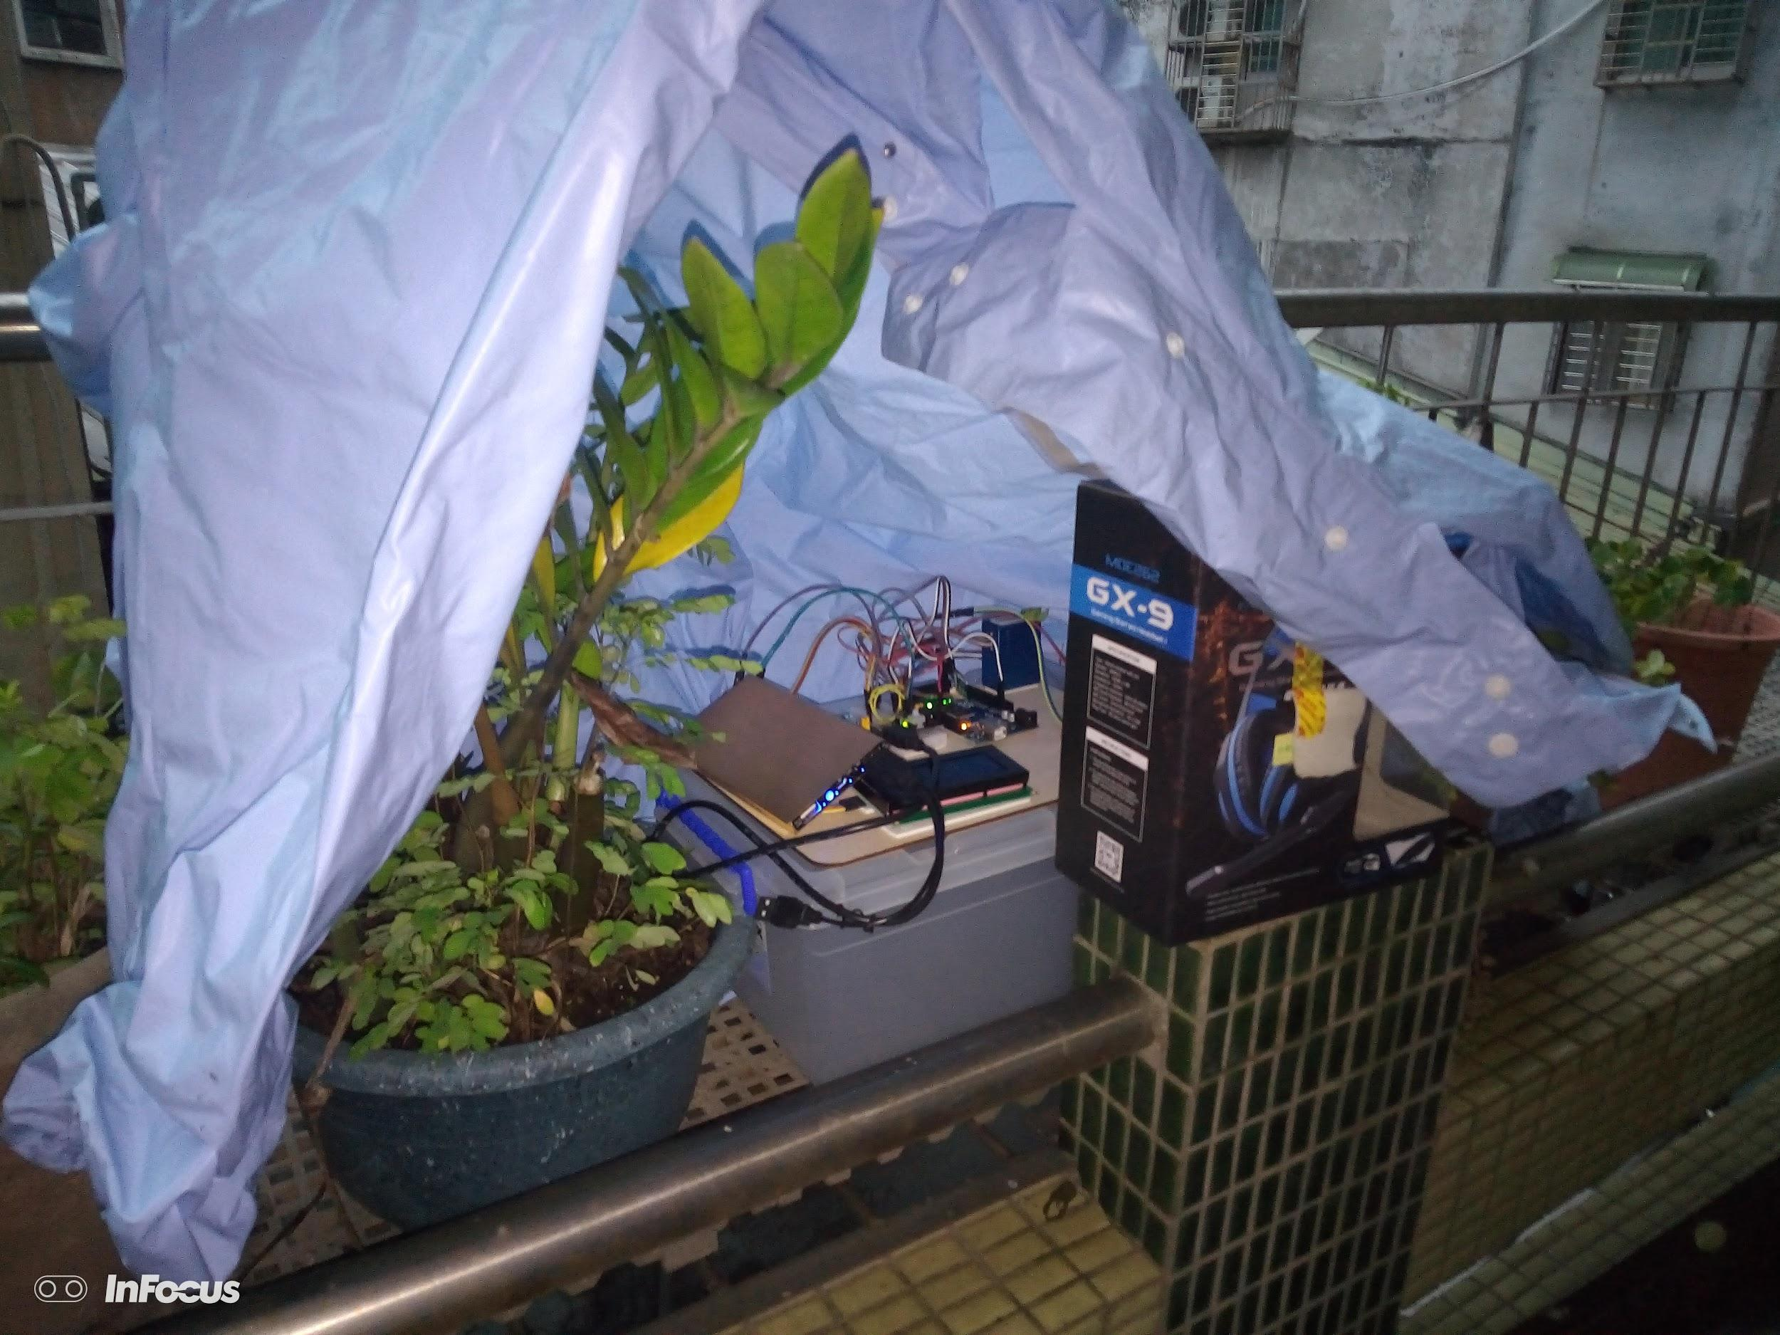
Station A: An Yi Road,  Anle District, Keelung City | Station B: Xinfeng Street, Zhongzheng District, Keelung City | Station C: Fuxing Street, Renai District, Keelung City

c.Research process: Figure 2 is the flow chart of this study.

Figure 2

Reading literature

Confirmation topic

Buying parts

Learning to assemble an air box

Design Arduino program

Placed at three points A, B, and C to start observation

Presupposition conclusion

Query data from various stations in Keelung area

Analysis of the correlation between PM2.5 and various factors of air

Analysis chart

Problems and discussions

Verification conclusion

d. research methods
(1) Data collection
(a). Internet access to the EPD and the Central Meteorological Administration
(a1) Find PM_{2.5}, rainfall, humidity, and wind direction per hour in the station
data.
(a2) Use the value found to make a chart to see the correlation (hilly terrain).
(b) Define the value of the chart
(b1) The data is measured per hour (in original is per 15 minutes).
(b2) Except for the data of NA, and the exact value is not regarded as 0 (Example: # indicates that the instrument check is invalid value * indicates that the program check is invalid, X indicates that the manual check is invalid, A refers to the instrument. The invalid value NR generated by the suspected fault the alarm indicates no rain).
(c) The relative positions of the various stations in Keelung and each of the stations in the study
We use "Google Map" to map the location of all stations used in this study (see Figure 3, Table 4), and we can see the relative position of the self-made airbox and the reference station. (The final decision is not to use the information of the Peng Jiayu station)
(d) Place the homemade airbox at the A, B, and C positions of the station, start the test and collect the data required for the study.

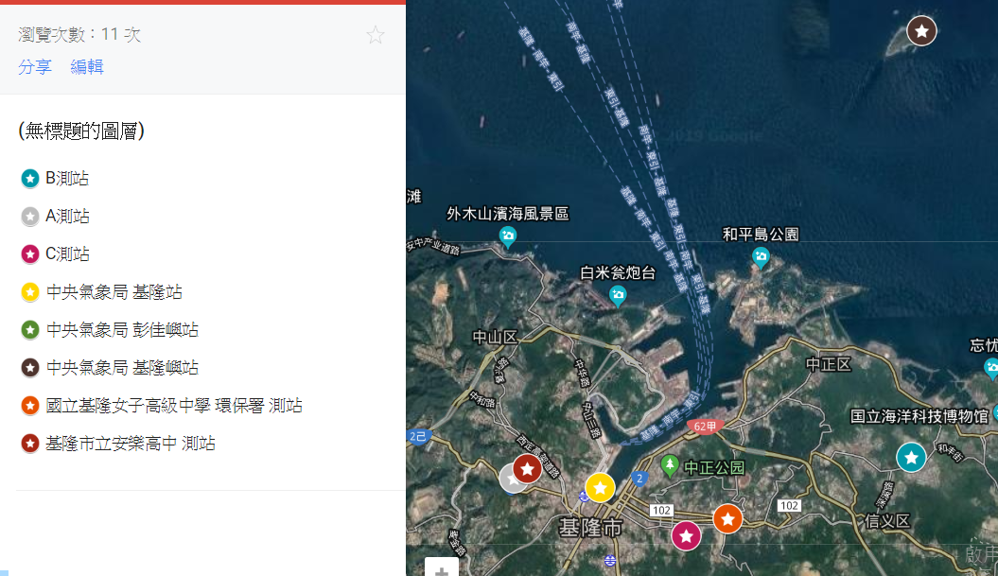
Figure 3 Location of each station in Keelung

Table 4 Reference station aerial view and altitude list
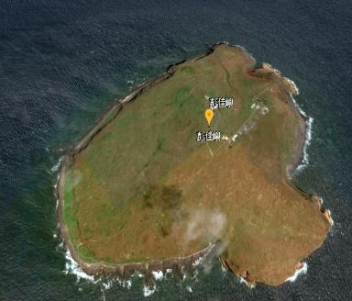 | 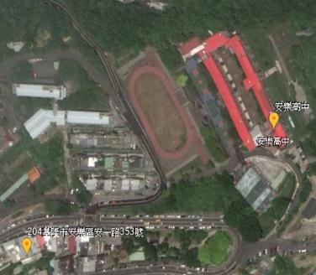 | 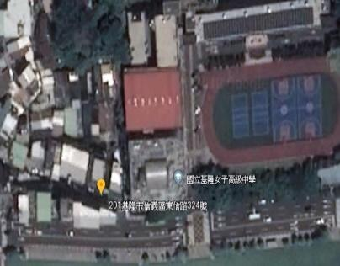
Central Weather Bureau  Keelung Island Station  Altitude: 99m | Keelung City Anle High School Station  Altitude: 66m | Keelung Environmental Protection Agency Station  Altitude: 17m
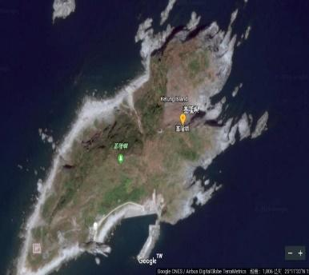 | 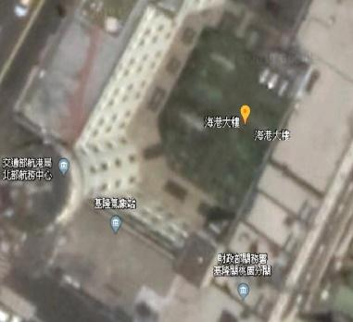
Central Weather Bureau Peng Jia Island  Station Altitude: 86m | Keelung Central Meteorological Bureau Station  Altitude: 26.7m

(2) Analysis chart
(a) Calculate the average and standard deviation of all observation data of the
respective stations.
(b) Calculate the number of rains and no rains at the reference station.
(c) Analysis of the relationship between rainfall delay and PM_{2.5} Definition: The average hourly value is greater than or equal to 50 for a bright yellow light
(d) Define the wind direction with 16 azimuth angles, and use 16 azimuths and
self-made function to calculate the wind direction value by 22.5°.Calculate the ratio of the latter item of the hourly PM_{2.5} to the previous item, and determine whether it is affected by rainfall and has a self-cleaning effect.
(e) Calculate the correlation coefficient between PM_{2.5} and temperature and
the humidity of each station.
(f) Standardize the raw data of PM_{2.5} at each station to observe the difference
between the three stations.
(3) Drawing a chart
(a) Draw a plot of the original data of the PM_{2.5} of the Environmental Protection Agency and the original data of temperature, humidity, and rainfall.
(b) Draw a plot of PM2.5 for the three stations and the original data for temperature,
humidity, and rainfall.
(c) Draw a line chart of the standardized data of the PM_{2.5} of the three stations.
(d) Draw a radar chart of the wind direction of the three stations.
(e) Draw the ratio of the PM_{2.5} of the three stations and the line chart of the rainfall data.
(f) Draw a map of PM_{2.5} and wind direction and rainfall data from the three stations.
(g) Make a list of basic statistics for the three stations.
(h) Make a list of correlation coefficients between PM_{2.5} and temperature and humidity for the three stations.

5.Research results

a. Observing the data of the Keelung station
(1) It can be seen from Fig. 4 that the temperature change of the Keelung station in February is not large, and the correlation between PM_{2.5} and temperature is not obvious, but when PM_{2.5} rises, the temperature is slightly increased; It can be seen that the temperature fluctuation of the Keelung station in March is more obvious, and the curve of PM_{2.5} and temperature shows the same situation of the same rise and fall. However, from Fig. 5, it was found that during the special period, around March 7th, PM_{2.5} was obviously high but the temperature did not rise significantly.

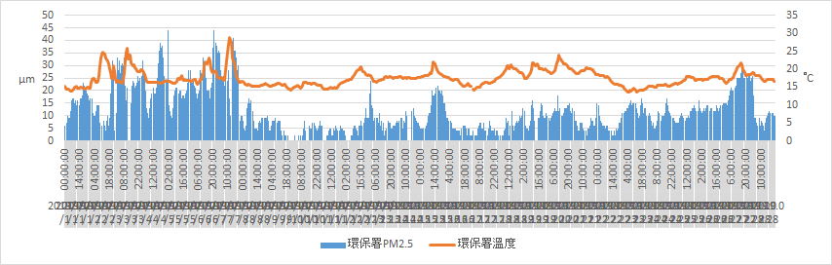
Figure 4 The relationship between PM_{2.5} and temperature of the Environmental Protection Agency Keelung Station in February 2019
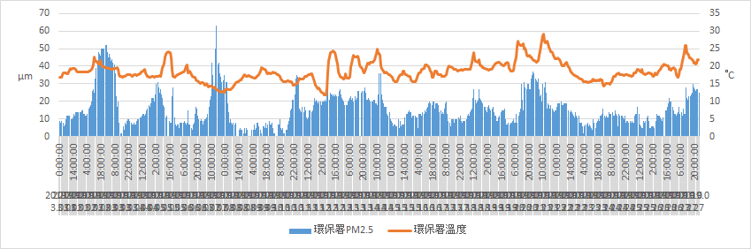
Figure 5 Relationship between PM_{2.5} and temperature of the Environmental Protection Agency Keelung Station in March 2019

(2) It can be seen from Fig. 6 and Fig. 7 that PM2.5 will be reduced 1 to 2 hours after the occurrence of rainfall at the Keelung station. However, it can be seen from Fig. 6 and Fig. 7 that there are two cases where there is no decrease in PM_{2.5} after rain, and the occurrence interval is around February 24 and March 7.
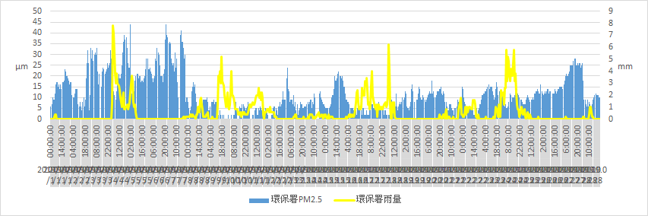

Figure 6 Relationship between PM_{2.5} and rainfall in the February 2019 of the Environmental Protection Agency's Keelung Station
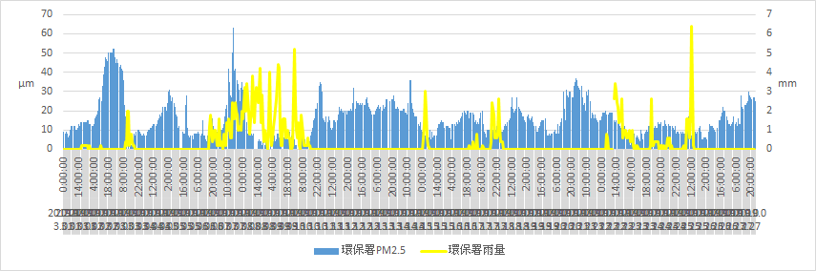
Figure 7 Relationship between PM_{2.5} and rainfall in the 2019 March of the Environmental Protection Agency's Keelung Station

(3) It can be seen from Fig. 8 that when the humidity of the Keelung station is not changed greatly in February, the humidity is slightly decreased when the PM_{2.5} rises; the humidity of the Keelung station in March is shown in Figure 9. The change is more obvious, and more data shows that when the PM_{2.5} rises, the humidity is also slightly lower.

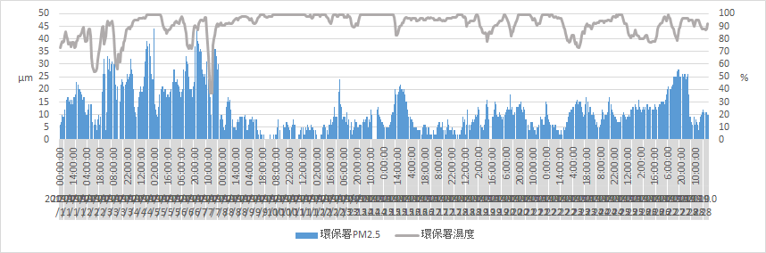
Figure 8 Environmental Protection Agency Keelung Station February 2019 PM2.5 and humidity relationship diagram

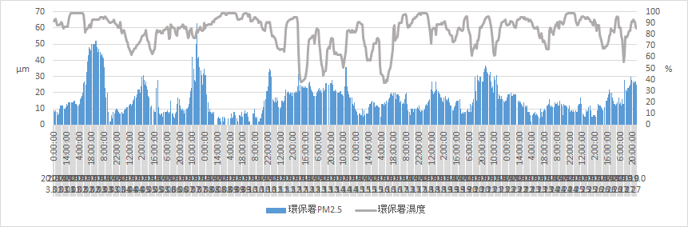
Figure 9 Relationship betweenPM_{2.5} and humidity of the Environmental Protection Agency Keelung Station in March 2019

b. Analysis of data from the Environmental Protection Agency's station and self-made
air box observations
(1) Figure 10 to Figure 12 are comparisons between the C station and the EPA because the distance between the two is close to that of other stations. The correlation coefficient of the PM_{2.5} data of the effective data of the Environmental Protection Agency's Keelung Station and the C Station is 0.59821965, showing a moderate positive correlation, indicating that the Keelung station data has a linear relationship with the C station. It can also be seen in Figure 8. The data of the two groups have the same corresponding curve; the correlation coefficient between the temperature of the Kelon station and the C station of the Environmental Protection Agency is 0.940067, which is highly positively correlated, the value of the C station is high; the humidity trend is wide, the EPA The correlation coefficient between the temperature of the Keelung station and the C station is 0.196715, showing a low positive correlation. It may be that the position of the airbox of the EPA station relative to the C station is more susceptible to dry cold wind, resulting in different humidity trends. It can be seen that PM_{2.5} , temperature, and humidity are positively correlated. Therefore, we quote the rainfall data of the Environmental Protection Agency's Keelung Station as the reference data for the C station.

(2) The most consistent time for the PM_{2.5} trend was from March 6th to March 7th.There were no large-scale domestic activities on the day, and it was inferred that it was affected by overseas pollution. The data from March 14 to March 22 of the C station was unfortunately lost.

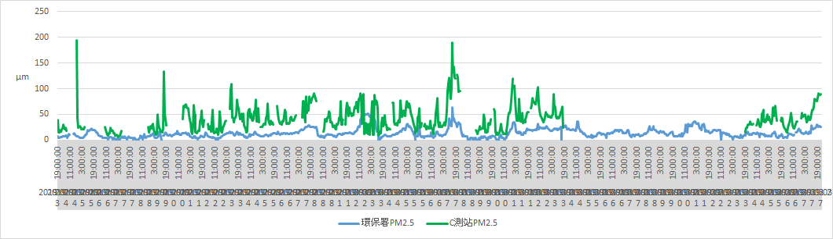
Figure 10 Comparison of PM_{2.5} between the Environmental Protection Agency's Keelung Station and C Station
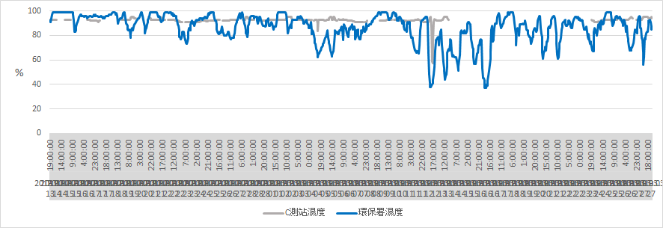
Figure 11 Comparison of humidity between the Keelung station and the C station of the Environmental Protection Agency
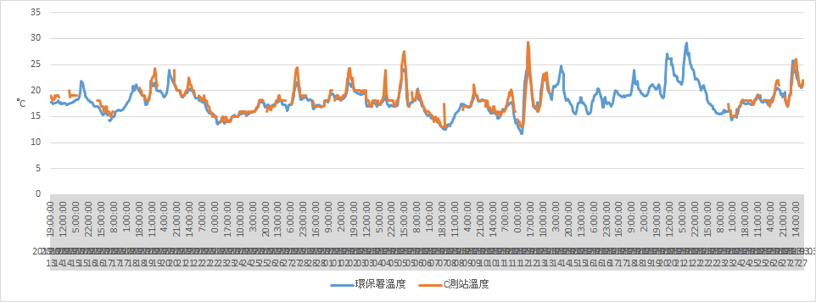
Figure 12 Comparison of temperature between the Keelung station and the C station of the Environmental Protection Agency

c. Observing the correlation between Keelung air factor and PM_{2.5}

(1) Figure 13 shows the value ofPM_{2.5} measured by the self-made air box at the three stations A, B and C during the observation period. It can be seen that the trend of PM_{2.5} at the three stations A, B and C is close, but there is There will still be high differences, which may be caused by terrain, wind direction, rainfall, and other factors, which may be natural or artificial.

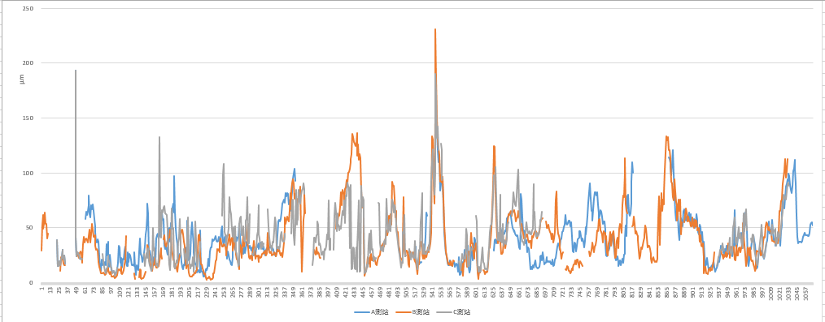
Figure 13 A, B, C station PM_{2.5} trend chart (A: blue, B: orange, C: gray)

(2) Table 5 is a basic statistical list of the measured data of the self-made air box at the A, B, and C stations during the observation period. The rainfall data of the A station refers to the central information of the Keelung City Anle High School Station and the B station. The rainfall data of the Keelung Station and the C station of the Meteorological Bureau are referred to the Keelung Station of the Environmental Protection Agency. The total rainfall hours are summed by the number of rainfall observations in the number of valid observations of the A, B and C stations. The average rainfall is the average when there is rainfall; Table 6 is a list of the correlation coefficient between PM_{2.5} and temperature and humidity of the data measured by the self-made air box at the A, B, and C stations during the observation period.

Table 5 List of basic statistical data of stations
 | Station A |  | Station B |  | Station C
 | average value | Standard deviation | average value | Standard deviation | average value | Standard deviation
PM_{2.5}(μm) | 39.8352 | 24.3189 | 39.5204 | 28.3435 | 42.9005 | 25.7864
humidity(%) | 90.4481 | 9.4145 | 92.7914 | 1.2654 | 92.52 | 2.3915
temperature(°C) | 17.8646 | 3.1055 | 18.8307 | 6.4992 | 18.19 | 2.5402
rainfall(mm) | 0.4884 |  | 1.1746 |  | 2.051
Effective number of documents | 772 | 772 | 913 | 913 | 1106 | 1106
Total rainfall hours | 289 |  | 166 |  | 206

Table 6 List of correlation coefficients between PM_{2.5} and temperature and humidity at each station
 | Station A | Station B | Station C
PM_{2.5} and temperature | 0.3151 | 0.0782 | -0.0901
PM_{2.5} and humidity | 0.0162 | 0.2215 | -0.0121

(3) According to Table 6, it can be found that PM_{2.5} has little relationship with humidity. According to Fig. 14, it can be seen that the relationship between humidity and PM_{2.5} is in accordance with Table 6. It can be seen that PM_{2.5} will also increase when the humidity rises; Figure 15 shows that the relationship between PM_{2.5} and humidity is low. Correlation; Figure 16 is suspected because of the large disturbance caused by terrain and human factors, and the data is less complete, the humidity does not change much, so the relationship between PM_{2.5} and humidity is not seen.
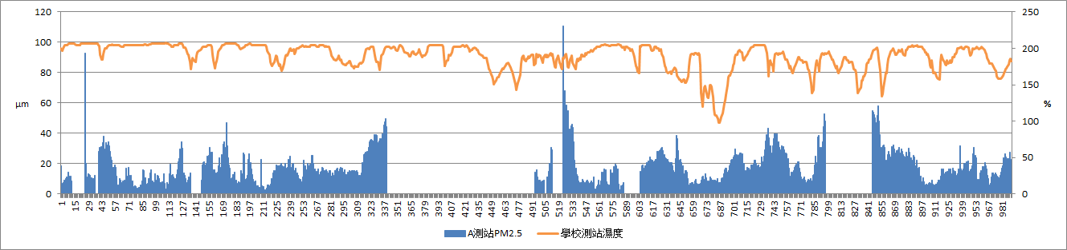
Figure 14 Diagram of PM_{2.5} and humidity in station A

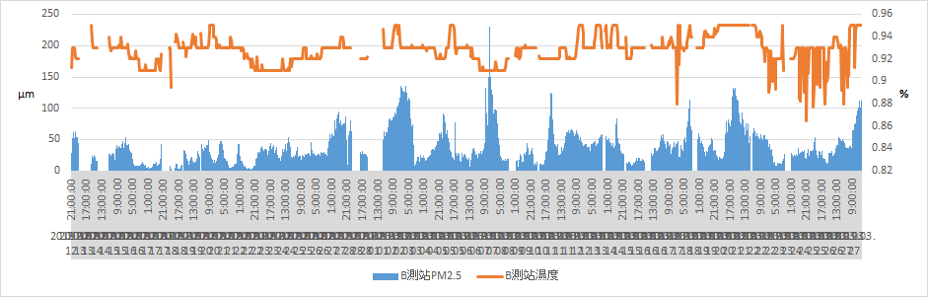
Figure 15 B station PM_{2.5} and humidity diagram
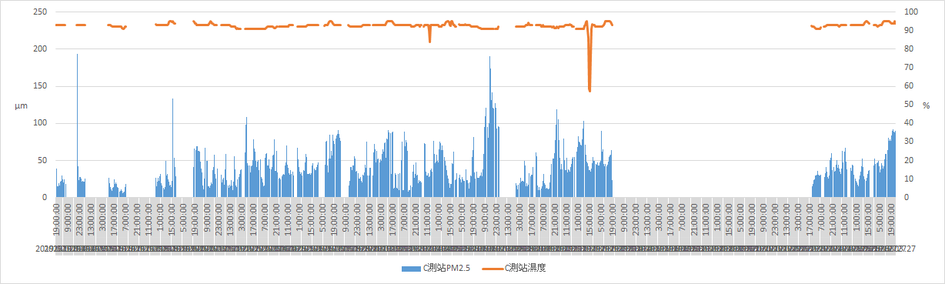

Figure 16 C stationPM_{2.5} and humidity relationship diagram

(4) It can be seen from Fig. 17, Fig. 18, Fig. 19 that PM_{2.5} will drop significantly
when there is rainfall. According to Fig. 17, it can be seen that when it rains, the value of PM_{2.5} will decrease, which can be found from the red circle. However, due to a large number of data damage, it cannot be well-explained thatPM_{2.5} has an opposite trend to rainfall; Figure 18 shows that PM_{2.5} has an opposite trend to rainfall (compared to Figure 17); according to Figure 19, it can be seen that PM_{2.5} will plummet when it rains, but the same data has faults and there are not many observations.
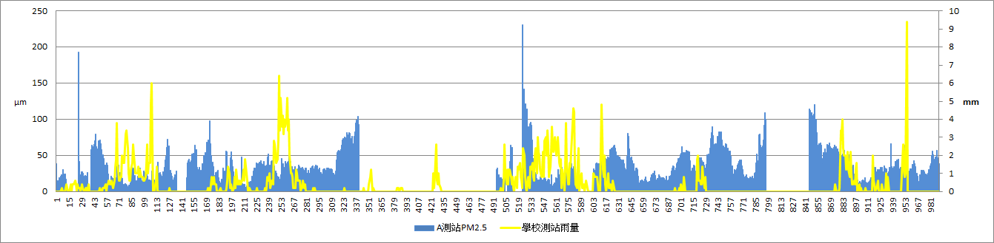
Figure 17 Diagram of PM_{2.5} and rainfall in A station

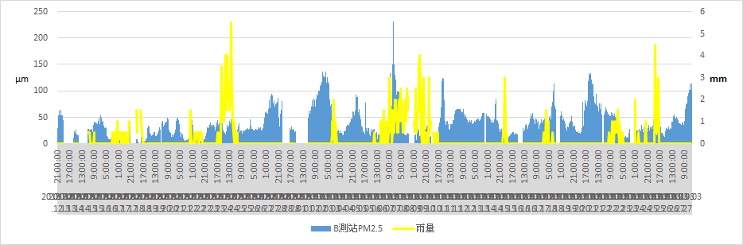
Figure 18 Diagram of PM_{2.5} and rainfall in B station

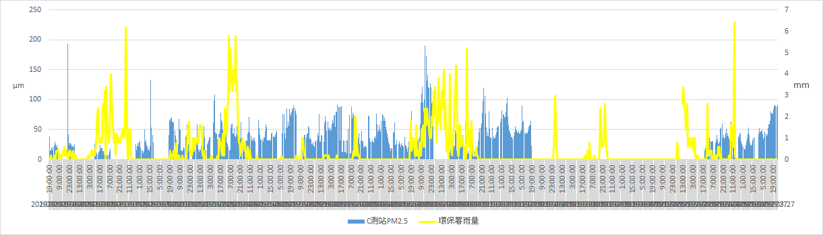
Figure 19 Relationship betweenPM_{2.5} and rainfall in C station

(5) The station B data is relatively complete, and the number of available data is the most, so the station B PM_{2.5} ratio (the latter item except the previous item) is used. The material and rainfall are drawn. When it rains, the PM_{2.5} ratio will decrease from greater than 1 to less than 1, the ratio map is more obvious than the original data map.

Green line: PM_{2.5} ratio Blue line: rainfall
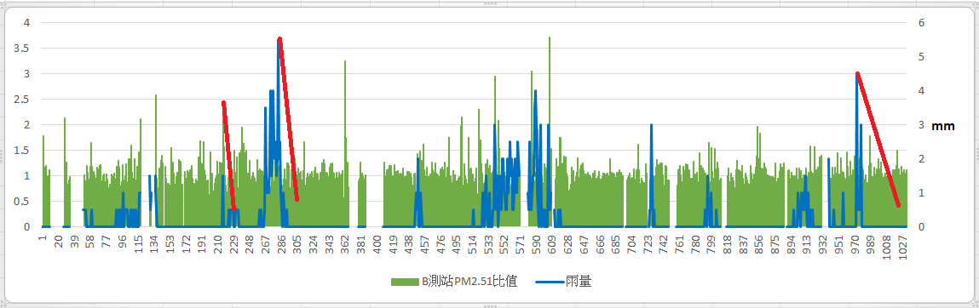
Figure 20 B station PM_{2.5} ratio, rainfall

(6) According to Fig. 21, Fig. 22, Fig. 23, it can be found that the value of PM_{2.5} increases with the increase of temperature, and the trend is quite obvious. The C station is consistent with the Environmental Protection Agency's Keelung station and the C station is similar to the A and B stations. There is little difference in temperature between different places.

Orange: Temperature Blue: PM_{2.5}
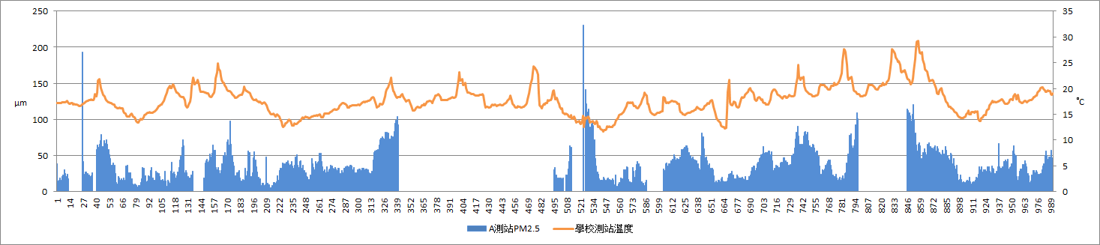
Figure 21 A station PM_{2.5}and temperature diagram
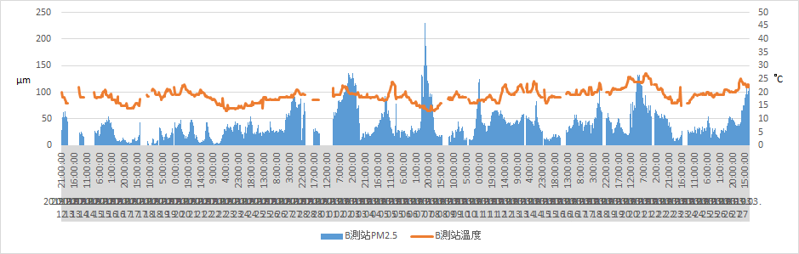
Figure 22 Diagram of B station temperature and PM_{2.5}
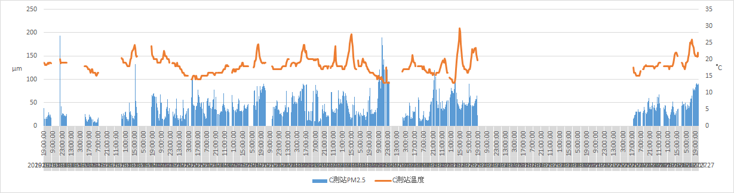
Figure 23 Relationship betweenPM_{2.5} and temperature in C station

(7) It can be seen from Fig. 24 and Fig. 25 that the PM_{2.5} value is also related to the wind direction. When the PM_{2.5} rises, almost all of the north wind or the northeast wind blows. In Figure 24, it can be clearly seen that thePM_{2.5} value does not fall and rises when it rains from 3/6 to 3/10. In the northerly winds, Keelung did not have any activities that would cause air pollution, so it was decided that the time was overseas pollution.

Green line: PM_{2.5}, yellow line: rainfall, blue point: wind direction
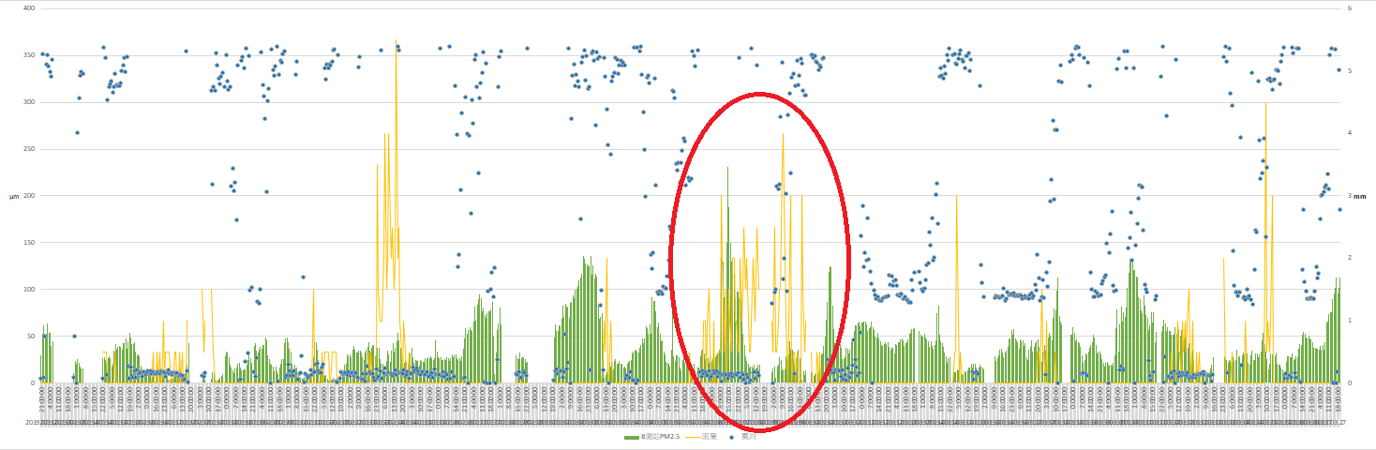
Figure 24 Diagram of PM_{2.5}, rainfall and wind direction at station B

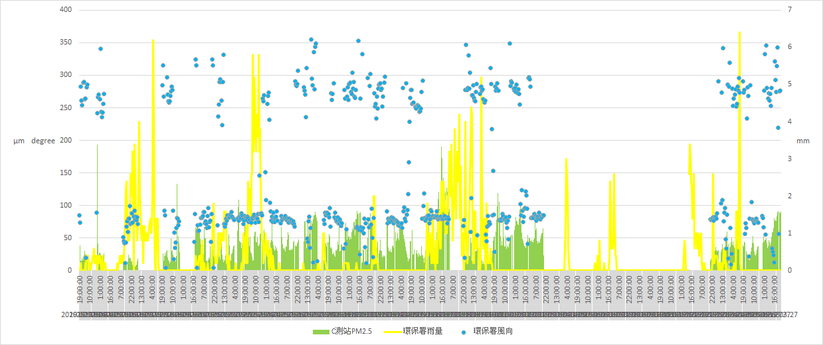
Figure 25 Relationship between PM_{2.5}, rainfall and wind direction at C station

(8) Standardized map of A, B and C stations Figures 26, 27, and 28 show that there are differences between the three stations, which may be caused by terrain, wind direction, and others. There are differences, but it can be seen that in the same environmental field, the PM_{2.5} value trend is about the same. If you increase the station, you can reduce it. Less PM_{2.5} difference.
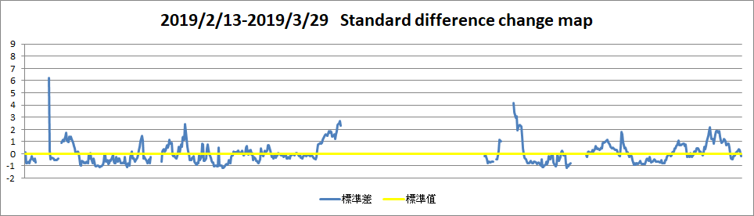
Figure 26 Standardized value ofPM_{2.5} value at station A

Blue line: PM_{2.5} table normalization value, orange line: Y=0 standard
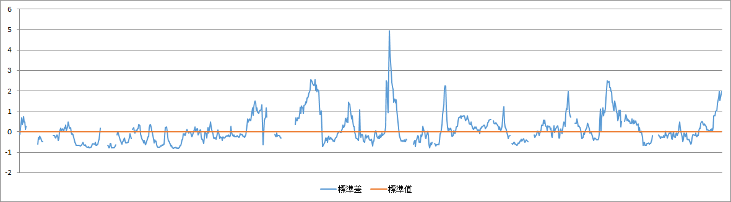
Figure 27 Normalized value of PM_{2.5} value of station B
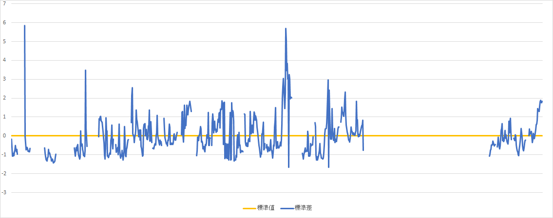
Figure 28 Standardized value of PM_{2.5} value of C station

d. analyze the correlation between the visibility of the captured image and the null factor We will divide the visibility into 1KM, 6KM, 9KM, 1KM for Guanghua National House, and 6KM for Keelung City Funeral Hall. The bone tower and 9KM are the Wufenshan meteorological radar station, which is used to judge the weather of the day, compared with the PM2.5 at that time. However, visibility is easily affected by weather factors such as humidity and cloudiness at the time.

Table 7 7:00 visibility list of 2019.1.11-2019.3.20
 | 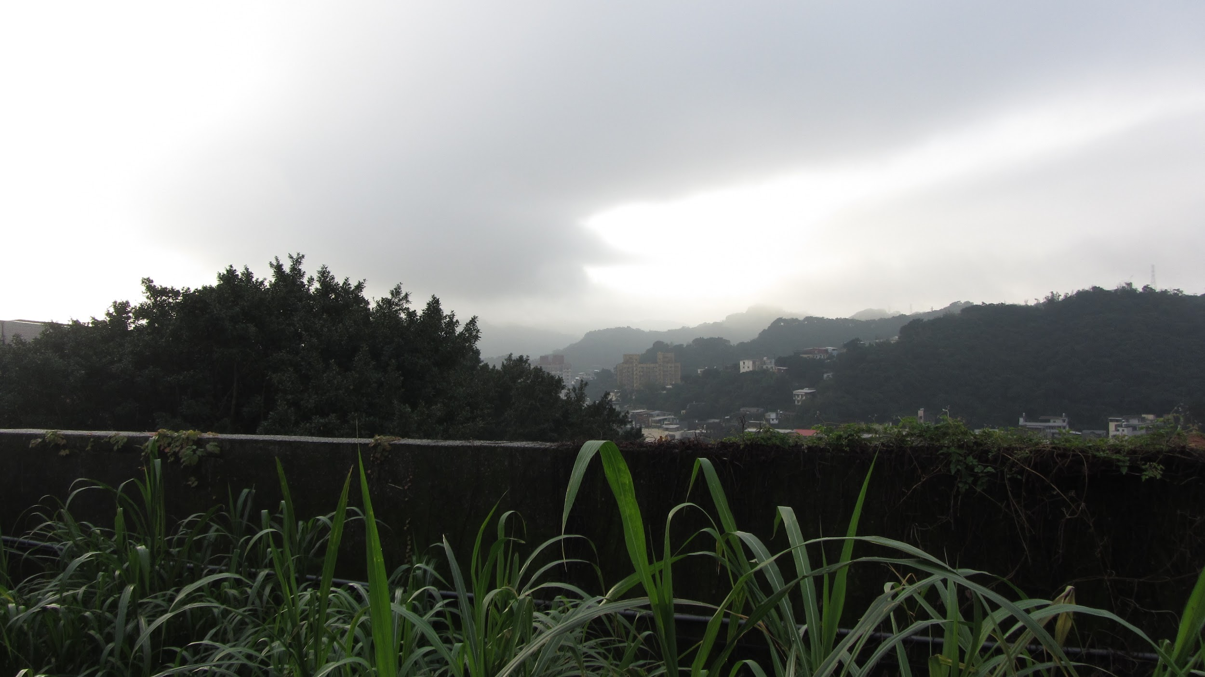 | 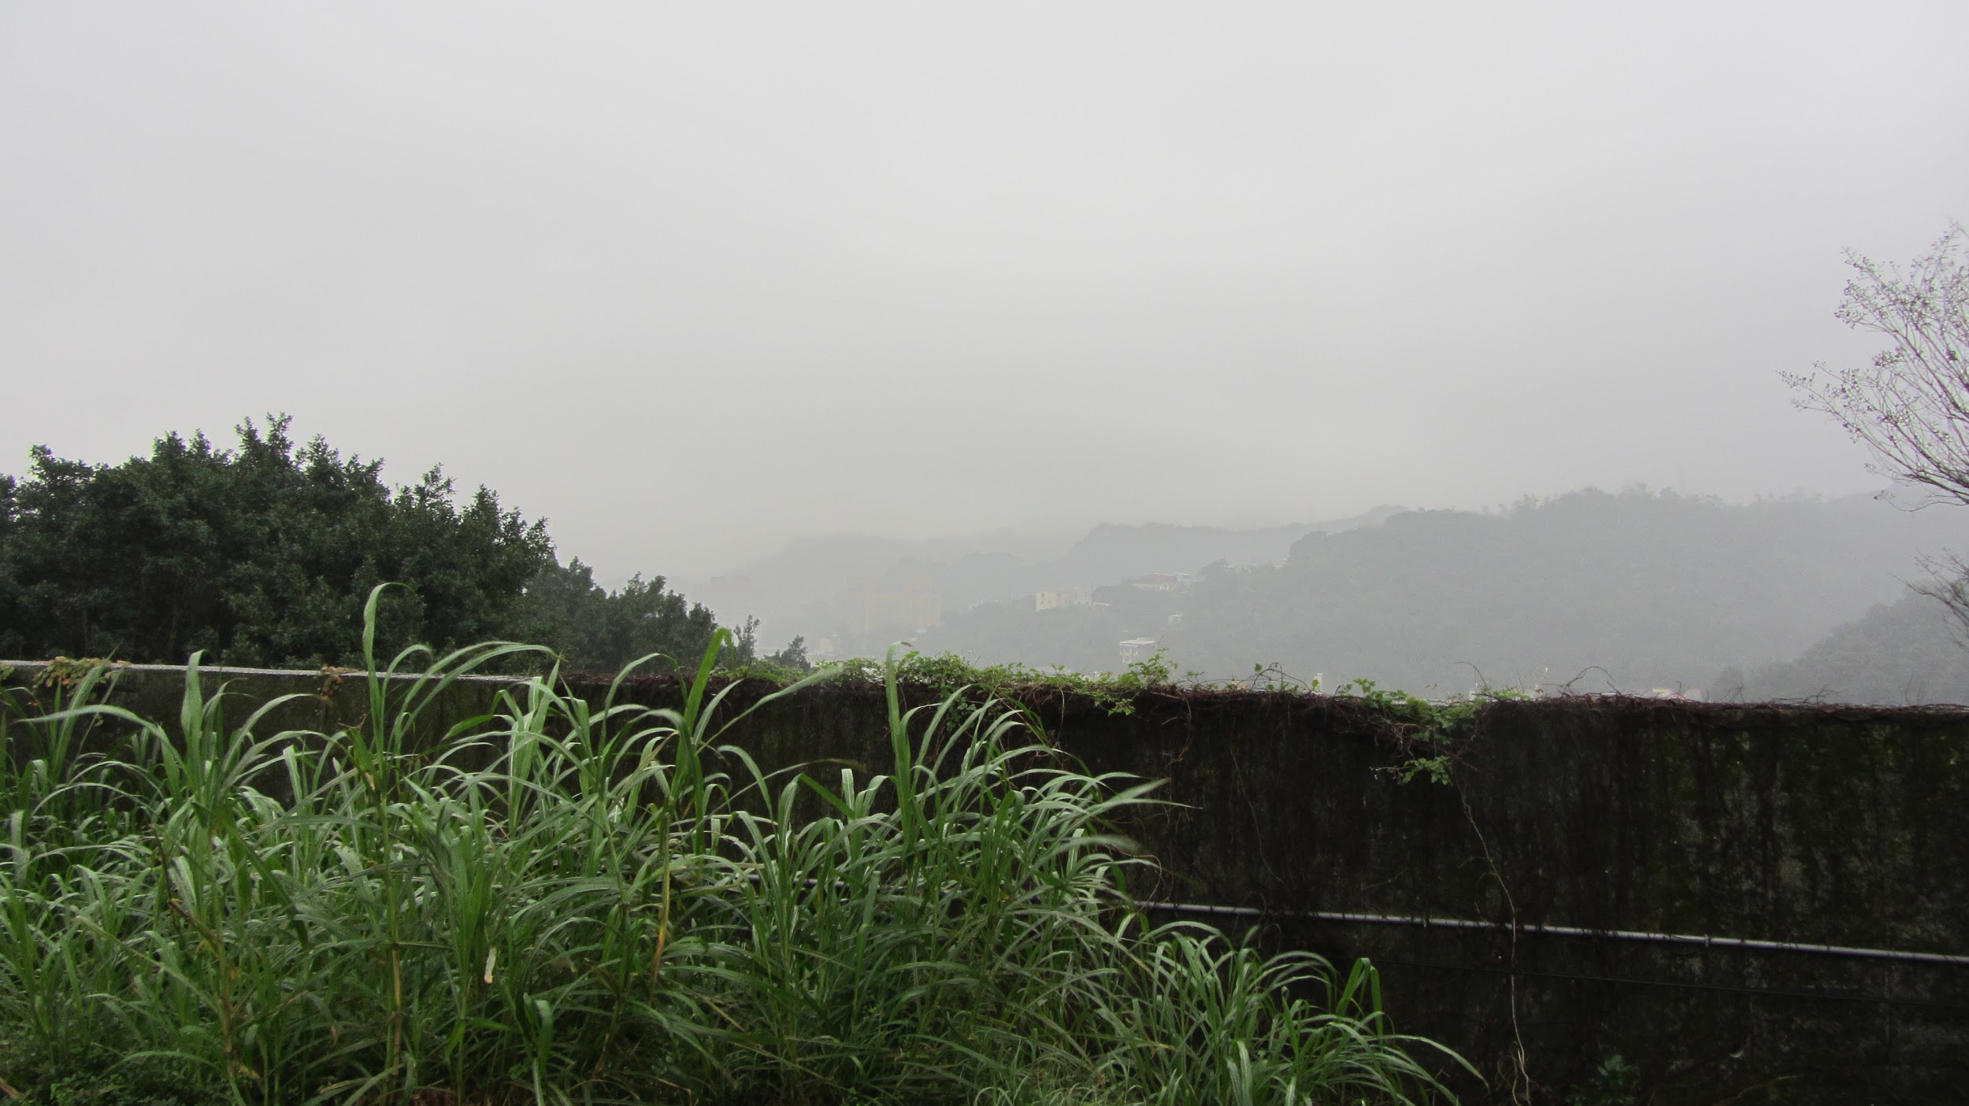 | 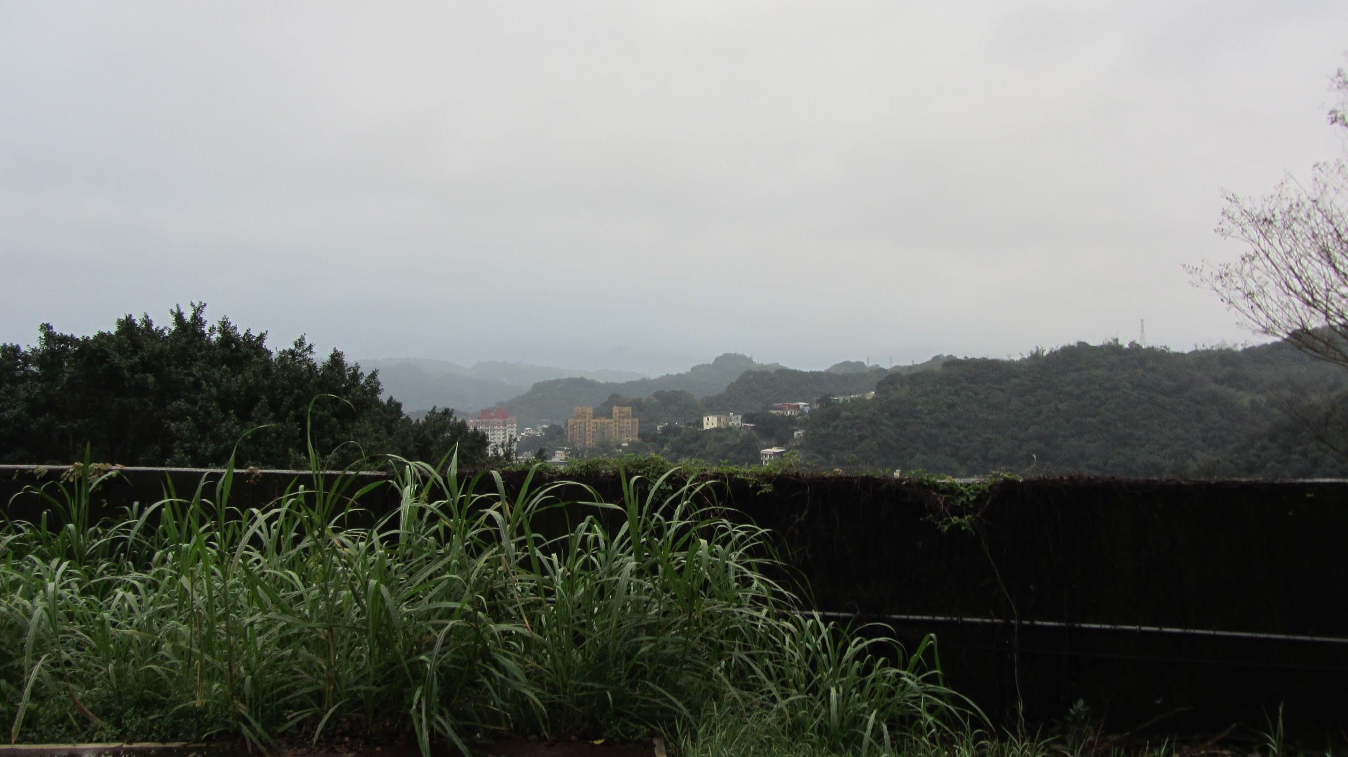 | 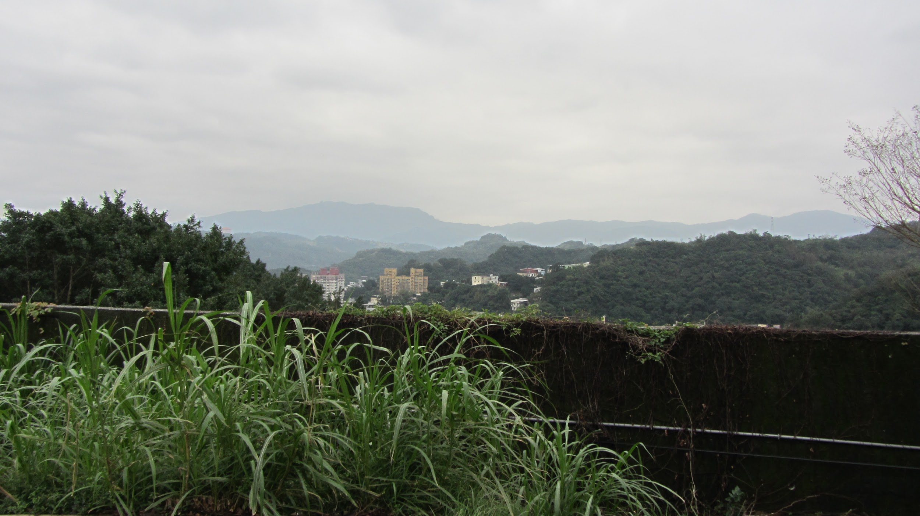 | 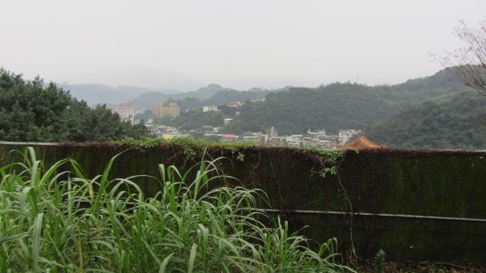 | 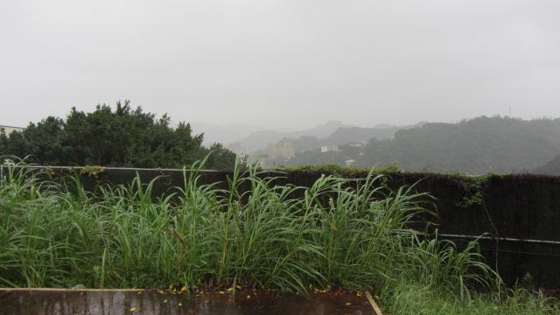 | 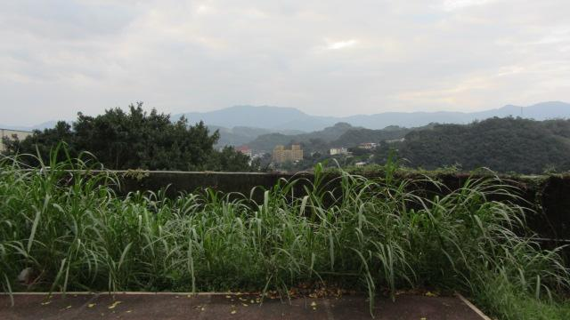 | 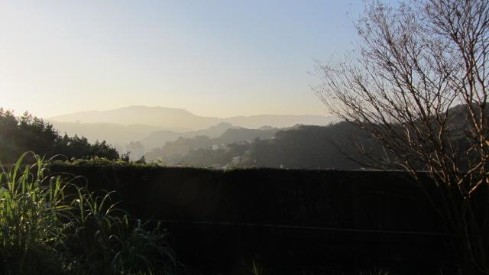 | 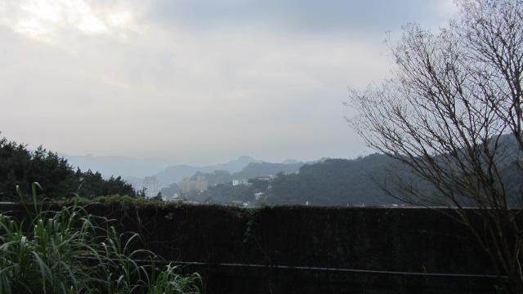 | 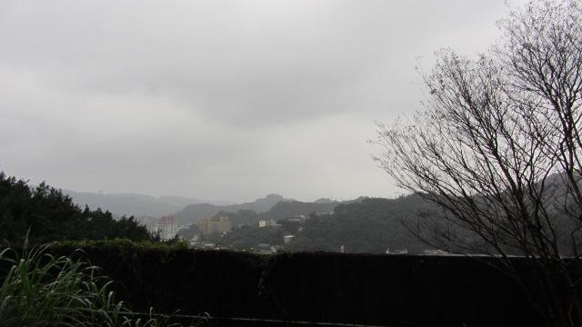
1/10 | 1/11 | 1/12 | 1/13 | 1/14 | 1/15 | 1/16 | 1/18 | 1/19 | 1/20 | 1/21
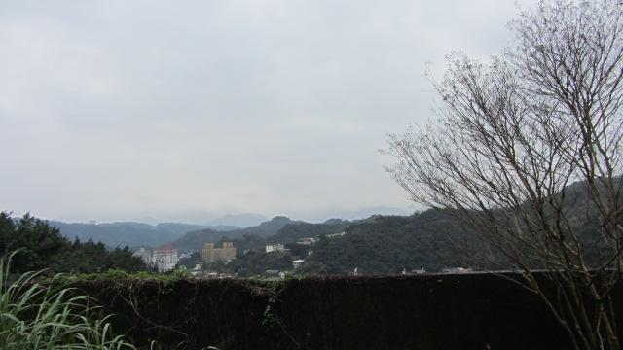 | 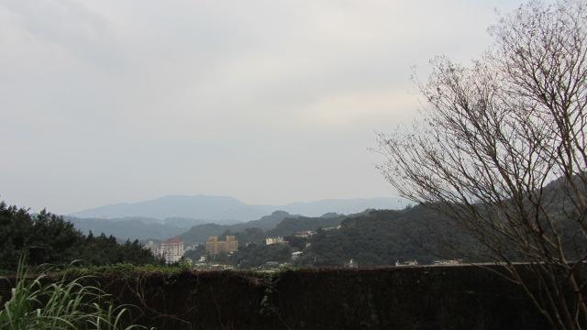 | 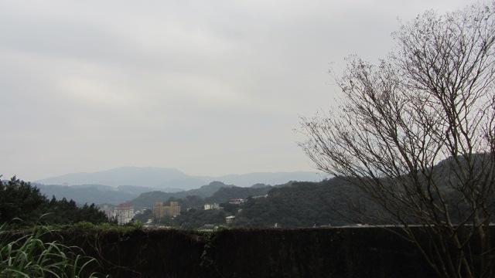 | 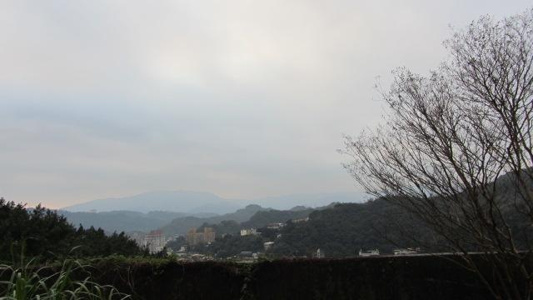 | 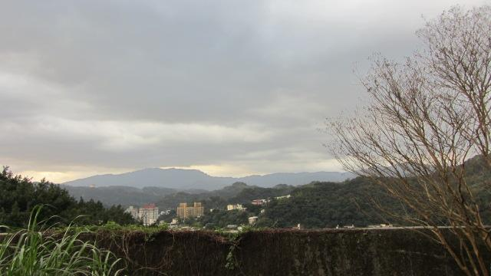 | 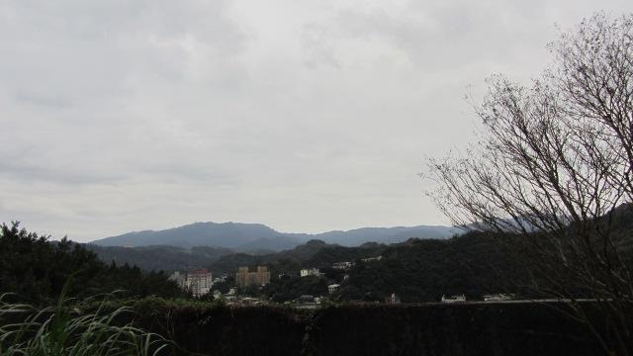 | 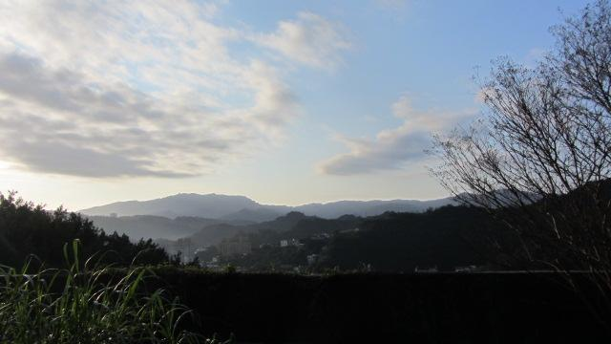 | 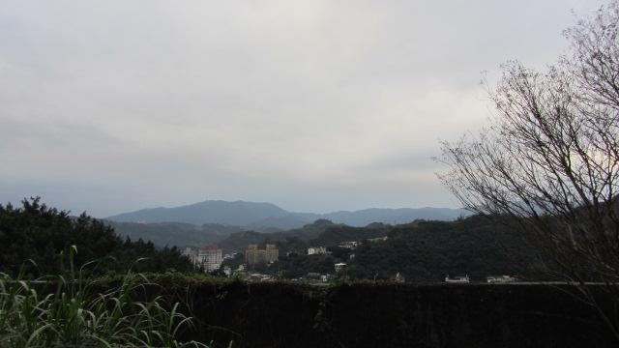 | 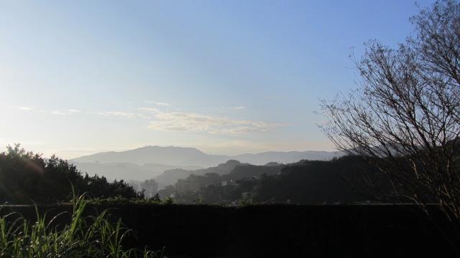 | 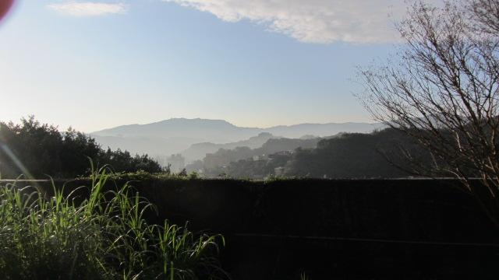 | 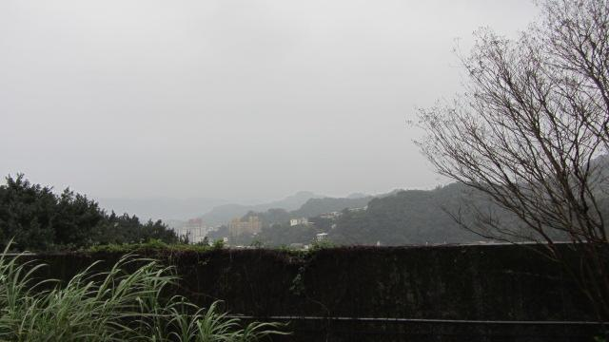
1/22 | 1/23 | 1/24 | 1/25 | 1/26 | 1/27 | 1/28 | 1/29 | 1/30 | 1/31 | 2/1
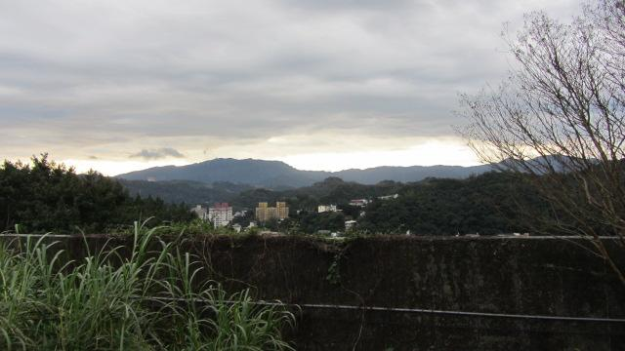 | 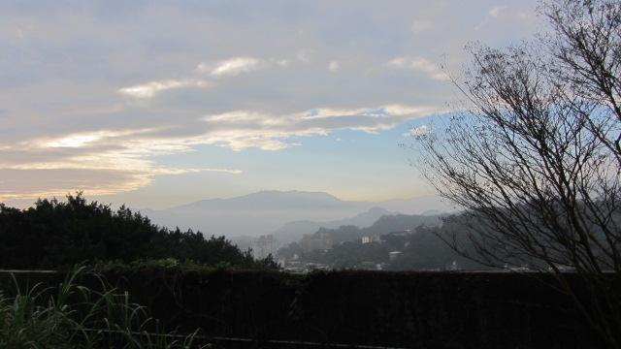 | 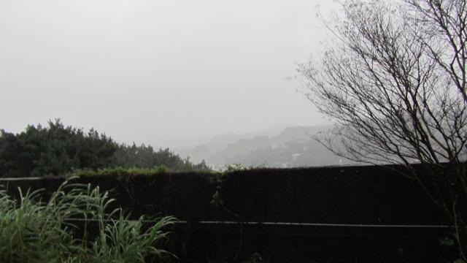 | 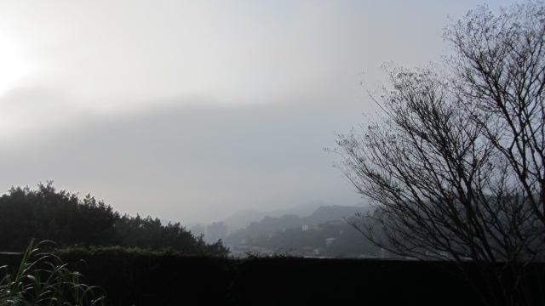 | 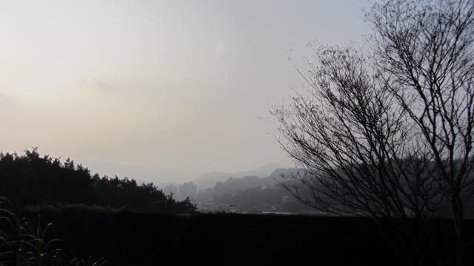 | 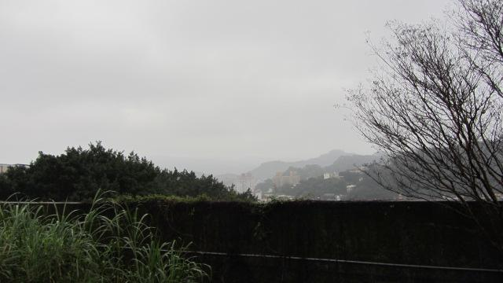 | 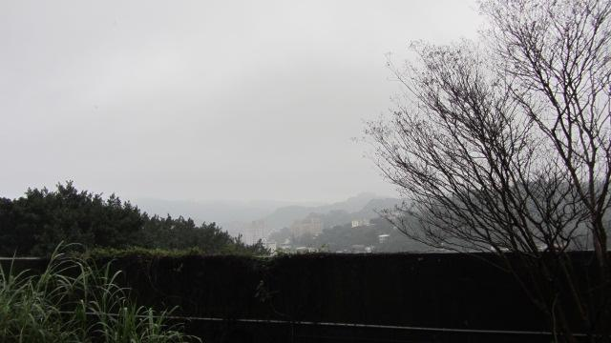 | 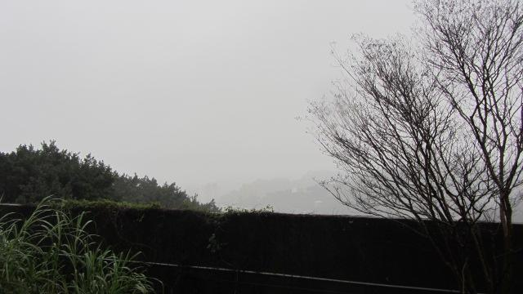 | 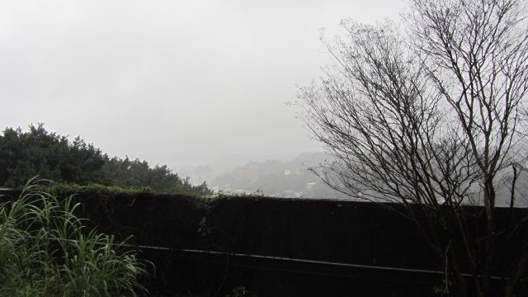 | 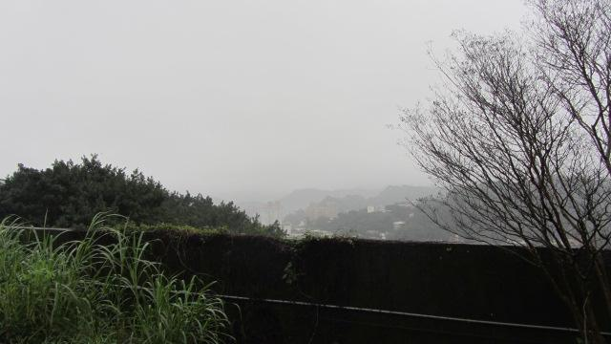 | 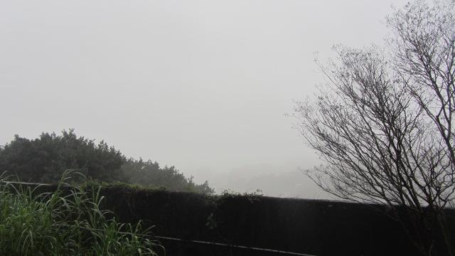
2/2 | 2/3 | 2/4 | 2/6 | 2/7 | 2/8 | 2/9 | 2/10 | 2/11 | 2/14 | 2/15
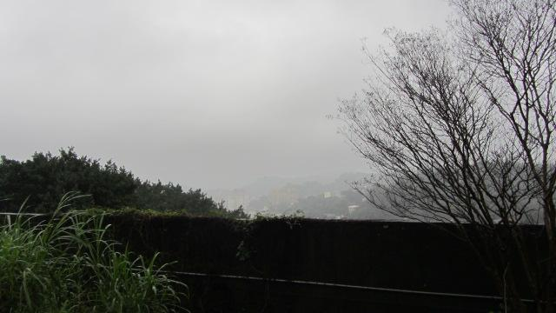 | 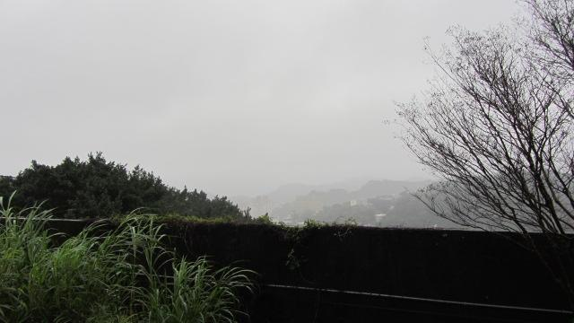 | 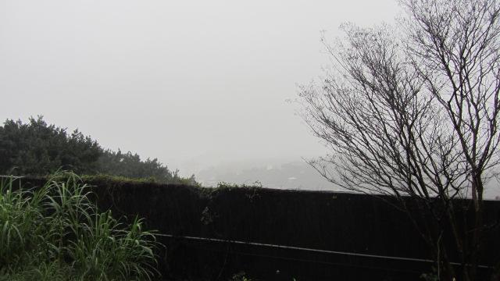 | 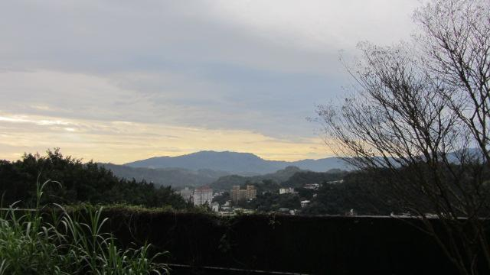 | 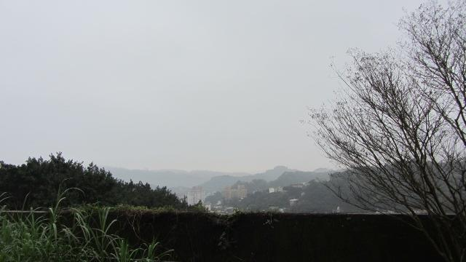 | 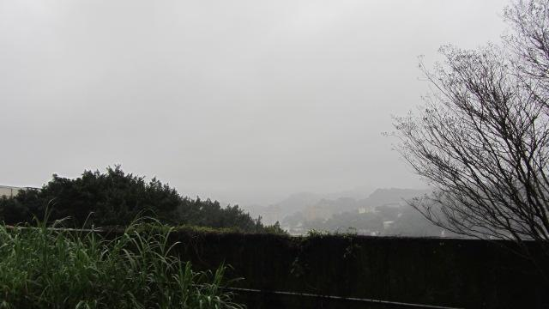 | 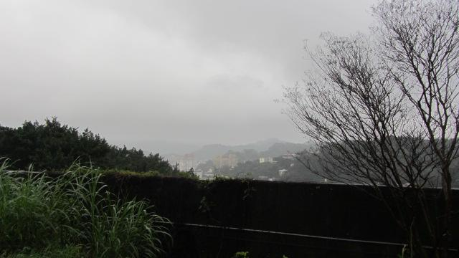 | 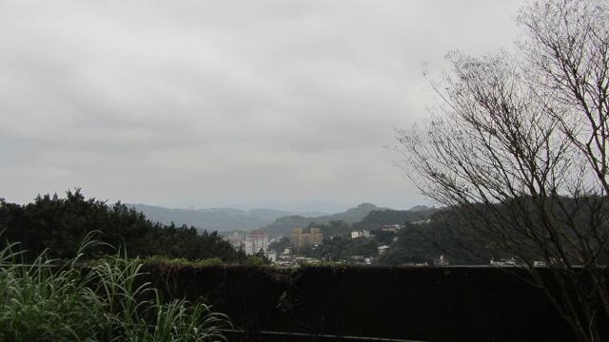 | 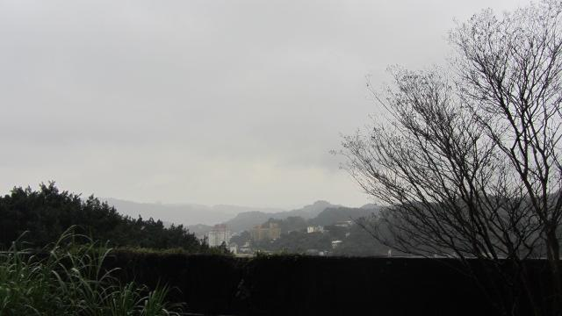 | 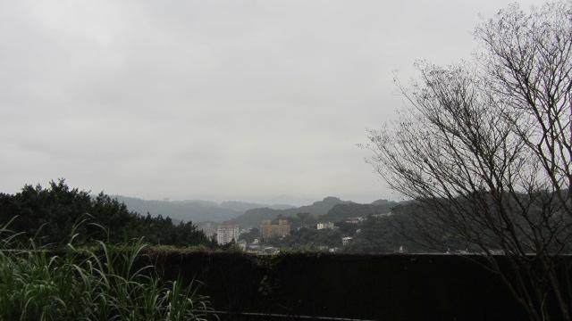 | 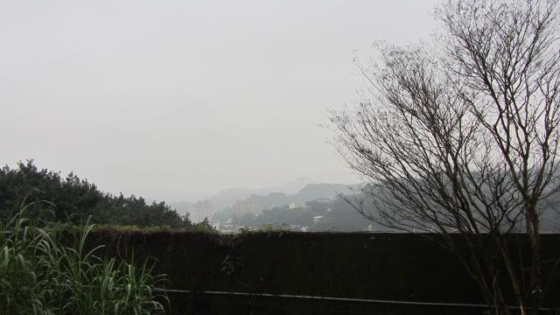
2/16 | 2/17 | 2/18 | 2/19 | 2/20 | 2/21 | 2/22 | 2/23 | 2/25 | 2/26 | 2/27
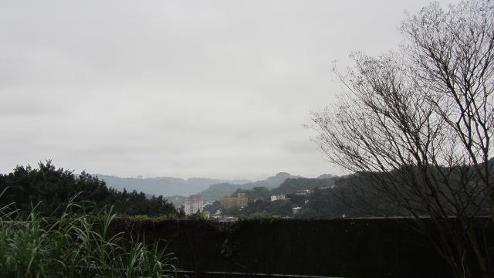 | 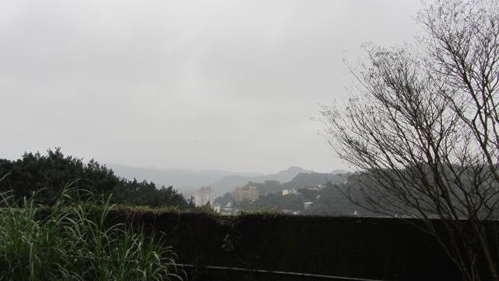 | 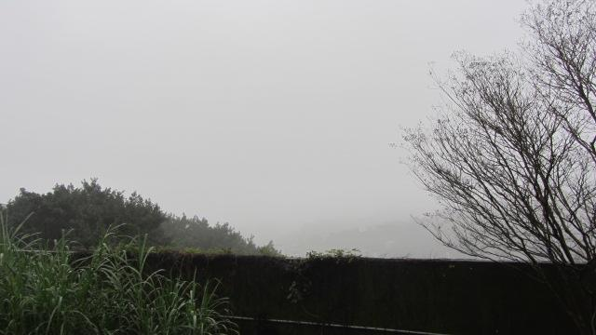 | 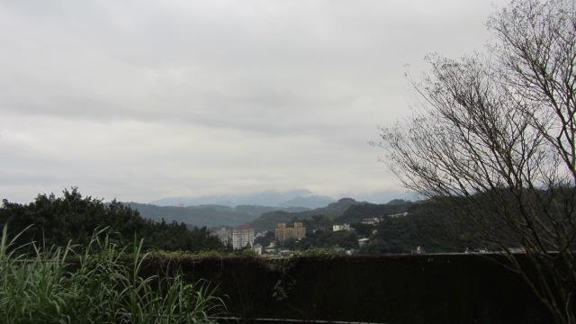 | 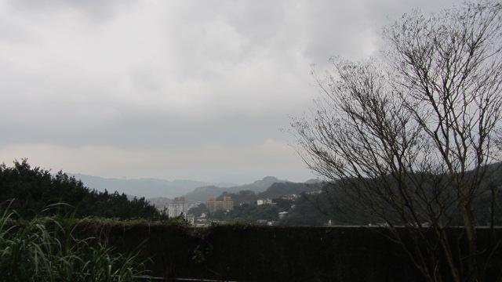 | 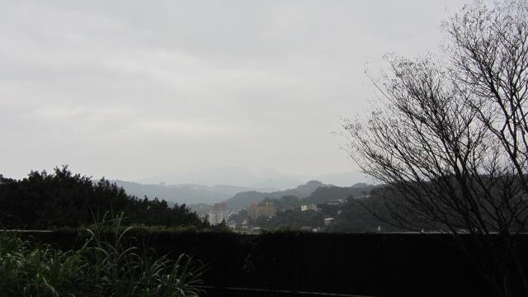 | 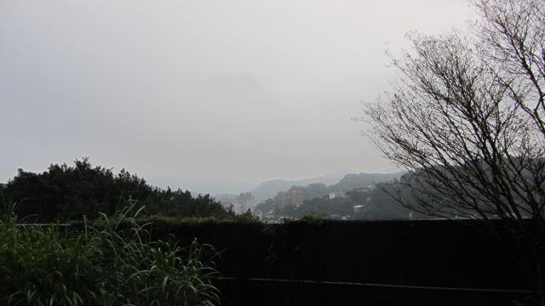 | 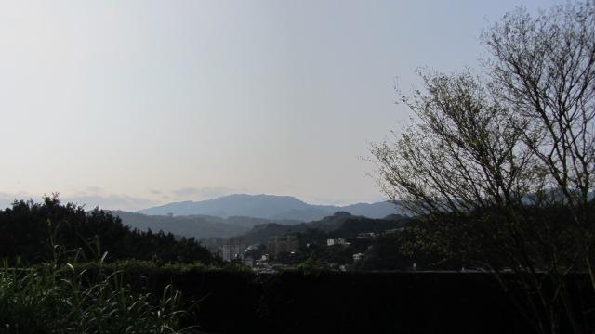
2/28 | 3/1 | 3/2 | 3/4 | 3/5 | 3/7 | 3/18 | 3/20

1. Figure 29 shows the weather factor relationship diagram for the upper photographing time.
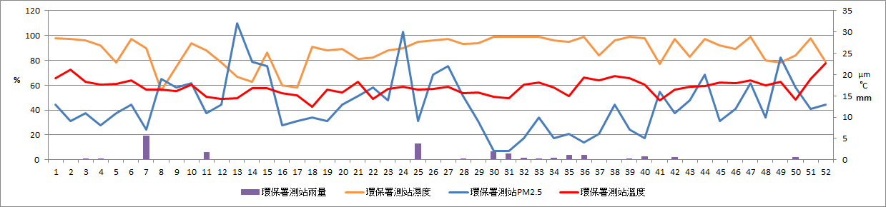
Figure 29 7:00 am weather factor relationship diagram

(1) It can be seen from Table 8 that the PM2.5 of 2/10 and 3/2 are still low, but the humidity is very high, and the PM2.5 value of 1/23 is compared with the other two days are high, but the humidity is very low, but the visibility is much better than the other two days. The comparison can be found that low visibility is likely to be caused by humidity.

Table 8 Photographed from January to March, when the air factor is a special value of visibility
chart
date | 1/23 | 2/10 | 3/2
PM_{2.5} | 32(μm) | 2(μm) | 18(μm)
temperature(°C) | 14.4(°C) | 14.8(°C) | 18.7(°C)
humidity | 67(%) | 99(%) | 99(%)
rainfall | 0(mm) | 2(mm) | 0(mm)

6. discussion

a. Because the observation of PM_{2.5} must consider precipitation, we took the station from the nearby meteorological bureau and found that if the distance is far away, precipitation and the relationship of PM_{2.5} removal is small. But the closer the distance is, the better the relationship between precipitation is clear. When it rains, in the air humidity will decrease first, causing PM_{2.5} to rise and rise. Basically, after 1-2 hours, the ratio of PM_{2.5} will be obvious decline. The downward trend is positively related to the amount of rainfall. The PM_{2.5} ratio will rise first in the rain.
b. When blowing north wind or northeast wind, the PM_{2.5} value will increase. If there is an exception to the above discussion, and it just happens to blow the north wind, In the northeast wind, it can be inferred that the PM_{2.5} value at the time was more serious. (Example: March 6 - March 10)
c. With the increase in precipitation on March 7, the PM_{2.5} value continued to rise, even reaching the highest level at 14 o'clock in the afternoon. Second only to Wanli Station. At this time, the wind direction is mainly north wind, which is obviously from overseas areas. In the future, we can explore the Keelung area. When blowing north wind, by the change of PM_{2.5} in Keelung area, it is speculated that factors that may affect the air quality in Keelung area come or come. source.
d. the number of wind direction of A, B, C three stations, A and B stations are mostly north wind, northeast easterly wind, but the C survey station wind source is significantly more for the east wind. It can be seen from Figure 31 that the EPA is at the foot of the mountain, and both the north wind and the northeast easterly winds are blocked by the mountains.
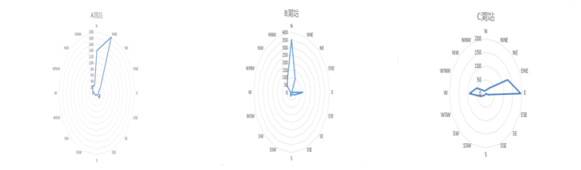

Figure 30 Radar diagram of the wind direction of the three stations
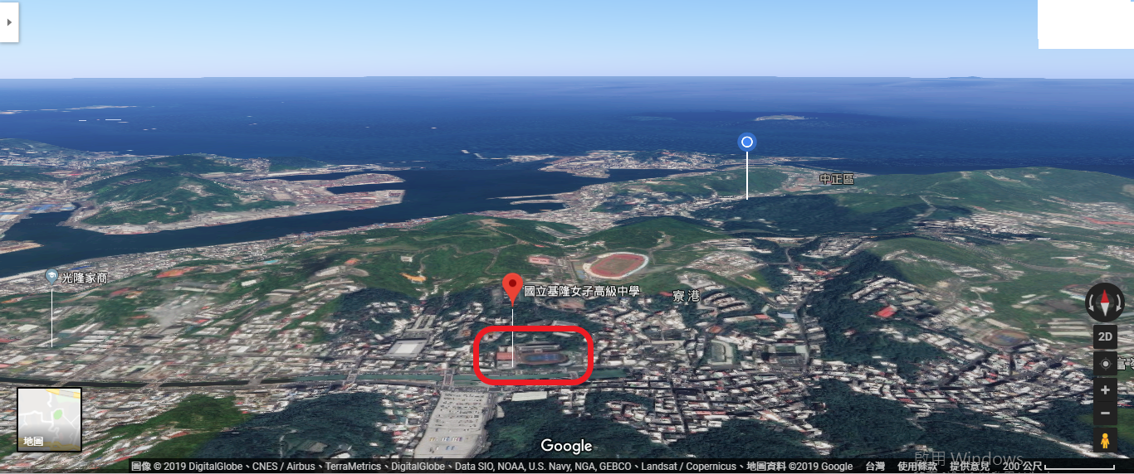
Figure 31 Station C and EPA Location Map

e. The PM_{2.5} observer we have prepared can only measure PM_{2.5}, and then prepare a temperature and humidity sensor. The reason is these instruments. It is easier to short-circuit the fault, causing the data to be interrupted. If an instrument fails, at least other data can continue. Measurements, not all three data are not available.
f. According to the average value of PM_{2.5} of "Table 5", the C value of the station is significantly higher than the stations A and B, and the station C is located in the urban area of Keelung. The urban PM_{2.5} value is significantly higher than the seaside and mountainous areas. It is recommended to put more PM_{2.5} stations in the urban area, and better measure the urban PM_{2.5} number. Value.
g. According to Figure 32, it can be found that the pollution in Keelung City comes from:
(a) Foreign source pollution brought by the northeast monsoon
(b) Concord Power Plant
(c) Keelung Port
(d) Badouzi Fishing Port has been to Dawulun Fishing Port

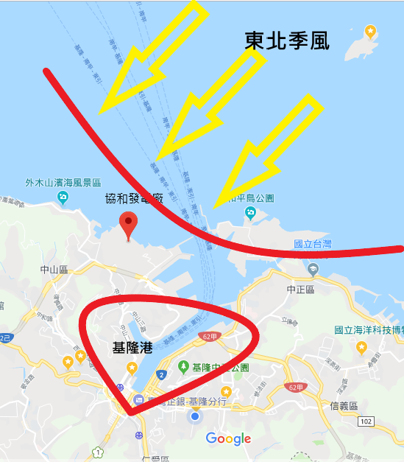
Figure 32 Source of air pollution in Keelung City

7. conclusion

a. the PM_{2.5} value and the rainfall are slightly opposite.
b. PM_{2.5} value and humidity will have different trends due to terrain and human factors.
c. the PM_{2.5} value and the temperature become slightly the same trend.
d. When Keelung blows northeast wind and north wind, the PM_{2.5} value will increase.
e. By means of wind direction, rainfall and temperature, it can be inferred that PM_{2.5} of No. 3/6-3/10 is an external source pollution.
f. Because the self-made air box is prone to short circuit or malfunction due to human factors or other factors, it is recommended to set up an air box or PM_{2.5} stations to ensure data integrity.
g. The PM_{2.5} values of the A, B, and C stations mentioned above are the same, but the trends are roughly the same from Figure 29 to Figure 31, but there are still differences, so it is recommended to set up an air box or PM_{2.5} station to make it clearer the trend of Keelung PM_{2.5}. Potential.

8.Reference material

a. 行政院環境保護署環境資源資料庫 https://taqm.epa.gov.tw/taqm/tw/HourlyData.aspx
b. 中央氣象局:測站資料來源 https://e-service.cwb.gov.tw/HistoryDataQuery/index.jsp
c. Google map 測站地圖 https://www.google.com/maps/d/u/0/viewer?mid=1thIkp5TG-q0Y6ebK-2hgdoSEZYAs-WH6&hl=zh-TW&ll=25.144370208749997%2C121.7708643103532&z=13
d. PM_{2.5}知多少? http://scitechreports.blogspot.com/2018/01/pm25.html
e. 中央氣象局:常識 https://www.cwb.gov.tw/V7/knowledge/encyclopedia/me013.htm
f. 科學人雜誌:近在眼前的熱危害及PM2.5 http://sa.ylib.com/MagArticle.aspx?Unit=webonly&id=3658
g. PM2.5懸浮微粒管制 https://lcss.epa.gov.tw/LcssViewPage/Responsive/InfoDetail.aspx?info=news&Id=7197332F2D209714EE493AD9EF99976C
h. 小狐狸事務所:Arduino 溫濕度感測器 DHT11 http://yhhuang1966.blogspot.com/2015/08/arduino-dht11.html
i. 揮不去的陰霾~ 談PM_{2.5} … https://science.km.edu.tw/storage/media/96/58d6a3dfa0c9a.pdf
j. 有了「空氣盒子」，面對空氣污染你也能主動出擊！ https://pansci.asia/archives/116585
k. 爭一口「氣」：探討PM2.5和溫度、濕度的關係 https://www.shs.edu.tw/works/essay/2017/11/2017111218495356.pdf
f. PM_{2.5}再也無所遁形：全台上千個空氣盒子，為你監測最即時的空氣質
https://www.seinsights.asia/article/3289/3269/4724
l. 懸浮微粒現形記 ～ 日常活動中懸浮微粒的檢測
https://www.shs.edu.tw/works/essay/2016/11/2016111809530912.pdf

