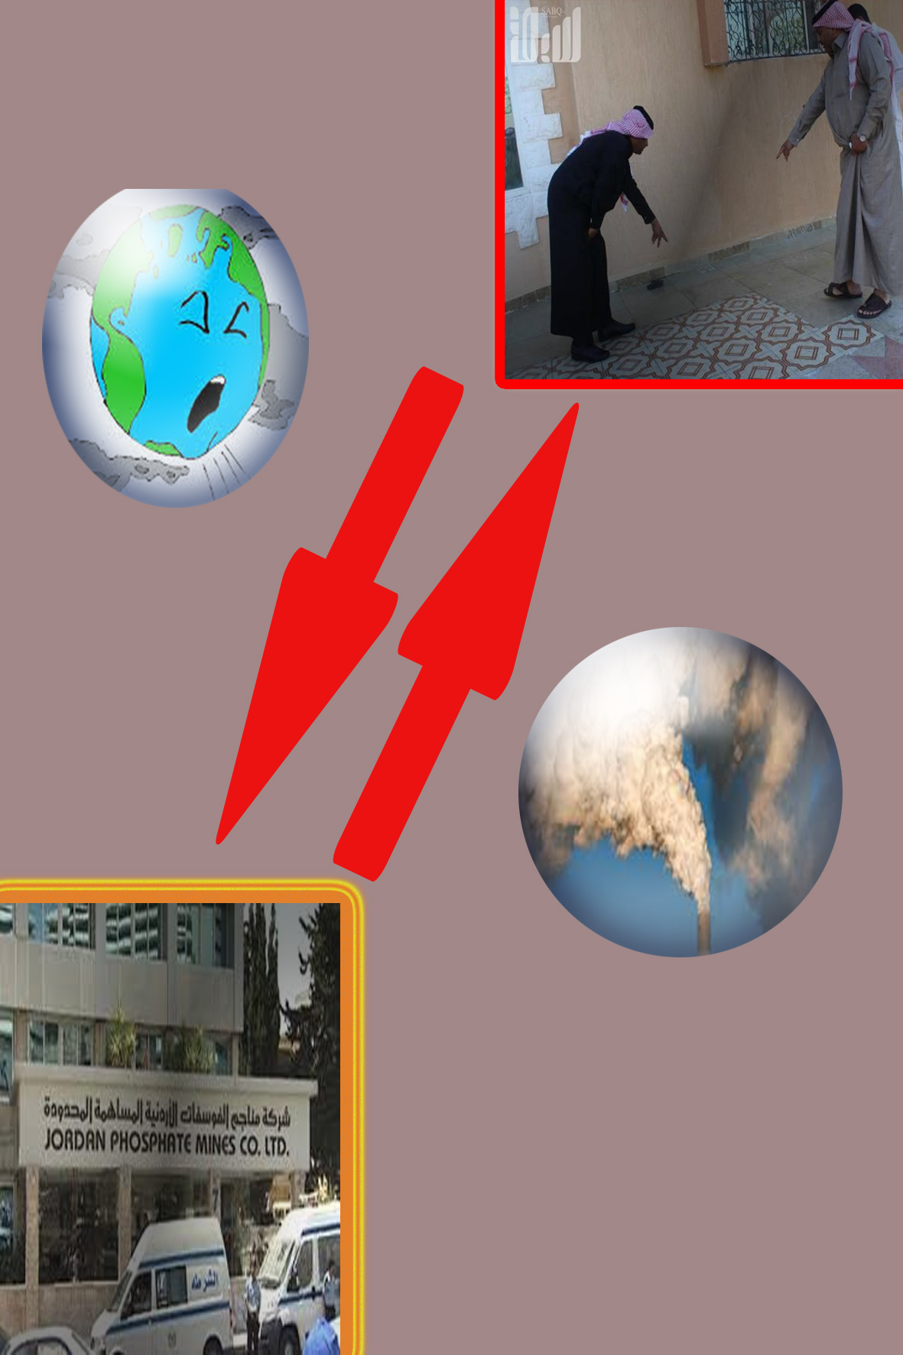

The problem of hagl residents with the phosphate plant in Jordan

Abdul Majeed Algamdi
Tariq Alhamadi
Mossab Alotaibi

Al Qadesiah Intermediate School at Tabuk

Conclusion
This scientific research was written to talk about the problem in the province of a field in Tabuk, which suffered a lot of population, which is centered around the problem of phosphate plant located in Aqaba, Jordan, and its impact negatively on the province of field

Questions and hypotheses
Effect of phosphate plant on the province hagl

Materials and method
Through field research and personal interviews

Analysis and results
The manufacture of phosphate in Jordan has not only caused damage in the province of a field on the one hand, only has been linked to several factors causing the so-called environmental pollution or environmental pollution. The pollution is not limited to air pollution, but also pollution of the surrounding environment of water or soil or other, because of several stages or successive degrees of pollution may enter the acid rain due to the escalation of the plant's fumes into the air and the accumulation of a long period of time, Pulling together with rain droplets composed of contaminated water is polluted and then the greatest catastrophe occurs soil pollution and sea water

References
- Wikipedia site
Facebook Facebook logo Keep me logged in
Facebook Facebook logo Keep me logged in
Ahmed Abdel Karim Salama. Environmental Protection Act. P. 342.
- The kindness of God Qari. Acid rain. King Saud University Press. Riyadh. P. 152.
Facebook Facebook logo Saad Shaaban. Pollution of the environment and ozone hole. Egyptian General Book Authority. Work and Life Series. 2000. p. 47 and beyond.

