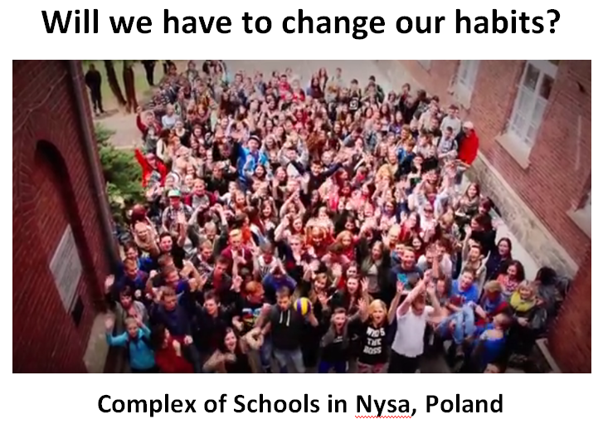
Students: Agnieszka Tomasiak, Agnieszka Ślimak, Anna Gońska, Artur Misiarz, Jakub Alasiński, Małgorzata Kocierz, Michał Jarek
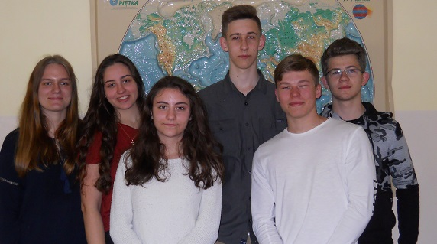
GLOBE Teacher: Jolanta Wawrzyniak-Rószczka
English Teacher: Lucyna Bagrowska-Feige
Contributors: dr hab. Krzysztof Markowicz – Professor of Warsaw University, member of the Scientific Board of GLOBE Program in Poland
Abstract
For the last few years the problem of climate change resulting particularly from the change of certain meteorological constituents has been widely talked about. Increase in weather and climatic anomalies has been observed by our parents, grandparents and us. Record-breaking heat waves, strong winds, violent storms, shorter, snowless and warmer winters are becoming more and more common. During the last 100 years air temperature has risen by around 0,8°C. IPCC 2007 report shows that most of temperature changes observed in recent years have been related to human activities (over 90%). A documentary movie „Before the Flood” (starring Leonardo DiCaprio) tells about human’s impact on environment. It enables us to witness negative effects of climate warming in different parts of our planet. We decided to check how air temperatures in Europe are changing. We picked 3 schools participating in the Globe Program (from Finland, Germany and Estonia), which have been conducting air temperature measurements every day for 10 years, and our school. The aim of our research was to find the answers to the following questions:
1. Are the trends of temperature changes similar in different parts of Europe?
2. Which effects of warming in Europe can be noticed in our environment?
3. Shall we change our habits related to our consumerist lifestyle?
4. Which actions should be undertaken?
Our hypothesis: The climate in Europe has been abruptly getting warmer since 1960

Our analysis confirmed that also in Europe global warming is rapidly progressing. We have no doubt concerning the negative changes which occur in natural environment as its result. Awareness of this condition is very disturbing to us.

Introduction

For the last few years the problem of climate change resulting particularly from the change of certain meteorological constituents has been widely talked about. It is being considered in different time and space scales. Increase in weather and climatic anomalies has been observed by our parents, grandparents and us. Record-breaking heat waves, strong winds, violent storms, shorter, snowless and warmer winters are becoming more and more common. Air temperature reconstructions in down-to-earth stratum in different places on Earth show the main climate warming and cooling intervals. After the Little Ice Age (1400-1850) contemporary warming has been observed. During the last 100 years air temperature has risen by around 0,8°C.
The main aim of currently conducted researches and scientific discussions is an attempt to explain the reasons of climate warming on Earth as well as estimating probable effect on natural environment. IPCC 2007 report shows that most of temperature changes observed in recent years have been related to human activities (over 90%). Only 5% have been caused by natural factors.

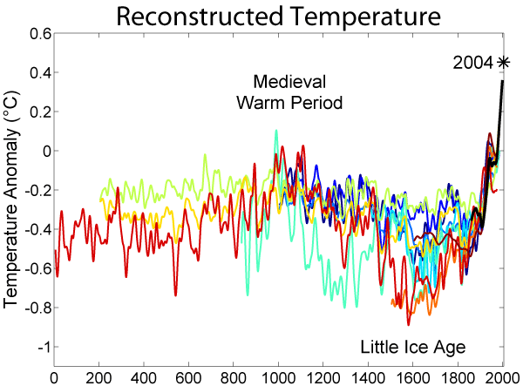
Figure 1. Reconstructed Temperature in years 0-2000
Source: https://en.wikipedia.org/wiki/Little_Ice_Age

A documentary movie „Before the Flood” (starring Leonardo DiCaprio) tells about human’s impact on environment. It enables us to witness negative effects of climate warming in different parts of our planet.
We’ve been truly moved by the problem of global climate changes, because current effects of average air temperature growth on Earth are dangerous both for us and the next generations.
We decided to look up how air temperatures in Europe are changing. We picked 3 schools participating in the Globe Program (from Finland, Germany and Estonia), which have been conducting air temperature measurements every day for 10 years, and our school.

Research questions and hypothesis
The aim of our research was to find the answers to the following questions:
1. Are the trends of temperature changes similar in different parts of Europe?

2. Which effects of warming in Europe can be noticed in our environment?
3. Shall we change our habits related to our consumerist lifestyle?
4. Which actions should be undertaken?
Our hypothesis: The climate in Europe has been abruptly getting warmer since 1960

The aim of our research was to analyze variability of thermal conditions in given localities in Europe as well as to evaluate the trend in changes of minimal and maximal air temperature observed in the last three decades. The rate of change we have estimated using linear trend.

Materials and Methods

Almost complete Europe lies in a temperate climate zone, in the north east it is colder, in the remaining parts warmer. Southern part of the continent lies within a subtropical climate zone, and it is separated from the temperate climates with the Pyrenees, the Alps and the Balkans. Northern ends of Europe have subarctic climate.

We searched the website http://vis.globe.gov/GLOBE/ for information and found schools which in the years 2007-2016 on daily basis carried out and reported measurements of minimum and maximum air temperatures. These are Utajarven Ylaaste in Utajarvi (Finland), Gymnasium Ohmoor in Hamburg (Germany), Kilingi-Nomme Gymnasium (Estonia) and our school in Nysa (Poland).
Using various sources of information we prepared climate characteristic for each of these places:
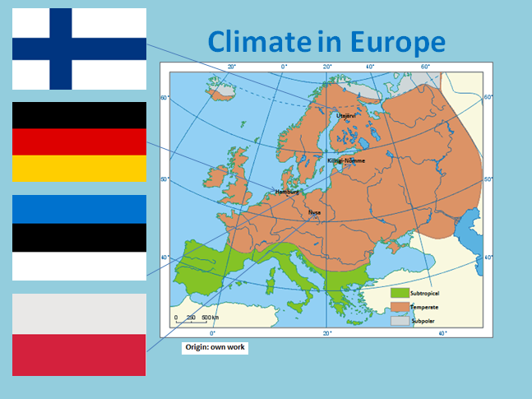

Figure 2. Climate in Europe

Utajarvi (64°N, 26°E) is a small town in Finland, located in Oulu province, is part of the Northern Ostrobothnia region, height 97 m a.s.l., climate area: polar, climate type: subarctic, main climate features: warm summers and freezing winters. Using the Climatological Information for Kuopio we have calculated the average annual minimum temperature (-0,5°C) as well as the average annual maximum temperature (6,7°C) for the years 1971-2000.

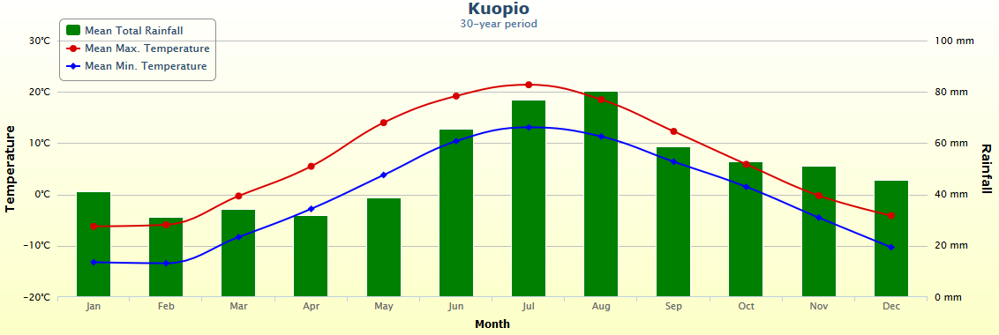
Figure 3. Climatological Information for Kuopio for period 1971-2000
Source: http://worldweather.wmo.int/en/city.html?cityId=171

Hamburg (53°N, 10°E) is a city in north Germany, situated on the river Elbe, the height is 6 m a.s.l., the sea climate is temperate, with softly warm winters and cool summers.
Based on The Climatological Information for Hamburg, we averaged the annual temperature for period 1971-2000. The minimum annual average is 5,2°C and the maximum annual average is 12,7°C.

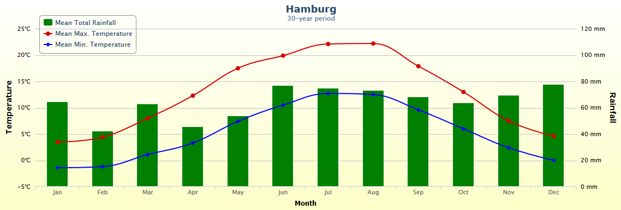
Figure 4. Climatological Information for Hamburg for period 1971-2000
Source: http://worldweather.wmo.int/en/city.html?cityId=55

Kilingi – Nomme (58°N, 25°E) is a town in Pärnu County, in southwestern Estonia, the height is 130 m a.s.l., the climate area is temperate, the climate type is cold, the main climate features are maritime, wet, with moderate winters and cool summers. Based on The Climatological Information for Tartu we averaged the annual temperature for period 1971-2000. The minimum annual average is 1,7°C and the maximum annual average is 9,3°C.
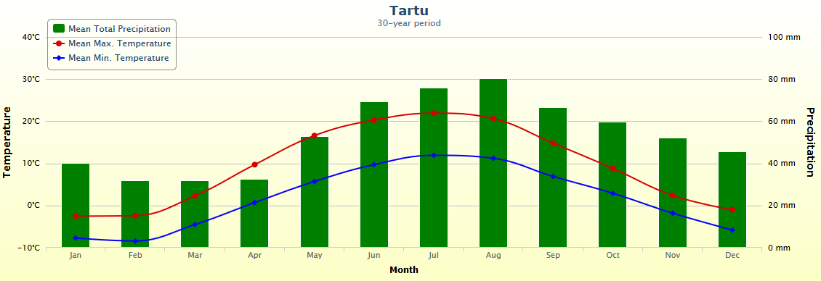
Figure 5. Climatological Information for Tartu for period 1971-2000 Source:http://worldweather.wmo.int/en/city.html?cityId=1927
Nysa (50°N, 17°E) is a town in southwestern Poland, situated on the Nysa Lake and on the river Nysa Kłodzka. The hight is 195 m a.s.l. The climate in the Nysa commune is transitional, continental-sea, shaped by the air mass flowing in from above the Atlantic Ocean or Eastern Europe and Asia. Based on The Climatological Information for Wroclaw we averaged the annual temperature for period 1971-2000. The minimum annual average is 4,3°C and the maximum annual average is 13,8°C.
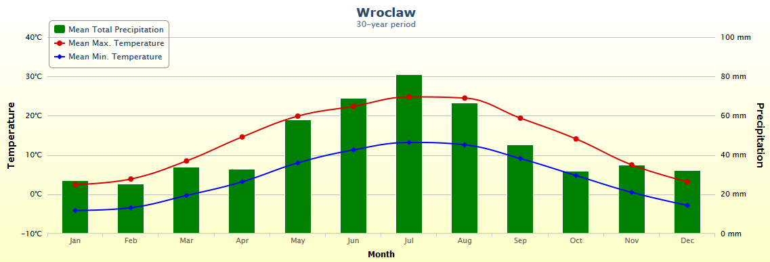
Figure 6. Climatological Information for Wroclaw for period 1981-2010 Source:http://worldweather.wmo.int/en/city.html?cityId=586

We used data of the daily maximum and minimum air temperature survey for the period 2007-2016 available on Visual Data for chosen schools ( http://vis.globe.gov/GLOBE/). We calculated average annual minimum and maximum temperatures for 2007-2016. Afterwards we trawled the website http://en.tutiempo.net/ for average maximum and minimum air temperature for the period 1960-2016 for the weather stations located near our schools. For Utajarvi we chose Oulu, for Hamburg – Hamburg, for Kilingi-Nomme – Tartu, for Nysa – Opole. After entering the data into the Excel program, we made charts which showed variations of maximum and minimum temperatures for researched locations. Than we drew a trend line for maximum and minimum temperature over a given time interval. We calculated the trend using the temperature values between the beginning and end of the period. Comparison of data shown on presented below charts, allowed us to state, that in the years 1960-2016 there was a strong positive trend of temperature in all the researched locations, referring to both maximum and minimum temperatures. For particular locations it can be presented as follows:

- Oulu – the average maximum temperature has increased by 1,6°C and the average minimum temperature has grown by 2,0°C in the years 1960 - 2016
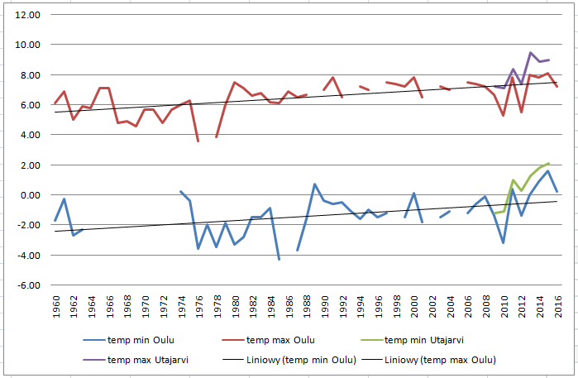Liniowy – trend line

Figure 7. Average maximum and minimum temperatures variations in Oulu in the years 1960-2016 and in Utajarvi in the years 2007-2016, with a trend line.

Origin: own work

- Hamburg – the average maximum temperature has increased by 2,1°C and the average minimum temperature by 1,5°C

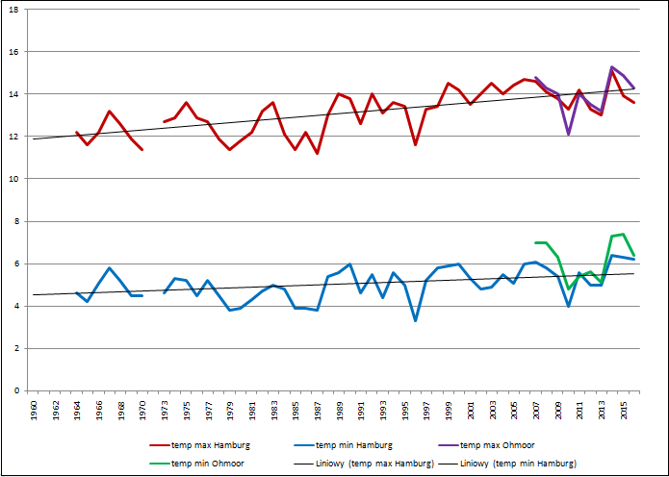
Liniowy - trend line
Figure 8. Average maximum and minimum temperatures variations in Hamburg in the years 1960 – 2016 and in Gymnasium Ohmoor in the years 2007 – 2016, with a trend line.
Origin: own work

Tartu – the average maximum temperature has increased by 3,0°C and the average minimum temperature by 2,4°C

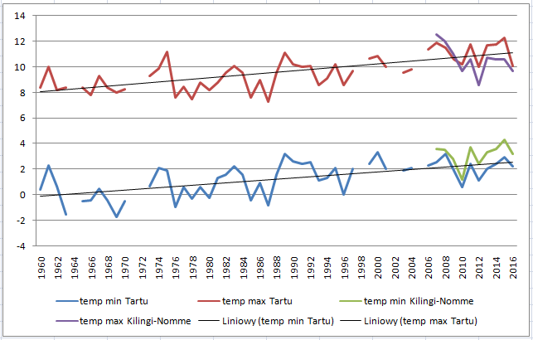
Liniowy - trend line
Figure 9. Average maximum and minimum temperatures variations in Tartu in the years 1960 – 2016 and in Kilingi-Nomme in the years 2007 – 2016, with a trend line.
Origin: own work

- Opole – the average maximum temperature has increased by 2,0°C and the average minimum temperature by 0,4°C

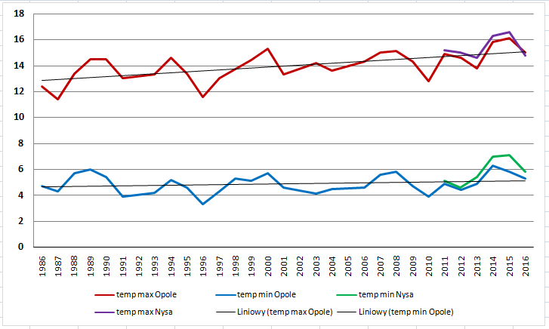
Liniowy - trend line
Figure 9. Average maximum and minimum temperatures variations in Opole in the years 1960 – 2016 and in Nysa in the years 2011 – 2016, with a trend line.
Origin: own work

Following Excel charts, we drew trend lines for each of these locations for specific decades. The results are shown below:
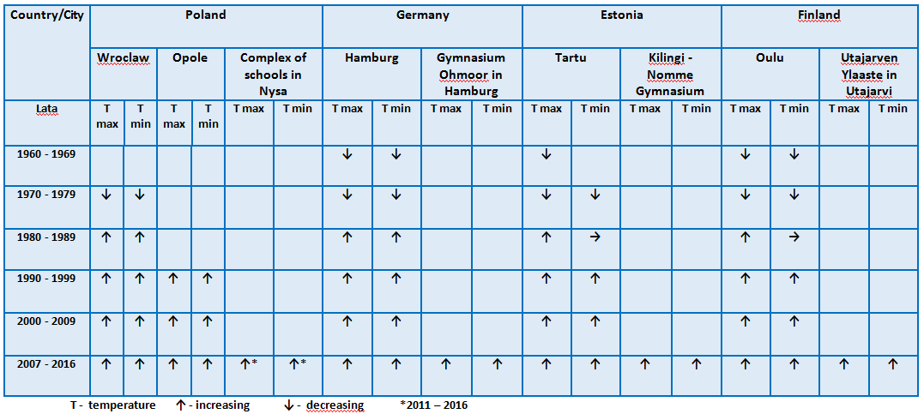

Table 1. Minimum and maximum temperature variations trend in the consecutive decades for the years 1960-2016 for the chosen locations in Europe.
Origin: own work

Taking these results into consideration, we can declare that the following tendency in minimum and maximum temperatures variations has been observed:
1960 – 1969 | decreasing
1970 – 1979 | decreasing
1980 – 1989 | increasing
1990 – 1999 | increasing
2000 – 2009 | increasing
2010 – 2016 | increasing
2007 – 2016 | increasing for schools from Globe Program

Afterwards, we determined temperature changes against the average long-term maximum and minimum temperature, calculated over the period of 30 years.

Locality | Long-term average temperature min | Long-term average temperature max | Average temperature min  2007-2016 | Average temperature max  2007-2016
Utajarvi/Kuopio | -0,5 | 6,7 | 0,3 | 8,1
Hamburg | 5,2 | 12,7 | 6,2 | 14
Kilingi-Nomme/Parnu | 1,7 | 9,3 | 3,2 | 10,6
Nysa/Wroclaw | 4,3 | 13,8 | 5,8* | 15,4*
*Data from the years 2011-2016 Origin: own work
On the basis of conducted calculations and data analysis for selected locations and schools from Globe Program, we concluded that Europe is experiencing warming of the climate, which is happening faster than global increase in temperatures on our planet. Data comparison from the weather stations and ours, from Globe Program, introduced on the ground of Integrated Atmosphere protocol (1-Day), indicates that our survey is authoritative and can be use to characterize weather phenomena and climatic conditions in the future. It gives us, the students, possibility to confirm their occurrence because they are measurable and verifiable. It is for us a chance to participate in scientific world discovering.

During our work on the project our limit was lack of data concerning maximum and minimum temperature so we used data for localities closest to our schools and with the same climate quality. Drawing of the trend line for the whole period of approximately 50 years and for 10-year periods are consistent with the trends of temperature changes in Europe. Some small errors may occur in the data from the Globe Program. In the case of calculating the average annual max and mix air temperature, in some cases, we calculated the average temperature not for 365 days, but slightly fewer then 365 days. In the situation when we missed the results of a long period of time, we didn't calculate the average temperature and we have a gap on our charts.

With the listed schools we made contact. We asked for interviews with parents and grandparents about changing weather phenomena in the last 50 years. This way, we obtained information about the observed changes and effects of global warming in the areas where our colleagues from Globe Program live.

Whichare:

Utajarvi | Kilingi- Nomme | Nysa
Some plants start to flower earlier.  Migrating birds come earlier.  The ice cover on lakes and rivers melts earlier, it can be dangerous to walk on ice.  The change of plant and animal distribution.  In Finland we have endemic species called Saimaa ringed seal. They get their babies in snow cave and if there is not enough snow, the young ones die in cold. In such a years when there are very little snow, volunteering people try to push the snow to the heaps, to make artificial snow home for seal babies.  In December the shorthest day length is less than 4 hours, so if there is no snow the winter is really dark. | Estonian climate change are similar.  Winters are become milder.  Snow cover duration is shorter and snow depth is smaller.  Stronger winds and more frequent storms are expected in winters and springs.  Springs have become warmer and begins earlier.  Migrating birds are arriving earlier. | Recently winter in Poland are getting warmer, they begin later and end quickly, growing season is longer, birds arrive sooner, snow cover is decreasing. Our grandparents didn't observe this type of phenomena.  Because of the rise in average air temperature we have noticed exacerbation of severe weather phenomena in Poland like: heat waves, droughts, rapid storms, tornadoes.  Winters are milder, shorter, we notice obviously warmer periods in winters, which cause the average monthly air temperatures rise above zero

Conclusion
Our analysis confirmed that also in Europe global warming is rapidly progressing. We have no doubt concerning the negative changes which occur in natural environment as its result. Awareness of this condition is very disturbing to us. Even more are we concerned about the speed and intensity of this process and a small interest in the problem. And yet the prognosis for life on Earth is terrible. What consequences will the unbridled consumerism bring? Each inhabitant of our planet should undertake proper actions to reduce their carbon footprint. We have made a commitment to change the habits that are harmful to the environment, and we are already working on it. We quote Leonardo DiCaprio: we can't waste time. Inspired by the World Water Day we started in our school "The Drop to the drop" campaign. 260 students have alredy joined our project - every day each of us will be working on becoming more eco-friendly.
Badges:
- Collaboration
In the project, systematically and conscientiously participated 7 students. We shared the work fairly and equally. Some of the tasks we completed together at school, others in groups and individually.

Common tasks | Tasks in groups | Tasks performed individually
Defining the research questions and hypotheses. | preparing charts for given locations | Checking min and max temperatures for given periods and storing them in Excel
Searching for data sources | Preparing information on climate in given locations | Drawing up tables and reports based on the data and information received from schools in the Globe Program
Drawing up analysis and conclusions | Searching for and preparing information about the climate change and its implications in the world, in Europe and in Poland
English translation | Making corrections and adjustments based on the advice of Mr. K. Markowicz
Preparation of a presentation
Preparation of a film

2. Connection to local or network scientist
During our project, we collaborated with Professor Krzysztof Markowicz from Warsaw University, the member of the Scientific Board of GLOBE Program in Poland http://www.igf.fuw.edu.pl/igf/?option=com_employees&Itemid=98&func=view&employee=7#
who watched over the factual side of the project. Cooperation involved the choice of adequate research methods and proper presentation of results and their analysis. We contacted by e-mail. In the beginning, we presented our proposal of application of research methods and the possible ways to use them, performed preliminary schedules and forwarded them for review. We implemented all suggestions concerning our work. After every completed and sent for review task, we systematically checked the material, following the suggestions we were given. On our own we have searched the Internet for data concerning the locations neighboring with schools, but in the end, we took advantage of the websites recommended by Mr. K. Markowicz. Our collaboration began already in October and was continued systematically till the end of the project.

- Interscholastic connection
Our project involved cooperation with other schools taking part in the Globe Program in Europe. We pre-selected 5 schools, and contacted four of them via e-mail. We are glad that students and their guardians allowed us to use the air temperature measurements carried out by them since 2007. We used http://vis.globe.gov/GLOBE/. Then we also asked for information on weather changes that occurred in their environment over the last 50 years. Thus, we received the necessary data, and in some cases photos, too. We also sent to them the information about the changes observed in this period in our area and in Poland.

Source:
http://vis.globe.gov/GLOBE/
www.globe.gov
www.worldweather.wmo.int
http://en.tutiempo.net/
http://www.eea.europa.eu/pl/themes
https://www.beforetheflood.com/act/
http://www.ecowatch.com/leonardo-dicaprio-before-the-flood-2057070140.html
https://www.ipcc.ch/publications_and_data/publications_ipcc_fourth_assessment_report_synthesis_report.htm
https://www.ipcc.ch/...and.../publications_and_data_reports.shtml
https://pl.wikipedia.org/wiki/Czwarty_Raport_IPCC
https://en.wikipedia.org/wiki/Climate_change
http://climate.nasa.gov/
http://www.ecy.wa.gov/climatechange/whatis.htm
https://en.wikipedia.org/wiki/Climate_change_in_Europe
http://klimada.mos.gov.pl/en/climate-change-in-poland/
https://pl.wikipedia.org/wiki/Zmiana_klimatu
http://ziemianarozdrozu.pl/encyklopedia/kategoria/26/zmiany-klimatu-zjawiska
http://www.eea.europa.eu/pl/pressroom/newsreleases/zmiany-klimatu-widoczne-w-europiehttp://www.eea.europa.eu/publications/climate-change-impacts-and-vulnerability-2016/key-findingshttp://eca.knmi.nl/
U. Kossowska-Cezak: Meteorologia i klimatologia
K. Kożuchowski: Meteorologia i klimatologia
Z. Szwejkowski: Pogoda, klimat i środowisko

