ABSTRACT

“Lighting Up?”
(A study conducted using the GLOBE Aerosol and Cloud Testing Protocol to analyze the effect of clouds and other materials on Visible and UV light)
Nella M. Forney
6th grade Alpena Middle School

This investigation analyzed the amount of light and UV radiation that penetrated different colored umbrellas, different level of clouds, and SPF-30, 50 and 70 sunscreen. It was predicted that the darker umbrella materials would block most of the UV radiation, the clouds would not all block enough to be safe from sunburn, and sunscreens would block the UV radiation.

A light meter and UV meter were used to collect 10 sets of data from sunlight and UV radiation going through white, maroon, black umbrellas; upper-level cirrostratus, mid-level altostratus, low-level stratus clouds; and SPF-30, 50 and 70 sunscreen sprayed on clear laminate sheets. GLOBE data for Clouds, and Aerosols was collected and entered into the GLOBE database for each observation.

Umbrella Tests: Direct sunlight: 104,520Lux, UV Index=10.25; White: 44,160Lux, UV Index=0.5; Maroon: 9,790Lux, UV Index=0.0; Black: 9,790Lux, UV Index=0.0. Cloud Tests: Direct sunlight: 103,420Lux, UV Index=10.35; High-level Cirrostratus: 90,030Lux, UV Index=7.7; Mid-level Altostratus: 49,600Lux, UV Index=4.05; Low-level Stratus: 7,650Lux, UV Index=0.4. Sunscreen Tests: Direct sunlight: 97,120Lux, UV Index=9.65; Direct Sunlight through Clear Laminate Sheet: 92,320Lux, UV Index=8.6; SPF-30: 88,230Lux, UV Index=0.7; SPF-50: 88,050 Lux, UV Index=0.3; SPF-70: 90,270Lux, UV Index=0.15.

The hypothesis was supported by the data. Maroon and black umbrellas blocked all the UV radiation and white 95%. 75% & of UV radiation went through high-level clouds, and mid-level clouds let 39% through. Low-level clouds blocked 96% of the UV radiation. The sunscreens all worked well; SPF-30 blocked 93%, SPF-50 blocked 97%, and SPF-70 blocked 98.5% of the UV radiation.

"Lighting Up"

A study using the GLOBE Aerosol and Cloud Protocols to analyze the effects of clouds and other materials on visible and UV light.

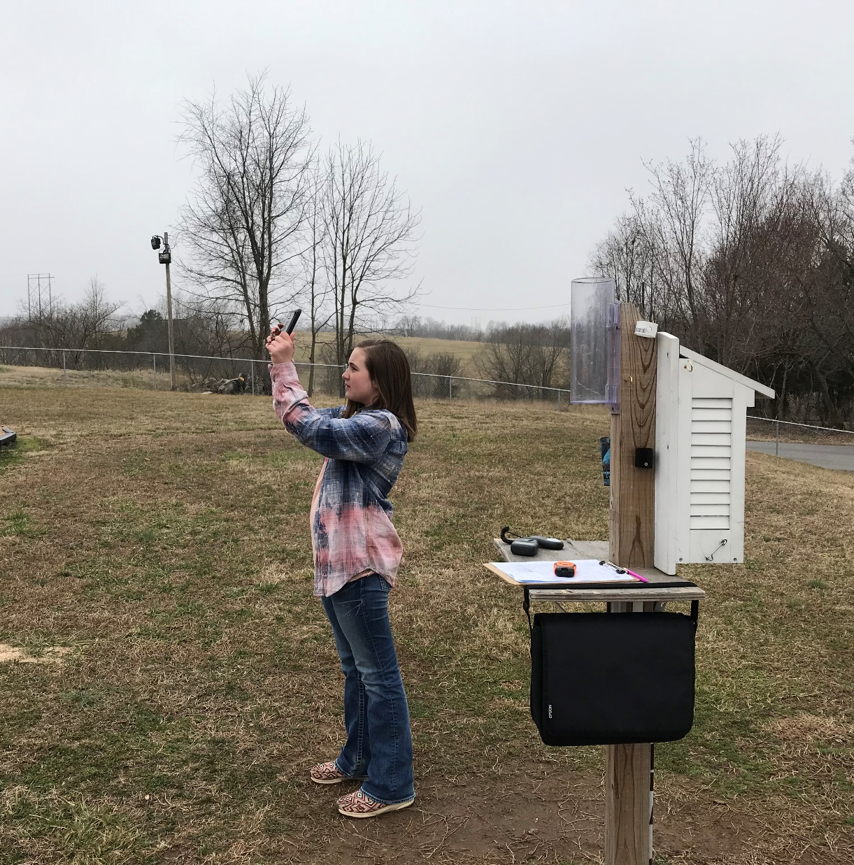

Nella M. Forney
6th grade Alpena Middle School
Roger Rose – Science Teacher
Tammy Rose – GLOBE Sponsor
March 12th 2020

TABLE OF CONTENTS

Abstract…………………………………………….……............. 1
Title Page and Table of Contents ……………..........................2-3
Research Question and Hypothesis………….…………………. 4
Methods & Materials……………………………….………..… 5
Data Summary (Chart & Graph) ……………………………......... 6 - 11
Analysis & Results………………….......................................... 12
Conclusions……………………………………….…................. 12
Discussion…………………………………………...………….. 12
Acknowledgements………………………………....................... 12
Display Board ………………………………………………13 - 14
References/Bibliography……………………………………….. 14

INTRODUCTION & RESEARCH QUESTION

The Sun's energy makes it possible for life on Earth. The uneven heating of the Earth's surface is responsible for the wind and weather that we have. The Sun provides light for us in the day time and it also reflects light off the moon to light up the night during the different phases of the moon. The Sun's light energy can also have a devastating effect on the earth. In areas that receive more direct sunlight and little rain, can become a dried up wasteland. The Sun also emits UV radiation that can be harmful to life on earth, causing sunburns and even skin cancer in humans. According to an article from Forefront Dermatology, “A UV Index between 3 and 5 means there is a moderate risk of sunburn for the average person. The time it takes for the skin to burn can vary between skin type, but at a moderate UV level it is approximately 30 to 45 minutes”. Millions of dollars are spent each year by people trying to protect themselves from the Sun's harmful UV radiation. People use umbrellas to try to block the Sun's energy. They also use sunscreen to block the harmful UV radiation from the Sun. Many people think that when there are clouds in the sky, that they don't have to worry about the UV radiation from the Sun. This investigation will attempt to find answers to some of the questions about blocking the UV radiation from the Sun.
PURPOSE
This investigation is designed to investigate three UV myths. First, does UV radiation pass through different colored materials? (using umbrellas). Second, how much UV radiation does cloud cover block from reaching Earth's surface? Third, do lower level SPF sunscreens block as much UV radiation as higher SPF level sunscreens?

HYPOTHESIS

It was predicted that the darker the material in the umbrellas, the more UV radiation they will block. It is also predicted that clouds will block some of the UV radiation from the Sun, but that there will still be UV radiation levels high enough to be dangerous for people for the mid-level and upper-level clouds. It is predicted that the lower SPF rated sunscreen will block UV radiation, but the level will be significantly less than the UV radiation blocked by the higher SPF sunscreen.

GLOBE Protocol Used
Aerosols (AOT) Cloud Cover
Air Temperature Relative Humidity
Barometric Pressure

RESEARCH METHODS

Three different tests were conducted for this investigation. One set of tests analyzed the amount of light and UV radiation that passes through different colored umbrellas. The second set of tests analyzed the amount of light and UV radiation that passes through different clouds. The third set of tests analyzed the amount of light and UV radiation that passes through sunscreen covered laminate sheets with different SPF levels; 30, 50, and 70. The GLOBE protocols for Aerosols and Cloud Observations were used during the observation and data collection phases of this investigation. The data for GLOBE was collected and entered into the GLOBE database each time observations are conducted. On a sunny day, a light meter was used to measure the amount of light in lumens, and a UV meter was used to measure the level of UV radiation from the sun. A Calitoo sun photo meter was also used to measure the level of Aerosol Optical Thickness, (AOT) in the air. Then, three different umbrellas were used to block the direct sunlight, white, black, and maroon. The same light meter and UV meter was used to measure the light that passes through the umbrella as well as the amount of UV radiation that passes through each umbrella. Ten measurements for each were recorded. The same light meter and UV radiation meter was used to measure the amount of light and UV radiation that passes through clouds on days when there are low stratus clouds, mid-level altostratus clouds, and high level cirrostratus clouds. On a sunny day, the amount of light and UV radiation was measured using the same light meter and UV radiation meter as before. An uncoated clear laminate sheet was also used as a second control for this part of the investigation. Clear plastic laminate sheets were coated with sunscreen; one with SPF-30, one with SPF-50 and one with SPF-70. After the laminate sheets have dried, they will be held up to the sun. The light meter will be held up behind each laminate sheet and the amount of light that passes through it was recorded. Next the UV radiation meter was held up behind the laminate sheet and the amount of UV radiation that passes through it was also recorded. The same procedure will be conducted 10 times for each of the laminate sheets; uncoated, SPF-30, SPF-50 and SPF-70.
Risk and Safety: Exposure to direct sunlight is the only risk of this investigation. However, the exposure is not any more than the researcher would normally be subjected to on any other day. The researcher did NOT look directly into the sunlight. Data Analysis: Once the data has been collected it will be analyzed by calculating the mean for visible light and UV readings. Charts and graphs will be created to help analyze the data further.

MATERIALS
Digital Calitoo Meter
Digital UV Index Meter
GLOBE Weather Station
Umbrellas (Black, Black/White, Maroon/White)
Sunscreen SPR-35, SPF-50, SPF-70
3ml Clear Plastic Laminate Sheets

DATA SUMMARY

UV Blocking Clouds Test Results
 | No Clouds  Direct Sunlight |  | High-Level  Cirrus Clouds |  | Mid-Level  Alto Clouds |  | Low-Level  Cumulus Clouds
Test # | Lux | UV | Lux | UV | Lux | UV | Lux | UV
1 | 104,700 | 11.0 | 89,300 | 7.5 | 50,200 | 4.5 | 7,500 | 0.0
2 | 103,200 | 10.5 | 89,900 | 7.5 | 49,800 | 3.5 | 7,400 | 0.5
3 | 106,500 | 9.5 | 89,700 | 8.0 | 49,700 | 4.0 | 7,600 | 0.5
4 | 100,200 | 10.5 | 90,000 | 7.5 | 49,900 | 4.0 | 7,700 | 0.5
5 | 102,100 | 11.0 | 90,400 | 7.0 | 50,400 | 3.5 | 7,300 | 0.5
6 | 106,600 | 11.0 | 90,800 | 8.0 | 49,300 | 4.0 | 7,900 | 0.5
7 | 104,300 | 10.5 | 90,300 | 8.0 | 49,200 | 4.5 | 7,900 | 0.5
8 | 102,700 | 9.5 | 90,200 | 8.0 | 49,000 | 4.5 | 7,300 | 0.0
9 | 101,000 | 9.5 | 89,900 | 7.5 | 49,600 | 3.5 | 7,800 | 0.5
10 | 102,900 | 10.5 | 89,800 | 8.0 | 48,900 | 4.0 | 8,100 | 0.5
Total | 1,034,200 | 103.5 | 900,300 | 77 | 496,000 | 40.5 | 76,500 | 4.0
Mean | 103,420 | 10.35 | 90,030 | 7.70 | 49,600 | 4.05 | 7,650 | 0.40
% | 100% | 100% | 87% | 74% | 48% | 39% | 7% | 4%
% Blocked | - | - | 13% | 26% | 52% | 61% | 93% | 96%

UV Blocking Umbrella Test Results
 | Direct Sunlight |  | White Umbrella |  | Maroon Umbrella |  | Black Umbrella
Test # | Lux | UV | Lux | UV | Lux | UV | Lux | UV
1 | 105,800 | 10.0 | 42,000 | 0.5 | 7,100 | 0.0 | 4,100 | 0.0
2 | 105,900 | 9.5 | 44,600 | 0.5 | 8,400 | 0.0 | 3,500 | 0.0
3 | 104,100 | 9.5 | 40,800 | 0.5 | 9,100 | 0.0 | 3,200 | 0.0
4 | 100,800 | 10.5 | 48,000 | 0.5 | 9,100 | 0.0 | 3,400 | 0.0
5 | 100,100 | 9.5 | 42,100 | 0.5 | 8,100 | 0.0 | 3,800 | 0.0
6 | 105,500 | 10.0 | 49,000 | 0.5 | 13,200 | 0.0 | 3,500 | 0.0
7 | 104,300 | 10.5 | 43,300 | 0.5 | 10,500 | 0.0 | 3,700 | 0.0
8 | 105,100 | 10.5 | 45,700 | 0.5 | 11,400 | 0.0 | 3,900 | 0.0
9 | 106,600 | 11.0 | 46,100 | 0.5 | 11,000 | 0.0 | 3,900 | 0.0
10 | 107,000 | 11.5 | 40,000 | 0.5 | 10,000 | 0.0 | 4,000 | 0.0
Total | 1,045,200 | 102.5 | 441,600 | 5.0 | 979,000 | 0.0 | 32,900 | 0.0
Mean | 104,520 | 10.25 | 44,160 | 0.50 | 9,790 | 0.00 | 3,290 | 0.00
% | 100% | 100% | 42% | 5% | 9% | 0% | 3% | 0%
% Blocked | - | - | 58% | 95% | 91% | 100% | 97% | 100%

UV Blocking Sunscreen Test Results
 | Direct Sunlight |  | Direct Sunlight  (through clear laminate sheet) |  | SPF-30  (on clear laminate sheet) |  | SPF-50  (on clear laminate sheet) |  | SPF-70  (on clear laminate sheet)
Test # | Lux | UV | Lux | UV | Lux | UV | Lux | UV | Lux | UV
1 | 98,100 | 10.0 | 92,600 | 8.0 | 89,000 | 0.5 | 89,500 | 0.5 | 91,700 | 0.0
2 | 97,800 | 10.0 | 92,700 | 8.0 | 88,100 | 0.5 | 89,300 | 0.0 | 86,800 | 0.5
3 | 95,800 | 9.5 | 92,400 | 8.5 | 88,300 | 0.5 | 89,200 | 0.0 | 94,100 | 0.0
4 | 98,500 | 9.0 | 92,000 | 8.0 | 88,600 | 1.0 | 89,700 | 0.5 | 88,200 | 0.0
5 | 97,300 | 9.5 | 92,100 | 10. | 88,500 | 0.5 | 86,100 | 0.0 | 87,900 | 0.0
6 | 97,700 | 10.5 | 92,000 | 11.0 | 90,000 | 1.0 | 89,600 | 0.5 | 87,800 | 0.0
7 | 96,600 | 9.5 | 92,300 | 8.0 | 86,700 | 0.5 | 87,000 | 0.0 | 90,400 | 0.5
8 | 97,000 | 9.5 | 92,200 | 8.5 | 87,600 | 1.0 | 86,000 | 0.5 | 90,900 | 0.0
9 | 96,000 | 9.0 | 92,400 | 8.0 | 88,800 | 1.0 | 87,500 | 0.5 | 91,300 | 0.5
10 | 96,500 | 10.0 | 92,500 | 8.0 | 86,700 | 0.5 | 86,600 | 0.5 | 93,600 | 0.0
Total | 971,200 | 96.5 | 923,200 | 86.0 | 882,300 | 7.0 | 880,500 | 3.0 | 902,700 | 1.5
Mean | 97,120 | 9.65 | 92,320 | 8.60 | 88,230 | 0.70 | 88,050 | 0.30 | 90,270 | 0.15
% | 100% | 100% | 95% | 89% | 91% | 7% | 91% | 3% | 93% | 1.5%
% Blocked | - | - | 5% | 11% | 9% | 93% | 9% | 97% | 7% | 98.5%

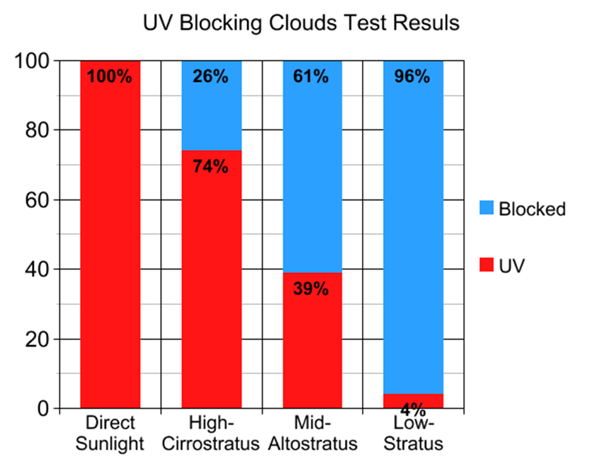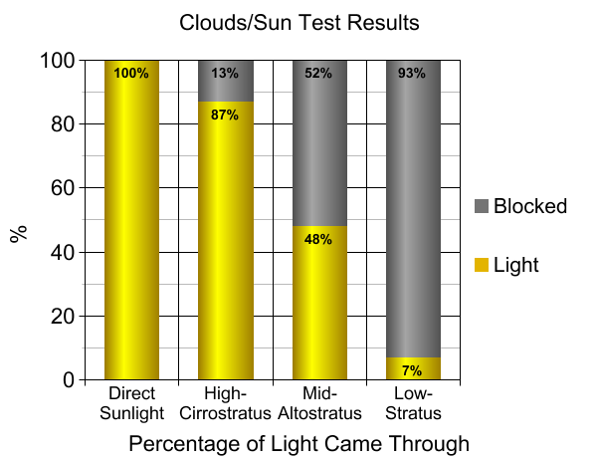

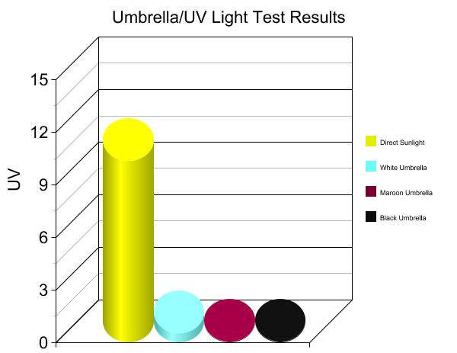
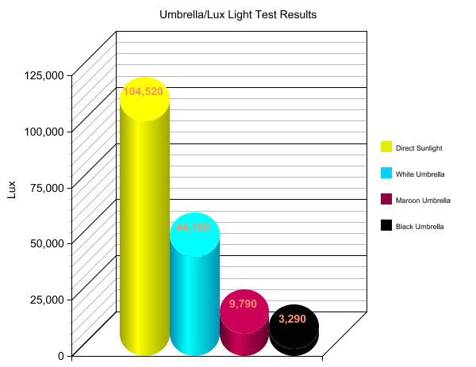
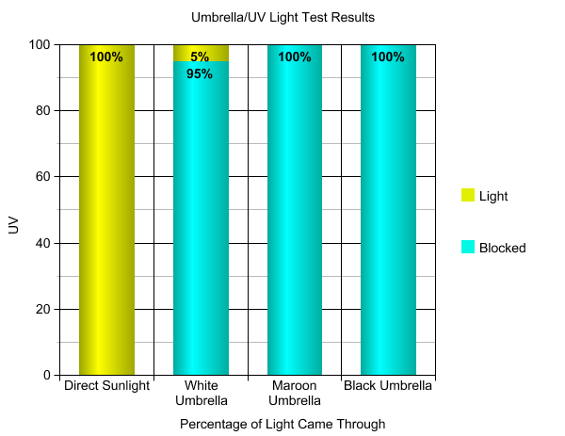

Sunscreen Light Test Results
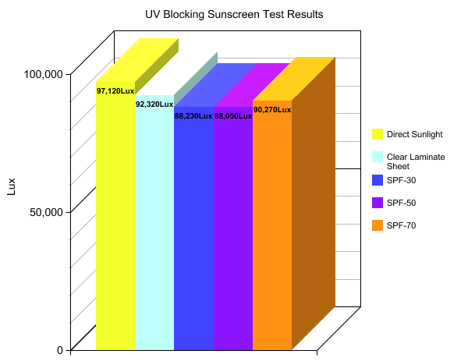

ANALYSIS AND RESULTS

Results for the Umbrella Tests:
Direct sunlight: 104,520 Lux, UV Index=10.25; White Umbrella: 44,160 Lux, UV Index=0.5; Maroon Umbrella: 9,790 Lux, UV Index=0.0; Black Umbrella: 9,790 Lux, UV Index=0.0.

Results for the Clouds Tests:
Direct sunlight: 103,420 Lux, UV Index=10.35; High-level Cirrostratus Clouds: 90,030 Lux, UV Index=7.7; Mid-level Altostratus Clouds: 49,600 Lux, UV Index=4.05; Low-level Stratus Clouds: 7,650 Lux, UV Index=0.4.

Results for the Sunscreen Tests:
Direct sunlight: 97,120 Lux, UV Index=9.65; Direct Sunlight through Clear Laminate Sheet: 92,320 Lux, UV Index=8.6; SPF-30 Sunscreen: 88,230 Lux, UV Index=0.7; SPF-50 Sunscreen: 88,050 Lux, UV Index=0.3; SPF-70 Sunscreen: 90,270 Lux, UV Index=0.15.

CONCLUSION

The hypothesis was supported by the data. The maroon and black umbrellas blocked all of the UV radiation and the white only let a very small amount through. 75% of the UV radiation went through the high level clouds, and the mid-level clouds only let 39% of the UV radiation through. However, the UV Index for both the high-level and mid-level clouds was still in the range for sunburns to occur. The low level clouds blocked 96% of the UV radiation. All three SPF rated sunscreens provided protection against sunburns according to the UV Index. SPF-30 blocked 93%, SPF-50 blocked 97%, and the SPF-70 blocked 98.5% of the UV radiation.

DISCUSSION

It was really interesting how well the sunscreen blocked the UV rays but still let a lot of light through the clear laminate sheets. As expected the cloth of the umbrellas did a really good job at blocking the sun’s UV radiation. It was also very interesting that even though there might be some cloud cover, there were still enough of the UV radiation coming through the mid-level and upper-level clouds that a person would need to take precautions against sunburn.

ACKNOLWEDGEMENTS

My mon helped with the data analysis and took pictures while I was collecting data. My science teacher, Mr. Rose helped during the data collection process and supervised the process. Our GLOBE sponsor, Ms. Tammy also helped guide and support my efforts in collecting GLOBE data during the past two years.

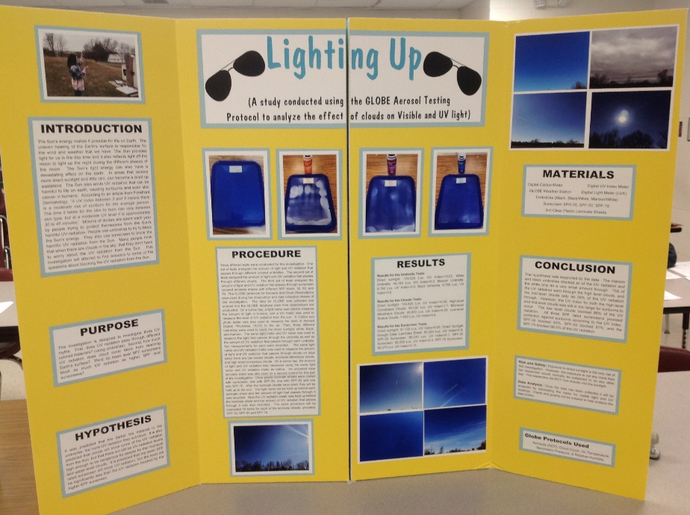

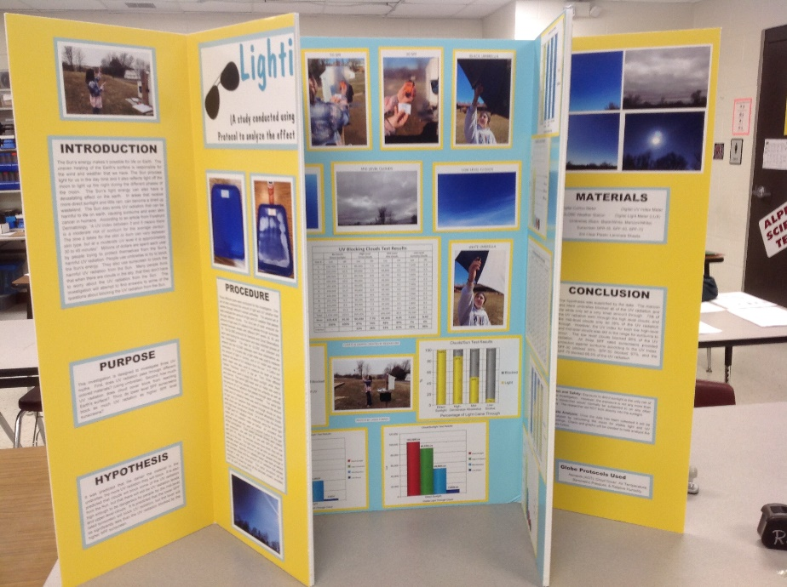
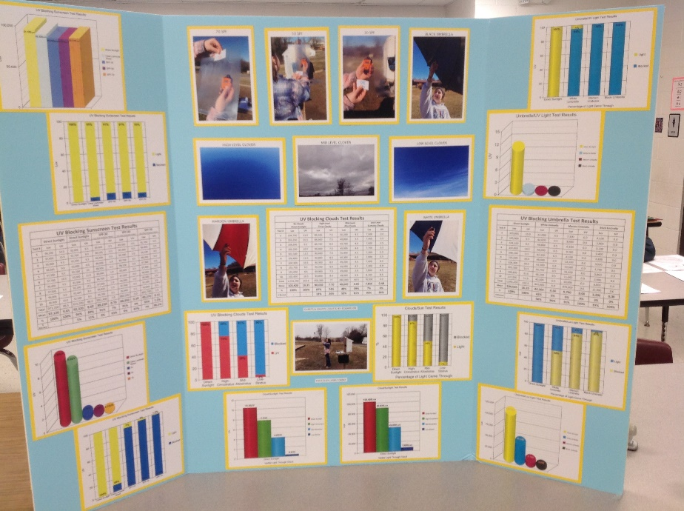
BIBLIOGRAPHY
Board, Ocean Studies, and National Research Council. Climate intervention: Reflecting sunlight to cool earth. National Academies Press, 2015.

Forefront Dermatology, “UV Index: The Sun Safety Scale, May 31, 2017, retrieved from the internet on 1-6-2020
https://forefrontdermatology.com/uv-index-sun-safety-scale/

Keith, David W., Edward Parson, and M. Granger Morgan. "Research on global sun block needed now." Nature 463.7280 (2010): 426-427.

Maslin, Douglas L. "Do suncreens protect us?." International journal of dermatology 53.11 (2014): 1319-1323.

Pelham, Roger H. "Sun blocker." U.S. Patent No. 5,265,929. 30 Nov. 1993

Rittié, Laure, and Gary J. Fisher. "UV-light-induced signal cascades and skin aging." Ageing research reviews 1.4 (2002): 705-720.

Siegfried, Robert W., et al. "Polyester-based suncreen formulations." U.S. Patent No.

Spinhirne, J. D., and A. E. S. Green. "Calculation of the relative influence of cloud layers on received ultraviolet and integrated solar radiation." Atmospheric Environment (1967) 12.12 (1978): 2449-2454.

Stacener, M. D. "Suncreen vs Sunblock & Which One to Tan With." (2008). 5,833,961. 10 Nov. 1998.

Sun, Jianhui, et al. "Photocatalytic degradation of Orange G on nitrogen-doped TiO2 catalysts under visible light and sunlight irradiation." Journal of hazardous materials 155.1-2 (2008): 312-319.

Thompson, Sandra C., Damien Jolley, and Robin Marks. "Reduction of solar keratoses by regular sunscreen use." New England Journal of Medicine 329.16 (1993): 1147-1151.

Wild, Martin, et al. "From dimming to brightening: Decadal changes in solar radiation at Earth's surface." Science 308.5723 (2005): 847-850.

Young, A. R. "The sunburn cell." Photo-dermatology 4.3 (1987): 127-134.

Young, A. R., J. A. Harrison, and S. L. Walker. "Low SPF suncreens reduce photoageing in mice: a biochemical and histological study." Cosmetics and toiletries 103.7 (1988): 49-51.

