(1 of 7)
Using GLOBE Data Entry
From the GLOBE Data Entry Home, you may enter measurements, edit previous measurements and edit or create new sites. With the new data entry system you do not need to create a site before you enter the data, the app will create it for you automatically if it doesn’t already exist.
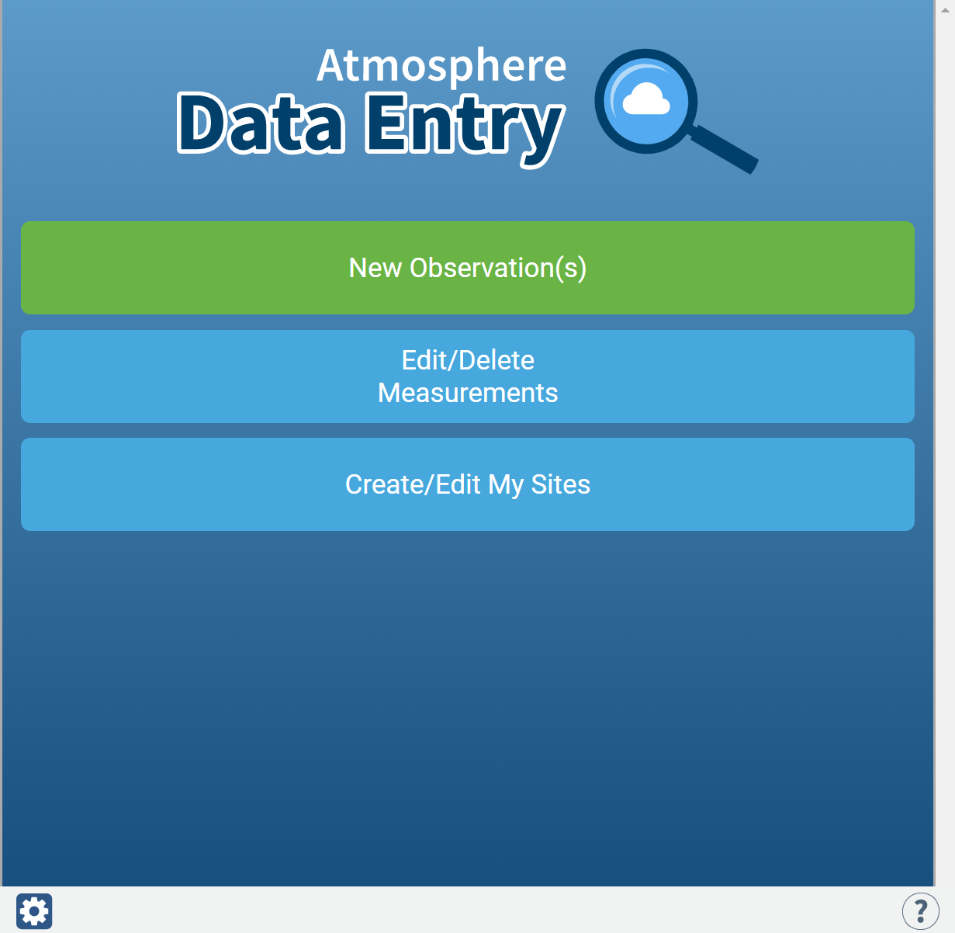

(2 of 7)
To enter measurements, select as many protocols as you have data for
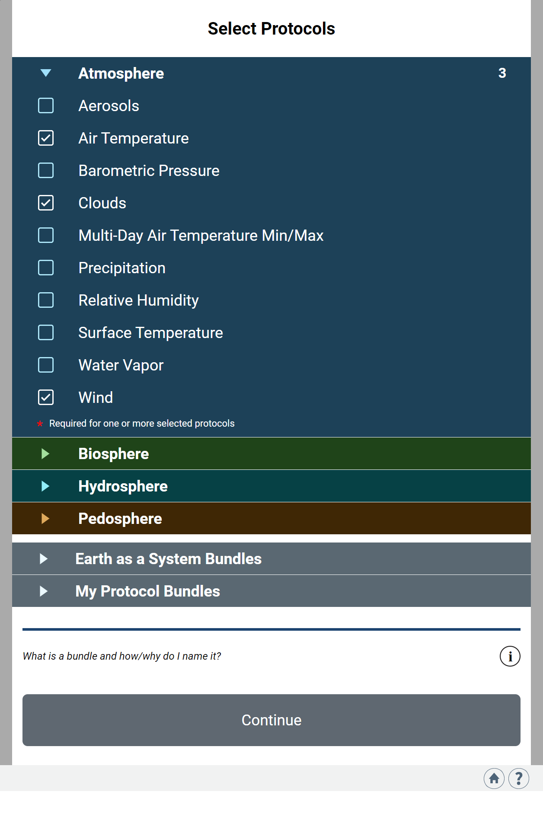
(3 of 7)
Choose your site, or add a new site (if on a phone your current location is shown, if on a computer, your school’s location is shown)
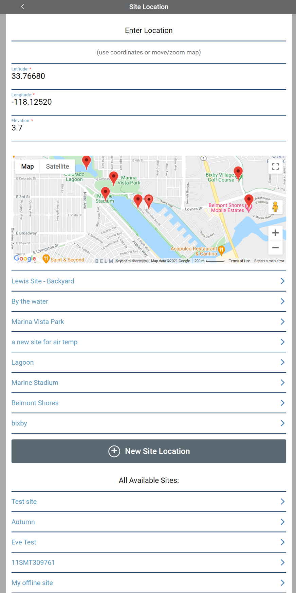
(4 of 7)
Enter the Date and (local) Time of the measurement
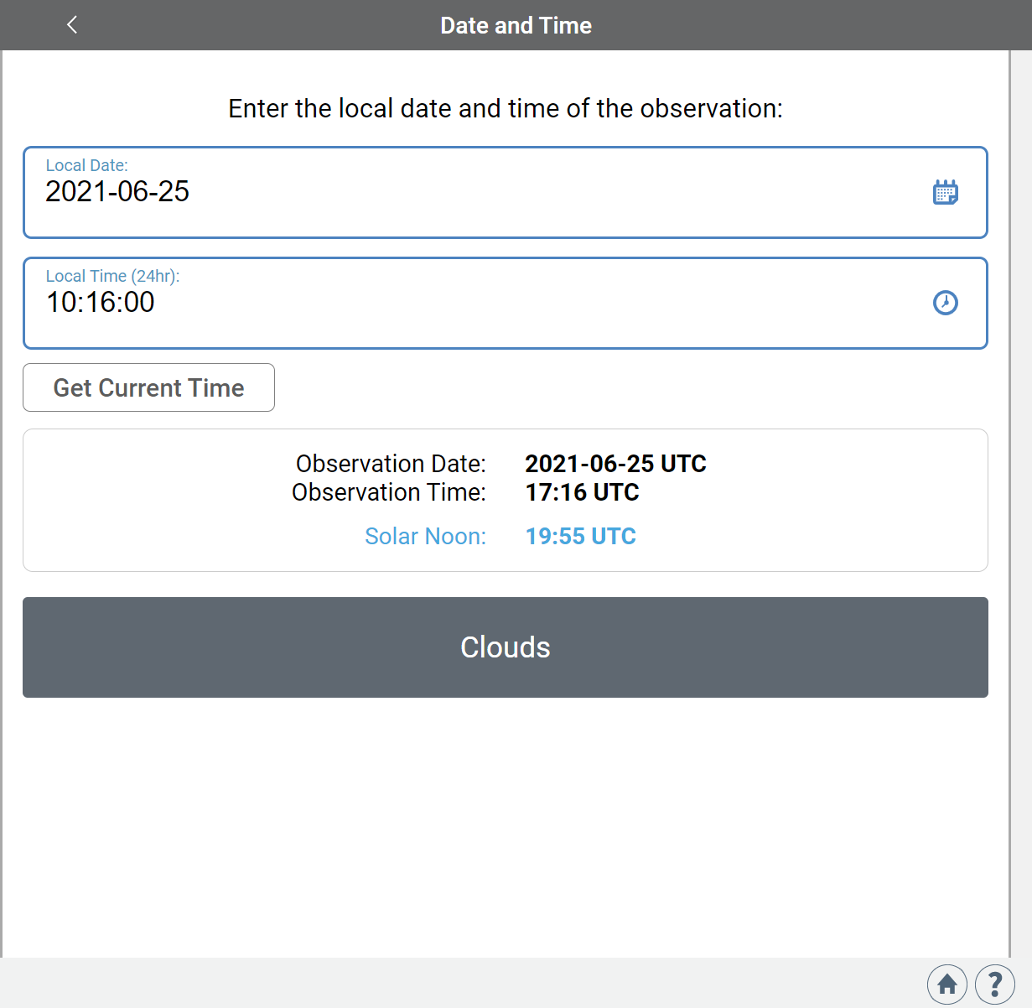

(5 of 7)
Enter the measurement data for each protocol
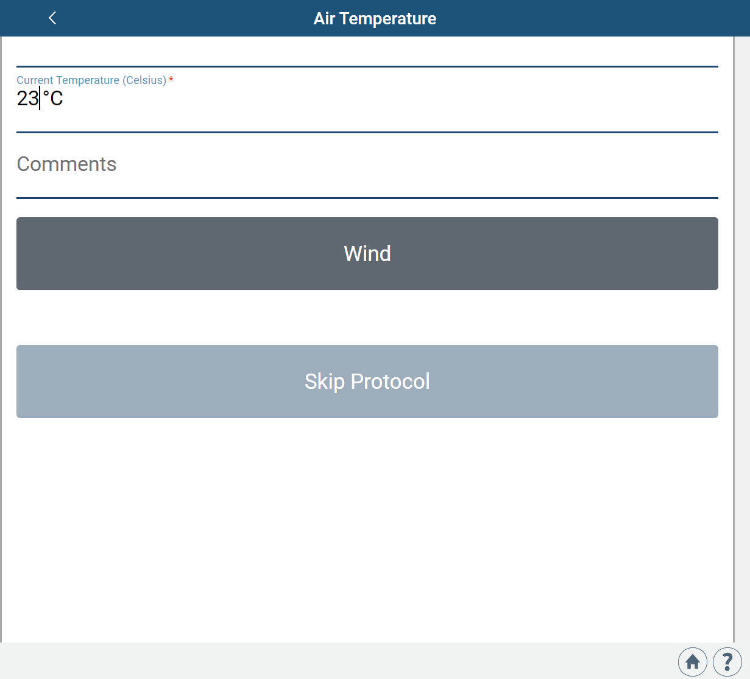

(6 of 7)
Review your data, then send to GLOBE
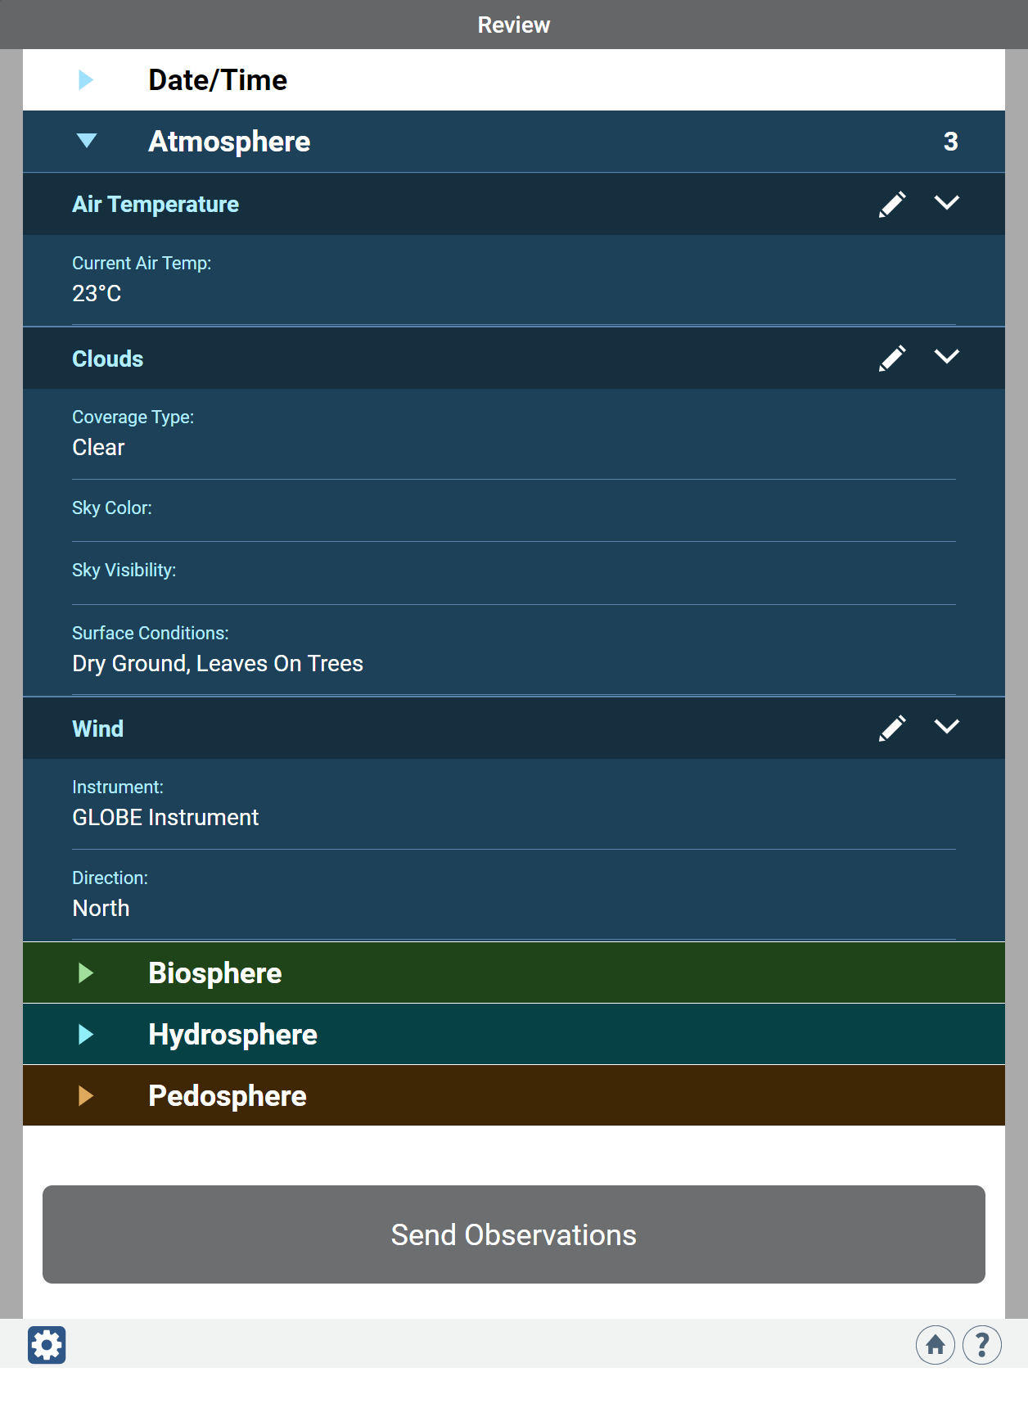
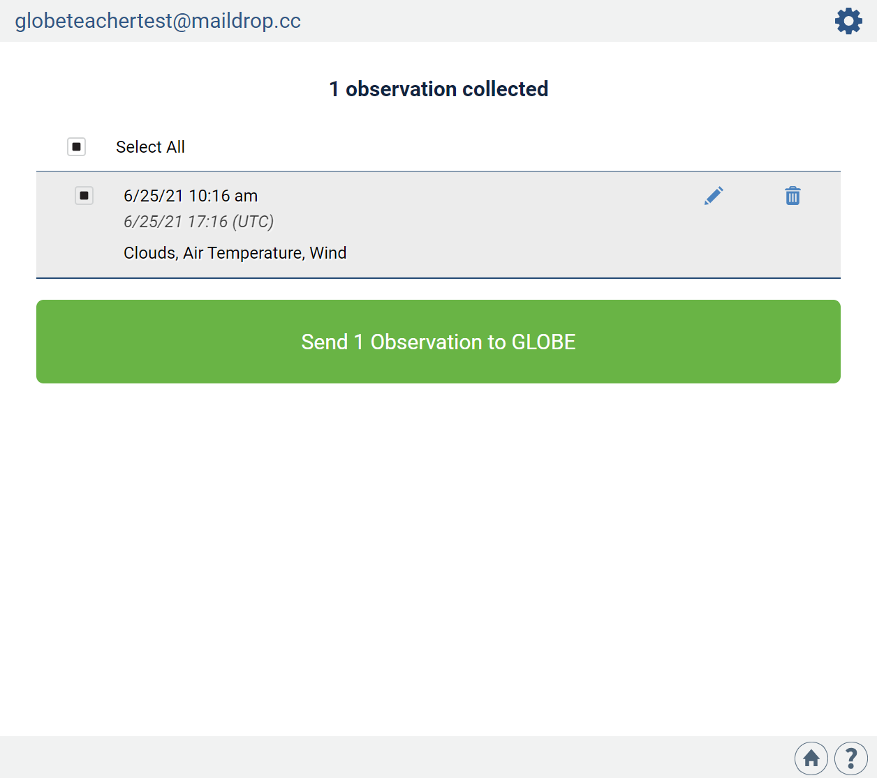

(7 of 7)
If on a phone – don’t forget to send your data to GLOBE!
