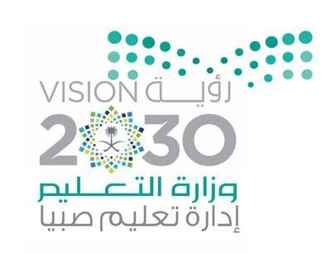
Saudi Arabia
Department of education of a Sabia.
Besh Education Office
High school girls decisions 3.
History/14/3/2020 m

Search title/
The future of wind energy on the beach Beach
Shoog Yahya Ibrahim Hattan
ايميل / shooghattan77@gmail.com
Globe program coordinator, environmental and research supervisor
Homaa Ahmed Mohamed Hattan

Table of contents

Numbers | Contents
1 | Problem
2 | Target
3 | Hypothesis the scientific background
4 | Materials and method
5 | Actions
6 | Data summary
7 | Analysis and findings
8 | Conclusions
9 | Discussion
10 | Thanked
11 | reference guide
12 | Contents

Title/ The future of wind energy on the beach Beach
Introduction to the study problem:
Energy is an essential component of the universe, and is one form of existence, usually energy derived from natural sources and other abnormal, so divided into two main types: renewable energy and other non-renewable problem talking about poor use of renewable energy from the power Winds on the Red Sea coast in Saudi Arabia and luy city extent in electricity generation problem: note that there is not sufficient capacity and exploitation rather for that energy from wind power in electricity generation and the establishment of monitoring stations for those winds on the shores of the sea. The red city of pesh in JAZAN in electricity generation in Saudi Arabia compared to the power of the wind through the seasons, particularly monsoon this energy is clean energy
Objectives:
Stand on studying the future use of wind power on the Red Sea coast city of pesh in JAZAN in electricity generation in Saudi Arabia according to the 2030 vision.
Conclusion the relationship between the future use of wind power on the Red Sea coast city of pesh in JAZAN, Saudi Arabia increased demand and domestic production of Vision 2030.
Find the relationship between the four seasons and the wind speed and intensity in the electricity generating turbines on the shores of the Red Sea city of pesh in JAZAN, Saudi Arabia
Questions and research hypotheses:
The reality of the future use of wind power on the shores of the town of pisz in JAZAN in electricity generation in Saudi Arabia according to the 2030 vision?
Is there a statistically significant relationship between the future use of wind power on the Red Sea coast city of pesh in JAZAN in Saudi Arabia and increasing demand and domestic production of Vision 2030.
Is there a statistically significant relationship between the four seasons and the wind speed and intensity in the electricity energy assurance turbine on the shores of the Red Sea city of pesh in JAZAN in Saudi Arabia?
Hypothesis:
There is a statistically significant relationship between the future use of wind power on the Red Sea coast city of pesh in JAZAN, Saudi Arabia increased demand and domestic production of Vision 2030.
There is a statistically significant relationship between the four seasons and the wind speed and intensity in the electricity energy assurance turbine on the shores of the Red Sea city of pesh in JAZAN, Saudi Arabia.

Significance of research:
Many believed the increased future demand lower costs and fewer bills as an inexhaustible source of renewable energy continues with the permission of Allah.
Scientific background:
First: a number of previous studies illustrate the importance of energy and wind potential in electric power generation, including the study of the book of wind energy from a Nikki Walker (translation of Omar Saeed ayyubi) Abu Dhabi authority for culture and heritage cultural complex included the following:
History of wind energy.
Humans have used wind power for thousands of years. Some machines were the first innovative wind works, find ways of using the ancient energy to business performance winds make their lives easier and more accessible.
The ancient Egyptians used the first sails around the year 3200 BC to sail along the Nile River square sails were made from leaves or reeds knotted. Sails enabled people to sail easily downwind but was hard to sail in other directions if you can manage to receive her masts on sails to the wind.
In the ninth century a.d. invented Arab sailors trigonometric sails. You can manage the spinnaker on the mast to receive wind from any direction, unlike the square sail spinnaker works even if the wind behind him it's also easy to steer the boats with triangular sails. By the fifteenth century European sailors began sailing ships equipped with triangular sails.
2. the chronology.
Thousands of years before people rely on themselves or on animals, or run water or wind as energy sources do most of the work played an important role in the history of mankind, and alternative energy sources such as wind power and become an important part and our future.
3200 BC, the ancient Egyptians invented a small sailing vessels.
700 a.d. use windmills in Persia to pump water and grind grain.
Twelfth century Europeans start building windmills.
14 th century alterations to the sails of the windmills in Europe to improve efficiency.
Nineteenth century European settlers start building windmills in North America.
In 1854 m Daniel halday builds and sells halday mill, a windmill is the first designed specifically for the West, characterized by high wooden blades spin wind direction
1888m Charles rush built the first large Windmill to generate electricity in Cleveland, Ohio, use this pump to pump groundwater.
First/how wind turbines.
All wind turbines are the same basic pieces: blades and pulleys Tower Fund, these pieces together to get the kinetic energy of wind and convert it into electrical energy.
. The wind blows the blades then run
. The associated encryption key or column axis. When you spin the main rotor blades shaft too.
. Spine associated with large wheel box inside the box slowly, making small gears spin fast
. Run another quick column column gears very quickly.
. Generator associated with rapid column consists of a magnet inside the copper wire file. When it spins fast spin column magnet produces electrical wiring area.
. Movement of the thick power cords or electricity from the turbines.
II how much safety in turbines.
Engineers are always looking for ways to make wind turbines are safer and more effective, so draw more of the lighter winds. Of course, increasing the speed of the wind turbine speed is increasing. The strong winds may make the turbine last fast so strong cause strong vibrations and caused entire turbine alariash amtlakh. It is important then equip air turbines by means of deliberate security internally working automatic override on top speed.
III/how limiting safety speed wind turbines
The ongoing massive turbines equipped with electronic control systems that measure wind speed and direction. They are constantly fine tuning alariash angle and direction of the entire turbine to wind conditions. When the wind speed exceeds a certain limit down alariash face the wind, don't last as fast as wind turbines most also provide huge brakes to slow its speed. Smaller turbines were equipped with overloading the link bariashha. When the last alariash more speed work power window on pushing weights away than spinning alariash to face the wind..
IV/the effect of the wind potential in the environment.
Air turbines environment beautiful projects, for example, does not produce harmful waste, but to people to intercept two exterior noise
VA/safety measures
Strong winds can cause spinning very quickly occur vibration in turbine blades can crash or broken. To avoid these accidents turbine designed to achieve maximum speed varies according to the size of the turbine. When a commercial turbine maximum speed the computer tilt his blades to reduce face wind and slow speeds, it is called a folding computer also holds the brake rotor blade speed, not I swivel small turbine connected to the tower by the hinges. When it reaches the turbine rotor tends to maximum velocity on hinges to reduce face wind and slow down the speed of the blades.
Vi/wind potential in the future.
The increasing demand for wind potential will continue in the future with the increasing interest people sustained environment and pollution issues. Canada, for example, plans to generate about one-fifth of its electricity from wind potential. Salva was one of the main obstacles to higher cost using wind potential. Now, the electricity generated by wind turbines, the best types of cheap electricity generated equal cost in bokod working capacity coal terminal. We argue that wind power costs can be lowered by half using materials comprising lightweight, computer control systems, better and more efficient generators
Secondly: the Web sites included: first location of renewable energy Atlas website (city of King Abd Allah) 2016.
Wind generated on Earth for three reasons and difference in temperature between the poles and the equator, the Earth's rotation around its axis, and the differences in the degree of absorption of solar radiation between Earth and sea. These mechanisms are working together in a complex, where the wind speed increases as we drove up from Earth's surface to match the amount of power generated with cubed wind speed, making for greater impact wind speed in determining the amount of energy generated, as specific wind speed of quick change rates and high tolerance for Of time in many circumstances which limits and restricts the usefulness of providing a general average wind speeds for extended periods of time. It also requires other data about wind speeds such as storms and periods of immobility and silence where and no wind.
Don't give the wind resources in Saudi Arabia enough yet, like renewable energy and wind energy current monitoring devices on a trial basis in the city of King Abd Allah for. So they'll make models to measure the average annual wind speed in Saudi Arabia, represented by force of the wind at height of 80 meters above ground level (AGL) how 3 *, this data is available in the Atlas site.
Preliminary studies indicate that Atlas also gate, to an annual average wind speeds in most areas in Saudi Arabia about 6.0 to 8.0 meters per second, but did not include potential average wind power for long periods of time.
Materials and method Materials and method:
Method of preparation:
(A descriptive study).
(Electronic questionnaire). Through a statistical study to sort the answers we found the answer (Agreement) in total, most answers (somewhat agree) and answer (I don't agree), very few
Action:
Study shows here chose a sample search and representation through the stratification of the sample to study.
With the research community included 124 (electricity company employees and another in pisz, a group of students and teachers from schools Finder) 62 sample and study estimated 50%.
View photos of beaches and wind turbines (wind sections) run the first wind turbine with a partnership ' GE ' American conservative Saudi Tarif
Explain the tools used in generating kinetic energy from the wind and turn it into energy turnover by turbine in turbine rotor device, run by liquid or gas, such as water, steam and gas and air. Turbine change kinetic energy (energy of motion)
For the liquid to a special kind of kinetic energy and rotational energy is used to move machines. Connects to other machines turbine mechanical energy by rotor rotation therefore used in generating electricity
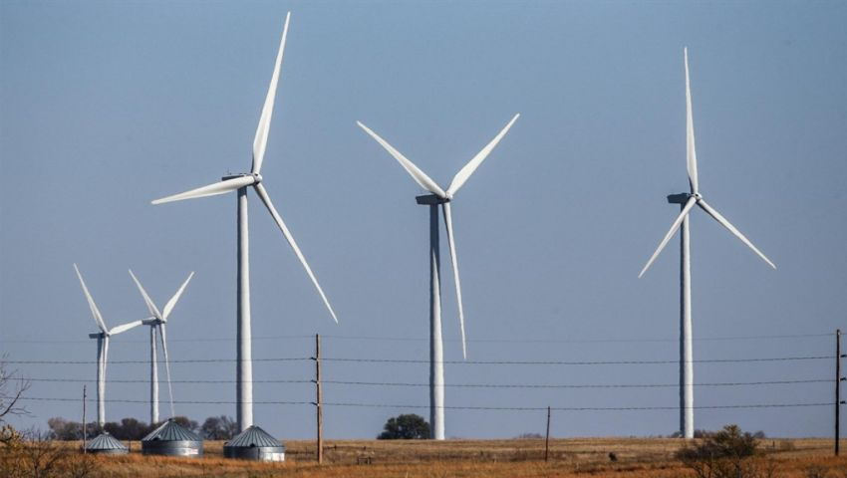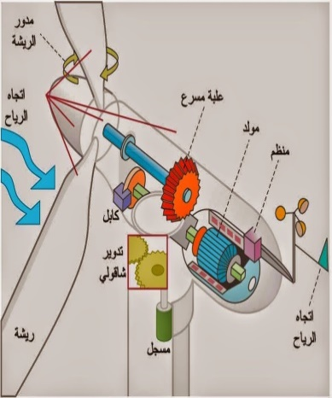
Run the first turbine to generate power from the wind in Saudi Arabia

Data summary of actions will also develop a questionnaire about the problem as follows:
Results of the questionnaire distributed to random sample:
Results (proportions and duplicates) through statistical study for the type of instrument used in research (questionnaire) the electronic questionnaire distributed for scientific research of secondary school 3 decisions to measure the use of wind power on the Red Sea coast city of pesh in JAZAN in electricity generation With Saudi Arabia under Vision 2030. included a set of questions was in the first final taking place indicating the type of sample (age * qualification * job (work) included 62 people from total 124 community sample and work tables and graphs relative to clarify them as shown in the figure and table of Talley
:

Research methods of materials and method: the method of preparation:
The method used in research methodology (ASG-descriptive). (Electronic questionnaire) through statistical study to sort the answers we found that answer (I agree) in total forms most of the answers (somewhat agree) and answer (I don't agree) very few actions: study shows here and choose a sample search and representation through the stratification of the sample to the A study in research. with 124 research community included (electricity company staff and another in pisz, a group of students and teachers from the school researcher) took a sample of 62 and study estimated for b 50%.

X 1/percentage agree to 19.4% agree somewhat on 79%, agree on the percentage of estimated 1.6%
X 2/percentage somewhat agree agree 3.11% 87.1 per cent and 1.6 per cent of the estimated agreement.
I agree somewhat X 3 ratio of 25.8% 69.4% approves the agreement, an estimated 4.8%
X 4/ratio somewhat agree with 14.5% to 79%
Estimated 17.5 per cent rate agreement
X 5/percentage of 11.3 per cent agree somewhat agree 19.4% consistent with 69.4 per cent
X 6/
For agree somewhat agree 29% 67.7% disagree
3.3 per cent

Through the table position to answer questions

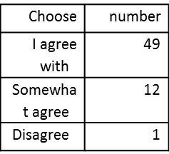

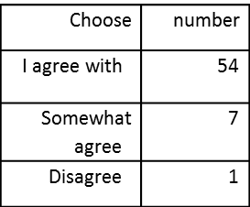
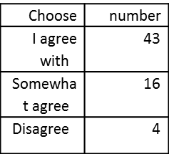

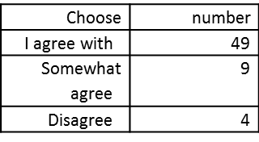

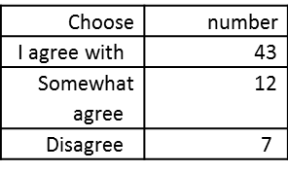

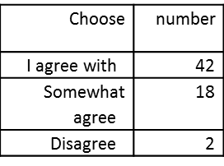

Analysis and findings
Main results: at the end of my studies and research on the question came at last to a set of results and conclusions:
Conclusions:
. 1-study area location features easy and standard enjoys a permanent winds movement in the monsoon season.
. 2-the ' wind energy ' renewable energy and the exploitation of clean energy use for electricity generation makes the future of pesh a promising future for development and construction.
. 3-technology use faster winds new electricity generating sources of global growth
4. observe through research that wind and wind resources in Saudi Arabia had not fully studied yet but have been using wind power stations monitoring devices in some regions to create electricity generation projects for economic development vision 2030 experimental level
from the biggest city of JAZAN economic city basic and manufacturing industries and will be under Royal parasol, which makes one of the most important cities in the Kingdom Besh investment and future national economic tributary of their intentions by people of JAZAN especially residents of the Kingdom..
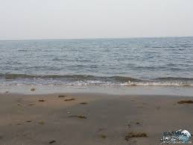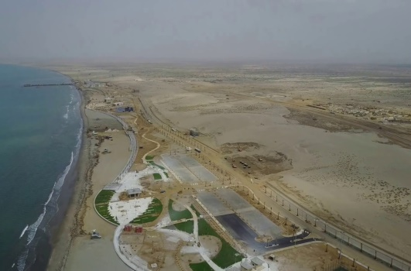
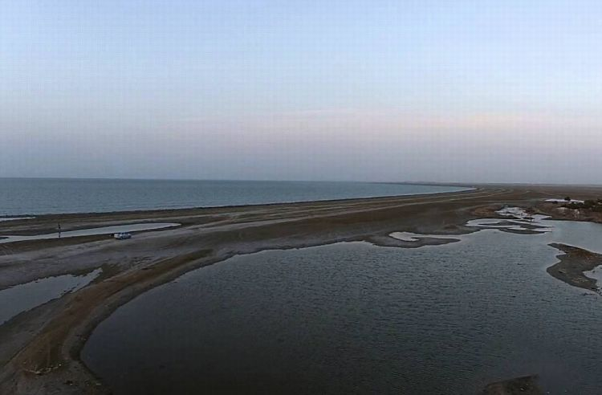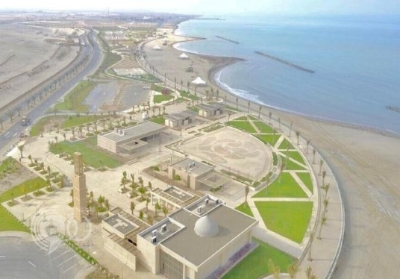
The shores of the Red Sea/Beach
Recommendations and proposals
. work on technology transfer that energy (wind) and the establishment of monitoring stations in the city of pesh on the shores of the Red Sea in JAZAN for Saudi Arabia in 2030.
. update the wind uses studies in Saudi Arabia by 2030 through seminars and regular meetings for this area.
. work on training and preparation of scientific capacities and human resources and adopted by the State is building a national wind energy specialist staff working on the transfer of expertise and technology to exploit those resources and find ways of scientific cooperation with the Nations of the world to see their experiences and educate the younger generation about The importance of renewable energy.
. make use of wind power and invest in various areas such as power generation and agricultural uses such as water pumping and down and focus on their applications for the development of the economy of the city of pesh in JAZAN in Saudi Arabia, in addition to its use in the development of the industrial sector JAZAN city basic and manufacturing industries
. the moral and material support and stimulating research in the fields of wind power and encourage the private sector and venture capitalists to invest in wind energy.
. pilot projects and quite large according to level a City Beach in JAZAN, Saudi Arabia as a source of energy and training.
Discuss
Previous studies of extension of the current study came to benefit from wind energy to generate electricity and the interest of capital through turbines, windmills and pumping water out of their power at least cost and pollution free and clean natural energy, Saudi Arabia has encouraged The use and study of future use in areas of Saudi Arabia on the Red Sea coast city of pesh in JAZAN, Saudi Arabia Vision 2030.

Appreciation and thanks
Thanks thank Allah, Lord of the worlds, and blessings and peace be upon the Prophet Mohamed Ashraf senders and his family and companions and his praise and glory first, and less what we bestowed grace and bounty and inspired me to be patient until you complete this research.
And thanks again to my mom and I thank Bish Office learning activity management and education section in the Ministry of education Saudi Arabia Sabia and embrace how scientific research lglob ecosystem and deepening his love in the hearts of her students and her students through the open door of opportunity to participate in the virtual student Symposium ' research ' lglob International environmental.

Bibliography electronic source https://www.youtube.com/watch?v=6mNl_VK8iYM
iYM references found on a Web page
1. the Internet (lecture on line July 2009 lldktormhamd Uddin Yusuf)
2. renewable energy Atlas website (city of King Abd Allah) 2016 m
3. encyclopedia of sustainable energy wind potential authors Professor (Ahmed Shafiq al-Khatib – Yusuf Suleiman okay Allah) Lebanon library publishers
Bibliography of research libraries and encyclopedias 3-wind power generation from a Nikki Walker (translation of Omar Saeed ayyubi) Abu Dhabi authority for culture and heritage
4- Wind power generation from a Nikki Walker (translation of Omar Saeed ayyubi) Abu Dhabi authority for culture and heritage cultural complex
https://www.youtube.com/watch?v=6mNl_VK8iYM
Saudi Aramco announced the completion of Cornish Beach in JAZAN-class length 1.7 km on the Red Sea, the total area up to 280 thousand square meters, to become ready to receive people and visitors as the latest beautiful beaches that have been implemented in accordance with international standards.

The decals
* Collaboration
Globe students cooperation in distributing the questionnaire to answer questions through social networking sites for a bunch of random samples of school students in the attached questionnaire and then extract mathematical estimate for answers and do graphs and mathematical statistics in research

* World of data and the study sample and effect theme
And showing the impact and effectiveness of the subject search through altgwab and interaction on six questions answered in questionnaire through a posting in one of the social networking sites at random for different age groups have been analyzing the data in the search through the study analysis by category Age and school level job
This study was the interaction with the show:
Material and method: the method of preparation:
The method used in research methodology (ASG-descriptive).
(Electronic questionnaire) through statistical study to sort the answers we found that answer (I agree) in total forms most of the answers (somewhat agree) and answer (I don't agree) very few actions: study shows here and choose a sample search and representation through the stratification of the sample to the A study in research. where the research community included 124
(Electricity company staff and another in pisz, a group of students and teachers from the school researcher) took a sample of 62 and study estimated for b 50%.
Q1/percentage agree to 19.4% somewhat agree 79%,
Because I agree with estimated 1.6%
X 2/ratio somewhat agree 3.11% agree to 87.1% and 1.6% of estimated agree.
X 3/somewhat agree ratio 25.8% 69.4% agree to agree an estimated 4.8%
X 4/ratio somewhat agree with 14.5% agree to 79%
The ratio of the estimated 17.5% agree
Q5/ratio to 11.3% agree somewhat agree 19.4% agree with 69.4%
X 6/ratio somewhat agree 29% agree to 67.7% disagree 3.3%

* Communicate with competent, textured STEM
* Communicate with the competent and experienced STEMIt by communicating with a group of specialists, the study of arbitrators and research: • Communicate with some of the staff of the City / Beach Energy Company Scientific Supervisor of the Professor of Global Environment / Lola HighwayHelp me out and review the steps of writing research. • The search for arbitration by the Research Coordinator of the Department of Education of a boy. • Globe Program Coordinator. School Professor / HWMAA HATTAN to supervise research. • Health Officer for English translation of older brother Salah Hattan to translate the research. School of Professor / Ms. Fayza Bahri

* Networking among schools
. schools participating in environmental globe by knowing how to write search virtual Symposium and submitted for environmental site.

* Engineering solutions to the problem.
. never with an at bat people from objection to the use of wind turbines but in our research established
Wind turbines nicer environment dirty projects. For example, it does not produce any waste harmless, but for people on two interceptions are noise and external appearance.
. how much safety in turbines.
Engineers are always looking for ways to make wind turbines are safer and more effective. It is important then equip air turbines by means of deliberate security internally working automatic override on top speed

* Communicate with Pro STEM
Science teachers at school and electricity companies to clarify the difference between wind electricity generation using wind turbines in the city and generated by petroleum derivatives

* Communicate with Pro STEM
* Search story got the globe site badge to school year 2016 m
- The students and students of research who have already won the student / Noha student at the exhibition 2016, explaining its effect and its results in the effectiveness of Zamzam diabetes and the importance of alkaline water (Phz-PH8) to treat many diseases.
I also handed out a set of questionnaire to members of the school and by communicating with the globe converging results parameter

