

Kingdom of Saudi Arabia
Ministry of Education
Directorate General of Education in
Tabuk Region
The Second secondary school

The Relationship between Groundwater depth and Percentage of Melting Oxygen in Alhara region in Tabuk

26/3/2017

Prepared by student
Aisha Salem Al-Wadai

Supervised By Globe Teacher School Manager Ms. Fatima Al-Enzi Ms. Mha Salem AL atwi

Abstract
The underground wells are regarded the most important sources of water in the Kingdom of Saudi Arabia, while the Kingdom digs these wells. It has been proven that there are many wells in some regions such as Al-Harrah region in order to face the water crisis.
This research aims at studying the effect of underground wells in Al-Harrah region on the decrease of Oxygen saturation rate in water the deeper the wells are.
This research is divided into two parts: the theoretical and the practical part through the usage of the experimental method for its adaptability to the nature of the current study.
The study has reached to important results among which:
When the well becomes deeper, the rate of Oxygen saturation in the water decreases.
Some of the study's recommendations are:
- Doing a project research that aims at studying the radiation rates in the underground water in the said regions.
- Warning individuals of random digging of wells and making them depend on specialized companies in this field.

Hypotheses:
There is a relationship between the deep underground wells in Al-Harrah region and the decreased rate of the Oxygen saturation in its water.

Procedures:
Samples of wells with different depths in Al-Harrah region was drawn to measure the Oxygen saturation therein.

1
Main Results:
After making the measurements, the decrease of the oxygen saturation with the depth of the well was has been observed.

Results:
There is a negative relationship between the increase of the well depth and the rate of the Oxygen saturation in the water.

Research Question:

What is the relation between the depth of the deep underground wells and the rate of the oxygen saturation?

Hypotheses:
There is a relation between the existence of deep underground wells in the region of Al-Harrah and the decrease of the Oxygen saturation rate in its water.

Study Objectives:
Human has faced a fearing concern and a big danger represented in his expose to the radiated elements and their dangerous effect on health. These radiated elements may have a big negative effect on the human life and they could also harm the coming generations. The harm, which may afflict the human body through his expose to the radiated materials, depends on the exposure dose to these radiated materials. In this study, we would like to draw the attention to the possibility of the occurrence of radiation pollution to the underground water in Al-Harrah region in the Kingdom of Saudi Arabia.
2

Table of Contents

Subject | Page Number
Abstract | 1
Research Question and Hypotheses | 2
Research Objectives | 2
Dedication | 5
Introduction | 6
Water Problems in the Kingdom of Saudi Arabia | 7
Water Sources in the Kingdom of Saudi Arabia | 8
Arab Shield | 14
Al-Harrahs of the Triassic Period | 15
Study Procedures | 17
Study Results and Data Analysis | 22
Discussion | 23
Previous Studies | 24
Results | 26
Recommendations and Suggestions | 27
References | 28

3

Page Number | Forms
15 | ( Shape1) ‘Harat Aoard’ and ‘Alrah Harat’ in Tabuk
15 | ( Shape2)Sample number 2 ___Location of the well
16 | ( Shape3) A map showing kinds ,distributions and extensions of Alhara in Saudi Arabia
23 | ( Shape4) Initial geological map shows the spread of Radon gas in the Arabian shield in Saudi Arabia .
Table of Forms

4

Thanks and Dedication:
All the achievements of our lives would be beautiful if they were shared with our beloved ones. Therefore, I thank each one helped in the completion of this research and its success. I present the research to each researcher, scientists, and student; besides each one who is interested in the matter of our nature … I present this research to you….
I'm thankful to Dr. Abed Abdullah El Atawi Member of faculty of KSU of agriculture as he was very cooperative. When we displayed the problem,he supported us the reports that proven the existence of problems in the groundwater and his follow-up of the results we have reached.
for providing us with the samples we ( Arab Skills Agr.Trad.Group ) I'm also grateful to the wells services and drilling company needed in our study .

5
5
Introduction:
Water is an essential life element on earth as the surviving is impossible without water. It represents 70% of circumscription of earth. Most of this percent is ice that represents 77.6% and groundwater 21.8%. The remaining amount, which does not exceed 0.6%, is the responsible to meet the need of 6 billion human beings to water in the agriculture and industrial activities, and all daily needs.
UNESCO said in a study prepared recently that more than 31. Thousand people die every day from drinking water shortages. In addition, that more than one billion people in the world have problems in clean water sources, and that three billion people in the world do not have a sewage system.
Water scarcity has been exacerbated by high population growth rates compared to average per capita in 1960. Of 3430 m³ and the average share in the year 2025, which will be 667 m³, a decrease of up to 80%. Naturally, this leads us to look at the rate of renewable water resources in the world, and in the Arab world, which is 350 billion cubic meters, and 31% of them are covered by rivers coming from outside the region. That is coming through the Nile River 56 billion cubic meters, The Euphrates River is 25 billion m³ and the Tigris River, which pumps 38 m³. Hence, the problems of water in the world and the conflict have started to appear. This problem has been exacerbated by the increase in the population, the lack of water resources and the indicators of its depletion, as we mentioned at a time when the Arab world consumes only 50% of its water resources and the rest is wasted.
6
Water Problem in the Kingdom of Saudi Arabia: -
Water scarcity has become worrisome all over the world, especially since the wide areas experiencing a decline in water sources as well as population growth and industrial expansion. on the other hand, concerns about the abundance of water has become an unequivocal reality that cannot be exceeded. Furthermore, Saudi Arabia is fully aware of these concerns.
The problem of water in the Kingdom in its geographical location as it is desert areas located in the dry range and the consequent scarcity of rainfall and the absence of rivers and lakes permanent.
Despite these water shortages , water demand in Saudi Arabia has been estimated at 17 billion cubic meters a year, which is four times higher than the water quantities produced by the Gulf countries.
Official statistics shows that Saudi is the third big consumer of water. Moreover using 231 liters per day , is equivalent to about twice the average global consumption

7
Water Resources in the Kingdom of Saudi Arabia:-
Water resources can be divided into five main sections:
- Surficial water.
- Springs and fountains
- Subterranean water (shallow groundwater)
- Deep groundwater
- Distillated water
- Treated wastewater

- Surficial water.
Surficial water accumulates above the surface of the earth after precipitation in the depressions or behind dams and mounds. Rainfall follows a shallow runoff of water in the valleys and various reefs of the drainage systems, which are called the drainage basin.

Drainage basins are mainly divided into two parts:

- External discharge ponds: Their waters are disposed of outside the area of rainfall towards the sea, such as drainage networks of valleys of the western part of the Kingdom such as the valleys of Fatima, Numan, and Jazan.

8
- Internal drainage basins: Their waters are disposed of in the inland basins in the direction of the east, including the valleys of Najran, Rama, Sarawat and Torba.

In general, surficial water is lost either by intense evaporation or by leaching into the ground. This fraction represents a small proportion of the amount of rainwater, which often turns into running water in the form of floods after a short period of rainfall, which is lost either in the sea or to the desert sands.
It is known that the leakage of surficial water to the ground through the filtration process contributes to the subsurface recharge, thus leading to a high percentage of groundwater inside. The amount of water lost to the sea was estimated at 1265 million annually, constituting 62% of the Kingdom's total. To benefit from these floods, the state established a large number of dams, such as Wadi Jazan dams, Wadi Fatima dams and Wadi Abha dam.

9

The utilization of surficial water in the Kingdom is limited and is often limited to the cultivation of some crops in the areas where the floods are in addition to the use of water stored behind dams in irrigation as in the Jazan.

- Springs and fountains

Springs are defined as places where water appears on the surface without human effort. There are types of human-made springs such as Al-Dobol, watercourses and fountains. Spring is usually used to irrigate farms. Examples of natural springs are the springs of Wadi Fatima, Al-Leith and Al-Ehsaa. Examples of industrial springs are Fountains Sultanate of Oman and Ain Zubaydah. The persistence of the springs depends on the availability of constant feeding of rain and floods. Good maintenance and good cleaning of the subterranean channels of the sediment maintain water flow in these springs. The Kingdom has many springs whose discharge rate varies from a few liters per second to more than 1,000 liters per second. The quality of its water is also fresh (salted less than 500 mg / L) to saline (salinity exceeds 5,000 mg / L). The flow of some springs in the Kingdom such as the springs of Wadi Fatima and Khulais and others has stopped for several reasons:
- Decreased precipitation, which reduced the amount of nutrition.
10
- The significant increase in pumping rates from the wells, which led to a drop in the water level.
- Neglecting the cleaning of the eye ducts and dolphins from the folds and sand.
- Other less costly and more productive substitutes are in wells.

- Subterranean water
Groundwater is sub-surface when rainwater is deposited through soil pores into the ground so that it is stored in layers known as aquifers.
Surface deposition of surficial water is related to surface factors, such as the nature of the surface (soil permeability, soil saturation, slope of the earth surface), rainfall, precipitation, vegetation.
One of the most important areas rich in subterranean water are valleys, especially those in the Arabian Shield where the hydrological cycle is active compared to the rest of the Kingdom. The cracks in the mountain rocks surrounding the valley are among the most important outlets for the arrival of rainwater to the bottom of the surface sediments that fill the reservoirs of the different valleys. This water is usually stored in the sediments, in addition to the upper part of the glacial or fractured rocks of the base. The depth of the groundwater level is usually within a few meters - 25 meters, and the depth varies from one period to another according to the quantities of nutrition and discharge. This near-surface water is obtained by drilling large-diameter handwaters that are coated with stones or concrete slabs that prevent them from being filled. The tenders for these wells vary from tens to hundreds of cubic meters per day and their water quality varies
11
from fresh (tens of thousands of parts per million) to saline (tens of thousands of parts per million.) Well water is used for irrigation and sometimes for drinking in villages and rural areas, Asir, Baha and Taif.

- Deep groundwater
The sedimentary water-bearing sediments, which form part of the stratified rocks, are the main source of groundwater. These aquifers contain large amounts of water. The area covered by these sedimentary rocks is estimated at 1.5 million km², which is about 5500 m. and the qualities and depths of groundwater from one place to another and from one class to another, and it is possible not to find a specific composition except in a particular area. For example, the leg components are not in Riyadh or in the Eastern Region. It is dry in another area, and the composition may be flowing in a region while it needs to get water from the same configuration to pumps in another area. There are twenty water-bearing plants in the Kingdom, nine of which are major (Al-Sak, Al-Wageed, Tabuk, Al-Mongoor, ABiad, Al-Wassa, Umm Radma, Al-Damam and Al-Nujin) and the other are secondary. The composition of the composition of the water is dry and suitable for consumption and covers a large area of the Kingdom.
Aqueous formation is a type of rock capable of transporting and storing water due to its porosity and high permeability.

12
To determine the size of the water stored within the water composition, the limits of that composition must be defined horizontally and vertically and knowledge of its hydraulic properties (i.e., the permeability, the concentration, the storage parameters)
In addition, the sources and quantities of recharge should be determined in addition to the areas and quantities of discharge from the aquifer. The sedimentary aquifers in the Kingdom are based on the rocks of the non-executing Arab shield and gradually descend from west to east. This property is important in the formation of artesian wells, as in the tourist area of Qassim. Sedimentary formations are fed through their surface surveys. However, the quantities of this current feed are very small due to the lack of rain. The groundwater in the sedimentary rocks is estimated to be more than 20,000 - 30,000 years ago, when the rainy periods dominated the Kingdom's environment at the time.

13
Arab Shield:
The Arabian Shield forms the western third of Saudi Arabia. It is narrow in width in the north and in the south. Its width varies from 50 to 10 kilometers in the north, while in the south, it reaches about 200 kilometers, and it expands in the center to about 700 kilometers. The Arabian shield rocks consist of the radiant and shifting basalt rocks of the primeval life (pre-Cambrian). The rocks of the shield range between (450 - 1000 million years), although there are recent indications of the existence of rocks up to more than (1600) million years.
Since its establishment, the Arabian Shield has been subjected to numerous distortions and regional transformations that have caused the disappearance of most of its original features.
Detailed studies have shown that the Arabian Shield rocks consist of a number of sedimentary volcanic rock groups and overlapping surface rocks and cuttings of the applied rocks. Sedimentary volcanic rocks contain volcanoes and sediments derived from volcanic sequences or overlapping subterranean rocks, whose composition ranges from base to acid, either deposited in aquifers or on land. These rocks were affected by a number of regional Mountain motions, which were accompanied by interferences of heterogeneous rocks in shape, size and composition, and violent deformation movements.

14
Regions of the volcanic triangular era:

The volcanic areas cover a large part of the Arabian plate (about 18,000 km) and consist of three and four-basaltic basaltic fields. It extends in the shape of a wide, sporadic belt with a northern direction from Yemen to the south to Syria to the north. This type of spread is due to fractures ), Which began at the end of the Oligocene era or the beginning of the Miocene era (about 25 million years), when the Arabian Shield separated from the Nubian Shield, which led to a decrease along the Red Sea axis and its edges. Gabro and Dolorite, along the axis of the Red Sea on the western edge of the Arabian Shield in the form of cracks filled with the base magma, which has crystallized in the depths and emerged at the present time as a result of air erosion following the composition.
Most of the magma has reached the surface of the earth and formed superficial flows that led to the formation of volcanic areas (basalt plateaus) covering about 10,000 km of the Arabian Shield, the Red Sea coast and the letters. Volcanic eruptions have occurred since the Miocene era (25 million years) to the present, where several volcanic eruptions have been recorded in the geological history of the region. The Kingdom's latitudes between 50 km and 500 km east of the coast of the Red Sea (except for the free ponds on the coast of the Red Sea coast) are generally characterized by volcanic, rocky and synthetic characteristics.

15
The emergence of basal and acid flow, cones and domes reflects the presence of volcanic activity in the near geological past, which was confirmed by determining geological age by radiation and geological records, which showed that the last volcanic eruption was Bahra Rahat in 1256 CE.
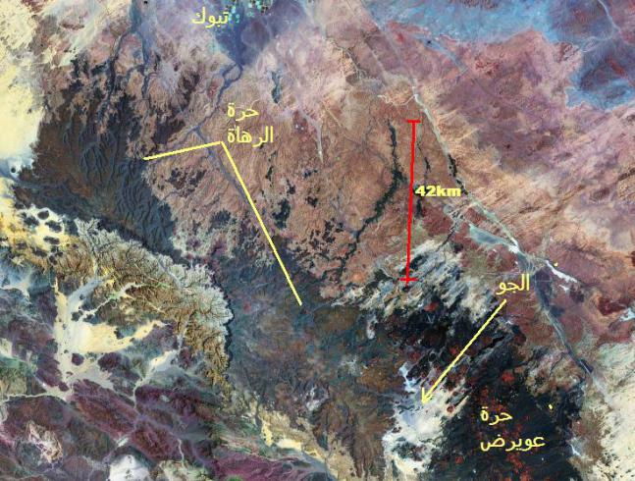
( Shape1 ) ‘Harat Aoard’ and ‘Alrah Harat’ in Tabuk
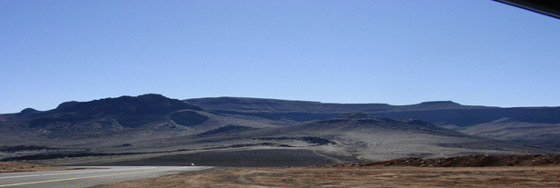 ( Shape2 ) Sample number 2 ___Location of the well
16
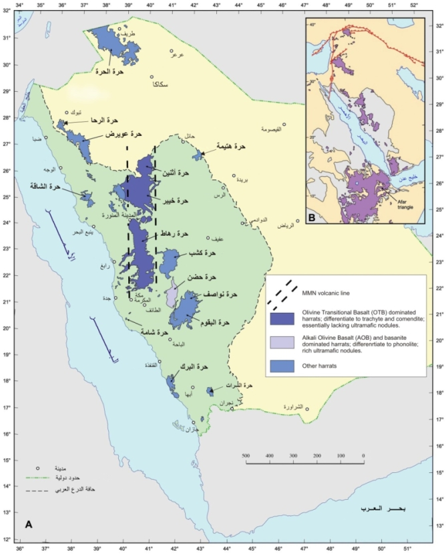
( shape 3 ) A map showing kinds ,distributions and extensions of Alhara in Saudi Arabia

Study Procedures:
Method of Taking Water Samples
The values of water characteristics indicate directly to the validity of the source of water to the sea life and the validity of water for different uses.
The characteristics of water widely influence it usability for agriculture and the determination of the corps that would be grown.
The most distinctive characteristic that would be studied in this is study is:
Dissolved Oxygen.

Dissolved Oxygen:
Dissolved oxygen means the quantity of the partial oxygen that is dissolved in water. It does not means the quantity of the oxygen that is dissolved in water molecule itself.

17

The dissolved oxygen is added to water through plants during the stage of photolysis, or through its distribution with atmosphere, or through ventilation that occurs when water is combined with water. This combination happens through waves, disturbances or waterfalls.
Most of plants need dissolved oxygen with a level of 5 – 6 part per million.

Collecting Water Samples for Performing Measures
A dry and clean bucket (washed with distilled water) shall be used through tying it with water rope in the location of the study and it the bucket shall be cleaned completely from any distilled water then it shall be thrown in the source of water nearly through the rope to be filled to its three quarters and dragged outside to make the measures instantly. In case that there was a need for delaying the measures, clean bottles shall be secured with covers to be filled with the sample of the water and closed firmly and not to be opened but when making measurements.

18

Equipment and Materials
Devices:
Pack of measuring the dissolved oxygen

Materials:
Bucket _ sample bottle _distilled water
======================================================

Variables :
Independent Variable well depth
Dependent Variable Percentage of Oxygen Melting
Control Variable The region where the well is located ( Alhara Region)

19

Procedures:-
Samples have been taken from underground wells from many locations in Harrat Al-Ruha and Harrat Owairad located in Tabuk; in the north-west of the Kingdom of Saudi Arabia, and it is one of the biggest harrats in the Kingdom, whereas its size is (20.000) km2. We have performed this through the existence of a specialized company in digging wells, while the research team has applied the water protocols in Globe Program specifically the temperature and the dissolved oxygen rate.
The measurements have been performed while Globe team was in the concerned individuals in the second secondary stage whose number is 15 students, Globe teacher Ms. (Fatema Al-Anzi), besides the team of Globe Sixteenth Intermediate School whose number is 12 students and Ms. (Fatima Al-Balwi) and the supervisor of Globe in the region Ms. (Mona Al-Fadli), in addition to the students of Tabuk University in many scientific specializations.

The time and place limitations :
March 26, 2017
The place : Harat Al-Ruha and Harrat Owairad located in Tabuk; in the north-west of the Kingdom of Saudi Arabia
N 27 59 813
E 36 38 740

20
The following schedule presents the distribution of roles and tasks on the Globe team

Name | Performed Role
Ms. Fatima Al-Anzi | Communication with the company of wells digging and coordination with tem in regard of obtaining the samples.
Globe Team in Sixteenth Intermediate School | Providing a water sample from one of the wells in Tabuk region
Globe Students | Collecting the water samples and selecting coordinates.
Globe Team in Second Secondary guided by Ms. Fatima Al-Anzi | Arranging for a suitable environment for doing experiments.
Ms. Fatima Al-Anzi and the Student Aisha Salem Al-Wadai | Dividing students into two groups.
Ms. Fatima Al-Anzi | The leader of the first team and the distributer of tasks between members.
Aisha Salem Al-Wadai | The leader of the second team and the distributor of the tasks between members.
Globe Team from Second Secondary and Globe Team from Sixteenth Intermediate School | Entering data in Globe website.

21

Results and Data Analysis :

Depth of well | Dissolved oxygen ratio
150m | 4ml/l
200m | 4ml/l
250m | 4ml/l
500m | 3ml/l
1000m | 3ml/l

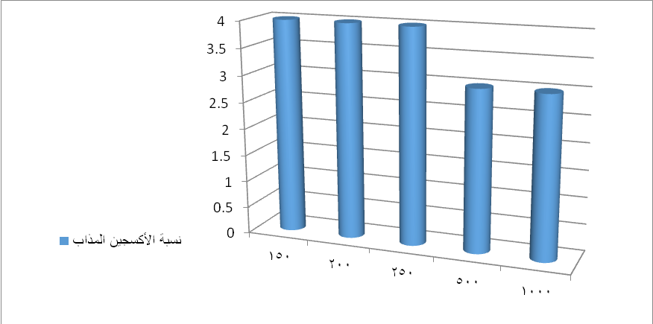

22

Discussion:
World Health organization has put international norms about the quality and type of water in the shape of indicators that should be used considerably for the determination of systems and norms in the developed countries and developing countries all over the world.
When analyzing water, it should be compatible with the following characteristics:
It has no taste, color or odor.
The dissolved oxygen level in the water should be between 5 – 8 mg per liter of water at twenty-five degrees Celsius.
The dioxide carbon dissolved should not be more than 3 mg per liter at twenty-five degrees Celsius.
It should be completely devoid of any impurities either natural or biological
The power of Hydrogen (PH) should be seven units.
To be completely void of compounds and mineral salts either they were organic or inorganic.
The water density should be nearly 0.998 gram per cubic centimeter at twenty degree Celsius.
The boiling degree should be 100 Celsius and the freezing degree should be zero Celsius.
There are many other specifications that should be available in the safe water like the degree of thermal conductivity, power conductivity, refractive index, vapor pressure, specific heat, and surface tension, and all these norms should be included in the measurement and permitted international specifications.
When performing the measurements on samples that we collected, we have found that the level of dissolved oxygen in the samples of some wells is less than agreed level for the safe usability of water.
23

It is known that the decrease of oxygen in water is resulted from many factors such as:
Water Stagnation
The differences of the water layers and the increase of the salt rate.
The inputs of organic materials as oxygen would decrease due to the oxidation of the organic materials and the thermal gradient density.
Whereas the dissolve of oxygen gas is decreased at high-temperature degrees compared to the low-temperature degrees, and we have researched on the effect of the geographic location of the well and the different results that we found where in the wells of Al-Harrah region other than the wells of the edges of the Arab Shield Area.
Previous Studies:
Some studies and air geo-physical surveys have shown the existence of radiological spots of irradiated radon gas in the region of the Arab Shied and the boundaries of the Arab Shield with a sediment apron. A report from Saudi Geological Survey has indicated that field studies were performed in this regard, supported by direct measurements on rock samples from the places mentioned to have radiological spots. Through these samples, the radiological rate that could be exposed to the body could be measured. This step would have a special importance on many dimensions and this study may have benefited in discovering the real reasons for the increasing rates of lung cancer infection between the Saudi nationals, especially in the place in which the gas is active.

24
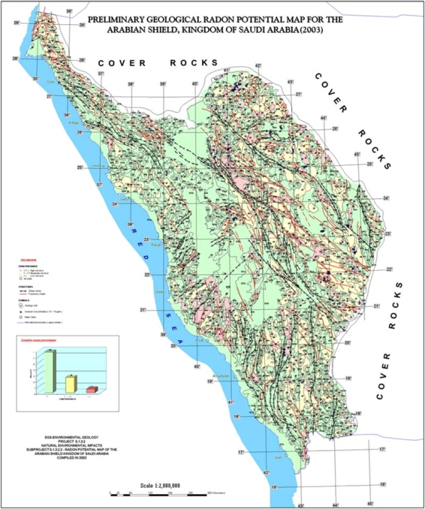

(Shape 4) Initial geological map shows the spread of Radon gas in the Arabian shield in Saudi Arabia .

The researcher and the expert in the water affairs of the Middle East, Saheb Al-Rubai, in his book (Water Pollution – Causes and Treatments) that the radiological pollution is the most dangerous type at all because it has a direct risk to the lives of the living creatures in nature. As we mentioned that the underground stores could be exposed to nuclear radiological pollution and it could cause environmental disasters and some of the potential harms because of this are:
- Increase in the temperature of the sea water temperature and its effect on the living creatures such fishes and other creatures.
- Intervention in the thermal cycles of the earth which represents a danger to humans.
- The increase of the water temperature leads to decreasing its content of dissolved oxygen required for the water creatures in seas and oceans.

25

"Researchers have also studied in the Center of (Jumar Helmholtz) for oceans researches in Germany, the data that has been five decades in the biggest survey ever for the oxygen rates in the water of oceans, where it has been found that the oxygen quantity in the world oceans has been decreased by 2% with an increase in the
temperature degrees around the
world to lead to a chemical interaction under the sea and this makes the warm water less efficient in trapping gases like oxygen."

Conclusions:

There is a negative relationship between the increase of the well depth and the rate of the Oxygen saturation in the water.

26

Recommendations and Suggestions:
The complementary studies of underground water under Harrats are few, and there are old valleys buried under the volcano eruption contains underground water, therefore the research team recommends with:
- Establishing a project of studying the usability of the underground water in Harrats and discovering the radiations levels in of radiations in these regions to make a qualitative and quantitative evaluation of them.
- No making any random digging for wells for individuals and depending or specialized companies to make studies required for the specifications of the well water.
- Planting many plants that absorb the radiations in the surrounding area like such as sunflower, bamboo and some cactus and Serengeti, such as Maidenhair Fern, Nephrolepis Exaltata, lily and others.

27
27

References
Alrabea, Saheb (2008) : Water pollution, causes and treatments, Dar Alhasaad: Damascus.
Dr. Ahmed Muhammed Alsarea, Mr. Hassan Othman Muhammed/ Radiative pollution of the environment
Graduation Project for the biologist engineer/ Abdulfatah Alqaheri/ Analyzes in the underground water
Aldawrani, Musa Omar (2001): Geography of the Arab nation, Beirut national library: Beirut.
Weleae, Abdullah Nasser (1996): Biogeography for Kingdom of Saudi Arabia : King Fahad national library.
Weleae, Abdullah Nasser (1998): Geology and geomorphology of Saudi Arabia : Research and Studies Center in Almedina, Geology of Medina.
Baiumi, Tareq Hassan: Water geology of the Kingdom of Saudi Arabia
Habib Ullah Muzfer Marghalani, Seismic of Arabian Peninsula, the third Arab study forum for Seismic science, Riyadh.

Nawab, Zuheer Abdulhafeez: Kingdom of Saudi Arabia- Facts and Numbers.
Mamoun, Mansour Muhammed (2003): Treatment of soil and water pollution, Madbouly library: Cairo, Waleed.
Abu Batah / environment role in the maintenance of facilities and the safety of its personnel
28

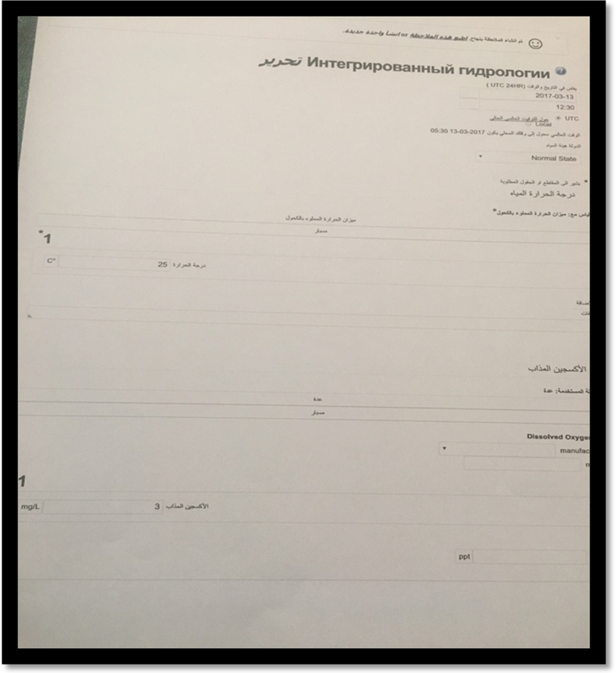
Enter the study data at the Globe site

29

